Reflective Journal on two key issues in contemporary education.
Every school has a duty to ensure that students receive an education that they are entitled to. However, as time goes on things are developing more, schools are improving their institutions in many areas such as budget, resources, testing and assessment and mental health and wellbeing. This does not mean that every single school is at the standard that parents, guardians and society want for children. Primary schools and secondary schools both have different methods to how they cater for a child’s education. For the this essay the reflection will be on primary schools. It will look at the issues regarding policies and inclusion and pedagogy within primary schools. It is essential to understand what can be improved in schools and why to ensure a change is made. Every school operates in different ways, they consider things such as deprivation of the area the school is located in, the different needs of the students that attend the school and also suggestions made through either the LEA or Estyn. Therefore, it is important to also look at the reasonings as to why the education may excel or require improvement in some areas. Along with the needs of education stated through the government, education is at the heart of the public. It is important to look at what the public require from education and why.
A relevant issue in contemporary education is that there are always changes in polices. Although these changes in the past have been to better education for children, and in which some cases they have succeeded. This is not always the case. In some situations polices make education worse than it was. The ‘new curriculum’ was first introduced by Graham Donaldson in 2015. It has many changes as to how the education system would work within schools. One of the many reasons behind it was that the last curriculum was developed in 1993. This was before the advanced technology there is today and when schools were expected to give a very standard education to all children, despite their different capabilities, needs and wants. Donaldson states that the ‘new curriculum’ will allow teachers to teach more freely and allow children to express themselves. There has been a lot of controversy towards whether this ‘new curriculum’ can actually implement what it has set out to do or if it will cause more problems for children’s education. Any policy change that is going to be potentially made to schools need to be tested out beforehand, this process can take a very long time as it allows the government to see what improvements need to be made. There are up to 30 pioneer schools since 2016 who are currently using the ‘new curriculum’ structure in their schools. The aim of the government is to have this new policy running in all schools in Wales by 2022 (Welsh Government, 2017).
Donaldson (2015) conducted a review on the Welsh education with evidence from many other countries. Apart of his review he stated many recommendations which form the ‘new curriculum’. These recommendations include that children should be ambitious and capable learners, creative contributors, informed citizens of Wales and confident individuals. One of the problems with trying to achieve all these things within a school is increasing class sizes. The diagram below shows that there has been an number of increase in students attending secondary schools, this pattern also follows through in primary schools.


(Rhodes, 2017)
As a result of this increase, figures show that there are more than 36 children being taught in one classroom as there is an increase in students. One of the pioneer schools for the ‘new curriculum’ is Christchurch primary school. The school highly focuses on the foundation phase learning through play which was also another recommendation by Donaldson. However an issue they face it that they have too many children in one class and their school building is rather small. They work on a structure that all children throughout the school are put into groups of colours which are not based on ability. These colour groups are mixed between year groups. Primarily each group has 8-10 students allowing the lesson to be more affective. They have done this so they can implement Donaldson’s recommendations better. Despite making this change the school still face a struggle as class numbers exceed 10. Another struggle they face due to trying to implement this strategy is that when they split the groups between two year groups they are faced with 4 sets of groups but do not have 4 classrooms. Teacher’s in most cases have to result in teaching in their main hall which is also used at the canteen, gym and assembly hall. While being at the school it was visible to also see that they struggle with classroom space as well.
The school are trying to implicate the ‘new curriculum’ in many ways. An aspect they highly focus on is independence. This is also a factor that is focused on in contemporary education as a whole Children are encouraged to pick which challenge they would like to complete throughout the day which are spread out throughout different classroom’s when they have finished their activity. The individual needs to be self-aware so they can know what challenge they have already completed. On the other hand, due to this children will be disrupting other students education as they will be walking into the classrooms which still have ongoing lessons on as they wish. Furthermore, this could be an issue if the topic in which they are to be independent is before their understanding and knowledge. Philosopher Aristotle stated that children should be trained to respond virtuously to life’s demands. Therefore, it would argued that teachers should not take a step back in education and be more involved. They should teach accordingly to what they believe what that child would need in the future (Flanagan, 2006).
However, the school pride themselves on encouraging out door learning which is a big element of the foundation phase so they will often use the yard for lessons. This is also another way of resolving the issue of having larger class sizes and less space. Also they have an ‘outdoor’ classroom for lessons. Philosophers such as Maria Montessori show the importance of outdoor play stating that it improves well-being, sense of self-worth and confidence. Using outdoor play as a form of teaching also adds to the schools agenda in making the children more independent. This does highlight one of the benefits of Donaldson’s ‘new curriculum’ as there is plenty of evidence to show how outdoor learning can improve education. Furthermore, Montessori also states that while implementing outdoor play that children should be able to be with nature and appreciate it as this will allow for their physical development to improve (Montessori, 2014). In England they carried out a 4 year project in relation to outdoor play, teachers found that children were more engaged in their learning, with a 72% increase in health and well-being (Gov.uk/Natural England, 2016). A way Christchurch primary school have implemented this is by ensuring the children receive a significant amount outdoors. This can be seen in the picture below that shows each group has one hour for outside learning which is top of their play time, also they would be able to go outside if they needed to finish one of their challenges.
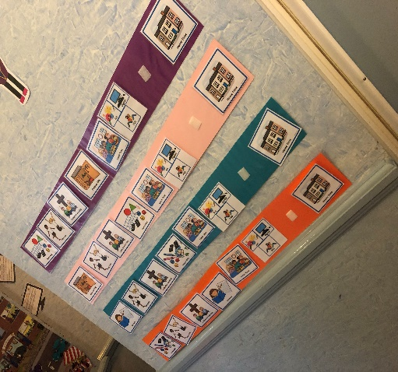

Furthermore, another benefit to having these small group would be that it allows for shorter lessons which open up more opportunities within the day. The school highlights this factor with their teachings as there are studies that show children have a short attention span. Research shows that a child should be able to concentrate in their activity 2 or 4 times their age so for example a 4 year old could pay attention for up to 16 minutes (O'Hanlon, 2013). Furthermore, studies also show that children have a higher attention span when learning outside compared to a classroom. This study also support the time frame given previous as it found that children ages 5-6 had an attention span on 20 minutes (Marie, 2015).
Therefore, they will learn more in an hour in two different topics rather than a whole hour on the same subject. Although these small classes have their benefits, there are also flaws within it. As the classes are mixed between years the children are at different stages of their education. What was found while being at the school was that teachers were essentially teaching two different lessons within the classroom even if they are on the same subject. This can cause problems for the students and also the teacher. Firstly, the children were found getting confused between what their activity was. Secondly, the teacher was struggling to split their time equally between two groups. Lastly there was a lot of disruptions throughout the classroom with other students and staff continuously going in and out, children in lesson wondering around and the teacher was with the other group for a long period of time.
Contemporary education also faces another issue with inclusion and pedagogy. This entails the relationship between the student and teacher. Also, it could include the environment children learn in and the activities they take part in. Alongside this it also would consider the strategies schools have in place to ensure inclusion. This would create a stronger pedagogy between the student and teacher as they student would give more meaning behind what they learn, rather than going off on their own. John Dewey was another philosopher who also looked at the relationship of learning, which would support a stronger pedagogy between students and teachers. It was seen in the school that when a student learns something specific from a teacher such as ‘tie your shoelace before your trip’, the child is more appreciative of what they have learnt and it allows them to ask more questions. However, if the child was to go out to play and trip due to their laces. Dewey stated that in order for in to be an educative experience they would need to learn a lesson rather than just be in pain as a result (Flanagan, 2006). Rather than looking at contemporary education, children in general in contemporary society are eager to learn, they are full of questions and queries. This should be followed up by schools and encouraged.
Vygotsky states that in order for a child to gain affective dialog and knowledge they need to be involved in joint activity with the teachers. This would lead them to be able to enquire and ask questions. This implies that a teacher should be involved in a child’s learning even when it is during play. However this is not the case in all schools (Anning, 2004). It could be seen that in Christchurch primary school students are encouraged to choose their own activity and do so without the involvement of a teacher. This would make what is requested from the student difficult as they are expecting to complete ‘challenges’ before they can freely play. These challenges are also to be completed independently. Firstly, a problem with this which was previously mentions, was that children were not at the age where they are able to read the instructions for the challenges on their own. Therefore, the child would choose not to do it and go to another classroom. A classroom where the teacher has no knowledge as to what this student has previously done, so the child continues to play in the classroom. Teachers are not engaged in what activities or challenges students are completing. And as everything is to be completed alone, students do not create a stable relationship with teachers to be able to ask questions and further their knowledge. This is an issue that can be overcome in contemporary education as all teachers have access to emails. They could be continuously updating each other in what each student has done when they go from one classroom to another. Also, in contemporary education every child should be able to approach a teacher and state what they cannot do or ask for help so they can reach their full potential as article 29 of the Conventions on the rights on the child states (Unicef, n/a). Following on from this there are many other philosophers who would encourage a stronger pedagogy within schools in general. Steiner states that teachers along with their students are still learners and need to responsibility involve themselves, rather than allowing children to take rein of their education wholly.
Although there is no set definition as to what inclusion means as it could be considered different based on different contexts. Inclusion within schools may refer to involving everyone’s values and diversities to become a whole when learning. It is including the wider communities and the minorities to have equal opportunities within the school. A common issue with inclusion is mistakenly thinking that it refers to only students with disability and additional learning needs (ALN) (Ainscow M, 2007). However, this is not always the case. Inclusion can be for ethnicity, gender and race. It could also be due to social class.
Despite this there has always been a fight for students with disabilities and ALN to be able to attend mainstream school unless in extreme circumstances. Also, one the recent issues regarding inclusion has been gender and allowing children to make their own choices. On the other hand, although inclusion for students with disabilities and ALN is a great movement it needs to be considered whether mainstream schools can provide the support needed. In some cases where the ALNco believes that a child is capable of remaining in mainstream school the budget for one to one and other resources get passed to those who require it more. However, a student capable of staying in mainstream school does not mean that they do not require more help from the classroom teacher. As there is a weaker relationship system between student and teacher is it having a negative impact on students with ALN. Due to the system Christchurch school have implement which is focused on play based learning this could be a problem for students with disabilities or ALN. Students with Autism as an ALN would require structure in their day. However, as students are able to take part in which ever challenge or activity they want throughout the day could cause some issues for these students. While being at the school it was clear to see that students with ALN were struggling with the system as they could not comprehend why they were going from one classroom to another when the timetable on the board suggest otherwise. They also were struggling with handling different activities with different teachers on short basis as they take awhile to get comfortable with what they need to do and the teacher. Although there never is enough funds for all the resources that school require, they could possibly try and adjust the teaching methods and activities where possible to assist the child. This shouldn’t be an issue in contemporary education as there is a lot teachers as an individual can do to improve their knowledge on a topic they have not been trained on previously. They could do this accessing resources such as social story for free online to help students learn social skills therefore they will not be as excluded by other children. Furthermore, students from different cultural backgrounds or ALN may not engage with all activities which are play based as they could have restricted play experience (Anning, 2004). This could be overcome with more attention given to the relationships with the students, as a teacher could be able to tell that whichever activity may be set out won’t be suitable for a particular student.
Regardless of this issues, Christchurch Primary school still work very hard in ensuring the school is inclusive. As it is a Voluntary aided school by a church one of the difficulties they face with inclusion is religion. The school has a wide range of students with different religious and cultural backgrounds. This can be seen as an issue although parents will knowingly send their child to this school, their child could feel excluded on a regular basis. Although the school do not impose the religion on anyone, the school is full of representation of the Christian faith. While attending the school, it can be seen that every child is aware of this difference. During the start and end of the day each class does a prayer. Students who are of the Christianity faith continuously inform children from other backgrounds such as Hindu or Muslim students that they don’t have to say the prayer or hold their hands in the form that a Christian prayer is said. Teaching children these differences and being able to accept different faiths is great as they will be aware. However, when in a class full of 20 children and only 1 or 2 children are being pointed out for being different could open up room for them to be stigmatised. Every day the whole school attend ‘collective worship’ which is another schools would be regarded as assembly. During this time they will learn about stories from the bible which teach valuable lessons. The bible holds a multitude of values which are then passed through to the children. The children then use these values and put them into action to make the school inclusive. Some of these values are forgiveness, thankfulness and appreciation. The school teaches that these values should run through their day despite any religious difference or any other factor that could exclude someone.
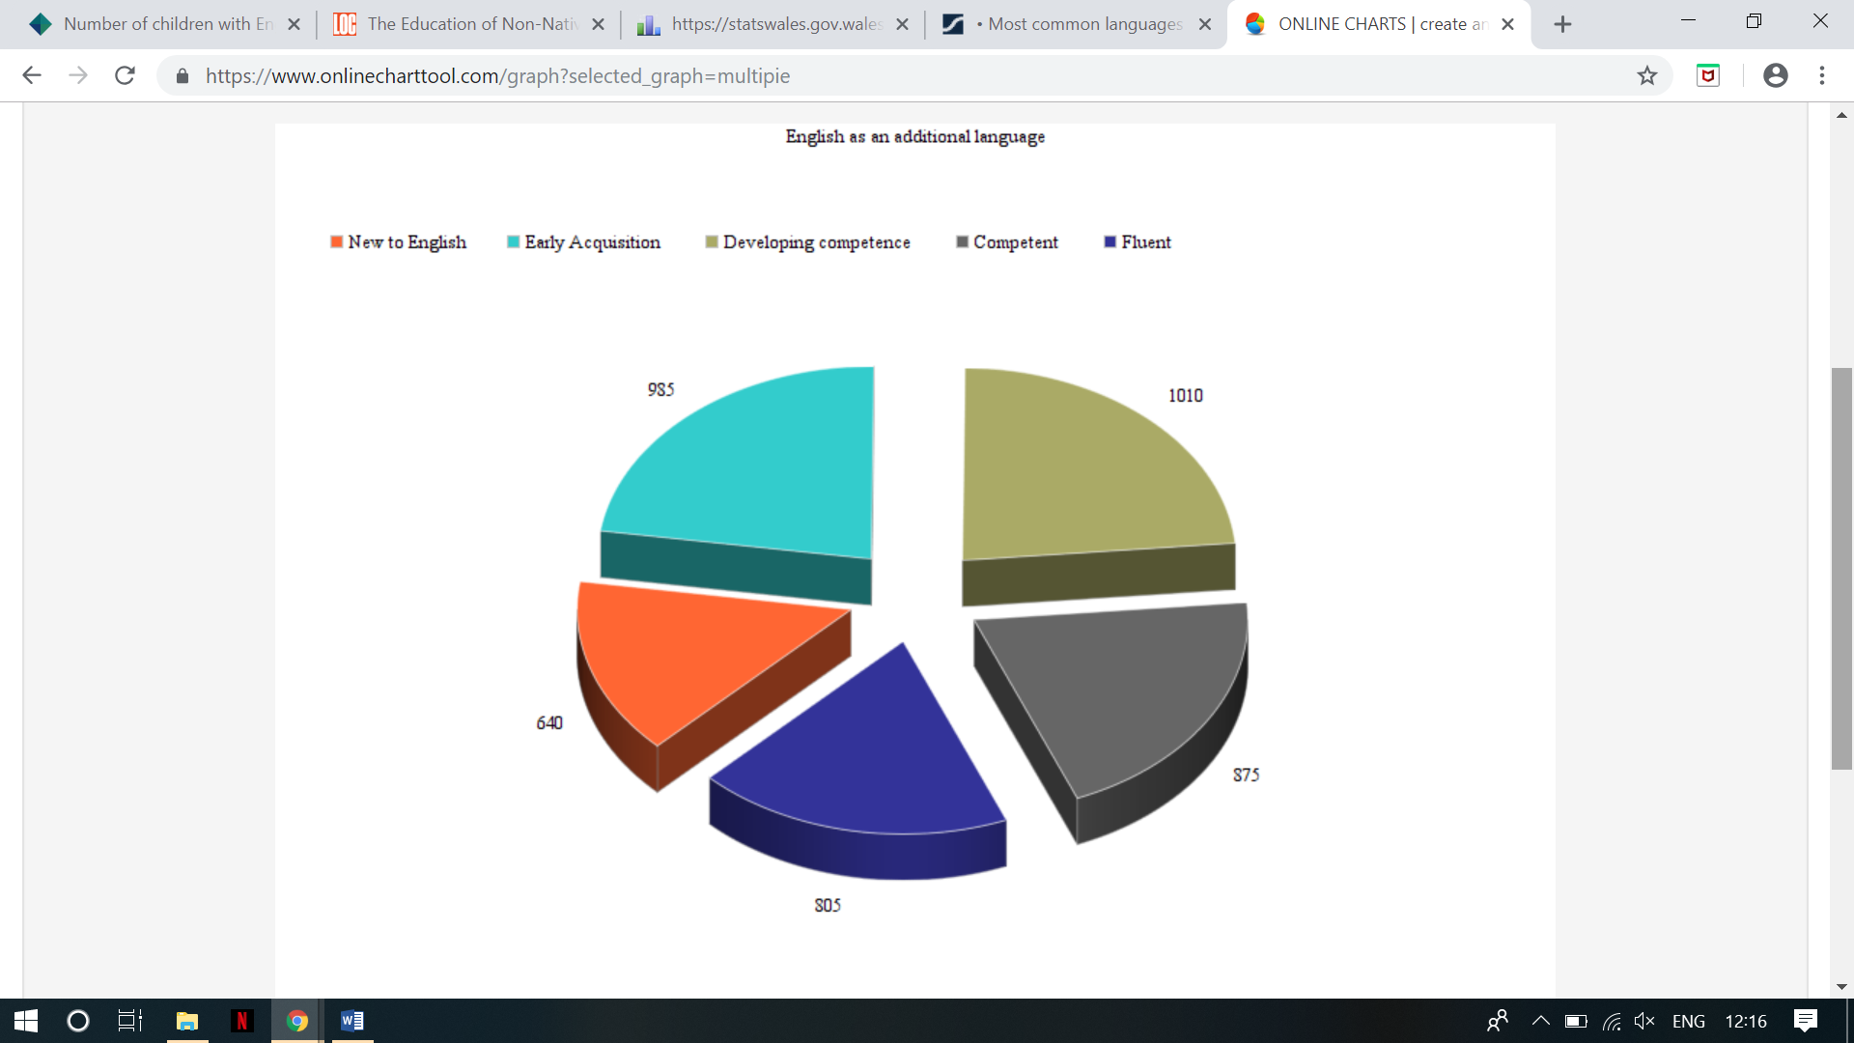
Inclusion also comes at the hand of the teacher and the pedagogy within schools. A teacher might not notice that their fears, likes and assumptions are noticed by young children. Teachers have a duty to ensure that a child gets the best education their entitled to. And in doing this they must be critical and ask questions. They need to be able to adapt their teaching in response to the learner. Teachers are very interested in a child’s attainment however they also need to be aware of the changes they make on a child’s attitude. A child could have many aspects which can exclude them for example having a language barrier. This would also be an area that a teacher is not well informed in. Due to this lack of knowledge it could lead to an unresponsive practice, where the teacher and student relationship suffers. The teacher could be blaming the student for not understanding or the student could feel resentment towards a teacher as they spend more time with other students as they have a form of communication (Andy Howes, 2009). In 2013 it was stated that 6.7% of primary and secondary schools students were learning English as their second language. As can be seen in the chart below the number of children new to English is rather high and continues to increase.

(Stats Wales , 2018)
While being at the school it was clear to see that this could easily be the mindset of a teacher. There are a number of pupils within each class that have a language barrier and in cases where the student could not comprehend the task purely on the basis that they did not understand what was being asked of them, the teacher would get frustrated thinking they are choosing not to complete the task. Rather than try to understand a reason behind it and finding ways to involve them or accommodate their needs (Anning, 2004). In contemporary education there is a clear solution as to how a teacher could overcome this. Technology is a massive part of society and has increasingly become accessible in schools. A teacher could find some statement words on google in the language required which would be used regularly to include in the classroom or one to one with the student. Although the student would need to gradually learn the English language, it is a starting point for both the student and teacher. It would also improve the relationship as the student would be able to see the teacher is trying to communicate with them.
In addition to all the issues schools face with pedagogy a way they can improve is through extra teacher training. Gipps and MacGilchrist state that teachers need to have a better understanding of how learning takes place. If they were to understand how a student takes on information then it will improve the pedagogy and learning of students. A study carried out by the writers on the views of teachers when it comes to learning found that their methods of teaching do not support a single theory about learning. Furthermore, as it was found that teachers have a lack of knowledge regarding learning theories and not acknowledging their views have an impact on the children increases a higher chance of children falling into the self-fulfilling prophecy. Many child are naughty and that is apart of their personality while growing up. However, this is not always the case. Sometimes there is more meaning as to why a child is misbehaving. As teachers do not know the difference in how certain children learn differently, they might not be able to adapt their teachings to meet that child’s need. Therefore, that child might act out resulting in misbehaving (Mortimore, 1999).
To conclude, it can be seen in contemporary education there have been changes made to improve education and some things that still require changing. Two of these things which are stated above are changing is policies for example the ‘new curriculum’ and also inclusion and pedagogy. While experiencing some of these benefits, it is clear to see how children and contemporary education can exceed far beyond our expectations by building on some of the issues within the education system. Although, this does not mean it is all down to the government, some of the issues identified above can be due to the school and its system. While reflecting, the issues above can be seen as unorganised, puts children with ALN at a disadvantage and there is no flow throughout the education for the individual. As the ‘new curriculum’ is not yet fully implemented within Wales, there are still many changes that need to be made to it. It can be seen as unrealistic as schools such as Christchurch primary school are implementing it however compromising the children’s education at the same time. Children can be seen at a disadvantage as there is no real recollection of what they have learnt throughout the day by their teachers as there is not a strong relationship between teachers themselves and also the students and teachers. Furthermore, if teachers were to improve on pedagogy, it will benefit the children significantly as there will be a better flow to their education with an open communication for everyone at the school. Many philosophers have stated through their findings and theories that teachers and pedagogy can improve education. There are statistics mentioned above which show how inclusiveness and pedagogy, along with the ‘new curriculum’ can be affected due to means which cannot be controlled such as language barriers and increasing population. There also changes that a school can take on themselves to improve contemporary education for example use technology to its fullest potential for more resources. Despite these issues arising in contemporary education, it can be seen that there are attempts in order to resolve these issues and improve the education for each children.

References
Ainscow M, T. B. a. A. D., 2007. Improving Schools, Developing Inclusion. London: Routledge.
Andy Howes, S. D. a. S. F., 2009. Improving the context for inclusion. New York: Routledge.
Anning, A. a. C. J. a. F. M., 2004. Early childhood education. London: Sage Publication.
Donaldson, G., 2015. Successful Futures: Independent review of cuuriculum and assessment in Wales, s.l.: OGL.
Flanagan, M. F., 2006. The greatest educators ever !. London: Continnum.
Gov.uk/Natural England, 2016. England's largest outdoor learning project reveals children more motivate to work when outside.. [Online]
Available at: https://www.gov.uk/government/news/englands-largest-outdoor-learning-project-reveals-children-more-motivated-to-learn-when-outside
[Accessed 17 January 2019].
Marie, V. J. a. J., 2015. Comparison of academic performance and attention span of children between Montessori and traditional pedagogical approaches of preschool. International Conference for Information Communication Technologies in Education, pp. 336-348.
Montessori, M., 2014. The Montessori Method. London: Transaction Publishers.
Mortimore, P., 1999. Understanding pedagogy: And its impact on learning. London: Paul Chapman Publishing.
O'Hanlon, L. H., 2013. How to improve attention spans. [Online]
Available at: https://www.parents.com/kids/development/intellectual/how-to-improve-attention-spans/
[Accessed 17 January 2019].
Rhodes, D., 2017. BBC News. [Online]
Available at: https://www.bbc.co.uk/news/uk-england-38506305
[Accessed 9 January 2019].
Stats Wales , 2018. Pupils in nursery, primary, middle and secondary schools acquiring English as an additional language by local authority and stage of development, Cardiff: Welsh Government.
Unicef, n/a. The rights to education. [Online]
Available at: https://www.unicef.org.uk/rights-respecting-schools/the-right-to-education/
[Accessed Friday 18 2019].
Welsh Government, 2017. New school curriculum: Overview. [Online]
Available at: https://beta.gov.wales/new-school-curriculum-overview
[Accessed 14 January 2019].

