

An Investigation into understanding motivations towards Dark Tourism

A case study of Welsh Tourism Sites

Author: Bethan Jemma Watkins
Date: 11th May 2018

This dissertation submitted as part of the requirements of the award Mtour Tourism and Events Management

Declaration

This work has not previously been accepted in substance for any degree and is not being concurrently submitted in candidature for any degree.

Signed...................................................................... (Candidate)

Date........................................................................

STATEMENT 1

This work is the result of my own investigations, except where otherwise stated.

Other sources are acknowledged by footnotes giving explicit references. A bibliography is appended.

Signed..................................................................... (Candidate)

Date........................................................................

STATEMENT 2

I hereby give consent for my work, if accepted, to be available for photocopying and for inter-library loan, and for the title and summary to be made available to outside organisations.

Signed..................................................................... (Candidate)

Date........................................................................

NB Candidates on whose behalf a bar on access has been approved by the University (see Note 1), should use the following version of Statement 2:

I hereby give consent for my work, if accepted, to be available for photocopying and for inter-library loans after expiry of a bar on access approved by the University.

Signed..................................................................... (Candidate)

Date........................................................................

Candidate's signature........................................................................... Date…………….

Acknowledgements
In my life, I am truly blessed to have to have too many people to thank. The continuous love, encouragement, inspiration, support and belief I have received from my family and friends through the hard times and the best times of my life.
I would first like to thank my mother, Samantha Watkins, helping me through my School years, encouraging me to continue my studies for higher education (no matter how many excuses I conducted not to do it). Your passion of travelling and enriching my knowledge of history is one of the main reasons why you are my source of inspiration, and I cannot forget you Rhys for always pushing me to my limit and taking me to university when I needed you.
Mama and Dado, you both have helped me understand my Welsh roots more and more throughout the years, and I could not be more proud of where my roots and the heritage that I have through you both.
Jean-Paul, we are celebrating six years together this year. Words cannot express my appreciation for simply having you in my life for this length of time. Six years is a long time to let someone go to achieve a goal, and you did it with the up most understanding and pride. One more thing, thank for being my chauffeur.
Billie Morgan, Silje Gronn and Hannah Thomas-Peters as my friends I also consider you my family as you three have been my ride and die through the whole year. Through the crying out of fear and sadness and crying out of laughter. No matter where we all end up, just remember one thing; HERE FOR A GOOD TIME NOT A LONG TIME.

Empathy, understanding and encouragement from the staff at the University of Wales Trinity Saint David have throughout helped me towards my goal of a Master’s Degree. Kathryn Flynn and Jacqui Jones thank you for your guidance, patience and direction. If it were not for you both there would not have been a BA (hons) or a Master’s degree over the past four year.
Finally, thank you to all the staff and volunteers that contributed to my dissertation. Your input has greatly affected the outcome of my dissertation and the results. In addition, of course thank you to all the participants in this investigation who kindly donated their time to complete all questions for this dissertation.

Abstract
An investigation into understanding motivations towards Dark Tourism:
A case study of Welsh Tourism Sites (May 2018)
Bethan Jemma Watkins, Mtour,
University of Wales Trinity Saint David

Dark Tourism, a term that is rarely used but almost everyone in today’s world has either heard or visited a site related to dark tourism, why? Because people are simply fascinated with disasters, tragedies and death. When travelling along the motorway, where there has been a car accident, one simply has to watch traffic slow to a crawl when passing. This is just one way to understand the term, although there is much more to dark tourism than the motorway.
Globally known sites such as 9/11 memorial and museum attracts 30 million visitors since opening in September 2011 (9/11 Memorial & Museum, 2016). Another being Auschwitz Concentration Camp receiving over 1.5 million visitors in 2014 (Auschwitz Birkenau, 2015), while Chernobyl receives 10 thousand visitors in 2015 (Daily Mail, 2015). The list of globally known dark tourism sites could continue, and by each year, a new site may add to the list.
This new Niche Tourism market has increased throughout the years, leading to new authors to come forward and produce work studying the phenomenon. Despite ongoing studies from authors such as Seaton who developed the term Thanatourism, Rojek who advanced the concept of black spots and finally, the leading in the field, Lennon and Foley who labelled this market as Dark Tourism, there is little known about the motivations of visitors visiting Dark Tourism sites.

Wales, known for the Welsh Dragon, Rugby, and possibly for the food, has a darker side. The Castles that the whole of Wales has to offer visitors, the industrial sites that many families have lost loved ones due to accidents but also due to unfortunate events.
The authors are able to divide sites into categories of Dark Tourism simply by understanding the sites history, is it a site of death and suffering? Alternatively, a site associated with death and suffering?

Table of Contents
Declaration 1
Acknowledgements 2
Abstract 4
Table of Contents 6
Figures 10
Tables 11
Abbreviations 11
Translations 11
1.0. Introduction 1
1.2. Rationale 2
1.3. Research Question(s) 2
1.4. Aims and Objectives 3
1.5. Background Research 4
2.0. Introduction 5
Objectives 6
2.1. Tourism definitions and typologies 7
Historical development of tourism 9
2.2. Tourism Demand 13
Visitation 16
Maslow’s Hierarchy of Needs 17
Travel-career needs 18
Traits for tourists behaviour 19
Motivation and Perspectives 22
2.3. Tourism Products 24
Niche Tourism 25
2.4. Dark tourism 27
Impacts of Dark Tourism 31
Social Impacts of Dark Tourism 33
Marketing Dark Tourism 33
2.5. Tourism provisions in Wales 34
Visit Wales tourism strategy 34
Current Provision 35
Top-driven attractions in Wales 36
2.6. Case Studies 38
Aberfan Memorial Site & Garden 38
Rhondda Heritage Park 38
Caerphilly Castle 39
Conclusion of Case Studies 40
3.0. Introduction 41
3.1. Research Defined 42
3.2. Research Objectives 43
3.3. Research Paradigms 44
3.4. Research Onion 45
3.5. Research Design 47
3.6. Design of Questionnaires 48
3.7. Design of Interviews 50
3.8. Sampling 50
3.9. Piloting 51
3.10. Data collection 52
3.11. Data analysis techniques 53
3.12. Reliability, Validity and Generalisability 56
3.13. Limitations and Recommendations 57
4.0. Introduction 58
4.1. The Survey Pool of Respondents 59
Background 59
Q.21. What is your gender? 60
Q.22. What is your age range? 61
Q. 23. In what country do you reside? With Q. 25. What is your nationality? 62
4.2. KEY THEME 1: Objective 1 – Motivational Factors 64
Personal Motivation 64
Holiday Motivation 69
Dark Tourism Motivation 71
4.3. KEY THEME 2: Objective 2 – Common Trends 78
Maintaining Dark Tourism Sites 78
Elements to visit a Dark Tourism Site 79
Experience at Dark Tourism Site 82
Conclusion of Chapter 4 85
5.0. Conclusion Introduction 86
5.1. Discussion 87
Conclusion Summary 93
Limitations and Recommendations 94
Opportunities for Future Researchers 95
6.0. References 96
7.0. Appendix 103
7.1. Research Questions 103
7.2. Maslow’s hierarchy of needs 104
7.3. Fourfold classification of tourst experiences and roles 104
7.4. Design of Questionnaires 105
7.5. Data Collection Continued 109
7.6. Survey Results 111
7.7. Letter to organisations 125
University of Wales Trinity Saint David 125
7.8. Interview Transcripts 126
Interview 1 – Consultant for Letha Consultancy 126
7.9. Interview Matrix Table 3

Figures
Figure 1 - overview of UK visitors’ statistics in 2016 9
Figure 2 - total revenue from statistics 2015 12
Figure 3 - determinates of tourism demand 15
Figure 4 - Overseas visits to UK continues to grow 16
Figure 5 - The Five major role-related behaviours for 15 travellers’ categories (Pearce, 1982, p. 32) 22
Figure 6 a Categorisation of Dark Tourism (Dan, 1998) 27
Figure 7 - Typology of dark tourism (Palancsa, 2012) 28
Figure 8 - The Dark Tourism Product (Stone, 2006) 29
Figure 9 A Dark Tourism Spectrum (Stone, 2006) 29
Figure 10 UK Day Visitors (Welsh Government, 2017) 36
Figure 11 All UK Staying Visitors (Welsh Government, 2017) 37
Figure 12 All Overseas visitors (Welsh Government, 2017) 37
Figure 13 - Research Onion Diagram (Saunders, 2009) 45
Figure 14 - Google Forms example of pie graph 54
Figure 15 - Creating Spreadsheet with Microsoft Excel 54
Figure 16 - Microsoft Excel COUNTIF formula 55
Figure 17 - Google From bar chart example 55
Figure 18 - Respondents Gender (Google Forms, 2018) 60
Figure 19 - Age Ranges of respondents (Authors own credit) 61
Figure 20 - Questions 1 and 2 presented in pie charts (Google Forms, 2018) 64
Figure 21 - Responses for Question 3 (Google Forms, 2018) 66
Figure 22 - Responses of question 5 in the form of a pie chart (Google Forms, 2018) 69
Figure 23 – Responses to question 10 (Authors own credit) 71
Figure 24 - Influences to visit Dark Tourism sites (authors own credit) 74
Figure 25 - Reasons for the visit (Authors own credit) 76
Figure 26 - Question 17 responses (authors own credit) 78
Figure 27 - Personal Experiences at Dark Tourism Site (authors own credit) 82

Tables
Table 1 - Spine core of needs 18
Table 2 - Types of tourist by interaction with destination 20
Table 3 - Niche Tourism Framework, Adapted from Novelli (2005) 26
Table 4- Palancsa (2012) Dark Tourism Practitioners 30
Table 5 - Assumptions of the main paradigms (Creswell, 1994, p.5) 44
Table 6 - Qualitative data analysis (Easterby-Smith, et al., 2012) 47
Table 7 - Non-probability and probability sampling (Authors own credit) 51
Table 8 - Pilot Study Feedback (Authors own credit) 52
Table 9-Analyses of respondents living in Wales (Authors own credit) 62
Table 10 - Cross-analyses of questions 1 and 2 (Authors own credit) 65
Table 11 - 3-way cross analyses (Authors own credit) 67
Table 12 - Question 6, Types of travel destinations (Authors own credit) 70
Table 13 - Responses to question 18 (authors own credit) 78
Table 14 - Individual Experiences from Dark Tourism Sites (authors own credit) 82
Table 15 - Question 17, reasons why visitors have not visit DT sites (authors own credit) 84

Abbreviations
- (VFR) – Visiting friends and relatives
- (UNWTO) – The World Tourism Organization
- (DCMS) - The Department for Culture, Media & Sport
- (UK) – United Kingdom
- (EU) – European Union
- (RQ) – Research Question(s)

Translations
- (CADW) – A Welsh word meaning ‘to keep’ or ‘to protect’

Chapter 1
INTRODUCTION

Introduction
The importance of Dark Tourism, according to Gander (2017) is more than ever due to the divisive political climate. An article that was created by Peter Hohebhaus (Hohenhaus, 2017) suggests that the top five dark tourism sites are Auschwitz-Birkenau, Poland, Chernobyl & Pripyat, Ukraine, Hiroshima & Nagasaki, Japan, Berlin, Germany and lastly, Rwanda – Murambi, Nyamata and Kigali genocide memorials. These top five dark tourism sites serve to highlight the acceptance that people wish to visit a site of Dark Tourism but understanding the reasons why the individuals want to visit these sites is still not clear. As mentioned in the Abstract the three Dark Tourism Sites, 9/11 memorial and museum, Auschwitz Concentration Camp and Chernobyl all combined receive over 100,000,000 million visitors, this provides evidence of atrocity.
Wales does not make the top five globally, Hohebhaus (2017) created an article dedicated to Aberfan Memorial Garden and Cemetery; however, this is the only site in South Wales that has been publicised regarding Dark Tourism site within Wales.

1.2. Rationale
The purpose of this study is not to discover new Dark Tourism Sites, but rather to examine the motivations of individuals that visit Dark Tourism Sites in Wales. To do this, the researcher will discovering the past, present or future ambitions of the visitors. Mentioned previously in the introduction chapter, globally known Dark Tourism Sites such as 9/11 memorial and museum, Auschwitz Concentration Camp and Chernobyl would not be feasible to research these key Dark Tourism Sites as it would not be viable for this study. Nevertheless, the researcher found that there is a variety of locations in Wales with a Dark Tourism past; this attracted the researcher to investigate in more depth. As the location of this study is taken place in South Wales, the researcher may have potential insight in 3 locations: Caerphilly Castle, Rhondda Heritage Park and Aberfan Disaster Garden/Cemetery.

1.3. Research Question(s)
Research Question
Does personal motivation give evidence of the individual wanting to travel to a new culture, heritage and unusual site? | When selecting a holiday, do individuals select a destination to their personal travel type preference or solely on the destination? | Which Dark Tourism Site is the most common in Wales? | What external factors played a part in selecting a Dark Tourism Site?
When visiting a Dark Tourism site, what internal factors played a key role after reflecting their reasons to visit? | Why do the individuals believe that maintaining a Dark Tourism Site is important or not? | How do professionals feel regarding Dark Tourism linked to the selected case study sites? | What did the visitor gain from visiting a Dark Tourism Site?

Aims and Objectives
Title of study

An Investigation into understanding motivations towards Dark Tourism
A case study of Welsh Tourism Sites

Aim

The aim of this study is to investigate the motivations of individuals that visit a Dark Tourism Site in South Wales

Objectives
- Determine factors of motivational factors of visitors visiting a dark tourism site.
- To assess whether there is a common trend to the motivations of visitors to popular dark tourism sites.
- On completion of the research, the researcher will provide a conclusion of why visitors visit dark tourism sites.
- On completion of the research, the research will provide recommendations to each site.

1.5. Background Research
Throughout one’s life, the need to travel and explore new things, shown through the means of tourism; therefore, tourism plays a major part. There are initially seven different terms of tourism classified by The Tourism Society (2017), overall tourism is a generic term, which can cover both demand and source. On the contrary, The World Tourism Organisation (2010) can define tourism as both demand and source.

“The activities of persons identified as visitors. A visitor is someone who is making a visit to a main destination outside his/her usual environment”
(The World Tourism Organisation, 2010)
For this research in particular, dark tourism will focus within South Wales. Dark tourism, which is essentially an individual visiting a site with a dark past is “more important than ever” (Independent, 2017). Peter Hohenhaus, a visitor that spends his majority of time visiting dark tourism sites, remarks that “as is often said: those who do not learn from history are bound to repeat it”. Some may argue with Hohenhaus fortunate position, where he may visit the sites whenever he pleases, however, this is not the case for people who live and remain in these sites, such as Aberfan, Rhondda and Caerphilly. All three of these destinations have a site that may or may not be related to dark tourism. However, what are the main motivations for visitors to visit sites such as these three? The research paper will enable the readers to discover the moitvations of these three sites.

Chapter 2
Literature Review

Introduction
The focus of this study is to investigate the motivations and participation of visitors visiting dark tourism sites in South Wales as South Wales is not globally known to have any dark tourism sites, however, history in the selected attractions can suggest that there has been death, human tragedies and dark events occurred.
The objective of this study is to focus on secondary research as a method as this helps to identify synthesize and evaluate existing work published by scholars and researchers (Tranfield, et al., 2003). The researcher will be using one of two forms of literary analysis, where Onwuegbuzie, Leech, & Collins, (2012) identifies these as “within-study literature analysis” and “between-study literature analysis”. The researcher will be using both analyses to determine the “gap” within the literature and to address objective (a)
Dark Tourism identifies as visiting sites with a dark past where murder and death have taken place (Hohenhaus, 2017). The importance of Dark Tourism, according to Gander (2017) is more than ever due to the divisive political climate. An article that was created by Peter Hohebhaus (Hohenhaus, 2017) suggests that the top five dark tourism sites are Auschwitz-Birkenau, Poland, Chernobyl & Pripyat, Ukraine, Hiroshima & Nagasaki, Japan, Berlin, Germany and lastly, Rwanda – Murambi, Nyamata and Kigali genocide memorials. Although Wales does not make the top five globally, Hohebhaus (2017) created an article dedicated to Aberfan disaster, however, this is the only publicised Dark Tourism site within Wales. Therefore, the purpose of this study is to explore the motivations of dark tourism sites within South Wales, which will include case studies of Welsh Tourism Sites located in South Wales, these are the Aberfan Disaster, Rhondda Heritage Park, and Caerphilly Castle. Through this investigation, there will be a conclusion and of why the visitor visits these sites in Wales and provide recommendations to each case studies on how to attract visitors to each site.

Objectives
- Determine factors of motivational factors of visitors visiting a dark tourism site.
- To assess whether there is a common trend to the motivations of visitors to popular dark tourism sites.
- On completion of the research, the researcher will provide a conclusion of why visitors visit dark tourism sites.
- On completion of the research, the research will provide recommendations to each site.

Tourism definitions and typologies
People who are visiting a specific place to undergo different types of activities is the main form that people identify tourism. These can include sightseeing, visiting friends and relatives (VFR) or simply taking a holiday to have a good time. Nevertheless, tourism can result in the means of business, as people travel to a specific location to participate in a business or professional activity (Goeldner & Ritchie, 2012).
“People being away from their own homes, on short term, temporary visits, for particular ‘tourism’ purposes” (Davidson, 1993, p. 2)
Burkart & Medlik (1989) and Burns & Holden (1995) and identify three main aspects to define tourism. The first definition can define the motivations of why travellers travel to destinations which will draw distinctions between, instance, business and pleasure. Secondly, is the concept of time, in the sense of whether the traveller will be travelling for a day trip or an overnight trip. Lastly, the third element may be that the traveller is travelling to migrate, transit or a sea trip. As result to this, Mathieson & Wall (1982) definies tourism as a
“temporary movement of people to destinations outside their normal place of work and residence.” (Mathieson & Wall, 1982, p.1)
With all definitions considered, tourism, have two different purposes that is assossiated with tourisim as a whole, leisure and business (Davidson, 1993).

The first concept is leisure tourism where people travel for various purposes:
- Holidays
- Sports (non-professional)
- Culturual Events
- Visiting friends and relatives

Arguably, Davidson (1993) created the theory of sports being a non-professional leisure tourism, prior to the 2012 Olympics in London that received an overall of “685,000 visits from overseas to the UK in July, August and September,” (VisitBritain, 2013) due to the Olympics. The same being said for the Champions League final that was held in Cardiff in 2017, the BBC News (2017) reported that the “total of 314,264 fans soaked up the atmosphere” unlike the previous record of 270,421. This now suggests that more people will travel to visit a sporting event that is professional.
The second purpose associated with tourism is business tourism where business tourisim does consist of travel for various reasons (Davidson, 1993):
- Business meetings
- Exhibitions and trade fairs
- Conferences and conventions Although less popular than leisure travel, VisitBritain.org, (2016) shows 2016 forecast of the number of visitors that travel via business. Figure 1 shows the overview of visitors statistics in 2016 and the percentage changes.

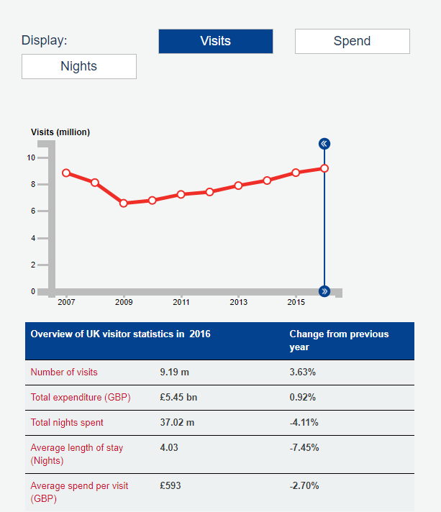

Figure 1 - overview of UK visitors’ statistics in 2016

Historical development of tourism
Understanding the definitions of tourism can help understand the history of how long tourism has existed in the throughout years. In the classical world, such as the Romans era, educational and recreational travel already existed, and with this, even earlier evidence suggests that the Egyptians did in-fact travel to existing luxury lifestyle with the search of amusement, experience, and relaxation.
The early indications of what modern tourism within the 16th and 18th centuries, later revealing that this will be the precursor of modern tourism. Within this time, The Grand Tour which is where the sons and daughters of the British aristocracy that travels through Europe (Davidson, 1993), where the young nobles visited countries such as London, Paris, Amsterdam, Madrid, and Munich. This tour would last three years allowing the young nobles to visit educational sites throughout these cities, thus, providing tourism as a form of art (Kopetzki, 2001).
Coastal tourism, in the 1900’s was widely popular due to the rise and demand for tourists to travel by cruise liners. This also resulted in European trade rising and the demand for business travellers to travel to different countries. Page (2007) provides an example of how in 1914 up to American visitors would visit the UK in numbers up to 150,000. As the first world war and second world war came to a close, Vladimir Raitz has been credited with creating what the current generation of tourism know now as the first-holiday package. According to Travel Weekly (2010), Raitz was the first to offer charter flights and all-inclusive holidays. In May 1950, Raitz created this package when 11 paying passengers flew to Corsica.
Page, (2007, p. 67) recalls that in 1970, 1980 and in the 1990s “there was an increasing proliferation of tourism products and experiences and a growing global reach for travel.” However, throughout this period, the number of people travelling in the UK did not change as British holidaymakers dropped to 6.75 million in 1974 due to the oil crisis whereas in 1971 the number was 8.5 million (Page, 2007, p. 67).

Contemporary tourism
Contemporary tourism is where the tourists move to destinations, this can be from their normal place of work and home life, and while these tourists are away in the destination, the activities that bought at the destinations and the facilities that created to cater their needs (Mill & Morrison, 1985 & Sharpley & Stone, 2011).
Expanding further on Mill & Morrison (1985) and Sharpley & Stones’ (2011) definition, Goeldner & Ritchie, (2012) further develop the definition for contemporary tourism with key factors.
The first factor being the tourists, where the tourist in question seek psychic and physical experiences and satisfaction. To achieve this the traveller will travel to a destination where culture and heritage is the key point of the travelling. The nature of these will largely determine the destinations chosen and the activities enjoyed.
The second factor is that the business where the traveller will go provides the tourist with goods and services. Stated by Cooper & Hall (2008), the business may combine all elements to create a product package, accommodation, travel, food and beverage and amenities at one price.

United Kingdom Policies
The World Tourism Organization (UNWTO) (2005) is the leading specialized agency of the United Nations is able to define tourism solely as:
“Tourism is a collection of activities, services, and industries which deliver a travel experiences comprising transportation, accommodation, eating and drinking establishments, retails shops, entertainment businesses, and other hospitality services provided for individuals or groups travelling away from home”. (World Tourism Organization, n.d.)
UNWTO can define tourism further into categories where Goeldner & Ritchie (2012) introduces the different types of tourism that found throughout the world.
- International tourism
  - Inbound tourism: Visits to a country by non-residents.
  - Outbound tourism: Visits by residents of a country to another country.
- Internal tourism
Visits by residents and non-residents of the country of reference
- Domestic tourism
Visits by residents of a country to their own country
- National tourism
Internal tourism plus outbound tourism (the resident tourism market for travel agents)

Established in 2001, with the support from the Secretary of State for Culture, Media and Sport, the purpose is to identify and develop strategies and policies within the 200,000 businesses throughout the UK. The Tourism Alliance acts as a voice for tourism, partically in England mostly, and maintains a favourable operating environement for businesses (Tourism Alliance.com, 2018). New statistcs have been published by The Tourism Alliance (2017) with the report of ‘UK Tourism Statitics 2017’. Figure 2 demonstrated that 2015 was a record-breaking year for tourism in the United Kingdom, as statistics show a revenue of £127.4bn from tourist spending.
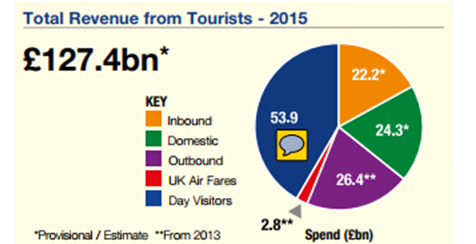

Figure 2 - total revenue from statistics 2015

Therefore, August 2016, the Government created a “Tourism Action Plan” which has been created by the Department for Culture, Media & Sport. This report addresses the key concepts of what attracts tourists to visit the United Kingdom and what the Government are doing to help boost tourism in the UK. The Department for Culture, Media & Sport, (2016) (DCMS) comments that there are five points that will help boost tourism.
- The tourism landscape: strengthening co-ordination and collaboration.
- Skills: boosting apprenticeships and attracting more people to careers in tourism
- Common sense regulation: examining the scope for deregulation
- Transport: making it easier for visitors to explore by rail, bus, and coach
- A GREAT Welcome: driving continuous improvements in our visa service.
(The Department for Culture, Media & Sport, 2016)
One year on from the action plan, The DCMS (2017) created a following document called ‘Tourism Action Plan – One Year On’ where all points above are discussed. Resulting in the United Kingdom voting to leave the European Union (EU), The Department for Digital, Culture, Media & Sport (2017) states that exisiting the European Union will present opportuinites for the tourism industry as well as challenges. The benefit from this is that the Government launched a three-year £40 million fund for Discover England, however, no fund has been mentioned for Wales.

Tourism Demand
As mentioned previously, tourism in the United Kingdom is growing which results to the demand for more holidays to rise. To understand the definition of what tourism demand is Mathieson & Wall (1982) idenfies tourism demand as the total number of persons who travel, or wish to travel, to use tourist facilities and servcies at places away from their places of work and residence.
In contrast to this, the more economic based demand definition can be more concerened with the definitation of that;
“The schedule of the amount of any product or service which people are willing and able to buy at each specific price in a set of possible prices during a specified period of time” (Cooper et al. 1995, p.15)
Arguably, three other elements are addressed which understands the travellers need to use tourism as a form of holiday. Page (2007, p.51) provides an insight of what these three elements are. The number of people that are participating in tourism is the effective or actual demand. From this, measured by statistics, tourism would typically be travellers departing and arrival destinations. Alternatively, the suppressed demand, where a proportion of the population who are unable to travel. Finally, the member of the population who do not have the desire to travel or unable to travel.
A study that has been published by Uysal (1998) can determine the demand for tourism as economic, social-psychological and exogenous determinants. Figure 3 shows an overview of Uysal (1998) the complexity of tourism demand has to offer for tourists, however, does not explain the area of motivation of travel only the general context for tourism demand.
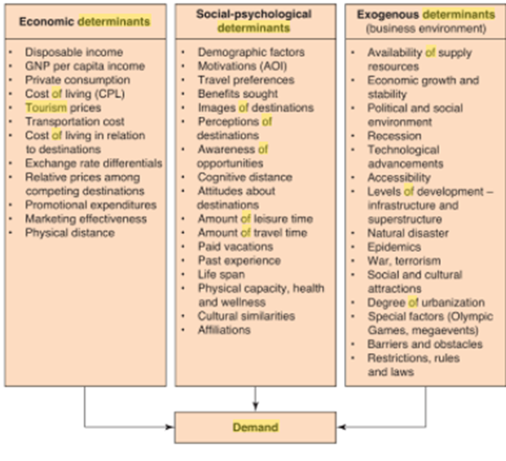

Figure 3 - determinates of tourism demand

Visitation
Following understanding the demand of tourism, demand in tourism in the United Kingdom has increased per year according to Visit Britain (2016). 2016 set the record for both visiting and spending,
“2017 is forecast to see the fastest rate of visit growth since 2006, spending is forecast to grow at its fastest rate since 2013 (and the second fastest since 2006)”
(Visit Britain, 2018)
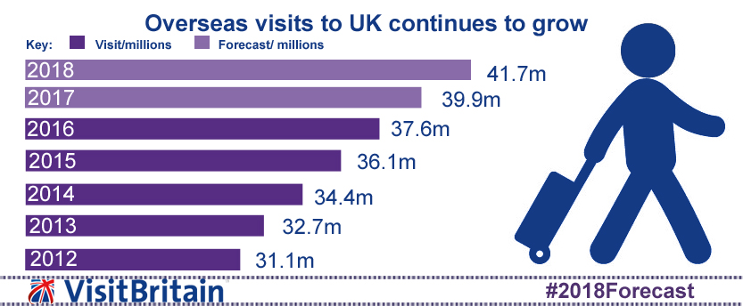
Predictions show that 2018 is set for 41.7 million visits unlike the past year of 2017 where figures were 39.9 million. However, these figures may not be valid due to the implications of what may hold when the United Kingdom choose to leave the European Union and if travellers would wish to visit the UK.
Figure 4 - Overseas visits to UK continues to grow

Figure 4 demonstrates the significant change of overseas visits in the UK within in 6 years. The numbers have increased by 10 million within the 6 years which comparing to Italy. The Local (2017) provides statistics of 48.3 million visitors visited Italy in the year 2017 which is 7 million of what Visit Britain (2018) is predicted for 2018.

Maslow’s Hierarchy of Needs
All figures for visitation in the United Kingdom are increasing; nevertheless, understanding the needs of the visitors while they are visiting is crucial to determine why they are travelling to the United Kingdom. Maslow’s (1954) hierarchy of needs can provide an insight of the reasons why travellers select a certain location.
Esentially, Ryan (2002) addressed the needs in a more simpler format, physiological needs, saftey and security needs, love and belonging needs and esteem needs.
The simpler format of needs addressed by Ryan (2002) are called defict needs, these needs can be seen as a mean of how the tourist will survive and are instincitve. Ryan (2002) continues by stating that;
“Essentially, our salient needs may be met, but past deprivation inhibits the maturation of the personality by the individual becoming fixede on those past deficts”
Maslow (1954) joined self-actualisation with growth motivation, providing an insight of what sort of people meet the self-actualisation needs. Maslow (1954) identifies these characterisics as -
“reality-centred, problem-centred, a strong ethical sense, possessing a need for privacy, showing empathy, an acceptence of self and others, spontaneous, a prefence for simplicity, a freshness of appricition; they are creative, inventive and tend to have more peak experiences than other people”
Ryan (2002) comments that Maslow estimated that only two percent of the human population can reach the self-actualisation.

Travel-career needs

Overtime, Maslow’s hierarchy has been modernised to suit the travellers of today. Goeldner & Ritchie (2012) has explained further Maslow’s hierarchy with a more in-depth view of the heriarchy. Table 1 shows Goeldner & Ritchie (2012) verison of the spine or core of needs for nearly all travelers seems to include relationships, curisity and relaxation.
Table 1 - Spine core of needs
By understanding the ladder of the travel-needs, this ladder can provide an answer for understanding tourism. According to Goeldner and Ritchie (2012), the ladder acts as a blueprint for the assessment of tourist motives and requires individual tailoring to specific situations.

Traits for tourists behaviour
Maslow’s Hierarchy of Needs demonstrates what the traveller’s needs, furthermore, the basic segmentation known as ‘interactional segmentation’ of travellers such as holidaymakers, VFR, business tourists’ and others can now be identified as psychographic segmentation (Bull, 1995). Researchers in consumer behaviour such as Schiffman & Kanuk (1987) found motivations in travel and tourism where goods and services, product-specific links and how personality differences linked to selected services and products.
Additionally, further researchers analysed the psychographic segmentation. Schewe & Calantone (1978) and Plog (1987) identied a limited number of traits which are important to tourists, these are;
- Venturesomeness - the degree of ‘risk’ tourists want
- Hedonism – the degree of comfort required on a trip
- Changeability – the extent to which tourists are impulsive or seeking something new
- Dogmatism – the extent to which a tourist cannot be persuaded to change ideas.
- Intellectualism – the degree of ‘culture’ tourists want.

Research by Bull (1995) and Plog (1972) further investigate the traits and again summarise these traits in order to split the tourists’ types. Plog (1972) considered each trait and ‘scored’ each to try to identify the groups. By understanding these traits, Plog (1972) further comments that traits can understand and influence tourist activity or the purchasing characteristics which Plog (1972) created a model which can be used to divide tourism markets. This cognitive-normative model identifies tourists as:
- Allocentric – highly venturesome,
- Mid-centric – like to explore, but with home comforts too
- Psychocentric – disliking the unfamiliar or risky.

Although, tourists types, A, B and C are evidentially different, this can mean that products and services are different and the experience in demand conditions.
As Plog (1972) addressed the personality traits of the tourists’ types, further research specifies the effect of tourist behaviour is equally important. Naming this segmentation called ‘interactional segmentation’. Smith (1977) and Cohen (1972) grouped the ‘interactional segmentation’ incorporate demographic or psychographic types. Table 2 shows a table of the types of tourist by interaction with destinations created by Cohen (1972) and Smith (1977)
Table 2 - Types of tourist by interaction with destination
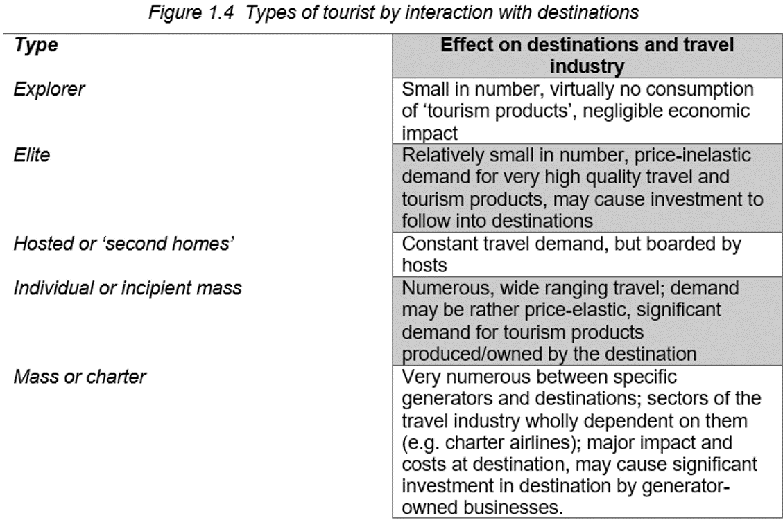

These types of tourists may not be possible for every single destination that can be found in the UK, however, the UK can in-fact classify with 4/5 types of tourists. Bull (1995) believes that the types of tourists viewed in the table 2 may not be as easily targeted in marketing programmes.

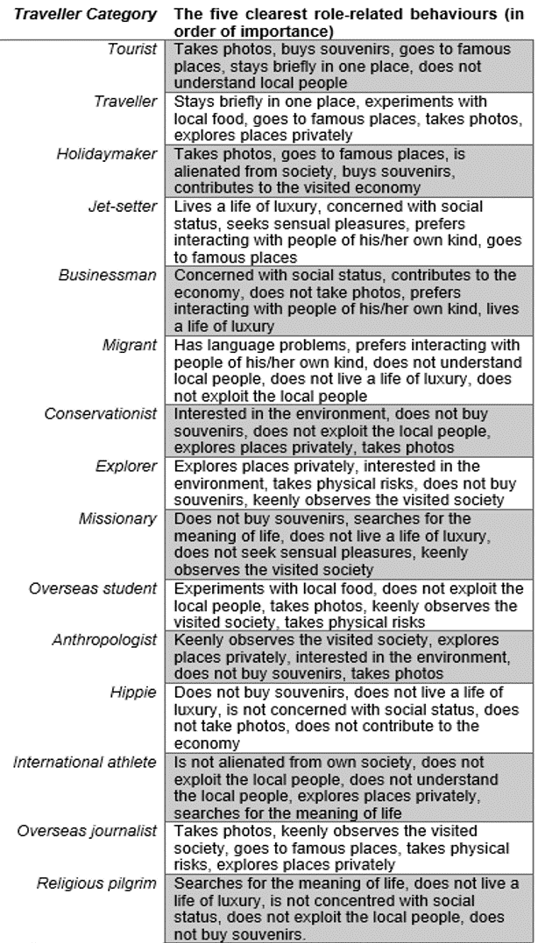
Motivation and Perspectives
Figure 5 - The Five major role-related behaviours for 15 travellers’ categories (Pearce, 1982, p. 32)

As mentioned in the ‘Traits for tourist behaviour’, Cohen (1972) and Smith (1977) introduce stereotypical categories of what the tourist behaviour is. Mathieson & Wall (1982) continue exploring the different types of tourst which is in fact based on Cohen (1972) work which continues a more in-depth description of tourst behaviour, this table can be seen in appendix 2.9 – Fourfold classification of tourst experiences and roles. Furthermore, Pearce (1982, p. 32) introduces the method of the role-related behaviours to the tourist categories, which Burns (1995) comments that Pearces’ (1982) model is self-explanatory, albeit the model is based heavily on a judgment processes, the model craeted by Pearce (1982) establishes the different special characteristics of travellers.
By understanding, the different types of tourists that may travel to these attractions the researcher will be able to determine which individuals will best suit this investigation within in the research chapter.
Further analysis shows that Peace (1982) has further developed Plogs’ (1972) characteristics of psychographic types, referring to the cognitive-normative as mentioned previously. This table of the travel characteristics of psychographic can be adapted to best suit the individual characteristics best suited for this investigation.

Tourism Products
Characteristics and spatial diversity has become so great in every destination that a traveller travels to that is in important to identify the psychology and motivation behind the reasons to travel (Goeldner & Ritchie, 2012). A classifcation of destinations has been further developed by Smith (1997) where the author has 6 categories to identify the travel experience provided in different destinations.
- Ethnic tourism
- Cultural tourism
- Historical tourism
- Environmental tourism
- Recreational tourism
- Business tourism

Although this classification is gives an example of the tourist experience, travellers may find that destinations can provide more than one tourist experience, in most cases do. This may the case if a tourist has an interest in a historical destination however, most destinations in the selected country has a historical appeal (Goeldner & Ritchie, 2012).
Considering all six categories, the researcher is able to identify which category is best suited for each case study. Ethnic tourism may the case for all three case studies due to each study being different in their own right nevertheless giving a first-hand experience to the travellers of the performance they may display presentation and attractions portraying or presented in a small community (Moscardo & Cook, 1999 & Goeldner & Ritchie, 2012). Cultural, heritage and historical tourism plays a major part in each case studies as each traveller can take pictures throughout the destination but also unqiue experiences (Solimar International, 2018). These experiences could include travellers submerging into the Heritage Park and experiencing minors experience underground, learning about how the minors worked but also the exclusive Black Gold Experience gives travellers a chance to see the original lamp room (Rhondda Heritage Park, 2018 & Cultural Tours, 2018). This can be the said for Cardiff Castle. Cardiff Castle is known as one of Wales’ leading heritage attractions as the capital has over 2,000 years of history (Cardiff Castle, 2018). Cardiff Castle offers specilist tours for travellers, in-fact 7 different tours; house tour, connoisseur tour, curartor tour, clock tower tours, film location tour, the town walls of Cardiff and The Cardiff castle ghost tour (Cardiff Castle, 2018). All case studies are either well-known attractions such as Cardiff Castle or Rhondda Heritage Park or local communities know the history behind the destination such as the Aberfan Disaster, all link with a dark past.

Niche Tourism
Recent figures show that passenger numbers hit 238 million in the year 2014 where UK airport handled 10 million (4.4%) (Civil Aviation Authority, 2014).
‘Niche tourism’, according to Novelli (2005) has been emerged from the term ‘mass tourism’. The notion of mass production and consumption continue to relate to tourism characterisations and contemporary internationally (Novelli, 2005). This can be argued by Poon (1993), defines mass-tourism in a larger-scale phenomenon, packaging and selling standardised leisure services at fixed prices to a mass clientele. A statement was made by Godfrey and Clarke (2000), that niche tourism can be associated with more sophisticated tourists that demand a specialist tourism products. Furthermore, Godfrey and Clakre (2000) further comments that attracting a high-end, high-yield tourists by tailoring specfic products at a destination through an extremely personalised ‘niche’ service.
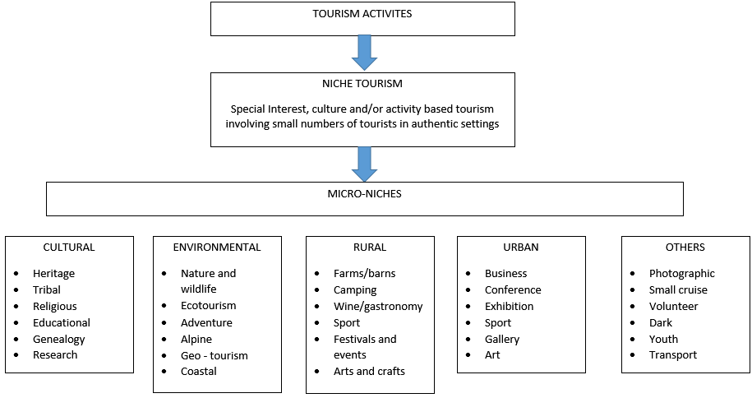
Table 3 - Niche Tourism Framework, Adapted from Novelli (2005)
Table 5 illustrates the tourism activities, niche tourism followed by micro-niches followed by subheadings such as cultural, environmental, rural, and urban and others. By using this adapted framework, the case studies that have been chosen for this investigation will be able to identify within the micro-niches under the subheading of cultural and others. The case studies may be identified by heritage and dark.

Dark tourism
This investigation will be focusing closely on Dark Tourism sites in South Wales; therefore, classifications will be looked at more thoroughly.
Like Cultural heritage, the traveler travels and visits sites, attractions and exhibitions, which have real or recreated death, suffering or the seemingly macabre as a main theme stated by Ekesong (2009). Another definition stated by Lennon & Foley, (2000) regarding dark tourism that that dark tourism related primarily to the ‘presentation and consumption (by visitors) of real and commodified death and disaster sites. Both definitions are simular, furthermore, Ekesong (2009) gives and example of a broad spectrum as to the identifcation of dark tourism and also Dann (1998) is able to categorise the ‘Divisions of the Dark’. These divisions of the dark and the dark tourism spectrum will be able to assist with dividing the case studies. Rhondda Heritage Park may be cateogires in ‘Perilous Places’ due to the significance of undergoing the minors history. Aberfan and Cardiff Castle can be identifed as Fields of Fatality due to the significance of the battleground may hold a bloody history.
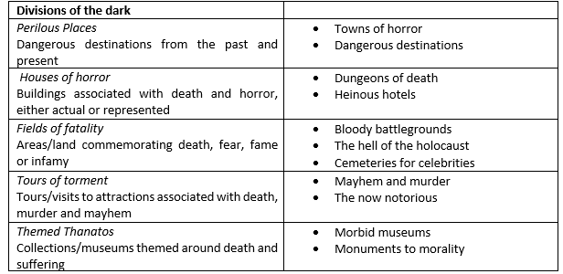

Figure 6 a Categorisation of Dark Tourism (Dan, 1998)
Additionally to Dan (1998) ‘divisions of the dark’, Palancsa (2012) demonstrates the different dark tourism types as shown in figure 3. This figure gives an example of, according to the author Palancsa, (2012) of the two major forms of dark tourism in the last two decades.

Figure 7 - Typology of dark tourism (Palancsa, 2012)
As seen in figure 7, the first category is the ‘old and historical’; this may give the tourists/visitor the desire to visit such sites as a form of curiosity, thrill, to gather information but to enrich ones knowledge of the site in question (Kulcsar, 2015). The second category is ‘new site’ that has a subheading of ‘warm & alive’. This differs from the ‘old and historical’ due to the fact that the individual is present at the time of the disaster that may be the closest to the time of the disaster (Palancsa, 2012). Stone (2006), another author that studies in the field of dark tourism identifies the forms in which dark tourism manifests.

Figure 8 - The Dark Tourism Product (Stone, 2006)

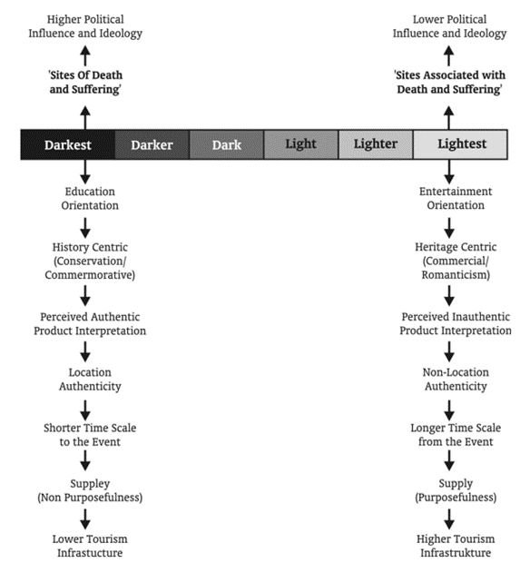
Stone (2006), created a dark tourism spectrum which allows a tourists to identify how dark or light the dark tourism product can be seen as, as shown in figure 9.
Figure 9 A Dark Tourism Spectrum (Stone, 2006)
This spectrum shows the darkest of attractions to the lightest of attractions. By applying this to the investigation this may be able to help identify which questions may be appropriate to ask in chapter 3 – the research methodology. Darkest may recognised as the Aberfan Disaster as it is the site of death and suffering, where education found for schools across the communities. While Caerphilly Castle and Rhondda Heritage Park may be associated with the ‘lightest’ scale as the site is associated with death and suffering. By using both spectrums by Stone (2006), the researcher will be able to identify where each case study placed along the spectrums.
Palancsa, (2012) in his opinion, identifies types of dark tourism practitioners.
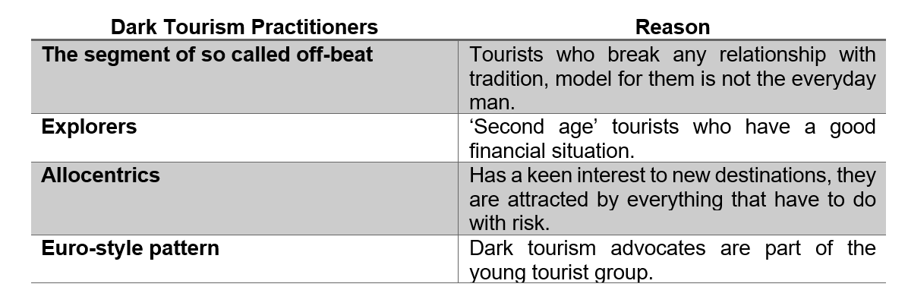

Table 4- Palancsa (2012) Dark Tourism Practitioners

Impacts of Dark Tourism
While a visitor is travelling to dark tourism destinations, there is currently a considerable amount of research into what visitors do, think and feel during the visitation (Light, 2017). A recent paper by Packer & Ballantyne (2016) is able to classify 10 surfaces such as; physical, sensory, restorative, introspective, transformative, hedonic, emotional, relational, spiritual and cognitive of the visitor experience. There are other experiences that can be associated with the visitor experience such as visitors seek to ‘connect’ with the attraction through showing empathy to the victims or by witnessing a performance from the attraction that recreates the history. Due to the emotional experiences that visitors may know, this can cause consequences such as anxiety and vulnerability to death (Light, 2017 & Stone, 2006). Stone (2009) argues that visiting a dark tourism destination or attraction can be a way of reconfiguring and communicating within society. Due to the declining rate of religion that gives a moral guidance for individuals, the individuals seek the guidance of morality and ‘correct’ behaviour due to the confusion and uncertainty (Stone, 2009).
Dark tourism sites have challenges which separate the norm of well-known attractions which managers of the dark tourism attraction may come across. The sensitivity and respect of preservation of these attractions is a must for all visitors and to maintain a sense of peaceful aura is essential to maintain the harmonious atmosphere of respect and sensitivity, this is one of the key issues managers face (Seaton, 2009). A report published by Paris (2016) argues that local communities need to be considered due to the impacts of visitors a comment suggesting that commentators have suggested that these should be updated with something more positive, and that the city should not forever looking to the past. However, Professor Lennon argues that communities should change with the time but ensuring that the history of the past is accurate (Paris, 2016).
For visitors visiting Dark Tourism Sites locally, Professor Lennon – a lecturer in dark tourism, is interviewed by The Independent Journal, believes that it is important for the site to promote accurate events that is presented to the visitors should be publicly accurate. The professor points out that for visitors visiting a Dark Tourism site it could be a cirtial way for humans to learn from the past. Professor Lennon comments that “when we look at which sites are maintained and developed and which are not, it provides an insight into which are acceptable and unacceptable histories” he further comments that “to remain silent and not to record and interpret these events for tourists, may encourage future generations to ignore or forget these terrible periods of human history”. To refelct on professor Lennons comment, this will be a vital to this current research for potentional furture researchers to understand how the visitors feel and their opinions after they have visited their dark tourism sites (Paris, 2016).

Social Impacts of Dark Tourism
Dark Tourism, according to Dark Tourism (2014) is a new field of study, furthermore, there is a wealth of topics to be explored. The term Dark Tourism may carry negative connotations, which results to visitors not understanding the true definitation of Dark Tourism (Dark Tourism, 2014). This statement being said, Dark Tourism in todays society has developed an abnormal fascination with death. Yuill (2003) comments that “one simply has to watch traffic slow to a crawl when passing a car accident to understand this. However, this facination goes beyond the side of a highway and enters the realm of tourism.”
From the three case studies, 2 out of 3 sites have created their site into a vistor attractions, Caerphilly Castle and Rhondda Heritage Park, however, Aberfan Memorial Garden and Site is a site where families, friends and visitors are able to visit for rememberance and possibly curiosity.

Marketing Dark Tourism
Digital marketing, throughout the years, has known many titles according to Chaffey & Ellis-Chadwick, (2016). These titles consist of digital marketing, internet marketing, e-marketing and web-marketing this reuluts to the main title of what digital marketing is “achieving marketing objectives through applying digital technologies and media” (Chaffey & Ellis-Chadwick, 2016).
The issues that sites have in modern day is social media. Jahnke (2003) explains that it is how death is presented to mass audiences is complex. Following this issue, Stone (2012, p1565) sugguests that there is a need to help tourists to become add further awareness of the mortailty of other as dark tourism media may convey a “neutralisation of death”. The means of marketing dark tourism sites, such as movies, television, newspapers and comic strips, all these markeitng roles plays a central role for mass media. By marketing dark tourism sites the researcher will be able to concludet the influences that media plays on selecting the three case study sites.

Tourism provisions in Wales
Tourism, according to Business Wales (2018), generates a mass amount of business in Wales. Business Wales (2018) further comments that tourists in Wales generates around £14 million a day which results into £5.1 billian a year. A statement regarding tourism in Wales from Visit Wales (2018) explains that,
“Wales will provide the warmest of welcomes, outstanding quality, excellent value for money and memorable, authentic experiences to every visitor”.
(Visit Wales, 2018)
The only recent statistics for tourism in Wales is from 2015. The Welsh Government (2018), claims that Wales attracted over 970,000 international visitors and that the top four countries from overseas that visit Wales is Ireland, France, Germany and USA.

Visit Wales tourism strategy
The Welsh Government in 2013 introduced their new tourism plan, which is called ‘Partnership in Growth: strategy for tourism 2013-2020’, which the Government quotes that “this strategy sets the vision for us and the industry to work in partnership to increase visitor spend in Wales” (Welsh Government, 2013). The Welsh Government (2013) created five key focuses, which will help identify the product-led approach to develop and marketing tourism in Wales. These five focuses are promoting the brand, product development, people development, profitable development and lastly, place building. By identifying these, the Welsh Government (2013) will be working with iconic, high quality, reputation-changing products and events.
A following report released in November 2016 that discusses the strategy progress review where all key focuses refl90ected. Promoting the brand addressed by promoting distinctive destinations (Welsh Government, 2016), however, evidence provides from Dearsley (2018) that not all 3 case studies of this investigation made the top 12 top-rated tourist attractions in Wales.

Current Provision
Wales, a large peninsula in western Britain, which divided by England by major rivers and mountain ranges, can offer visitors a unique experience (BBC News, 2012). Visit Wales (2018) comments that Wales offers a unique culture, warm Welsh welcome and the finest food and drinks (Visit Wales, 2018).

Top-driven attractions in Wales
In the year 2016, the Welsh Government (2017) published three reports that incorporates travellers questioned on their activities in all of Wales. These three reports cover overseas visitors, UK staying visitors and UK day visitors. Each individual underwent two stages of the questioning, stage one being a face-to-face survey following stage 2 a follow-up telephone call; all three demographics listed in Figure 7, 8 and 9. The list of survey locations summarise the amount of locations that all individuals were questioned, a few being Cardiff Castle and Rhondda Heritage Park (Welsh Government, 2016).
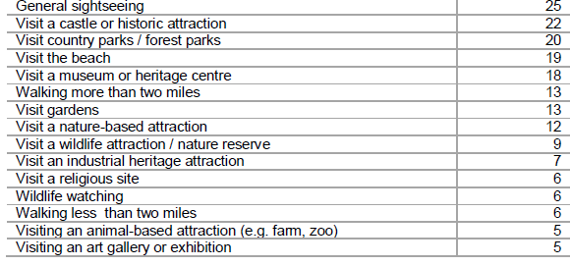

Figure 10 UK Day Visitors (Welsh Government, 2017)

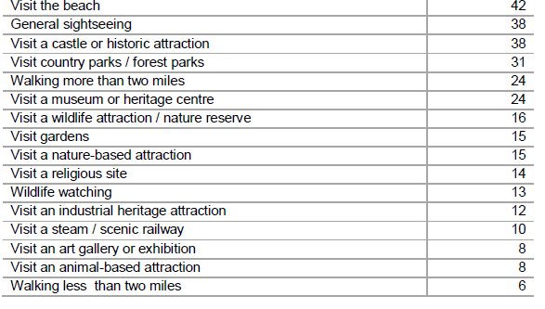

Figure 11 All UK Staying Visitors (Welsh Government, 2017)

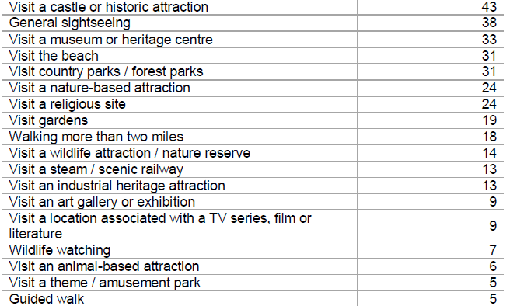

Figure 12 All Overseas visitors (Welsh Government, 2017)

Overall, visiting a castle or a historic attraction positions itself first for overseas visitors ranking at 43% whereas UK visitors visits the beach or general sightseeing. However, UK staying visitors ranked third for castle or historic attraction and second for day visitors.
Following this, in 2015 the Welsh Government released a Wales Visitor Attraction Survey, which to record is the only published survey to date. Only two case studies made it to the visiting percentage. In each report there is a detailed list of survey locations, all reports included locations in the case studies, Cardiff Castle and Rhondda Heritage Park. Total number of interviews conducted at stage on in the South East Wales is 3,081 for stage 1 while only 1,556 conducted stage 2. The Welsh Government (2015) also released a report for Wales Visitor Attractions Survey in 2015; no contact made for the case study attractions to participate.

Case Studies

Aberfan Memorial Site & Garden
Friday, 21 October 1966, two-hundred and forty pupils attended Pantglas Junior School where they attended their daily classes as normal, as their mothers and fathers went to work or carried on with their home-life. The majority of the fathers worked in the Merthyr Vale mines (near Merthyr Tydfil). However, the mine was not as thriving as it once was. There had been numerous complaints made to The National Coal Board regarding one of the seven massive slag heaps or spoil tips, which was located above the village. There was a petition by the Pantglas School in 1963 that addressed the issue of the coal slurry tipped at the rear of the school.
At 7:30 a.m. on that morning, the tip had sunk by twenty feet. The intolerable thing is that if fate were to deal the cards twenty minutes earlier, the school would have been completely empty. (BBC News, 2016) The result of the tip sliding from the site is that one hundred and forty-four people died in the Aberfan disaster, one hundred and sixteen of them were schoolchildren. (Johnes & McLean, 2014)

Rhondda Heritage Park
Before the Rhondda Heritage Park formed, the former Lewis Merthyr Colliery known for its masses of coal that was produced, estimating from 1,250 tons per day with a workforce of 1,160 men (A Welsh Coal Mines, 2017). The colliery has transformed into The Rhondda Heritage Park based in Trehafod (Culture24, 2017). Once a thriving working colliery now been preserved as a tourist attraction for South Wales. Awarded with The Certificate of Excellence, and rated #34 of #163 for things to do in Cardiff and rated a 4.5 with guest reviews (TripAdvisor, 2017). Although now a thriving attraction, there is an underlying history or fatal injuries and deaths that accrued at this site, two deaths one which was seventeen and the other sixty-nine and seven deaths (A Welsh Coal Mines, 2017).

Caerphilly Castle
Caerphilly castle was to defend against Llewlyn ap Gruffydd, the last Prince of a united Wales, this was before the conquest of Edward II. Llewlyn built the castle roughly between 1268 and 1271 after long-running dispute with Gilbert ‘The Red’ de clare, Lord of Glanmorgan. The castle vacated in the 15th century as the use of a home and defence diminished. Then in the 18th century, the Bute family took over and continued to work on the castle until 1950, by then the castle family handed the castle over to the government (BBC Wales, 2010).
During the time where Edward II was king, Edward I was travelling to Caerphilly Castle as his reign was coming to end sought refuge in Caerphilly Castle. Unfortunately, he and his party did not make it to the castle successfully as overnight; Edward was found and detained in Llantrisant Castle, which later announced dead in September 1327 (BBC, 2011).
Edward II is not only the only human that has died in the castle, there has been reporting is of paranormal activity inside the castle walls. Kozak (2014) underwent a paranormal session in the castle where she wished to find The Green Lady of Caerphilly Castle. Kozak (2014) states that legends say the spirit is in fact Alice de la Marche of Angouleme, France, niece of Henry II, and the disgraced lover of a knight named Gruffydd the Fair. Kozak (2014) further comments that Caerphilly is where her father was born and that she grew up from childhood stories hearing the story of Green Lady of Caerphilly Castle.

Conclusion of Case Studies
All three case studies in this investigation were careful, thoroughly and cautiously selected. As the studies will be investigated to determine the motivations of their visitors and why the visitors have chosen to visit these selected sites. When conducting primary data for chapter three all three sites will be included in one question alongside other more known Dark Tourism sites. The determination of doing this is to analyse the number of visitors that visit these sites but to conclude to the importance of why maintaining the sites is important for the people visiting.

Chapter 3
RESEARCH METHODOLOGY

Introduction
Dark Tourism, a personal interest of the researcher, is one of the main reasons why the researcher has chosen this topic for the study. The researcher herself is born and bred in Wales, the history, culture and heritage are one of the two reasons why the three case studies that is selected is located in South Wales. The second reason are that the more ‘well-known’ Dark Tourism destinations such as, Auschwitz and the Ground Zero Museum was not feasible for selection of the case studies due to the limitations of the studies, moreover, South Wales is where the reseacher is located and that primary research can be conducted thoroughly. The selections of the interviews were completed by March 2018 and all selected for the interviews respondent efficiently; this met with the number of respondents for the surveys’ published on social media in March 2018.
While visiting three case studies sites it was apparent that the history of all that worked, lived and experienced the disaster/tragedies made the history become alive. After the sites stopped functioning as originally planned for example; Aberfan School no longer stands but replaced by a memorial garden for remembrance of the lives lost at the site. Rhondda Heritage Park no longer operates as a working colliery for men to operate in but as a visitor attraction and Caerphilly Castle stands proud to be in the centre of Caerphilly as one of the main visitor attractions. What do all these sites have in common? A variety of people visits these sites. With this in mind, the questionnaires and survey that has published were taken in the upmost respect for all individuals that were/potential involved in the history of the sites as the sensitivity around the subject may cause for an individual feel uncomfortable.

Research Defined
Research, is different throughout business and academic studies. The reason for this is that research can mean different things to different people. However, Collis & Hussey (2009) agrees that there is a general understanding of what research is.
“Research can be seen as a process of enquiry and investigation, systematic and methodical and increases knowledge”.
(Collis & Hussey, 2009, pg. 3)
Argubly, there are 3 means of reseach, best practice research where people are surveyed in order to assess how they have tackled, or solved, the same problem (Burgoyne and James, 2006), action research making changes in an organisation and engaged research where academics and practitioners work closely together (Van de Ven and Johnson, 2006). The researcher will be conducing the research under engaged research where the researcher (which is the academics) will be working closely with the practitioners.

Research Objectives
The aim of this study is to investigate the motivations and participation of visitors visiting dark tourism sites in South Wales as South Wales is not known to have dark tourism sites however, there has been a location where death and dark events has happened. Because of ensuring the aim is achieved the following objectives will be conducted.
- Determine factors of motivational factors of visitors visiting a dark tourism site.
- To assess whether there is a common trend to the motivations of visitors to popular dark tourism sites.
- On completion of the research, the researcher will provide a conclusion of why visitors visit dark tourism sites.
- On completion of the research, the research will provide recommendations to each site.

Research Paradigms
A research paradigm must be decided before the research is conducted. According to (Collis and Hussey (2009) determine that a research paradigm is a philosophical framework that guides how scientific research should be conducted which will be based on people’s philosophies and their assumptions about the world and the nature of knowledge.
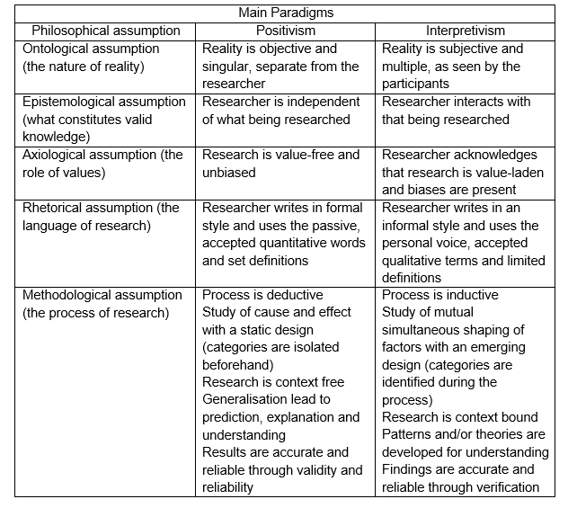

Table 5 - Assumptions of the main paradigms (Creswell, 1994, p.5)

Table 6 reflects the author Creswell (1994) provides a summary of philosophical assumptions that underpin the two main paradigms of positivism and interpretivism. Reflecting on the aim and objectives of this study the belief of using interpretivism would best suit the study; the reasons for this decision are detailed in this chapter.

Research Onion
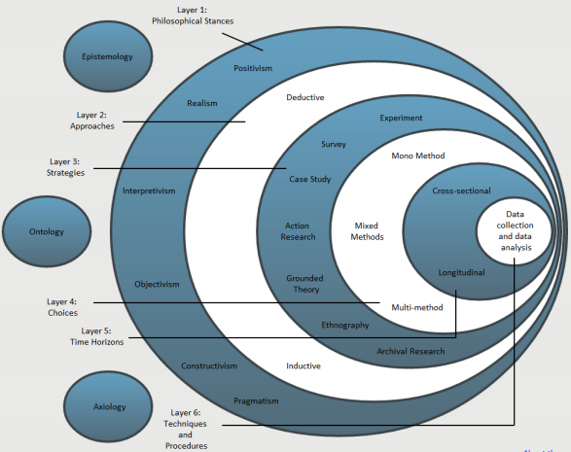
Figure 13 - Research Onion Diagram (Saunders, 2009)

Interpretivism is the means of the philosophical stance, as this will produce a result in the data.
The researcher will be able to study what thoughts the participants have on motivation, generally, but also whether they believe the selected case studies are in fact related to dark tourism. Through the Interpretivism method, the idea and what meanings are important. When conducting the investigation, the researcher must respect the areas of sensitivity in certain locations such as Aberfan Memorial Garden and Cemetery and why the thought of travelling to a site of death and sadness would interest travellers Invalid source specified.. This approach is critical, as there are different levels of the meanings behind the case studies. The importance of the participants that undertake the study such as the drive forces, motivation, sensitivity, the history of the location, therefore different motivational assets.

As there is a little research on this investigation, inductive is the best approach for this study alongside interpretivism. By implementing this technique, the researcher is able to research the question: What motivates travellers to visit dark tourism sites in South Wales? Then to observe and description to analyses this question to participants of their motivations, different thought process, lifestyles and conclude with an overall theory of why people are motivated to travel to dark tourism sites. Motivational methods such as Maslow’s Hierarchy and other sources of motivational literature matched with the opinions that gathered from the dataInvalid source specified..
In this study, Mixed Methods shall be utilised in this study just as quantitative and qualitative methods will be utilised. These techniques will be able to give a deeper evidence (Saunders & Lewis, 2012). Furthermore, the Triangulation Methodology where the use of multiple sources of data, different research methods used to analyse the data collection (Collis & Hussey, 2009).

Research Design
As quantitative method will be used to give percentages and statistics which will result in the number of travellers that have travelled to a dark tourism site globally. Cluster Sampling at hand to divide the population and dividing the population into selected clusters, however, considering that this investigation is a specific category, systematic random sampling shall be used to ensure that the participants of the survey are interested in Dark Tourism. Invalid source specified. Whereas qualitative the researcher can collect a natural language data such as an in-depth interview with local councils of the selected case studies.
As seen in table 2 the qualitative data analysis Content analysis would be best suited for this method as the researcher aims for clarity and unity of the study and will be searching for truthful content Invalid source specified..

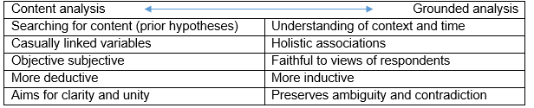

Table 6 - Qualitative data analysis (Easterby-Smith, et al., 2012)

Gathering data will be implemented with the cross-sectional approach due to the significance of the pinpoint data of only requiring the motivational behaviour of past visitors to Dark Tourism sites and future visitors. Hence, the cross-sectional approach will be able to give a snapshot view of the particular situation in time, which will be more feasible to the aim and objectives of this study as the study requires knowing why travellers wish to visit these sites Invalid source specified.. By using this approach alongside both analyses, the researcher will be able to measure an aspect of behaviour, more so with interviews of selected participants but also the statistics that will be gathered via the survey Invalid source specified.. To reduce the bias opinions, this method will be able to define distinctions between variables but also allowing the sampling measures of large numbers Invalid source specified..
The data collection will undertake the method of the case study. The study will be looking at three organisations. With the literature in the previous chapter 2, the data collection will be based on the interpretations of visitors’ motivations from other Dark Tourism locations (Askew & Theodore-Shusta, 2013 & Easterby-Smith, et al., 2012).

Design of Questionnaires
Choosing the correct source, design, and method is important for the researcher as the design and all members of the public will use the tools. The first source considered for the questionnaire was Survey Monkey. Survey Monkey proved to be very popular due to the tools created for the questionnaires; however, after consideration Survey Monkey only provided 15 free questions whereas the researchers’ survey needed more than 15. After research, Google Forms was the result of the design of the questionnaires.
The questionnaire consisted of four sections; personality type, general travel motivations, dark tourism motivations and background information. The questionnaire has 25 questions that cover the information required for this investigation, refer to the appendix 7.3 for the questionnaire.
The first section, personality type (questions 1-5), will identify if there are any special characteristics of dark tourists personalities. The personality traits from the theories of Pearce’s (1982) five major role-related behaviours for 15 travellers’ categories, Smith (1977) and Cohen (1972) groups of ‘interactional segmentation’ incorporate demographic or psychographic types and Plogs’ (1972) model of division in tourism markets.
The second sections of the questionnaire, General Travel Motivations (questions 6-9) are a question that establishes an understanding of general past holidays that builds up a travel profile. These questions can help identify external travel/holiday motivations that may affect the travel/holiday decision.
Section 3 is the core section of this investigation. This question (questions 10-21) aims to establish the dark travellers’ motivations where the responses collect the vital information from the questionnaires should answer the fundamental question of this investigation. Questions 14 and 19 gives the respondents a chance to express their own personal feelings on the dark destination(s) that they have collected, however, question 17 gives the respondent a chance to express why they have not visited any dark tourism sites (if they have selected the option).
The final section of this questionnaire is general background information (questions 22-24). These questions aim to gain an understanding of the respondent; this will help during the data collection process.

Design of Interviews
The interviews consisted of different editing techniques to suit the different individual case studies and employees. The researcher created a word document that consisted of a letter of introduction that explained the reason for this study and attached the questions to the bottom of the letter. The questions that asked to, for example, Sara Brown, Collections Department would differ from the different case studies Rural Councils such as Merthyr Tydfil.

Sampling
Easterby-Smith, et al., (2012) states that there are two different types of sampling, non-probability and probability sampling. Continuing with this statement, Remenyi, et al., (1998) explains that non-probability consists of statistical techniques such as convenience samples, judgement samples, quota samples and snowball samples. Whereas probability samples are where the individuals have known, not necessarily equal, the probability of being selected (Remenyi, et al., 1998).
There are 2 main target groups for this investigation. The questionnaire target market will be addressed to tourists that have visited the three case studies, Rhondda Heritage Park, Aberfan Memorial Garden/Cemetary and Caerphilly Castle. Whereas the interviews will be targeting employees of these sites and also the Rural Council. Table 6 shows the breakdown of the sampling process and how the sampling will be used to gain information for the investigation.
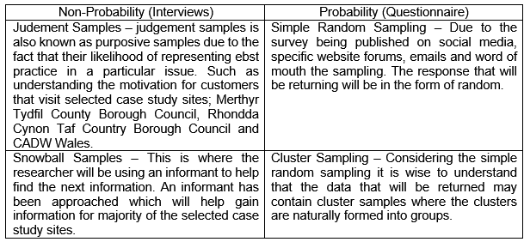

Table 7 - Non-probability and probability sampling (Authors own credit)

Piloting
Piloting identifies as the final step of the framework. The pilot study may be much broader than the actual final study that is the testing ground for both the substantive and methodological issues (Remenyi, et al., 1998). In a simpler term, the pilot study is a small-scale version of the questions and interviews will be published (Robson, 2002).
Two professionals in the field of the study conducted the pilot study, additionally, students, friends, and family conducted the pilot study in late March 2018.
The pilot study provided successful due to the feedback from all that took part, table 7 shows the feedback and the result from the feedback. From the pilot study, there was a critical issue that a professional addressed, numbering the questions. Google Forms does not provide the questions with numbers, therefore, the researcher needed to add in all numbers manually.
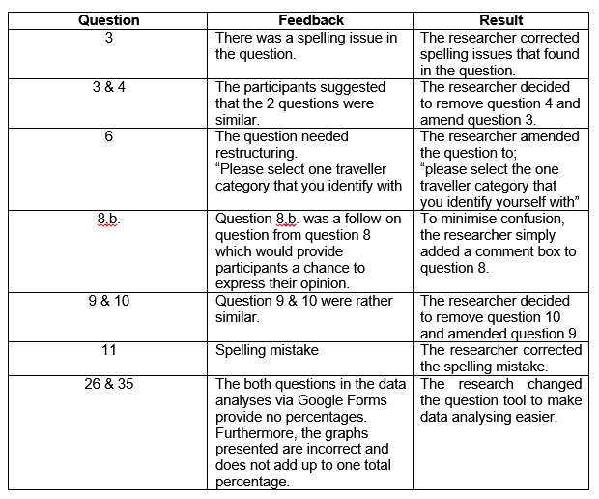

Table 8 - Pilot Study Feedback (Authors own credit)

Data collection
The data collection process consisted of the researcher collecting primary data at the beginning of March; appendix 7.4.
There were two plans set in place, one, going to the selected sites, and creating a relationship with the employees that would lead to a hopeful interview in the future. The second plan would be to contact the Rural Councils where the selected sites are located and arrange a meeting over either the telephone or face-to-face. Six emails were sent to the Dark Tourism sites, the Rural Councils, and a Dark Tourism professional. Gratefully, all six respondents replied within a matter of a week.
Alas, the original plan differed. Proving to speak to an employee while on duty proved to be difficult due to their job commitments where the employee simply did not have the time to complete questions provided to them face-to-face. Two employees did respond and accepted to answer all questions via a telephone call whereas all other four interviews were answered via email.
On the completion of the surveys being completed, steps were taken to ensure the distribution of the surveys would reach across all forms social media platforms. The data collection of these surveys will be found on the publisher of the survey, Google Forms. When the first researcher first published the survey on 29th of March, all participants were made aware that they would be taking part in a dissertation survey and that the survey may take 8-10 minutes to complete.

Data analysis techniques
To describe and illustrate, condense and recap and evaluate data, data analysis is the process of the systematically which applies to the research (Shamoo & Resnik, 2003).

Survey’s
As the researcher already has an account with Google.com, the researcher has all use of the tools that Google has to offer to their customers, Google Forms and Google Drive being one of them. Google Forms and drive can be accessed anywhere if there is an internet connection, this will be used as an advantages when checking the respondents of the survey and editing the survey. Google From have few benefits from using the tool. When collecting all the data from respondents, Google Forms provides a Summary and Individual responses. The title, Summary, shows all data that will be collected into one overall summary. The advantage of this is that Google Forms automatically put into a pie graph or a bar graph as shown in figure 14.
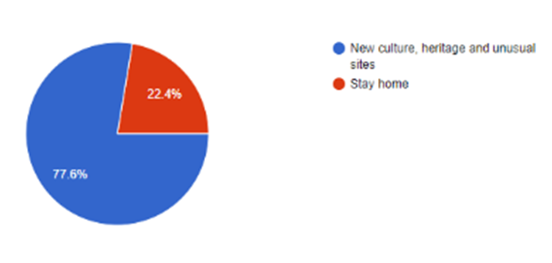

Figure 14 - Google Forms example of pie graph

One other advantage that Google Forms is able to do is create a spreadsheet with all the responses automatically, figure 15 shows a circle covering the image that allows the user to create a spreadsheet.
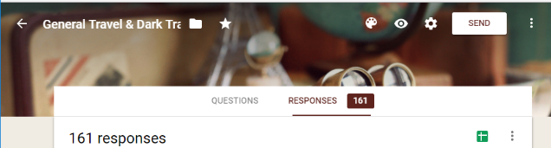

Figure 15 - Creating Spreadsheet with Microsoft Excel

There are two main disadvantages of Google Forms. One being, when collecting qualitative information Google Forms only displays the responses as respondents wrote the answer. This will mean that the researcher must manually enter data into Microsoft Excel using =COUNTIF (range, criteria) formula as seen in figure 16.
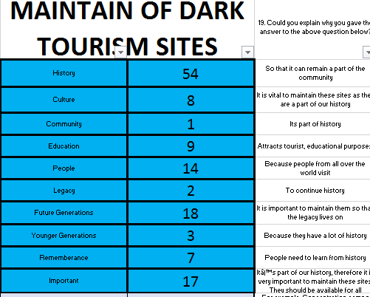

Figure 16 - Microsoft Excel COUNTIF formula

By using this formula, the researcher is able to look at the question and the respondents’ answers. The research can find if there is a pattern with the amount of times, a certain word is repeated and =COUNTIF can be used to cross analyse two questions.
The second disadvantage is that the bar charts can vary depending on the question type, for example, question 24 gives the respondents a choice writing down the country that they reside in, however, as 161 respondents answered this question the bar chart is very scattered as shown in figure 17.
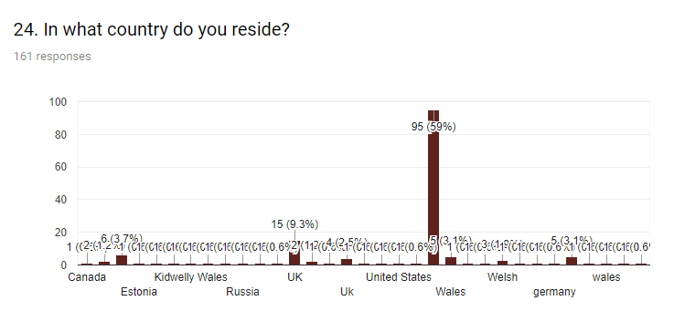

Figure 17 - Google From bar chart example

Telephone/Email interviews
There are two forms of interview structures that the researcher will be collecting, semi-structured and structured. Both structures will be utilised as explained earlier in this chapter, due to the time restrictions of this investigation. Telephone interviews will be semi-structures, as the questions have been sent prior to the telephone interview, however, when conducting the telephone interview the interviewee can continue speaking off-topic or provide more information. Whereas, structured interviews conducted over email and the interviewer cannot ask further questions as they are structured.

Reliability, Validity and Generalisability
“Reliability refers to the absence of differences in the results if the research were repeated”
“Validity is the extent to which the research findings accurately reflect the phenomena under study”
(Collis & Hussey, 2009, p.g. 64)
In terms of reliability, the researcher ensure that all questionnaires repeated numerous of time to ensure that there is no language barrier between the questionnaires. To do this there was only one questionnaire which was in English and this sent across different countries, where the results show that different nationalities are able to answer the questionnaire. The questionnaire completed by the researcher herself but also by a professional, which after piloting all the same respondents that completed the pilot study asked to complete the questionnaire once again, and the information that received was the same information.
The researcher will be using construct validity as the phenomena that the researcher will be observing will be motivation and this cannot be directly observable. The research required validity as the qualitative data that has been collected was created from respondents own opinions, however, this may cause some issues due to the trustworthiness from the individuals that what they state is the truth.
Generalisation is concerned with the extent of the research findings and that it’s extension to other cases or settings (Collis & Hussey, 2009). As mentioned previously, in the study there are different types the different types of samples, however, all individuals that have chosen to be a part of this research may conclude with the same conclusion of Dark Tourism sites.

Limitations and Recommendations
Due to the nature of this investigation being three different case studies, believed that the limitations could be found in the case studies themselves. This can be found, e.g., that some employees did not respond to the interviews that were emailed, but the fact that Dark Tourism is a sensitive topic and a selection of employees did not know what Dark Tourism was before the emails were sent to them. This may prove that there is a limit to the opinions that the employees can provide for the evidence of this study. The other limitation is the fact that Dark Tourism is such an unknown tourism type that respondents may not be able to answer the survey, therefore, providing the researcher with less information.
For future notes, using Microsoft Excel proven difficult at times especially with the amount of data that needed to be analysed. This can be seen as a positive because the research then had to count all respondents answers twice to ensure that calculations were precise.

Chapter 4
DATA ANALYSIS AND RESULTS

Introduction
The following chapter will examine the results from the respondents from the published survey and the interviews that the researcher received structured and semi-structures interviews.
This chapter will consist of the aim of the study, which is to investigate the motivations towards Dark Tourism: A case study of Welsh Tourism Sites, where the main findings from the objectives will be examined against key themes.
- Determine factors of motivational factors of visitors visiting a dark tourism site.
- To assess whether there is a common trend to the motivations of visitors to popular dark tourism sites.
To address the purpose of the results chapter only objectives directly relevant, objectives 1 and 2 will be focused on at this stage of the study. Objective one being the motivational factors of visitors and the second is to investigate to see if there is a common thread in motivations. The first section will introduce the respondents and their background information that has gathered a general view for the researcher. Following section one, the second, and the third sections will address the two objectives. Displayed through the forms of graphs, matrix tables and pie charts, which closed ended questions is the quantitative data. Majority of the data has been extracted from Google Forms whereas the open-ended questions are individually created through the means of Microsoft Excel.
Qualitative data is displayed in the forms of tables created by Microsoft Excel and Microsoft Word.

The Survey Pool of Respondents
Through two different methods of data collection, the researcher received 161 survey responses. The number includes the six interviews that conducted over the means of telephone and email and an additional 161 surveys completed through Google Forms. On reflecting on the responses from the interviews, the researcher was able to use all responses from the individuals. While reflecting on respondents answers on the questionnaires the researcher was able to use all surveys as the individuals completed the questionnaire fully. All answers for the qualitative data answered through the medium of English and all individuals were able to answer fully.

Background
The background section that is located in section 4 of the questionnaire created an understanding for the researcher of the respondent. Section 4 was the last section of the survey, centred upon demographic questions based on e.g., gender, age, country, and nationality.
The following section of this study will outline the results for the demographic questions from the survey that was published.

Q.21. What is your gender?
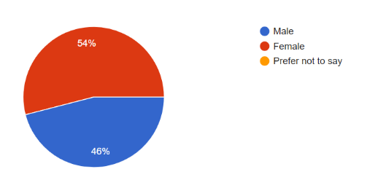

Figure 18 - Respondents Gender (Google Forms, 2018)

From the responses, figure 18 shows that in red with the majority of the percentage is, in fact, female with 54% with 87 responses and although not completely equal, the males percentage is 46% with 74 responses. Although the female population is more than the male, with only 13 respondents between both sexes the questionnaire responses are fair.

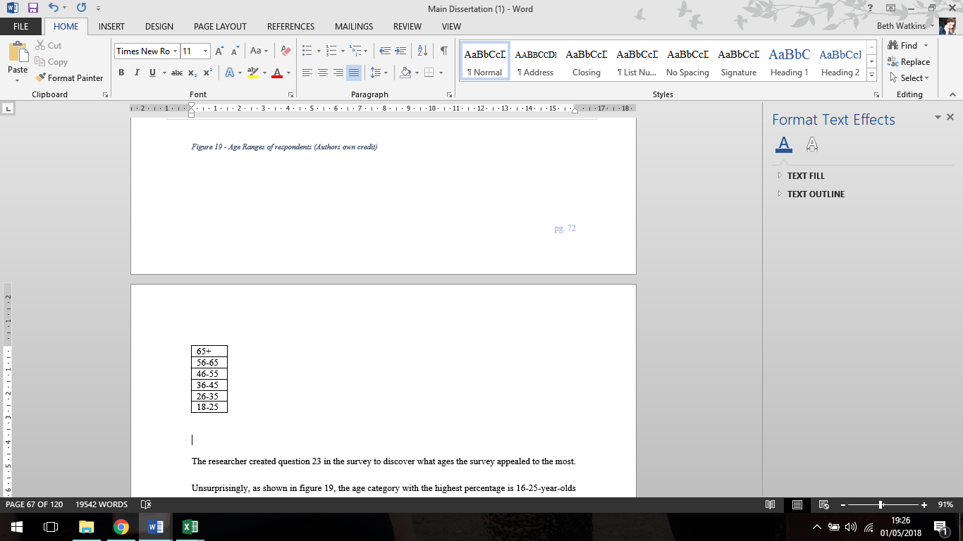
Q.22. What is your age range?

Figure 19 - Age Ranges of respondents (Authors own credit)

The researcher created question 23 in the survey to discover what ages the survey appealed to the most. Unsurprisingly, as shown in figure 19, the age category with the highest percentage is 18-25-year-olds with 41%. It is believed that due to the survey being published on social media that the majority of the age brackets do in fact use social media. What is in-fact surprising is that the age category of 46-55, 56-65 and 65+ is almost equal.

Q. 23. In what country do you reside? With Q. 25. What is your nationality?
Nationality | Wales
Welsh | 72
English | 2
British | 9
Irish | 0
Romanian | 0
German | 0
Russian | 0
Polish | 0
American | 0
Scottish | 0
Iraqi | 1
Canadian | 0
Norwegian | 0

Table 9-Analyses of respondents living in Wales (Authors own credit)

Table 9 demonstrates a cross-analyses created by the researcher where Nationalities and Countries have been cross analysed. Unsurprisingly, Welsh was one of the top nationalities that was received in the survey, second being British and third being English. For the purpose of this study, as the case studies are located in Wales it was applicable for Welsh people to answer the survey.
For the purpose of this study, as stated in chapter 2.1, The Welsh Government (2016) released figures of the top four countries from overseas that visit Wales; Ireland, France, Germany and USA. As shown in table 9 and 10 there are respondents from 2 of the countries that The Welsh Government (2016) has stated. By cross analysing both questions, the researcher is able to see whether respondents live in Wales, table 11 demonstrates that 72 respondents are in fact Welsh where the second most popular response was British than English. Unfortunately, not one of the top four countries from overseas resides in Wales.

KEY THEME 1: Objective 1 – Motivational Factors

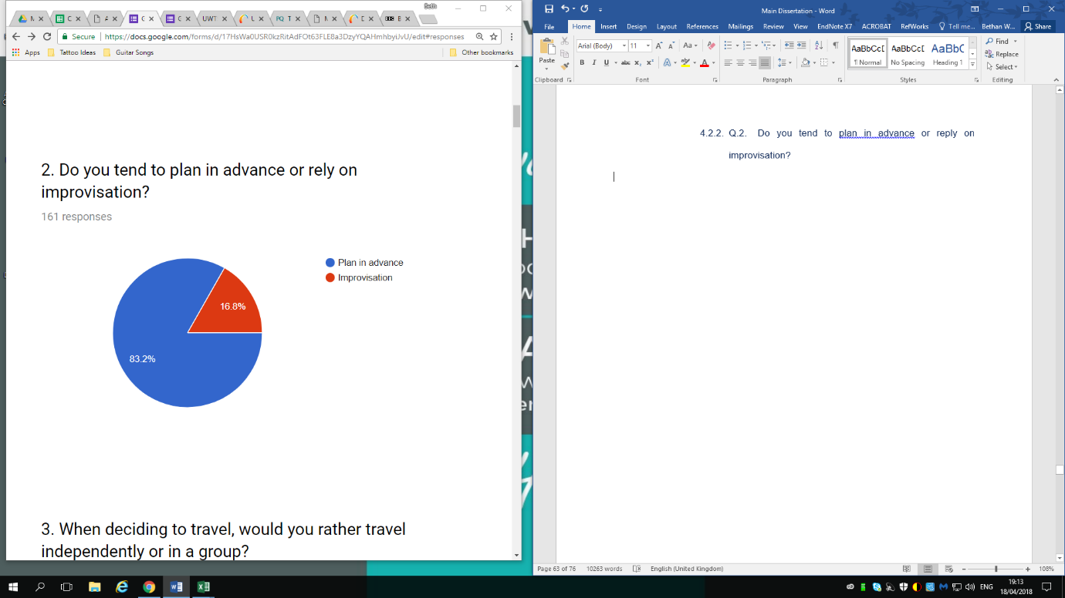
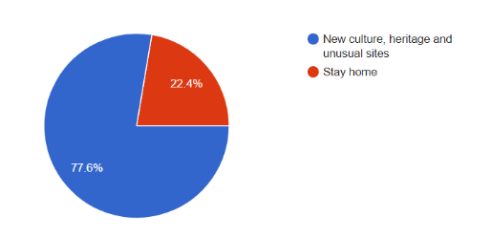
Personal Motivation
Figure 20 - Questions 1 and 2 presented in pie charts (Google Forms, 2018)

The first section of the survey dedicates to the respondent’s personality type and its place on the sensation-seeking scale of each respondent by answering five quantitative questions. Question 1 and question 2 will be testing the theory of Plog (1972) to see test personality types, whereas question 3 will demonstrate Cohen (1972) and Smith (1977) tourist interaction with destinations. To calculate if the correlation between the questions, the investigator used =COUNTIF from Microsoft Excel. Whereas question 3 will test the theory of Mathieson and Wall (1982) of the Fourfold classification of tourist experiences and roles (mentioned in chapter 2) determines which categories the respondents identify in with the theory of Mathieson and Wall (1982).
Presented to the respondents on the survey, is the first question to ask whether the respondent travels to explore a new culture, heritage and unusual site or stay at home. As presented by figure 20, 77.6% (125) of respondents answered that they would travel to a new culture, heritage and unusual sites; whereas, 22.4% (36) responded that staying at home would be the suitable option for them. Question 2 of the survey allows respondents to think, when they travel, do they plan in advance or do they rely on improvisation. The category that received the highest percentage was ‘plan in advance’ with 83.2% (134), respondents; consequently, improvisation received only 16.8% (27) respondents. By cross analysing both questions (shown in table 10) the total number of respondents that plan in advance to a new culture, heritage and unusual sites is a total amount of 101, whereas, improvisation to a new culture, heritage and unusual sites is 24. The stay at home category received fewer respondents than planning in advance with only 33 staying at home and only three would travel on the impulse.
 | Plan in advance | Improvisation
New culture, heritage and unusual sites | 101 | 24
Stay home | 33 | 3

Table 10 - Cross-analyses of questions 1 and 2 (Authors own credit)

It is believed that the 101 respondents that selected ‘plan in advance’ with ‘new culture, heritage and unusual sites’. Schewe & Calantone (1978) and Plogs (1987) theory suggests that this portion of the respondents’ traits can be identified with ‘Hedonism’ as the respondents require a degree of comfort required on the trip alongside with Plog (1972) theory of the cognitive-normative identifies these tourists as ‘Mid-centric’ models.
The 33 respondents that selected they ‘plan in advance’ but prefer to ‘stay at home’ can identify as ‘Intellectualism’, as the tourists understand the needs that they want. The second option that respondents could have chosen was improvisation where 24 respondents selected this option and selected ‘new culture, heritage and unusual sites’. These respondents can identify with Schewe & Calantone (1978) and Plog (1987) theory as ‘changeability’ as the tourist are impulsive or seeking something new alongside Plogs (1972) theory of tourist, that they are ‘Allocentric’ as they are highly venturesome.
Only three respondents were found that they selected on the impulsive and chose to stay at home, these three may be identified as ‘Dogmatism’ as they cannot be persuaded to change ideas and ‘psychocentric’ as they dislike unfamiliar or risky holidays.
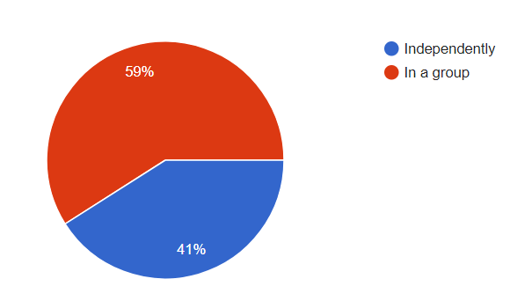

Figure 21 - Responses for Question 3 (Google Forms, 2018)
Question 3 gives respondents the chance to select two options, one, whether the respondent travels independently or in a group as shown in figure 21. This question received over 161 responses, 95/161 selected that the respondent prefers travelling independently, whereas, 66/161 selected they prefer travelling in a group. This question relates to Mathieson and Wall (1982) theory of ‘Fourfold classification of tourists experiences and roles’. From the four classifications, the 95 (59%) of which selected ‘in a group’ can be identified as ‘the organised mass tourist’ as this role can see the individual needing a package tour where itineraries are fixed, stopped and planned (Mathieson and Wall, 1982). The last three options in Mathieson and Wall (1982) theory all related to the respondents travelling ‘independently’ as ‘the individual mass tourist, the explorer and the drifter’, all three suggests that the respondents prefer not planning the visits or planning their own trips independently (Mathieson and Wall, 1982).

Table 11 - 3-way cross analyses (Authors own credit)

To conclude, the respondents that answered the survey published by the researcher, the researcher compared all three questions. The results are shown in Table 11, which the majority of the respondents plan in advance to a new culture, heritage and unusual site with a group of people. These respondents through theory can identify as ‘The Organised Mass Tourists, Mid-Centric and Hedonism’ (Schewe & Calantone, 1978: Plog, 1987: Plog, 1972: Mathieson and Wall, 1982).
The 3-way cross-analyses (created by the author) is a means for to compare with where the respondents fall in Goeldner and Ritchie’s (2012) adapted and modernised version of Maslow’s Hierarchy of needs. Believing that the respondents that travel new culture, heritage and unusual sites that plan in advance within a group may indeed reach relationship needs, self-esteem/development needs and fulfilment needs, appendix 7.8 gives further analyses.

Holiday Motivation
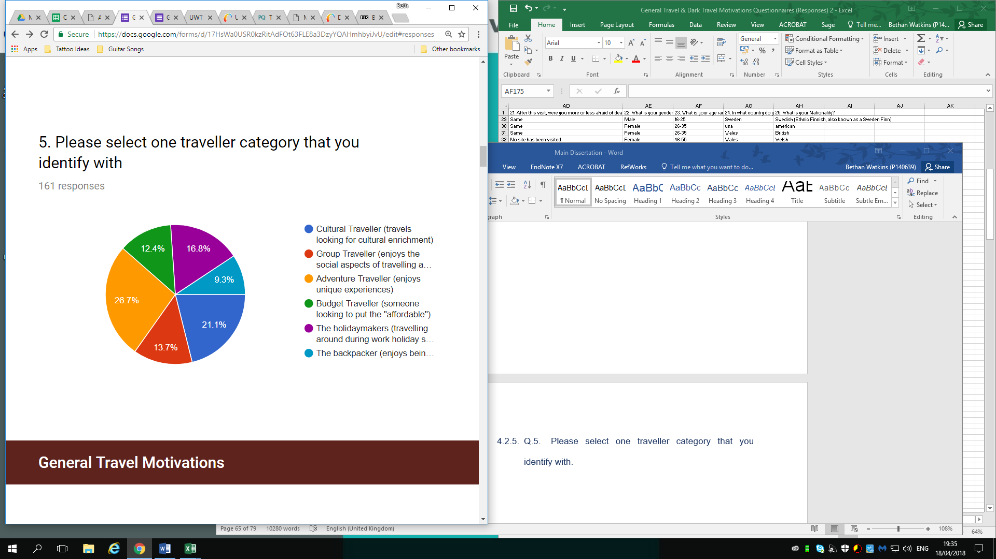

Figure 22 - Responses of question 5 in the form of a pie chart (Google Forms, 2018)
Questions 5 and 6 of section 1 and 2 of the survey provides an insight of the respondents’ individual motivations when planning a holiday. Both questions received 161 respondents, the respondents have been broken down in percentages of their categories, as shown in figure 22 and table 12.
Table 12 - Question 6, Types of travel destinations (Authors own credit)
Previously in chapter 2, The Tourism Alliance (2018) provides statistics of outbound tourists in 2015 that is 26.4% proving that majority of the United Kingdom’s population do in fact travel outside of the United Kingdom for a holiday.
Question 8 and 9, mistakenly by the researcher are extremely similar. The questions ask the respondents how often they travel, to view the graph it is located appendix 7.5. The most general response showed that the holidaymakers travel only once a year with over half the respondents answering ‘I never travel’. From the results, as shown in figure 22 demonstrates that the most popular option was, in fact, Adventure Traveller with a 26.7% and the least popular being The Backpacker with 9.3%. From Table 12 the most popular type of destinations, with Beach Holidays receiving 104 respondents, secondly, All Inclusive Holidays and thirdly, Family Holidays.
There may be a clear link in why these are the top three options for respondents as the respondents spend their holiday with their family, in an all-inclusive resort that could be located on a beach. As the data shows, this could possibly be the respondents’ one and only holiday a year meaning they wish to travel to a sunny destination. As mentioned previously, Adventure Traveller in question five deemed to be the popular answer, however, by selecting Adventure Traveller the respondent is suggesting that the respondent looks for new adventures and experiences.

Dark Tourism Motivation
Figure 23 – Responses to question 10 (Authors own credit)
Dark Tourism Motivations consists of questions that found in Section 2 of the survey published by the researcher. Question 10 presents options to the respondents where they are able to choose if they have visited any of the sites, additionally, they are able to write other dark tourism sites. Overall, this question received 161 responses, figure 23 shows the sites that the researcher inputted, whereas, 20 additional comments were made for sites such as Pompeii ruins, Hurricane Katrina Museum, and the list goes on which can be found in appendix 7.5, question 10,b. The interviews that were conducted through the means of structured and semi-structured, furthermore, question 4 of the interviews revealed why the interviewees believe that visitors visit the more ‘well-known’ dark tourism sites, such as the National September 11th Museum and Auschwitz. As found in Chapter 2, the researcher uses the ‘Divisions of the dark’ created by Dann (1998) to categories the three case studies, whereas, all other options found in question 10 can also be divided, such as, Chernobyl Power Station can be identified as Perilous Places, as well as Auschwitz concentration camp. Fields of Fatality is the category of Battlefield sites where 30 respondents selected these options. All sites, furthermore, are under Palancsa (2012) typology of dark tourism, a mix or old and historical, again, Auschwitz concentration camp, battlefield grounds, and then new sites known as Rhondda Heritage Park and Titanic Museum in Belfast. As Palancsa (2012) statement suggests that there are two different types of typology of dark tourism, Interviewee 2, Senior Monuments Inspector for CADW, contradicts this statement by saying that “it takes time for almost atrocities today to become history”.
The purpose of this question is to gather information whether or not respondents have been to the three case studies selected for this study and surprisingly, all three have had over 30 responses.
As shown in figure 23, the most popular site that the respondents have visited is Caerphilly Castle with 83 responses, secondly, the National September 11th Museum with 34 responses. As the researcher has divided the sites mentioned previously, Caerphilly Site, according to Palancsa (2012) is classed as an old and historical site, whereas National September 11th Museum is known as a new site as the individuals that visit this site is present at the time of the disaster (Palancsa, 2012). When asking the interviewees the question of why visitors visit the more ‘well-known’ sites, three responses, however, had different opinions. Interviewee 1, a consultant for Leatha Consultancy, comments that “they are globally covered via modern media”, interviewee 6 argues this statement made by interviewee 1, by stating, “Dark tourism sites are not much promoted.”
These two statements made by the interviewees suggests that, one, dark tourism sites globally covered by the modern media, or two, dark tourism sites are not promoted.
This leads to the following question from the survey (question 12) to understand the motivations of the influences of selected the dark tourism sites.

Question 12 demonstrates the influences that the respondents chose when visiting their selected Dark Tourism Site. Figure 24 shows that the most popular answer was, in fact, unexpectedly Family and Friends with 85 respondents and predictably, with 45 respondents, the internet is second. When asked the interviewees, do they believe that the selected site promotes dark tourism site, interviewee 1, 3 and 4 all disagree with the fact that their site is promoting Dark Tourism. Interviewee 1, that commented on all three sites (Aberfan Memorial Garden/Cemetery, Rhondda Heritage Park and Caerphilly Castle) states, “I don’t think they (all three sites) they are”. Whereas, interviewee 3, a collections officer for the Rhondda Heritage Park, does not define Rhondda Heritage Park as a Dark Tourism Site, however, commenting that “because of its mining history and not necessarily…focus on the tragedies associated with it” and that their market is “school and colleges”
Figure 24 - Influences to visit Dark Tourism sites (authors own credit)
Interviewee 4, the visitor attractions and heritage service manager, comments, “no, we do not recognize that dark tourism is applicable”.
A comment made by Jahnke (2003) expressing that the issue of dark tourism sites is social media by the means of marketing via movies, television, newspaper and comic strips. As this comment made in 2003, believed that this can be outdated due to the modern advancement of modern technologies. As this may be the case today, the main influence of word and mouth through family and friends seen as the main influence of past visitors that have visited these sites.
This question shows that although the professionals that work in the dark tourism site do not believe that the site promotes Dark Tourism, the influences such as Family and Friends, which could be possible tragedy stories, and the internet, that could show scenes of death, may play a role in why visitors visit these three case study sites.
The following question that the researcher has is what deeper influences, the main reasons why the respondents have to visit these sites.

To further understand the reasons and the feelings that the respondents choose to go to the Dark Tourism Sites, Question 11 establishes a multiple choice grid where respondents are able to choose between, strongly agree, agree, moderately, disagree and strongly disagree. Figure 25 a scatter graph where ‘to show respect and empathy’, is the strongest value with strongly agree and ‘entertainment’ is the lowest value of strongly disagree. When asking the interviewees, why do you believe that visitors visit their selected site (Aberfan Memorial Garden, Rhondda Heritage Park and Caerphilly Castle), interviewee 1 explains that, “I don’t think it is part of a conscious dark tourism plan”. This could be under the category of ‘curiosity’ shown in figure Interviewee 2 makes a comment that in Caerphilly Castle there is a “visual display…quite. Grizzly characters’ kind of dying”. Following a conversation the interviewee continues to say, “It certainly has a positive reception”, this can lead to respondents visiting the Castle for entertainment, although this did receive a negative reaction. Interviewee 3 and 4 comment that visitors visit Rhondda Heritage Park to “gain insight to the industry” and that there is an “international importance of its mining history”, both may show that the visitors visit to the site for education and curiosity. Sadly, interviewee 5, predictably comments that visitors visit Aberfan Memorial Garden/Cemetery “to visit loved ones graves” as they have a “connection to Aberfan”.
Figure 25 - Reasons for the visit (Authors own credit)
Some respondents may disagree with one-another, the results have a mix-result into why respondents and how the respondents feel when they visit the dark tourism sites. Overall, for this question, as it is personal it depends on the person in question.

KEY THEME 2: Objective 2 – Common Trends

Maintaining Dark Tourism Sites

Explanations | Total
History | 54
Culture | 8
Community | 1
Education | 9
People | 14
Legacy | 2
Future Generations | 18
Younger Generations | 3
Remembrance | 7
Important | 17

Table 13 - Responses to question 18 (authors own credit)
Figure 26 - Question 17 responses (authors own credit)

For the purpose of this study, the reasons for why respondents believe that maintaining Dark Tourism Sites is important is vital. Questions 17 and 18 gives the opportunity for the respondents to express their opinion within the survey while providing a further explanation of the motivations for the next generations to keep these sites active. Question 17 is a simple, yes, no and unsure answers, whereas, question 18 is where the respondents express their opinion. As demonstrated in figure 26, the highest response to the question “do you believe that maintaining these sites is important?” predictably is, yes. By using COUNTIF= from excel, the researcher was able to find the most common words that 133 respondents used. The most popular being ‘history’, ‘importance’ and ‘future generations’.
Previously in Chapter 2, the researcher discusses Professor Lennon’s comments that the professor made to the Independent Journal (2017). The professor confirms the responses that were received for both questions, that and that “to remain silent and not to record and interpret these events for tourists, may encourage future generations to ignore or forget these terrible periods of human history”.
Upon further reflection, both primary data and secondary data can see a clear link between both. That it is, in fact, important for sites to continue maintaining the dark tourism sites for the purposes of the history and the future generations.

Elements to visit a Dark Tourism Site
Revealed from previously results in Chapter 4, the researcher discussed the influences of visitors visiting a dark tourism site. To further, analyse the three case studies, Caerphilly Castle, Rhondda Heritage Park and Aberfan Memorial Garden and Cemetery. The researcher has two questions to gain a personal opinion from the interviewees. Question 2 asks the interviewees if they feel that these three selected sites related to dark tourism. This enable the researcher to understand if the professionals of the field understands the term dark tourism, while question 6 asks the interviewees to rank the three case studies using Stone (2006) Dark Tourism Spectrum to further analyse their opinion from question 2 which can be found in appendix 7.8.
Interviewee 1, a consultant for Letha Consultancy, comments regarding all three of the case studies. Aberfan being the first, the interviewee briefly comments, “I’m not sure if it’s an ‘official’ tourist product”. Secondly, Caerphilly Castle as the interviewee mentions, “it did see battle during attacks” and that the “site has a number of stories, some darker than others” and lastly, Rhondda Heritage Park, the interviewee simply states, “I don’t think RHP is dark” but suggests that there are “elements of which are sad”. Interviewee answered Stone (2006) with the following ranking; “Caerphilly – light, RHP – light and Aberfan – dark”.
Interviewee 2, The Senior Monuments Inspector for CADW, expresses that Caerphilly Castle does not use the term ‘Dark Tourism’ but the “use the term ‘hot interpretation’”. To answer question 6, interviewee 2 believes that when Caerphilly Castle “was first built, it was probably quite dark but gradually through time it’s got lighter”.
Interviewee 3, a collections officer for Rhondda Heritage Park merely notes that Rhondda Heritage Park “not focusing on the tragedies associated with it” (it, meaning the history of Rhondda Heritage Park). Whereas, interviewee 4, the visitor attractions and heritage service manager of Rhondda Cynon Taf Council, keeps the comment short regarding Rhondda Heritage Park that it’s “definitely not”. Interviewee 3 and 4 are in mutual agreement that Rhondda Heritage Park is believed to be among the lightest of the scale.
Interviewee 5, Park and Bereavement Services Manager for Merthyr Tydfil and interviewee 6, author and creator of Dark-Tourism.com discusses Aberfan Memorial Garden/Cemetery. Interviewee 5’s personal opinion is simply, “no”, however, further commenting, “but there may be a small element who consider this so”. Interviewee 6 statements is in disagreement with interviewee 5 as he/she believes that Aberfan Memorial Garden/Cemetery “has a very dark connection and you can visit it”. Interestingly, both responses are different to what the researcher predicted. As Aberfan Memorial Garden/Cemetery is a site of death and suffering, the researcher predicted that both responses would be dark, however, interviewee 5 categorize mourners that visit the site as ‘dark’, and interviewee 6 placed their own rating of the site.
To summarize, it is believed by the interviewees responses that Aberfan Memorial Garden/Cemetery 2 do not believe that this site is Dark Tourism related, although one interviewee does agree as it has a dark connection, but do believe that on Stone (2006) scale Aberfan Memorial Garden/Cemetery is the darkest. Rhondda Heritage Park, both interviewees do not connect the castle with dark tourism, only that the site has seen dark history in the past. Finally, Rhondda Heritage Park, do not believe their site is dark tourism related, and rank at the lightest of Stone (2006) scale.

Experience at Dark Tourism Site
Figure 27 - Personal Experiences at Dark Tourism Site (authors own credit)
Individual Experiences | Total
Empathy | 1
History | 2
Culture | 1
Learning | 2
Emotional | 4
Family | 4
Disrespectful | 2
Eye opener | 1
Respect | 6
Humbleness | 3
Moving | 1
Better Understanding | 1
Curious | 1
Interesting | 1
Heart-breaking | 5
Heritage | 2
Event | 2
Sad | 4
Empathy | 1
Table 14 - Individual Experiences from Dark Tourism Sites (authors own credit)

When visitors visit any Dark Tourism Sites that they have selected question 13 which received 70 respondents as this was not a required question and 14 of the survey offers to give the respondents and opportunity to express their opinion on their experiences at the dark tourism sites in the means of qualitative data and a multiple choice gird. Table 14 shows the mutual words that respondents used when writing their experiences.
As shown in table 14, the most collective responses that the respondents comment is that when they visited their selected sites, is ‘Respect’, ‘Heart-breaking’ and ‘Sad’. Question 14 enables the respondents to express their individual experiences into options that the researcher has given in the survey.
Mentioned previously in Chapter 2, Packer and Ballantyne (2016) addresses the 10 surfaces, physical, sensory, restorative, introspective, transformative, hedonic, emotional, relational, spiritual and cognitive. The both authors follow this statement with the explanation that the visitor experience may cause the visitor to ‘connect’ with the attraction by showing empathy to the victims. The interviewees had a question of if they have visited the three case studies sites and how the case studies made them feel when they visited. Interviewee 1 visited Caerphilly Castle and Rhondda Heritage Park for work and pleasure, although, visiting Aberfan left the interviewee feeling bereft. Interviewee 3 expresses that there was an event to hold a day of remembrance for the 60th anniversary of the last coal mining disaster where all the family and friends were invited to the Park. The interviewee continues to say that that the day “was very positive” and that “to take something so sensitive and within living memory of the loss people and turn it into a positive thing and commemorative day, remembering the accident”. This statement can suggest that although family and friends visiting on the day may have felt sad and the staff members felt empathy for those involved the day had a positive outcome.

Most frequent words used by individuals | Total
Haven't had the chance | 5
Time | 7
Upsetting | 1
Sunny & Hot holidays | 3
Not Interested | 3
Not sure | 2
Not the right company | 2
Money | 2
Work | 2
Children | 1
No reason | 1

Table 15 - Question 17, reasons why visitors have not visit DT sites (authors own credit)

The survey overall did receive a positive feedback that many respondents have previously visited a dark tourism site; however, there is a few selection of respondents that have not. Question 6 in the survey allows respondents who have not visited a dark tourism site to express the reasons why. Found in Chapter 2, Seaton (2009) gives an insight of what issues that managers face with visitors visiting, issues such as maintaining a sense of peaceful aura, maintaining the harmonious atmosphere of respect and sensitivity. These reasons could possibly be a reason why visitors do not wish to visit Dark Tourism Sites, Paris (2016) express a following issue alongside Seaton (2009), those local communities need to be considered due to the impacts of visitors. The respondents’ reasons for not visiting is possibly the that they simply do not have enough time to visit locations, or that they have not had the chance.
By asking this question, it gives the researcher an insight of what respondents would rather participate in doing rather than visiting a dark tourism site. This question may be addresses as the anti-motivational factors that the case studies could use to their advantage.

Conclusion of Chapter 4
All three case studies for this research has been includes answering the research question. As predicted by previously authors the motivations to visit sites may remain the same throughout history as invidious need and emotions taken into consideration when visiting a dark tourism site. As Ekesong (2009) states “the traveller travels and visits sites, attractions and exhibitions, which have real or recreated death, suffering or the seemingly macabre”. All three case studies can relate to the term ‘Dark Tourism’, although some might disagree with this statement. As confirmed by Stones’ (2006) ‘Divisions of the Dark’, each case study site can fall on the scale, whether it being dark or the lightest spectrum. The research suggests that individuals only take one holiday a year to a sunny destination or beach holiday that received 104 responses alongside with all-inclusive holidays with 94. This could provide the reasons why individuals plan in advance when selected a holiday, even though the data provides that the most mutual percentage of travellers are ‘adventure travellers’ that enjoys unique experiences. As the data shows that beach and all-inclusive holidays are the most mutual at some degree respondents have travelled to a Dark Tourism site at some point in their life, which family, friends and the internet influenced the individual. When visiting the dark tourism site the individual expressed how they felt, and gained respect for the site, educated the individual on the value of life and other personal experiences.
To summarise, maintaining a dark tourism site is essential, according to the data, for the future generations to visit the sties, and to remember the history of the site.

Chapter 5
CONCLUSION

Conclusion Introduction
The preliminary purpose of this study was three-fold. The first section undertook investigation to relative broad tourism definitions, typologies, demand, products. Following these definitions, the study lead to Dark Tourism and the impacts dark tourism had in general, socially and marketing dark tourism. Next is the importance of tourism in Wales as a whole, as the case studies selected for this study based in South Wales. The three case studies chosen were, Aberfan Memorial Site and Garden, Rhondda Heritage Park and Caerphilly Castle. The second section introduces the means of how the researcher will conduct the primary research for these three case study sites, by using qualitative and quantitative data. The survey supported information on general dark motivations and the survey created information to professionals that work at the case study sites. Lastly, this section will sought out to gather all information for this study and to answer the eight research questions.
As dark tourism is relatively a new tourism market, any findings must be taken in context. As the primary research that gathered information to different respondents, it is challenging to understand the characteristic or expected motivations as none have been published. This study, aims to find the motivations for the three case studies selected; Aberfan Memorial Garden/Cemetery, Rhondda Heritage Park and Caerphilly Castle.

Discussion
A review of the literature proposed that The Welsh Government’s (2016) tourism plan, ‘Partnership in Growth: strategy for tourism 2013-2020’ provided the researcher with statistics that visiting a castle or a historic location deemed to be in the top 5 activities to do in Wales. As Dan (1998) noted, that there are two categories that Dark Tourism Sites place into, one being ‘old and historical’ and the other a ‘new site’. At the commencement of this study, the researcher formulated eight research questions (RQ) that shall guide the investigation where eight questions centred on motivations of visitors that select a dark tourism site. These eight questions shall test the two main objectives for this study:
- Determine factors of motivational factors of visitors visiting a dark tourism site.
- To assess whether there is a common trend to the motivations of visitors to popular dark tourism sites.

Key Theme 1: Objective 1 – Motivational Factors
RQ 1 - Does personal motivation give evidence of the individual wanting to travel to a new culture, heritage and unusual site?
Questions 1, 2 and 3 of the survey that published to the public introduced the idea of the respondents questioning what personal motivations that they have to travel. The most popular answers for these three questions were; ‘New Culture, heritage and unusual sites, Plan in advance and in a group’. By using authors such as Plog (1972) personality types, Cohen (1972) and Smith (1977) tourist interaction with destinations, Mathieson and Wall (1982) different types of tourists. The researcher created a three-way cross analyses to tie all three questions together and to summarise what respondents believe their personal motivation is. With this data it is believed that the respondents plan in advance before travelling, within in a group and to a new culture, heritage and unusual site. To answer RQ 1, the professional literature and the primary data gathered does show that individuals do prefer to travel to new culture, heritage and unusual sites which can lead to the individuals travelling to a dark tourism site.

RQ 2 - When selecting a holiday, do individuals select a destination to their personal travel type preference or solely on the destination?
The purpose of this question was to discover what kind of travellers the respondents believe that they are but where they travel to go on holiday. Question 5 allows the respondents to choose between six categories: Cultural traveller, group traveller, adventure traveller, budget traveller, the holidaymakers and the backpacker. The researcher predicted that as question 1 provides only to answers and the most popular being new culture, heritage and unusual sites that question 5’s most popular answer would be ‘adventure traveller’. The predication proved correct, however, the second most popular answer would be ‘cultural traveller’, whereas question six asks the respondent to pick which type of destination that they have visited in the last 5 years, the two that proved to be the most popular was ‘beach holidays’ and ‘all-inclusive’. Reviewing this data back to back demonstrates the respondents true holiday preferences. On the contrary, question 5 could identify as a personal motivation as this is what oneself truly believes they portray as a traveller. If the researcher were to do the survey again, questions 1 and 5 would merge into one question as this will help the professional literature identify the traits of tourists through the professionals of Calatone (1978), Plog (1972,1987) and Bull (1995).

RQ 3 - Which Dark Tourism Site is the most common in Wales?
The researcher did not want to limit the respondent on how many dark tourism sites that they have visited; therefore, question 10 of the survey introduces some of the more globally known dark tourism sites but also introduces the three case study surveys. There is a mix of what typology, introduced by Palancsa (2012), found in this question, old, historical, and new sites. Unpredictably by the researcher, Caerphilly Castle was the most common place that respondents have visited, secondly, Rhondda Heritage Park and thirdly Aberfan Memorial Garden/Cemetery. The researcher believes that when constructing the interview questions, there should have been a question regarding visitor numbers to the interviewees, as this will enable the researcher to compare statistics between the question and the interviewee’s answers. Although this was not the case, a comment made by one of the interviewees become known and compared through the literature of Palancsa (2012). The researcher did gather the information to answer this question, being that Caerphilly Castle is one of the most popular dark tourism sites in South Wales.

RQ 4 - What external factors played a part in selecting a Dark Tourism Site?
When writing question 12, ‘what influenced you to visit the sites that you have selected?’, the researcher should have considered two points; there are external and internal factors that can influence a choice of a respondent to visit a dark tourism site. Question 12 only suggested external points. This can be the same said when asking the interviewees questions, such as the question regarding does the site promotes themselves as a dark tourism site. This should be rethought and asked the following question; how and whom do they promote too? Although this is not the case, question 12 and the interviewees gives an insight of what external factors play a part in influencing the respondents to visit. Family, friends, and the internet play a crucial part and this seen as a disagreement with the professionals that work at the sites. This is supported by the literature by Jahnke (2003), as dark tourism sites promotes their site through the means of movies, television, newspaper and comic strips. It is believed that this statement is considered as outdated due to the modern advancements of technologies, therefore, the researcher

RQ 5 - When visiting a Dark Tourism site, what internal factors played a key role after reflecting their reasons to visit?
The researcher wanted to discover how the respondent felt during their time in a dark tourism site. Question 11 establishes reasons that may be considered to the respondent after their visit. When reflecting on this question, the researcher believes that restructuring the question may have been more effective as the question that published was simply ‘what was the reason(s) for your visit?’ The main internal factor that played a major part was ‘to show respect and empathy’ towards the site, they have selected. The interviewees were asked a similar question, why do they believe that visitors visit their dark tourism site? There were mixed responses from the interviewees, one suggests that it is not part of a conscious dark tourism plan and others suggested that it is the way the site marketed themselves towards visitors. Unfortunately, the researcher found that there is no literature that can link to this question. However, the researcher believes that the question has been answered.

Key Theme 2: Objective 2 – Common Trends
RQ 6 - Why do the individuals believe that maintaining a Dark Tourism Site is important or not?

This question involves the future of a dark tourism sites and the potential motivations of future visitors. Question 17 and 18 (from the survey) simply asks the respondents to express why they believe a dark tourism site should be maintained. Predictably, the top words that were found in the questions were history, importance and future generations. Supported by Professor Lennon’s comments from the Independent Journal (2017). Reflecting on this question, there is a clear link between both literature and primary data and the question has indeed been answered.

RQ 7 - How do professionals feel regarding Dark Tourism linked to the selected case study sites?

The purpose of this question for the researcher is to discover how the case study sites felt being linked to dark tourism. All three sites disagreed with this statement, although the primary data suggests otherwise. There is no initial link in literature in this study, however, the interviewees were asked a following question, to rank their site on Stone (2006) dark tourism spectrum and each and every one of the interviewee believes that the selected site falls upon this scale. It is believed, shown by the evidence, that although these sites may not promote dark tourism, there are certain elements behind the history of the site that is, in-fact, dark tourism related.

RQ 8 - What did the visitor gain from visiting a Dark Tourism Site?
This question, in the researchers’ opinion, made the respondents think back to their own personal experience and what did the respondent gain from visiting the site. Questions 14 and 15 introduced open and closed questions. There is no literature that can support these questions, as there is none is found, however, the researcher believes it is vital, as this may be one of the reasons why individuals are motivated to travel to a dark tourism site. All five options given by the researcher received an overwhelming response of ‘strongly agree’, where the open-ended question received were very similar. This question may be different to every single one of the respondents, as, as mentioned before, it is a personal experience, and every personal experience is different.

Conclusion Summary
This study highlights the important of motivation of visitors visiting dark tourism sites in South Wales.
To summarise, the key findings from this research are:
- The main factors for personal motivation to travel, as the majority of respondents from the primary data revealed enjoy travelling to new culture, heritage and unusual sites, within a group by planning in advance.
- The majorioty of the respondents travel once a year, and when selecting a holiday the most popular destination to travel to is a beach holiday with facilities such as all-inclusive.
- Although respondents believe that they want to travel to a new culture, heritage and unusual site, their traveller type is differed to what type of travel destination they have visited in the last 5 years.
- Caerphilly proved to be one of the more popular dark tourism site in Wales.
- While professionals that work in the case study sites do not believe that, their site is dark tourism promoted, the history of the site seen as element of dark tourism.
- When asked by the researcher to the interviewees do they understand the term dark tourism, only a handful ever heard the term before this study took place.
- The main external influences to visit the case study sites is family, friends and internet. In addition, the main internal influences to visit the selected sites is to show respect and empathy alongside with remembrance.
- The maintenance of the three case study sites is important for our future generations and the people associated with the sites.
- Upon leaving all three sites, the visitors is left feeling empathy for the people associated with the site, allowing the visitor to learn something about their own heritage, better understanding of the history behind the site, educated the visitor the value of life and finally, enriched their knowledge.

Limitations and Recommendations
Dark tourism is a subject that can be explored, studied and examined at any part of the world. By doing this, it shall increase the knowledge of comprehension of visitor motivations at the sites of dark tourism.
The more pressing issue that found while conducting this study is that all literature that found relatively out-dated compared to new literature regarding general motivation. If the researcher found new literate that could be used for this study, perhaps the questions that asked to the surveys and interviewees may have been different and more current. There are countless research papers regarding more known popular dark tourism sites, however, finding any sources that can relate to more less known dark tourism sites such as castles, the industrial tragedies and tragedies from the past proved to be difficult to compare.
Definitely, there is more research that needed to be undertaken to understand the full important of dark tourism visitor motivations, however, due to the time restraints of the researcher this could not be done. The possibility of providing two surveys, one aiming at only dark tourism visitors and the second being aimed at visitors who have never visited a dark tourism site could be utilised and compared to one another.
Given the sensitivity of the topic and ethical considerations, the researcher may have used focus groups, as this will be a way to address the emotions, actions and reactions of the participants. This can be said regarding the interviews that took place, instead emailing and arranging a time to discuss over the telephone, the researcher could/should met with the interviewees for the same reason as above.
Marketing and social media are very normal ways to advertise a site; this could have been a question in itself. There should have been a question regarding the use of social media in the selected case study sites.

Opportunities for Future Researchers
For the future academics that wish to understand a survey regarding dark tourism, there is endless amounts of literature regarding motivation as a general topic but very little regarding motivations to a dark tourism site. Personally, if the researcher were to do this dissertation once more, the thought of travelling to a globally known dark tourism site may have been an option and to conduct the primary research at the location itself. There are many fields of dark tourism that one can explore, marketing, the visitor experience etc. Ensure that the subject that you have chosen will be broad enough to discuss.

References
9/11 Memorial & Museum, 2016. By the numbers. [Online]
Available at: https://2016.911memorial.org/
Auschwitz Birkenau, 2015. Visitors to the Auschwitz Site. [Online]
Available at: http://70.auschwitz.org/index.php?option=com_content&view=article&id=82&Itemid=173&lang=en
BBC News, 2012. Profile: Wales, Cardiff: BBC News .
BBC News, 2017. Champions league brings record-breaking numbers to Cardiff. [Online]
Available at: http://www.bbc.co.uk/news/uk-wales-south-east-wales-40259821
BBC Wales, 2010. Caerphilly Castle. [Online]
Available at: http://www.bbc.co.uk/wales/history/sites/themes/society/castles_caerphilly.shtml
BBC, 2011. The deaeth of Edward II - The Welsh connections. [Online]
Available at: http://www.bbc.co.uk/blogs/waleshistory/2011/10/death_of_edward_ii_welsh_connections.html
Bull, A., 1991. The Economics of Travel and Tourism. Melbourne: Pitman.
Bull, A., 1995. The Economics of Travel and Tourism: Second Edition. Melbourne: Longman Australia Pty Ltd.
Burkart, A. & Medlik, S., 1989. Tourism: past, present and future. Oxford: s.n.
Burns, P. & Holden, A., 1995. Tourism: A New Perspective. London: Prentice Hall.
Business Wales, 2018. Tourism. [Online]
Available at: https://businesswales.gov.wales/tourism/
Cadw, 2018. About Cadw. [Online]
Available at: http://cadw.gov.wales/about/?skip=1&lang=en
Cardiff Castle, 2018. History. [Online]
Available at: http://www.cardiffcastle.com/history/
[Accessed Feburary 2018].
Cardiff Castle, 2018. Introduction. [Online]
Available at: http://www.cardiffcastle.com/introduction/
[Accessed Feburary 2018].
Cardiff Castle, 2018. Specialist Tours. [Online]
Available at: http://www.cardiffcastle.com/specialist-tours/
[Accessed Feburary 2018].
Chaffey, D. & Ellis-Chadwick, F., 2016. Digital Marketing: Strategy, Implementation and Practice. 6th ed. London: Pearson Education Limited.
Civil Aviation Authority, 2014. Passengers at UK airports increase for the fourth year in a row. [Online]
Available at: https://www.caa.co.uk/News/Passengers-at-UK-airports-increase-for-the-fourth-year-in-a-row/?catid=4294967494
Cohen, E., 1972. Towards a Sociology of International Tourism. Social Research, pp. 164-182.
Collis, J. & Hussey, R., 2009. Business Research: A practical guide for undersgraduate & postgraduate students. 3rd ed. London: Palgrave MacMillian.
Cooper, C. & Hall, C. M., 2008. Contemporary Tourism: an international approach. Oxford: Elsevier Ltd.
Cooper, C. P., Fletcher, J., Gilbert, D. G. & Wanhill, S., 1993. Tourism: Principles and Practise. London: Pitman.
Cultural Tours, 2018. Cultural, Heritage and Historical Tourism, United Kingdom: Cultural Tours.
Daily Mail, 2015. Holiday in the death zone: How nuclear disaster-hit Chernobyl now has ten thousand tourists a year. [Online]
Available at: http://www.dailymail.co.uk/travel/travel_news/article-3047031/Chernobyl-thriving-holiday-destination-following-rise-dark-tourism-phenomenon.html
Dark Tourism, 2014. Dark Tourism Group Essay. [Online]
Available at: https://blogs.commons.georgetown.edu/humw-011-wdb38/
Davidson, R., 1993. Tourism. England: Addison Wesley Longman Limitied.
Dearsley, B., 2018. 12 Top-Rated Tourist Attractions in Wales. Planet Ware, p. 2.
Department for Culture, Media & Sport, 2016. Tourism Action Plan, London: Gov.uk.
Department for Digital, Culture, Media & Sport, 2017. Tourism Action Plan - One Year on, London: Government .
Departnment for Gitial, Culture, Media & Sport, 2017. Tourism Action Plan - One Year On, London: Gov.uk.
Ekesong, D., 2009. Dark Tourism: A Fine Line Between Curisosity and Exploitation. The Travelzine.
Gander, K., 2017. Why Dark Tourism Is More Important Than Ever In Grim Political Times. [Online]
Available at: http://www.independent.co.uk/travel/news-and-advice/dark-tourism-important-alt-right-politics-north-korea-auschwitz-rwanda-a7585601.html
Godfrey, K. & Clarke, J., 2000. The tourism development handbook: a practical approach to planning and marketing, London: Continuum.
Goeldner, C. R. & Ritchie, J. B., 2012. Tourism: Principles, Practices, Philosophies. Canada: John Wiley & Sons, Inc. .
Google Forms, 2018. General Travel & Dark Travel Motvations Questionnaire. [Online]
Available at: https://docs.google.com/forms/d/17HsWa0USR0kzRitAdFOt63FLE8a3DzyYQAHmhbyiJvU/edit#responses
Hohebhaus, P., 2017. Aberfan. [Online]
Available at: http://www.dark-tourism.com/index.php/great-britain/15-countries/individual-chapters/324-aberfan
Hohenhaus, P., 2017. Top 20 Dark Destinations. [Online]
Available at: http://www.dark-tourism.com/index.php/18-main-menus/mainmenussubpages/616-list-of-top-20-dark-tourism-destinations
Hohenhaus, P., 2017. Visiting the sites of past atrocities is crucial when politics become ultra-divisive, according to one blogger [Interview] (21 February 2017).
Independent, 2017. Why Dark Tourism Is More Important Than Ever In Grim Political Times. [Online]
Available at: https://www.independent.co.uk/travel/news-and-advice/dark-tourism-important-alt-right-politics-north-korea-auschwitz-rwanda-a7585601.html
Jahnke, D., 2013. Dark Tourism and Destination Marketing. [Online]
Available at: https://www.theseus.fi/handle/10024/64693
Kopetzki, A., 2001. When travelling was an art: from the beginning of modern tourism. Berlin: Wagenbach.
Kozak, R. W., 2014. The Green Lady of Caerphilly Castle. [Online]
Available at: https://europeupclose.com/article/the-green-lady-of-caerphilly-castle/
Kulcsar, E., 2015. The Magic of Dark Tourism. 1st ed. Cluj-Napoca: University of Cluj Napoca.
Lennon, J. & Foley, M., 2000. Dark Tourism: The Attraction of Death and Disaster. London: Comtinuum.
Light, D., 2017. Progress in dark tourism and thanatourism research: An uneasy relationship with heritage tourism. Tourism Management, Issue 61, pp. 275-301.
Maslow, A., 1954. Motivation and personality. New York: Harper and Row.
Mathieson, A. & Wall, G., 1982. Tourism: Economic, Physical and Social Impacts. Harlow: Longman.
Mill, R. & Morrison, A., 1985. The Tourism Development in Pacific Islands. New Jersey: Prentice Hall.
Moscardo, G. & Cook, J., 1999. Understanding Ethnic Tourists. [Online]
Available at: http://www.wettropics.gov.au/site/user-assets/docs/ethnicTourism.pdf
[Accessed Feburary 2018].
Novelli, M., 2005. Niche Tourism: Contemporary issues, trends and cases. 1st ed. Oxford: Elsevier.
Onwuegbuzie, A. J., Leech, N. L. & Collins, K. M., 2012. Qualitative Analysis Techniques for the Review of the Literature. The Qualitative Report, p. 5.
Packer, J. & Ballantyne, R., 2016. Conceptualizing the Visitor Experience: A Review of Literature and Developemtn of a Multifacted Model. Visitor Studies, 2(19).
Page, S. J., 2007. Tourism Management: Managing for Change. London: Elsevier Ltd.
Palancsa, A., 2012. What is in fact dark tourism?. Dark Tourism, Issue 23, pp. 22-29.
Paris, N., 2016. Dark tourism: why are we attracted to tragedy and death?, s.l.: Telegraph.
Paris, N., 2016. Dark tourism: why are we attracted to tragedy and death?. [Online]
Available at: https://www.telegraph.co.uk/travel/comment/Dark-tourism-why-are-we-attracted-to-tragedy-and-death/
Pearce, P., 1982. The Social Psychology of Tourist Behaviour. Oxford: Pergamon Press.
Plog, S., 1972. Why Destination Areas Rise and Fall in Popularity. USA: Proceedings of the Southern California Chapter.
Plog, S., 1987. Understanding Psychographics in Tourism Research. New York: Travel, Tourism & Hospitality Research.
Poon, A., 1993. Tourism, Technologu and Competitive Strategies. 1st ed. UK: CAB International.
Remenyi, D., Williams, B., Money, A. & Swartz, E., 1998. Doing Research in Business and Management. 1st ed. London: SAGE.
Rhondda Heritage Park, 2018. Black Gold Experience. [Online]
Available at: https://www.rctcbc.gov.uk/EN/Tourism/RhonddaHeritagePark/BlackGoldExperience/BlackGoldExperience.aspx
[Accessed Feburary 2018].
Robson, C., 2002. Real World Research. 2nd ed. London: Blackwell Publishing Ltd.
Ryan, C., 2002. The Tourist Experience. London: Continum Books.
Schewe, C. & Calantone, R., 1978. Psychographic Segmentation of Tourists. Journal of Travel Research, pp. 14-20.
Schiffman, L. & Kanuk, L., 1987. Consumer Behavior: Third Edition. USA: Englewood Cliffs.
Seaton, T., 2009. Purposeful Otherness: Approaces to the management of thanatourism. The Darker Side of Travel, pp. 75-108.
Shamoo, A. E. & Resnik, B. R., 2003. Responsible Conduct of Research. 1st ed. London: Oxford University Press.
Sharpley, R. & Stone, P. R., 2011. Tourist Experience: Contemporary perspectives. Abingdon: Routledge.
Smith, V., 1977. Hosts and Guests: the Anthropology of Tourism. Philadelphia: University of Pennsylvania Press.
Smith, V., 1997. Hosts and Guests. University of Pennsylvania, pp. 2-31.
Solimar International, 2018. What is Cultural Tourism?. [Online]
Available at: http://www.solimarinternational.com/resources-page/blog/item/224-cultural-tourism-four-examples-of-how-it-works-for-destinations
[Accessed 2018].
Stone, P., 2009. Dark Tourism: Morality and new moral spaces. The darker side of travel: The theory and practice of dark tourism, pp. 167-185.
Stone, P., 2012. Dark Tourism and Significant Other Death: Towards a Model of Morality Meditation. Annals of Tourism Research, Volume 39, p. 1565.
Stone, P. R., 2006. The Darker Side of Travel: The Theory and Practice of Dark Tourism. [Online]
Available at: http://web.mnstate.edu/robertsb/390/A%20dark%20tourism%20spectrum.pdf
Swetnam, D., 2009. Writing your dissertation. London: Robinson.
The Local, 2017. Record numbers of people visited Italy this summer, Italy: The Local.
The Tourism Soceity, 2017. Tourism Definitions. [Online]
Available at: http://www.tourismsociety.org/page/88/tourism-definitions.htm
Time Ref, 2018. Cardiff Castle. [Online]
Available at: https://www.timeref.com/places/cardiff_castle.htm
[Accessed Feburary 2018].
Tourism Alliance.com, 2018. Mission Statement. [Online]
Available at: http://www.tourismalliance.com/details.cfm?p=ab&s=ms
Tourism Alliance, 2017. UK Tourism Statistics , London: Tourism Alliance.
Tranfield, D., Denyer, D. & Smart, P., 2003. Toward a Methodology for Developing Evidence-Informed Management Knowledge by Means of Systematic Review. British Journal of Management (Vol. 14), pp. 207-222.
Travel Weekly, 2010. Obituary: Vladimir Raitz - founder of the package holiday. Travel Weekly, p. 1.
Ueli, G., 2018. The History of Tourism: Structures on the Path to Modernity. [Online]
Available at: http://ieg-ego.eu/en/threads/europe-on-the-road/the-history-of-tourism
UNWTO, 2010. UNWTO: Annual Report, s.l.: World Tourism Organisation.
Uysal, M., 1998. The determinants of tourism demand: A theoreticla perspective. London: Routledge.
Visit Britain, 2016. 2018 inbound tourism forecast. [Online]
Available at: https://www.visitbritain.org/latest-monthly-data
Visit Britain, 2017. Latest monthly data. [Online]
Available at: https://www.visitbritain.org/latest-monthly-data
Visit Wales, 2018. Welcome. [Online]
Available at: http://www.visitwales.com/
[Accessed 2018].
VisitBritain.org, 2016. Business visits & events. [Online]
Available at: https://www.visitbritain.org/business-visits-events
VisitBritain, 2013. Inbound Tourism during the London 2012 Olympic and Paralympic Games. Foresight: Issue 113, p. 5.
Wales Online, 2017. It is 70 years since Cardiff Castle was given to the people of the city. [Online]
Available at: https://www.walesonline.co.uk/whats-on/whats-on-news/crowds-celebrate-70-year-anniversary-13599328
[Accessed 2018].
Welsh Government , 2017. Wales Visitor Survey 2016: UK Day Visitors, Cardiff: Welsh Government .
Welsh Government, 2013. Partnership for Growth: strategy for tourism 2013-2020, Cardiff: Welsh Government.
Welsh Government, 2016. Strategy Progress Review, Cardiff: Welsh Government.
Welsh Government, 2016. Wales Visitor Attractions Survey 2015, Cardiff: Welsh Government.
Welsh Government, 2017. Wales Visitor Survey 2016: Overseas Visitors, Cardiff: Welsh Government.
Welsh Government, 2017. Wales Visitor Survey 2016: UK Staying Visitors, Cardiff: Welsh Government .
World Tourism Organization, n.d. Definition. [Online]
Available at: http://www2.unwto.org/content/abiout-us-5
Yuill, S. M., 2003. Dark Tourism: Understanding Visitor Motivation at Sites of Death and Disaster, s.l.: Master Thesis.

Appendix

Research Questions
Research Question | Survey Questions | Interview Questions
Does personal motivation give evidence of the individual wanting to travel to a new culture, heritage and unusual site? | 1, 2 & 3 | N/A
When selecting a holiday, do individuals select a destination to their personal travel type preference or solely on the destination? | 1 & 6 | N/A
Which Dark Tourism Site is the most common in Wales? | 10 | 4
What external factors played a part in selecting a Dark Tourism Site? | 12 | 3
When visiting a Dark Tourism site, what internal factors played a key role after reflecting their reasons to visit? | 11 | 5
Why do the individuals believe that maintaining a Dark Tourism Site is important or not? | 17 & 18 | N/A
How do professionals feel regarding Dark Tourism being linked to the selected case study sites? | N/A | 1, 2, 6
What did the visitor gain from visiting a Dark Tourism Site? | 13, 14 | 7

Maslow’s hierarchy of needs

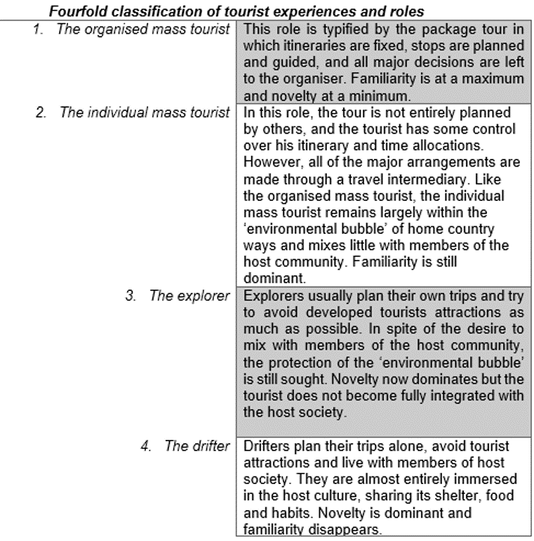Fourfold classification of tourst experiences and roles

(Mathieson and Wall, 1982, p. 19

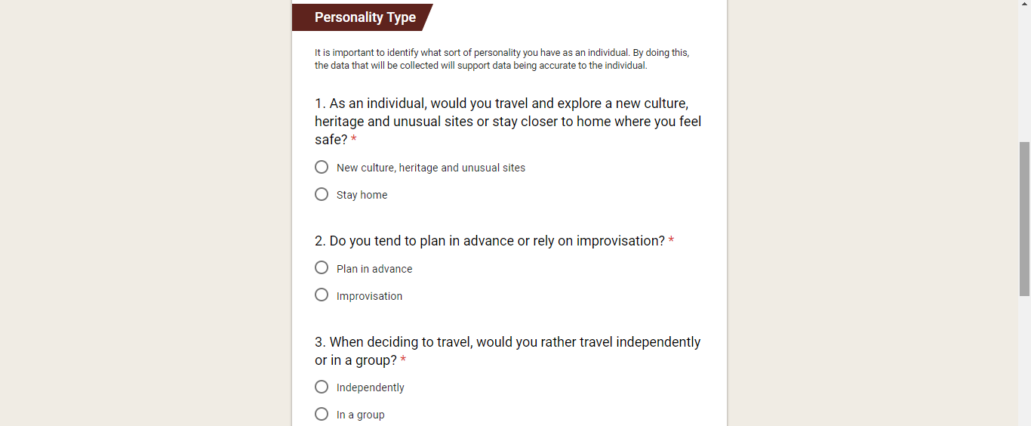
Design of Questionnaires
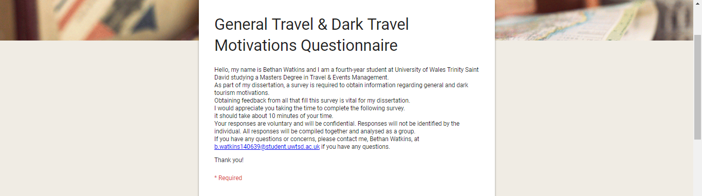
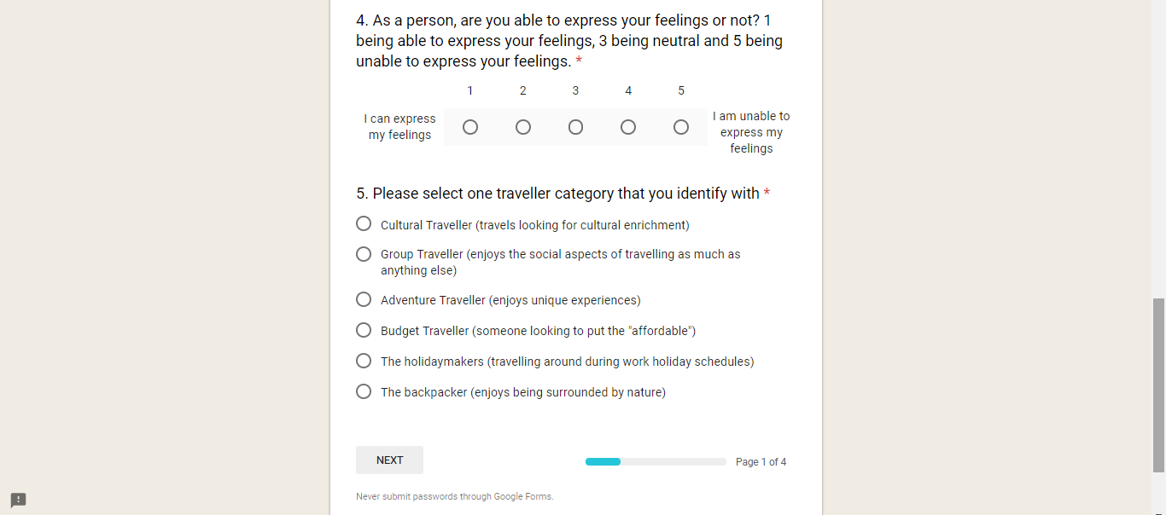

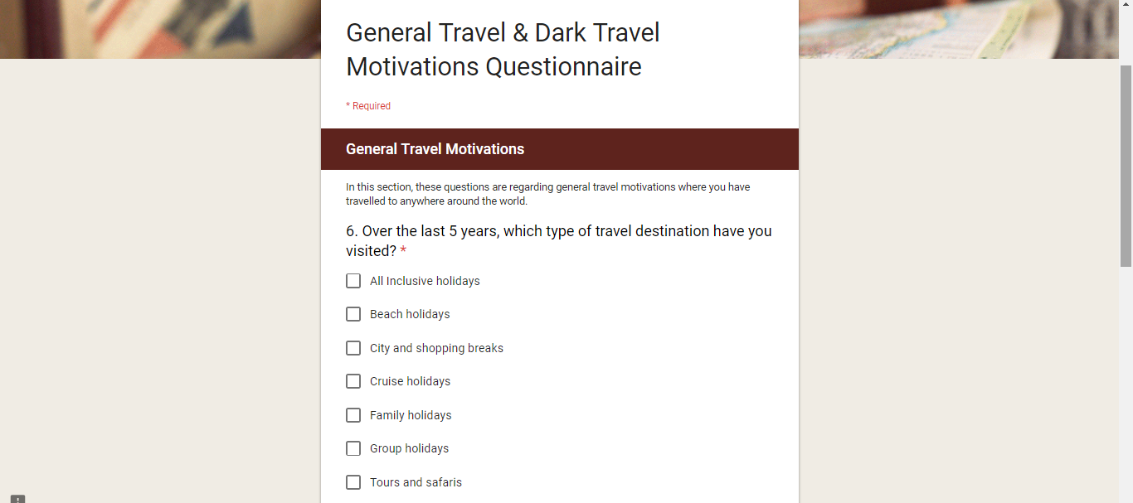
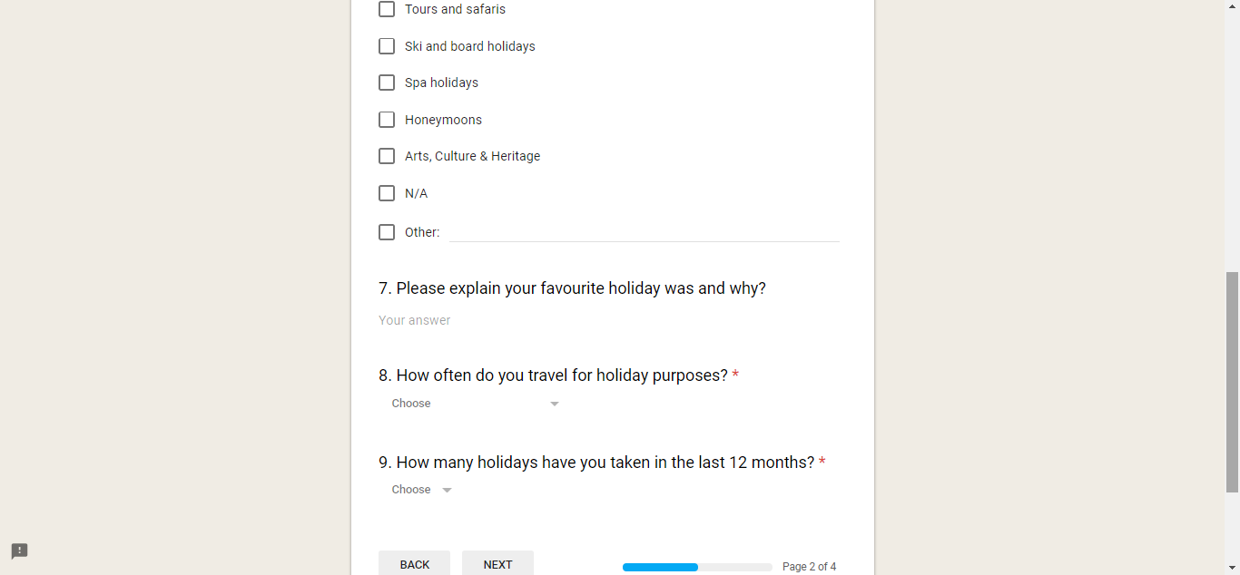

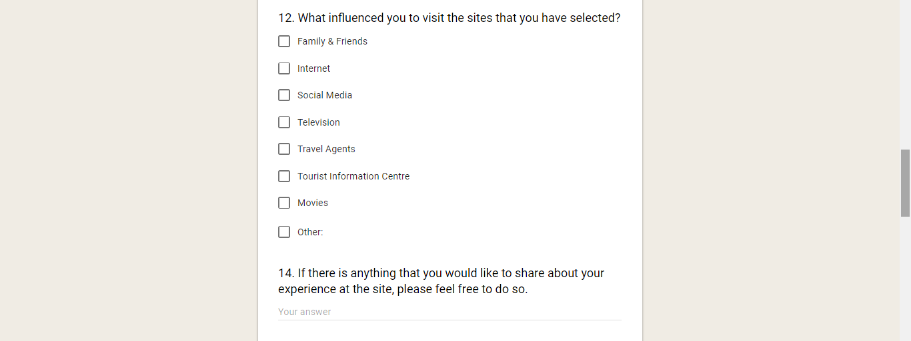
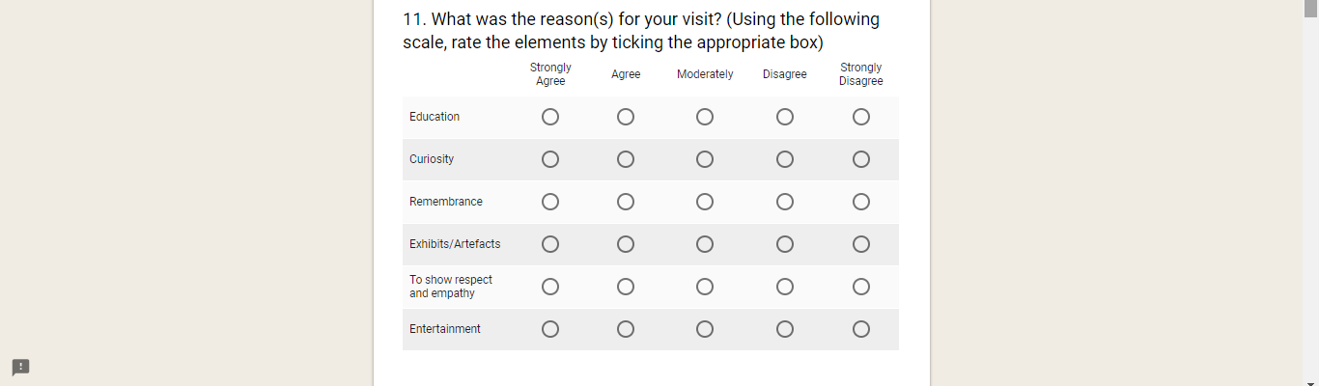
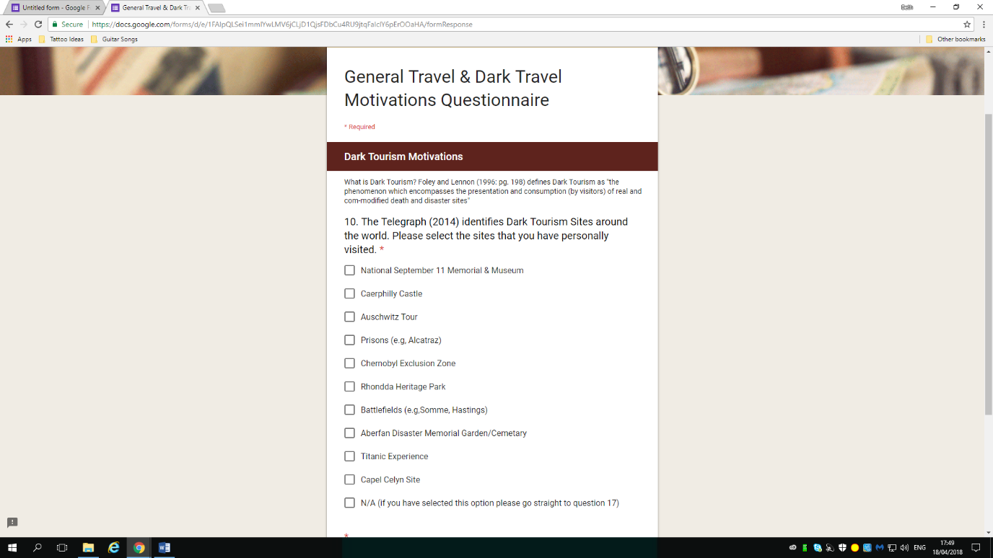

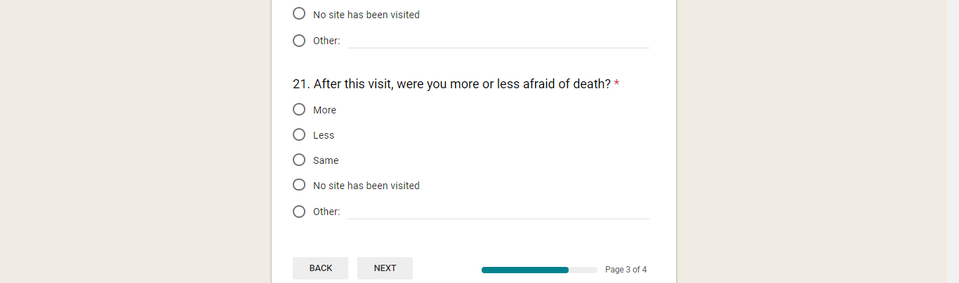
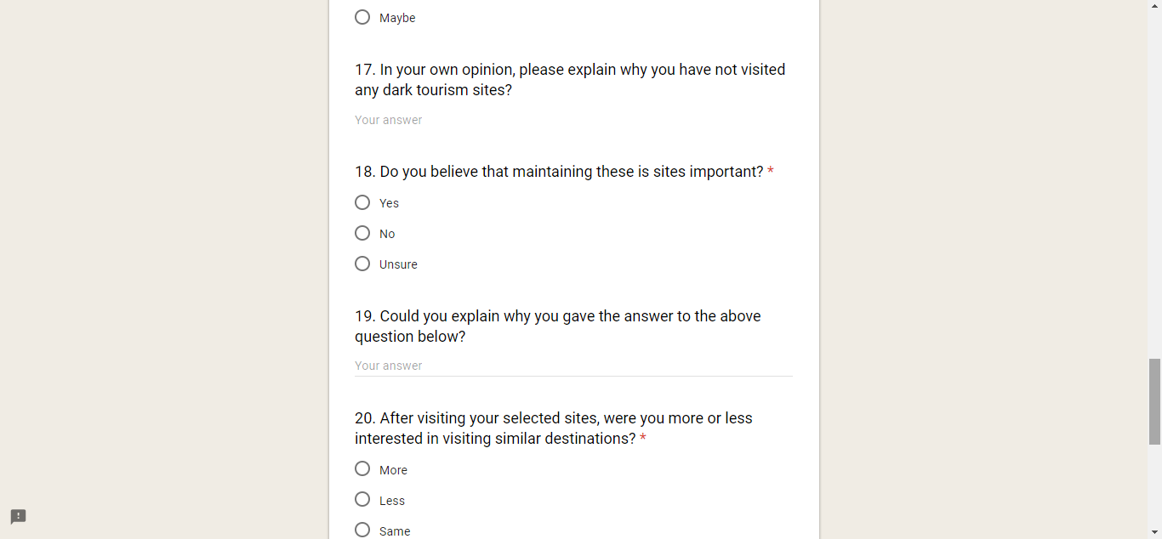
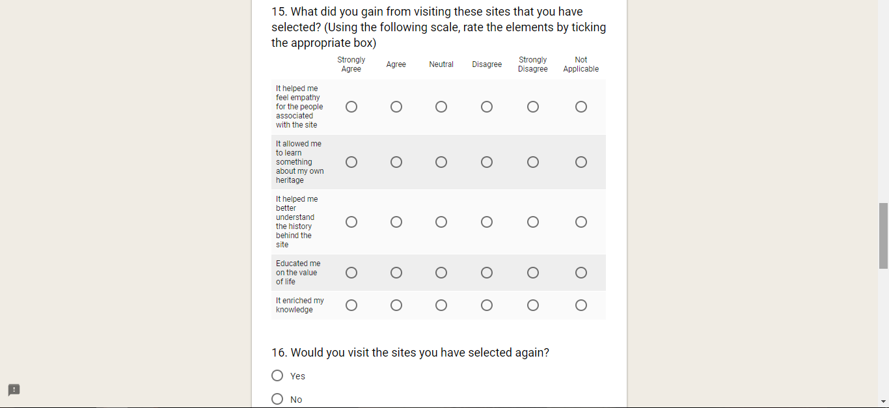

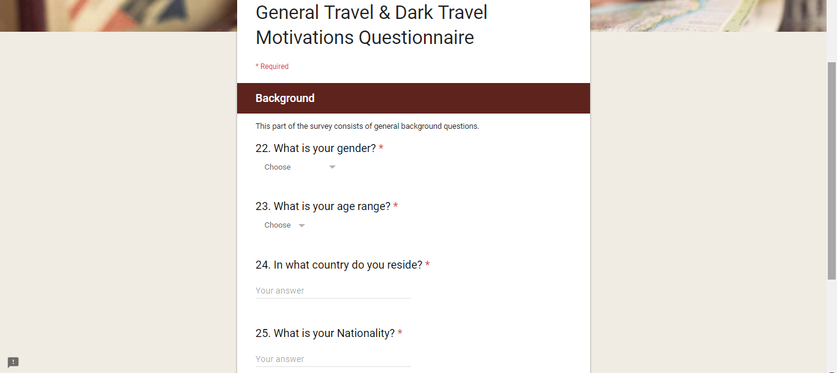

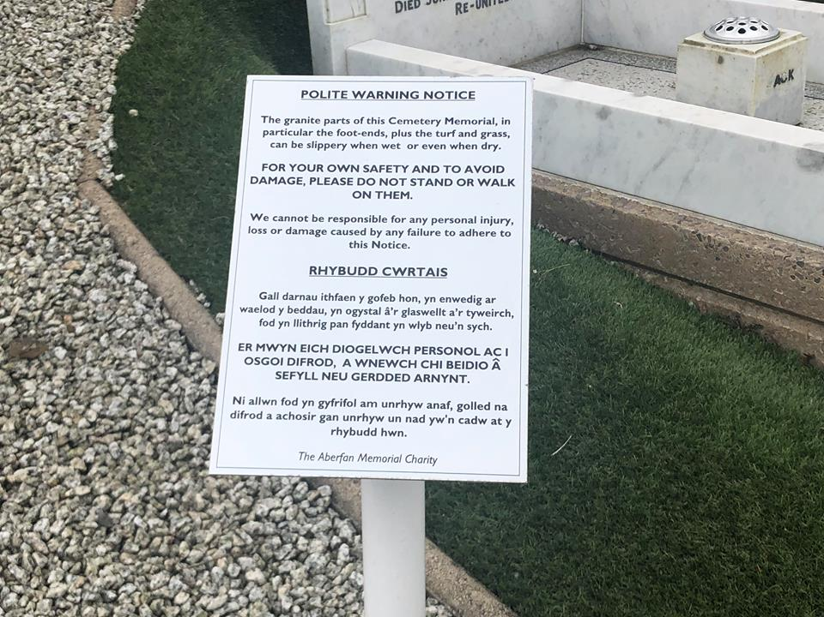
Data Collection Continued

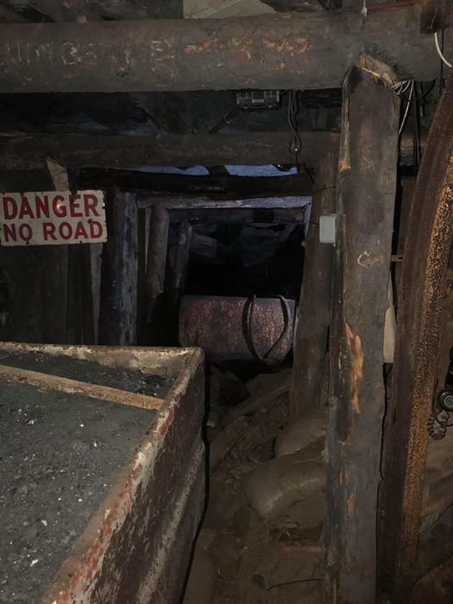
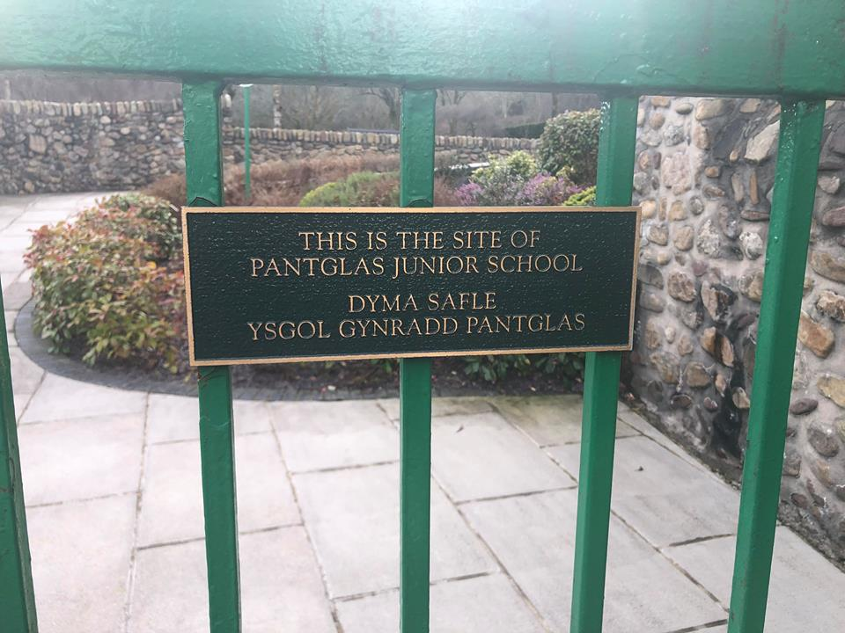
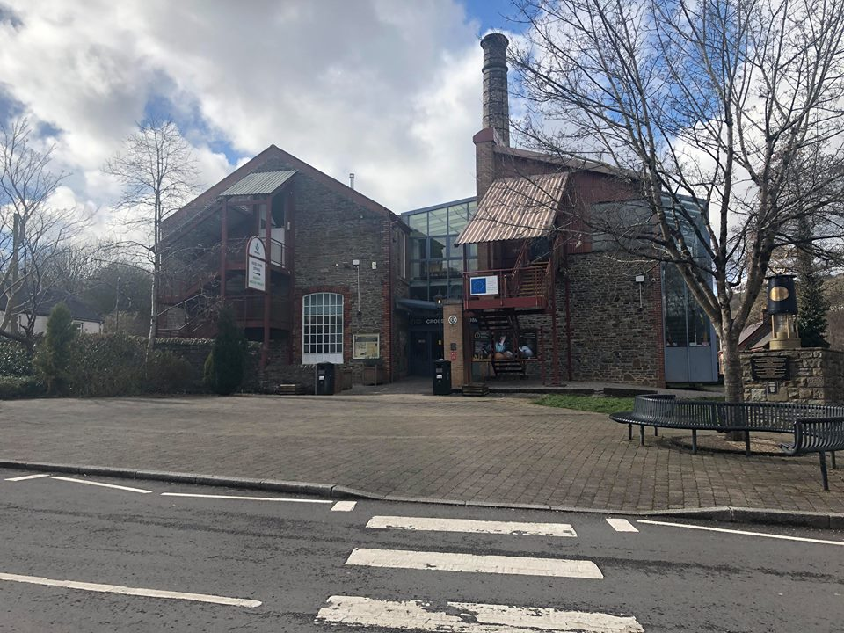

Survey Results

Question 1

Question 2

Question 3

Question 4

Question 5

Question 6

Question 7
Destination | Result
Malaysia | 1
Venice | 4
UK/United Kingdom | 2
Cruise | 12
Amsterdam | 2
Florida | 5
Cyprus | 2
Paris | 4
Ibiza | 3
Colorado | 1
Malta | 3
New Zealand | 3
Australia | 2
Peru | 1
Cuba | 2
Disney | 4
Skiing | 1
Family | 24
Africa | 1
Caribbean | 2
Russia | 1
Bali | 1
Iceland | 1
Magaluf | 2
Caravan | 2
Spain | 3
Thailand | 3
London | 2
Mauritius | 1
Asia | 2
Dominican Republic | 1
New Orleans | 2
Scotland | 1
Estonia | 1
Finland | 1
Germany | 1
USA | 3
Malaysia | 1
Venice | 4

Question 8

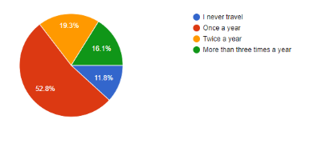

Question 9

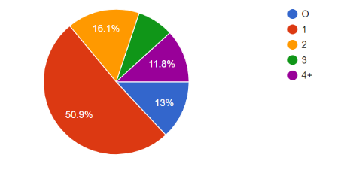

Question 10
Question 10, b. Additional responses from respondents
Pompeii | 6
Colosseum | 5
Old sites in Greece and Corsica | 1
Old war zones in Finland | 1
Cambodia Killing Fields, Cambodia prison Tuol Sleng | 1
Oradour Sur Glane | 1
Hurricaine Katrina Museum | 1
German Concentration Camp | 1
Anne Frank Museum | 2
Victory Park in Moscow and the Lost Forest in Cyprus | 1

Question 11

Question 12

Individual Experiences | Total
Empathy | 1
History | 2
Culture | 1
Learning | 2
Emotional | 4
Family | 4
Disrespectful | 2
Eye opener | 1
Respect | 6
Humbleness | 3
Moving | 1
Better Understanding | 1
Curious | 1
Interesting | 1
Heart-breaking | 5
Heritage | 2
Event | 2
Sad | 4
Empathy | 1
Question 13

Question 14

Question 15

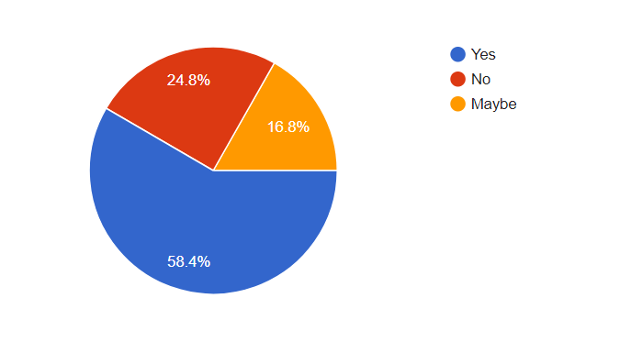

Question 16

Most frequent words used by individuals | Total
Haven't had the chance | 5
Time | 7
Upsetting | 1
Sunny & Hot holidays | 3
Not Interested | 3
Not sure | 2
Not the right company | 2
Money | 2
Work | 2
Children | 1
No reason | 1

Question 17

Question 18
Explanations | Total
History | 54
Culture | 8
Community | 1
Education | 9
People | 14
Legacy | 2
Future Generations | 18
Younger Generations | 3
Remembrance | 7
Important | 17

Question 19

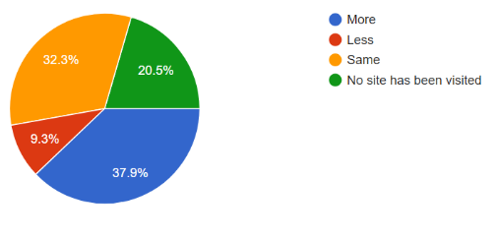

Question 20
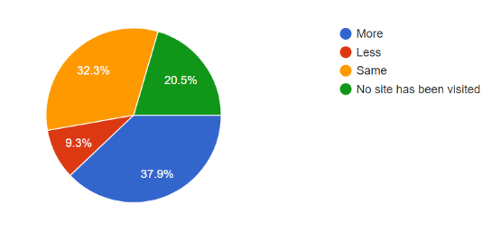

Question 21

Question 22

Question 23
Country that the individual resides | Total
Wales | 109
United Kingdom | 25
Sweden | 1
Romania | 1
Germany | 2
Norway | 1
United States | 6
Canada | 1
Estonia | 1
Russia | 1
Scotland | 5
Hungary | 1
England | 8
Denmark | 2

Question 24
Individuals Nationality | Total
Welsh | 94
British | 34
Irish | 1
Romanian | 1
German | 2
English | 8
Russian | 1
Polish | 1
American | 3
Scottish | 5
Iraqi | 1
Canadian | 1

Letter to organisations
University of Wales Trinity Saint David  Swansea business campus, high street, swansea, sa1 1ne  07467515311 | bwatkins.140639@student.uwtsd.ac.uk | 
Dear Sir/Madam,
My name is Bethan Watkins and I am fourth-year student at the University of Wales Trinity Saint David Swansea, studying Mtour Tourism & Events Management. I am currently in the process of compiling research for my dissertation, entitled ‘an investigation into motivations towards Dark Tourism: A case study of Welsh Tourism Sites’.
I plan to explore the larger understanding of visitor motivations to such as [EDIT TO THE ORGANISATION] Since my recent visit to all three sites, where I acknowledged my culture, heritage and history as being born in Wales I would like to add more to my research. Additionally, I have compiled a questionnaire to the public and the feedback that received is that visitors visit sites, such as yours, out of curiosity and remembrance, where I can agree to this. I can understand that speaking and answering questions regarding dark tourism can be sensitive and some questions could be hard to answer, however, I would appreciate any feedback.
This being said, I would appreciate to speak someone at your organization to listen to your opinions on visitor motivations. If this is possible, please contact me on 07467515311 or additionally email bwatkins.140639@student.uwtsd.ac.uk. I can appreciate that you may be busy and may not have time to speak; therefore, I have attached the questions to this letter where you will be able to answer the questions in your own time.
Furthermore, if you would not like to talk further with me, I would like to thank you for taking the time to acknowledge this letter.
I look forward to hearing from you in the near future.
Edrychaf ymlaen at glywed gennych chi yn y dyfodol agos.

Yours Sincerely,
Cofion cynnes,
Miss Bethan Watkins
BA (Hons)

Interview Transcripts

Interview 1 – Consultant for Letha Consultancy
NB: The responses received were through email
Question 1: In your own words, please define dark tourism, as you understand it.

Response: Tourism based on a site associated with warfare, imprisonment, death, disease/illness (like Bedlam), a tragic event, and or destruction. These sites are marketed directly to tourists

Question 2: Do you feel that all three sites (Aberfan memorial cemetery and garden, Caerphilly Castle and Rhondda Heritage Site) are dark tourism related?

Response: Aberfan is associated with a tragic event and people do visit, but I don’t think it is marketed as a ‘destination’, so I’m not sure it is an ‘official’ tourist product compared to somewhere like Auschwitz. Caerphilly is sold as a Marcher Lords castle and did see battle during attacks, but it was also a statement of power and wealth and was at peace more than it was at war throughout its life. What we see there today owes much to a Victorian restoration using cash from the Industrial Revolution , so the site has a number of stories, some darker than others. I often wonder how long ago something dark had to happen for a site to still be considered dark tourism. It’s leaning tower and its sheer age/size are what usually attract people – I’m not sure they always wonder why it is there and what that might represent.
I don’t think RHP is dark – it commemorates an industry and the people who worked in those industries, elements of which are sad, true enough, but there are also positive stories re ingenuity, camaraderie and bravery.

Question 3: Do you believe that these sites promotes as a dark tourism site?

Response: If your sentence means ‘are they promoted as Dark Tourism’, then I don’t think they are overtly for the reasons above.

Question 4: Globally, there are famous dark tourism sites such as Auschwitz and Ground Zero. Why are these sites more common for visitors to visit?

Response: They are part of everyone’s collective memory (even if you weren’t born then, you will know about them at some stage in your education/life)
Auschwitz has become one of the most striking symbols of the holocaust and man’s inhumanity to man
Ground Zero is within recent memory and was globally covered via modern media/ represents the horrors or terrorism.
They are on people’s bucket lists
A decision has been made to actively market both of them.
Nb Aberfan was internationally covered by the media, but at a time before the internet/social media etc. Also, these were babies taken from their parents and many of those parents are still alive in that small village – it was the destruction of a generation within a small close-knit community and I don’t believe they wanted to be gawped at. Neither of the 2 sites ( GZ or Auschwitz) had the surviving ‘victims’ living on the doorstep in the same way.

Question 5: Why do you believe that visitors visit all three sites that have been selected?

Response: Do they? I’m not sure they often do ‘collect’ these 3 and if they do, I don’t think its part of a conscious dark tourism plan – more of a ‘where else is there to go’ scenario.

Question 6: Stone (2006) created a Dark Tourism Spectrum where the scale starts from the darkest (sites of death and suffering) to the lightest (sites associated with death and suffering). Where do you believe that these sites fits within this scale, and why?

Response: Caerphilly – light, RHP – light, Aberfan – dark

Question 7: Have you visited these three sites, if so, why and how did they make you feel?

Response: Yes all for work and Caerphilly castle/RHP for pleasure
Aberfan left me feeling bereft; the others left me feeling that I’d enjoyed a slice of Welsh heritage

Interview 2 – Senior Monuments Inspector for CADW
The start of this telephone interview was not recorded, as this phone call was unexpected. The conversation starts with Mr. Jonathan Berry explaining what Dark Tourism is and what CADW believes Dark Tourism means to them. He continues to explain that they believe that they use ‘hot interpretation’.

Interviewee – “Dark Tourism, we tend to think of as umm…we have obviously 129 sites in Wales,
Which we present to the public…
Interviewer - “…yeah…”
Interviewee – “…30 of them are staffed, so you know, Caerphilly being the one of them…umm…and you know because we either own them outright, we own freehold of them or we have them under legal guardianship as part of our duties the ancient monuments and the agrological areas act we have to manage them and stop them from falling down and then umm… and then we also chose to present them to the public…”
Interviewer – “…okay…”
Interviewee - “…so we have to interpret and we put in facilities for people to come along and there has been a very recent pull to encourage people to come along to our monuments. We’ve got the…umm…augmented reality that’s going on in Castell Coch at the moment, where you can go and chase fairies around and we’ve got a similar app, the augmented reality app, in Chepstow Castle where you can go and find the dragons…”
Interviewer -...” Oh, yes!” …
Interviewee – “So they are pretty much designed at the younger audience to try and get them in there and to try and keep them there. You must have seen in the press locally about…umm... the dragons that we have at Caerphilly Castle and they have been on the national tour and then we’re just in the process of for the next three years we’re going to be having a home for 2 adults and the 2 younger dragons, ha-ha!” …
Interviewer - …” Aww!” …

Interviewee – “…they’ll be presented, there’s a whole market planning going on at Caerphilly about how we can get people in…umm… how get families in to stay for longer. Whereas the Dark Tourism, that tends to be nefarious uses of our sites, so certain sites have got certain problems with antisocial or criminal behavior, so Castell Coch for example, the carpark there, you know, that’s used for ‘dogging’…”
Interviewer – “…oh my gosh!” …
Interviewee– “…yeah, after hours, the carpark at Ogmore Castle we know that that’s being used for people selling drugs, buying/selling drugs in the past. We’ve got people who, you know, who…umm… it’s just vandalism I suppose really, you know anti-social behavior really. So, each one of our monuments has got its own challenges and there are certain monuments where we think twice about putting interpretation in because it might get wrecked within weeks of putting it in…”
Interviewer – “…aww, yeah…”
Interviewee – “…Flint Castle is a classic example of that where we put some interpretation in because we were hoping to change our wider audience attitudes towards the castle and it just was seen as a challenge to breakup and removed within a fortnight. That’s how we see Dark Tourism, something where people are coming along to our sites and they could be setting fires, doing unauthorised metal detecting, trying to steal sculptured pieces of stones, they might be trying to knock holes in it. We have a lot of people that want to camp out, have parties and all sorts of weird and wonderful things…”
Interviewer - “So, Dark Tourism in your concept instead of it being related to death and tragedy it’s more to do with criminology in a sense…”
Interviewee – “It’s antisocial behavior and criminality, when it comes to it, Beth, lots of monuments that we have people have either died building them, they’ve died during their operational use, or descending them or attacking them or sometimes our visitors have fatal accidents on monuments as well. It’s the same as up in Historic England and Historic Environment in Scotland as well, even people from our workforce, on rare occasion die on our sites as well. We have umm…”

Interviewer – “…incidents in a sense then?”
Interviewee – “I suppose all that conflict or the dark side, we don’t see it as dark because it’s a part of the historic values of the monument itself. We don’t really separate death out in that sense, its part of the broader narrative. There are sites where the past is contested or uncomfortable but in our opinion we shouldn’t be shying away from that because otherwise we’re just giving a very kind of generic, safe…”
Interviewer – “environment really…”
Interviewee – “yes, yes, it is kind of sanitising it really and history is often kind of ugly really.”
Interviewer - “Yes, that’s exactly it! Thank you very much for that, it’s brilliant!”
Interviewee– “Have I basically gone through your questionnaire, is there anything that I have missed out?”
Interviewer – “Umm, if I read them out to you – In your own words, how would you define Dark Tourism as you understand it?”
Interviewee – “Well, we would use the term ‘Hot Interpretation’, rather than Dark Tourism. Dark Tourism for us is basically in-house description within CADW for antisocial behaviour and low level criminality that occurs on our monuments in state care and the legally designated scheduled monuments of which there’s about 4,200 across Wales.”
Interviewer – “Right, okay, fabulous. The second question then is: do you feel that Caerphilly Castle is a dark tourism site, but again I believe that it is a Hot Interpretation site now that you have mentioned it. Obviously as it is a castle there will be history of death and things, I think that it is ‘Hot Interpretation’. And then question 3 asks, do you believe that Caerphilly Castle promotes itself as a dark tourism site? For example, is it a family attraction site?”
Interviewee – “Well, if you go into the inner ward, you go through the main castle gate house and then you go across the moots and you go up to the inner ward itself, there is an audio-visual display which basically talks about the history of the castle and there are quite grizzly bits in there. It’s done in a cartoon narrative style of various characters’ kind of dying, one of them is hung, drawn and quartered and basically his bits are splattered across the screen but the kids love it! It’s something that we, well I wouldn’t say ‘glorified’ it’s too strong of a word but certainly include it and it certainly has a positive reception. It is obviously a martial site in a sense, it is a defensive site but it was also used to project power. You know, it is associated law and order on the king’s behalf there. I think that the castle was attacked once when it was in the process of being built but it was held and contested. The interesting thing about Caerphilly is and I am not sure how many people know it but there’s an area, you know that it’s surrounded by the lake?”
Interviewer – “Yeah!”
Interviewee – “On the North Side there is an area called Groove and CADW got its masons workshops and work depots and things that’s the area. Where the Siege Engines there, which are being rebuilt, and they are in the process of test firing them and fine-tuning and view to having them catapulting things in the molts on a regular basis as part of our interpretation of our monument. Again, it’s fairly sanitised because we’re not lobbing big rocks or flinging barrels of oil at the castle in order to take it, it’s more for the spectacle of people going ‘oh and ah’ and watching it. There are elements of it, to use your term, that we have a dark tourism site and that we don’t shy away from telling the stories but it’s not like going to the London Dungeons where they completely focus on Dark Tourism.”
Interviewer – “Okay, umm… I think you you’ve covered everything else really with what you’ve explained and I can adjust it to my questions…”
Interviewee – “ I was just looking at your question 4 about globally there are Dark Tourism sites Auschwitz and Ground Zero where there are other ones, which obviously it takes time for almost atrocities today to become history. And there are people going back to like the Balkans, when I was in university in the 1900’s all that seemed to be on the news was the Balkans crisis. And you can go to Dubrovnik in Croatia it’s a fantastic war town with fantastic history and there’s a map just before you go into the entrance and it shows you each individual house that was either partially or completely destroyed during the bombardment of that city and they have now been rebuilt to how they were before…”
Interviewer – “I’ve been to Dubrovnik and I never saw that! And that’s almost the same as Pompeii really. I’ve been Pompeii as well and they’ve been rebuilding some of the houses that had down there, yeah so, it’s almost the same so I understand what you mean.”

Interviewee – “Yeah and Caerphilly Castle has been around for quite a long time and you can’t put a monument…”
Interviewer – *mutes microphone so JB cannot hear what she is about to say*
“Question six”
Interviewee – The interviewee continues conversation without interruption
“You can’t put a monument with such a long history into a point in the spectrum I think what you’ll have to do is look at it and break it down so it’s historical competent. So when it was first built and it was functioning as it was designed to function it was probably it was quite dark but then gradually through time it’s got lighter because the other important thing about Caerphilly castle is that, yes it is the largest castle in South Wales it’s the best depiction of concentric deference…”
Interviewer – “definitely, yeah”
Interviewee– “it was the pre-cursor of Edwardian Castles in North Wales but the other big thing about it is that Lord Bute who was the richest guy in the world on the back of the coaling out of South Wales he basically built huge parts of the castles. Now that when you go around it there’s little medieval you see, because it was all rebuilt and that was so much to do with him trying to find work for wounded service personnel people who were displaced after the first world war after the 1920’s so rebuilding the site and representing it. It is an interpretation largely it’s not an authentic site in the same way as many of our unaltered castles are. In the 1940’s in came into state care and then from that point onwards it is a visitor attraction. It is probably the lightest end of the scale it is we looking back at the monument on how it has been. I expect that Caerphilly possibly with a few blips along the way starts off really dark and then gets lighter and that’s over centuries, centuries and centuries and what might be interesting is to compare that with other sites where perhaps it’s got a different trend through time”
Interviewer – “Oh wow, okay! Umm… and then it’s the last question, have you visited Caerphilly Castle and why?”
Interviewee-“Well as I’ve said I work with CADW it’s one of our principle monuments and I have a lot to do with it and I am there once a fortnight and I do visit it with family and friends, well I’m based in Nant-Garw so that and Castell Coch are my 2 nearest monuments”
Interviewer – “Well I think that’s everything, thank you very much Jonathan that’s really helped me…”
Interviewee “Pleasure”
Interviewer – “…I can’t wait to write this up now”
Interviewee-“Sorry I’ve just realised that, umm… I tell you what if I give you my email address and then if you have any follow-up questions because I know what it’s like talking to someone and then you think you’ve get everything down and then you kind of go ‘oh I wish I asked that’, and you can just email me then
Interviewer– “yeah okay!”
Interviewee- “It’s jonathan.berry@gov.wales.uk that it then!”
Interviewer– “Well thank you very much for that, I really appreciate it and now I can get my dissertation done!”
Interviewee– “Yeah well best of luck with that! And I look forward to…oh well actually send me a copy of the finished dissertation”
Interviewer – “Thank you for calling me! Bye bye!”

Interview 3 – Collections Officer for the Rhondda Heritage Park/Collections Department
*NB- The interviewee and the interviewer were exchanging emails before this telephone call interview took place. The interviewer started recording the main dialogue after the introductions were made.

Interviewer – “…so yeah it’s just to see if you have got the time to go through my questions with me and then I can write down your answers for my dissertation if that’s okay?”
Interviewee – “Yeah, of course! No problem at all”
Interviewer – “So, question 1 is, please define dark tourism as you understand it, so anything on top of your head what would that be then for you?”
Interviewee – “Honestly, that was the first time that I have ever come across the term…”
Interviewer – “Aww!”
Interviewee – “So, umm… we wouldn’t, obviously read on through the questions and you mention Auschwitz and Ground Zero we wouldn’t necessarily define ourselves as a dark tourism site…”
Interviewer – “Right, okay that’s fine!”
Interviewee – “I think, well it answers your question 2, do you feel that Rhondda Heritage Park is a dark tourism site? We wouldn’t necessarily…we try to, The Rhondda Heritage Park tries to tell the stories of The Rhondda Valleys kind of all composites, really, obviously, the nature of our site being a coal mine, the industrial side and the industrial aspects of Rhondda’s history is quite an important part for us, hence why the underground experience is all about the mines and that sort of thing. I kind of get what you’re saying that mining was a dangerous profession?
Interviewer – “Yeah…yes…yes”
Interviewee – “I think for us we very much try to, certainly in our museums galleries and that, highlight the importance of the Rhondda Valleys and the, so like the international importance because of its mining history and not necessarily although we touch upon it, focus on the tragedies associated with it”
Interviewer – “Yeah”
Interviewee – “So we would never ignore that, obviously, the mining industry was dangerous but that’s just a small part of the history”
Interviewer – “Great! So, I was on the phone the other day with Caerphilly Castle and they said that they do hot interpretation, so it’s not dark tourism as such but it interprets the history that they had beforehand”
SB – “Yeah so we touch upon, mining disasters, I mean the colliery itself, our last disaster was 1959, where I think 7 men died in a pit accident and obviously, that’s still within living memory. We’re very sensitive about way we discuss it. You know, we don’t want our site to be all about death in the mining industry because similarly at the same time in 1910 death rates for women of a certain age were higher than men working in coal mines.”
Interviewer– “Oh crikey, okay, that’s really interesting”
Interviewee – “So, actually, you know as dangerous as the mining profession was, the lack of sanitation and the overcrowding and the lack of maternity provision made it more dangerous for women than it did for men at that time, so, for us, it’s an aspect of our history. Similarly, we have a museum in Aberdare which were responsible for, they decided to do a building of a concept of an old iron work and now in Aberdare sanitation was a big problem which is something that is touched upon in our gallery but it’s not something that all-encompassing as a site we wouldn’t define ourselves by it, I don’t think.”
Interviewer – “No, that’s fine, I think I’d agree. I’ve been to Rhondda Heritage Park, I went there and I went up to the gallery and the only think that I thought that was related to tragedy and death was the bathtub which was interesting for me I was like ‘oh!’. That for me sums up what the men went through. I was going to say that I think that you’ve answered question three as well, Stone, 2006, created a dark tourism spectrum, so obviously, it’s a scale from darkest being something as horrible as Auschwitz and Ground Zero where the lightest is a site that is associated with death and suffering, where do you believe that Rhondda would fit on the scale?”

Interviewee – “Probably, the lightest, you know. I think any museum if it’s about a community or something to do with throughout South Wales would probably fall on that spectrum. Yeah, we don’t push the darker side of our history because we want it to be a positive story really.”
Interviewer – “Yeah, you want to bring the history back to life. When I went around the tour with the tour guide, he was literally bringing everything back alive, it was brilliant to see that on the tour”
Interviewee – “Yeah, yeah”
Interviewer – “And umm…it was great! I just loved it”
Interviewee – “Oh good! Ha-ha!”

NB- At this point in the interview, the microphone stopped recording

Interviewer – “OH! It’s back! That was weird, sorry!”
Interviewee – “No, that’s fine don’t worry”
Interviewer – “So my question 4 then is just to identify the tourists that you have coming into Rhondda. Do you have my questions up on your screen?”
Interviewee – “Yeah, I do”
Interviewer – “Sorry if I pronounce these wrong, how would you identify the tourists with these A to E categories? Which one do you think is the best suited for your tourists that come there?”
Interviewee – “Oh, I don’t have any categories. My question 4 is globally there are dark tourism…”
Interviewer – “Aww, I think that I am on the wrong questions!”
Interviewee – “Right, okay”

*NB – The interviewer now notices that the wrong document is open, therefore, the questions are different from the interviewee. The interviewer turned microphone off and resumed interview when the correct questions were presented.

Interviewer – “Number 4, here we go! Yeah, so it’s basically, why do you think that those sites are much more common for people to visit than our sites that bring culture and heritage back to life?”
Interviewee – “Umm…arguably with those sites selections, Auschwitz and Ground Zero they have more of a global impact and so therefore more of people sharing those histories. I wouldn’t say that they are more common for visitors to visit than our sites but they have different audiences I think”
Interviewer – “I think it’s just the fact that they want to go there just to see obviously, what happened”
Interviewee – “I mean you’re talking about a global story of those sites and so I think it’s probably a different audience and a different market from us, yeah”
Interviewer – “There we go, thank you for that. What was your question 5? Because I have here, why do you believe that visitors visit your site?”
Interviewee – “yeah, that’s what I got. So, our market is, we’ve got quite a various market, obviously, educational market and local schools and colleges, we get a lot of visits from them.”
Interviewer – “My College didn’t come to your site, I would have been interested in coming there if we had the option. Only recently, well I’m 22 and only now I’ve come!”
Interviewee – “So we have a lot of school visits but we also get a lot of _9:44____ tourism, so peoples whose family were miners and specifically from the area. So, we get a lot of visitors through that market, I guess we are not kind of a museum but we are a tourist attraction and so lots of our markets come in for events. So, a lot of our families turn up for events there are peak times associated with those, and then we have a smaller market that is growing thankfully which is the wider tourism market so we’ve been specifically targeting; coach trips and overseas visitors and those markets are now growing with us as well.
Interviewer – “Great, I think that too. If it’s okay, could I ask you a question that’s not on the letter?”
Interviewee – “Yeah!”

Interviewer – “So what attracted you to work in your current field then? So, what is your position in the Rhondda and obviously, what made you want to work in the heritage site itself?”
Interviewee – “Okay, so I work for the Rhondda Cynnon Taf Heritage Services so not specifically for the heritage site I am responsible for the museum collections so I am a collections officer so I work across a number of sites in Rhondda Cynnon Taf and the heritage park being one and that’s where most of the redevelopment has gone into the year so far. I guess I kind of loved history that’s probably why I got into it, I trained as a conservator at university so my background isn’t history its looking after/care of cultural objects so that’s how I got to where I am”
Interviewer – “Brilliant, cool. Just one more question, is there anything you can share regarding your time working at your place of work? So, has anything stuck out for you? Has any visitors asked you anything that is related to tragedy and death? Sorry, I know that it’s a sensitive subject”
Interviewee – “No, no, its okay, its fine. So, 2 years ago we commemorated the 60th anniversary of the last coal mining disaster in the Lewis Merthyr Colliery, so where the heritage park is based”
Interviewer – “Oh yes I know”
Interviewee – “So we held a day of remembrance, we invited family and friends who died on the day and working on the day. We had talks from local historians and people who were there on the day sharing their thoughts and feelings, it was really nice and it was really well-attended by the community. We also had a temporary exhibition about the day and the events leading up to the accident and how everything fell into place and we exhibited a list almost like a honour roll of everybody who had died in a coal mine that we could find through the Rhondda Valleys, so, that was quite nice. Obviously, it was all for the anniversary events I think that the exhibition was up for a month on top of my head, but yeah it was lovely as a result of that we’ve had a few new acquisitions coming into the collections so one of the gentlemen that died during the accident his son came and gave us his personal effects of his father, including a brass pocket watch case that his father actually had on him the day of the accident and was brought up with him after the event. So yes, it was a very positive experience for everyone involved and to take something so sensitive and within living memory of the loss of people and turn it into a positive thing and a commemorative day, remembering the accident.
Interviewer – “I wish I came to that now. Well I think that I have got everything that I need”

*NB- The microphone was turned off at this point as the interview had ended with all the questions. The interviewer explained that SB’s name will be confidential and that if there is anything further the individual would like to add the interviewer provided an email address.

Interview 4 – Visitor Attractions and Heritage Service Manager of Rhondda Cynon Taf Council
Question 1: In your own words, please define dark tourism, as you understand it.
Response: I have not heard of the term Dark tourism used in this connotation. The Welsh Mining Experience at Rhondda Heritage Park is primarily a facility that celebrates the impacts of Coal Mining in the Rhondda Valley. Through interpretation gives visitors an insight into the success in innovation, entrepreneurship, and human progression through a collective conciseness that drove the miners to invest within their own communities in order to provide opportunities for their children and future generations for betterment. Through learning within the collages, libraries and welfare provision and for better health and leisure opportunities, they provided through the hospitals and recreational facilities that they built. The South Wales Valleys were developed through this collective contribution, a remarkable and uplifting story and delivered from a society that had so little to give at that time. With the greatest respect, I feel that your premise is wrong in assuming that ‘ Dark Tourism’ applies generally in this case, albeit, there may be a minority who are attracted for these reasons, whoever, we have no feedback to suggest that is the case.

Question 2: Do you feel that Rhondda Heritage Park is a dark tourism site?
Response: Definitely not. This visitor attraction gives insight to the main influences that shaped the landscape and people of the Rhondda Valley.

Question 3: Do you believe that Rhondda Heritage Park promotes itself as a dark tourism site?
Response: No – We do not recognize that dark tourism is applicable, unless the premise is that all social history attractions have an element of attraction because suffering of some sort was apparent in within the history of the subject matter.

Question 4: Globally, there are famous dark tourism sites such as Auschwitz and Ground Zero. Why are these sites more common for visitors to visit?
Response: In cases such as those listed, they are famous because of they serve to remind and educate people. First and foremost, of the extreme horror and tragedy of which they represent, as opposed to the Welsh Mining Experience, who purpose is to first and foremost tell a social story, that had elements of hardship and tragedy woven within, as part of its history.

Question 5: Why do you believe that visitors visit Rhondda Heritage Park?
Response: To gain insight to the industry and social history that defined Wales within the twentieth century.

Question 6: Stone (2006) created a Dark Tourism Spectrum where the scale starts from the darkest (sites of death and suffering) to the lightest (sites associated with death and suffering). Where do you believe that Rhondda Heritage Park fits within this scale, and why?
Response: I don’t know the scale, however, I believe it would be at the lightest point of reference, if at all.

Question 7: Have you visited the Rhondda Heritage Park, if so, why?
Response: I am responsible for visitor attractions within Rhondda Cynon Taf County Borough Council.

Interview 5 – Parks and Bereavement Services Manager for Merthyr Tydfil County Borough Council
Question 1: In your own words, please define dark tourism, as you understand it.
Response: Tourism to places associated with death and suffering

Question 2: Do you feel that Aberfan Memorial Garden and Cemetery is a dark tourism site?
Response: No, but there may be a small element who consider this so.

Question 3: Do you believe that Aberfan Memorial Garden and Cemetery promotes itself as a dark tourism site?
Response: No.

Question 4: Globally, there are famous dark tourism sites such as Auschwitz and Ground Zero. Why are these sites more common for visitors to visit?
Response: These sites are internationally known and are marketed as tourism sites. Aberfan cemetery is a functional cemetery

Question 5: Why do you believe that visitors visit Aberfan Memorial Garden and Cemetery?
Response: Primarily to visit their loved ones graves, Then there are those that like to visit the disaster memorial, some with some connection to Aberfan, others being curious and have heard the story about the disaster.

Question 6: Stone (2006) created a Dark Tourism Spectrum where the scale starts from the darkest (sites of death and suffering) to the lightest (sites associated with death and suffering). Where do you believe that Aberfan Memorial Garden and Cemetery fits within this scale, and why?
Response: If mourners are classed in the darkest category, then darkest

Question 7: Have you visited the Aberfan Memorial Garden and Cemetery, if so, why?
Response: I’m the manager, but also out of interest

Interview 6 – Author and Creator of Dark-Tourism.com

Question1: In your own words, please define dark tourism, as you understand it.
Response: I always emphasize the educational value of dark tourism (I have learned more about the world through DT than in my entire academic life before), the trying to understand and/or come to terms with contemporary/modern history is for me the focus. Place authenticity also plays a major role (being in a real place in person rather than just abstractly reading about it), and on some occasion the visual dimension (for photography). More definition attempts are scattered over my website, especially in the central dark tourism section (various links from there).

Question 2: I can see that on your website you have written about Aberfan, Wales. Why do you believe that this is a dark tourism site?
Response: Aberfan was the site of a major disaster, and this is commemorated in a garden that is set within the footprint of the school that was destroyed in this disaster. So it is a real site, and it has a very dark connection and you can visit it, ergo it has to count as a dark tourism site ... as does the cemetery with the graves of the victims.

Question 3: Stone (2006) created a Dark Tourism Spectrum where the scale starts from the darkest (sites of death and suffering) to the lightest (sites associated with death and suffering). Where do you believe that Aberfan fits within this scale and why?
Response: On my website I gave Aberfan a "darkometer" rating of 4 (out of 10 - for comparison see here), which is more or less in the middle, given that the top rankings of 9 and 10 are quite few. It would have got a higher rating had there been more place authenticity, but the memorialization is a little abstract. Nothing much of the disaster remains actually visible today

Question 4: Do you believe that Dark Tourism sites promote the Dark Nature to the visitors that visit?
Response: this question is a bit vague ... do you mean Aberfan specifically or DT sites in general.
If the latter, than this varies enormously, from no promotion whatsoever, to some over-emphasis, and everything in between. As a rule, the majority of DT sites are not much promoted and are rather familiar only to those "in the know" (with the usual exceptions - see next question).
If you mean Aberfan specifically, then no, I would not say it is being "promoted" for outside visitors. The memorialization is much more for the locals in this case. Yet dark tourists do go there occasionally.

Question 5: Globally, there are famous dark tourism sites such as Auschwitz and Ground Zero. Why are the more popular Dark Tourism sites more common for visitors to visit?
Response: the answer is actually already in the question - simply because these places are so well known. Virtually everybody will at least have heard of them. That is very different for say, other concentration camp memorials such as Groß Rosen or Flossenbürg. In addition, because of the famous names, both Auschwitz and the 9/11 Memorial (& museum) are top mainstream tourism attractions as well as top-league dark places. Tours to Auschwitz, for instance, ar amongst the four main things advertised in the Krakow Tourist Information Office. In addition, a large proportion of visitors to New York would not consider their visit complete without at least a short stint at the 9/11 site.

Question 6: I can see that you have visited many Dark Tourism sites. Which site, in your opinion, has made the most impact on your emotions and feelings?
Response: Overall I would say Chernobyl made the biggest impression on me, partly because it works on so many levels all at the same time - major disaster site, ghost town, unique, iconic industrial ruins, and perhaps most importantly: time travel - both backward (to the Soviet Days) and forward (allowing a glimpse into a post-human or post-civilization dystopian world).

Question 7: Finally, could you explain why you have created a Dark Tourism website? What were your aims and objectives when you created the website?
Response: Simply because it was a gap and I, though it deserved being filled. There are still no other dark-tourism guides of a similar nature and/or comprehensiveness. I simply wanted there to be such a thing, and as it did not yet exist, I had to make it myself. While there are plenty of academic resources on DT, and several individual travelogues and photo collections, a practical guide plus in-depth background info had been missing until I set this site up. Yet I totally underestimated the magnitude of the task when I started a good ten years ago. Now it has become more or less the centre of my life, with still endless scope for growth. I see it as a service to like-minded people, same as DT's page on Facebook. Something I wished I had found already existing when I discovered the topic of dark tourism (I had already engaged in it, but had not been aware of the term until 2007). Now it is really my thing, and carrying on with it has almost an addictive nature. I could not just stop it now. In addition, it has dominated my own travels. I think it is probably fair to say that I am the most widely travelled dedicated dark tourist. It feels exhilarating - even if it can also be hard work at times.

Interview Matrix Table

