
Approaches to Innovation and Organisational Change
Antony Pugh - 2221728

May 12, 2025
University of Wales Trinity Saint David

Executive Summary
The purpose of this report is to analyse and evaluate an organisational change that happened at Pembroke Refinery. The change occurred following a prolonged and problematic shutdown in 2021 on the cracking & Olefins complex. The shutdown was difficult for several reasons. This included complex work conditions due to a super lift for a significant project, underestimation of the work scope and COVID-related labour shortages. These factors combined to create a highly challenging environment. Planning inaccuracies and unforeseen complications resulted in delays and financial implications. The complex nature of the super lift required meticulous coordination. However, insufficient preparations led to delays and disruptions. Additionally, the underestimation of the work scope meant that resources were not used efficiently, which led to further delays during the execution phase. Furthermore, the impact of COVID-19 on workforce availability further exacerbated these issues. Skilled workers were frequently absent or limited. This, in turn, caused further delays and reduced productivity. The failure of the turnaround led to the dismissal of the previous refinery manager. A new manager was introduced in early 2022, who implemented a transformational leadership style. The shift in focus went from output-maximisation to structured planning, KPI performance and environmental compliance. This strategic change aimed to address the root causes of the inefficiency and enhance long-term operational stability. The goal was to move away from the previously reactive practices and more to a proactive management approach. The introduction of structured planning helped to ensure that future projects were more predictable and manageable. This reduced the risk of similar failures in the future. The report critically examines the effectiveness of the change process through the application of Lewin’s Forcefield Analysis, Kotter’s 8-Step model and motivational theories described in Mullin’s (2012), motivation and organisational behaviour. It identifies key driving forces and resisting forces and explores the cultural shift in leadership style. The report also evaluates the impact on staff morale, particularly between permanent and contract workers. The change led to measurable improvements, including one of the refinery’s most successful shutdowns in 2024 on the Refining complex. Recommendations include improving contractor engagement, enhancing transitional communication and aligning motivation strategies more closely with workforce needs.

Table of Contents
Executive Summary 1
Introduction 3
Main findings 4
Background of Change at Pembroke Refinery 4
Application of Change Management Models 5
Lewin’s Forcefield Analysis 5
Kotter’s 8-Step Change Model 8
Motivation and Leadership during organisational change 11
Conclusion 13
Bibliography 14

Introduction
Adapting to change is essential in capital-intensive industries such as oil refining (Burnes, 2017). Valero Energy Corporation is a Fortune 500 company and an international manufacturer and marketer of transportation fuels and petrochemical products (Valero, 2025). Pembroke Refinery is in Wales and is Valero’s only UK Refinery. It is a critical part of its global operations. Organisations like Valero must constantly evolve to remain competitive, efficient, and sustainable. This is especially true in high-risk, high-regulation environments (Burnes, 2017).
In 2021, Pembroke Refinery experienced a significant organisational challenge due to a planned turnaround on the Cracking and Olefins complex exceeding its budget and timeline. This, in turn, led to increased corporate scrutiny and pressure for change. In response, Valero decided to replace the existing manager with a new leader. The new leader introduced a structured, KPI-driven approach, prioritising maintenance schedules, environmental compliance, and planning discipline over output maximisation. The shift in leadership style was to stabilise operations and rebuild the refinery’s performance reputation.
Leadership change can be better understood through long-established change management and motivational frameworks. Some of these include Lewin’s Forcefield Analysis (1951), Kotter’s eight-step change model (2012), and motivational theories proposed by Herzberg (1959), Maslow (1954), and Vroom (1964). These models can help contextualise the leadership shift and the varying responses from the refinery's workforce.

Main findings

Background of Change at Pembroke Refinery
The organisational change at Pembroke Refinery was caused in part by the failed Cracking and Olefins complex shutdown in 2021. The shutdown significantly overran its planned duration. Originally, the shutdown was scheduled for eight weeks. However, the shutdown ended up spanning nearly 16 weeks. This was due to several contributing factors, such as underestimated scope, excessive emergent work, and the complexity of a major vessel replacement project on the Alkylation unit. This period also aligned with the COVID-19 pandemic, which impacted labour availability and required the refinery to fly in American contractors to support the outage (McLaughlin, 2022). Most of the issues seemed to be associated with the Alkylation unit. As the shutdown progressed, it was clear across the site that planning gaps and resourcing issues played a significant role in the delay.
The refinery manager at the time showed traits similar to a transactional leader. Overtime pay was treated as a reward for achieving maximum output of the refinery. Transactional leaders prioritise performance targets, which are often achieved by using financial incentives to drive productivity. (Bass and Avolio, 1994). However, at the end of the turnaround in June 2021, the manager was called to Valero headquarters in San Antonio, Texas. The manager was consequently relieved of the position with immediate effect. In the absence of an immediate replacement, operations continued under his principles until January 2022. Under the manager's leadership, maintenance schedules were often sacrificed for emergent work. This put extra pressure on the staff to keep the plant running at full capacity. Furthermore, this created a culture where employees were expected to work long additional hours at short notice. This resulted in a great deal of stress for some people (Karasek and Theorell, 1990).
The arrival of a new manager marked a transformational shift in both leadership style and operational priorities. Influenced by his background in California, he introduced a strong focus on environmental compliance and KPI performance. This included reduced flaring and staying within budget. Overtime was cut back dramatically overnight, and the workforce structure changed to prioritise efficiency and accountability. A new time on tools system was introduced that involved employees swiping onto the unit to provide a new metric. These measures led to disappointment amongst the contract staff. However, the staff employees adapted well to the change. Morale generally improved under the more structured, value-driven leadership (Nadler and Tushman, 1997).
These changes laid the foundation for long-term success, culminating in one of the refinery’s most successful shutdowns on the refining complex in 2024. The shutdown was completed on time and on budget, which removed the dark cloud surrounding Pembroke Refinery since the 2021 shutdown failure and, in turn, helped boost morale at the refinery (Cameron and Green, 2019).

Application of Change Management Models

Lewin’s Forcefield Analysis
Kurt Lewin (1951) was a social psychologist who developed the Force Field Analysis model to help understand organisational change. The model comprises opposing forces; one side has driving forces needed to facilitate change, and the other restraining forces that resist the change. For change to happen, the driving forces must outweigh the restraining forces. This tool is used to establish what helps and what hinders an organisation's change and can be used as a guide to the decision-making process. It is invaluable to implement change more effectively (Lewin, 1951).

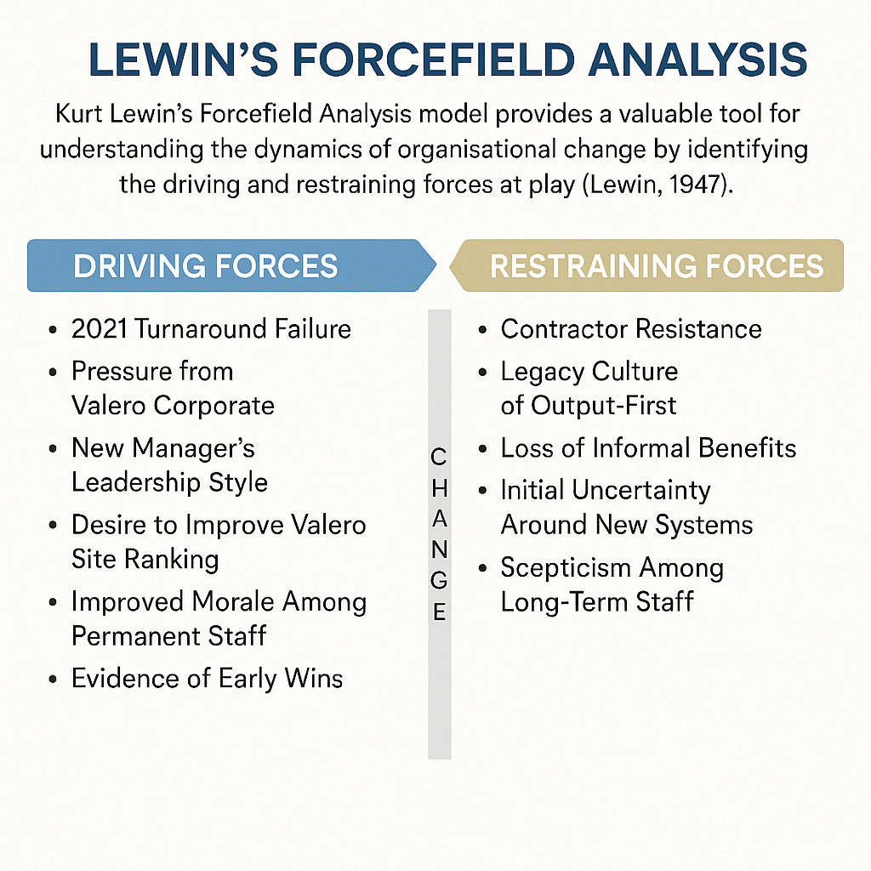
Figure 1. Adapted diagram of Lewin's forcefield analysis (Mullins, 2016)

Driving forces
2021 Turnaround Failure
- The turnaround exceeded the planned duration and went over budget. This created an immediate urgency for structural reform.
Pressure from Valero Corporate
- Headquarters were disappointed with Pembroke Refinery's performance. A change in leadership was required to restore credibility and performance.
New Manager’s Leadership Style
- The new manager brought a structured KPI driven and environmentally aware approach. This was a stark contrast to the previous output maximising culture.
Desire to Improve Valero Site Ranking
- Pembroke Refinery’s rating was low in comparison to the other 13 refineries, which was a motivating factor for leadership and staff to improve performance.
Improved Morale Among Permanent Staff
- The new leadership style brought clearer expectations due to better planning and a less reactive working environment. This led to an improved work-life balance.
Evidence of Early Wins
- The refinery started to hit targets, such as schedule compliance, budget adherence and flaring reduction. This, in turn, reinforced the belief that the new approach worked.

Restraining forces
Contractor Resistance
- The move to reduce overtime was met with resistance from the contract workers. This meant a loss of earnings and caused some to leave and find work elsewhere.
Legacy Culture of Output-First
- Longstanding habits were hard to shift. This made the move towards stringent KPI driven leadership hard to accept.
Loss of Informal Benefits
- Workers were used to a culture where overruns and emergency jobs meant extra money in the form of overtime. The contract employees were unhappy about losing this additional money.
Initial Uncertainty Around New Systems
- At first, the new systems, like time-on-tools, weren't always used correctly. Frustration and non-compliance were the result.
Scepticism Among Long-Term Staff
- Some people did not think the new system would produce better results. While others, accustomed to the former manager's methods of operation, were hesitant to trust that it would work.
The model developed by Lewin (1947) offers a useful foundation for comprehending organisational forces. However, its simplicity has drawn criticism. Hughes (2010) argues that it can undervalue the dynamic and emerging nature of organisational culture. Furthermore, during the implementation stage, results may be impacted by informal networks of influence and ongoing change, which are not fully considered.

Kotter’s 8-Step Change Model
John Kotter (2012) is a renowned leader in change management and a professor at Harvard Business School. His most well-known contribution to organisational change management is the eight-step Change Model. Although not officially used, the new manager's strategy was quite similar to Kotter's eight-step Change Model (Kotter, 2012).
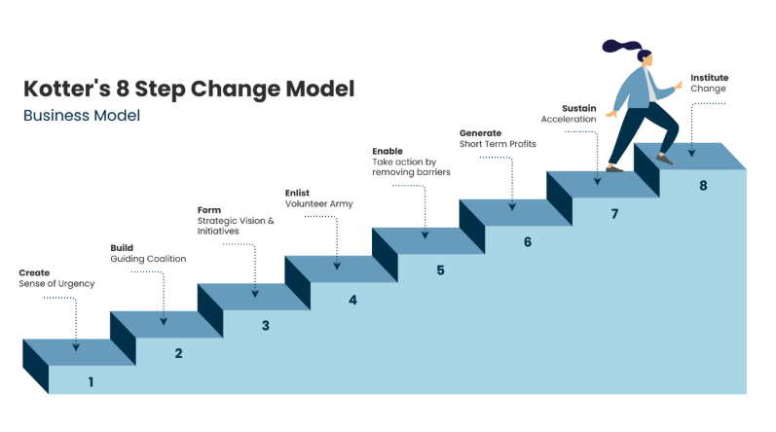
Figure 2. Kotter's 8-Step Change Model (Visual Paradigm Online, 2025).

Step 1: Create a Sense of Urgency
Kotter (2012) emphasises that establishing a sense of urgency is the first step in a successful change. This step is important because it helps break complacency while motivating stakeholders to take action. The failed 2021 turnaround was more expensive and took longer than expected. This highlighted serious issues with efficiency and cost control, which increased the urgency. As a result, headquarters understood that change was necessary.
Step 2: Build a Guiding Coalition
According to Kotter (2012), building a guiding coalition involves forming a powerful group that supports and leads the change effort. The coalition is required as it brings together a diverse set of skills and authority. This helps ensure credibility and support across the organisation. A new Refinery Manager was appointed with a mandate to improve performance. This leadership change reflected a broader coalition at the top. The headquarters were committed to driving a new direction. They wanted Pembroke Refinery to mirror the culture and procedures used in American refineries.
Step 3: Form a Strategic Vision and Initiatives
Kotter (2012) states that forming a strategic vision helps clarify how the future will differ from the past. The initiatives outline how to achieve the vision. The new manager introduced a strategic shift. He moved the refinery away from prioritising maximum output and instead focused on meeting KPI’s and staying within budget. This vision guided all the following decisions and changes.
Step 4: Enlist a Volunteer Army
Creating a volunteer army involves motivating a large group of people to drive the change. Kotter (2012) stresses that change initiatives are more successful when there is support from enthusiastic employees and the leadership who share the same vision. Most permanent staff accepted the new direction with minimal resistance. However, some contract workers were frustrated by reduced overtime opportunities and chose to leave. Overall, the workforce supported the change.
Step 5: Enable Action by Removing Barriers
Kotter (2012) clarifies that obstacles to change must be removed. This often involves changing systems, structures, or practices that undermine the vision. Process reforms and cultural shifts addressed barriers to change. These included improved planning and schedule compliance and a more disciplined and stringent stance on cost control.
Initial uncertainty following the leadership shift was confusing. Future changes should be supported by consistent communication through briefings, email updates, and Q&A forums. Clear messaging reduces anxiety and helps staff understand the rationale behind change (Cameron and Green, 2019).
Step 6: Generate Short-Term Wins
According to Kotter (2012), generating short-term wins helps build momentum and demonstrates the value of the change. Early successes validate the new approach and motivate continued effort. The 2024 turnaround was completed on time and within budget. This early success validated the new approach and demonstrated the effectiveness of the new leadership and process changes.
Step 7: Sustain Acceleration
Kotter (2012) stresses the importance of building on early successes to maintain momentum. Sustaining acceleration involves implementing new systems and reinforcing practices that align with the vision. Following the successful turnaround, the organisation reinforced new working methods and expectations. The staff embraced the changes, showing the new change's momentum.
Step 8: Institute Change
According to Kotter (2012), the final step involves embedding new practices into the organisational culture. Change becomes sustainable when it becomes the new norm. The changes became embedded in the refinery’s culture and day-to-day operations, normalising cost control and performance expectations.
The success of the new approach depends on consistency. Supervisors should receive training in change leadership, employee engagement, and performance management. This is currently happening at Valero Pembroke. It will help sustain the cultural shift (Day et al., 2014).
Kotter’s (2012) model has been critiqued for assuming a linear progression through its stages. Burnes (2017) notes real-world change processes are often more iterative and unpredictable, particularly in high-risk industries. Furthermore, Kotter (2012) does not fully address informal power dynamics or resistance arising from cultural inertia. These limitations should be considered when applying the model in practice.

Motivation and Leadership during organisational change
Motivation is a key component when managing organisational change, as it influences how employees respond to new expectations. At Pembroke Refinery, the leadership change revealed differences regarding motivation between permanent and contract staff. By applying established motivational theories such as Herzberg’s Two-Factor Theory (1959), Maslow’s Hierarchy of Needs (1954), and Vroom’s Expectancy Theory (1964), we can help explain the varied responses.
Herzberg’s Two-Factor Theory
Herzberg (1959) identifies two types of workplace factors: motivators, which increase job satisfaction, and hygiene factors, which, if absent, lead to dissatisfaction. The new management approach at Pembroke addressed motivators for permanent staff by setting clear KPI’s and offering recognition through structured planning. Reduced overtime stresses, improved hygiene factors, and enhanced job satisfaction.
In contrast, contract workers were negatively affected by the loss of overtime pay. This extra pay had previously acted as both a financial incentive and a form of recognition. Removing this key hygiene factor led to dissatisfaction and reduced motivation, as predicted by Herzberg (1959). Mullins (2016) supports this view, noting that changes in financial stability can disrupt morale, particularly among vulnerable staff.
The removal of overtime disproportionately affected contractors. Management could have introduced structured engagement, such as surveys, listening sessions, and fair performance-based incentives. This would have retained talent and minimised resistance (Abdalla et al., 2023).
Maslow’s Hierarchy of Needs
Maslow (1954) argues that employees are motivated to fulfil basic needs ranging from physiological requirements to self-actualisation. Permanent staff saw their esteem needs met through improved planning and reduced stress. The structured approach aligned with their desire for stability and growth.
However, contract workers faced a different reality. Reduced overtime affected their financial security, which hindered the fulfilment of basic needs. According to Maslow (1954), employees struggle to focus on higher-level goals when fundamental needs are unmet. This explains why contractors felt demotivated when their priority was financial stability.
Mullins (2016) highlights that motivation varies across workforce groups and that effective leadership requires understanding these differences. The failure to address the contractor’s financial concerns at Pembroke led to disengagement.
Vroom’s Expectancy Theory
Vroom (1964) states that motivation depends on the link between effort, performance, and reward. The new approach clarified this connection for permanent staff. Improved performance led to recognition and job security. This alignment increased their motivation to engage with structured planning.
Conversely, contractors perceived a broken link between effort and reward. Previously, overtime had represented a direct payoff for extra effort. Once the overtime was reduced, the value of increased effort diminished, ultimately leading to decreased motivation. Mullins (2016) notes that when employees perceive that effort does not reap rewards, their commitment declines.
Different factors motivate permanent and contract staff. According to Mullins (2016) and Herzberg (1959), motivation strategies should be tailored. This could be achieved by using recognition and growth for permanent staff. Moreover, contractors could receive rewards and clarity regarding work expectations (Mullins, 2016).
Leadership and Cultural Shift
The leadership transition at Pembroke reflects a shift from a transactional to a transformational style. The former manager’s transactional approach focused on short-term output through overtime incentives. While the new manager adopted a transformational style, by promoting structured planning and long-term cultural change.
Bass and Avolio (1964) describe transformational leadership as fostering motivation through vision setting and engagement rather than short-term incentives. Permanent staff responded positively, as they felt more involved and appreciated. However, the contractors were accustomed to transactional rewards. Because of this, they struggled to adapt to the new culture.
Mullins (2016) suggests that successful leadership during change requires balancing structure with flexibility. This is particularly true when managing diverse staff needs. At Pembroke, the transformational approach improved long-term morale among permanent workers but failed to address the contractors' financial concerns, leading to resistance.

Conclusion
The organisational change at Pembroke Refinery demonstrates how leadership transformation can reshape operational culture, improve performance, and address long-standing issues. The new manager restored stability and focus by shifting from an output-first mindset to a structured KPI-driven model.
Lewin’s Forcefield Analysis helped show the main reasons for and against the change. The failed 2021 turnaround made the need for change clear. Pressure from the company headquarters and a new leadership approach added to this. Together, they helped overcome resistance. Kotter’s 8-Step Model (2012) was not used officially, but the steps were followed in practice. This helped lead to a successful turnaround in 2024.
Success should be measured beyond just schedule and cost. Metrics such as staff retention, nonattendance, morale surveys, and safety performance can provide a broader view of the change's effectiveness. A balanced scorecard could help track these metrics (Kaplan and Norton, 1996).
To maintain the gains, the refinery should concentrate on contractor participation, enhanced communication, and customised motivational techniques. Training frontline leaders and using a comprehensive approach to monitoring progress will further support the transformation.
To ensure long-term sustainability, focus should be on a few post-change actions. These should be structured planning sessions, KPI workshops, and leadership training embedded into routine operations. These actions will help reinforce the new culture and prevent regression into previous habits (Mugenyi et al., 2022).
Ultimately, this case study illustrates how difficult organisational transformation can be. Structural reform alone is not enough for success. It involves interacting with people and learning about their motivations. The goal is to create a culture that encourages sustained progress.

Bibliography
Abdalla, A., Li, X., Song, Z. and Yang, F. (2023). Incentive mechanisms for managing local subcontractors in international construction projects. Journal of project management, 8(4), pp.239–252. doi: https://doi.org/10.5267/j.jpm.2023.6.002. [Accessed 15 Apr. 2025].
Appelbaum, S.H., Habashy, S., Malo, J. and Shafiq, H. (2012). Back to the future: Revisiting Kotter’s 1996 Change Model. Journal of Management Development, [online] 31(8), pp.764–782. doi: https://doi.org/10.1108/02621711211253231. [Accessed 18 Apr. 2025].
Bass, B.M. and Avolio, B.J. (1994). Improving Organizational Effectiveness Through Transformational leadership. Thousand Oaks, California: Sage.
Burnes, B. (2017). Managing Change. 7th ed. Harlow: Pearson Education Limited.
Cameron, E. and Green, M. (2019). Making Sense of Change Management: a Complete Guide to the models, Tools and Techniques of... Organizational change. 5th ed. S.L.: Kogan Page.
Day, D.V., Fleenor, J.W., Atwater, L.E., Sturm, R.E. and McKee, R.A. (2014). Advances in Leader and Leadership development: a Review of 25 Years of Research and Theory. The Leadership Quarterly, [online] 25(1), pp.63–82. Available at: https://www.sciencedirect.com/science/article/pii/S1048984313001197. [Accessed 20 Apr. 2025].
Herzberg, F. (1959). The Motivation to Work. 2nd ed. New York: John Wiley & Sons.
Hughes, M. (2010). Managing Change: A Critical Perspective. 2nd ed. London: Chartered Institute Of Personnel And Development.
Jango, J. (2024). Leadership and Management of change: Introduction to Navigating Organizational Change. EuroMed journal of management, 6(1). doi: https://doi.org/10.1504/emjm.2024.10060497. [Accessed 10 Apr. 2025].
Kaplan, R.S. and Norton, D.P. (1996). The Balanced Scorecard: Translating Strategy into Action. Harvard: Harvard Business Review Press.
Karasek, R. and Theorell, T. (1990). Healthy work : stress, productivity, and the reconstruction of working life. New York (N.Y): Basic Books.
Kotter, J.P. (2012). Leading Change. Boston, Massachusetts: Harvard Business Review Press.
Lewin, K. (1947). Frontiers in Group Dynamics: Concept, Method and Reality in Social Science; Social Equilibria and Social Change. Human Relations, [online] 1(1), pp.5–41. doi: https://doi.org/10.1177/001872674700100103. [Accessed 22 Apr. 2025].
Lewin, K. (1951). Field Theory in Social Science. New York : Harper.
Maslow, A.H. (1954). Motivation and Personality. New York: Harper & Row.
McLaughlin, K. (2022). Coronavirus’ Business Impact: Evolving Perspective. [online] www.mckinsey.com. Available at: https://www.mckinsey.com/capabilities/risk-and-resilience/our-insights/covid-19-implications-for-business. [Accessed 16 Apr. 2025].
Mugenyi, A.R., Karemera, C., Wesana, J. and Dooms, M. (2022). Institutionalization of Organizational Change Outcomes in Development Cooperation Projects: The Mediating Role of Internal Stakeholder Change-Related Beliefs. Administrative Sciences, 12(2), p.60. doi: https://doi.org/10.3390/admsci12020060. [Accessed 21 Apr. 2025].
Mukhlis, M. and Tyas, A.A.W.P. (2024). The Role of Change Management in Improving Organizational Performance. Jurnal Ilmiah Manajemen Kesatuan, [online] 12(3), pp.773–782. doi: https://doi.org/10.37641/jimkes.v12i3.2606. [Accessed 17 Apr. 2025].
Mullins, L.J. (2016). Management and Organisational behaviour. 11th ed. Harlow: Ft Prentice Hall.
Nadler, D. and Tushman, M. (1997). Competing by design: the power of organizational architecture. New York: Oxford University Press.
Onyekwere, L.A., Ogona, I.K. and Ololube, N.P. (2023). Leadership and Management of Change in Organizations. South Asian Research Journal of Humanities and Social Sciences, [online] 5(03), pp.96–106. doi: https://doi.org/10.36346/sarjhss.2023.v05i03.012. [Accessed 25 Apr. 2025].
Shah, N. (2023). A Literature Review on Leadership Style and Organizational Change Management. ResearchGate, [online] 2(2). Available at: https://www.researchgate.net/publication/376200883_A_Literature_Review_on_Leadership_Style_and_Organizational_Change_Management [Accessed 9 May 2025].
Valero (2025). Valero | Advancing the Future of Energy. [online] www.valero.com. Available at: https://www.valero.com/. [Accessed 20 Apr. 2025].
Visual Paradigm Online (2025). Kotter’s 8 Step Change Business Model | infoart.templates.kotters-change-model.type-name Template. [online] Visual-paradigm.com. Available at: https://online.visual-paradigm.com/ja/infoart/templates/kotters-change-model/kotters-8-step-change-business-model/ [Accessed 27 Apr. 2025].
Vroom, V.H. (1964). Work and motivation. New York: John Wiley & Sons. [Accessed 27 Apr. 2025].

