BEng ELECTRONICS AND ELECTRICAL ENGINEERING

ELECTRONIC SYSTEMS DESIGN
ASSIGNMENT

SAMIH ALTIGANY

Table of Contents
Introduction 4
Literature review 4
Temperature and humidity sensor 5
The selected temperature and humidity sensor 6
Wind speed sensor options 6
The selected wind speed sensor 7
Wind direction sensor options 7
Wind direction sensors 8
The air bone particle sensor 9
The selected air bone particle sensor 9
VOC level sensor 10
ams IAQ-CORE C, Air Quality Sensor 10
GPS position sensor 10
SAM-M8Q Qwiic 10
Ublox NEO-6M GPS module 10
The sunlight brightness sensor 11
The selected brightness sensor 11
The UV level sensor 12
GUVA-S12SD 12
The selected UV sensor 12
VEML6070 UV 12
The LED selection 12
Memory sizing and structure considerations 13
The SD card memory structures 13
The memory sizing 13
Microcontroller specifications 14
ROM size approximation 14
RAM size approximation 14
CPU speed approximation 15
Number of pins 15
Minimum specifications 15
Microcontroller selection 16
Voltage regulator 16
Voltage regulator selection 16
The available options for the battery 17
Connectors selection 18
The case options 18
The selected case 19
The push button options 19
The selected pushbutton 20
The SD card header 20
The operational flowchart 21
The operational schematic design 21
Power nets 21
Addressable I2C sensors 22
Non- addressable I2C sensors 23
The analogue sensors 23
The SD card 24
USB and RS232 24
PCB schematics 25
The pricing lists 27
Design improvement suggestions 28
References 29

Introduction
This report illustrates and details a literature review of the different types of weather stations available in the market highlighting the important specifications and aspects of each weather station.
In addition, it details the design process of a microcontroller-based weather logger in order to collect data of the temperature, humidity, wind speed, wind direction, air bone particles count, sunlight brightness, UV level, GPS position, VOC level.
The design is required to include a USB port to read the data stored in the non- volatile memory, also the design has to be portable and adaptable and has its own battery, and an LED flashes every 10 seconds for 1 second indicating the operation of the weather logger.

Literature review
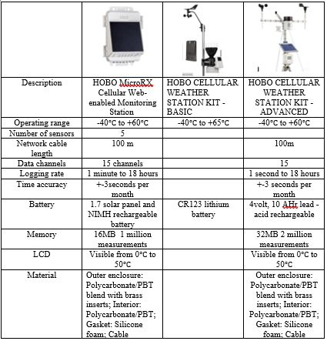
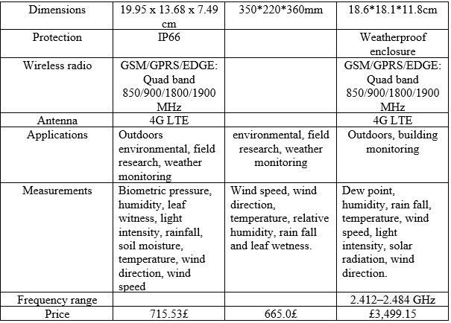Table1: highlights different types of weather stations [1]

Temperature and humidity sensor
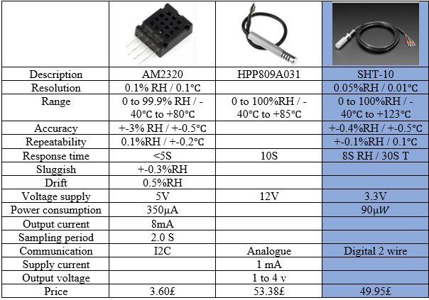Table2: highlights different types of humidity and temperature sensors [2] [3] [4]

The selected temperature and humidity sensor
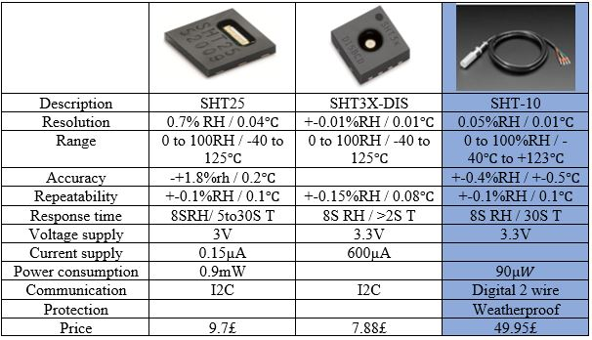Table3: highlights different types of IC humidity and temperature sensors [5] [5] [4]

Wind speed sensor options
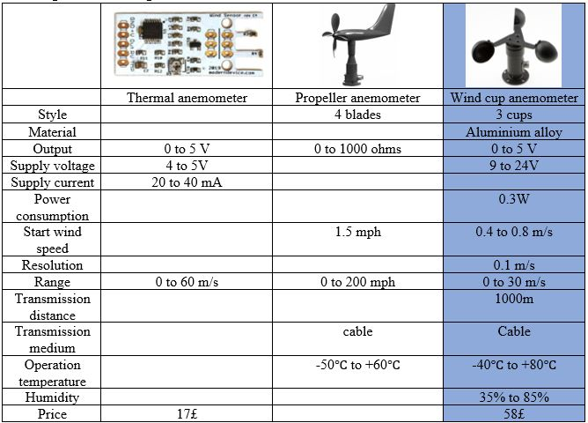Table4: highlights different types wind speed sensors [6][49] [7]

The selected wind speed sensor
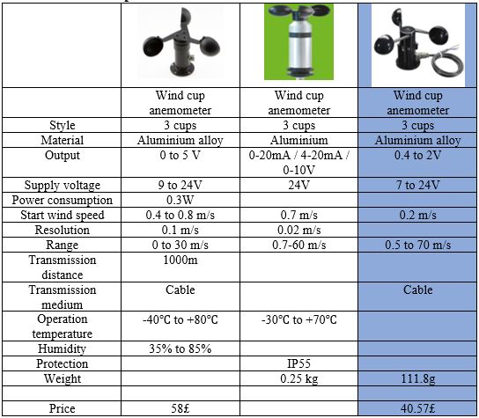
Table5: highlights the selected wind speed sensors [6] [8] [9]

Wind direction sensor options
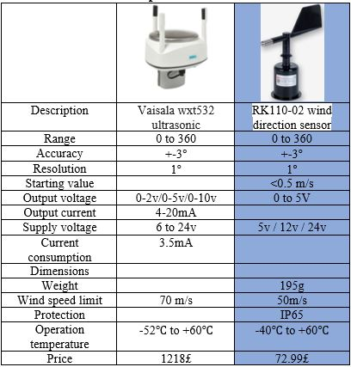
Table 6: highlights the types of wind direction sensors [48] [11]

Wind direction selected sensor
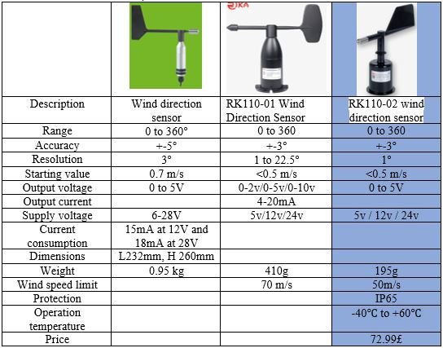
Table 6: highlights the selected wind direction sensors [10] [11] [11]

The air bone particle sensor
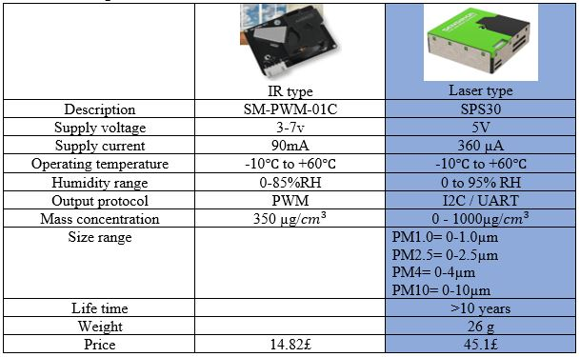 Table 7: highlights the different types of air bone particle sensors [12] [13]

The selected air bone particle sensor
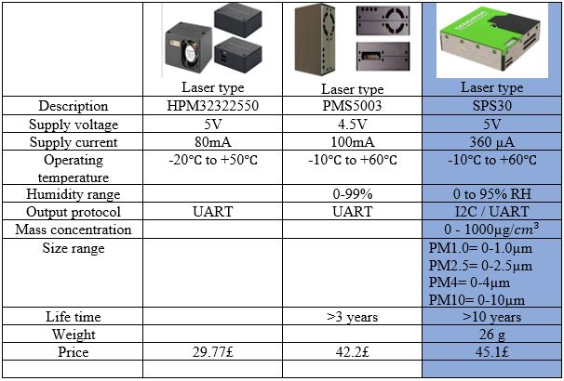Table 8: highlights the selected air bone particle sensor [12] [12] [13]

VOC level sensor
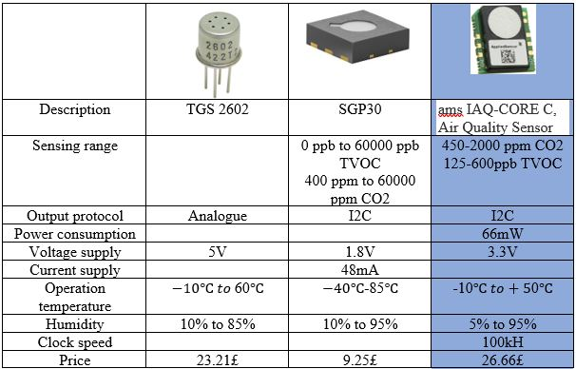Table 9: highlights the selected air quality sensor [14]

GPS position sensor
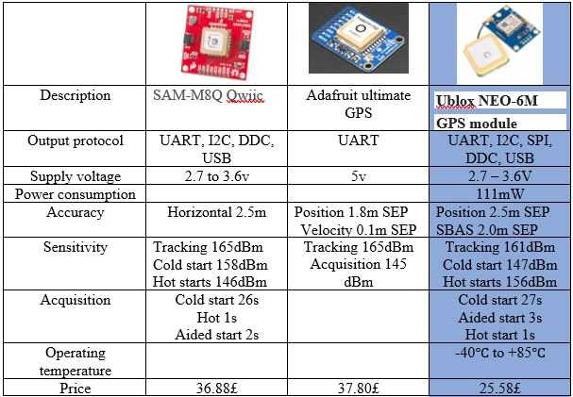Table 10: highlights the selected GPS position sensor [15] [16] [17]

The sunlight brightness sensor options
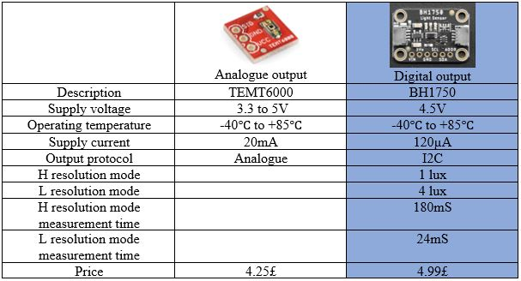Table 11: highlights the selected GPS position sensor [18] [19]

The selected brightness sensor
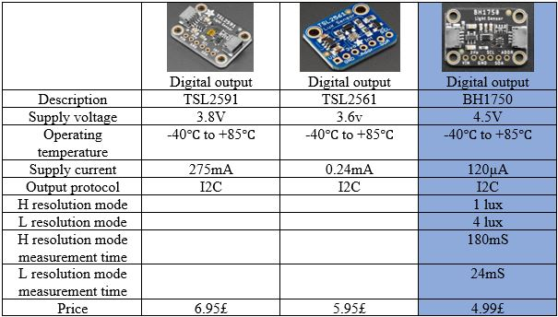Table 12: highlights the selected brightness sensor [19]

The UV level sensor
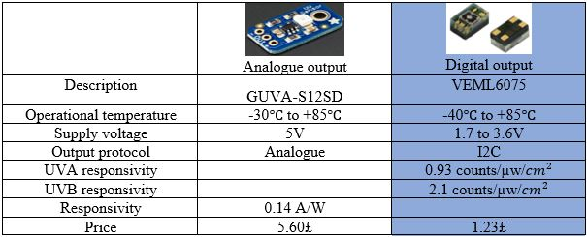Table 13: highlights the types of UV sensor [20] [21]

The selected UV sensor
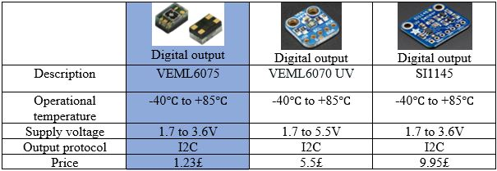Table 13: highlights the selected UV sensor [21] [22] [23]

The LED selection
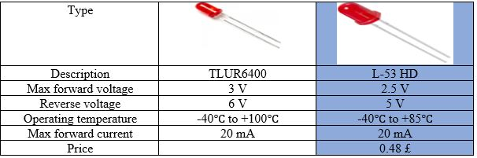Table 14; highlights different types of LEDs and the selected one [24] [25]

Memory sizing and structure considerations

 | Logging rate | Number of bits | A/D conversion depth | Signal | Memory size
Temperature | 1/10S | 12bits | N/A | Digital | 2bytes
Humidity | 1/10S | 14bits | N/A | Digital | 2bytes
Wind speed | 1/10mS | 8bits | 8bits | Analogue | 1byte
Wind direction | 1/10mS | 8bits | 8bits | Analogue | 1byte
Air bone particle counter | 1/S | 2bytes | N/A | Digital | 2bytes
VOC level | 1/10mS | 4bytes | N/A | Digital | 4bytes
GPS position | 1/14days | 100bytes | N/A | Digital | 100bytes
Sun light Brightness | 1/S | 2bytes | N/A | Digital | 2bytes
UV level | 1/S | 2bytes | N/A | Digital | 2bytes
Table 15; highlights the design specifications

The SD card memory structures
Time mS | GPS | temperature | Humidity | Particle counter | Brightness | UV level | VOC level | Wind direction | Wind speed
0mS
10
20
30
40
50
60
70
80
1
2
3
4
6
8 sec
10 s
Table 16; demonstrates the memory structure

The memory sizing

 | Memory for one reading | Logging rate | Number of readings in a record | Memory for a record
Temperature | 2 bytes | 1/10S | 1 | 2 bytes
Humidity | 2 bytes | 1/10S | 1 | 2 bytes
Wind speed | 1 byte | 1/10mS | 1000 | 1000 bytes
Wind direction | 1 byte | 1/10mS | 1000 | 1000 bytes
Particle counter | 2 bytes | 1/S | 10 | 20 bytes
VOC | 4 bytes | 1/10mS | 1000 | 4000 bytes
GPS | 100 bytes | 1/14days | 1 in 14 days | 100 bytes out of the record
Brightness sensor | 2 bytes | 1/S | 10 | 20 bytes
UV sensor | 2 bytes | 1/S | 10 | 20 bytes
total |  |  |  | 6164 bytes / 10second
Table 17; demonstrates the process of memory sizing
For the time duration of 14 days, it requires 745,597,440 bytes which is nearly 800 Mbytes.

Microcontroller specifications

ROM size approximation
The size of the programme memory could be determined by checking the size of a similar programme been written already such as 4KB, and as a rule of thumb the size has to be doubled twice to get extra overhead allowances which yield in 16KB.

RAM size approximation
 | Memory for one reading
Temperature | 2 bytes
Humidity | 2 bytes
Wind speed | 1 byte
Wind direction | 1 byte
Particle counter | 2 bytes
VOC | 4 bytes
GPS | 100 bytes
Brightness sensor | 2 bytes
UV sensor | 2 bytes
total | 16 bytes
Table 18; demonstrates the memory size of the readings in the RAM

The RAM deals with the temporary files such as reading the inputs and executing the outputs, which in this case roughly 20 bytes inputs excluding the GPS reading as it happens before the record as shown on the table above assuming that all the readings happen at the same time with the same speed which is the speed of the fasted reading 1/10mS, therefore, to execute the programme, read the inputs, write them on the SD card and prepare for the next reading this will take 20*4=80 bytes round it up to 100 bytes.
For more allowances, as a rule of thumb, the approximate RAM size has to be doubled twice ending in 400 bytes which is enough for the GPS reading as well.

CPU speed approximation
PIC microcontroller has quadrature architecture which means it take 4 clock cycles to execute one instruction and in order to select the input, read the value, convert it then store it in the SD card, this could take 20 instructions five for each step.
Assuming that all the 9 readings happen at the same time with the same speed which is the speed of the fasted reading 1/10mS, therefore, this yields nearly 100 readings per second and 10*100 readings per second for all the parameters which is 1000 readings per second.
As every reading takes 20 instructions, therefore, 1000 readings take 1000*20 which is 2,0,000 instructions per second, and as every instruction takes 4 clock cycles, then it will take 4*20,000 which is 80,000 clock cycles which is 80 KHZ processor and as a rule of thumb for more allowances, the approximate CPU size has to be doubled twice ending in 320KHZ. But as the CPU speed in PIC microcontroller is in MHZ, then the speed will be rounded up to 4 MHZ which is the minimum available.

Number of pins
 | Number of signal pins
Temperature & humidity | 2
Particle sensor | 2
VOC sensor | 2
GPS sensor | 2
Brightness sensor | 2
UV sensor | 2
Wind speed | 1
Wind direction | 1
USB module | 3
RS232 module | 2
SPI | 3
Start button | 1
Digital tell | 1
power | 1
Ground | 1
Total | 24 pins
Table 19; demonstrates the number of pins required

Minimum specifications
USB | SPI | UART | I2C | ADC inputs | ADC resolution | RAM | ROM | CPU speed | Pin count
1 | 1 | 1 | 1 | 2 | 8 | 400 bytes | 16 KB | 4 MHZ | 24
Table 20; demonstrates the minimum microcontroller required

Microcontroller selection
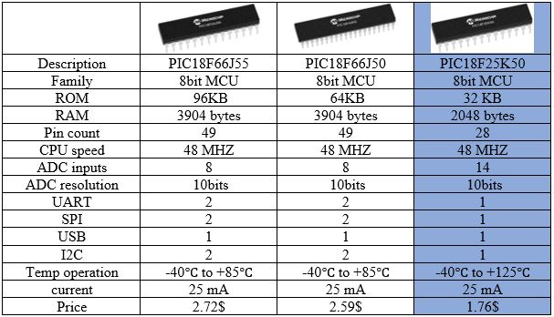Table 21; highlights the different specifications of microcontrollers and the selected one [26]

Voltage regulator

Component | Supply voltage | Supply current | Interface
Temperature & humidity sensor | 2.4 – 3.3 – 5.5V | 1mA | I2C
Wind speed sensor | 7-24V | 10mA | Analogue 0.2-2V
Wind direction sensor | 5, 12-24V | V/500=10mA | Analogue 0-5v
Particle counter sensor | 4.5 - 5 - 5.5 V | 360 µA | I2C, UART
VOC sensor | 3.3V | 20mA | I2C
GPS | 2.7 to 3.6 V | 22µA | I2C, UART, SPI, USB
Brightness sensor | 2.4-3-3.6V | 190 µA | I2C
UV sensor | 1.71 – 3.6V | 480µA | I2C
LED | 2.5V | 25mA
Controller | 5V | 25mA
Total |  | 101.052 mA
Table 23; demonstrates the voltage and current consumption of the circuit
From the table it is clear the highest voltage required for the circuit is 7 volts, therefore, the voltage regulator has to be 12V voltage regulator.

Voltage regulator selection

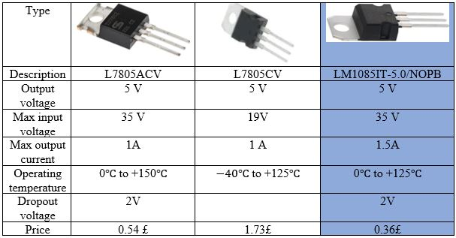Table 24; highlights the different types of 5V voltage regulators and the selected one [27] [28] [27]

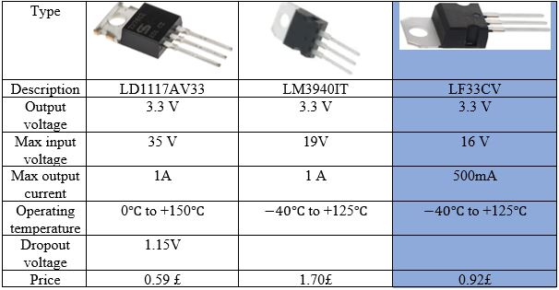Table 24; highlights the different types of 3.3V voltage regulators and the selected one [28]

The available options for the battery
From table [] the highest voltage is 7V and the total current supply is 101.052 mA, therefore, in order to power the circuit for 14 days which is 336 hours, the power calculation will be as follows (102*336) + (102*336)*50%= 51,408 mAh at least.

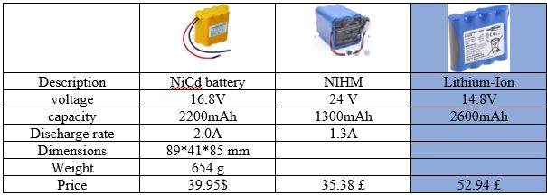Table 25; highlights the different types of batteries and the selected type [29] [30] [31]

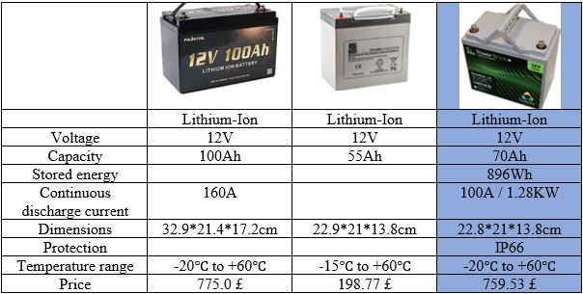Table 26; highlights the selected battery [32] [33] [34]

Connectors selection

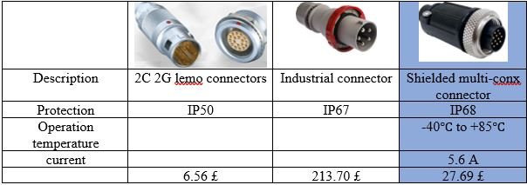Table 27; highlights the different types of connectors and the selected type [35] [36] [37]

The case options

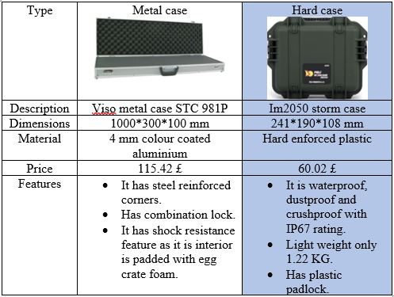Table 10; highlights the key differences between types of cases [38] [39]

The selected case
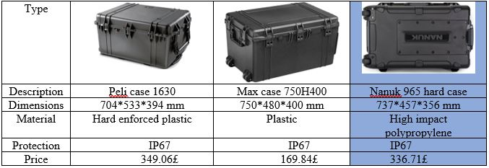Table 11; highlights the different cases and the selected type [40] [41] [42]

The push button options

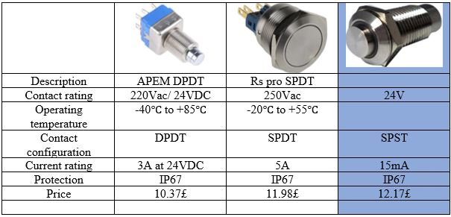Table 30; highlights the different types of push buttons available [43] [44] [45]

The selected pushbutton

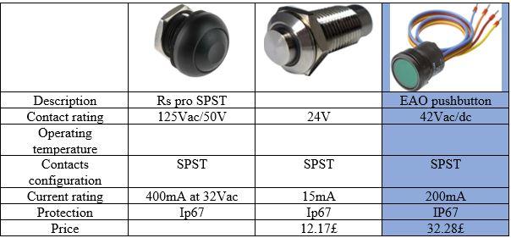Table 30; highlights the selected push button [46] [47]

The SD card header
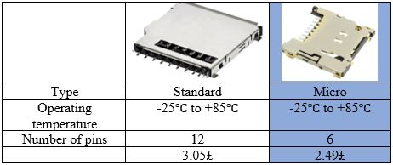
Table 3; highlights the selected push button [50]

The operational flowchart
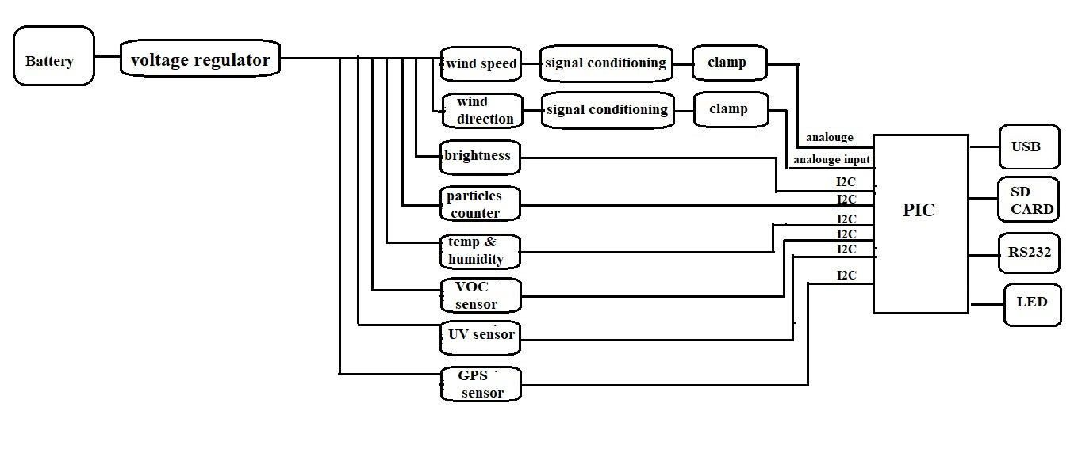

The operational schematic design

Component | Supply voltage | Output
Temperature & humidity sensor | 2.4 – 3.3 – 5.5V | I2C
Wind speed sensor | 7-24V | Analogue 0.2-2V
Wind direction sensor | 5, 12-24V | Analogue 0-5v
Particle counter sensor | 4.5 - 5 - 5.5 V | I2C, UART
VOC sensor | 3.3V | I2C
GPS | 2.7 to 3.6 V | I2C, UART, SPI, USB
Brightness sensor | 2.4-3-3.6V | I2C
UV sensor | 1.71 – 3.6V | I2C
LED | 2.5V
Controller | 3.3V
Table 30; demonstrates the inputs and outputs for all the sensors

Power nets
12V | 5V | 3.3V
Wind speed | Wind direction | Microcontroller
 | Particle sensor | Temp & humidity
 |  | UV sensor
 |  | VOC sensor
 |  | GPS sensor
 |  | Brightness sensor

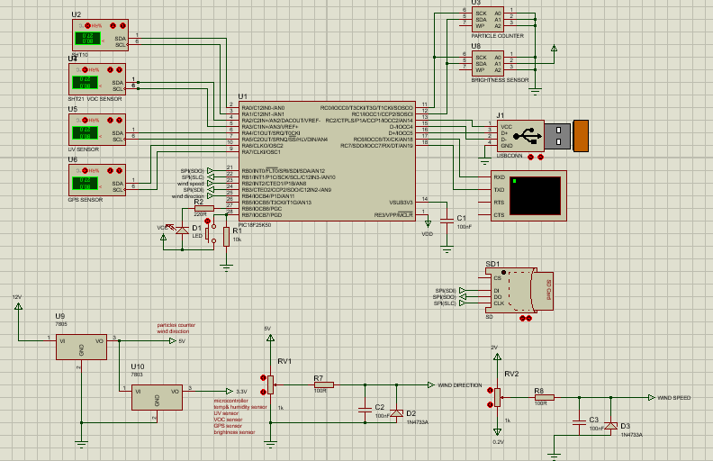

Addressable I2C sensors
The brightness sensor and the air bone particle counter are addressable I2C sensors where the particle counter should always be on address zero (0x00), and the brightness sensor could be on address two or three, therefore they were connected together directly to the microcontroller through I/O pins as follows where the brightness sensor addressed on address two.
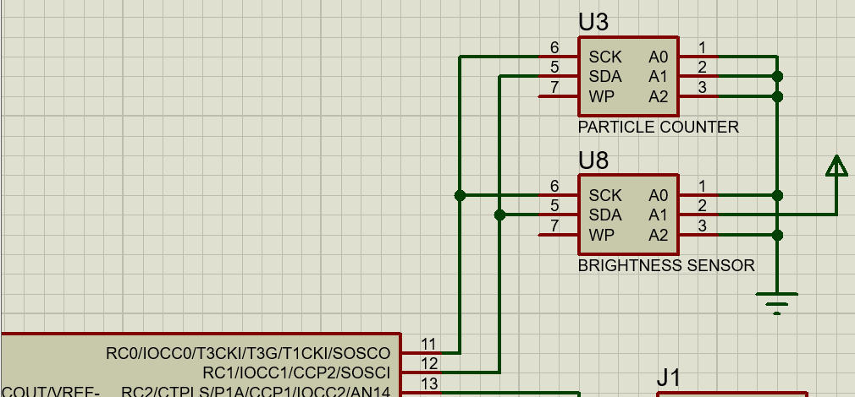

Non- addressable I2C sensors
The temperature and humidity sensor, the VOC sensor, the UV sensor and the GPS position sensor are non-addressable I2C devices connected directly to the microcontroller through I/O pins
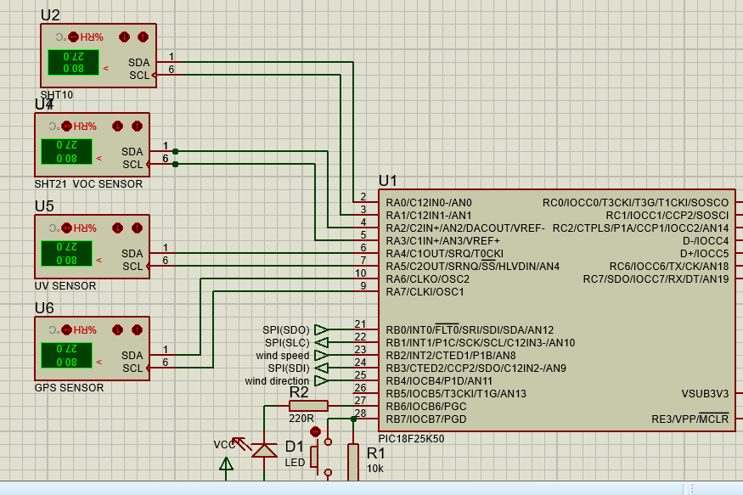

The analogue sensors
The wind direction and the wind speed sensors are analogue devices connected to the microcontroller through analogue pins and the signal goes through a clamp to avoid current overshoot.
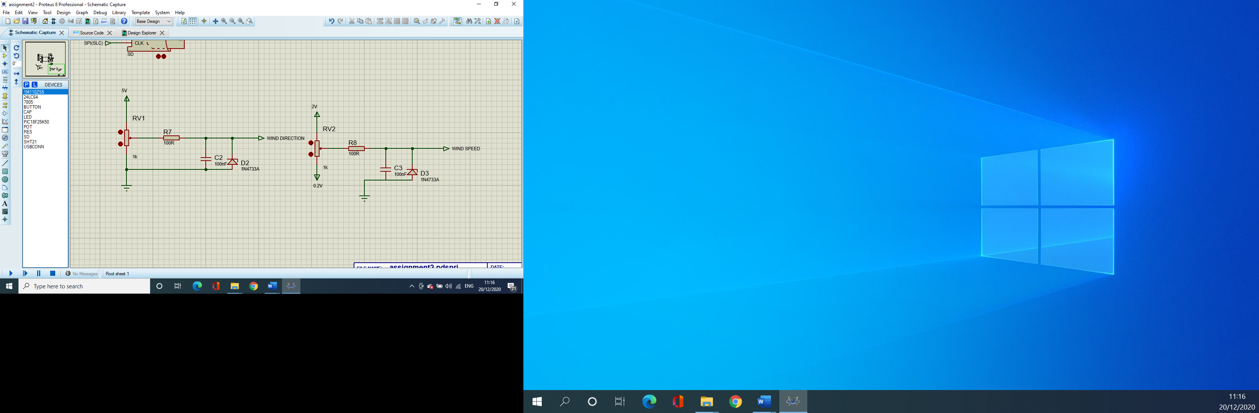

The SD card
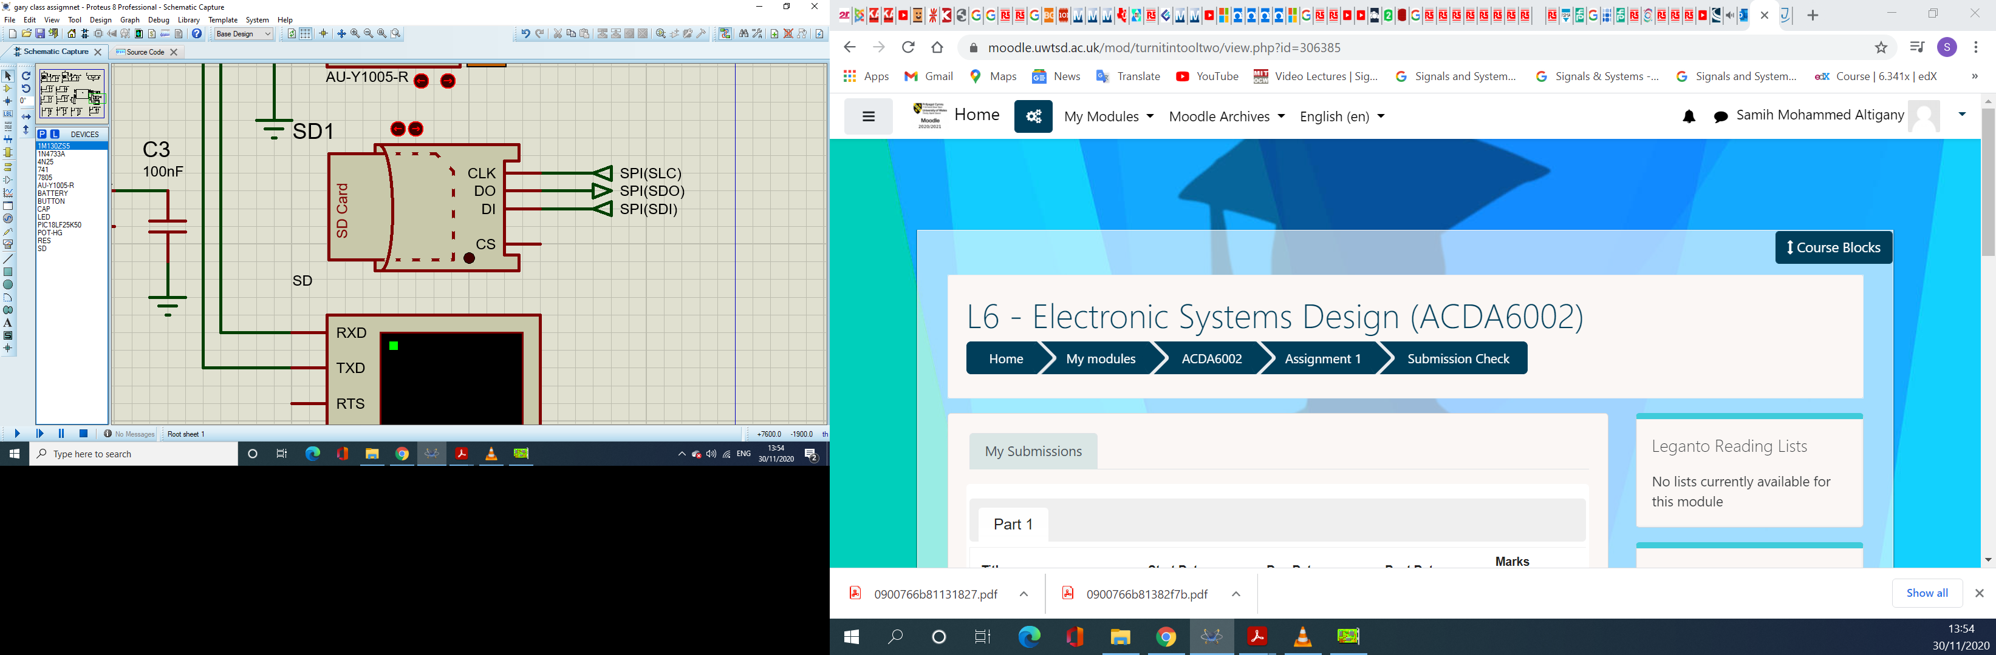
Using SPI protocol, the USB is connected to the microcontroller where the DO pin on the USB module is connected to SDI “serial data in” on the controller and DI “data in” pin on the USB module is connected to DO “data out pin” on the controller.

USB and RS232
RS232 connector is connected by connecting Rx on the connector to Tx on the controller and Tx on the connector to Rx on the connector, which is the same as the USB module by connecting D+ to D- and D- to D+.
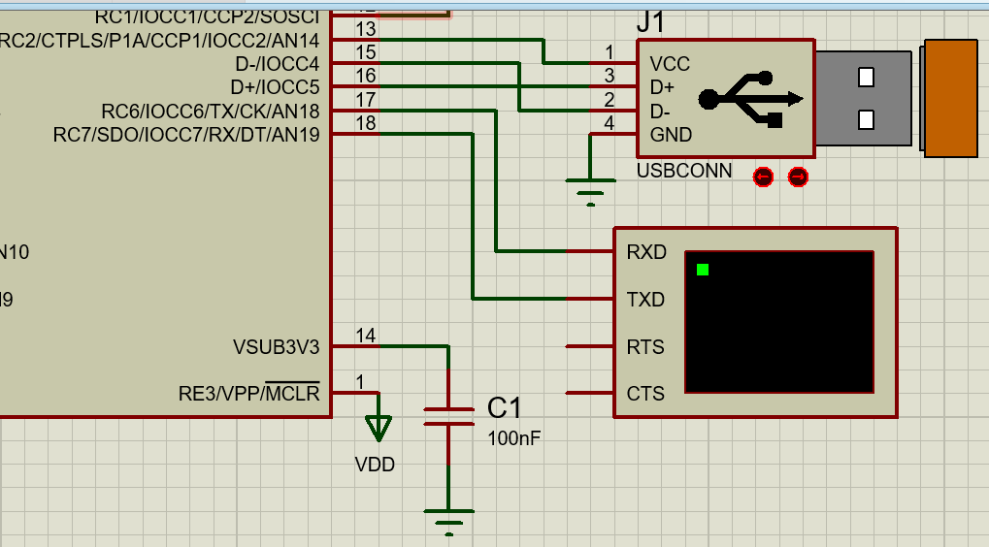

PCB schematics
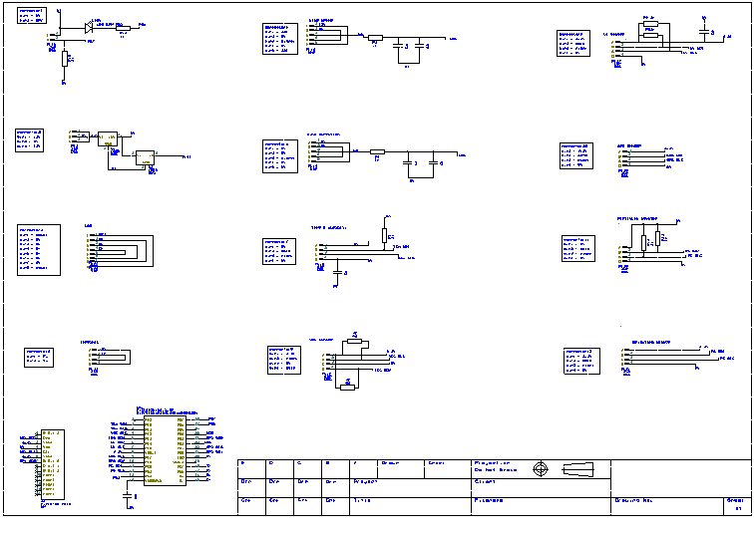
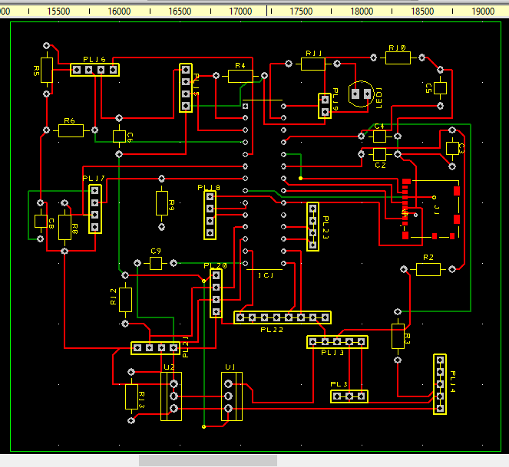
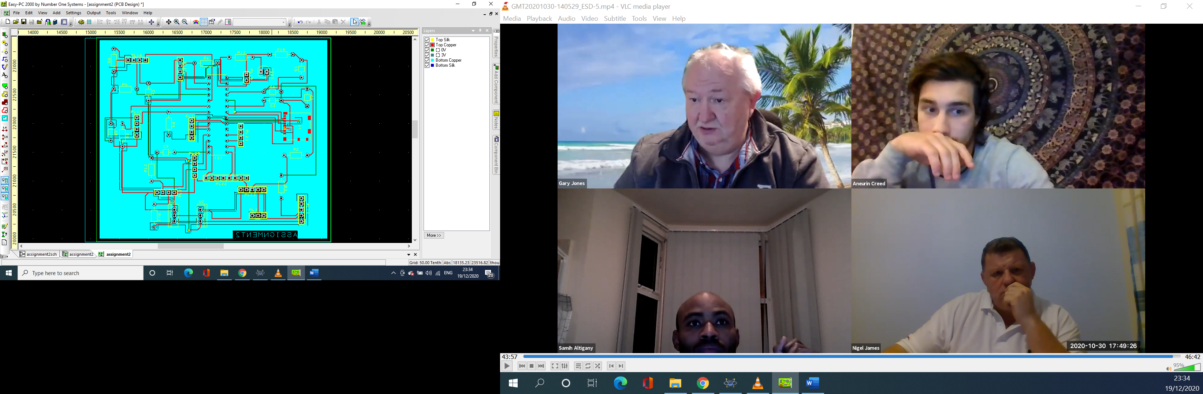

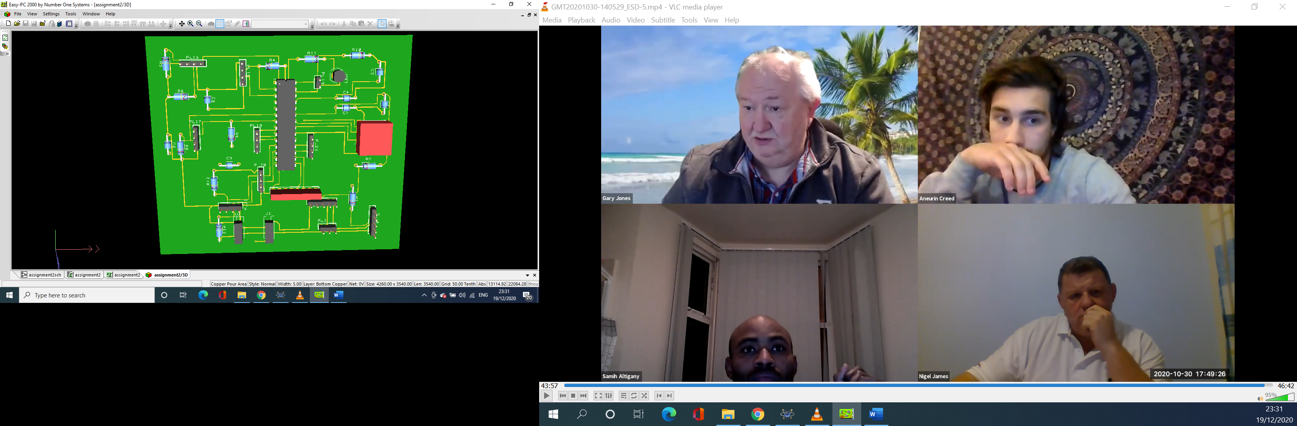
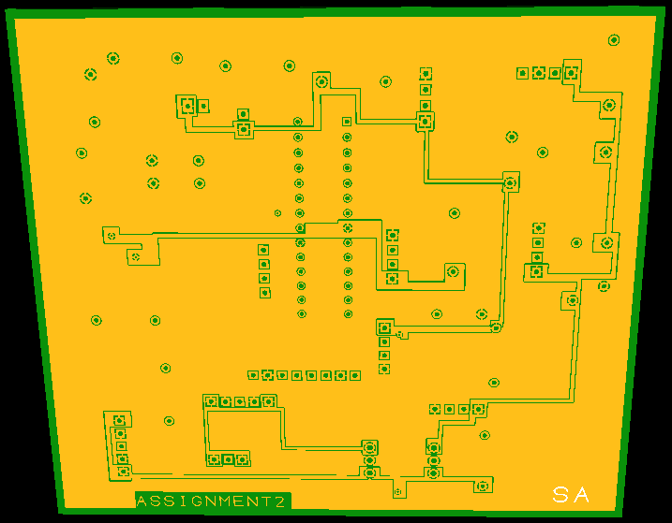

The pricing lists

Component | Price
Temperature and humidity sensor | 49.95£
wind speed sensor | 40.57£
Wind direction sensor | 72.99£
Air bone particle sensor | 45.1£
VOC level sensor | 26.66£
GPS position sensor | 25.58£
Sunlight brightness sensor | 4.99£
UV level sensor | 1.23£
LED | 0.48£
Microcontroller | 1.76£
Voltage regulator | 0.558£
Battery | 759.53£
Male connectors | 27.69£*8= 221.52£
Female connectors | 27.69£*8= 221.52£
Case | 336.71£
Pushbutton | 32.28£
Passive components | 5£
SD card connector | 2.49£
PCB | 35.50$
Total | 1884.338£

Design improvement suggestions
- Display: having a display could become an advantage as it offers the option of instant monitoring and reading the values of the data logger readings.
- WIFI module: which enables the data logger to access a designated server and upload all the collected date.
- Bluetooth: offers extra feature for transferring data with no need to stop the datalogger of operation during test time.

- Ability to connect to smart phones in order to monitor the weather and the readings from distance and at any time without the need to physically travel the location of the data logger.

References
[1] https://www.weathershop.co.uk/shop/rx3000-weather-station-kit-advanced
(Accessed: 5th December 2020)
[2] https://shop.pimoroni.com/products/digital-temperature-and-humidity-sensor?variant=35611648138&currency=GBP&utm_source=google&utm_medium=cpc&utm_campaign=google+shopping?utm_source=google&utm_medium=surfaces&utm_campaign=shopping
(Accessed: 6th December 2020)
[3] https://uk.rs-online.com/web/p/temperature-sensors-humidity-sensors/1704381/
(Accessed: 6th December 2020)
[4] https://www.adafruit.com/product/1298
(Accessed: 6th December 2020)
[5] https://uk.farnell.com/sensirion/sht25/humidity-temp-sensor-digital-dfn/dp/1855469
(Accessed: 6th December 2020)
[6] https://wiki.dfrobot.com/Wind_Speed_Sensor_Voltage_Type_0-5V__SKU_SEN0170
(Accessed: 6th December 2020)
[7] https://moderndevice.com/product/wind-sensor/
(Accessed: 6th December 2020)
[8] https://www.lambrecht.net/en/products/wind/wind-speed-sensors-industry
(Accessed: 6th December 2020)
[9] https://www.digikey.co.uk/product-detail/en/adafruit-industries-llc/1733/1528-1328-ND/5356813
(Accessed: 6th December 2020)
[10] https://www.lambrecht.net/en/products/wind/wind--direction-sensor-basic
(Accessed: 6th December 2020)
[11] https://www.rikasensor.com/rk110-02-wind-direction-sensor-wind-vane-sensor.html
(Accessed: 6th December 2020)
[12] https://www.digikey.co.uk/en/products/filter/particle-dust-sensors/509
(Accessed: 7th December 2020)
[13] https://www.digikey.co.uk/en/products/detail/sensirion-ag/SPS30/9598990
(Accessed: 7th December 2020)
[14] https://uk.rs-online.com/web/p/air-quality-sensors/1024162/
(Accessed: 8th December 2020)
[15] https://www.robotshop.com/uk/sparkfun-gps-breakout-board-sam-m8q-qwiic.html
(Accessed: 8th December 2020)
[16] https://shop.pimoroni.com/products/adafruit-ultimate-gps-breakout?variant=288854706&currency=GBP&utm_source=google&utm_medium=cpc&utm_campaign=google+shopping?utm_source=google&utm_medium=surfaces&utm_campaign=shopping
(Accessed: 8th December 2020)
[17] https://www.openimpulse.com/blog/products-page/product-category/ublox-neo-6m-gps-module/
(Accessed: 8th December 2020)
[18] https://learn.sparkfun.com/tutorials/temt6000-ambient-light-sensor-hookup-guide/all
(Accessed: 8th December 2020)
[19] https://www.adafruit.com/?q=bh1750&sort=BestMatch
(Accessed: 8th December 2020)
[20] https://www.adafruit.com/product/1918
(Accessed: 8th December 2020)
[21] https://www.digikey.co.uk/product-detail/en/vishay-semiconductor-opto-division/VEML6075/VEML6075CT-ND/5878946
(Accessed: 8th December 2020)
[22] https://thepihut.com/products/adafruit-veml6070-uv-index-sensor-breakout?variant=27740204945&currency=GBP&utm_medium=product_sync&utm_source=google&utm_content=sag_organic&utm_campaign=sag_organic
(Accessed: 8th December 2020)
[23] https://www.adafruit.com/product/1777
(Accessed:8th December 2020)
[24] https://www.vishay.com/docs/83171/tlur640.pdf
(Accessed: 18th November 2020)
[25] https://uk.rs-online.com/web/p/leds/2285988/
(Accessed: 18th November 2020)
[26] https://www.microchip.com/ParamChartSearch/Chart.aspx?branchID=30048
(Accessed: 22nd November 2020)
[27] https://uk.rs-online.com/web/p/low-dropout-voltage-regulators/5455764/
(Accessed: 18th November 2020)
[28] https://www.mouser.co.uk/Semiconductors/Power-Management-ICs/Voltage-Regulators-Voltage-Controllers/LDO-Voltage-Regulators/_/N-5cgac?P=1yx5k7vZ1z0shyuZ1z0wcrx
(Accessed: 16th December 2020)
[29] https://www.batteryspace.com/nicd-battery-pack-16-8v-2200mah-37wh-14xsc-hump-with-16awg-wire.aspx
(Accessed: 23rd November 2020)

[30] https://www.manomano.co.uk/p/vhbw-nimh-battery-1300mah-24v-for-medicine-technologyekg-device-cardioline-delta-60-ecgdelta-60-ecgdelta-60plus-ecg-replaces-batt-1102607741715-13652914
(Accessed: 23rd November 2020)
[31] https://uk.rs-online.com/web/p/rechargeable-battery-packs/7760869/
(Accessed: 23rd November 2020)
[32] https://www.qualitysource.co.uk/products/lifepo4-hd-series-professional-for-high-current-160ah-continuous-bms-lithium-battery-12v-100ah?variant=30492284190784&utm_medium=cpc&utm_source=google&utm_campaign=Google%20Shopping
(Accessed: 16th December 2020)
[33] https://uk.rs-online.com/web/p/lead-acid-batteries/7270436/?cm_mmc=UK-PLA-DS3A-_-google-_-CSS_UK_EN_Batteries_%26_Chargers_Whoop-_-Lead+Acid+Batteries_Whoop-_-7270436&matchtype=&pla-341223427143&gclid=CjwKCAiA_eb-BRB2EiwAGBnXXj-QlIUQ-L5XuYQPP4IlLQ3vXnLur7WcLFjIdXO9EmiZYPiN6EMQARoCULcQAvD_BwE&gclsrc=aw.ds
(Accessed: 16th December 2020)
[34] https://www.intellitecmv.com/products/lfp-powerbrick-12v-70ah?utm_medium=cpc&utm_source=google&utm_campaign=Google%20Shopping
(Accessed: 16th December 2020)
[35] https://www.lemo.com/en/products/low-voltage-connector/2c2g-series
(Accessed: 23rd November 2020)
[36] https://uk.rs-online.com/web/p/industrial-power-connectors/7249154/?cm_mmc=UK-PLA-DS3A-_-google-_-CSS_UK_EN_Connectors_Whoop-_-Industrial+Power+Connectors_Whoop+(2)-_-7249154&matchtype=&pla-475829811830&gclid=CjwKCAiA2O39BRBjEiwApB2IkpHMkYMGMV69-2angvMjhFsmdrxVQes_CnH3q7JYf0M78-LzYl2PexoCxGsQAvD_BwE&gclsrc=aw.ds
(Accessed: 23rd November 2020)
[37] https://www.mouser.co.uk/Connectors/Circular-Connectors/Standard-Circular-Connectors/Standard-Circular-Connector/_/N-av49j?P=1y9isww&Rl=av49jZerajZ1yvsm2aZ1ytkls1SGT&Keyword=158487552&FS=True&Ntk=P_MarCom
(Accessed: 23rd November 2020)
[38] https://www.protective-cases.co.uk/product/viso-metal-case-stc-918p/
(Accessed: 14th November 2020)

[39] https://peliproducts.co.uk/im2050-storm-case?print
(Accessed: 15th November 2020).
[40] https://www.casesuk.com/peli-protector-cases/1630-001-110E.html
(Accessed: 16th December 2020)
[41] https://www.thecaseshop.co.uk/max-case-max750h400_2094?gclid=CjwKCAiA_eb-BRB2EiwAGBnXXiv6yXTQxyszOzkgAzWj6tNvHWJtzqnYEiveLHuXsRKRbu8JP0pOHhoCweoQAvD_BwE
(Accessed: 16th December 2020)
[42] https://www.thecaseshop.co.uk/nanuk-965-case-with-wheels_3551?gclid=CjwKCAiA_eb-BRB2EiwAGBnXXoJyL5wAiQoiA3owB10SJiZX0tLi7NymYqn2XpYfRJ5B-LLJwbX53RoC40IQAvD_BwE
(Accessed: 16th December 2020)
[43] https://uk.rs-online.com/web/p/push-button-switches/0320994/
(Accessed: 29th November 2020)

[44] https://uk.rs-online.com/web/p/push-button-switches/8118480/
(Accessed: 29th November 2020)

[45] https://uk.rs-online.com/web/p/push-button-switches/1116513/
(Accessed: 29th November 2020)
[46] https://uk.rs-online.com/web/p/push-button-switches/7346704/
(Accessed: 29th November 2020)

[47] https://uk.rs-online.com/web/p/push-button-switches/6906803/
(Accessed: 29th November 2020)
[48] https://www.bellflowsystems.co.uk/vaisala-wxt532-ultrasonic-wind-speed-and-direction-sensor.html
(Accessed: 16th December 2020)
[49] https://novalynx.com/store/pc/200-2201-200-2206-NovaVane-Wind-Sensor-p323.htm
(Accessed: 16th December 2020)
[50] https://uk.rs-online.com/web/p/memory-card-connectors/7636794/?cm_mmc=UK-PLA-DS3A-_-google-_-CSS_UK_EN_Connectors_Whoop-_-Memory+Card+Connectors_Whoop-_-7636794&matchtype=&pla-341832817320&gclid=Cj0KCQiAifz-BRDjARIsAEElyGIS27dl1V7OkSgQiXIFF-ahT_Z9zPg4SEhbXcHwL2g6GowoTdwNeg8aAp5wEALw_wcB&gclsrc=aw.ds
(Accessed: 20th December 2020)

