
Academic and employability skills
Reflection on my learning in this module -BMSW 4001

May 5, 2020
university of wales trinity saint david
London campus


Teacher: Sylvia Hoffman
Student: Camelia Elena Roata- 1906945

Contents

Introduction 2
Academic and Employability Skills Module 3
Reflective Writing or reflection 3
Gibbs Model of reflection 3
Kolb Theory of Experiential Learning 4
Driscoll Model of Reflection 6
Reflection on this module 6
- Reflection of Time Management topic 7
- Reflection of Employability Skills topic 8
- Reflection of Paraphrasing topic 9
- Reflection of Critical Thinking Topic 10
Conclusion 12
References 13

Introduction

This academic report has been created to explain the reflection on my learning in the Academic and Employability Skills module, by recognised methods of reflection, and the reflection of 4 topics in this module. The academic module seems to not be fully understood by most of the students and happens to get bad grades or feedbacks even it is not so difficult to get pass on this module. Moreover, Academic and Employability skills is one of the important module in my course, showing the knowledge and the skills that you achieve during the year which prepare you for the next step. However, the reflection on this module should highlight the learning outcomes, with examples and suggestions.

Academic and Employability Skills Module

Academic skills are the skills that you develop with the time during your studies. The academic route helps to develop your knowledge through research and prepare you for your future career. Some of the academic skills could be such as write an essay/report ,a CV or cover letter, time management tools, paraphrasing and summarizing to avoid the plagiarism, how to create and present information using Microsoft Office Tools, problem solving and decision making, critical thinking and analyse of different situations (Morgan, 2017).

Reflective Writing or reflection

Reflective writing is your deep thought written in a piece of paper of an action/experience that happened. In University of Wales Trinity Saint David, the reflection or reflective writing is important in education. The teachers are looking for the thoughts of the students to have a brief of how challenging the modules had been for them and how they faced it, or how did they manage the information that they received, knowing if something should be improved or the aims and objectives had been reached the expectations.
According to Jay (1999), the reflection could be a strategy of problem – solving (Jay, 1999).
There are few models of reflection that I would speak about.

Gibbs Model of reflection

The theory of Gibbs (1988), wants to make understandable the fact that learning is coming from experience either the experience went well or not.
Gibbs Reflective Cycle (1988), can help us to understand his theory better.

Gibbs Reflective Cycle (1988)

Source: Created with Microsoft Word

The Gibbs Reflective Cycle can help anyone to understand what a reflection is, by reviewing and reflecting upon experience.
According to Gibbs (1988), to learn from your previous experience, it is not enough that does just happen. However, the ideas come from reflections of your feelings and thoughts which you had at that time (Gibbs, 1988).

Kolb Theory of Experiential Learning

Kolb, D.A. in 1984, wrote a book about a theory of experiential learning which lead to reflection. He analysed 3 models of experiential learning and put them together, forming a unique theory which says that the “Learning is the process whereby knowledge is created through the transformation of experience” (Kolb, 1984).
Although, the Kolb’s, (1984) Theory is about Experiential Learning, his theory can be related to what Gibbs, (1988) said about reflection in educational learning.
However, (Kolb, 2015), wrote a second edition of his book about experiential learning, being a foreword to the first book, where he is analysing the challenges that experiential learning had been faced through the years. (Kolb, 2015).
The University of Wales Trinity Sant Davis is applying Kolb’s Theory of Experiential Learning, being interested in how the students achieved the learning outcome, if it was difficult or what tools they used for learning resources and strategies, and if they reached the true potential that an organization is looking for.
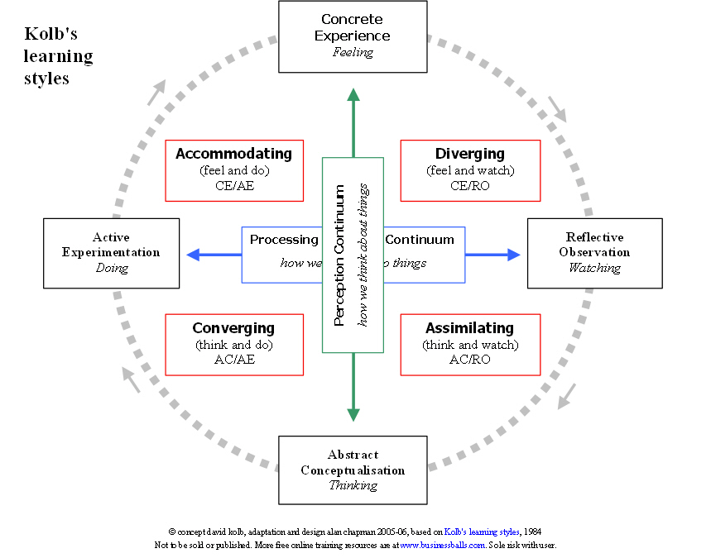
Source: www.businessballs.com

Driscoll Model of Reflection

Driscoll (1994), has also a theory of reflection, which is based on the 3 WHAT; “WHAT?”, “SO WHAT?”, and “NOW WHAT?” (Driscoll, 1994).
Driscoll (1994) Reflective Model

Source: Created with Microsoft Word

However, answering at the 3 questions above, as (Driscoll,1944) said, those questions can help with the reflection of what was learnt (Driscoll, 1994).

Reflection on this module

At the time that I start this module, I did not reflect, because I did not know what I was supposed to do, having a poor vocabulary and a limit of understanding of academic speaking and writing. Although, reflecting on that time, I feel angry with myself, knowing that I could do better than I did, and I felt frustrate because I did not give 100% to my reading.
This module had been the most challenging for me, creating confusion in my head and trying to find out what do I need to do. However, reflecting on this module could be my chance to understand what I did wrong and why.
With this module I had achieved many skills which I did not had, such as time management, employability skills, paraphrasing and critical thinking. Those topics have been the most challenging for me and I will explain why through my reflection.

Reflection of Time Management topic

Time management it is all about us, is a process, because we cannot control the time but we can control our lives by prioritising and focusing on what is urgent and what is important, understanding the difference between urgency and importance ( Morgan, 2017).
The time management matrix shows how to manage your time and how to spend it, in base of your daily duties. The matrix that I will show below, is the Stephan Covey Time Management Matrix (1989), which anyone can start with, to focus and prioritise what are the top things to do, sorting by the deadlines.
Stefan Covey Time Management Matrix (1989)
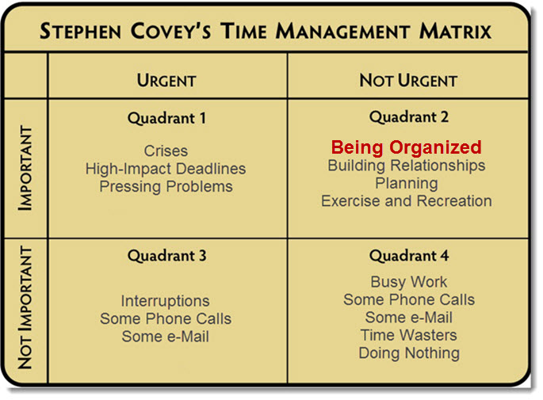
Source: www.acleanvision.com

Time management is kind of complex, but taking notes and prioritising the thighs to do, like Stefan Covey (1989) matrix shows, the life will be easier to manage.
I have been struggling with this topic because I did not read all about it, and when we spoke in the classroom about, I did not know what a matrix was and why this topic was so important for us. However, I went home, and I start to read everything about time management and at the end it was not difficult like I thought.
Moreover, I learned how to manage my time after this topic, having no idea before how to organize myself with the studies and job, which now it is easier for me having the knowledge of this matrix. Furthermore, this will help me in my future career. I suggest everyone to take a diary and plan the day that they can remember the things to do, and by the end of the day they are going to be organized persons without missing any deadline.
Conclusion, next time I will go through all the topic, make all the research I need, following the tutorial advice and reflect about it, for sure I will not miss any concept anymore.

Reflection of Employability Skills topic

Employability skills is another topic that I enjoyed, and which gave me the idea of what an employer wants.
Thus, the definition of Employability skills is a set of transferable skills or interpersonal skills such as abilities or specific skills required for the job which you are going to apply (Morgan, 2017).
Moreover, one of the main skills is communication. As you must have seen, the jobs are requesting strong communication skills. What this means? This does not mean that you need just to be able to speak fluently, but you need to be an active listener and have a professional vocabulary which lead you to be a proper co-worker into the company.
As example, in my workplace they do not require communication skills, but they require efficiency and to be able to work under stress, and this it is wrong, because from my opinion in the retail industry is not enough the ability to work under stress and the efficiency, but also an excellent customer service and a good team worker, both depending of a good communication skill.
Furthermore, after this topic, I understand what is required in a workplace and why, I have been able to write down a CV because I have reflected on my skills, my abilities, my assets, being able to identify them which before this topic I did not have any idea of what does those means or how to write a CV, or which are my skills and the results exceeded expectation.
I have seen people that are struggling doing a CV, or if you ask them ‘what skills do you have?’ they get blocked. However, I believe that having the opportunity to study this topic in this module, helped me to achieve more knowledge about myself.

Reflection of Paraphrasing topic

Paraphrasing is writing an idea in your own words, using synonyms, and changing the words order of others work, keeping the same meaning to avoid the plagiarism (UEfAP, 2019).
It is not enough just to paraphrase a text to avoid the plagiarism, but you need also to citate the idea where is come from, showing respect to the other people’s work (Morgan, 2017).
Thus, we avoid the plagiarism, which is an offence for the University, let them think that is your own work, without mention that is someone else work. The university penalise the plagiarism, named also academic misconduct (Morgan, 2017).
The first time when I heard about paraphrasing, I did not have any idea what this means, how it happened with all the topics, being the first time for me in the University after 10 years that I stopped to study, and also being in a new country, my level of spelling and understanding of the academic terms was very poor.
However, because of this, I always hesitated to ask questions about the topic, being scared that of my wrong spelling I could not made me understandable. All the in-class exercises had been with bad feedback, and more I had tried, more I did not went well.
I started to practice paraphrasing at home further, asked myself why I could not understand, what was so difficult, but I did not have an answer. I was so disappointed, everything I was trying was useless, and I realized why. The issue that I have faced was, the poor vocabulary, I only knew the basic grammar and the basic speech, this making a limit in my expression. Furthermore, I start to read more to improve my vocabulary in an academic way, I start to work on the assignment, which I have changed 3 times because of my grammar and my misunderstanding.
Although, I have been struggling with the paraphrasing for an entire trimester, when I uploaded my assignment into Turnitin, the similarity was only 2%. In that moment I realize how much I have progressed, being proud of my paraphrasing and all the work I have made to reach that result.

Reflection of Critical Thinking Topic

Critical thinking is the way how something it is been evaluate by analyse, evaluation and creation produced by questioning, observing, reflecting (The foundation for critical thinking, 2019).
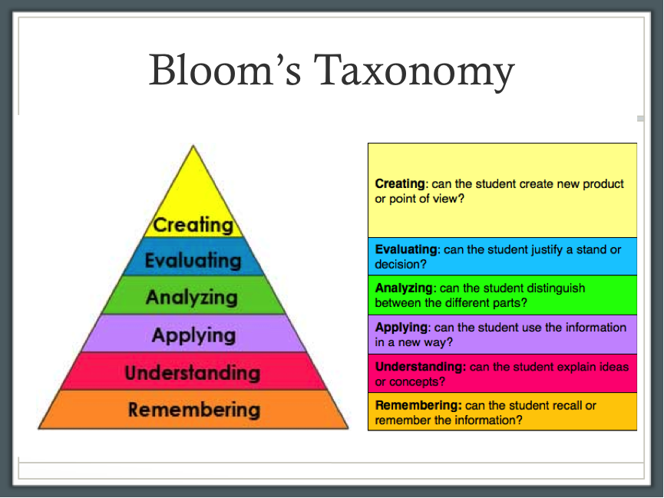
Source: https://hpc3o.blogspot.com/
Due to Covid – 19 pandemic, our classes has been replaced with the online teaching. Due the situation, I am working more hours than usual, and I am not able to request days off because of missing staff. Although, I have been present to the teaching hours, I could not be an active listener, because I was working at the same time. Moreover, I did not understand the topic, because of the situation, and this made me reflect on how important is to be 100% involved in the teaching hours.
However, I went home, trying to work on my assignment, and learn the topic that the teacher presented to us in that day, which was Critical Thinking. I was struggling with the topic, so I decide to add it to my assignment, with the intention of showing the challenges that the students are facing in this period, due the circumstances.
Thus, I did my research about Critical Thinking, and I did understand that the Universities are looking for this skill, which the students should be able to improve during the academic year, by showing their ability of evaluation of a situation or an idea, analyse it, understanding the concepts and remember the information.
Most of the students, have already this skill, perhaps they do not know the right following steps, but if they start the research and read further, they will understand that, they are doing every day this kind of thinking, in different circumstances of course.
However, after this topic, I can say that I will be able to ‘criticize’ a concept by questioning, having the evidence of my idea, doing my research, and achieving my objectives.

Conclusion

This module is important for all students, preparing them for the future career, by improvements of the skills that the employers are looking for, and helping them to be the perfect candidate in them further jobs. However, the reflection helps to understand what went wrong, why went wrong, by analysing the situation in an analytical and critical way. In my case, what and why went wrong, is because I did not give enough time to my studies, assuming that the teacher explanation will be enough for me to get all the information that I need, and was not like that. As I always say, every day is a new day to learn more.

References

- Gibbs, G. (1988) Learning by doing: a guide to teaching and learning methods. [London]: FEU.
- Hampshire Online Learning (Year) Driscoll (by Borton) Model of Reflection (1994). Available at: https://www.hampshireonlinelearning.co.uk/pluginfile.php/4368/mod_resource/content/6/What%2C%20So%20What%2C%20Now%20What.pdf [Accessed 11 Apr. 2020].
- Jay, Joelle K. (1999). Untying the Knots: Examining the Complexities of Reflective Practice. [online] Available at: https://files.eric.ed.gov/fulltext/ED431732.pdf [Accessed 8 Apr. 2020].
- Kolb, D.A. (2015). Experiential learning: experience as the source of learning and development. Upper Saddle River, New Jersey: Pearson Education, Inc. Available at: https://whel-primo.hosted.exlibrisgroup.com/permalink/f/14dj339/44UWTSD_ALMA21174168780002421 [ Accessed 8 Apr. 2020].
- Kolb, D.A. (1984). Experimental learning: experience as the source of learning and development. Englewood Cliffs; London: Prentice-Hall. Available at: http://www.learningfromexerience.com/images/uploads/process-of-experiential-learning.pdf [Accessed 6 Apr. 2020].
- ‌Morgan, P. (2017). Business student’s guide to study and employability. Los Angeles: Sage.
- The Foundation for Critical Thinking (2019). ‘Defining critical thinking.’ Online:https://www.criticalthinking.org/pages/defining-critical-thinking/766 [Accessed 11 Apr. 2020].
- UEfAP (2020). - Paraphrase. [online] Available at: http://www.uefap.net/writing/writing-reporting/writing-reporting-paraphrase [Accessed 11 Apr. 2020].
‌

