University of Wales
Trinity Saint David
School of Applied Computing
Title: Scrabble Algorithm
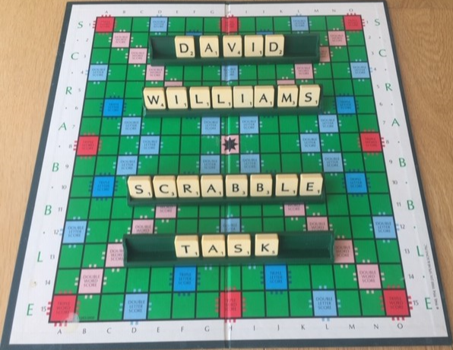
Module: Analysing and Solving Problems
Code: M4X 01499
Student: Martin Darzins
Student no.: 1909722
Programme: Bachelor of Science including Foundation
Lecturer: David A. Williams
Due Date: 27th April 2020

Acknowledgements
Due to the coronavirus situation and restrictions placed on fellow Applied Computing students, the author acknowledges contributions from Theresa Darzins.

Table of Contents
1 Acknowledgements 2
3 Introduction 5
3.1 Aims 5
3.2 Objectives 5
4 Task 1 - requirements 6
4.1 Scrabble Rules 6
4.1.1 Game Objective 6
4.1.2 Equipment 6
4.1.3 Set-Up 7
4.1.4 Rules 7
4.1.5 Game Play 11
4.2 Computer-based Solution 12
4.2.1 Requirements Analysis 12
4.2.2 MoSCoW 15
5 TASk 2 - implementation 18
5.1 Solution Identification 18
5.1.1 Variables 18
5.1.2 Constants 19
5.2 Algorithm 19
5.2.1 Visio flowcharts 20
5.3 Pseudo code 21
5.3.1 Sub-processes 21
6 References 23
7 Report Planning Methodology 24

Figure 1 - Standard Scrabble Board Layout (Kananat, S.) 6
Figure 2 - Letter Tile Distribution & Values (Kananat, S.) 7
Figure 3 - Level: Main Processes 13
Figure 4 - Level: Equipment 13
Figure 5 - Level: Set-Up 13
Figure 6 - Level: Rules 14
Figure 7 - Level: Game Play 14
Figure 8 - Scrabble Flowchart Overview 20
Figure 9 – Sub-process Overview: Set-Up (Visio extract) 21
Figure 10 - Pseudocode: Set-Up: Sub-process 22

Table 1 - MoSCoW: MUST haves 16
Table 2 - MoSCoW: SHOULD have 17
Table 3 - MoSCoW: COULD have 17
Table 4 - MoSCoW: WON'T have 17
Table 5 – Variables 18
Table 6 – Constants 19
Table 7 - Typical Visio Flowchart Symbols 20

Introduction

Aims
The aim of this report is to provide a computer-based solution for the board game Scrabble, to show how an individual Player wins the game, by obtaining the highest score.

Objectives
The purpose or the assignment is to show the evaluation process of a problem, formulate requirements and constraints, along with analysing a problem and producing a logical solution.
Split into 2(two) tasks (Requirements and Implementation), the report will incorporate the following;
- Describe the rules of Scrabble.
- Through Requirements Analysis listing prioritise requirements using MoSCoW (Must, Should, Could, Won’t{yet}) techniques.
- Identify and briefly describe the Variables & Constants within the solution.
- Create Visio flowcharts providing an algorithmic solution to the problem.
- Appropriate pseudo code with an overview of any required sub-processes.
The game objective when playing Scrabble is for an individual Player to obtain the highest score and thereby be declared the Winner of the game.

Task 1 - requirements

Scrabble Rules

Game Objective
For an individual Player to obtain the highest score and thereby be declared the Winner.
Play consists of forming and laying interlocking words, crossword fashion on the Scrabble board/computer screen, using letter tiles with various score values.
Each Player completes their Turn by using their tiles in combinations and locations that take best advantage of the letter values and board cell multipliers [1].

Equipment
- Scrabble Board
  - One (large enough) square shaped board comprising 15 cells high x 15 cells wide with gridlines to separate each individual cell.
  - Board Multiplier cells will be highlighted and colour-coded showing
    - Premium Letter cells
    - Premium Word cells [2]
Figure 1 - Standard Scrabble Board Layout (Kananat, S.)
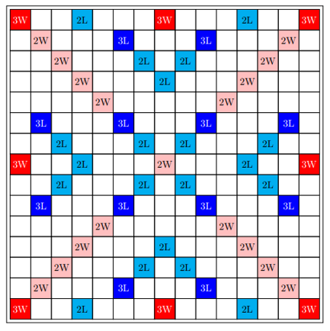

- Letter Tiles (100)
  - Each suitably sized to fit board cells
  - 98 lettered tiles, 2 blank tiles
  - Lettered tiles will have individual score value [2]
Figure 2 - Letter Tile Distribution & Values (Kananat, S.)
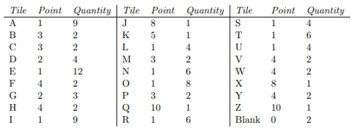
- Tile Rack facility
  - One for each player
- Tile (Exchange/Replacement) Bag facility
  - One for communal use by all players

Set-Up
- Determine Number of Players (minimum 2, maximum 4) playing.
- All (100) Tiles to be placed in Tile Bag (or screen equivalent).
- Each Player to have own Tile Rack (or screen equivalent).
- Select type of (Computerised) Game Mode
  - Standard / Tournament etc
- Players to agree which dictionary standard is to be utilised prior to game commencement.
- Method of Score Recording.
- Determine player turn time limitations (if any).
- Standard 26 letter Alphabet (A to Z) utilised.
- Valid words with a minimum of 2 tiles [3].

Rules
- Number of Players
Game can only be played between 2, 3 or 4 players only.
- Player Turns
After establishing Player 1 starting position, play begins with Player 1.
Next player play commences in Clockwise direction around the board from and after Player 1 has played.
Each Player takes 1(one) turn at a time and in turn clockwise one after another.
Players may agree (beforehand) to place time limits on player play/turn time, particularly utilised in tournament play mode.
- Tile Replenishment
Current player with an acceptable word placed on board, will replenish their tile rack with the same quantity of tiles used in their word, from tile bag.
Replenishment quantity is subject to the tiles available in tile bag and keeping within the 7(seven) tile rack maximum.
Tiles are replenished before next player turn begins.
- Tile Exchanging
Any Player may use their Turn to replace any or all of their tiles in their rack, discarding these tiles to the tile bag (tile letter determination to be unseen to the other players) and then replaced with an equal number of tiles from the bag.
Exchanging without word play means that this player does not score and their turn ends and must wait for their next turn before being allowed to play.
- Passing (missing a Turn)
Any Player, instead of placing their tiles on the board, or exchanging tiles, may decide to Pass, whether or not they are able to make a word(s).
This pass facility ends that player’s turn without score and game moves to next player.
However, should ANY Player pass twice in succession, then the game ends.
- Tile Rack Quantity
Whilst tile bag quantities allow, players to maintain 7(seven) tiles at all times.
- Scoring
To be tallied after each Player turn and all finally totalled at end of game.
  - Each letter tile has its own letter value
    - Blank tiles have no value
  - 1st Word (by 1st Player)
    - 1st word must cover the centre/STAR cell
    - Centre/STAR cell doubles the total word score for this word only (2W).
  - Premium cells (when tile placed on it) can
- Double and/or Treble the score of that letter (2L/3L)
- Double / Treble the score of the word (2W/3W)
- If the word crosses both premium letter and word cells, all bonus letter values are added together before complete word multiplier is applied.
- When word incorporates a blank tile, the sum of the whole word is still utilised, even though the blank tile itself has no value.
- Bridging
- Words created via Bridge formation will warrant doubling then re-doubling or trebling then re-trebling (i.e. 4 or 9 times) the complete score, if crossing appropriate premium cells.
- 7(seven) Tile Word Bonus
  - Players utilising all 7(seven) of their tile rack letters to create a word on the board will warrant a 50-point bonus.
  - Only applies to 7(seven) tile words placed on board.
- End Game Scoring Adjustments
  - Un-played tile values are deducted from that players total score
  - If 1(one) player has played all their tiles, their score is increased by the value of the total value of all the other players un-played tiles.
- Single use
  - Premium cell bonuses only apply to the turn in which the tiles are placed on them.
- End of Game
The game ends when either;
  - All the tiles have been drawn from the tile bag and 1(one) of the players has used all of their tiles in their tile rack.
  - When all possible plays have been made.
  - Any player has passed their turn in 2(two) consecutive turns.
- Word
  - Placement
    - 1st word
Player determined to be the starting player, needs to combine at least 2(two) or more tiles to form a word. The initial 1st word placement needs to have one of its tiles placed on the centre/Star cell.
    - All Words
Once placed on the board, the word cannot be moved unless successfully challenged at the time of placement.
All words need to be placed in a continuous manner either horizontally or vertically, but NOT diagonally.
  - Acceptance
    - Acceptable
Words that are found in a standard English dictionary can be used, with a minimum 2 tiles.
    - Unacceptable
Words that use; suffixes, prefixes, abbreviations, hyphens, apostrophes and/or Capital letters.
When utilising the English version of Scrabble, foreign words are not allowed, unless it appears in the standard English dictionary.
    - Challenged
Once a word has been placed, the word maybe challenged BEFORE the score is added up and the next player starts their turn.
Only during a challenge may the dictionary be consulted to check the word spelling or usage.
If the word challenged is unacceptable, then the player takes back their tiles, loses their turn and records no score.
- Dictionary / Validations [4]
A dictionary may NOT be utilised while game is in progress to search for words.
The dictionary can ONLY be consulted after a word has been played and challenged, for word validation purposes only.
  - Formations (to words already on the board) can be via
    - Adding tiles to beginning, end or both beginning and end
    - Placing a word at right angles (MUST use one of existing letters on board)
    - Placing a word in parallel (all adjoining tiles MUST form words)
    - Create a bridge (of 2 or more tiles) between words
    - The same word can be played more than once
    - Pluralised words are allowed

Game Play
- 1st Player Selection/Tile Return
To determine which player starts the game, each Player selects 1 tile from the tile bag, the player with the letter nearest to ‘A’ starts and plays commences ‘clockwise’ from that person.
If drawn during this phase, then the ‘blank’ tile supercedes ‘A’ and this player will start game.
All these initial tiles are returned to tile bag, ensuring that all tiles remain unseen, before and during commencement of game.
- Player Turns
At the start of each Player’s turn, they will draw 7(seven) tiles from tile bag (or computerised equivalent) and arrange them on their individual tile racks (or screen equivalent), at this stage the game is ready to Play.
After player completed their turn, play moves to next player in Clockwise manner
Dependent upon subsequent player turns, each individual player should maintain 7(seven) tiles on their rack.
- Player Choice
When it is a Players turn to play, they can choose to ether
- Create and lay a word,
- Exchange tiles or
- Pass
If (a) is determined an unacceptable word via a challenge, then those specific tiles are returned to that player and zero score is recorded, with turn now being handed over to next player.
When option (a) is utilised and after word has been accepted (not challenged), player replenishes their tile rack with the same number of tiles used, thus keeping within the 7(seven) tile rack maximum limit and the availability of remaining tiles within the tile bag at the time.
If (b) or (c) is chosen, then no scores are recorded and turn is handed over to next player.
If any player chooses option (c) twice in consecutive turns, game ends.
- Player Score
After each player turn, scores are calculated and recorded before play re-commences with next (clockwise) located player and the same sequence continues

- Next Player
After determining and recording current player score, play turns to next player in clockwise direction from player 1, following same sequence until game ends.
- End Game
When last play has been determined, total end scores are calculated and the Winner determined
  - Winner Determination
When each individual player scores are determined, the winner is the Player or Players with the highest total score at the end of the game, dependent upon;
- Each individual player Turn scores being added together.
- Each player’s score being reduced by the sum of their un-played tiles.
- If 1(one) player has played all their tiles, their score is increased by the same value of the total value of all the other players un-played tiles.

Computer-based Solution

Requirements Analysis
To provide a computer-based solution, a numbered list of requirements/features are constructed to enable further breakdown into greater detail.
Hierarchical charts are shown below to detail how the solution has been broken down into smaller modules, utilising Decomposition and Modularisation techniques.
Decomposition (Figure 3) is the first step breaking a problem down into smaller, more manageable units. Modularisation (Figures 4-7) further breaks down these elements by task, into even smaller more manageable units.
Modularisation provides Abstraction, which allows multiple people to be able to work on the programming, furthermore Abstraction identifies the high-level steps that need to be achieved while ignoring specific details. The figures below show the various overviews of the Game requirements.
Figure 3 - Level: Main Processes
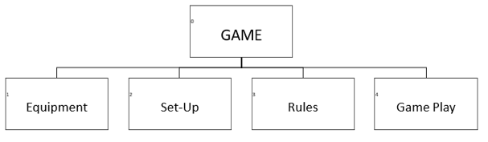
Figure 4 - Level: Equipment
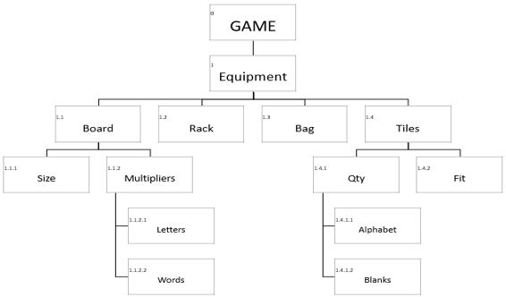
Figure 5 - Level: Set-Up
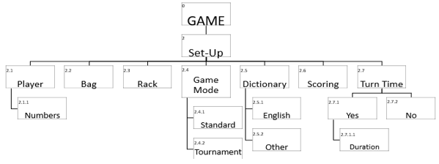
Figure 6 - Level: Rules
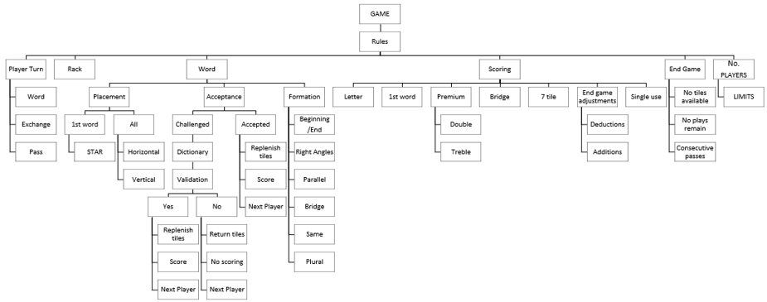
Figure 7 - Level: Game Play
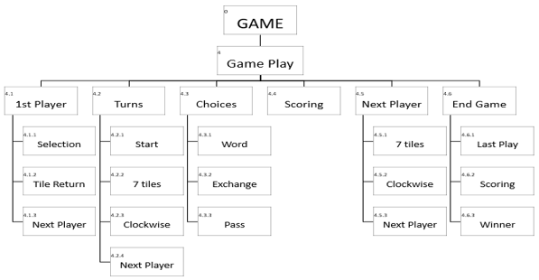

MoSCoW
- Definition and Terminology
The MoSCoW method prioritises the Requirements Analysis listing to distinguish between wants and needs and categorises them as; Must (M), Should (S), Could (C) and Won’t have yet (W) needs.
  - Must Have features are those critical for the solution to work, if not included, the solution is considered a failure.
  - Should Have features are important but do not have to be included at present, they are not time-critical and if excluded will not adversely affect the working of the solution.
  - Could Have features are desirable/nice to haves, they are not necessary, but could improve the user experience if added later, subject to time and budget.
  - Won’t Have (yet) features are not currently appropriate nor included at this moment, but may be considered and added later.

- Prioritisation
Table 1 - MoSCoW: MUST haves
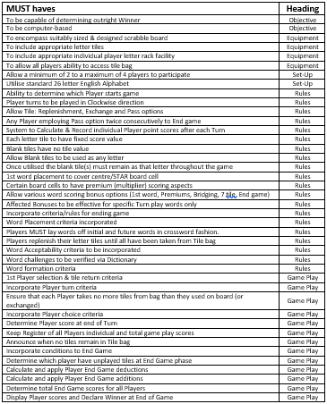

Table 2 - MoSCoW: SHOULD have
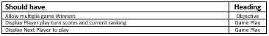
Table 3 - MoSCoW: COULD have
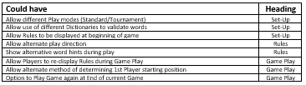
Table 4 - MoSCoW: WON'T have
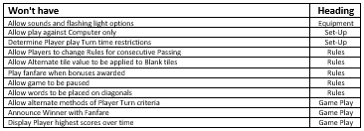

TASk 2 - implementation

Solution Identification

Variables
Variables are used to represent values that need to be used later in the programme, these values are stored in a Variable in the computer’s memory so that they can easily located, when needed. These will have a name given to a value, object or item in a computerised problem solution; examples of values that need to be remembered and stored are Inputs and Outputs.
Inputs need to be remembered in order to be used in processes, such as calculations etc. Outputs need to be remembered so that they can be displayed to the user, some outputs can be directly displayed without needing to store them in a Variable. Most outputs, that are involved in some form of calculation or process, will firstly be stored in a Variable.
The Variables identified for Scrabble are;

Table 5 – Variables
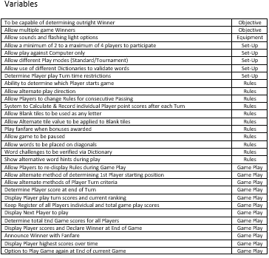

Constants
Variables with values that do not change are Constants.
Variables whose values change or have values that are not predefined (i.e. based on input) are Variables.
The Constants identified for Scrabble are;

Table 6 – Constants
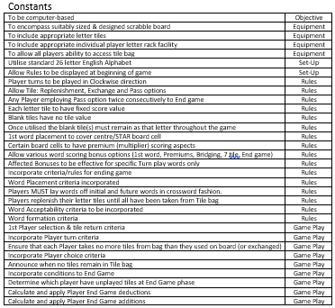

Algorithm
The following flowcharts provide an algorithm for the proposed computer-based Scrabble game solution.
The diagrams visually show the steps to take, utilising connected symbols to show the sequence of events, complete with any repeated and alternative steps.

Visio flowcharts
A flowchart is a diagram that represents a set of instructions, which normally use standard symbols to represent the different types of instructions. These symbols are used to construct the flowchart and show the step-by-step solution to the problem [5].
Table 7 - Typical Visio Flowchart Symbols
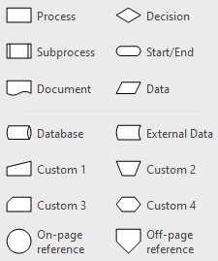
Figure 8 - Scrabble Flowchart Overview
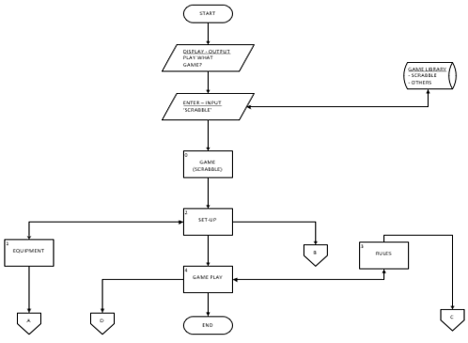

Pseudo code
Pseudocode is an informal high-level description of the operating principle of a computer program or other algorithm. It uses the structural conventions of a normal programming language, but is intended for human reading rather than machine reading [6].
Written in plain English using shortened statements, pseudo code is the informal language used to plan out the logic (algorithm) for a problem. It enables the problem to be broken down into more manageable steps, making it easier for a programmer to understandable and to convert into a computer solution.
It typically covers statements regarding; prompting for input, setting variable values, displaying output, along with simple calculations and processes. There are no technical rules for Pseudocode and there are different examples such as Fortran, Pascal, C type and Structured Basic styles of pseudo code.

Sub-processes
The start symbol indicates the beginning of the sub process and will contain the sub process’s name
instead of start, with the stop symbol indicating the end of the sub process at which point it should return
to the main program. In the sub-process, this stop symbol will contain the keyword Return, with all other
flowchart symbols being used as normal.
For consistency purposes Pascal style of pseudo code will be used for examples of some of the sub-processes, applying a Capital letter to denote the start of all new words when combining words to make a variable name.
An example of Pascal style pseudo code for some elements of the Set-Up sub-processes are;
Figure 9 – Sub-process Overview: Set-Up (Visio extract)
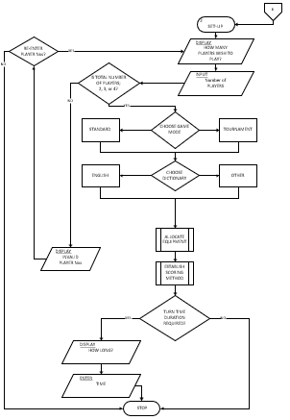
Figure 10 - Pseudocode: Set-Up: Sub-process
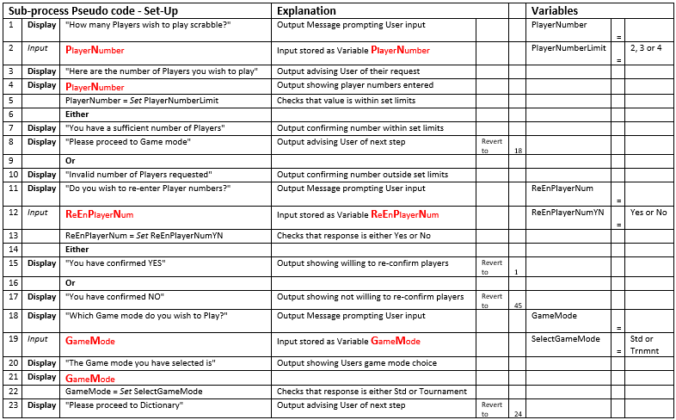
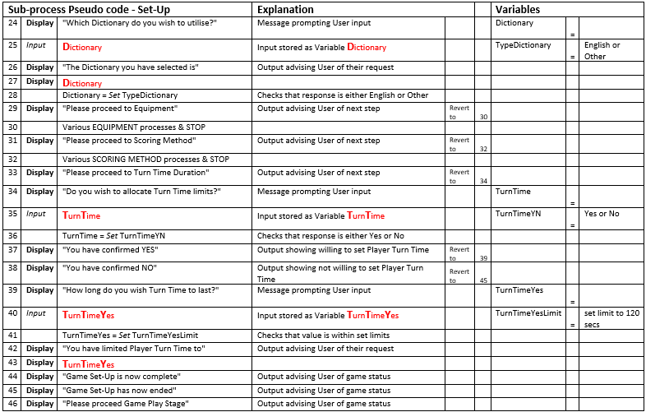

References
[1] Scrabble Pages (2020) Scrabble Rules – Scrabble Official Rules. Available at:
https://www.scrabblepages.com/scrabble/rules/ (Accessed: 28 March 2020)

[2] Kananat, S. (2018) An Analysis of Scrabble from the Viewpoint of Gamified Learning. Available at:
https://core.ac.uk/download/pdf/156904534.pdf (Accessed: 28 March 2020)

[3] V & A Museum (2020) Scrabble – J W Spear & Sons Ltd. Available at:
http://collections.vam.ac.uk/item/O198295/scrabble-board-game-j-w-spear/ (Accessed: 28 March 2020)

[4] Hasbro (2020) About Scrabble – FAQ. Available at:
https://scrabble.hasbro.com/en-us/faq (Accessed: 28 March 2020)
[5] BBC Bitesize (2020) Flowcharts. Available at:
https://www.bbc.co.uk/bitesize/guides/z3bq7ty/revision/3 (Accessed: 28 March 2020)

[6] Wikipedia (2020) Pseudocode. Available at:
https://en.wikipedia.org/wiki/Pseudocode (Accessed: 28 March 2020)

Report Planning Methodology
This Analysing and Solving Problems report assignment was completed by adhering to the following the activities;
- Read and understand the report brief and Task Summary.
- Make use of provided Official Rules to Scrabble.
- Make plan (Gantt chart) including time management – planning/research most time consuming, cater for other exams.
- Create report format and style – use Moodle template example.
- Follow structure
  - Abstract/Acknowledgements
  - Introduction
  - Main Body
  - Conclusion (if required)
  - References
- Define the problem and purpose of the report – decide assignment title, aims & objectives.
- Define audience – Lecturer/Tutor (David Williams).
- Brainstorm (Mindmaps) and Determine ideas to include.
- Research and gather information (Task Worksheet, library, internet etc).
- Collect, sort, evaluate organise material.
- Complete references (as you go) during all researching phases
- Analysing my research/material.
- Prepare outline drafts.
- Write the report, check spelling and grammar.
- Peer Review – (Terri & David Williams)
- Incorporate peer comments into final redraft.
- Submit final report via Turnitin.
- Submit Visio flowcharts

