Katerina Sugarova
Student ID: 2220482
UWTSD
Bible Theology
Matthew Cobb

Animal Testing Dilemma Mind Map
This mindmap was made to help plan on writting the "Animal Testing Dilemma." This graphic clearly shows the main ideas and related subtemes important for my project. The mindmap’s style is meant to be simple and easy to understand. The useful guide helps me to organise my thoughts and fokus on the most importtant parts of my subject. It will help me write my essay more organissed and logically.
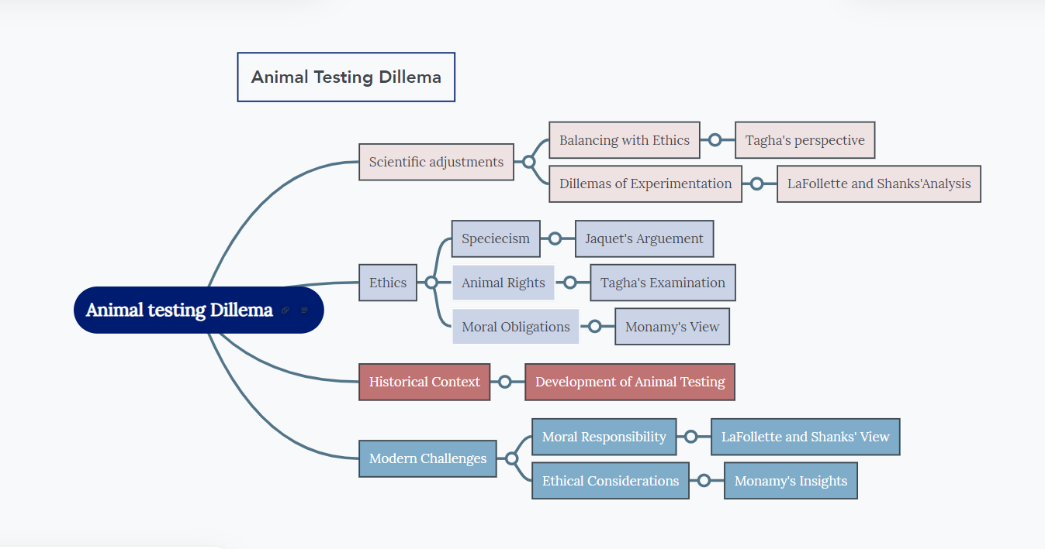
The core topic, "Animal Testing Dilemma, " is at the centle of the mind map." This represents the focus of your essay. From this centrral idea, the mindmap branches out into several key themes:
- Ethics: This section explores the ethical considerations of animal testing. It includes subthemes like 'Speciesism', with Jaquet's argument against it, 'Animal Rights', focuzing on Tagha's examination, and 'Moral Obligations', highlighting Monamy's views. These points help you discuss the moral aspects of animal testing.
- Scientific Advancement: Here, the focus is on how animal testing relates to scientific progress. It examines the balance of scientific growth with ethical ttreatment (Tagha's perspective) and the dillemmas of animal experimentatiion (analysis by LaFollette and Shanks).
- Historical Context and Modern Challenges: These branches provide bakground and current views on animal testing. They help me understand how animal testing has developd over time and the present-day ethical and moral challnges it faces.
Using this mindmap as a starting point, I can organize my essay to cover all the various pats of animal testing. This method ensures that i cover every importat aspect of the subject which makes the essay education.

