Digital Portfolio and Reflection

Introduction

Outlook

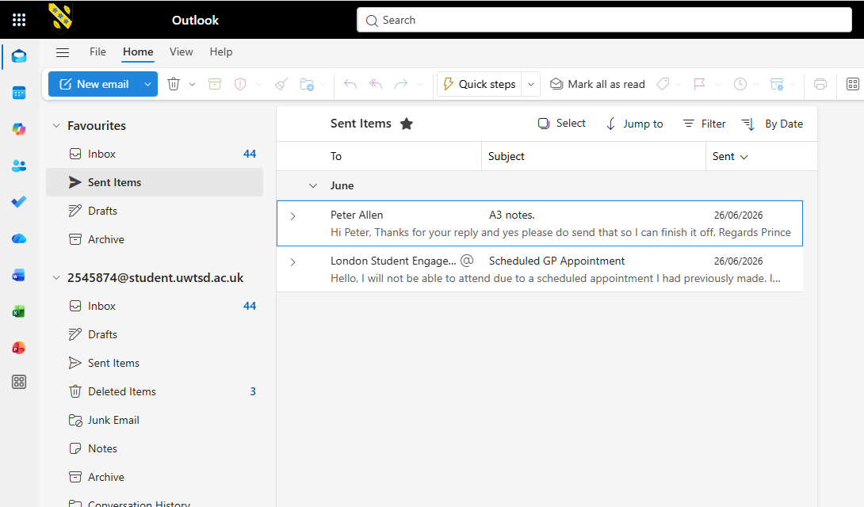

I

One-Drive

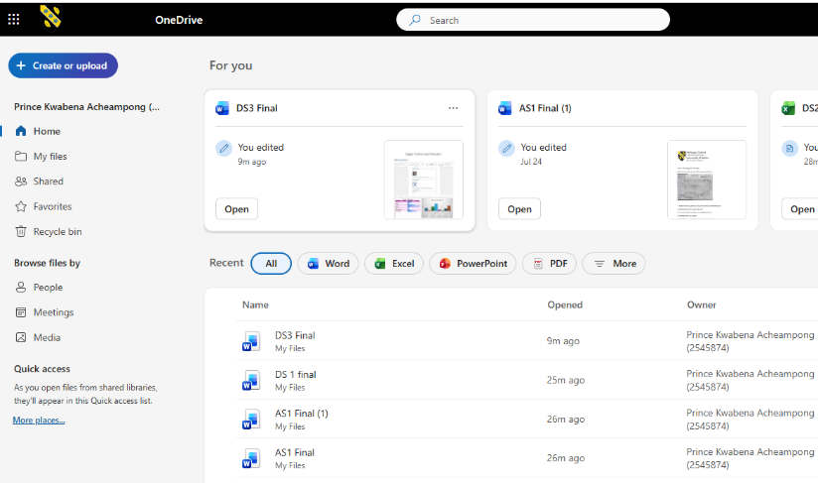

Microsoft Word
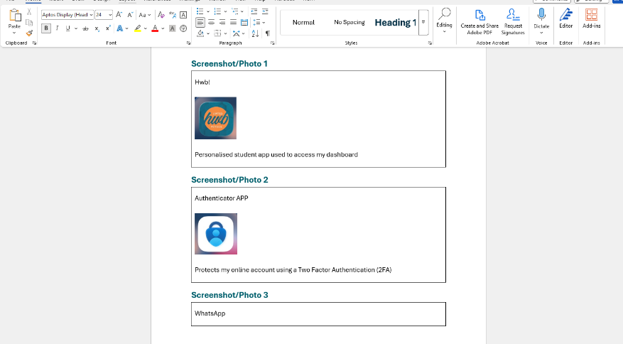

Excel
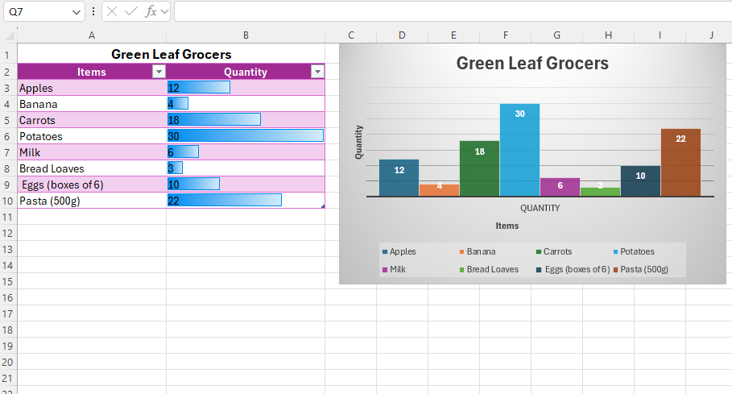

My Work

Above are the tools that I have used during the digital skills module

