Name: Tamara Brylewicz
Student ID: 1915163
Lecturer name: Charles Oham

TABLE OF CONTENT

- 1.0Introduction
- 2.0Models of communication
- 2.1Shannon n weaver
- 2.2Schramm
- 2.3Berlo
- 3.0Communication skills
- 3.1Verbal communication
- 3.2Nonverbal communication
- 3.3Listening -active listening
- 4.0Empathetic listening.
- 4.1Conclusions
- 4.2Referencing

Introduction

In this Report I will present to you a 2000-word report and the topics I will talk about are Channon n Weaver, Schramm, Berlo , and I will talk about communication skills and verbal and nonverbal communications I will be covering a topic about listening and what not to do while listening to any information and Empathetic listening and I will finish off with my conclusion and I will give my references in the right order so if you need to just take a look on all the information I have provided to you and what I have learned in this lesson and how I found this lesson and how it helped me to get through it , it was a bit hard to understand for me how to structure it one person is saying one thing the other is giving you other information and it made me a bit confused but now that it’s the end of this term 2 I have learned so much and gained so much confidence and learned so much about what a team needs to be a successful team.
I will now start with my first topic which is the different types of models for communication, hope you enjoy.

Models of Communication
They are general models used to explain the way humans communicate with each other. The first big model for communication was made in the year 1948 by Claude Shannon and put out to the public with an introduction by Warren Weaver for Bell Laboratories. Continuing the basic, communication is the action of sending and receiving messages in other words transferring information from one part to another, and the main models that can pe separated into 3 categories on models of communication today are,
- Linear models – It describes a nonstop response changeable as a function of one or more analyst. They can help you understand and tell the behaviour of difficult systems or analyse experimental, financial, data.
- Interactive models- It is direct, quickly paced, seven-step action that is effective for teaching children or Adults any academic or social skill, routine.
- Transactional models - The model of communication is the operation of incessant transformation and change Factors Affecting the Transactional Model that relate to communication to a group of individuals relational, and cultural backgrounds.
(© CallTutors )

- Shannon-Weaver – Shannon n Weaver model, it comes from the linear model of communication who provides the work frame for analysing on how messages are send and received it is best known for its ability and power to explain how different messages can be mixed up and misunderstood in the action of sending and receiving messages.

- In the year 1948, Claude Shannon Has published a story of a Mathematical theory of communication which came in two parts one that was made in July and one that was written in October, and the numbers of Bell system technical in this basis work he used to equipped in prospect theory that were developed by Norbert Wiener which then were their stages of being active to communication.
(helpfulprofessor.com)

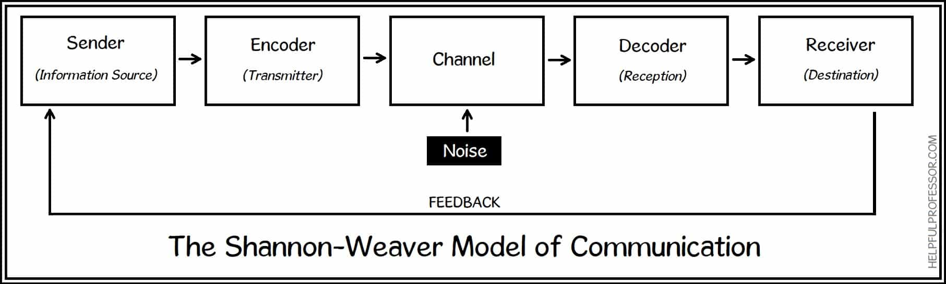

- Schramm – Schramm models of communication they were first found and put forward in 1954 by was Wilbur Schramm, like we learnt in our lesson that he himself suggested that communication is a two-way action where both the sender and receiver take their turns to send and receive messages (information and information is in no use unless it clear and carefully put into words and took to.( https://qsstudy.com/business-studies/schramms-model-communication )

- Berlo- Berlo models of communication were first found in the year 1960, it has mainly four sections to describe the communication process which they are,

- Sender – needs clear communication, and knowledge of what they are trying to say for the receiver to understand them clearly.
- Message – needs to be well structed with clear information.
- Channel – the channel of Berlo’s models include tasting, smelling, and seeing and hearing.
- Receiver – the receiver needs to have clear communication skills, knowledge, and culture.
Each of these sections are affected by many issues because the sender is the informants of the message or in other words the person who creates the message, and then the person who send the message to the receiver. (www.businesstopia.net/communication/berlo-model-communication).
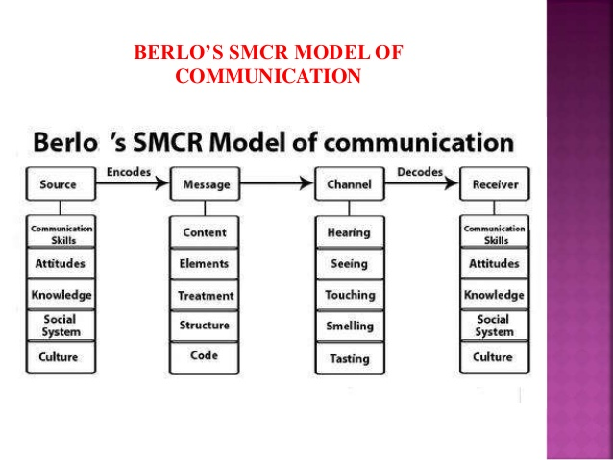

Communication skills

It is the skill to express and feelings effectively, it is to express yourself in a positive and clear manner, both when speaking to people and in writing also Communication is one of the main ingredients for a successful business, but the problem is that the phrase ‘good communication skills’ is a term so overused that it is difficult to pinpoint what it actually means (www.wikijob.co.uk/ , © WikiJob 2007-2021) , if you talk about verbal and nonverbal communication you have to understand what they both mean before you actually start a topic on them and what I learned about verbal communication is that, also having ,better communication skills makes you more open to speak to others and having this type of skills can make you a easy target to get hired to the job you always wanted, I have never had a bad communication skill when I came out to talking I usually communicate with others good as long as I don’t any false and rude person I don’t really mind talking to kind people I mean what would this world be if everyone would be direct with no emotions, because in my opinion being direct with someone and people nice to someone can have to turns and one or you can be polite or rude, I like to say how it is not how you want me to say it if you understand me, some people communicate by eye contact you don’t even need to move your lips and yet one another understand what is going on and there that is also a good communicator, here or some pointers on what verbal communication is defined too,
- It means that is it spoken or written in different types of ways.
- It is relating to or in the form of words.
- It is sharing information among different individuals and groups.
- It is essential and a soft skill to effectively communicate in a workplace or anywhere else with individuals.

verbal communication signifies to our use in words while nonverbal communication refers to communication that happens through what means other than words such as gestures and silence and of course body language, the way you behave, as for the nonverbal communication here are some examples which include, (importantindia.com)
- Facial expressions - when you give a smile or a frown that expresses a lot there is a lot of differences it is said that people can straight away tell a forced smile from a genuine one.

- Body language- the way we sit, stand, or move our feet as we talk, we can show how confident, nerves or relaxed we are feeling. This type of nonverbal communication is very often unaware.

- Sign language – it is not the same as a gesture, also it is not the same as talking or giving a speech it is usually a different language on its own there is a lot of different forms of ways of sign language on this earth we can learn, there is the one you use you hands or the one you contact each other by eye contact.

- Gesture – usually from a handshake to a okay sign, gesture can also speak parts, Gestures can be aware of different acts.

Listening-active listening
It means to pay attention at whatever you are doing or at school, work or at home, it means like listening to your manager and not going on your phone or fiddling with your hands, active listening means that you are fully concentrated to the person that is talking and you understand and respond to them and you then remember what has been said to you ,it is a technique used to support, training and solving conflicts and problems . Active listening requires, ( www.skillsyouneed.com/ips/active-listening.html )

- Eye contact
- Body Gestures
- Giving feedback
- Avoiding distraction
- Showing that you are listening.
Listening allows you to learn to plan and to develop to be part of something and to create and to think, it is a skill that can be learnt and develop with practice. Moreover, active listening can be difficult to master and will, therefore, take time and patience to develop, also if you don’t have active listening, you can then assume what the speaker is saying and their might be even conflict and problems, or finishing their sentences.

Empathetic listening- requires you to put yourself into the speaker’s shoes how would you feel if you stood all day and talked and explained teaching someone how succeed successfully, and they don’t pay attention to a word you are saying and when it comes to the deadline for giving up the work they haven’t done much because they were not listening to the speaker, the speaker has a very hard role as he is the one that gives out the information for the listener to understand and to take note of it (also a very good skill for listening , taking note of all the important information ) , Empathic listening is a practice of being attentive and responsive to other and during a conversation also listening empathically involves making an emotional connection with the other person and finding similarities between their experience and your own so you can give a more heartfelt response, being interested to what the speaker is actually saying, having good eye contact showing the speaker that your full concentration is to them and only them, Its best if you minimise any distraction, so hide your phone stop fidgeting with your hands and look up, inviting the speaker to expand the topic he is going through so he/she can see that you are active listening and to expand his or her thoughts on the subject they are going through, and always response to the speaker in the tone that is appropriate for the situation, showing the speaker that you understand and respecting their emotions. (www.indeed.com www.indeed.com/career-advice/career-development/empathic-listening ) is built on mutual respect and it shows that you are paying attention to the speaker.
Here are some examples of empathic listening to help you understand.
  - “Cristina’s teammate suddenly tells her that she wants to quit. Concerned, Cristina asks her why and if there is something she can do to help. Her teammate expresses her concerns while Cristina listens patiently without giving her advice.”
This example shows you that you must listen before you react, make assumptions or make judgments. What the speaker needs is a chance to express their feelings and emotions. Not only will this help you understand others but encourage positive interactions at work. (harappa.education/harappa-diaries/empathic-listening )
Empathetic listening also means to share our feelings with someone who’ll listen to us and understand us without judgment, It is about paying attention and being responsive while listening to someone. Also, Compassion is at the heart of empathic or empathetic listening. You can be an empathic listener both in your personal and professional life.

Conclusion
I have written in my report and I have covered these topics I have talked about Shannon and Weaver and I have given some examples, I have talked about Schramm and Berlo I have given examples and explanations on what I have learned from these skills and techniques I have went through communication skills and given definitions on active listening and empathetic and I finished off with my conclusion and I wrote all my references in the right order so if you need to just take a look on all the information I have provided to you on what I have learned in this lesson , this topic on effective team working and communication has been a little difficult and the start of the term but finishing the term realising that there is not only a thing called listening I found meanings and definitions of different types of listening and communications and every Tuesday I would come and take note of everything sometimes I would speak up and answer but most of the time I would listen and take notes of all the work we have went through I have built more confidence and I have now know more then I knew before I started the classes having successful listening skills will help you at work , home or anywhere else , also I went through models of communication.
Hope you enjoyed.

Referencing
- www.businesstopia.net/communication/berlo-model-communication).
- (© CallTutors 2021)
- harappa.education/harappa-diaries/empathic-listening
- helpfulprofessor.com
- importantindia.com)
- indeed.com/career-advice/career-development/empathic-listening
- qsstudy.com/business-studies/schramms-model-communication )
- www.skillsyouneed.com/ips/active-listening.html )
- www.wikijob.co.uk/ , © WikiJob 2007-2021)

