Name: Zuhel Miah |Student number: 1709521
University of Wales Trinity Saint David | Date of submission: 3rd March 2018
Management report on Employability skills

Executive Summary
The purpose of this report is to discuss the importance of employability skills and how they are vital for the workplace. The report highlights the required skills from an employer and employee’s perspective. The skills have been referred to the role of a Head Teacher. The report allows a deeper understanding of the skills that are required and necessary for a Head Teacher. The report identified that there are skills that are transferable which means that it can be used in different areas of work and different industries. The report outlined the nine main skills that are important in the role of a Head Teacher. It has been identified how a person can work at many tasks as a leader to and succeed. A good and academically skilled team is important. If the establishment let the team leader choose their own team, the establishment will look to create a happy and warm working environment for the best result. A head teacher must have good background experience such as holding a previous post in the facility and has an experience in other fields within the school and have a knowledge of the subject around the teaching curriculum. A person of this calibre needs to have good experience in problem solving. This can be given as an example such as the children with mental problem, and verbal and physical disadvantages.
The purpose of the report is to understand the key employability skills that are necessary for work place. Without this knowledge, it would be hard to understand what is needed to get into certain industries and this knowledge allows a person to be readier for the career path that they are looking to pursue. Transferable skills are very important in the world of work and this is something that can stay with someone for the rest of their life if exercised correctly.
A NPQH (National Professional Qualification for Headship) is desired to be qualified for a headteacher role and some essential skills such as qualified teacher status and expertise in professional development.

Contents Page

Terms of Reference 3 (41 words)
Introduction 4 (169 words)
Findings 5-7 (1554 words)
Conclusion 8 (165 words)
References 9-10
Appendix 11

Terms of Reference
This report was requested by Marie Pitson to be conducted by Zuhel Miah and to be submitted on 2nd March at 15:00. The report will cover the employability skills of a researcher and discuss the needs of the employers (Method123, 2010).

Introduction

Employability skills are important when it comes to the field of work as employers usually look for these skills when recruiting. According to Morgan( p24, 2017) ‘Employers typically look for individuals who have many qualities’ such as being able to work as a team and also individually. This shows that skills are needed for the workplace and there are many different skills for different areas of work and industries. Employability skills are also known as transferable/personal skills, this means that skills can be transferred from one job to another. There are many skills that fall into this category which will be mentioned. There are nine main skills that employers look for in potential employees which are: Team work, Commitment, Decision-Making, Flexibility, Leadership Skills, Communication, IT Skills, Research Skills and Self Reflection.
A Headteacher will need to utilise these 9 main employability skills to allow them to stand out from the crowd and the education such as a NPQH is essential to be in a chance to acquire the role.

Main Findings

Commitment
Commitment is another skill which has a sense of importance as this shows loyalty towards the employer and the place of work. Committed attitude also allows a sense of trust between the employer and employee which can result in less supervision for the employees and a higher motivation to work. A concern regarding this is being too friendly with the employees and not having an employer to employee relationship which is important to have at work. An employer can see this as a great attribute to have as a committed employee will mean that the employee is likely to stay with the organisation for a period. An employee who is committed may not be able to get rewarded as much as they would like to as they may be delegated tasks from peers who are not as committed to work (Maund, et al (2017). Relating this to desired role of a Head Teacher, commitment is important as this will enable to school to get the best results from their students and staff. Also according to Brooks (2016) who has mentioned ‘"I especially value the employee that, when times are tough, continues to strive for solutions and refrains from the 'blaming others' behavior that, unfortunately, we see too often.". This outlines how committed employees are seen as valued in the workplace.
Decisions Making
Decision Making is valuable in the workplace for both employer and employees as making important decision can expand the business and enhance the profits. Making the correct decisions shows that the person who is making the decisions is a risk taker as they are balancing the pros and cons of the outcome. An employer will see this a key skill as this will mean that decisions can be made for the success of the company but also some decisions may not be supported by certain people. An employee able to make certain decisions in their role shows that they are confident in the place of work (Kehoe, 2013). A Head Teacher will need to make very important decisions as this will have an impact on young children’s future and this is something that is vital to ensure that the children and staff get the correct support that they require.
Flexibility
Being flexible allows a person to work in an adaptable way. This skill is a transferable skill which is sometimes hard to perfect as being able to change routine and mindset is hard. For example a person who always does a 9-5 job may find it hard to change to a 12-9 shift as this is something that they are not familiar with. Being flexible means that a person can move with the time such as staying up to date with the newest technology or procedures to make work life easier (Bailey, S. 2014). Flexibility can mean many things such as being creative in the workplace such as exploring different approaches to make certain tasks easier. Being creative can allow new ideas coming on board which may mean a task must be done in a different way but in the long run can be more efficient. Another form of flexibility is being able to take on extra shifts at work to complete tasks. An employer will support flexibility and allow for this to happen as having a mindset like this allows the staff to be more innovative which can result in tasks being made easier. An employee can see this as a good way to think of new ideas as this shows that the employees views are important. As a Head Teacher being able to work on days off may be required as things can happen where the head teacher may be required to speak to a parent or decide based on a pupil’s behaviour or decisions based on the school itself.
Leadership Skills
Leadership Skills is a skill which is most important as this allows people to take control and plan. Being a leader allows a person to set up targets for colleagues to follow. A leader is a person who has the skills an ability to communicate with people and understand the needs of others and has skills that allow them to stand out from the crowd (Management Study Guide). A leader will look to motivate others around them and keep them engaged always. A leader does not always have to be a manager as the skills of a leader can be equipped by a person who is comfortable in the field of work. The leadership skills will allow a person to be more confident as they have the knowledge and education to provide guidance to colleagues so that they can find it much easier. Leadership skills also increases morale in workplace as engaging others to get the most out of them (Management Study Guide). An employer can use this to their advantage as this will allow them to delegate tasks to their subordinates and can take pressure off them. An employee can use leadership skills to show that they are an expertise in the field of work and stand out amongst their colleagues to make the managers more aware that they have knowledge about the work. Leadership skills as a Head Teacher will allow the staff to be motivated always and keep them engaged when they are losing interest.

Communication
Communication will allow a person to build relationships which can be done in various forms such as in writing, physically or verbally. Communication is very important as it allows a sense of trust to be made amongst employees which creates a better morale overall (Page, M. 2016). By having great communication in the workplace this allows the tasks to be set in clearly and ensuring that the objectives are being met. Keeping everyone involved such as encouraging. From an employer’s perspective communication within the workplace is essential as it is a two-way process which involves listening to each other. This will allow issues to be addressed and solutions to those issues. From an employee’s perspective, this encourages socialising with each other which a workplace cannot survive without. Referring to the role of a Head Teacher, communication is the foundation of the role as without communication there will be no progression from staff or pupils.

Team Work
Team work is important in the workplace as this allows people to get along with their peers such as working in a friendly environment. This also allows the workplace to have a healthier relationship with the peers and managers. A concern regarding team work is that there can be personality classes amongst peers as in a group there are many people who may not get along with certain people. Working as a team will allow tasks to be split into smaller portions so it can be accomplished faster (Brighthr.com, 2018). From an employer’s perspective, this is important as this allows a friendly environment for the staff to communicate and get the work done. The productivity of the workplace also increases and this is beneficial for the business as this shows that the business is on the right track. From an employees’ perspective, the work set out can be minimised as working in a group means that there is one goal that is set to be achieved and having ‘multiple perspectives, skillsets, and experiences all at once’ (Brighthr.com, 2018) can make this much easier. In the role of a Head Teacher, team work is essential as having a lot of pressure will require tasks to be delegated to subordinates to carry out.
IT Skills
These skills are ‘now more important than ever’ according to Crowfoot (2012) as society is changing there is more jobs based around having some knowledge in IT. From an employer’s perspective, IT skills is valuable as it something worth having as it is a skills that is adaptable to each industry e.g. Finance, HR. From an employee’s perspective having this skill will allow them to be versatile in the workplace. As a Head Teacher, this will allow them to be able to send emails, fax and also update details about the school and pupils on computer databases.
Research Skills
Researching about the area of work is fundamental element to gaining knowledge and learning in a more efficient way according to Zarah (2017). From an employer’s perspective researching is key and will allow the staff to gain more knowledge and will improve the intelligence within the company. An employee can research to become better at their jobs which will allow them to find the role easier. A head teacher will need to research methods to motivate staff and how they can create positivity in the workplace.
Self-Reflection
Self-reflection allows a person to learn from their mistakes as mentioned by Ayoubi (2013)‘We know intuitively that we learn by experience and also that we learn from our mistakes’ this indicates that it allows us to not make the same mistake again and know what to do when faced with similar experiences. An employer can identify who is looking to improve as self-reflection will show who values the work they do. An employee reflecting on previous experiences will learn from it and become well equipped for the future. A head teacher will need to reflect on themselves to see what method works and how they ca make their role more efficient.

Conclusion
To conclude, it can be identified that having transferable skills is very important as it allows employees to stand out from the rest if they have skills that other don’t. This will see them most likely to be chosen for a role over someone who does not have the skills to carry out the duties. However, it has been identified that these skills are transferable skills which means that the skills have been equipped from elsewhere such as a previous employment and adapted in a way which can be used for various industries.
Relating to the role of a Head Teacher, all the nine skills mentioned are vital for the role. The main skills are leadership skills and self-reflection as this has the most impact on peers and the organisation. As mentioned above the role will require leadership responsibilities and also self-reflection as the role will require improvement to work efficiently. This is needed for the desired role and will make the role much easier.

References
Ayoubi, J. (2013). The Importance of Reflection. Training Zone. [Online] Available from: https://www.trainingzone.co.uk/develop/talent/the-importance-of-reflection Accessed on 16/02//2018
BrightHr. (2018) The Importance of Teamwork in the Workplace.[Online] Available from: https://www.brighthr.com/brightbase/topic/culture-and-performance/teamwork/the-importance-of-teamwork-in-the-workplace Accessed on 16/02/2018
Brooks, C. (2016). 10 Job Skills Every Employer Wants. Fox Business. [Online]. Available from: http://www.foxbusiness.com/features/10-job-skills-every-employer-wants Accessed on 16/02/2018
Crawfoot, S. (2012). The Importance of Computer Skills. Iceni. [Online] Available from: https://www.iceni.com/blog/the-importance-of-computer-skills/ Accessed on 16/02/2018
ITN Mark Education, (2018). Headteacher. [Online] Available from: https://www.reed.co.uk/jobs/headteacher/34272969?utm_source=adzunacpa&utm_medium=aggregator&utm_term=REG&utm_campaign=education&utm_content=adz_4011 Accessed on 16/02/2018
Kehoe, K. (2013.) 10 Ways to Improve Your Decision Making Skills. Wise Bread. [Online]. Available from: http://www.wisebread.com/10-ways-to-improve-your-decision-making-skills Accessed on 16/02/2018
Zarah, L. (2017). Why Research is Important. Owlcation. [Online]. Available from: https://owlcation.com/academia/Why-Research-is-Important-Within-and-Beyond-the-Academe Accessed on 16/02/2018
Management Study Guide. n.d. Importance of Leadership. [Online] Available from: https://managementstudyguide.com/importance_of_leadership.htm Accessed on 16/02/2018
Management Study Guide. n.d. Importance of Communication in an Organization.[Online] Available from: https://managementstudyguide.com/importance-of-communication.htm Accessed on 16/02/2018
Method123. (2010) Understanding the Terms of Reference.[Online]. Available from: http://www.method123.com/template-your-terms-of-reference.php#!prettyPhoto Accessed on 16/02/2018.
Morgan, P. (2017) The Business Student’s Guide to Study and Employability, UK: SAGE
Page, M. (2016). The Importance of Good Communication. [Online] Available from: https://www.michaelpage.co.uk/advice/management-advice/development-and-retention/importance-good-communication Accessed on 16/02/2018
The Business Journals. (2014). 4 tips for being more flexible and adaptable. Available from: https://www.bizjournals.com/bizjournals/how-to/growth-strategies/2014/03/4-tips-for-being-more-flexible-and-adaptable.html Accessed on 16/02/2018
Wright, A. (2014), Why are Employability Skills important? Available from: http://www.amandawright-rec.co.uk/latest-news/why-are-employability-skills-important/57 Accessed on 16/02/2018.
Maund, A., Schriek, M. & Tinkler, P K.(2017) Certificate in Higher Education: Skills for the Workplace Student Yearbook, UK: SAGE

Appendix

Job description of head teacher:
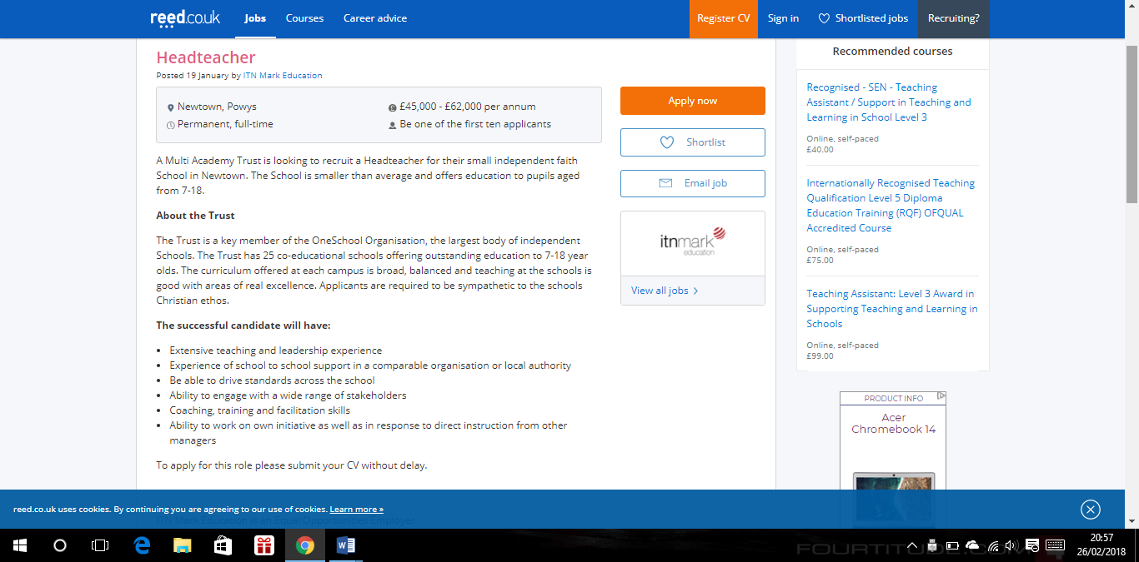
ITN Mark Education, (2018).

