

Programme: Master of Business Administration
Module Name: Marketing Management
Module Code: LCMB7024

Lecturer’s Name: Gladius Kulothungan

Assignment Title: Assessment component 2: Marketing Portfolio

Student Name: Md Rabiul Hassan
Student ID: 2504429

Word Count: 2563

Table of Contents
Introduction 3
Element 1: Choose a company and develop a Segmentation, Targeting, Differentiation, and Positioning (STDP) Analysis for a New Brand Concept 4
Company Overview and New Brand Voltair 4
Segmentation, Targeting, Differentiation, and Positioning (STDP) Analysis for Voltair 4
Element 2: Marketing Mix (4Ps or 7Ps) 7
1. Product 8
2. Price 9
3. Place (Distribution) 10
4. Promotion 11
Element 3: Marketing Strategy Pitch 12
Element 4: Reflection 13
Conclusion 15
References 16

Introduction

This report covers the design of Voltair, a new ultra-luxury electric brand of motorcycles under Rolls-Royce, aimed to combine the customised automation with the sustainability of mobility. In the analysis of STDP along with a marketing mix based on the strategic location, the report places Voltair in the niche segment of eco-aware High-Net-Worth Individuals. This is further summarised in the marketing strategy pitch, which shows how Voltair can reinvent the concept of luxury in the form of two-wheeled luxury by means of innovation, exclusivity, and responsible design.

Element 1: Choose a company and develop a Segmentation, Targeting, Differentiation, and Positioning (STDP) Analysis for a New Brand Concept

Company Overview and New Brand Voltair
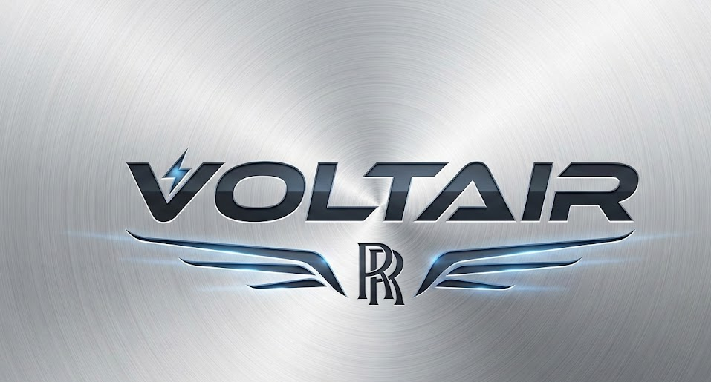
Figure 1 The New Brand “VOLTAIR”; Source: Self-made
Voltair is a new brand of Rolls-Royce that is a strategic venture in the Luxury Electric Motorcycle category. The flagship model, the Voltair R1, will be an electric two-wheel car designed to be the Rolls-Royce Motor Car equivalent, a two-wheel high-performance bespoke ultra-exclusive vehicle. The strategy of the New Brand will enable the corporation to tap into the development of the electric mobility industry, simultaneously maintaining the exclusivity and tradition of the main brand of cars under Rolls-Royce. The idea is to use Rolls-Royce levels of aerospace scope to implement a motionless, as yet strong, "waftable" riding experience, and set a new standard of sustainable luxuriousness in the motorcycle sector.

Segmentation, Targeting, Differentiation, and Positioning (STDP) Analysis for Voltair
Segmentation
Market segmentation refers to the process of subdividing a general market into small and more identifiable groups of consumers (Kotler et al., 2020). Voltair uses a concentrated (niche) marketing approach with High-Net-Worth Individuals (HNWIs).
Segmentation Variable | Description and UK Market Data
Geographic | Global alpha cities with a concentration of wealth, notably London, which is a key hub for UHNWIs (holding £30M+ in investable assets). The UK luxury goods market, fueled by this affluent base, is projected to be valued at £ 26.32 billion in 2025 (Mordor Intelligence, 2024).
Demographic | Ultra and High-Net-Worth Individuals (UHNWIs/HNWIs), executives, and entrepreneurs. The men’s luxury segment, a core market for performance vehicles, is expected to grow faster than the women’s segment in the UK.
Psychographic | Eco-Conscious Aesthetes who seek sustainable luxury. They are driven by the emotional benefit of exclusivity and view purchases as an ethical and highly personalized lifestyle statement.
Behavioural | Very Important Clients (VICs) and existing Rolls-Royce owners who demand bespoke customization and superior quality. They are early adopters of premium electric transport and value a refined, digital-first experience.
Targeting
Voltair chooses Curated Collector as its target market. This person is an affluent, discriminating consumer who regards the motorcycle as an object of engineering design and as a part of his or her customised luxury portfolio. The development of the luxury goods market in the UK, which is growing with the demands on customised goods, supports this strategy (Mordor Intelligence, 2024). The HNWIs, which are digitally proficient and are more concerned with authenticity and crafts than conventional prestige is flooding the market with an influx of High-Net-Worth Individuals (HNWIs) of 227,000 millionaires in London alone by 2025 (Gale, 2024). The older generations (Millennials and Gen X) are transferring their wealth to the younger generations, and this population needs luxury and sustainability. Votair is going directly to this target audience by combining the Rolls Royce heritage with the latest electric technology.

Differentiation
Differentiation entails developing high-quality customer value by differentiating the offering in the market as compared to other competitors (Kotler et al., 2020). Voltair draws the distinction between the R1 based on three prerequisites:
- Unrivalled Bespoke Craftsmanship: Figure highlights that UK luxury goods sector, with a worth of £ 26.32 billion in 2025 and anticipated to achieve £ 32.46 billion by 2030 (4.28% CAGR) is already driven by the need to customise and adopt personalised products (Mordor Intelligence, 2024). Whereas its competitors, such as LiveWire or Zero, focus on performance, Voltair relies on the focus on customised design of goods that 95% of the luxury buyers demand now and provide a level of finish unmatched in the motorbike industry.
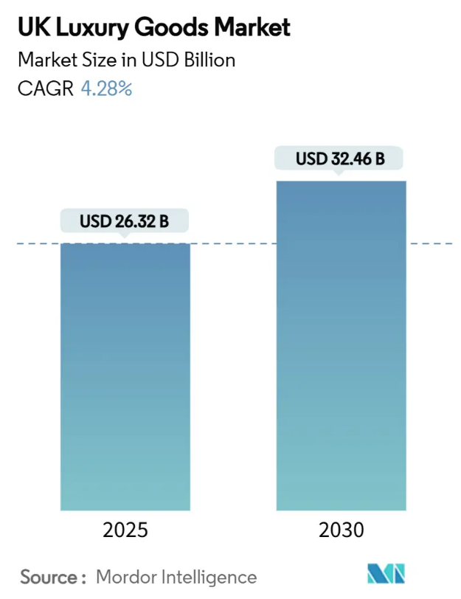
Figure 2 UL Luxury Goods Market; Source: (Mordor Intelligence, 2024)
- Refined, Silent Power (Product Quality): It has a concentration on quiet, gentle, "waftability" and not the brashness and speed, which gives it a unique and serene luxury riding feel that is unlike the aggressive performance of other typical high-end electric competition.
- Sustainable Opulence: Sustainable product as the consumer focus continues to move towards sustainability and the importance of sourcing in an ethical way, the brand does not position its electric platform as an essential good; instead, it is the ultimate piece of responsible, future-beneficial luxury.
Positioning
Product positioning involves defining the product by the customers on critical features, as opposed to other competing products (Hooley et al., 2020). Voltair is taking the Niche, Ultra-Luxury Positioning strategy. The UK market of electric motorcycles is growing at a high rate. It is estimated that between 2024 and 2033 it will increase £ 1.41 billion and £ 6.59 billion respectively (18.67% CAGR) (imarcgroup, 2025). Nonetheless, most of this growth in volume is present at the lower-powered segments at the moment. Deliberately having the High-End Premium (Above £50000) price structure, which firstly is a niche that the current leaders of the high-performance segment (LiveWire, Zero) inhabit, though secondly, they lack the ultra-luxurious brand image (Fitz-Gibbons, 2024).
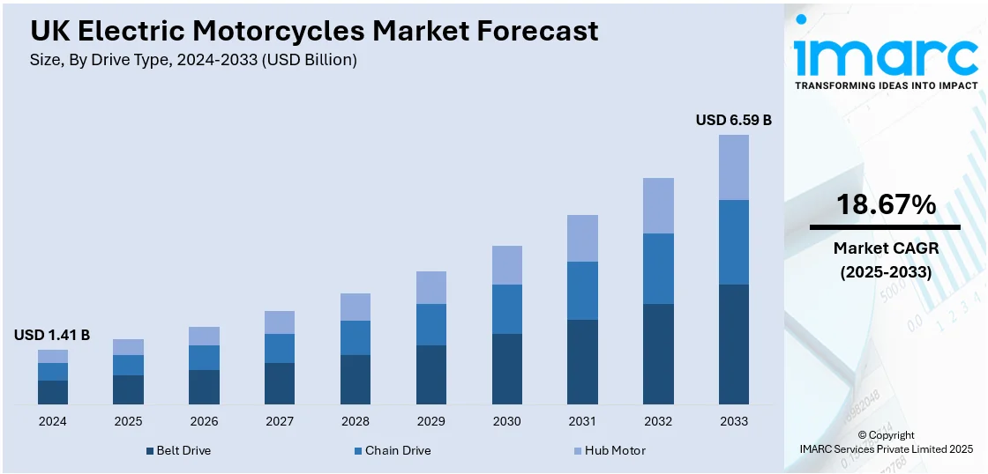
Figure 3 UK Electric Motorcycle Market; Source: (imarcgroup, 2025)
When the Curated Collector requires the refinement of unmatched craft and uncompromising silent, powerful performance, R1 Hyper-Luxury Electric Motorcycle is the ideal choice of expression of the ultimate expression of bespoke, sustainable mobility. In contrast to the high-performance electric contestants, Voltair is a two-wheeled Masterpiece of Engineering and Art which builds on the history of Rolls-Royce with its one-off ethos to the future of two-wheeled luxury.

Element 2: Marketing Mix (4Ps or 7Ps)

Voltair promotional mix is the operational model, which converts the Niche, Ultra-Luxury Positioning into market values of the brand. The 4Ps of Product, Price, Place, and Promotion are carefully combined as the Voltair R1 is a product-based electric motorcycle to see that all decisions are in support of the company values of Bespoke Craftsmanship, Refined, Silent Power and Sustainable Opulence.
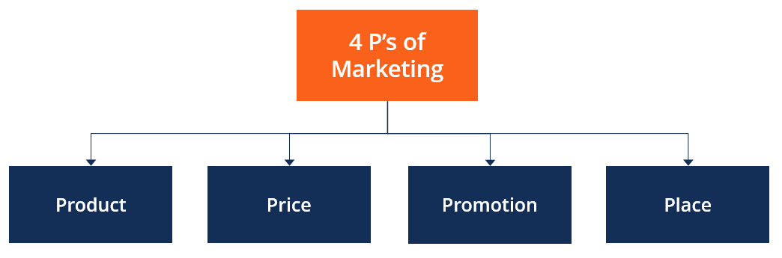
Figure 4 4Ps of Marketing Mix; Source: (Corporate Finance Institute, 2022)

1. Product
Most market offerings consist of both a physical, tangible product and an intangible service (Kotler et al., 2020). The Voltair R1 is meant to become the Masterpiece of the Engineering and Art as the ultra-exclusive two-wheeled vehicle that should be the Rolls-Royce Motor Car.
- Bespoke Craftsmanship: The main service included is highly customised automobile, in which the brand is founded on the philosophy that the experience is 95% personalization (Boeriu, 2014). It involves complete consultation with master craftspeople in the selection of material, unique paint make-up and details sewn by hand. This individual design emphasis serves into the increasing needs of customization and individualised products by the wealthier end-users.

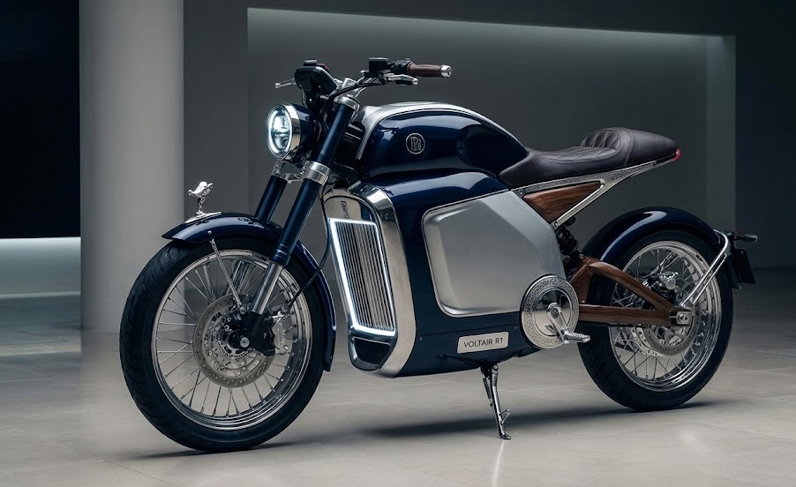
Figure 5 Voltair R1 Look
- Refined, Silent Power: Unlike competitor high-performance cars that ensure aggressive acceleration, the design of the R1 applies aerospace reach of Rolls-Royce to provide a waftable experience. The electric platform is optimised to run motionlessly and opulent acceleration, the distinctive calm and quiet luxury sense as opposed to performance-oriented aggression. This is an engineering decision that will make the otherwise silence of an electric motor into a symbol of quiet luxury to the Eco-Conscious Aesthetes.

2. Price
Voltair is using Ultra-High-End Premium Price Structure with Value-Based Pricing Strategy. This price is intentionally fixed higher than already high priced mid-to-high-end electric models.
- Veblen Effect and Exclusivity: The high price is a characteristic that serves to create increased values of the R1 as a status object and an object of desire to the Curated Collector. By offering a price point exclusive, Voltair sends an immediate message that the product itself is not targeting the market of the £10,000 market which has its own governmental grants, making sure that the brand is an exclusive and prestigious one.
Component | Strategic Rationale
Pricing Strategy | Value-Based Prestige Pricing. The price is based on the perceived value of exclusivity and bespoke luxury, not solely on manufacturing cost.
Anchor (Base) Price | £80,000$ to £100,000
Justification | This range firmly establishes the R1 in a separate tier above existing high-end competitors (£30K) and traditional petrol superbikes (£14K). This high price acts as a guarantee of superior quality and is an essential tool for reinforcing exclusivity.
Final Price Range | £120,000 and upwards
Justification | The final price is largely driven by the customization component. Given that the bespoke experience is 95% of the luxury proposition, the Curated Collector will add extensive, high-cost options, pushing the final price well into the six-figure range.

- Prestige Pricing: Voltair is using rounded prestige pricing (£100,000) and offers the final cost as being dependent on the amount of customization chosen by the client. This is a strategy that does not resort to standard retail pricing and focuses on the worth of high investment in the R1 as it is very important in a segment where there is no second-hand market to justify prices.

3. Place (Distribution)
Its distribution strategy will be Exclusive Distribution based on the Controlled Direct-to-Consumer (D2C) Model. Such a strategy is critical towards keeping up the image of an ultra-luxury brand and the risks of dealing with high-value assets.
- Voltair Atelier Showrooms: The R1 will be marketed with the fewest possible number of brand studios, the "Voltair Atelier" that will be situated only in global alpha cities with agglomerations of UHNWIs/HNWIs, including London. They are not dealership selling areas but consultancy design studios where the client is immersed into the creation of his or her motorcycle.
- Digital Private Portal: It is going to be a secure and encrypted online portal, which will be proposed as the main way of contact with existing Rolls-Royce owners and VICs to customise their orders, see their progress and get their private previews online. This recognises the digital savviness of the wealthy targeted group and restricts access to the purchasing process by the masses.
- Security and Control: The exclusive channel plays a very important role in risk management. Since the electric motorbikes are currently considered as a high risk when it comes to theft considering the fact that they are focal in the urban area, selling them in small studios which are regarded as safe places prevents it to be the only point of physical handling and thus the brand image and its prestige will remain intact, without the risk of over-diluting the image.

4. Promotion
The promotional strategy of Voltair is based on high-impact exclusive experiential marketing and relationship building, as opposed to the mass advertising of the product to the mass market. The communication objective is to sell sustainable opulence and unmatched craftsmanship.
- Exclusive Experiential Marketing: The main promotion activity is invitation only events and sneak preview in discrete and premium locations such as private galleries or estates. Such occasions use the psychological aspect of exclusivity and scarcity to create desire in the Curated Collector.
- Digital Storytelling and PR: PR does not use hard selling, but focuses on the brand positioning of the luxury level based on the digital narration. High-quality content, three-quarters of an inch long, exclusive on the top-tier of digital media, will include the bespoke development cycle, the Rolls-Royce legacy, and the responsible luxury the R1 promises. Strategic joint ventures will be aimed at luxury collectors’ clubs and sustainability-oriented magazines and magazines in order to be defined as an innovative and responsible market leader.
- High-Touch Relationship Building: Because HNWIs frequently use personal connexions to validate purchases, any engagement is a marketing opportunity. The brand is heavily dependent on creating effective Word-of-Mouth (WOM) among the current owners of Rolls-Royce as well as Very Important Clients (VICs).

Element 3: Marketing Strategy Pitch

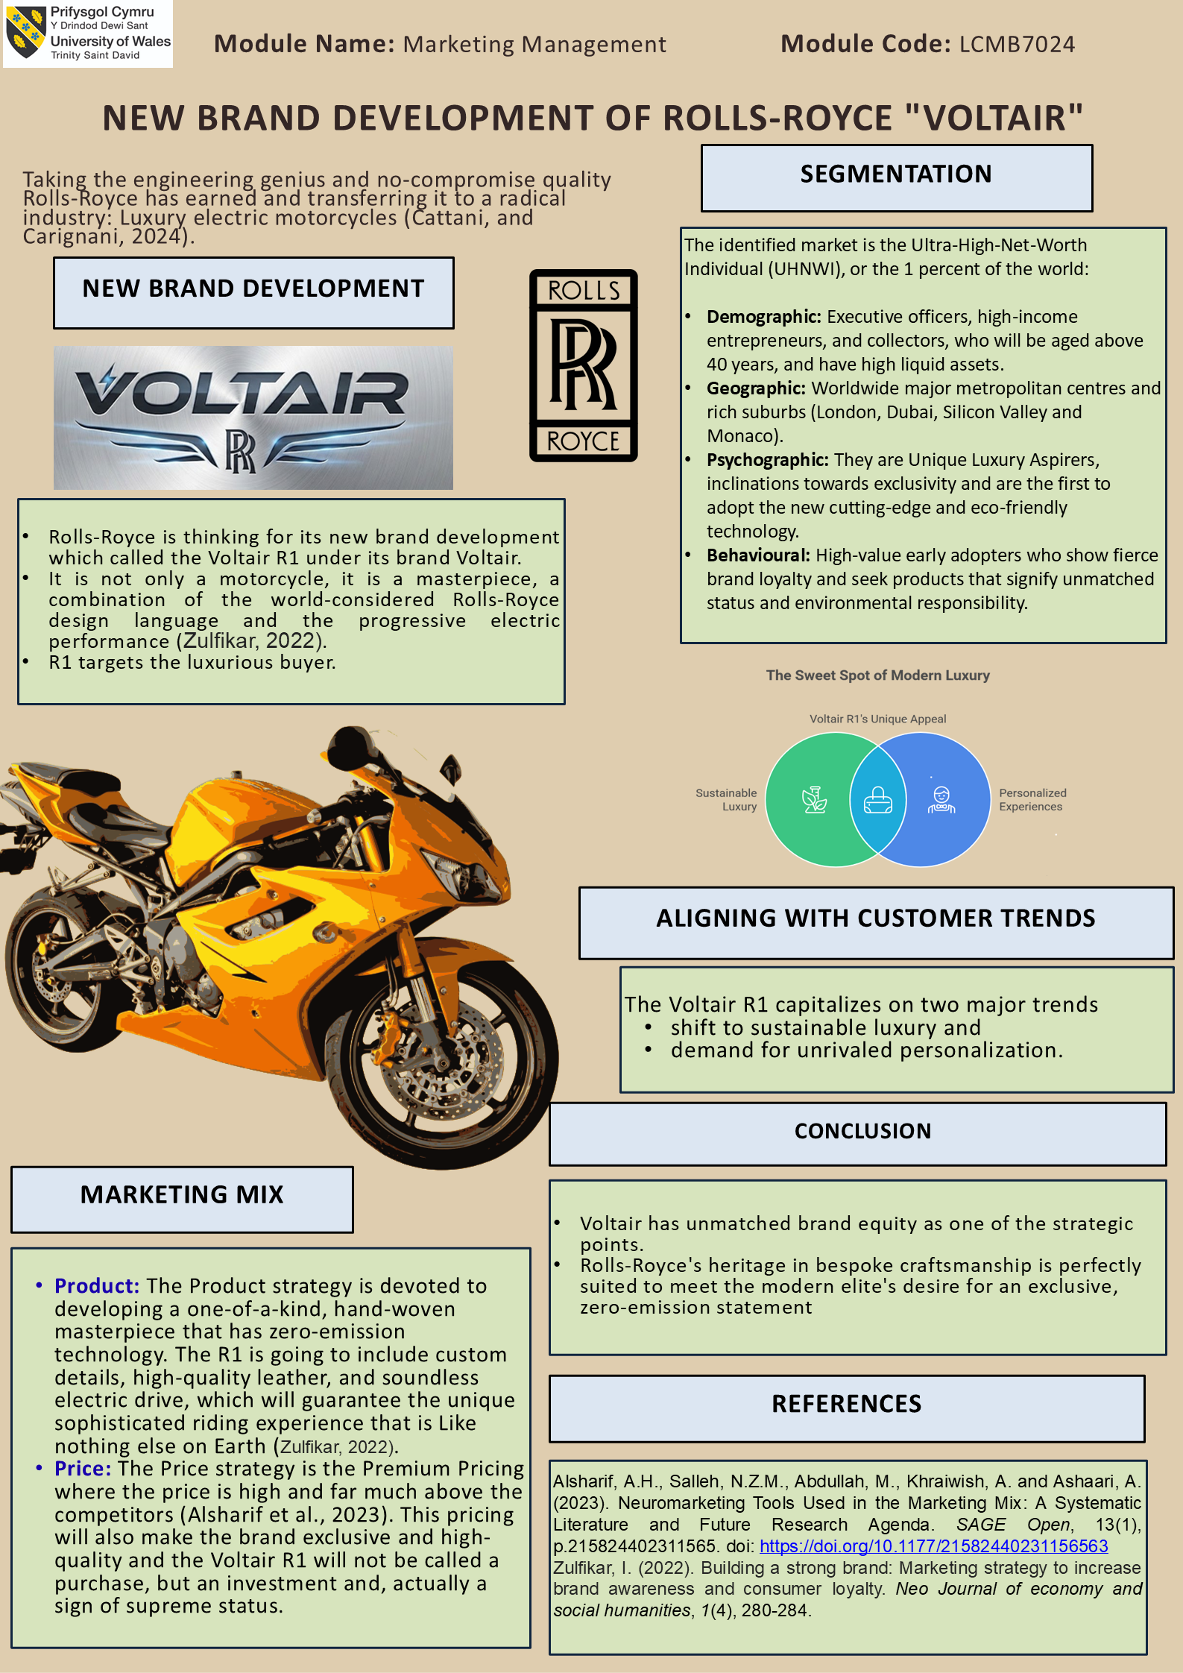

Element 4: Reflection

The reflection is an assessment of my learning process applied particularly in creation and presentation of the marketing strategy pitch of the Voltair brand based on a systematic model of the Gibbs Reflective Cycle (1988).
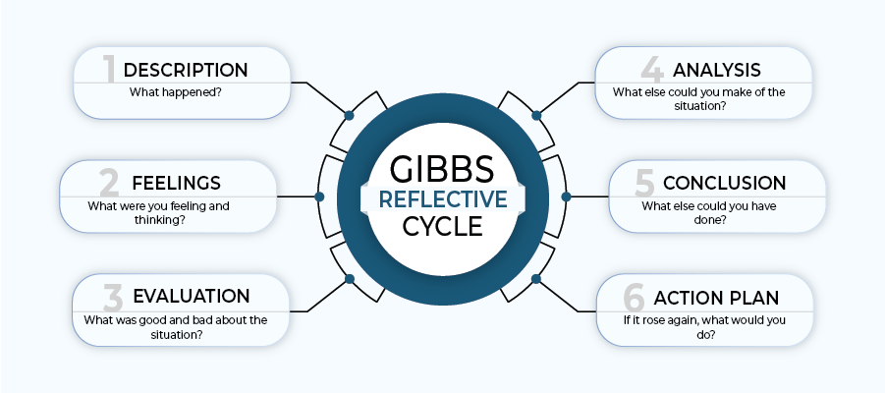
Figure 6 Gibbs Reflective Cycle; Source: (Assignment Desk, 2022)
1. Description
The marketing strategy pitch involved having to change a written strategy in detail, and condense it into a short, compelling oral presentation. The pitch was aimed at explaining the strategic fit of Voltair in the ultra-luxury electric mobility segment, why strategic decisions are made by STDP, and how the 4Ps brought the brand to where it was positioned with Rolls-Royce. Compared to the written report, pitch required being concise, confident, and narrating a story in a short amount of time.
2. Feelings
First, I experienced a mixture of excitement and pressure. Introducing a new luxurious brand with such a world-renowned name like Rolls-Royce raised high expectations towards the company. I had no doubts about the content but worryingly feared that I would not be able to explain and persuade the audience about complex strategic concepts in a clear and convincing way. Later, with the pitch, I was less nervous but I was aware of my style of delivery as well as the use of prepared notes.

3. Evaluation
My pitch had one of the strengths as the logical course of strategy especially the way I connected segmentation, positioning and pricing decisions with luxury consumer behaviour. I was capable of explaining why Voltair was targeting a niche segment of Curated Collector and the role of exclusivity and sustainability as the supporting value propositions. Although, one of my main weaknesses was that I used notes heavily, which decreased eye contact and the interaction with the audience. Also, I noticed that there were explanations that were too technical thus reducing the emotional aspect of the pitch a bit.
4. Analysis
The pitch development increased a number of valuable skills. I enhanced my strategic communication skill, which taught me to focus on the main insights and not show all the possible information. I also gained skills in brand storytelling, which entails that the marketing pitch on luxury products should not only appeal to the intellect, but it should also appeal to the emotion. One of the most important ones was the need to make complex pricing and positioning concepts simplified without reducing the strategic depth. This also marked a weakness in my verbal persuasion abilities especially on the ability to tailor language to live presentations.
4. Conclusion
In general, the pitch experience showed that a powerful marketing plan is not enough without comfortable and captivating presentation. I also got to know that pitch development is achieved through rehearsal, clarity and storytelling that are audience-oriented particularly in the case of luxury brands.
5. Action Plan
- Short-term: I will prepare visual pitch storyboards prior to scripting to minimize the use of notes and enhance the storyline.
- Medium-term: I will liberty practice time-limited mock presentations to enhance the presentation control and confidence to deliver.
- Long-term: I will enhance my strategic pitching techniques by concentrating on the methods of value-justification of ultra-premium brands, especially in the presentation live formats.

Conclusion

In general, the Voltair design and the marketing plan are the cases of how luxury legacy and contemporary sustainability could be implemented together. All metrics discussed in the STDP analysis, marketing mix, and strategic pitch make Voltair a first of a kind in the ultra-luxury electric motorcycles market. Through tailor-made engineering, performance and ethical creative approaches, the brand sets impressive grounds to its future expansion and competitive advantage.

References
Boeriu, H. (2014). 95% of Rolls-Royce cars purchased in 2013 were personalized by their owners. [online] BMW BLOG. Available at: https://www.bmwblog.com/2014/02/25/95-rolls-royce-cars-purchased-2013-personalized-owners/ [Accessed 2 Dec. 2025].
Corporate Finance Institute (2022). 4 Ps of Marketing. [online] Corporate Finance Institute. Available at: https://corporatefinanceinstitute.com/resources/management/4-ps-of-marketing/.
Fitz-Gibbons, M. (2024). Electric Motorcycle Guide (2024) – Is the future really electric? [online] Bennetts BikeSocial Membership. Available at: https://www.bennetts.co.uk/bikesocial/news-and-views/features/electric-motorcycles/guide.
Gale, A. (2024). London has 227,000 millionaires: More than Paris, but less than New York, and the figure is dropping. [online] Yahoo Finance. Available at: https://finance.yahoo.com/news/london-227-000-millionaires-more-073914040.html [Accessed 2 Dec. 2025].
Gibbs, G. (1988). Learning by doing: A guide to teaching and learning methods. Further Education Unit, Oxford Polytechnic, Oxford.
Hooley, G.J. et al. (2020) Marketing strategy and competitive positioning. Seventh edition. Harlow, England; Pearson.
imarcgroup (2025). UK Electric Motorcycles Market Size, Share, Report 2033. [online] Imarcgroup.com. Available at: https://www.imarcgroup.com/uk-electric-motorcycles-market.
Kotler, P., Armstrong, G., Harris, L. and Piercy, N. (2020) Principles of marketing. 8th European edn. Harlow: Pearson.
Kotler, P., Armstrong, G., Harris, L. and Piercy, N. (2020) Principles of marketing. 8th European edn. Harlow: Pearson.
Mordor Intelligence (2024). United Kingdom Luxury Goods Market Share, Growth | 2022 - 27. [online] www.mordorintelligence.com. Available at: https://www.mordorintelligence.com/industry-reports/united-kingdom-luxury-goods-market.
Rolls-Royce (2024). Home. [online] Rolls-roycemotorcars.com. Available at: https://www.rolls-roycemotorcars.com/en_GB/home.html.

