Reflective Review of Learning Journey
BMSK4005 (14th June 2019)

Professional Career Development

Yasmin Khalil
1100417

Table of Context
Executive summary………………………………………………………………………………………………3
Introduction…………………………………………………………………………………………………………4
SMART Objective………………………………………………………………………………………………….5
SWOT Analysis……………………………………………………………………………………………………..6
JoHari Windows Theory……………………………………………………………………………………….9
Myers Briggs Personality Profiling………………………………………………………………………11
VARK Learning Style……………………………………………………………………………………………12
The Go MAD Framework…………………………………………………………………………………….13
Personal Development Plan and Conclusion.……………………………………………………..15
References…………………………………………………………………………………………………………16

Executive Summary

“If you want something you’ve never had before, do things you’ve never done before” (Noke, 2012, p.44)

Professional career development skills are important in all aspects of business. In this report I will be demonstrating my understanding of my knowledge, skills, self awareness and personal potential. I will be outlining my personal development plan after establishing my personal career goals. In this report I will be bringing together all of my findings, research and evidence to show the various processes that will help me achieve my goal in a realist time. I will be outlining my strengths, weaknesses, opportunities and threats whilst going through different motivational theorist and models to support my documentation. All of my finding will be referenced using the Harvard system.

Introduction

When identifying development needs in relation to career development it is important to be self aware. In this document I will be gathering all of my finding and learnings from the last 5 weeks of lectures to produce a career plan.
The best place to start is to make a SMART plan and look into a S.W.O.T analysis on myself. After highlighting my strength, weaknesses, opportunities and threats I will be following that up with JoHari Windows Conversion Strategies.
I will then look at my personal preferred learning style and personality profiling that I undertook in class with different questionnaires. I will be discussing The VARK: how I learn best and Myer Briggs: personality profiling. Following that up with The GO MAD frame work to have a deeper understanding on the Why, What, How and When results. By looking at all these areas I can identify barriers and how to overcome them.
I will finish the document off with a PDP setting myself three key learning objective, explaining how I will monitor myself in a timely manner for a higher chance of successful results.

SMART Objective

“A goal without a plan is just a wish” (Saint-Exupery, Good Reads 2019)
SMART is a great way of setting particular objectives in order to reach the goal in mind. My goal is in 9 year from now I have a portfolio of 3 rented out properties. The big dream is to become a property investor with a property portfolio and to be comfortable enough to retire by the time I’m 50 years old and no longer work in a retail environment. Let’s take a closer look at my goal by dissecting it into the SMART Objective method. This will allow me to figure out if my goal is attainable. The SMART acronym stand for Specific, Measurable, Achievable, Realistic and Time-bound.
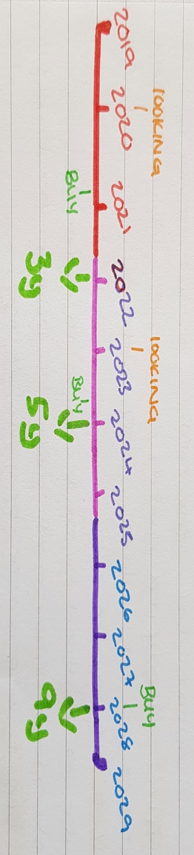
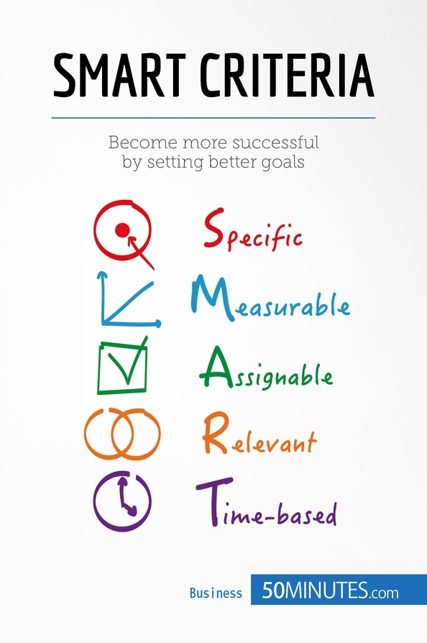
SMART- My 3-5 year plan:
I will be measuring this by using my last years actual savings as a target for this year. I can see how i am getting on by looking at my budgeting strategy through my online banking apps which i have 24/7 access too. Budgeting weekly and monthly spends.
If my circumstance don’t change massively then this is very realistic. And i have set myself a stretch goal. I will be happy with two properties by 2026 but I enjoy pushing myself. By micro managing/budgeting my finances like i have done last year and I achieved to save nearly half my annual salary i will continue to do the same over the next 5 years. Take advantages of the first time buyers government grants to help.
I will make this objective achievable by making sacrifices and compromises on my big holidays and limiting my self to materialistic luxury items. Always ask myself "do i want this? or do i need this?" for the next 5 years limit to 1 big holiday a year or 2-3 mini breaks a year. It Is Important to not be to hard on yourself to make successful gains all worth while.
Should have bought my first home by the end of 2020. This will give me opportunity to learn from any mistakes that were made in my first property bought when renting out e.g. Finding the right people, how long it realistically take from making the decision to buy to finally renting out. I will continue to save as I have been and purchase my second home by the end of 2023. The homes will ideally be targeting young couples, 2 bedrooms, off the main road and with easy access to public transport.

SWOT Analysis

Now that I have set myself a SMART goal the first step to learning and developing leadership skills is understanding one self (self-awareness). “Knowledge of self has been considered to be at the very heart of human behaviour and Management” (Showry, 2014, p.1) When criticising one's inner self it can only lead to developing a greater and kinder mental state, emotions, beliefs, desires and personality. A book called The 7 Habits of Highly Effective People by Stephen Covey talks about the importance of taking care of your self. He divides the habits into 3 categories such as; Accomplish, Connect and Grow. His final habit is called ‘Sharpen The Saw’ meaning “if we fail to build our personal capacity in these areas we quickly become ‘dulled’, and worn out” (Covey, S. 1995) the imbalance will effect us negatively not only in the present but also in the future. He encourages that we continuously look to strengthen our body, heart, mind and soul.
It is important to be aware of my strengths and weaknesses but also understanding where my opportunities and threats lie. To analyse these areas I will produce a SWOT analysis on myself. The SWOT acronym stands for Strength, Weakness, Opportunity and Threat. A SWOT framework helps to analyse and focus in on the internal factors i.e strengths/weaknesses and external factors i.e opportunities/threats. The example below shows what I have discovered after looking deeper into my habits and the circumstance around me. Some of the these habits I had noticed was only due to focusing on the specifics and otherwise wouldn’t have been picked up if I hadn’t done a SWOT.

- I can build good relationships
- I am a visionary
- I have friends that also have properties
- Able to compromise
- Adaptable
- I am very fickle
- Perfectionist
- Procrastinator
- Hard to trust others
- Falling off the waggon e.g. Healthy diet
- Living at home (saving money)
- Brexit (property price dropping)
- Pay rise in work
- Make new relevant contacts
- This course (refocus)

Strengths
- Living at home (personal relationships)
- Brexit (inflation)
- Secondment only (6mth payrise)
- Visionary- as much as I enjoy doing thins spontaneously I also love to plan ahead for big future event. I don’t enjoy surprises and prefer to be in total control. I have always been creative which helps me vision where I want to be in my future or bringing the image in my head to life. This is a positive way of thinking because it will help me keep focused on my long term plan whilst being in control of my results.
- Building relationships- I am a loud and bubbly character which has always helped me to gain trust with my fellow colleagues and clients. With this strength I will use it to build a contact list of people from the trade e.g. Builders, plumbers, landscapers, painter decorators, electricians
- Adaptable- This is a positive trait to have and I have demonstrated many time in my previous job roles that I allow constructive criticism. I believe change is good as long as it is coming from a proven or wise source.
- Friends in the Field- I have like minded friends who have successfully started developing their own portfolios and are willing to mentor me through my new adventure.

Weaknesses
- Fickle- I have a tendency to change my mind frequently or change direction due to outside influences or my emotional state. Sometimes I take things to heart e.g. If someone knocks my confidence back I either try and prove them wrong or I begin to doubt myself belief. I need to stay positive and not allow others to bring me down and not overthink
- Trusting others- I find it hard to trust people as I have been let down so many times. This is why I like being in total control. Sometimes I feel that people take my kindness and abuse it for their own beneficial needs. A person’s loyalty changes depending on what you can offer them. This isn’t great as I need to trust others to do their job properly otherwise I wont make a good list of contacts in the trade.
- Procrastinator- This is my biggest weakness. I am always last minute to everything e.g. Work, assignment, getting on a train or even conference calls. You will always find me speed walking to my destination. Time management is something I need to work on.

Opportunities
- Living at home- My parents allowing me to move back in with them has given me the greatest opportunity and chance to reanalyse my future plans. I am saving a lot by not have has much responsibility as I did when I lived on my own. My parents are apart of my support network. Giving me sound advise when I need it.
- Pay rise- An opportunity has come up in work for a secondment position. I will be the Store Manager during the time my boss takes over my Regionals position during her maternity leave. This will last maximum of 6 month
- Brexit- with a lot of uncertainty of what will happen when we leave the EU i think this might be an opportunity where the prices on properties may drop. Track record shows that when UK was going through recession the prices of house fell by 36%. This could work to my benefit and I could get more for my money

Threats
- Living at home- being 26 years of age and have had lived on my own for 5 years prior its hard adjusting back into ‘the house rules’. The temptation is there to move out and have my freedom back. Living at home has changed my social life and how I socialise with my friends.
- Secondment- the position is only for 6 months which means I will drop back down to my normal pay.
- Brexit- with a lot of uncertainty around the topic of how it will effect our economy prices of houses may go up due to inflation

JoHari Window Theory

After looking at my SWOT analysis I’ve decided to expand on my self awareness by using the JoHari Windows model. This is a useful tool for self discovery and personal growth. This tool is known as a disclosure/feedback model of self-awareness and some people call it a information processing tool. The model first looks at your strengths, weakness and areas that we don’t usual disclose or aware of. The aim is for mutual understanding through constructive feedback and disclosure. This model can only be done in a high trust environment. If it is done correctly it will then allows us to increase the open area and reduce the hidden, blind and unknown areas. (Normore and Long and Javidi, 2016 p.410)
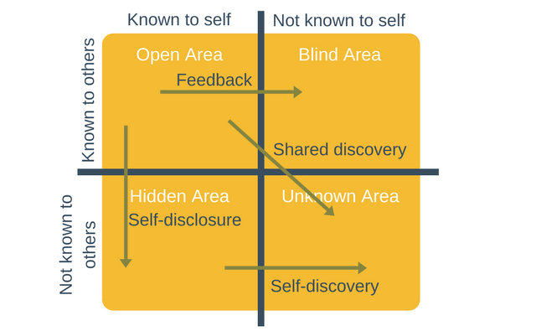
- Impatient
- Working under pressure everyone else can feel it
- Bossy
- Straight forward
- Worrier
- Likes to feel needed
- Easily bored
- People management skills
- Good communicator
- Trustworthy
- Compassionate
- Supporter
- Find it hard to trust people
- Observant
- Forgive easily
(Export program management, 2019)

The Johari Windows is a compound of four areas. In the above diagram are the four areas and my personal attributes. I will expand on my findings below and explain how I intend to use the model to increase my open areas.
- Open area- in this area you have what you already know about yourself and what everyone else’s knows about you. I am a compassionate manager who take it upon myself to get to know the people who work for me. A genuine interest in their personal life make clients and colleagues more comfortable around you.
- Blind area- in this area these are traits you don’t realise you have but everyone else can see it. I was told by my store manager how my bad habit of wanting to do everything all at once was coming across negatively to my colleagues because I wouldn’t focus on one thing at a time. Which would then lead me to managing my time badly and my mood would effect the others around me. By having this feedback I was able to reconstruct the way I delegate tasks by making ‘to do lists’ and be aware of my body language/verbal language/mood (feedback/opens up area)
- Hidden area- this is your secrets. Things that you know about yourself and don’t necessarily want others to know about you. I find it hard to trust people and therefore I’m very observant. This is something I would like to work on as I need to be able to trust people in the building trade otherwise nothing will ever get done. I need to be able to make new contacts and deal with new people without thinking they have a hidden agenda. Also this is not healthy for my emotional and metal state. However by my mentors knowing this about me it will help because they will pass me on their contacts for reassurance (shared discovery)
- Unknown area- this area is when you and others start to discover new things about you. I get easily bored when I don’t see results quickly. So to help me with this attribute I’ve decided to take on the ‘Jim Kiwk Weekly Challenge’ and have invited my best friend to do it with me. Creating positive habit change but by taking small steps. All of the challenges are to strengthen the mind, body and spirit. (Shared discovery)

Myers Briggs Personality Test

After discovering and disclosing my attributes to make positive impact on my self worth, I believe it would be helpful to understand my personality. This would give me an indications of why I do things the way I do.
For this part of my document I will be looking at my personality by using The Myers Briggs Personality Profiling Test. According to this theory there are 16 different personality types that an individual can be categorised into. This introspective self-report questionnaire Is used in many corporate businesses. It helps indicate different psychological preferences from how an individual perceives the world to why they make the decisions that they do.
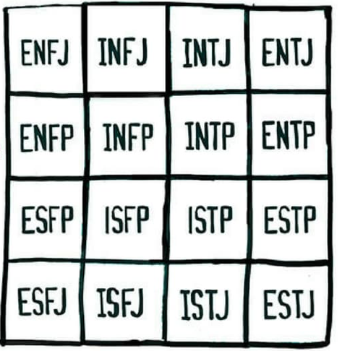
The diagram below shows all 16 possible abbreviations of personalities. One personality can only be made up of 4 letters. They are separated into 4 pairs dichotomy known as Perception, Judging, Deductive and Inductive. Each letter represents a preference:
(E)- Extraversion
(S)- Sensing
(T)- Thinking
(J)- Judging
(I)- Introversion
(N)- Intuition
(F)- Feeling
(P)- Perception

(Sol, M (2019) Lonerwolf)

I have done this test twice to see if I got different results each time. Both were done on the same day. The first questionnaire was a task set out in class. The questionnaire was restricted to two preferences per example. After completing this my results were ENFP also known as The Campaigner Personality. Couple of hours later I decided to do the online test to see if there would be a difference in my results. The answers to the online questionnaire is set out as a scale on how much you agree or disagree with the example given. My results changed to ESFP also know as The Entertainer Personality. As we can see there are some preference that haven’t changed such as- Extrovert, Feeling and Perception.When learning something new I am extraverted and prefer to use my feelings to determine if I believe it will work. After reading about both personalities I believe that I can sit in both categories however I feel as though I can relate more to The Entertainers Profiling. This was an interesting experiment and has help me understand why I behave the way I do in certain situations. Its helped me understand the strengths and weaknesses of my personality. I have listened them below:
Strengths
- Bold
- Original
- Aesthetic and showmanship
- Practical
- Observant
- Excellent people skills
Weaknesses
- Sensitive
- Conflict-averse
- Easily bored
- Poor long term planner
- Unfocused
(16Personalities, 2019)

VARK Model

“Im different, not dumb” (Allen, K & Sheve, J & Nieter, V, 2010. p.95)
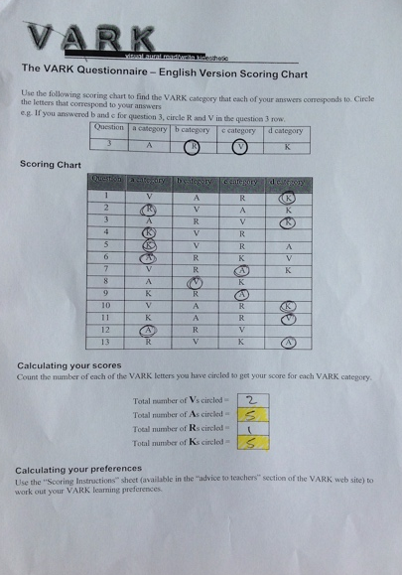
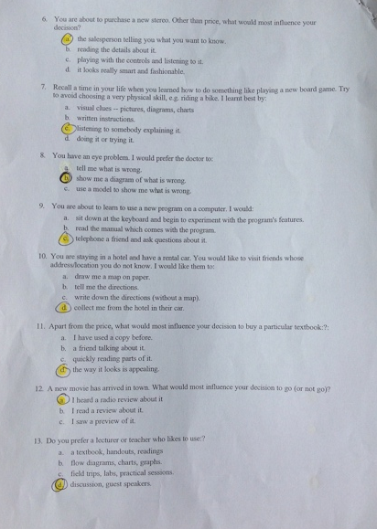
In class we were set out to do a questionnaire to find out what our preferred learning style was. For this part of my learning journey I will be looking at the VARK Model to find out what style of learning I get most out of. Neil Fleming created this simple and effective way to understand how individuals prefer to take in or to put out information. The acronym stands for Visual,Aural, Read/Write and Kinaesthetic. Back in year 2000 I did a VARK questionnaire and my results showed I was fully a kinaesthetic learner. It was in interesting to see the other areas that I have developed my learning preference into now that technology has advanced in the last 19 years. Below I have added the questionnaire that I completed in class. The results now show that I have an equal split between Aural and Kinaesthetic preferences.
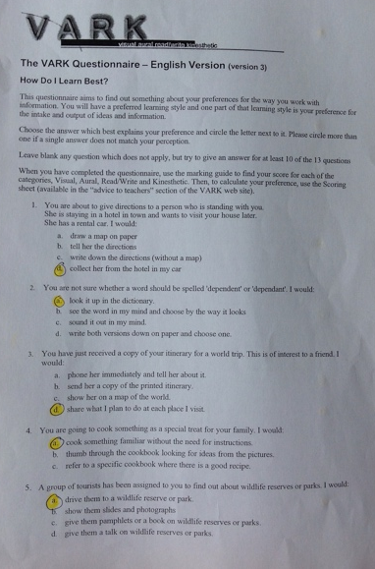
I believe that this is very accurate because I learn by watching and listening. Whenever I need instructions to put something together I rather find it on YouTube and watch/listen whilst I physically follow the instructions given.

The Go MAD Frame

“Do you want to stay in the same or make a difference- Go MAD” (Gomadthinking.com, 2019)
The Go MAD model is a success results frame work created by Andy Gilbert and Ian Chakrvorty in 1999. It was made to be an effective and efficient way to create success by looking at the: Why? Who? What? When? Where? And How?. This framework can not only be used for coaching but also a great for a diagnostic or analytical tool. I will be explaining this first part of my goal and how I will be using this tool whilst linking it to the SMART objective theory.
Below I have made the Go MAD work frame:
Take action & measure the results
7
Importance
Strengths
Check
Task
The buy in
Achievability

Level2
Level3
Level1
Personal responsibility
6
Define goals
1
Plan priorities
4
Reason why
2
Self belief
3
Involve others
5

Internal Triangle (bottom left)
Define Goal- When defining the goal we look at the specific and the time. My personal goal is to buy my first investment property by April 2020 and to have it rented out before the end of year 2020. The property to should be minimum of 2 bedrooms, off a main road, near to a public transport route and a school.
Going across the Strength line
Reason why- There can be many reasons why one might want to achieve their goal but the most important reason is the strongest and normally the first one you think of. Focus on the relevance/realistic aspect. I want to achieve this goal because I want to make an investment for my future. I want to have assets to my name and also feel secure as an independent woman.
Going up through the Achievability line
Self Belief- this is all about your confidence within yourself. How badly do you want your dream to become true? Take a look if the goal is achievable and if so then is it measurable?
Currently I am measuring my progress by saving money and using my banking apps to help me keep an eye on my finance.

External Triangle (bottom right)
Plan and Priorities- in this section we think about all the possibilities. We might even find that our first plan isn’t time-bound enough or that we can achieve the goal quicker than expected. Thinking about the resources, tasks, people involved.
Going up the task line
I have already been out to speak to my local bank about different types of mortgages available to me and so far the feedback has been positive.
Involve others- I have many supportive circle of friends and family but I have a female mentor who is one of my best friends whom already has a property portfolio.
The buy in line
She heard my plan start of this year and was happy and willing to help me with my development. This also give reassurance that my goal is achievable. This means that my goal hasn’t changed and my reason are still strong to continue this journey and my self belief remains high.

Personal responsibility- this is linked to all the other boxes. Taking accountability will make us strive to achieve. It will make us determine, take action and measure our own results. If the result we want isn’t there when expected then its time to reanalyse where we were lacked and rebuild the frame.

Personal Development Plan

Skills needed to help achieve my goal | Specific actions that will help achieve this | When will this be achieved | What support is required | Review
1. KNOWLEDGE | Go to a conference held by Kevin Green Wealth in Cardiff  Research what to look out for when purchasing property e.g history | KGW Gift of Wealth Coach  23rd June 2019 | This course is helping me identify the gaps in my knowledge -course  Internet research  Conferences  Local councils info
2. MANAGEMENT | Managing my finances by talking with bankers, mortgage brokers and other people with experience in this field | Speak to mortgage brokers/advisors 9th February 2020 | Finical advice from Daniel- accountant  Starting out advice from Elin/Cello- property portfolios  Banks and leaders  Legal advice from Zakiya- solicitor
3. COMMUNICATION | Note down where all the traders go when purchasing for properties e.g. Selco’s, crown centre, plumbing point, Hancock and brown  Building trust worthy contact list of trades men | Build contact list and make traders accounts by April 2020 | Gower college students that study certain trades.  Cello/Elin contacts  Oliver is an electrician  University course working with others

Conclusion
Through understanding all my different learning styles and goal setting models I have become more confident in striving forward for what I want. I intend to use some of the methods in my current job role as a ASM/SM but also to achieve my current goal set. Applying a SWOT analysis on myself has allowed me to understand my opportunities. The Go MAD framework has also made me look at specific details within my plans and priorities certain areas. My SMART goal will become a reality and I will be successful.

Referencing

Gomadthinking.com. (2019). Go MAD Thinking. Available at: https://www.gomadthinking.com (Accessed: 7th June 2019)

Covey, S.R, Merrill A.R and Merrill, R. (1995) First Things First. USA, Prentice Hall & IBD.

Allen, K, Sheve, J and Nieter V. (2010) Understanding Different Learning Styles. California, Shell Education.

16Personalities. (2019). Strengths & Weaknesses | Entertainer Personality (ESFP-A / ESFP-T). Available at: https://www.16personalities.com/esfp-strengths-and-weaknesses (Accessed: 7th June 2019).

Sol, M. (2019). Free Personality Test – Which of These 16 Temperament Types Are You?. Available at: https://lonerwolf.com/free-personality-test/ (Accessed: 7th June 2019)

Expert Program Management (2019) Johari Windows Model. Available at: https://expertprogrammanagement.com/2017/06/johari-window-model/ (accessed: 6th June 2019)

Normore, A., Long, L. and Javidi, M. (2016). Handbook of research on effective communication, leadership, and conflict resolution. USA, IGI Global

Showry, M. (2014) ‘Self-awareness- Key to effective leader’, IUP Journal of Soft Skills, V8 i/1. Available at: https://search.proquest.com/docview/1540082133?pq-origsite=gscholar (Accessed: 3rd June 2019)

Saint-Exupery, A. (2019) Good reads. Available at: https://www.goodreads.com/quotes/87476-a-goal-without-a-plan-is-just-a-wish (Accessed: 2nd June 2019)

Noke, C. (2012) There is not time like the present to create your future. America: Parry Design Studio Inc

