University of Wales Trinity Saint David – International Hotel Management
Foreign Languages & Cultural Awareness (M5X01923_LON)
Student: Milena Taneva
Student number: 1815095
M5X01923_FLC_A5_Oct 19 - Part 1
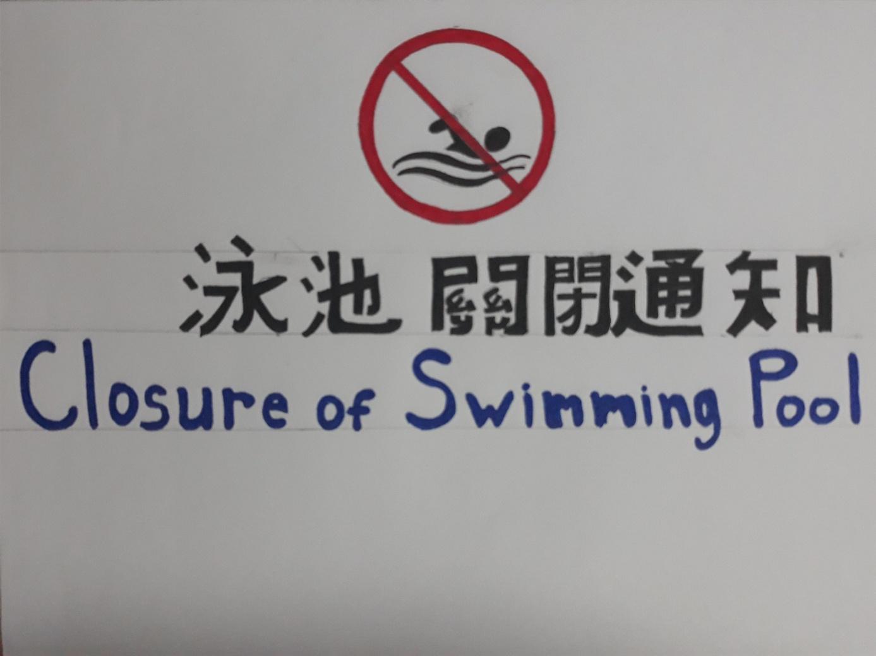
Chinese Signboard

