

Morgan Wheeler

Mechanical & Manufacturing Engineering

University of Wales Trinity Saint David

Reflective Project Report

ACMA5009 – Group Project

27th May 2022

Table of Contents
1. Introduction: 4
1.1.1 Aims of the report 4
1.1.2 Project Background 4
2. Project Plan 5
3. Gantt Chart 5
4. Pert Charts 5
5. Feasibility Studies 6
6. Failure Mode & Effect Analysis 6
7. Product Design Specification 7
8. Character Selection Matrix 7
9. Work Breakdown Structure 8
10. Design 8
11. Communication 10
12. Implementation & Testing 11
13. Project Management Methodologies 12
14. Conclusion 14
15. Works Cited 16
16. Appendices 17
Appendix. 1 – Gantt Chart: 17
Appendix. 2 – Critical Path Analysis: 18
Appendix. 3 – Feasibility Studies: 19
Appendix. 4 – FMEA: 19
Appendix. 5 – Product Design Specification: 20
Appendix. 6 – Character Selection Matrix 22
Appendix. 7 – Work Breakdown Structure 23

Figure 1 - Marketing Stand CAD Models 9
Figure 2 - Marketing Stand CAD Models 9
Figure 3 - Mobile Console Unit Front view CAD Models 9
Figure 4 - Mobile Console Unit Rear View CAD Models 9
Figure 5 - Render of Connected System AIX setup 10
Figure 6 - Basic Connected System Hardware Setup 11

Introduction:

The Connected system consists of a series of sensors and hardware which all connect and communicate together. The state of the Hall Effect sensors will then send feedback to an HMI (Human-Machine Interface), via an IoT Edge Controller (IoTEC). Each seat in an aircraft would have an IoTEC which would send the messages wirelessly to an IoT Gateway (IoTGW). The IoTGW acts as a hub for all the IoTEC’s. There may be one or two IoTGW in an aircraft cabin to receive all the IoTEC’s messages. The HMI will give written statuses and graphic indications to different features of the suite. This will help cabin crew to predict the passenger’s seat status. It will also be able to help on-the-ground maintenance crews by live updates, if there are issues with a seat or seat features, they will send error codes and be logged in an analytics portal. This will help maintenance crews be able to carry out quick turnarounds by ordering the component needed immediately or to be able to get ready to carry out maintenance in an efficient and effective manner.

Aims of the report

The aim of this reflective report is to be able to reflect on the project that was undertaken in Safran Seats GB (SSGB). The report will reflect on how the project could’ve been improved by better collaboration between suppliers and sister companies within the business.
This project will also reflect on the project management techniques that were used within the project such as PERT, GANTT charts, Critical Path and WBS (Work Breakdown Structure) and how effective these techniques were. This report will also analyse the project management techniques and learn about new techniques and theories such as Scrum, Agile, Waterfall, Adaptive Project Framework and how they could be implemented to the project to have an improved outcome.

Project Background

Safran Aerospace recently acquired the whole of Zodiac Aerospace just before the COVID-19 pandemic. This means Safran has taken a longer time to adjust within the seating market however, they injected a lot of money into research & development for new technologies to be introduced so that they are competitive in the market. The need for the Connected system is to reduce the total amount of time cabin crew must walk up and down the aircraft, to check the seat positions and seat feature positions are all in the Taxi, Take-off and Landing (TTL) position. The TTL position consists of all features such as meal table and armrests stowed, backrest is in the up position (not in bed or recline) and seatbelts being buckled while a passenger (PAX) is occupying the seat. The Connected system is an R&T project, which will eventually be sold to airlines. This system will help to modernise the seats within an aircraft, as well as using new technology that will benefit both the passenger and cabin crew. This project wasn’t requested by airlines however, after a working prototype was produced and presented to customers, this technology has become a very popular product and is expected to be sold to a lot of airlines in the future once the system has matured.

Some systems that use the same concept as the Connected system are seatbelts. Seatbelts have sensors in the buckle socket so when the latch plate is inserted, the sensor circuit is complete. When the latch plate isn’t inserted into buckle socket, a visual image will be displayed on the dashboard to inform the driver that the seatbelt is not secured.

Project Plan

During the Connected project, it was scheduled and tracked by using various tools and techniques that will be analysed in this report to explain how and why they were used. JotForm (2021) describes the importance of project planning is to utilise resources, time, labour as much as possible. This can help the project be more efficient and less stressful for project managers and employees.

Gantt Chart

A Gantt chart was utilised to be able to track key milestones throughout the project. A Gantt chart is used to log every activity that will take place during the project. The activity will then be given target dates in which the activity should be completed, and a progress bar to demonstrate how much of the individual activity is complete. They work by using a traffic light system (colours may vary). At the start of the project, you set target dates to work towards and plot them on the Excel spreadsheet in a colour to represent targets. Other colours are then used to track progress on the project. Red is then used to identify any targets that have not been met. The Gantt chart could then be modified to alter any set targets that have been missed or are unachievable.
The main topics such as overview, research, planning & implementation were the main headings; the documents that were relevant to those sections were the placed beneath the relevant headings.
Gant charts are one of the most popular project management methods as it is a very clear and easy to understand tool. For people who have never seen a Gantt chart, it wouldn’t take long to understand how it works. However, Gantt charts can be quite complex when creating one. There are a lot of rules and formulas in excel which can be used to help make the tool be updated and maintained easier. To see the full Gantt chart, see (Appendix. 1)

Pert Charts

Pert charts were implemented before the start of the project to give tasks estimated timeframes during the project. These are useful especially in the implementation section of the project, as it gave a good insight into how long the implementation process would take. They do not have to be carried out on every section, as some sections e.g., conclusions may not be relevant to do a pert chart on. They also allow tasks to be prioritised and determine which tasks can be done in tandem with other tasks, also to state the dependencies within the project (Williams, 2022). This was a good guide to follow to do the correct tasks at certain times. Pert charts and Gantt charts should align with each other on the number of days or weeks certain tasks should take, otherwise they can contradict each other.
Pert charts are also very useful as they can be adapted to demonstrate the critical path.
Critical path is a good tool to use to calculate the amount of flexible days (total float) within the project. Critical path analysis states the dependencies and the best and worst-case scenario timelines.
To see the Critical Path analysis, see (Appendix. 2)

Feasibility Studies

Feasibility studies were used to determine which project would be the most suitable. When picking between projects, it is important to demonstrate why that project has been picked over the other projects. All of the projects should have the same criteria compared as the category can be given a score to see which project is more feasible in that area. Once all project feasibility tables have been filled out, they should also be given a score and a percentage as this is where it is determined what project is the most feasible. The higher the percentage, the more feasible the project is. This method is just a tool to advise and give evidence why the chosen project has been picked. Bridges, J (2021) describes that the studies help to narrow down the key elements of any project and how achieveable that criteria is.
To see the Feasibility Study table, see (Appendix. 3)

Failure Mode & Effect Analysis

The FMEA analytical tool which was used was the FMEA table. In the document, a table is created and then document how the project might fail and cause other problems which need solutions. The failure must then be met with a ‘Potential Cause’. This is where the suspected failure will come from e.g., the wrong hardware could’ve been used or delivered. The potential effects of the wrong hardware must also be stated. Once the failure mode has been clearly indicated, there should be suitable solutions to ensure that this failure doesn’t occur or there is a plan to decrease the frequency of this problem. There are then several scales which must be looked at. These scales are the severity, occurrence and detection scales.
The severity scale will show how severe the failure will be. This is an important scale as it can help to prioritise the failures to ensure those with the higher severity have suitable solutions. The scale is scored by one = no severe problems and ten = critical concerns.
The occurrence scale is to help show the number of times the problem occurs. The more the problem occurs the more severe the problem might get. The occurrence number should be as low as possible.
The detection scale will be how easy the failure is to detect. If the problem occurring is not something visible, then the detection rate will be very uncertain. This may also make fault finding harder as the detection isn’t an obvious one.
Once these columns have been filled in with the severity, detection and occurrence of the failure, these can all be multiplied together to find the Risk Priority Number (RPN). The higher this number is, the more that problem should become a priority to fix. The lower the RPN the less serious the failure is, but they should still be fixed when they are suitable to do so (Forrest, 2022).
The largest RPN shows that the highest potential failure is between the IoT Edge Controller and the IoT Gateway. The wireless connection between both pieces of hardware could fail or there could be a long delay between the IoTEC transmitting messages and the IoTGW receiving those messages. This could mean that there are problems with the wireless module which is being used. This problem would get even worse when additional IoTEC’s were connected to the IoTGW. To control this, the hardware may have to be updated / changed to be able to cope with the number of messages being sent between the IoTGW and the IoTEC. The severity of this problem was quite high as this meant the system couldn’t function properly; the occurrence of this problem would happen every time the system is used, and the detection scale would also be high as it would be obvious to see the problem occurring.
To see the Failure Mode & Effective Analysis, See (Appendix. 4)

Product Design Specification

Once a project was chosen, a Product Design Specification (PDS) was created for the IoTEC & IoTGW hardware. Technical Foam Services, (2022) describes how a PDS must have a clear list of information outlining the specific requirements which must be adhered to. Once a project is completed, it will usually be checked against the PDS to ensure that the requirements have been met. A PDS will usually contain performance requirements, sizes, weights, materials, cost and many other points.
The Connected system had to be created which involved creating new hardware, sensors & software which must be airworthy to demonstrate to potential airline customers. Creating an airworthy system is a very costly project so the budget of this system was roughly £750,000. To make a sensor airworthy, it must adhere to certain tests setout by governing bodies such as the FAA and EASA. The sensor could cost less than a pound to purchase but once it becomes airworthy, it can cost more up to thirty pounds for one sensor.
A full copy of the PDS can be found in (Appendix. 5)

Character Selection Matrix

Character Selection Matrix (CSM) are similar to feasibility tables as they compare different components used within the project e.g. the Connected system needed sensors to be installed in the seat and furniture around the suite, this meant that the best fit for purpose sensors had to be chosen. Research was undertaken to compare various sensors and then each category was given a score.
From the CSM, it is clear that the Hall Effect sensor had the best score scores and was the most consistent through all of the categories. You can also see that the electro-mechanical sensor was the worst sensor that could’ve been used due to the sensor having moving parts, weighing more than all the other sensors and being very expensive. This tool can be used on various components if there are some uncertainties about what components to use within the project. It is important to conduct research into the components being considered as it provides evidence and technical data about the components. The Character Selection Matrix can be found in (Appendix. 6)

Work Breakdown Structure

A work breakdown structure (WBS) is a good project management tool to use as it is a breakdown of the tasks and actions which need to be completed. This breakdown should also assign companies to those individual tasks so that there is no confusion on all the deliverables. By creating the WBS, the actions could be grouped by suppliers, so they know the steps of what actions needed to be done next.
The SSGB actions included developing new sensors and electrical systems to be implemented into the seat, setting a scope for SCC to be able to create a HMI and then testing the systems once integrated to ensure all of the peripherals communicate effectively with each other.
SSUS oversaw the building of the Z400 (Triple PAX) and Z600 (Double PAX) seat structure which were modified to accommodate the Hall Effect sensors for the Connected system.
Safran Cabin Controls created the Human Machine Interface (HMI) and the hardware that consisted of the IoTGW and IoTEC. Safran Passenger Innovations then had to create an analytical portal which links to the HMI so data can be recorded and saved. The point of the portal is so airlines can see that they are able to use that certain data, to come up with their own applications for what they feel is useful. There were plenty of testing sessions between SSGB and SCC to be able to modify the HMI to make it more presentable for customer demonstrations and the Aircraft Interior Experience (AIX) show.
Safran Aero Systems took the lead on writing the Interface Control Document (ICD). This document is vital to allow multiple systems and subsystems work correctly, so all suppliers are working to the same ICD and are aligned with all the information with integrating with each other. This will indicate all the pinouts for connectors and CANBUS communication information (Garrett, 2007).
To view the Work Breakdown Structure, see (Appendix. 7)

Design

As part of the project, there was a need to design a mobile console unit that would have all of the hardware located within it, also a marketing stand that contains the same sensors that would be installed on a seat. Both of these units were created for the AIX show. The marketing stand was mad for using in demonstrations and exhibitions instead of shipping a full first class / business suite around which would have incurred large shipping costs and long lead times due to customs. The marketing stand could be easily shipped and is more aesthetically pleasing to customers and for sales demonstrations.
The mobile console unit was designed so it can show off the technology within the unit to make the connected system work; it would also have PC’s, Ethernet switches and cable routing in the rear of the unit so that it was disguised and neat.

The marketing stand and mobile console were designed using SolidWorks CAD software by the industrial design team and prototype builder.

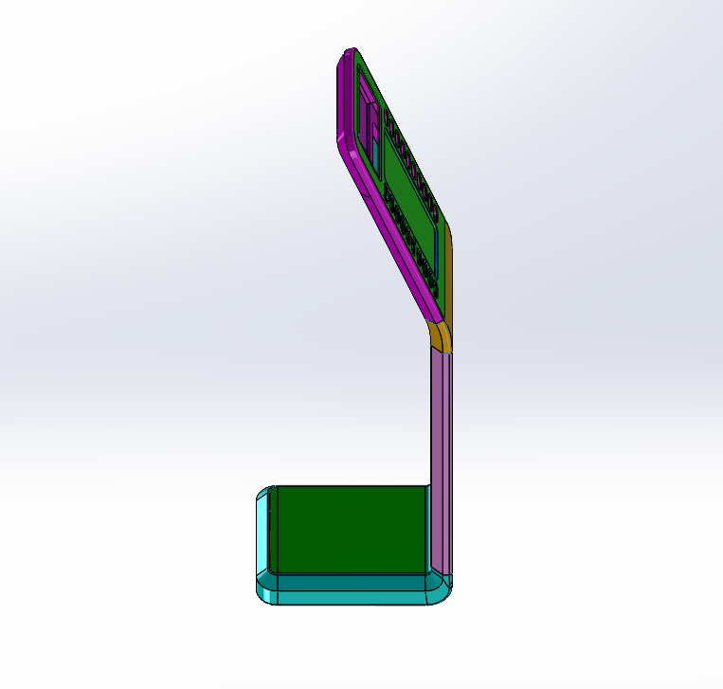
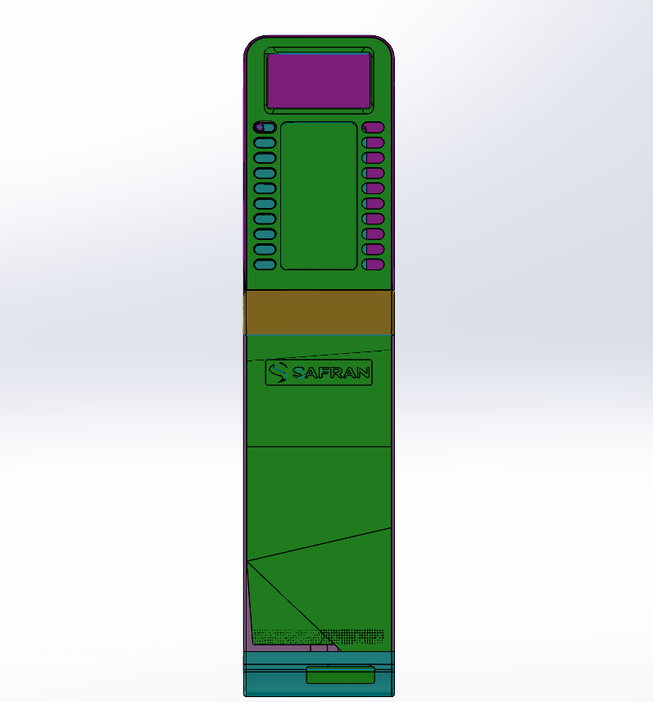
Figure 2 - Marketing Stand CAD Models

Figure 1 - Marketing Stand CAD Models
It was decided that the marketing stand should be an interactive stand that can accommodate economy, premium economy, business class and first class variant seats. The different seats are shown via printed inlays so that all variants can be shown on two marketing stands.

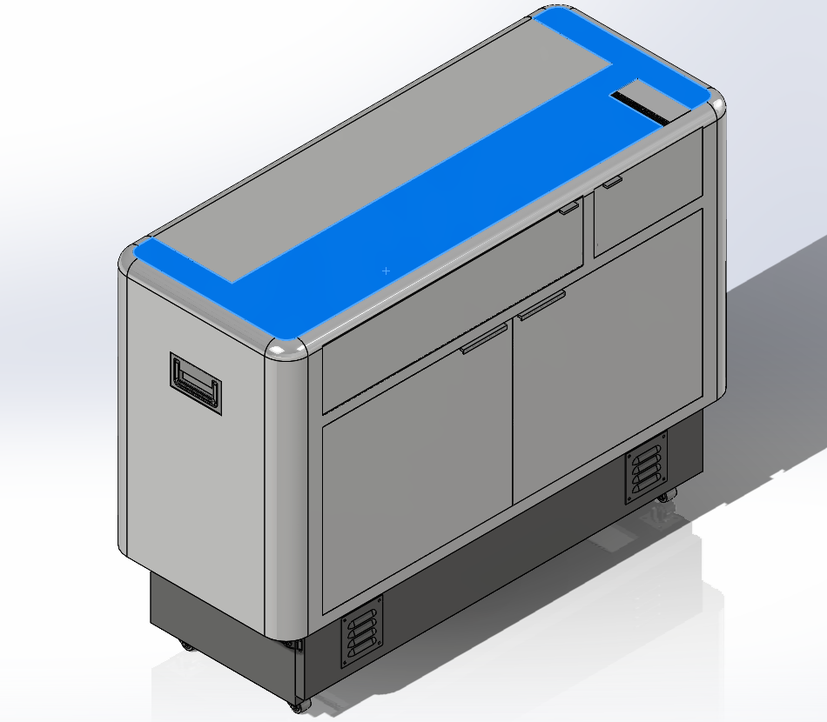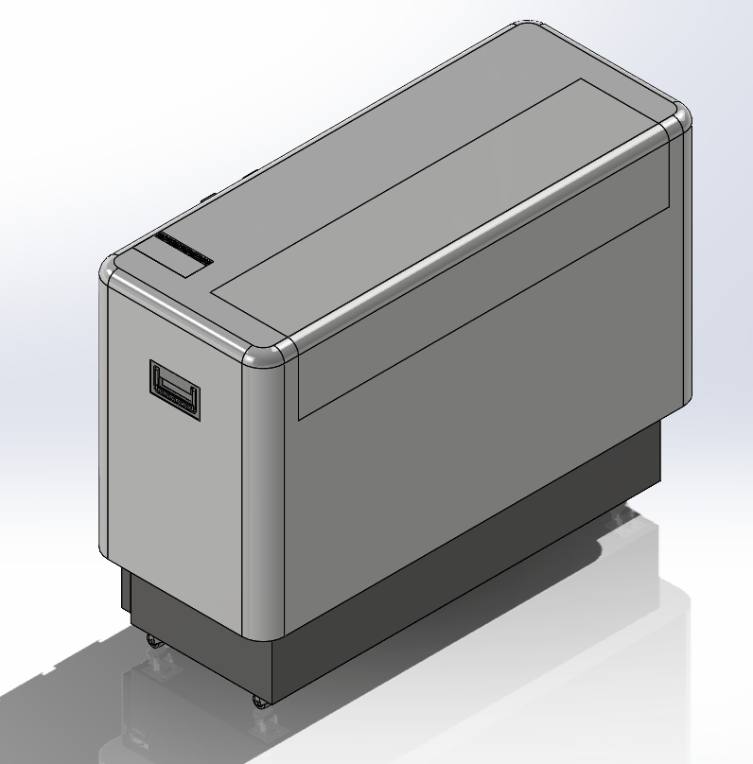
Figure 4 - Mobile Console Unit Front view CAD Models
Figure 3 - Mobile Console Unit Rear View CAD Models

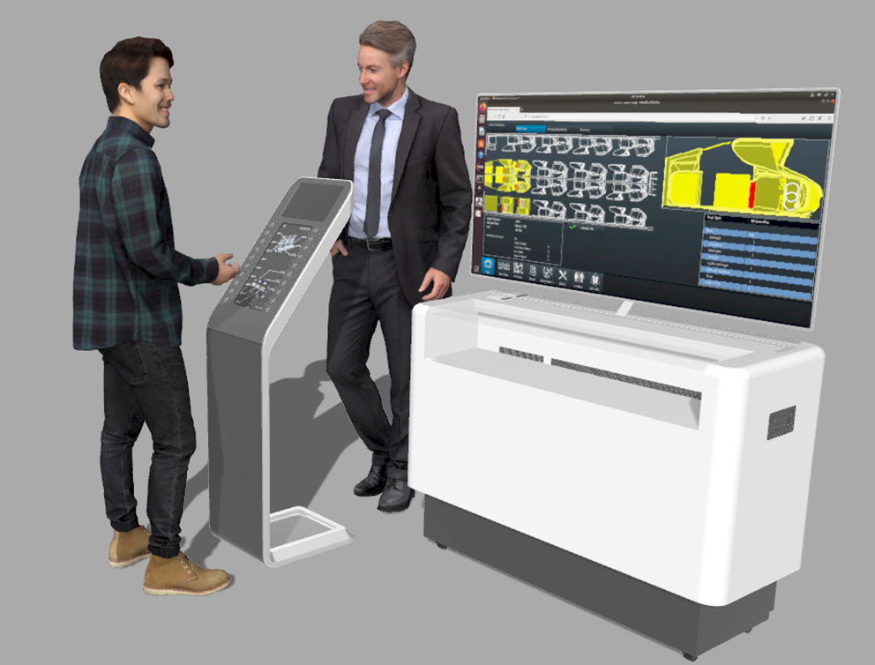

Figure 5 - Render of Connected System AIX setup

Communication

During the project, it was essential to have effective communication between suppliers to ensure the project ran as smooth as possible. The communication between SSGB and SCC was effective and collaborative, Bojic, A (2022) explains that collaborative communication is useful to streamline processes, creates a positive workplace culture and allows teams to work remotely, hybrid and distributed in different buildings. Some popular examples of collaborative working tools are Microsoft teams, Skype and Webex. SSGB and SCC had weekly progression meetings where any feedback regarding the system or any updates took place. This meeting was also used to look through the action tracker to see which actions were still to be completed, also to look through the project planning schedule to ensure any adjustments were made if necessary. The communication between SSGB and SPI was a bit more difficult as emails were delayed more than they should’ve been, the wrong team members were also part of the meetings which meant that meetings were not as efficient as they could’ve been either. It would’ve been easier to talk directly to the more technical colleagues rather than talking to the project managers who had to relay messages to the technical colleagues, which then had to email their answers.
Communication could have been improved by meeting suppliers face to face regularly to have progress updates and a more in-depth conversation, this will also help to build up the relationship between companies (Aromäki, 2011). By creating a development roadmap between two companies demonstrates the long-term gain for both businesses, this could help to boost the efficiency and communication between the companies.
The communication between SSGB and SSUS was also difficult due to the time difference between the UK and USA however, SSUS would always reply straight away so there was no issue with SSUS communication.

Implementation & Testing

When the hardware was received from SCC and the seats were received from SSUS, the sensor integration and testing could take place. The sensors were installed into their correct positions and tested using a GPIO test box to ensure they were working correctly. The hardware then had to be setup and connected so that the hardware could communicate together.

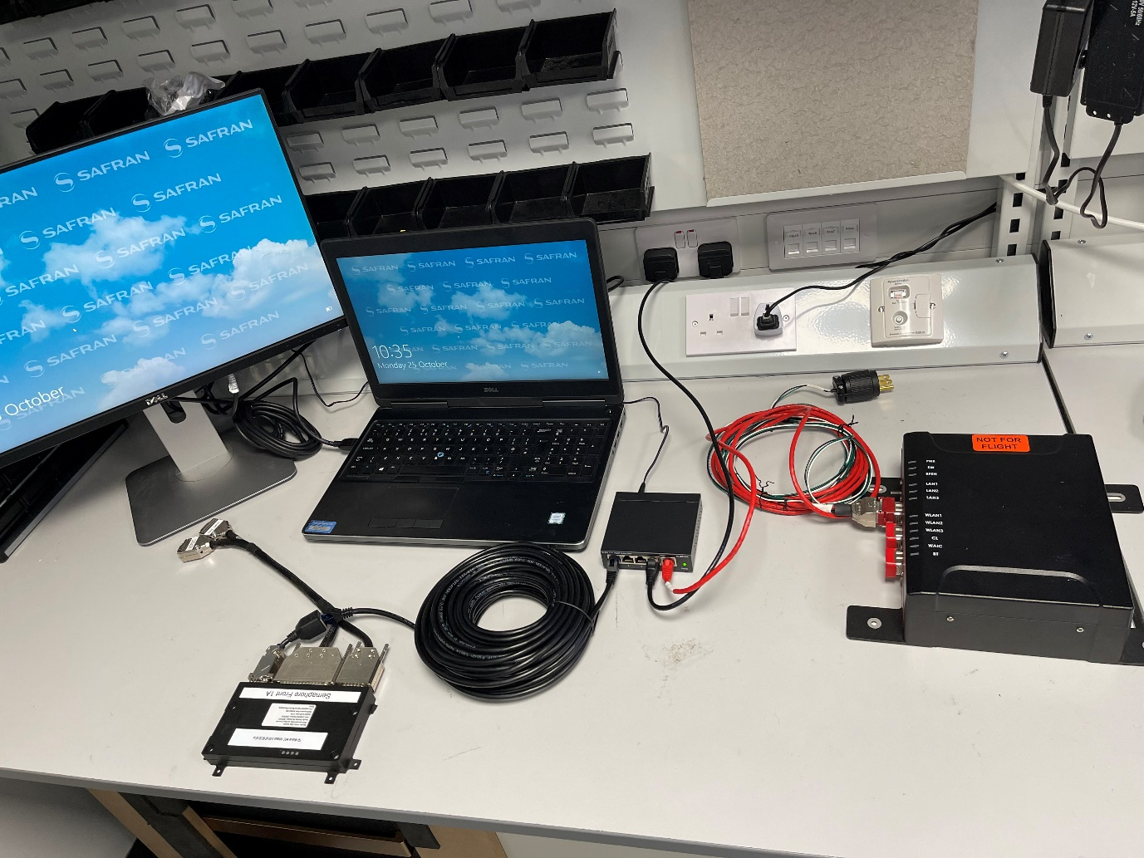
Figure 6 - Basic Connected System Hardware Setup
Once the basic setup was tested, the system could be fitted into the mobile console that will be displayed at the AIX.

Testing the system was the most important part of the project as any errors could be modified. For the project, there was a lot of testing involved with the system. The testing started out once the hardware was delivered. There were lots of different components which needed to be powered by a power supply, so these were the first tests that were undertaken to ensure all the hardware was operational. When the software was completed and implemented on the PC, the testing on the HMI began. It was tested extensively to ensure that it was fit for purpose and to how Safran wanted the software to look / operate.
The test benches were also designed for engineering purposes but for Connected, there were marketing stands that were designed by the industrial design team within Safran. This is because the engineering test bench were not professional or aesthetically pleasing to show to potential customers.
From testing the system, it became apparent that the wireless connection between the IoTEC’s and the IoTGW kept dropping out. It was then established that the wireless module could not cope with the amount of data being transferred so the system did not work as expected. This should’ve been tested by SCC before shipping the system so that it could’ve been improved much sooner. The system also had an Ethernet connection for updating / troubleshooting purposes.
Tests were carried out on the sensors by ensuring that they were the correct sizes and could cope with the different working temperatures and pressures by setting up some tests and by looking at different data sheets.
Some software configuration had to be undertaken in the HMI, which meant changing the .json file to ensure correct logic of the system and sensors, also to be able to configure different IoTEC’s to different seat variants.
For the performance, the PDS stated that the sensors needed to be able to work in different environments and be aircraft certified. This was all completed even though the certification took longer than expected due to various documents having to be approved.
The performance also stated that the sensors should be hidden and work with the other hardware devices that control the HMI.
The cost was roughly £100,000 under budget, which was a benefit as that money was able to be carried over to the next year to mature the system.
The testing was completed to the PDS standard and the system was tested and debugged when there were updates made to the system by SCC. All the points displayed on the PDS were covered in the project.
The testing must be done in the future if there is any more upgrades, as a simple typo within the software coding files could make the system not function correctly.

Project Management Methodologies

Project Management methodologies which were used throughout the project are Scrum, action trackers and Gantt charts. The scrum method was used very frequently as it needs to be updated daily. The Scrum management method uses 4 columns ‘tasks’, ‘sprint’, ‘validation’, ‘tasks closed’. The task column is for all the tasks which need to be started, all tasks will start in this column. The ‘sprint’ column is for any tasks that are in progress, these are usually the higher priority tasks which would be completed as soon as possible. Once the sprint has been completed, it must be validated either by the project manager or another relevant colleague, the task can then be closed as it is completed. Some people are resistant to this method as it involves micromanaging which some employees are against.
The Scrum method was used every day in the morning, so that the tasks can be put into their correct column. Chandana (2022) states the benefit of using the scrum method is that it can help teams achieve the deliverables quickly and effectively. The scrum method can also be used in various ways such as on a large whiteboard or an application on teams so that it can be accessed remotely.
(Chandana, 2022) also talks about the disadvantages of using the scrum method as the tasks do not have definite end dates. This can allow tasks to creep over their due date or to lose track of the progress. The whole team must remember to update the scrum as it could get too crowded if team members forget to take tasks off the board.

Another management method which could’ve been used is Agile. This method has four main principles which are ensuring software works before creating comprehensive documents; creating good relationships with customers / suppliers before creating processes and tools; good customer relationship before negotiating contracts and being able to adapt to change rather than following a set plan. This last principle can be supported by Kurt Lewin’s ‘un-freeze’, ‘change’ & ‘re-freeze’ theory which is seen as the original basis for change management (Cummings, 2015). Agile could be a good tool to implement as it concentrates on making sure that good customer relations are built before starting the project, it also allows good foundations for the beginning of the project by ensuring that the project will be working and functional before any comprehensive documentation is undertaken. This can also be seen as a disadvantage as some companies may need work scopes to follow throughout the project, which means creating documents mid-project. Another negative of Agile is that it could be hard to understand the end goal, this means it is hard to predict any costings, labour time or resources at the beginning of the project, this could lead to larger costs and resources being required if the project scope was to increase.

The waterfall method is where a process is completed in a sequential order, which flows like a waterfall throughout the process. This means that each phase must only be started after the previous phase has been completed. The five common phases within the method are requirements; deign; implementation; verification or testing and deployment & maintenance. The beneficial uses of the waterfall method are that any errors can be picked up within the analysis and design stages of the process. This can help risk mitigation before the implementation phase of the project. If any other colleague needs to get involved mid-project, this should be a quick catch-up as all the requirements should be in the scope of work produced at the start of the project. If there are any delays in a certain phase, this could mean a delay of the overall deadline of the project as that phase must be completed before starting the new phase. As the requirements are set at the beginning of the project, this means that scope should be locked into place however, it is usual for customers to change their minds or request new features later down the line (Adobe Experience Cloud, 2022).

The adaptive project management method is beneficial for accommodating some of the unknown factors which can creep up in a project. Galiana, D. (2020) describes the 5 phases to this method are project scope; cycle plan; cycle build; client checkpoint and final review. As usual, a scope of work should be carried out to ensure there is a foundation to the project. Once the project has been scoped, the cycle plan phase consists of creating a work breakdown structure which is important for assigning colleagues and companies and establishing dependencies throughout the project. The work must then be scheduled while creating deadlines and target dates for each phase of the project. Cycle build is the implementation part of the process, work should be started while being monitored. Any problems or incomplete work should be logged as they can then be moved to the next cycle. The client checkpoint is a mid-project review of the project to ensure that the customer is still satisfied with the quality of the product, the customer will be able to give feedback on any parts they feel need to be modified or upgraded. The final review is where all stakeholders evaluate how successful the project is, this is a phase where lessons learned analysis can be undertaken, it’s also where any recommendations or improvements for the future can be made.

Conclusion

The project overall has been interesting and challenging. It has allowed development and progress in things such as using drawings, creating test plans, creating work instructions and other relevant documentation, learning new HMI software, testing techniques, and using different CAD software and learning how to manage a work-based project and assembly with the help of colleagues if it was required.
The system is at a very good level for a baseline of the technology, which will only get better with the maturing of the system in connected 2022.

Due to COVID-19, the AIX 2021 show was presented virtually so it was impossible for customers to interact and see the connected system work fully. AIX 2022 is the next interior show, which will be hosted in Hamburg to lots of customers and airlines, this is important as they will be able to see the system work in real-time.

The Gantt and PERT charts were important trackers for the project. They gave target time scales to work towards, however if they were not met then they had to be justified why.

The project management and product evaluations are also very useful as they helped to explain how the project went, if there were many positives and negatives like a self-assessment. This will be good to look back on before the next project as it will be a reminder of some strengths and weaknesses and how they could be improved on for the next project.

The communication between SSGB and SPI could have been improved, as this caused tension and poor relations between the companies. This also had an effect on the deadlines, as the communication was poor and relied on emails rather than attending meetings.

Some improvements to be made to improve the system is to add some more applications into the HMI which will link to different projects ongoing on the technology demonstrator e.g., to control the suite / cabin lighting from a tablet, to control a UV air filter within the suite so that any viruses and bacteria are being killed within the aircraft. Also, linking the IoTEC to the PCU where you can choose meals from a tablet so cabin crew can have the correct number of meals to be prepared.
The new RACER module will also be installed to ensure that the wireless connection doesn’t drop out and will be able to handle more IoTEC being connected to the Gateway at one time.
For next time, a PDS would be created for every piece of hardware, as this will provide more technical information on each hardware device rather than a PDS for an overall system as this may not be very in-depth as a supplier would like.
Some improvements to be made to improve the system is to add some more applications into the HMI which will link to different projects ongoing on the technology demonstrator e.g. to control the suite / cabin lighting from a tablet, to control a UV air filter within the suite so that any viruses and bacteria are being killed within the aircraft. Also, linking the IoTEC to the PCU where you are able to choose meals from a tablet so cabin crew can have the correct number of meals cooked.
The new RACER module will also be installed to ensure that the wireless connection doesn’t drop out and will be able to handle more IoTEC being connected to the Gateway at one time.

Works Cited
Adobe Experience Cloud, (2022), Waterfall Methodology. [Online]
Available at: https://www.workfront.com/en-gb/project-management/methodologies/waterfall
[Accessed 8 May 2022].
Aromäki, J. (2011), Tips for successful communication with suppliers. [Online]
Available at: https://www.managebt.org/article/tips-for-successful-communication-with-suppliers/
[Accessed 24 May 2022].
Bojic, A. (2022), Collaborative communication: why it matters and how to improve it. [Online]
Available at: https://pumble.com/blog/collaborative-communication/
[Accessed 24 May 2022].
Bridges, J. (2021), What Is a Feasibility Study? How to Conduct One for Your Project. [Online]
Available at: https://www.projectmanager.com/training/how-to-conduct-a-feasibility-study
[Accessed 15 May 2022].
Chandana, (2022), Scrum Project Management: Advantages and Disadvantages. [Online]
Available at: https://www.simplilearn.com/scrum-project-management-article
[Accessed 7 May 2022].
Cummings, S. (2015), Unfreezing change as three steps: Rethinking Kurt Lewin’s legacy for change management. SAGE journals, 69(1), pp. 33-60.
Forrest, G. (2022), FMEA (FAILURE MODE AND EFFECTS ANALYSIS) QUICK GUIDE. [Online]
Available at: https://www.isixsigma.com/tools-templates/fmea/fmea-quick-guide/
[Accessed 7 May 2022].
Galiana, D. (2020), Adaptive Project Framework: an introductory guide for beginners. [Online]
Available at: https://www.wimi-teamwork.com/blog/adaptive-project-framework-introductory-guide-beginners/
[Accessed 8 May 2022].
Garrett, D. (2007), Interface Control Document (ICD). [Online]
Available at: https://www.projectmanagement.com/wikis/235680/Interface-Control-Document--ICD-
[Accessed 17 May 2022].
JotForm, (2021), Why is project planning important?. [Online]
Available at: https://www.jotform.com/blog/importance-of-project-planning/
[Accessed 26 May 2022].
Technical Foam Services, (2022), What is a product design specification (PDS)?. [Online]
Available at: https://www.technicalfoamservices.co.uk/blog/what-is-a-product-design-specification-pds/
[Accessed 18 May 2022].
Williams, S. (2022), Advantages of PERT charts vs. Gantt charts. [Online]
Available at: https://www.lucidchart.com/blog/advantages-of-pert-charts-vs-gantt-charts
[Accessed 6 May 2022].

Appendices

Appendix. 1 – Gantt Chart:

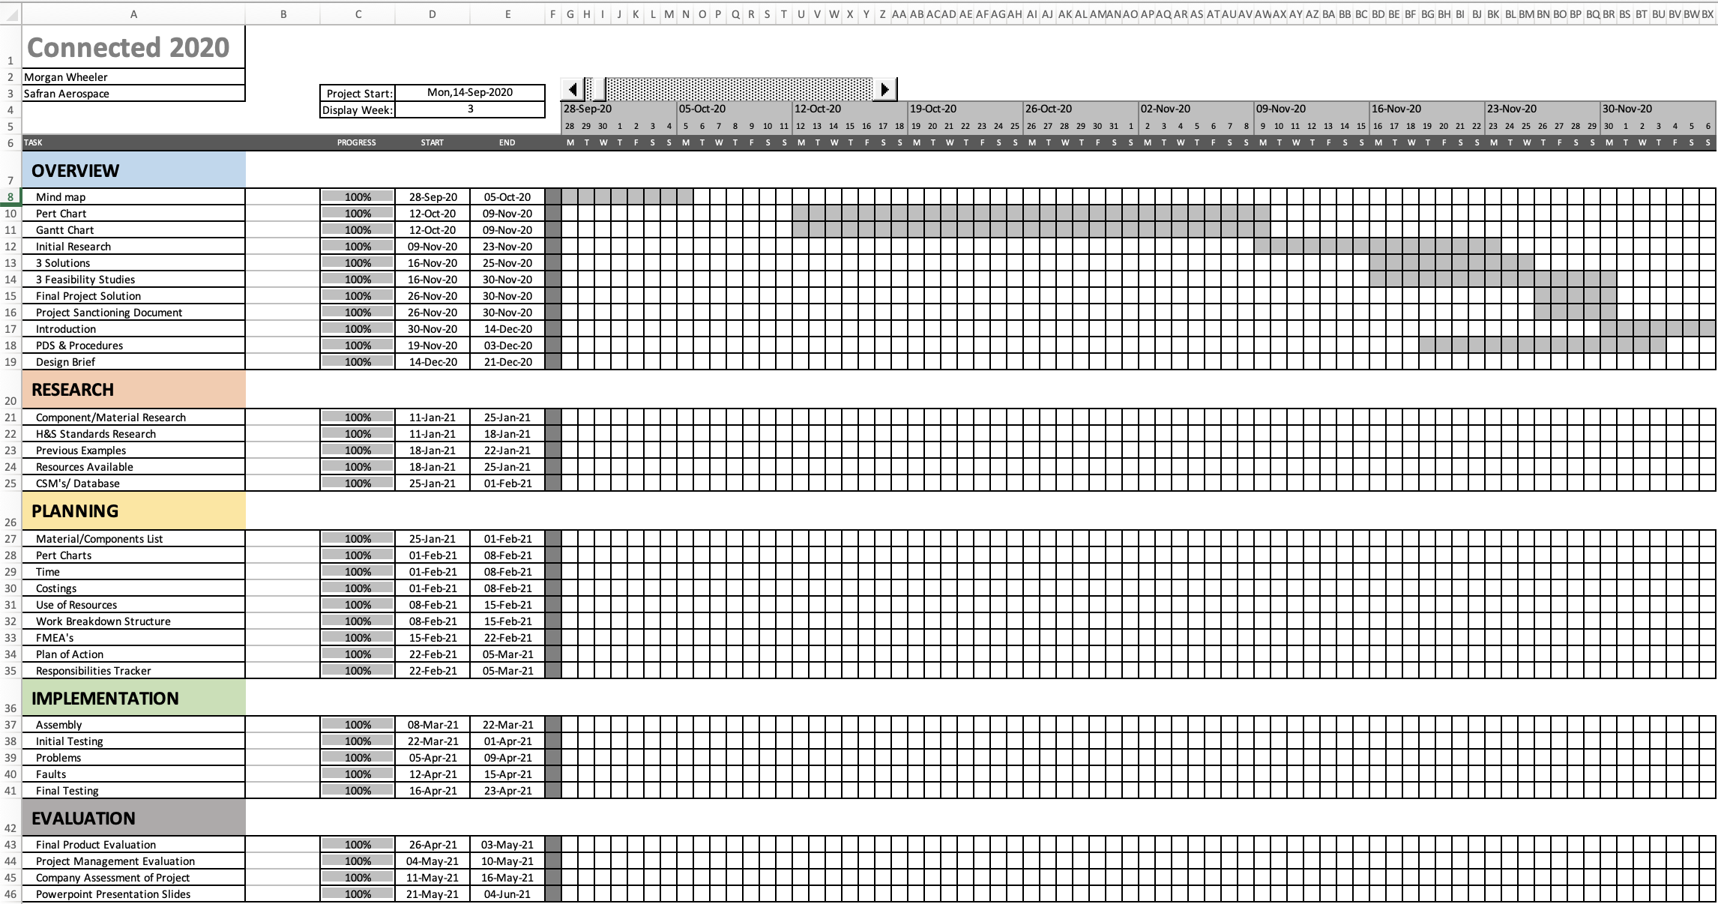

Appendix. 2 – Critical Path Analysis:
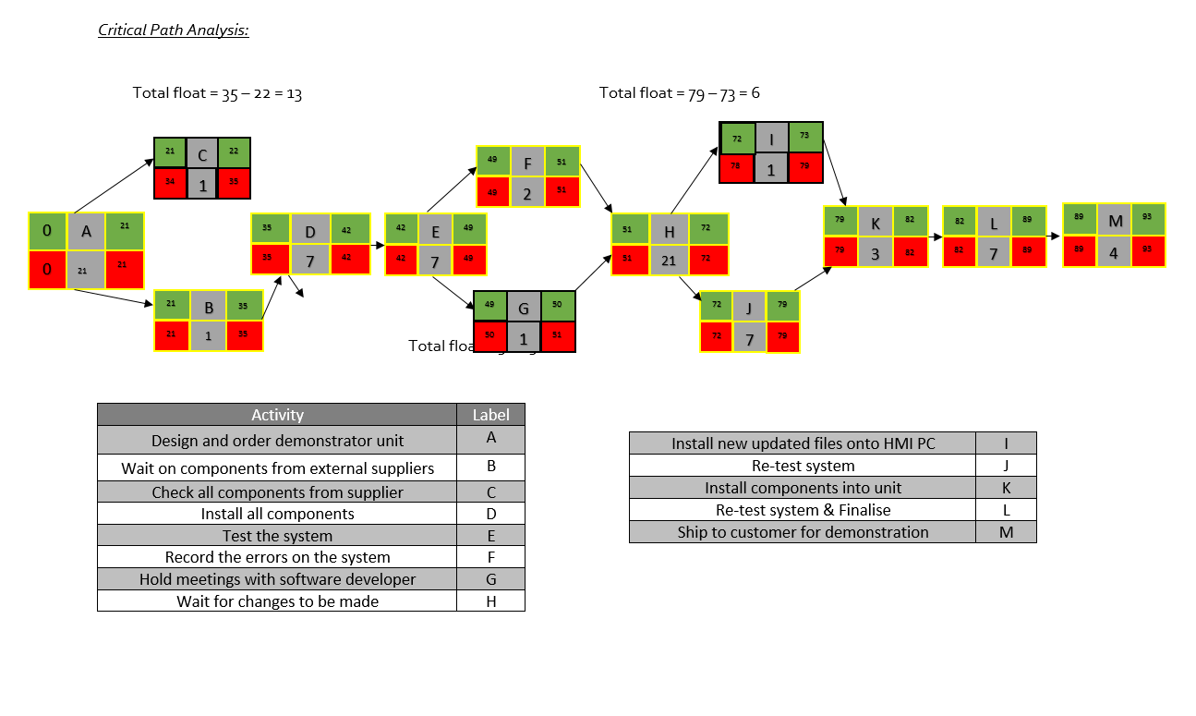
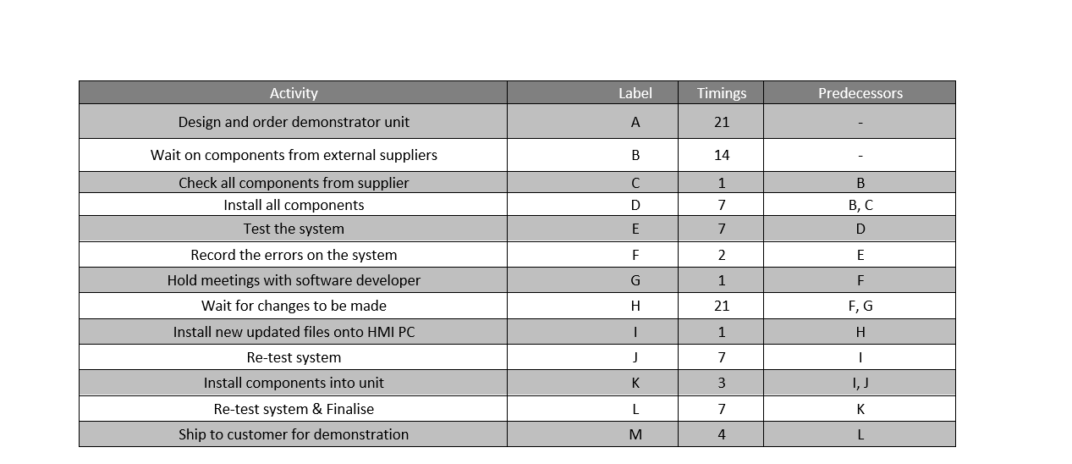

Appendix. 3 – Feasibility Studies:
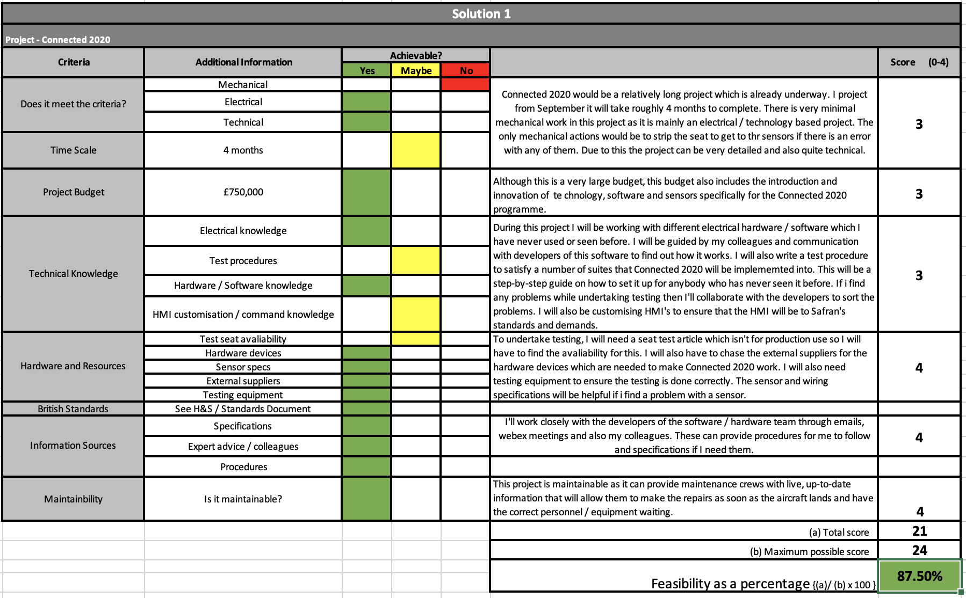

Appendix. 4 – FMEA:
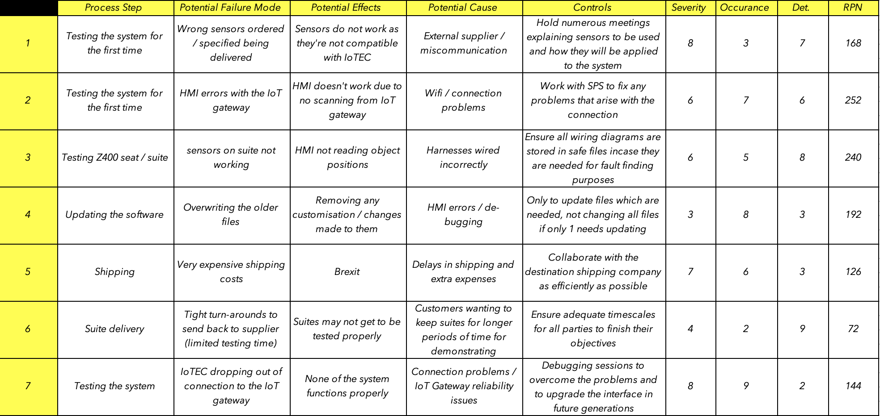

Appendix. 5 – Product Design Specification:
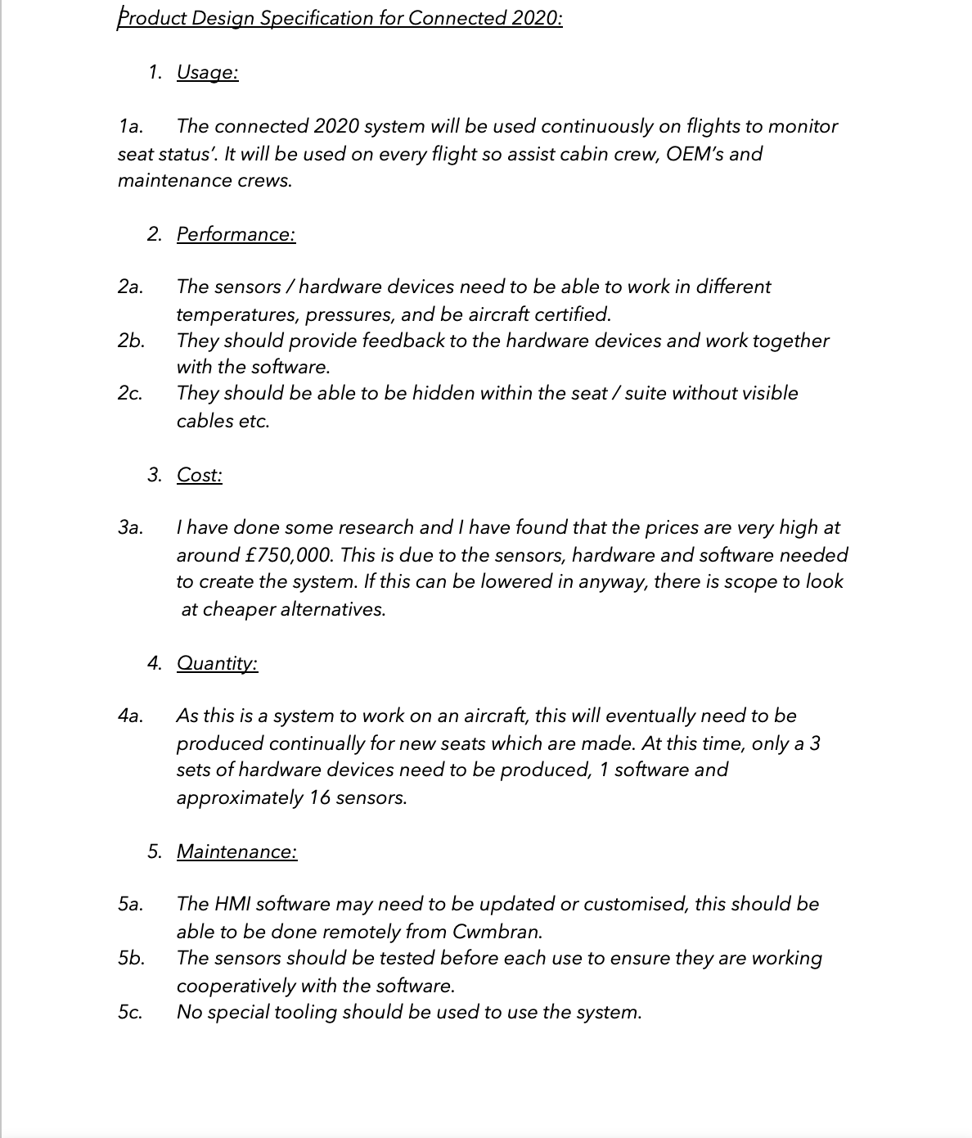
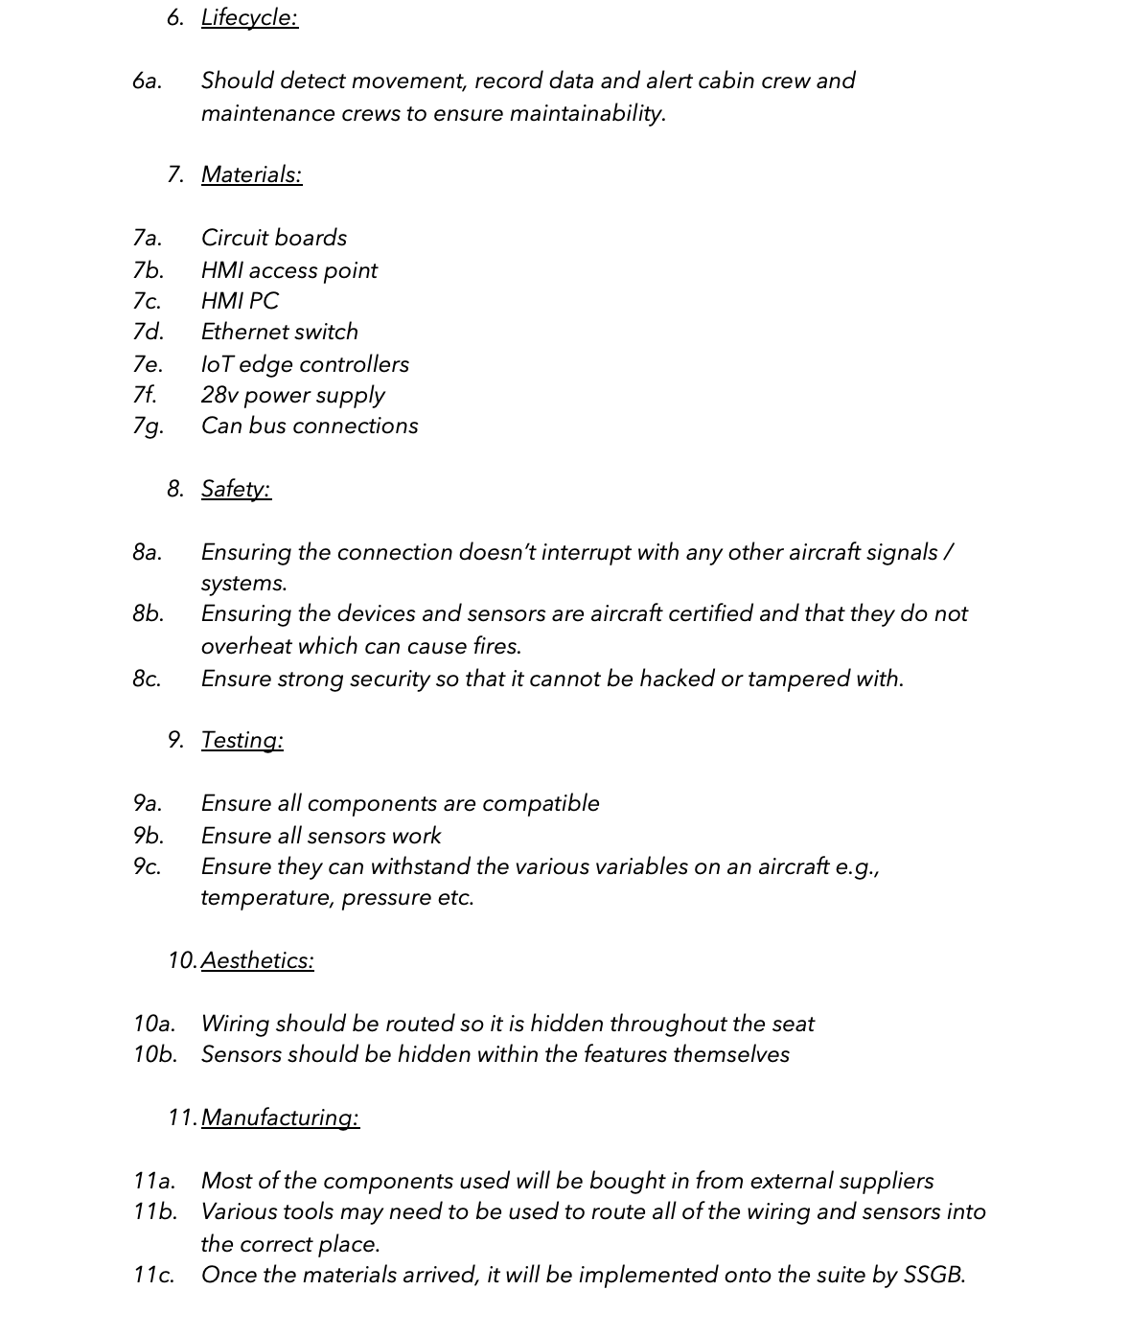

Appendix. 6 – Character Selection Matrix
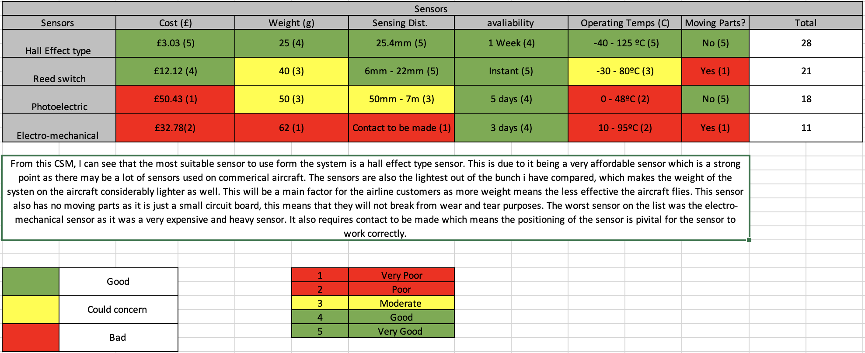

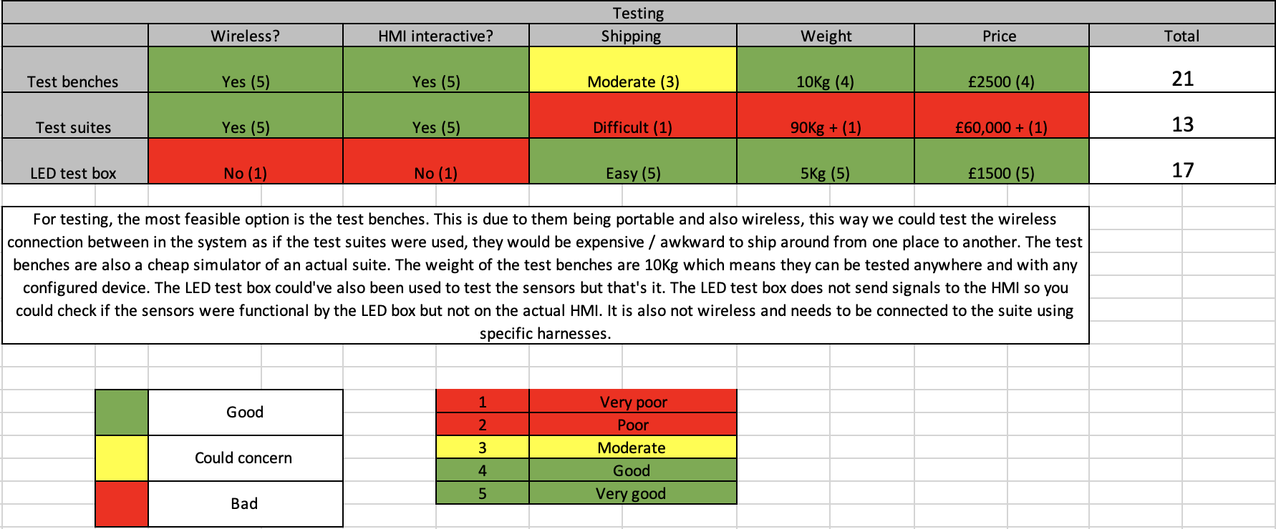

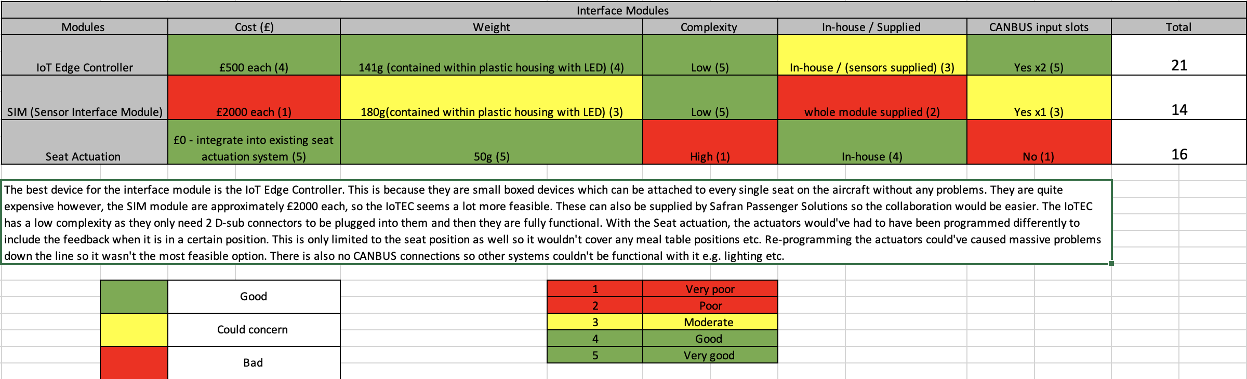

Appendix. 7 – Work Breakdown Structure


