WRITTEN ASSIGNMENT (REFLECTIVE REPORT)
COMPONENT 1

BSC HEALTH AND SOCIAL CARE
PRINCIPLES OF HEALTH AND SOCIAL CARE PRACTICE
BMHP5016
LECTURER: PRECIOUS IGBINIGIE

STUDENT NAME: ZAINEB RAJPAR
STUDENT NUMBER: 2421792

Contents
INTRODUCTION 3PRINCIPLES OF HEALTH AND SOCIAL CARE 3
TASK 1: REFLECTION ON THE IMPORTANCE OF PRINCIPLES OF HEALTH AND SOCIAL CARE 3
The Legal Foundations of Person-centred Care 3
Collaboration and the Health and Care Acts 4
Ethical Decision-Making in Practice 4
Reflection: Combining Maslow's Hierarchy with Legal Frameworks in Care 4
TASK 2 5
PRACTICAL EXAMPLES OF CONCEPTS IN PRACTICE 5
TASK 3 7
Reflective Account Using the ERA Model 7
Experience 8
2. Self-Reflective Individualised Care 8
Collaborating in Partnership 8
ETHICAL PRACTICE 9
Action 9
1. Strengthen Person-Centred Communication 9
2. Promote Ethical Awareness 9
3. Improve Partnership Working 9
4. Advocate for the Individual 9
5. Ongoing Professional Development 10
Conclusion 10
References 11

INTRODUCTION

PRINCIPLES OF HEALTH AND SOCIAL CARE
The fundamental ideas guiding health and social care are critically analysed in this report.
By applying Maslow’s Hierarchy of Needs Theory to the well-being of service users, task 1 considers the significance of these concepts. Practitioners promote higher-level psychological development by prioritising physiological and safety needs. This is consistent with the Health and Care Act 2024, which stresses integrated service delivery to enhance population health outcomes, and the “well-being principles” of the CARE ACT 2014, which require meeting holistic needs.
This report also assesses how ethics, partnership working, and person-centred care are applied in day-to-day operations and explains how I will determine my present professional strengths and areas for improvement using the ERA (EXPERIENCE, REFLECTION, ACTION) model of reflection. With a well-organised development plan to improve my qualities, this self-assessment ensures that my future work will continue to be moral, team-oriented, and in line with the changing standards of the health and social care industry.
Through the case study of Mrs. C, who is juggling the dual challenges of lung cancer and chronic obstructive pulmonary disease (COPD), Task 2 offers a practical application of these ideas. The intricacies of clinical care and the need for a comprehensive strategy that considers both the psychological effects of a terminal diagnosis, and physical respiratory symptoms are demonstrated by this scenario.

TASK 1: REFLECTION ON THE IMPORTANCE OF PRINCIPLES OF HEALTH AND SOCIAL CARE

The Legal Foundations of Person-centred Care
Person-centred care is primarily driven by the Care Act 2014, which imposes a legal obligation on local governments to advance each person's "well-being." The higher rungs of Maslow's hierarchy—esteem and self-actualization, in particular—are perfectly aligned with this legal change. The Act guarantees that service users are active leaders in their own care journeys rather than passive recipients by requiring that care "begins with the person" (Legislation.gov.uk, 2014).
Furthermore, the Human Rights Act 1998 provides the ethical foundation for this autonomy. Article 8 (Right to respect for private and family life) protects an individual’s right to make choices about their daily life, directly supporting the "belongingness" and "love" needs in Maslow's model. Without these protections, care risks becoming institutionalized, neglecting the psychological safety essential for human dignity (CQC, 2023).

Collaboration and the Health and Care Acts
The Health and Care Act 2022 revolutionised partnership working by establishing Integrated Care Systems (ICS). This legislation moved the NHS away from internal competition toward a "triple aim" of better health for all, better quality of care, and sustainable resource use. In the context of Maslow‘s hierarchy, this integration secures the "safety" and "physiological" needs of the population by ensuring seamless transitions between hospital and home.
Looking forward, the Health and Care Act 2024 (and associated 2024/25 guidance) further refine these collaborations by focusing on workforce stability and the Care Workforce Pathway. By professionalising the workforce and emphasising multidisciplinary " family help" in social care, the legislation strengthens the social support systems that satisfy a service user's need for security and community (NHS England, 2024).

Ethical Decision-Making in Practice
Ethical decision-making is not a solitary act but a legislative requirement. The Care Act 2014 introduces the "duty of candour", requiring providers to be open and honest when things go wrong. This transparency builds the trust necessary for a service user to feel safe (Maslow’s second tier). When practitioners face ethical dilemmas—such As Balancing a person's autonomy with their safety —they must apply the principles of the Human Rights Act, ensuring that any restriction of liberty is lawful, legitimate, and proportionate (SCIE, 2023)

Reflection: Combining Maslow's Hierarchy with Legal Frameworks in Care
In the UK, a strong legislative framework codifies the importance of person-centred care, partnership working, and ethics. When compared to Maslow's Hierarchy of Needs, these guidelines guarantee that health and social care services advance from clinical survival to holistic well-being.

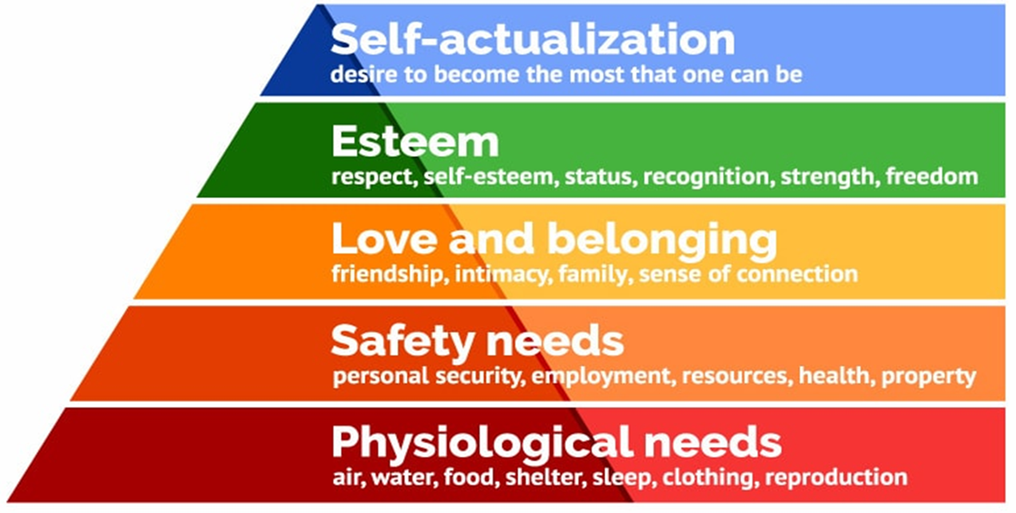


TASK 2

PRACTICAL EXAMPLES OF CONCEPTS IN PRACTICE
The case of Mrs. C shows how ethical practice, collaborative functioning, and person-centred care may be successfully applied within the framework of UK health and social care. Her experience is in line with the NHS's current policy approach, which emphasises integrated agency collaboration, shared decision-making, and individualised treatment. Examining her case critically from the perspectives of the Human Rights Act of 1998, the Care Act of 2014, and the Health and Social Care Act of 2022 reveals both practical advantages and persistent difficulties.
A key component of Mrs C's management is person-centred care. Her physical, emotional, psychological, social, and spiritual needs were answered by a holistic evaluation after she was diagnosed with advanced COPD and metastatic lung cancer. This is consistent with the personalised care model of NHS England, which encourages supported self-management, tailored care planning, and collaborative decision-making (NHS England, 2023). Mrs C actively participated in decisions on hospital admission, thresholds, resuscitation status, and palliative care. A fundamental ethical ideal, respect for autonomy is reflected in this, and it is legally reinforced by Article 8 of the Human Rights Act 1998, which safeguards the right to private and family life. Enabling her to articulate what matters most —remaining at home, maintaining independence and reducing hospital admissions —demonstrates compliance with the Care Act 2014 wellbeing principle, which places dignity, control and participation at the centre of care.
Collaboration amongst her general practitioner, community nurses, oncology, respiratory, and palliative care teams, as well as voluntary and community services, demonstrates partnership working. In Mrs. C's example, coordinated care planning and information sharing operationalise the Health and Social Care Act 2022's promotion of integration and collaboration between health and social care organisations. The broader determinants of health, such as isolation and decreased mobility, are addressed by social prescribing, which includes volunteer shopping assistance, a lunch club, and weekly health walks. To improve the quality of life for people with life-limiting illnesses, the World Health Organization (2020) acknowledges the importance of integrated palliative and community-based methods. Although in practice, information-sharing obstacles and staff demands may compromise its efficacy, this multi-agency model lessens fragmentation and promotes continuity of treatment.
Crucially, even though Mrs. C's example exemplifies best practices, difficulties still exist. Implementation may be hampered by a lack of workers, digital exclusion, and inconsistent funding for community service. The British Lung Foundation (2021) draws attention to persistent disparities in access to respiratory care throughout the United Kingdom. Patients with complicated needs would benefit from improved digital care coordination systems, regular early palliative referrals, and ongoing community service funding.

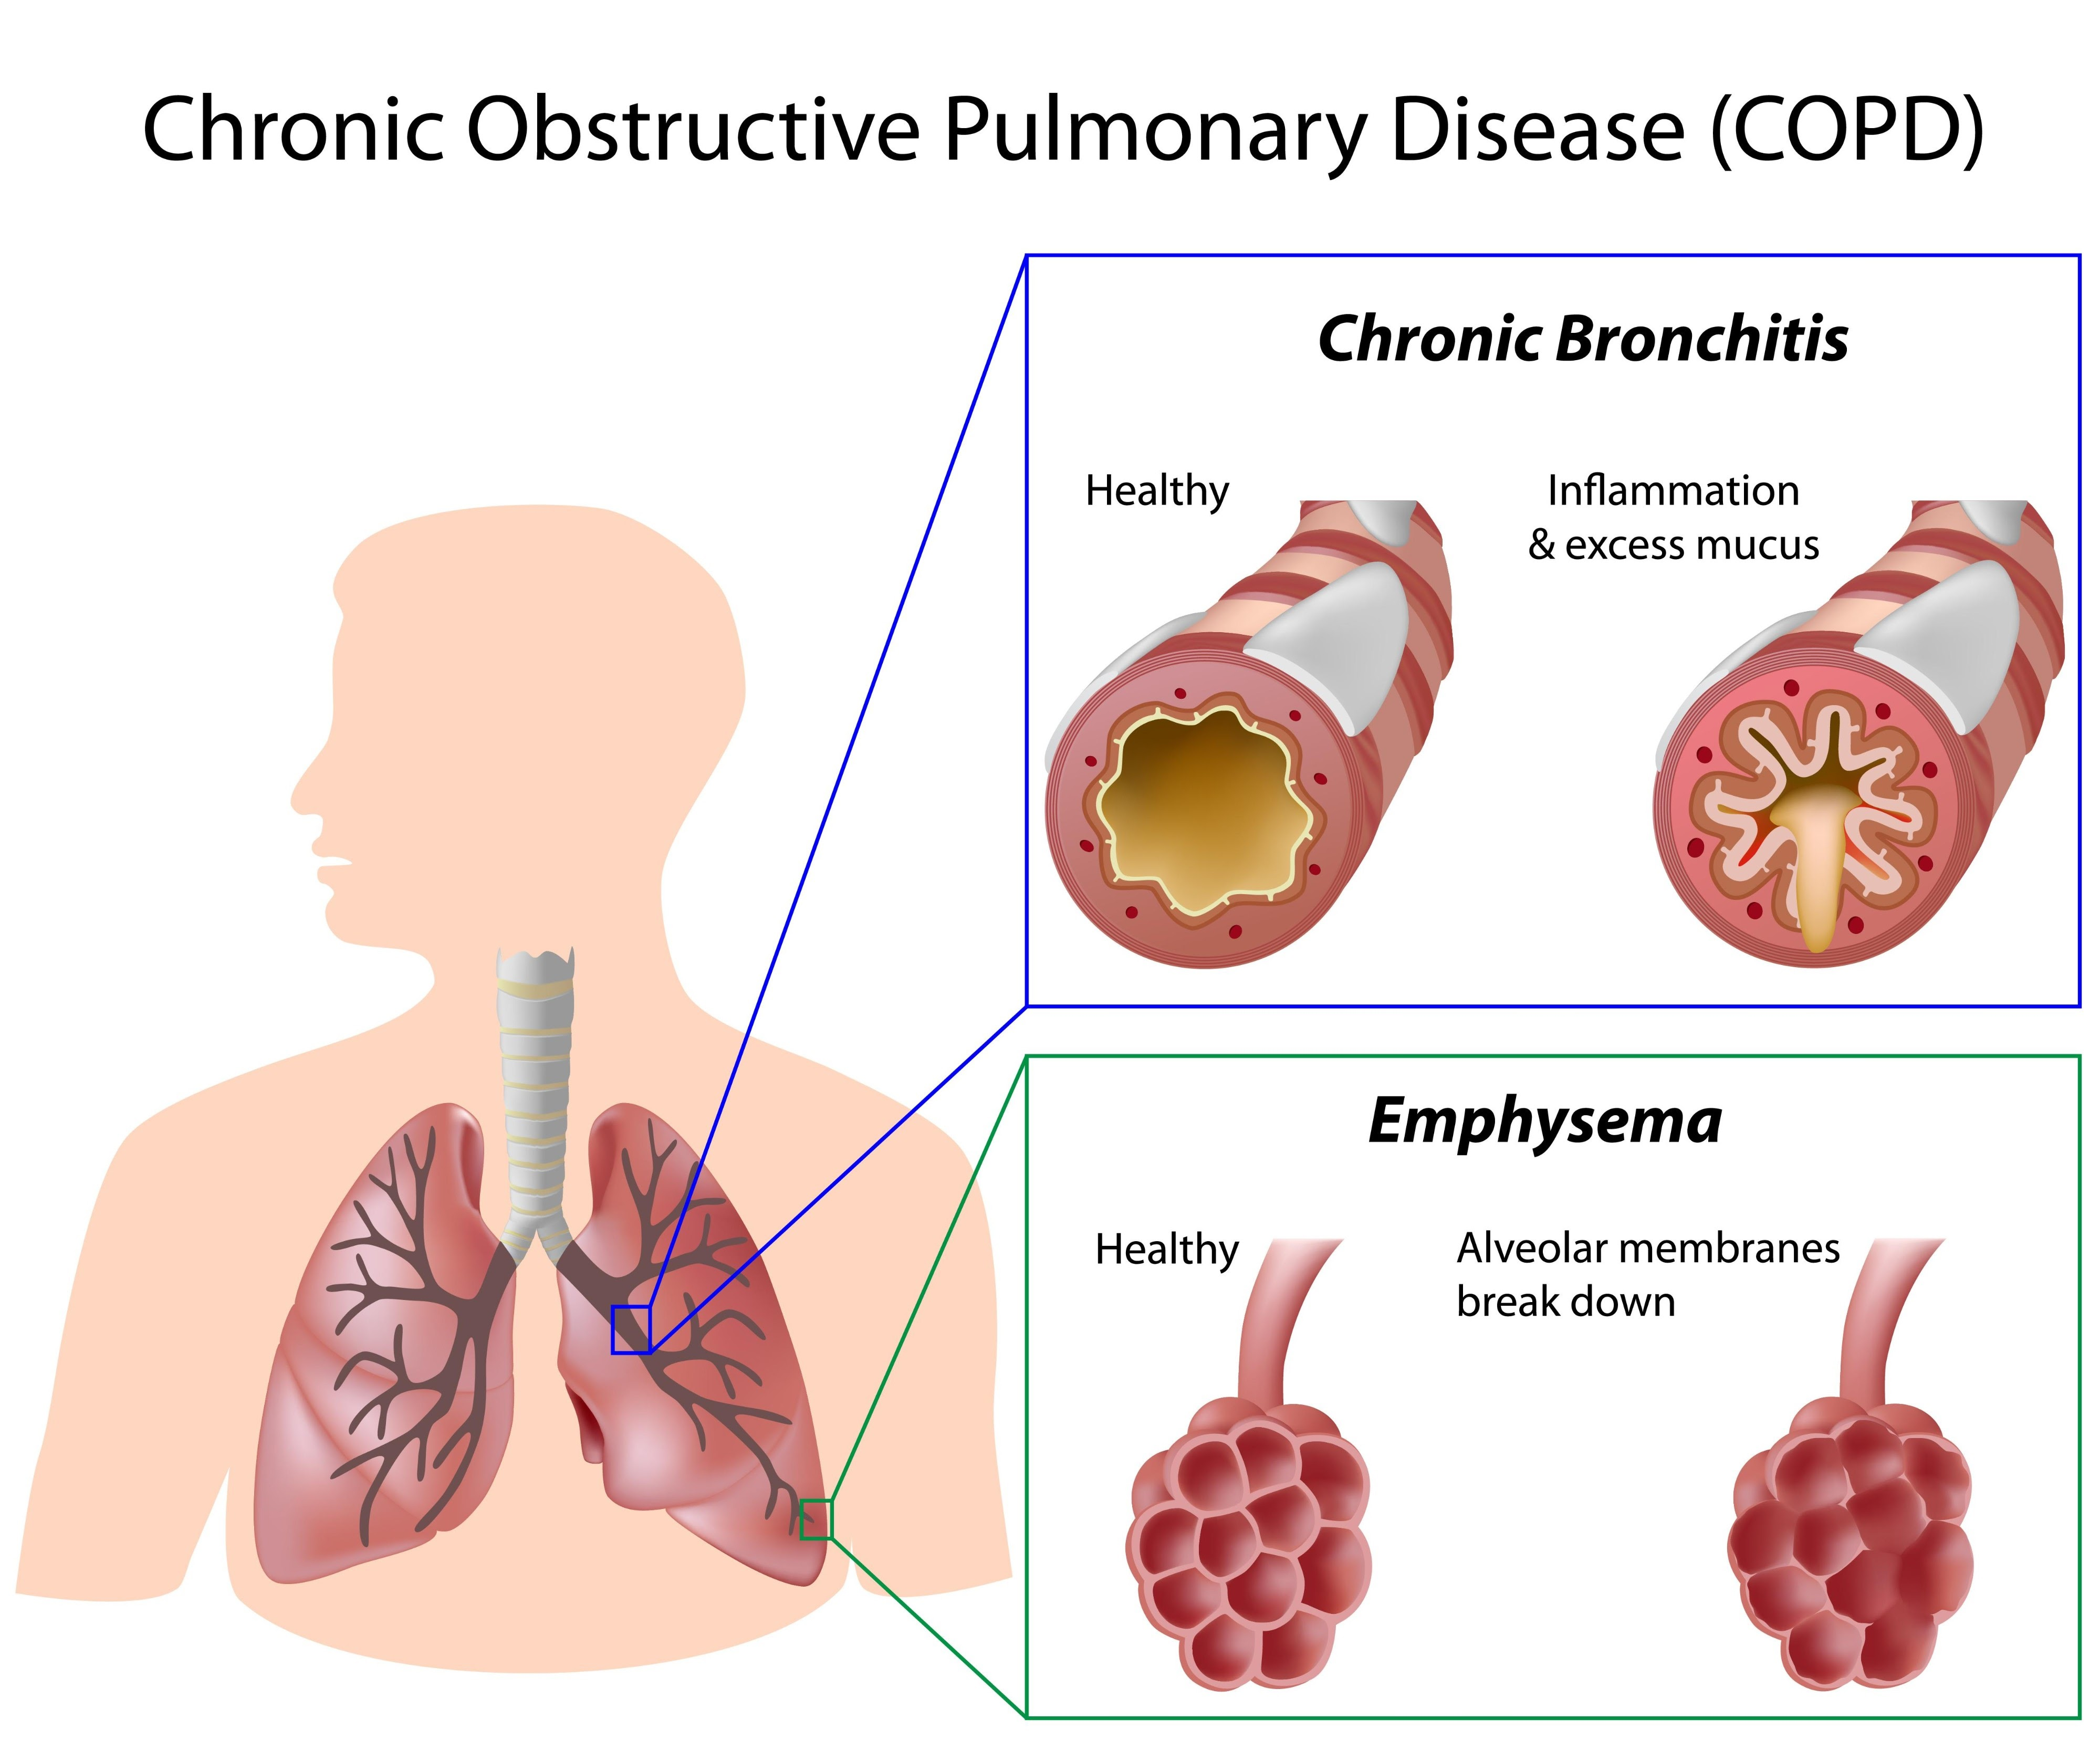
NHS (2024)

TASK 3

Reflective Account Using the ERA Model
Person-centred care, collaboration, and ethical decision-making are some of the core values that guide my work as a health and social care professional. The Human Rights Act of 1998, the Health and Social Care Act of 2012, and the Care Act of 2014 are just a few examples of UK laws that uphold these ideals. Current NHS and international guidelines also support them. By using the ERA (Experience – Reflection – Action) model to reflect on these, I can critically assess my work and create. A strategy to improve my knowledge and abilities going forward. (NHS, 2024).

Experience
I frequently come across circumstances in my day-to-day work assisting persons with complicated health and social care requirements that call for person-centred, ethical, and cooperative approaches. For instance, I provided care to a client who had severe respiratory disease and was frequently hospitalised due to episodes of dyspnoea. She mentioned that care conversations frequently took place about her rather than with her, and she felt nervous about the decisions she made concerning her care.
This demonstrated the need for better methods of shared decision-making and communication, particularly in making sure her beliefs, interests, and emotional concerns were at the centre of care planning. Additionally, it emphasised the significance of collaboration amongst multidisciplinary teams (MDTs), community services, carers, and voluntary organisations, which is mandated by the care guidance.

2. Self-Reflective Individualised Care
Person-centred care centres care planning and delivery around the needs, values, and choices of the individual (NHS England, 2023). The Care Act of 2014, which requires that well-being including dignity, control, and participation, be the main emphasis of evaluation and support planning, is the direct source of this principle (Department of Health and Social Care, 2014).
I was able to identify the client's wish to stay at home and prevent needless hospitalisations in my practice by listening with empathy. However, I saw that my evaluation tended to focus more on clinical concerns than on conversations about life goals and personal values, which have been found to be crucial to true person-centred practice in the research (McCance & McCormack 2021).
This is further supported by the Human Rights Act of 1998, which upholds the ethical obligation to fully involve people in decisions regarding their health and care by safeguarding Article 8 rights (respect for private and family life) (UK Government, 1998). In line with ethical and human rights commitments, the World Health Organization (2020) underlines that respecting autonomy and dignity, particularly in cases of serious illness, improves quality of life and lessens distress.

Collaborating in Partnership
To coordinate care across system boundaries, especially for individuals with complex needs, partnership functioning is crucial. To enhance continuity and care quality, the Health and Social Care Act of 2012 encourages coordinated efforts across NHS organisations, local governments, and third-sector partners (UK Government, 2012).
After some thought, I realised that although I can effectively communicate with other professionals, there are moments when I expect others to handle coordination without actively making sure that care information is communicated and approved. Effective MDT communication improves outcomes for individuals with long-term diseases and lessens fragmentation, according to research (Alaton et al., 2021).

ETHICAL PRACTICE
When making decisions, ethical practice demands striking a balance between autonomy, beneficence, non-maleficence, and fairness. Shared decision-making on treatment choices showed respect for autonomy in my client's case, but I acknowledged that I occasionally shied away from difficult discussions (like advance care planning) out of discomfort or fear of upsetting them. Nonetheless, recent clinical recommendations emphasise that sensitive, early discussions about preferences improve results and minimise unintended interventions (NICE, 2021).
The Care Act of 2014 also imposes safeguarding obligations on practitioners to keep people safe, which includes making sure that care arrangements do not put them in unnecessary danger. This necessitates examining informal care arrangements- like depending on neighbours or unpaid carers—ethically.

Action
As a result of this reflection, I will take the following actions to strengthen my day-to-day practice:

1. Strengthen Person-Centred Communication
I will prioritise open-ended questions and shared decision-making conversations during assessments and reviews. I will ensure care plans clearly reflect the individual’s expressed preferences, not just clinical recommendations.

2. Promote Ethical Awareness
I will consciously apply ethical principles in routine decisions, particularly around consent, confidentiality, and best-interest discussions. Where capacity is in question, I will ensure legal frameworks are followed appropriately and respectfully.

3. Improve Partnership Working
I will proactively communicate relevant information to multidisciplinary team members and participate actively in case discussions. Where communication gaps exist, I will escalate concerns appropriately to protect continuity and safety.

4. Advocate for the Individual
If I observe that an individual’s wishes are not being fully considered, I will act as an advocate to ensure their voice is heard. This supports both ethical practice and human rights obligations.

5. Ongoing Professional Development
I will seek further training in shared decision-making, advance care planning and safeguarding to maintain competence and confidence in applying legislation to practice.

Conclusion
A SOLID STATUTORY FOUNDATION FOR CONTEMPORARY PRACTICE IS ESTABLISHED BY THE INTEGRATION OF THE CARE ACT 2014, THE HEALTH CARE ACT 2022, AND THE 1998 ACT ON HUMAN RIGHTS. To protect Mrs C's autonomy and dignity, I conducted a comprehensive assessment that went beyond clinical criteria by integrating Malow's Hierarchy of Needs with her care. A crucial shift from abstract theory to practical professional responsibility was made possible by using the ERA MODEL, emphasising the importance of ethical collaboration and person-centredness in achieving high-quality results. Therefore, incorporating these legal frameworks into daily operations guarantees that care is strictly focused on the well-being of each individual, legally compliant, and ethically defendable

.

References
British Lung Foundation (2021) Living with COPD: support and care services. Available at: https://www.blf.org.uk (Accessed 25 February 2026)
British Lung Foundation (2021) Living with COPD: support and care services. Available at: https://www.blf.org.uk (Accessed: 27 February 2026)
Care Quality Commission (CQC) (2023) Our updated human rights approach. Available at: https://www.cqc.org.uk/about-us/our-updated-human-rights-approach/ (Accessed: 25 February 2026)
Department of Health and Social Care (2022). Health and Care Act 2022. Available at: https://www.gov.uk/government/publications/health-and-care-act-2022 (Accessed 25 February 2026)
Department of Health and Social Care (2022). Health and Care Act 2022: Integration and Partnership Working. Available at: https://www.gov.uk/government/publications/health-and-care-act-2022 (Accessed: 27 February 2026).
(Accessed 28 February 2026)
Legislation.gov.uk (2014). Care Act 2014. Available at: https://www.legislation.gov.uk/ukpga/2014/23/contents (Accessed: 25 February 2026)
NHS England (2023). Comprehensive model for personalised care 2023 update. Available at: https://www.england.nhs.uk/personalisedcare
Accessed: 2 March 2026)
NHS (2023) Chronic obstructive pulmonary disease (COPD). Available at
https://www.nhs.uk/conditions/chronic-obstructive-pulmonary-disease-copd
(Accessed: 2 March 2026)
NHS England (2024) 2024/25 priorities and operational planning guidance. Available at: https://www.england.nhs.uk/long-read/2024-25-priorities-and-operational-planning-guidance/ (Accessed: 25 February 2026)
NICE (2021). Shared decision -making -making (NG197). Available at: https://www.nice.org.uk/guidance/ng197
Social Care Institute for Excellence (SCIE) (2023). Human rights, choice, and control in care planning. Available at: https://www.scie.org.uk/mca/practice/care-planning/human-rights-choice-control/ (Accessed: 25 February 2026).
World Health Organization (2020). Palliative care. Available at: https://www.who.int/news-room/fact-sheets/detail/palliative-care (Accessed 27 February 2026)
World Health Organization (2020). Palliative care. Available at: https://www.who.int/news-room/fact-sheets/detail/palliative-care (Accessed 25 February 2026)

