Title

Course Title: BSc Applied Computing
Assignment Title: Usability Analysis of Interactive Museum Exhibits
Student Name: Adam Dennis
Date: 31st of March 2020
Contents Page
- Background
- Usability Review of Two Displays
- Interface Evaluation
- Guidelines and Accessibility
- Virtual and Augmented Reality
- Bibliography

Background

This report will include a usability review, an interface evaluation and the guidelines and accessibility of two online interactive displays at two different museums. The background about VR (Virtual Reality), AR (Augmented Reality) and a design for an AR display at a Welsh museum about Welsh heritage will also be included.

Usability Review of Two Displays

The two interactive displays that will be reviewed are from two different museums which are the British Museum (1) and the Louvre Museum (2).
The British Museum
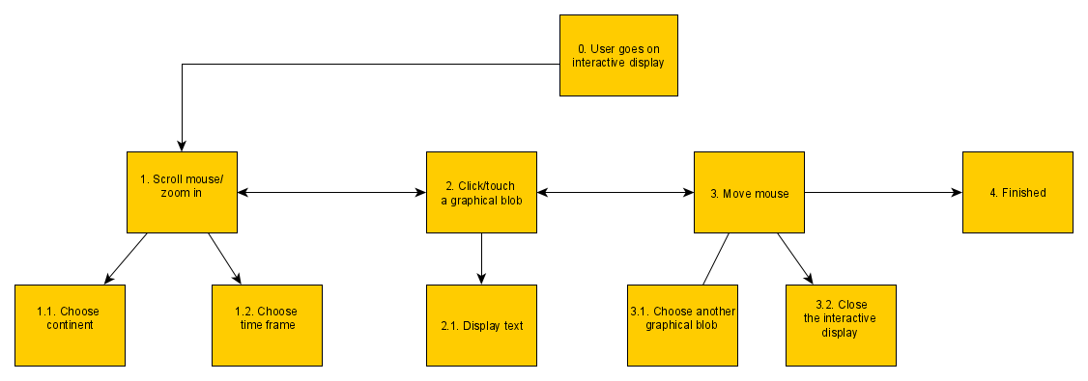
This is an interactive display that shows different events that happened in specific continents at different time periods throughout history. The information and concepts this display are communicating is educational information and specific information from a certain time period and continent in the form of an interactive graphical display by showing text explain in more detail about that time period and continent when the user has clicked on a button in the shape of a blob. The time periods range from the stone age up until the 1940s and the continents include the five continents Europe, Asia, North America, South America and Oceania.
This sketch shows the hierarchical process of the British Museum interactive display. When the user goes on the interactive display a continent and time frame can be chosen by scrolling the mouse wheel or using a touchscreen. The user can then click on or touch a graphical blob which will show information about the continent and time frame they have chosen. The user can choose another graphical blob if they want to and/or close the interactive display which will finish the process.
This interactive display is better than Louvre interactive display because the display uses mouse movement to either move side by side or to zoom into the display. The mouse scrolls side by side without needing the user to click on a button. The user can use the mouse scroller or pressing the buttons on the side to zoom into the display which updates the screen with more time periods. Clicking on an event in a time period displays a preview of what the event is and allows the user to find out more about the event if desired and also shows the user what topic this is by using a visual design and highlighting the topic. The interactive display uses blobs of circles for the user to click on an event on a graphical background. The contrast is grey and the brightness is not too bright or too dark. Multiple colours are used such as yellow, orange, green, blue and purple. The interactive display uses no audio and the display is sensitive to use on a touch screen. A metaphor used is the blob of circles that indicate to a user that they can click on them to display an event. This interactive display passes the affordance test because I knew what to do without being told.
Applying usability of general computer systems is really helpful to the design of this interactive display because it allows people to access and see information the British Museum has for free while being friendly to use for people who are not advanced with using computers which is really helpful in situations where people cannot physically go to these museums or cannot afford to go to them.
The Louvre Museum
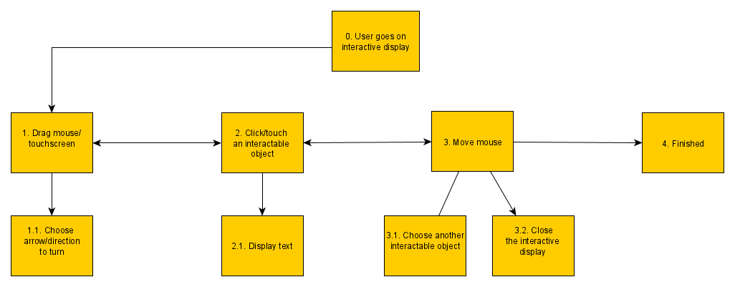
This interactive display allows the user to look around a room in inside the museum in whatever direction they like and their choice is totally up to the user. The information and concepts this display are communicating is educational information and specific information about a particular image by providing text explaining in more detail about the object and an interactive tour of the room because the user can move around the room by using their mouse on the arrows place on the side of the screen.
This sketch shows the hierarchical process of the Louvre Museum interactive display. When the user goes on the interactive display the direction to turn around the room can be chosen by clicking on an arrow or using a touchscreen. The user can then click on or touch an interactable object which will show information about the interactable object they have chosen. The user can choose another interactable object if they want to and/or close the interactive display which will finish the process.
The mouse control when turning the camera is easy to use and is smooth. There are dialogues of text prompted to the user when hovering over a particular object or image. The interactive display allows the user to zoom into a specific area to read text or view a picture such as an image in more detail. The interactive display uses arrows on the side which moves the camera when clicked on. The interactive display uses buttons for the user to click on and text boxes over pictures for the user to read more about them. The contrast is normal and the brightness is not too bright or too dark. White is the colour mainly used. The interactive display uses no audio but the display is not hard to use on a touch screen. A metaphor used is the arrows on the side that indicate to a user that they can click on them to turn the camera. This interactive display passes the affordance test because I knew what to do without being told.
This interactive display could be improved by using more colour instead of just mainly white to give the display a more pleasing look and by using audio to inform the user about the information via hearing instead of just using visual methods for people who have eyesight problems. This interactive display could also include more interactive objects for the user to interact with such as more images and by having more information about each object because the interactive objects are limited and the information provided about each object is brief.
Applying usability of general computer systems is really helpful to the design of this interactive display because it allows people to access and see the Louvre Museum itself and information the museum has remotely for free while being friendly to use for people who are not advanced with using computers which is really helpful in situations where people cannot physically go to these museums or cannot afford to go to them.

Interface Evaluation

The interface evaluation of the interactive exhibits at both the British Museum and the Louvre Museum and also new interactive displays created in the future will be evaluated as a strategy/timeline which will be based on the user control, colours used for the interactive exhibits, the text and font of the interactive exhibits, the interactive exhibits control features, the speed when using the interactive exhibits and audio such as music or sounds if any are used.
The British Museum interactive exhibit allows the user to select what piece of information the user wants to read about from a certain time frame and/or continent in no particular order. The mouse control when moving the camera is easy to use and zooming in using the mouse wheel is smooth. There is also the option of using your fingers on a touchscreen device which also moves and/or zooms in the camera which feels the same as using the mouse. There are dialogues of text prompted to the user when hovering over a particular object which shows feedback to the user displaying information and the font used is easy to read. The speed of the interactive exhibit control and updating data when the user is using the interactive exhibit is fast and updates accordingly. This interactive exhibit could be improved by using more colour to be more visually pleasing because the interactive exhibit can get a bit dull after looking at the same limited colours for a while and by using audio such as music to keep users entertained.
The Louvre Museum interactive exhibit allows the user to look around the room in whatever direction they like and of their own choice by not forcing the user to interact with objects in a certain order. The mouse control when turning the camera around the room is easy to use and is smooth. There are arrows on the side of the screen that the user can click on which also turns the camera around and these feel the same as using the mouse. There are dialogues of text prompted to the user when hovering over a particular object or image which shows feedback to the user and the font used is easy to read. The interactive exhibit allows the user to zoom into a specific area to view a picture within the room of the museum such as an image in more detail and the speed of the interactive exhibit control and updating data when the user is using the interactive exhibit updates accordingly but can be slow on times. This interactive exhibit could be improved by using more colour to be more visually pleasing because the interactive exhibit can get a bit boring after looking at the same limited colours for a while and by using audio such as sounds for people who have eyesight problems and to keep users engaged.
This evaluation strategy/timeline was chosen because this allows the current and new interactive exhibits in the future to be evaluated thoroughly and highlights both the good and bad parts of the current and potential interactive exhibits. The evaluation strategies used in the timeline are critical evaluation and process evaluation. Using critical evaluation allowed to explain the strengths and weakness for each interactive exhibit and to make links to other components within the interactive exhibits where applicable. (3) Using process evaluation allowed to measure the quality of the components in the interactive exhibits and to see if the components worked as intended for the target audience. (4)

Guidelines and Accessibility

The usability and accessibility guidelines that could be applied to the interactive museum exhibits are Dixs design guidelines which include learnability, flexibility and robustness. Learnability includes predictable, synthesisable, familiar, consistent and generalizable. Flexibility includes dialogue initiative, multi-threading, task migratable, substitutive and customisable. Robustness includes observable, recoverable, responsive and task conformance. (5) The Dix design guidelines that are applicable to the interactive museum exhibits are predictable, familiar and consistent for learnability, multi-threading, task migratable and dialogue initiative for flexibility and recoverable, observable and responsive for robustness so only these will be talked about when coming up with recommendations for the interactive museum exhibits. The Dix design guidelines that are not applicable to the interactive museum exhibits are synthesizable and generalisable for learnability, substitutive and customisable for flexibility and task conformance for robustness so these will not be talked about.
The British Museum interactive exhibit is learnable because the layout is familiar and predictable by using a consistent design and colour scheme. The British Museum interactive exhibit is flexible because it is dialogue initiative and uses multi-threading by telling the user what to do when using the interactive exhibit by using text instructions on screen and the text for information updates accordingly depending on what the user has clicked on. The British Museum exhibit is robust because it is responsive and recoverable by allowing the user to back track when using the interactive exhibit and keeps track of where the user is within the interactive exhibit. The British Museum interactive exhibit could improve learnability by using more colours to give a more pleasing visual look, could improve flexibility by using a wider variety of prompts such as text to speech for people who have visual problems and could improve robustness by being smarter such as using AI so the interactive exhibit requires less user input.
The Louvre Museum interactive exhibit is learnable because the layout is familiar and consistent by using the same colours and interactable objects. The Louvre Museum interactive exhibit is flexible because it is dialogue initiative and task migratable by being able to perform more than one task at a time such as displaying text while looking around the room and the text updates to match the user input. The Louvre Museum interactive exhibit is robust because it is responsive and observable by keeping track of where the user is looking inside the interactive exhibit and updating the room visually from the users’ point of view as if the user was inside the building. The Louvre Museum interactive exhibit could improve learnability by using more user friendly design standards, could improve flexibility by using more prompts such as adding a clip of someone using sign language for a particular piece of text for people that have trouble hearing and could improve robustness by giving the user more control such as allowing the user to back track within the interactive exhibit .
Accessibility advice aimed at web designers applies to designers of online museum exhibits to some extent because both of these designers use the internet for their specific design needs and following web guidelines such as the W3C web accessibility initiative (6) will make the online museum exhibits more user friendly and a pleasant experience for the users when using them such as making the online museum exhibits easy to use for elderly users or people who do not use the internet much, making the online museum exhibits usable for users who have disabilities including vision problems, trouble hearing and hand problems such as arthritis and to comply with up to date internet guidelines and/or recommendations.

Virtual and Augmented Reality

VR (Virtual Reality) is a non-real interactive experience that can be simulated to be the same or similar to the real world. The three types of VR are avatar based in a 3D environment such as a video, projector based which simulates real world activities such as flying an aeroplane and desktop virtual reality such as first-person video games. An example is VR is a driving simulator that makes the player think they are actually in a car. (7) VR was first invented in 1957 by Morton Heilig and his Sensorama multimedia device is considered one of the earliest VR devices. There were multiple VR devices created in the 1960s and 1970s by various people but the term VR would eventually be properly developed later in 1987 by Jaron Lanier which would lead to VR gaining ground throughout the 1990s and 2000s which would lead to modern VR today in the 2010s. (8) Ivan Sunderland invented the first VR head mounted display called “Sword of Damocles” in 1968 along with his student called Bob Sproull by having the device connect to a computer instead of a camera but this device was to heavy for a user to wear comfortably and hanged from a ceiling. Ivan Sutherlands vision was to have a device that could make VR so realistic that the user could not tell the difference between VR and actual reality. This vision included seeing a visual world through a headset which appeared realistic by using 3D sound as feedback, using computer hardware to create this virtual world to be viewed in real time and for the user to be able to interact with objects within the virtual world. This vision would eventually become the blueprint for modern VR today. (9)
AR (Augmented Reality) is an interactive experience of a real-world environment. AR constructive is added something to the real-world environment and AR destructive is seeing something inside a real-world environment object acting as an X-Ray. An example of AR is a shop showing what products look like using 3D models. (10) User immersion is feeling as if the AR or VR world is real and the user does not want to leave because the user is unaware of the fact that they are actually in the artificial world instead of just observing the artificial world through a metaphorical window. (11) AR shares the same desired characteristics as VR such as user immersion because the user feels like they are in a different world when something is added on top of a real-world environment or are able to see what is inside an object the same way that a Xray works because distinguishing between AR, VR and actual reality is extremely difficult with how similar each reality can look and feel with the technology, graphics and advancements available today.
The augmented reality exhibit will be for the Swansea National Waterfront Museum (12) and will be about Welsh heritage. The augmented reality exhibit will be 3D objects that appear over real-life objects with details about that particular object when the user opens an app on their phone and puts the phone next to the glass cases in the museum such as restoring an old object back to life and information about the object. This augmented reality exhibit will use dimensions that are suitable for the object being displayed. The visual appearance will be pleasing, recognisable and realistic to make the user think that the layer on top is real by adding a suitable augmented background within the glass case. The size of the augmented reality exhibit will be the same as the object it is meant to be showing to match the size of the real-life object. The augmented reality exhibit will be useful because this will show the user a realistic version of the object when it was newer and the user experience will be a pleasing one.
The users will interact with the augmented reality exhibit by using their smartphones. The hardware needed would be a mobile phone and the software needed would be an app that the user can download from the museum. The augmented reality exhibit will be designed to be user friendly, fun to use and have accessibility for people with disabilities. Examples of successful augmented reality games include Pokemon Go and Temple Treasure Hunt (13) so the augmented reality exhibit will implement features that are similar to these games so that it is fun to use. The augmented reality exhibit will also follow Schneiderman’s eight golden rules of interface design which are to be consistent, allow the use of shortcuts, provide informative feedback, add dialogue, have error handling, be able to easily reverse user actions, make the user feel in control and to reduce short-term memory so the augmented reality exhibit follows a design standard and can be used by a wide range of users. (14)

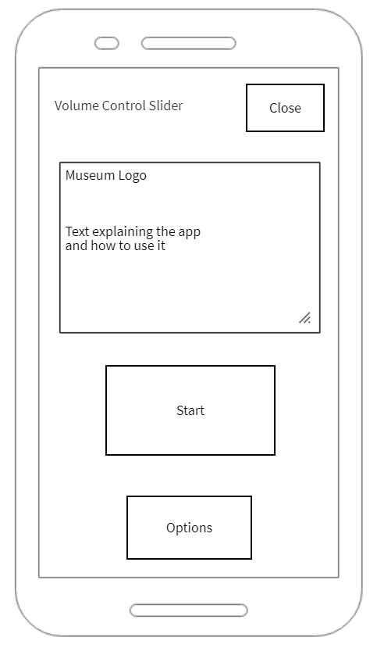

This shows the sketch for the augmented reality exhibit within the mobile phone. On the smartphone app there would be the museum logo with text how to explain the app and a user-friendly colour scheme would be used. On the top there would be a volume control slider and a button to close the app. On the bottom there would be a button for options such as changing font size and a start button which would begin the augmented reality exhibit app. For accessibility a text to speech feature would be used for people who have vision problems and the volume can be turned up for people that have trouble hearing.

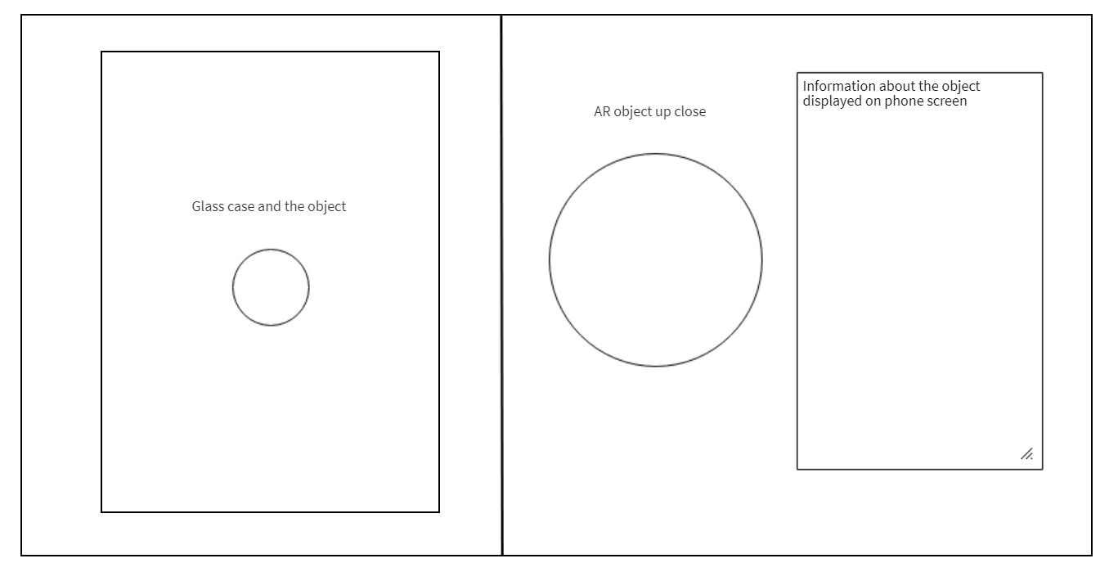
This shows the sketch for the augmented reality exhibit when pressing the start button on the app. The left side of the sketch shows an object inside a glass case which is what the user would see when inside the museum. The right side of the sketch shows the object up close in the form of AR when the user puts their phone near the glass case and the information about the object which would be displayed next to the AR object on their phone screen. For accessibility a text to speech feature would be used for people who have trouble seeing to explain the AR object and to read out the information which explains the object.

Bibliography

- British Museum [Internet]. Britishmuseum.org. [cited 31 March 2020]. Available from: https://www.britishmuseum.org/
- Louvre Museum Official Website [Internet]. Louvre.fr. [cited 31 March 2020]. Available from: https://www.louvre.fr/en
- What does critically evaluating mean? | PILOT [Internet]. Gcu.ac.uk. [cited 21 April 2020]. Available from: https://www.gcu.ac.uk/library/pilot/researchskills/criticalreviewing/whatdoescriticallyevaluatingmean/
- Types of evaluation [Internet]. Mypeer.org.au. [cited 21 April 2020]. Available from: http://mypeer.org.au/monitoring-evaluation/types-of-evaluation/
- Design Principles [Internet]. Cs.uct.ac.za. [cited 28 April 2020]. Available from: https://www.cs.uct.ac.za/mit_notes/human_computer_interaction/htmls/ch06s06.html
- Home [Internet]. Web Accessibility Initiative (WAI). [cited 28 April 2020]. Available from: https://www.w3.org/WAI/
- What is Virtual Reality? - Virtual Reality Society [Internet]. Virtual Reality Society. [cited 05 May 2020]. Available from: https://www.vrs.org.uk/virtual-reality/what-is-virtual-reality.html
- Poetker B. The Very Real History of Virtual Reality (+A Look Ahead) [Internet]. Learn.g2.com. [cited 05 May 2020]. Available from: https://learn.g2.com/history-of-virtual-reality
- History Of Virtual Reality - Virtual Reality Society [Internet]. Virtual Reality Society. [cited 05 May 2020]. Available from: https://www.vrs.org.uk/virtual-reality/history.html
- What is Augmented Reality? [Internet]. The Interaction Design Foundation. [cited 12 May 2020]. Available from: https://www.interaction-design.org/literature/topics/augmented-reality
- VR, AR, MR and What Does Immersion Actually Mean? [Internet]. Think with Google. [cited 12 May 2020]. Available from: https://www.thinkwithgoogle.com/intl/en-cee/insights-trends/industry-perspectives/vr-ar-mr-and-what-does-immersion-actually-mean/
- National Waterfront Museum [Internet]. National Museum Wales. [cited 19 May 2020]. Available from: https://museum.wales/swansea/
- 25 Best Augmented Reality Games for Android and iOS | Thinkmobiles [Internet]. Thinkmobiles. [cited 19 May 2020]. Available from: https://thinkmobiles.com/blog/best-augmented-reality-games/
- Schneiderman’s Eight Golden Rules Will Help You Design Better Interfaces [Internet]. The Interaction Design Foundation. [cited 19 May 2020]. Available from: https://www.interaction-design.org/literature/article/shneiderman-s-eight-golden-rules-will-help-you-design-better-interfaces

