Isabel Kate Porch
2004147
Surface Pattern Design and Textiles
Module: ADAD5004 Research in Practise
Word count: 2532
Julia Lockheart
Three Key Words: Stitch, Narrative and Health

Introduction

This essay explores three key words related to my practice: stitch, narrative, and health. Through the essay these words will be described and analysed in relation to three artworks and three key thinkers. The three artworks I will look at are ‘Blue Jumper’ by Bridget Harvey, ‘Quilt of Remembrance’ by WAVE Ballymoney and ‘Investment- Tabitha’ by Tabitha Moses. The three key thinkers that will help me to expand my knowledge of the words and images are: Rozsika Parker in The Subversive Stitch, Karen Nickell in Troubles Textiles: Textile responses to the conflict in Northern Ireland and Mihaly Csikszentmihalyi in ‘Flow: The Psychology of Optimal Experience’. The discussion of these key words, images and texts will lead to a research question which will inform the basis of my dissertation.

Stitch

Stitch can be understood as to “make, mend or join (something) with stitches” (Dictionary.com, 2022) using a needle and thread and is traditionally linked to domestic function and/ or decoration of cloth. Stitch is universal and apparent across cultures; it is a diverse medium which can be a hobby or profession. Traditionally stitch has been given a low status due to its associations with women and the domestic. “It is ironic that despite being derogated as ‘craft’ and ‘women’s work’, textile making provides an important source of cognitive coping or intellectual stimulation for many women” (Collier, 2011, p.110). Women’s status and stitch both lack respect and appreciation; this is seen through history and time. Stitch has always historically been a big part of women’s lives, as a form of expression, protest, for personal use and a form of language (Sabau, 2018) enabling women to have a voice and express how they were feeling in addition to providing comfort. Limited by their sex, women were encouraged to sew, and this provided a freedom and sense of independence. These ideas are echoed in the feminist text by Rozsika Parker, The Subversive Stitch, that speaks of embroidery as “both a weapon of resistance for women” and “…a source of constrain. It has promoted submission to the norms of feminine obedience and offered both psychological and practical means of independence” (2010, XIX). Stitch provided a sense of liberation for a woman in a time of female restraint; however, this was still within the confines and expectations of the ‘woman’s role’. Whilst offering the opportunity for self-expression, it arguably was still self-limiting.

Within contemporary society stitch is still used as an active method of expression. The Blue Jumper by Bridget Harvey (see figure 1) can be seen as a symbol of anti-waste; moth eaten but still repaired through heavy darning. Harvey uses her stitch as a slogan, representative of her views on repair, re-wearing, and the pressures of buying new clothing. “Personal, political, active, and rebellious. Resilient against pressure to buy new: I can, I will, I am, through choice and necessity, wearing, repairing, and re-wearing” (Harvey, 2022). Harvey uses the blue jumper as a symbol of decorative activism. Although the stitches serve a purpose, they are also a form of decoration and expression of her personal views on the waste prevalent in the twenty-first century. Stitch joins things together, metaphorically as well as physically. Repairing increases the longevity of an item and creates a caring connection and new love for items. Melanie Klein in The Subversive Stitch wrote,

When I was growing up, all the women in my house were using needles. I have always had a fascination with the needle, the magic power of the needle. The needle is used to repair damage. It is a claim to forgiveness. It is never aggressive, it’s not a pin (Klein, xix, 2010).

Stitch is a peace maker, it makes ends meet, it joins things together and mends them. Stitch can be used as a form of peaceful protest, passivist activism, and brings people together. Repairing increases the longevity of items and adds personality to them. The time that is spent on mending can be seen as an act of care and love, forming a stronger connection to the item and it is often kept for longer as a result (Gauntlett, 2011).

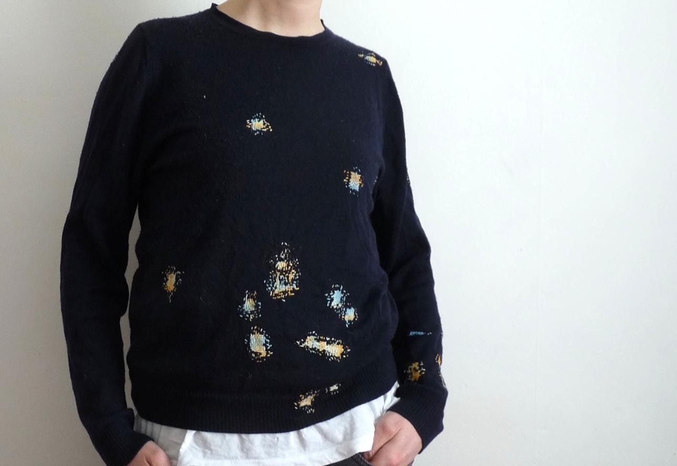
Fig.1: The Blue Jumper.

Increasing environmental concerns have brought stitch to the forefront as sewing clothes and repair are used as methods to tackle the waste from over consumption of clothing. The ‘make do and mend’ philosophy from the Second World War is being reintroduced, as the national curriculum moves to teach students to design and fix their own clothing (Webster & Bennett, 2019). A more robust connection to clothing is made through the method of repair with an emotional connection being formed (Gauntlett, 2011). Clothing becomes a memory of the experiences a person has had and the time they have spent with an item; a new narrative and meaning is thereby created with each stitch.

Narrative

This section will explore the word ‘narrative’ and its context within stitch. The Cambridge Dictionary defines narrative as “a story or a description of a series of events" (Cambridge Dictionary, 2022). Stories can be communicated through various art forms such as textiles and stitch. Sonja Andrews (2008) in her paper Textile Semantics: Considering a communication-based reading of textiles, proposes that textiles are cultural signifiers that communicate meaning. She says that images that create a narrative, symbols, motifs, text, visual language and materials, all have meanings. As such these can be used to tell stories through cloth and stitch. However, stories are not only stitched into cloth, but stories can also be told verbally whilst stitching. In Inuit culture the older generation would tell of stories “about life on the land” and remember stories of their ancestors and feel close to them whilst sewing patterns linked to their family and heritage (Emanuelsen et al., 2020, p.5). Like Inuit textiles the Gee Bend quilts tell stories of their heritage through stitch. “The quilts have many stories to tell of artistic innovation, triumph over hardship, and pride in heritage” (Philadelphia Museum of Art, 2022, p.1). Stitch can be a way of recording a family history and memorialising a past.

As such, stitch can tell stories about creativity, skill, technique, new innovations in making, social, economic, and political narratives as well as historical and cultural traditions. Alice Kettle in Stitched Stories describes how stitch connects the “... past with the present...” and “...merges personal memory with collective remembering…” (Kettle, 2016, pp. 264- 265). Remembering and stitching can also have health benefits, helping people to relax and talk about troubling events. “Participants described sewing as a mechanism they used to get through emotional times in their lives and as a tool to help when they needed to calm down or think through situations” (Emanuelsen et al., 2020, pp.5-6). This demonstrates how stitching can support wellbeing and help people to tell their stories. This is further exampled through the textile work of Louise Bourgeois which Frances Morris describes as “... psychological repair. This active process of transformation of material, self and being in the world, shaped by thread and stitching, in Bourgeois’ case is emancipatory, hopeful and recuperative” (Kettle, 2016, p.264). In describing stitch as emancipatory, Morris points to the political power of textiles and stitch. Alice Kettle argues, “Thread has the potential to make change, transform the materials and people it engages with and to describe the world” (Kettle, 2022, p. 14). Textiles has had a significant role to play in both personal transformation and change but also social, economic, and political change. Textiles have historically been used as a political voice for women through embroidered banners in the suffragette movement, through to Arpilleras (patchwork quilt made by Spanish women), where images and text have been stitched, patchworked, and weaved to record narratives through history.

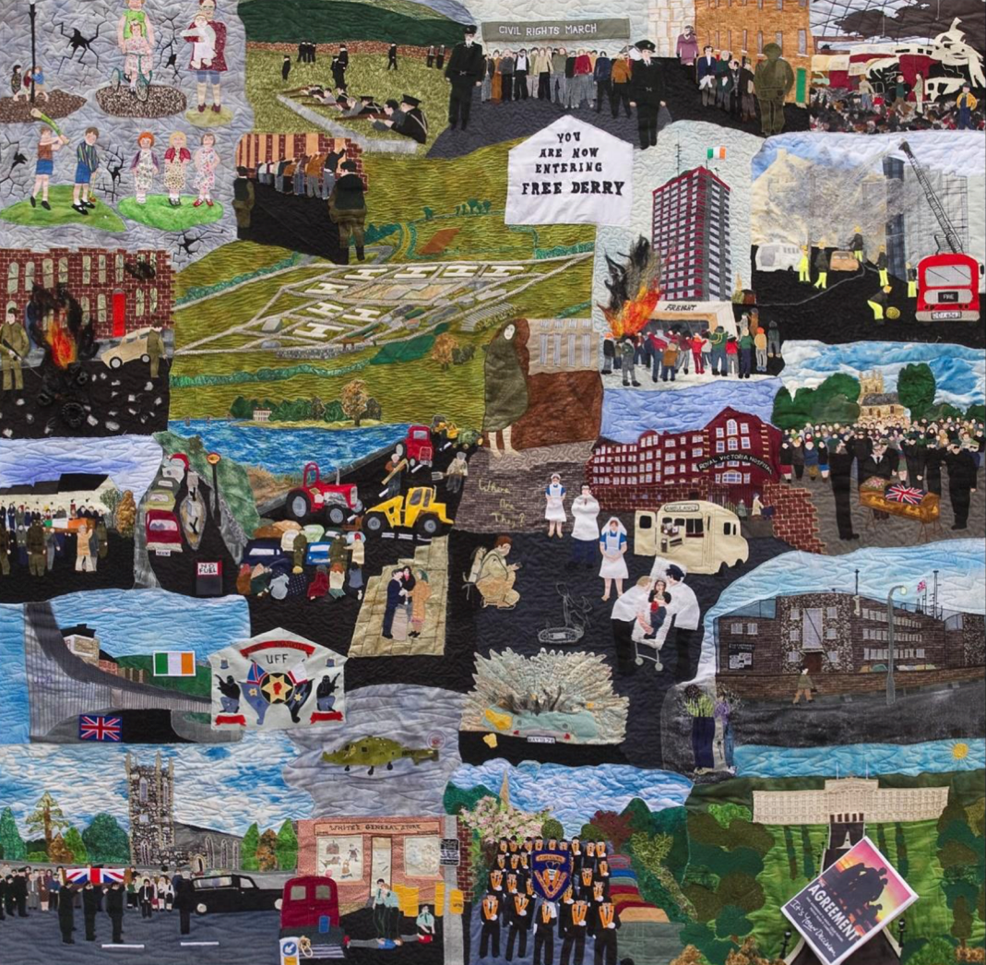
Fig. 2: Quilt of Remembrance.

Figure 2 is a collaborative quilt project run by WAVE Ballymoney, an organisation which provides support to those who have been affected or traumatised by the Northern Ireland conflict. The Quilt of Remembrance was inspired by the Aids Memorial quilt which was exhibited in Ulster in 1991 and is made up of 10 panels; figure 2 shows one of these panels which contains 49 squares. Each square remembers a deceased person from the Nationalist/ Republican side of the conflict and uses their clothes, symbols, and images to tell their story. The Quilt of Remembrance as such contains powerful personal stories. However, in only representing the stories of a group of people from one side of the conflict it opens debates about “contested memory, and the continuing memorialisation disputes of who should be remembered and how” (Nickell, 2022, pp.234-251). More recent approaches taken by WAVE in making quilts is to focus on collaborative projects with people from both opposing views, all of whom are looking for therapy. They make quilts that include neutral symbolism about reconciliation and peace in a neutral sense. In Karen Nickell’s essay ‘Troubles Textiles’: Textile responses to the conflict in Northern Ireland says, “the language of cloth gives us a way to talk about a fragmented society and nation - holes, tears, seams, patches, layers, mending, darning, joining, fraying, ripping – all ways to visualise and articulate the fabric of society” (Nickell, 2022, Introduction). Nickell’s uses textile terminology as a metaphor for people's experiences to allow them to identify their shared human suffering and come together in unity and reconciliation.

Health

The final key word is health. This section will use the journal article Sewing and Inuit women’s health in the Canadian Arctic by Kristin Emanuelsen et al. (2020), which introduces the idea of sewing being a self-care and form of healing for mental and physical health within Inuit culture. It will also look at the idea of flow and optimal experience that sewing can promote. Tabitha Moses will be the artist discussed in this section as she works with mandalas and sewing as a form of healing for her health and experience of infertility.

Sewing can help maintain social relationships and cultural traditions which creates a sense of personal identity and feeling part of a wider community; these factors support health and wellbeing (Emanuelsen et al, 2020). Emanuelsen et al. (2020, p.6) suggest that sewing helps people to connect with their heritage, culture, identity and ancestors and reports, “Others described sewing as something they really love, that makes them feel healthy because of the happiness it brings them and the memories it helps them create”. The Inuit's used sewing to help them feel better, give them space to think and work through problems both emotionally and physically; the physical act of sewing through thick, tough fabrics to express their anger and frustration. As such sewing was described as “...a form of healing...” that gave them a sense of satisfaction and achievement (Emanuelsen et al, 2020, Abstract). In summary the Inuit people felt that sewing brought positive health benefits and was a meditative practise, enabling them to absorb themselves within a ‘flow’ state.

Flow is “a state of concentration so focused that it amounts to absolute absorption in an activity”, which results in feelings of satisfaction (Csikszentmihalyi, Harper and Row, 1990, p.1). Flow is the perfect point in which we set “ourselves challenges--tasks that are neither too difficult nor too simple for our abilities” (Csikszentmihalyi, Harper and Row, 1990, p.1). This helps us to build a strong self-belief that we can overcome obstacles and our lives can be improved both mentally and physically. Flow has meditative and healing qualities as it creates a space in which “... time no longer seems to pass the way it ordinarily does. Generally, after the experience we do not know where the time went; however, during the actual experience, time seems to stand still” (Csikszentmihalyi, Harper and Row, 1990, p.5). Through sewing a meditative state can be created and an overall sense of wellbeing.

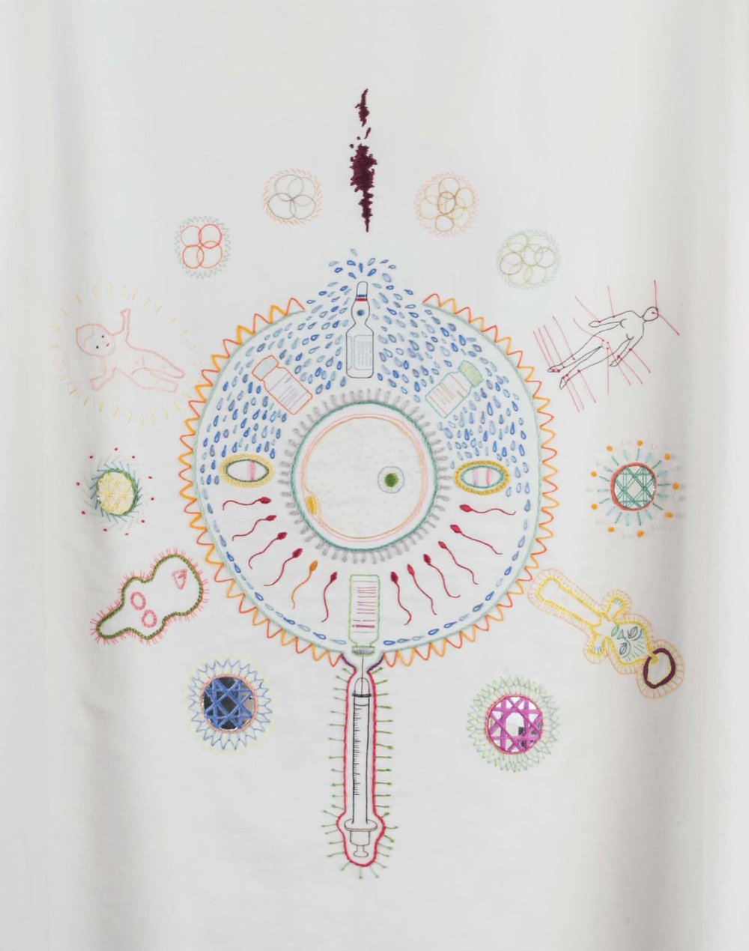
Fig.3: Investment- Tabitha

Tabitha Moses explores the themes of stitch, narrative and health in her textile piece called ‘Investment- Tabitha’ which is about Tabitha's ongoing journey with infertility. On a hospital gown she embroidered lucky symbols and imagery that corresponded to her story and experience with infertility. It took four weeks to complete the hospital gown. Tabitha’s gown includes embroidered depictions of the IVF process, drugs, sperm, egg, womb, tear drops, acupuncture points, good luck imagery, cells, and a baby with a halo around it. Tabitha uses the phrase ‘magical thinking’ in her work which Eugene Subbotsky explains “...just as rational thinking helps us to cope with problems in the physical world, magical thinking comes to our aid when we deal with problems in our personal, social and emotional life” (Subbotsky, 2004, p.339). Tabitha Moses also explores the state of flow and meditation. Through stitch she says “I find hand embroidery a contemplative, and sometimes therapeutic, act – it takes so long that you spend time getting to know the subject intimately. My hands are busy but my mind is free to roam” (National Museums Liverpool, 2022). Through sewing Tabitha is able to absorb herself in a therapeutic state enabling her to express her emotions.

Conclusion

From my exploration of these three key words, images and texts it is evident that there is a connection between them. The words stitch, narrative and health can be understood through each other. Narratives about health and well-being can be stitched using imagery, text, and visual language. These can take the form of personal stories, community or cultural experiences and traditions. Textiles have been historically linked to ‘women’s work’ and women’s stories. Stitch has been closely linked to the idea of femininity and so through time the view of stitch has corresponded to public views of women, being weak and not skilled. Many women and artists are reclaiming stitch today in their personal and public work. Textiles can be a form of communication which can narrate political messages as seen through the pieces I have researched, in addition to suffragette banners and arpilleras which are all also a form of activism. Stitching with others also helps to build social and cultural relationships and connections to one another through meeting and making. Stitching can help relax someone so that they are able to freely talk about their personal experiences and narrate stories. Stitch itself has its own story and through its process and technique, metaphors of mending and repair can allow for emotional experience to take a physical form and emotional healing. Stitching has many health and therapeutic benefits including its meditative, expressive, and repetitive properties, that help with creating a sense of achievement and overall wellbeing.

Even though the three images I chose have different stories, concepts, functions, purposes, and unique narratives they are connected through the benefits that stitch brings to health. They all example how stitch, through its physical process and its metaphors of repairing, mending, joining, and connecting have an emotional and wellbeing impact on the individual maker and their communities. This topic has lots of potential to be developed into a study for my dissertation and reflects my interests and practice as a surface pattern designer and textile maker.

Question

How can stitched stories support health and wellbeing? This work explores stitched textiles in relation to health, with a focus on narrative, by means of image analysis, artist interviews and academic resources.

Bibliography

Andrew, S. (2008) Textile Semantics: Considering a Communication-based Reading of Textiles. Textile The Journal of Cloth and Culture, 6(1):32-65. Available at: https://www.researchgate.net/publication/233647550_Textile_Semantics_Considering_a_Communication-based_Reading_of_Textiles (Accessed: 1 May 2022)

Cambridge Dictionary (2022) Narrative. Available at:
https://dictionary.cambridge.org/dictionary/english/narrative (Accessed: 20 April 2022)

Csikszentmihalyi, M. (1990) Flow: The Psychology of Optimal Experience. Harper & Row, Acadamia.edu, pp. 1-5. Available at: https://www.academia.edu/31812103/FLOW_The_Psychology_of_Optimal_Experience
(Accessed: 1 May 2022).

Dictionary.com (2022) Stitch. Available at: https://www.dictionary.com/browse/restitch (Accessed: 20 April 2022).

Emanuelson, K. et al. (2020) ‘Sewing and Inuit women’s health in the Canadian Arctic’, Social Science and Medicine, 265, pp.113523-113523. Available at: https://librarysearch.uwtsd.ac.uk/discovery/fulldisplay?docid=cdi_proquest_miscellaneous_2465437983&context=PC&vid=44WHELF_UWTSD:44WHELF_UWTSD_VU1&lang=en&search_scope=MyInst_and_CI&adaptor=Primo%20Central&tab=Everything&query=any,contains,Inuit%20womens%20health (Accessed: 12 April 2022).

Harvey, B. (2022) Blue Jumper (2012 ongoing). Available at: https://bridgetharvey.co.uk/blue-jumper (Accessed: 5 April 2022).

Kettle, A. (2016) ‘The Story and the Stitch’, Textile Society of America Symposium Proceedings, 976. Available at: http://digitalcommons.unl.edu/tsaconf/976 (Accessed: 12 April 2022).

Kettle, A. (2022) ‘Threads of Life’, Embroidery, 73, pp.14.

National Museums Liverpool (2022) Tabitha Moses- artist guest blog. Available at: https://www.liverpoolmuseums.org.uk/stories/tabitha-moses-artist-guest-blog (Accessed: 20 April 2022).

Nickell, K. (2022) ‘Trouble Textiles’: Textile Responses to the Conflict in Northern Ireland. Available at: https://pure.ulster.ac.uk/ws/portalfiles/portal/11511359/Troubles+Textiles+accepted+version+with+images.pdf (Accessed: 15 April 2022).

Philadelphia Museum of Art (2022) Gee’s Bend: The Architecture of the Quilt and African American Quiltmaking Traditions- A resource guide for teachers. Available at: (https://philamuseum.org/doc_downloads/education/ex_resources/geesBend.pdf (Accessed: 14 April 2022).

Sabau, J. (2018) Textile Art. Available at: https://awarewomenartists.com/en/decouvrir/textile-art/ (Accessed: 5 April 2022).

Subbotsky, E. (2004) ‘Magical Thinking- Reality or Illusion?’, The Psychologist, 17(6), pp. 336-339. Available at: https://www.researchgate.net/publication/236981242_Magical_Thinking-Reality_or_Illusion (Accessed: 15 April 2022).

Webster, B. & Bennett, R. (2019) ‘Stitch in time may help to save the environment’, The Times, 19 February. Available at: https://www.thetimes.co.uk/article/stitch-in-time-may-help-to-save-the-environment-83gb8mfv9 (Accessed: 20 April 2022).

List of Illustrations

Figure 1: Harvey, B. (2012) The Blue Jumper [photo]. Available at: https://bridgetharvey.co.uk/blue-jumper/ (Accessed: 15 April 2022).

Figure 2: WAVE (Wave Trauma Centre) Ballymoney (2014) Quilt of Remembrance. Available at: Troubles+Textiles+accepted+version+with+images.pdf (ulster.ac.uk) (Accessed: 12 April 2022).

Figure 3: Moses, T. (2014) Investment- Tabitha. Available at:
https://www.axisweb.org/p/tabithamoses/ (Accessed: 15 April 2022).

