Problem Solving and Decision Making

By
Elena Serbanoiu
UWTSD ID: 1818451

Table of Contents
Introduction 2
Company Overview 2
Define a complex problem in the workplace including its scope and impact. 2
Analysing information on the identified problem, to help inform the decision making process 3
Propose a range of alternative solutions to the problem 4
Decision-making technique to evaluate a range of solutions to identify the most appropriate option 5
Plan for implementing the solution 5
Communicate the plan to stakeholders 6
Appropriate monitoring and review techniques to ensure successful implementation of the solution 7
Conclusion 8
References 9

Introduction
Employees and organisation have to face different problem while operating the business and day to day activities. Management should have plan and solution for the arising problems especially for the complex ones. The nature of problems and the impacts on the organisation have been evaluated here. Confirming the problem solving method and decision making information is to collect and analysed. Again different solutions have to compare and weight to select the best ones. The techniques and the planning strategies of decision making or problem solving of Tesco Plc. have been evaluated here.

Company Overview
Tesco Plc. Is one of the oldest and largest grocery supply chain in the world. Tesco Plc. is the public limited and popular multinational supply chain. It is the market king throughout the UK. Tesco has already broadened its business in Asia and Europe. This market king has already proved the market position making more than 6 billion pound. This global organisation has different ventures and grocery supply chain is the largest one. This multi-billion profit making organisation was founded by Jack Cohen in 1919 (Tesco, 2020). Hundred years old organisation headquartered in England. This presentation will be analysed the customer engagement issues and problems. The best solution planning and implementing those would be recommended and shown here.

Define complex problem in the workplace including its scope and impact.
Complex problem: Complex problems refers the problems that arise from the managerial activities of the organisations and not easy to understand while it is not possible to eliminate the problems permanently from the organisations. These problems are known factor to the management and management has plan and strategic steps to control or remove these.
Scope and impact
Tesco Plc. is the largest grocery supply chain in UK. Being the market king Tesco has to serve throughout the world. Tesco has global business line and has to operate these vendors effectively to maintain the market value and reputation. Tesco has wide range of stakeholders. Tesco has to maintain the relation with this large number of clients or customers. Any wrong step in decision making or operation can immediately hamper the reputation of the business. For example, Tesco should maintain the efficient supply of groceries and possible home delivery services for the lockdown cases in maximum areas. While customers would fail to have the required services from this largest global supply chain, the customer satisfaction issues may hamper. Again different social responsibilities and charity activities should be operated in this unavoidable COVID situation.
Tesco has to focus to the improved services and performances to satisfy the large amount of stakeholders. The customer needs and the satisfaction issues should be the main priority in every situation. Maintaining relation and expectation of the customers is not an easy task for the management of Tesco. This would be the great challenge for the management while taking any wrong decision and handle this complex problem of the management (Adair, 2012)

Analysing information on the identified problem, to help inform the decision making process
Information is must for the decision making. Without analysing the related information decision cannot be perfect. In the case of Tesco time to time customer survey and active customer engagement is needed to ensure the maximum information flow from the customers knows any immediate facts.
Big Data: Big data is must for the market research of any big organisation like Tesco Plc. The complex data should be analysed gaining from big data maintaining by the management.
Sorting out the relevant information: All the information may not equally relevant for the market research and finding the best solutions. For example, customers may have emotional information regarding satisfaction issuers. Emotional information may not have business gain directly but very mush necessary for the relation improvement with the customers.
Identify the relevant and needed information: The relevant information should be found out to make the best solutions. For example, while facing some complain issues the real customers and the actual event should be known to make the right decisions.
Mapping out the consequences: While analysing the information and planning the solutions or decisions the consequences should be considered immediately. The future impacts of the decision to the customers, staffs and management should be mapped out.
Knowing the consequences: While the consequences are clear to the management the planned decisions can be taken. The clear result can help to start making the plan regarding implementing those (Allwood & Selart, 2016)
Make decisions: The perfect decision can be taken while the analysed data is perfect. So considering the above facts the relevant and needed data should be selected and used by the management of Tesco Plc.

Propose a range of alternative solutions to the problem
Alternatives: Problems can be arisen in regularly. So finding the best solutions is the best way to cope with the problems. The creative minds don’t bother finding the problems but make the best solutions. Management team Tesco has brainstorming group to find the solutions regarding customer engagement issues to all the regions. The team is not only involved to find the solutions but find the best ones for the final implementation. Solutions may seem impressive or effective in first view. But the needed analysis and future findings should be sort out to make the decision perfect.
Compare the alternatives: Comparing the alternatives related all the factors should be analysed. Alternatives may have different important and unavoidable factors regarding the business value or reputation. Some of these needed factors are:
- Impacts on the current business,
- Customer relation and satisfaction issues,
- Effects on the employees and line workers,
- Costing and legal issues,
- Ethics and corporate responsibilities (Daft & Lane, 2015)
Make a choice: After comparing the above factors the best solutions can be easily sorted. The best options should be the best solutions fulfilling the needs. Sometimes the solution of the arisen problems may involve more acutely to the customer engagement. Besides that, best option can be found considering related factors.

Decision-making technique to evaluate a range of solutions to identify the most appropriate option
Decision tree is one of the most used and effective tool for decision making. Decision tree consider the alternatives and the outputs to select the best ones. The decision nodes of decision tree evaluate the alternatives and leaf nodes shows the result. The toll is the graphical presentation of different alternatives. The leaf nodes represented the outputs considering the cost, probability and the value of the alternatives. The decision tree model considers all the related outcomes of the decision to compare those selecting best one.
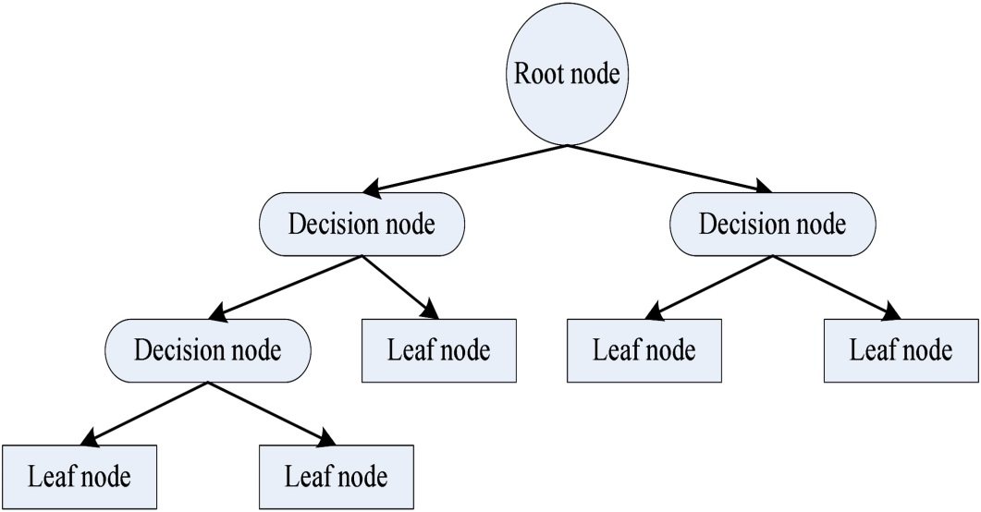
Figure: Decision Tree
The above figure shows there are two types of nodes. The decision nodes are for presenting the planned actions or alternatives while the leaf nodes would show the outputs. The decision makers or management compare the leaf nodes which represent the output or result of the alternatives. The best options are measured and chose the best alternative comparing the all leaf nodes (Dery, 2013)

Plan for implementing the solution
Successful implementation program focuses some facts. These facts help to find the best implementation plan. Management would find the answer of where the business is now, what is the problems and how management can solve the problems. The implementation process of the solution is evaluating here:
The current satisfaction and customer engagement level should confirm to measure the changed effects by implementing the solution.
The solution should have clear view where the customer engagement would be gone after the implementation. The picture would help to know the effectiveness of the solution.
Finding the best solution the reasons behind the solution should be clear to management. While the reasons are clear, solution would be perfect. The time measurement, result oriented and time focused solution should be implemented. For example, customers may have current demand on specific product line. This problem should be solved immediately.
The targeted position or the target solving the problems would be exact in the implementation plan. The implementation plan would focus the target. The management of Tesco would focus the customer engagement and satisfaction first while implementing the plan (Helfand, 2017)
In the last steps of the implementation planning the whole plan would be successfully review and measure the time scale, budget and other factors. This help to know the ultimate progress by the implementation of the plan and possibility solve the arisen problem.

Communicate the plan to stakeholders
Communicating the stakeholders is must for the efficient customer engagement. Customer would be engaged in timely manner. Communicating the valuable stakeholders or the customers Tesco should apply the following plan or steps. Practicing effecting communication systems would ease the ultimate communication with the stakeholders.
Communication objectives: The objective of the communication should be clear. The needed information should be focused in the communication. According to the needs the objective should be set.
Key messages: The key message of the communication should according to the needs. While Tesco needs satisfaction issues, the massage would be prepared and sent focusing satisfactions issues.
Target stakeholders: The target stakeholders should be marked and communicated with them. While investing the market to know the customer’s perception target customers should be locked and confirmed.
Effective communication tactics: Different communication tactics are available to communicate with the stakeholders. Tesco can use market research using leaflet, mail, questionnaire or other medium. Best tactics should be confirmed while communicating stakeholders (Leonard, 2017)
Assessing the plan and result: The plan may need to modify or revise. The result should be measured and compare to confirm the maximum output from communication systems. While management fails to get the needed information or responses Tesco should apply different strategies to get the maximum value.

Appropriate monitoring and review techniques to ensure successful implementation of the solution
The final step of the problem solving and decision making is to monitor the overall progress of the plan and implementation. The taken actions or implemented plan would be track to find the accuracy and development of the plan.
The management of Tesco Plc. would track the report to know the actual output comparing the market condition. The first thing that the team has to ensure is good records of the planned actions. The implementation process starts doing the planned actions focusing the objectives of the plan. The recording and tracking process should be clear and pre planned. Monitoring or reviewing the changes the accurate tracking systems should be confirmed and developed (Shapira, 2013)
Tracking, monitoring and reviewing the progress and changes the following steps should be maintained by the management:
- The planned activities should be kept maintaining the standards,
- Ensure the consistency of the actions and records of the actions,
- The recorded information should be attached to different statements for the future use,
- The internal and external effects of the problem solving actions and the required adjustments should be taken.

Conclusion
Identifying the complex problems is must for the reputed organisation like Tesco Plc. It is not an easy task to identified and take necessary courses of actions. The plan and the solution need to be accurate. The overall planning and decision making have been explained here. The communication systems of Tesco and needed information execution from the stakeholders have also evaluated here. Finally the monitoring and reviewing techniques are shown here to measure the accuracy of the overall problem solving and decision making process.

References
Allwood, C., & Selart, M. (2016). Decision Making. Springer Netherlands.
Adair, J. (2012). Decision making and problem solving.
Tesco - Supermarkets | Online Groceries, Clubcard & Recipes. Tesco.com. (2020). Retrieved 27 April 2020, from https://www.tesco.com/.
Daft, R., & Lane, P. (2015). Leadership. Cengage Learning.
Dery, D. (2013). Decision-making, problem-solving and organizational learning. Omega, 11(4), 321-328. https://doi.org/10.1016/0305-0483(83)90025-7
Helfand, M. (2017). Shared Decision Making, Decision Aids, and Risk Communication. Medical Decision Making, 27(5), 516-521. https://doi.org/10.1177/0272989x070270050101
Leonard, B. (2017). Multidimensional decision making. Emerald.
Shapira, Z. (2013). Organizational decision making. Cambridge University Press.




