1.Introduction

There are many ways for artists to convey their emotions, and they also draw inspiration from cultural heritage and social contexts to create works of art that resonate universally. An artist's identity is a fusion of cultural heritage, personal experience and external influences. Different life experiences, family backgrounds, and social backgrounds all play a role in shaping artists' perspectives and artistic choices. These influences intertwine to create a rich and subtle artistic identity that reflects individuality and shared humanity. This paper focuses on the reasons that influenced creators to choose to use huge animals as a subject. It is closely related to their life experiences, the context of their times and their cultural background.

For artists, personal experience is a very valuable inspiration. Personal experience may be the basis of their artistic creation, or it may be the sublimation of the content of the work, but also the embodiment of the sense of reality of the work. Frida Kahlo's unapologetic self-portrait, an exploration of pain and femininity. Famous works by Vincent van Gogh during his struggle with mental health, these emotional landscapes prove how personal experiences can be the driving force behind an artist's work. They are a reflection of the artist's inner world.

Cultural background is also one of the inspirations for artists to create, and each country and different regions within the country have their own cultural characteristics. They may be traditional culture, symbolic literature, customs and beliefs, art forms or social practices handed down over thousands of years. Artists will be attracted by these cultural features, and they will rethink the connection between these cultural contexts and themselves and society. Wu Jian's collages of integrated materials (Figure 1& Figure 2 ) and his works of sculpture and installation are derived from his love for ancient myths.

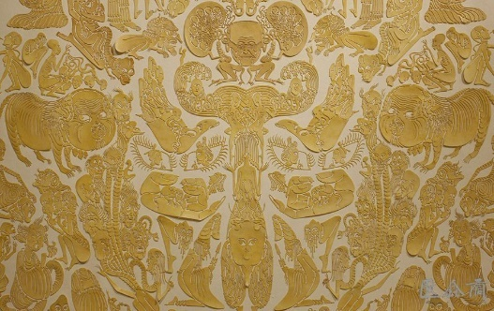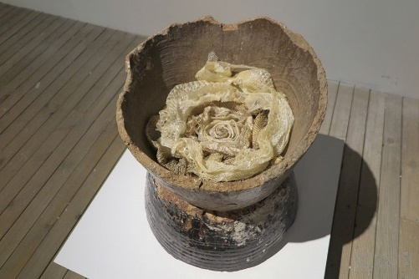
Figure 1 Qi Ceng Ke，2012 Figure 2 Po Ta Ji，2015

The background of The Times is also one of the important reasons that affect the artist's thinking and creation, we will see many images with the mark of The Times in the creation. For example, the Science fiction，it was born in the 19th century as a result of the rise of industrial civilization in Europe, reflecting growing ambivalence about the impact of technological developments on society and individuals（Wikipedia， Accessed：2025）. There is also the development of Japanese animation, Iron Arms Astro Boy (1958) was the first really popular Japanese animation. After World War II, the Japanese government and the United States government wanted to promote nuclear power generation in Japan, but because of the atomic bomb attacks in World War II and the United States in the Pacific test explosion of hydrogen bombs caused ecological destruction, Japanese society was very antipathy to atomic energy（Wikipedia， Accessed：2025）. The character of ‘Atom’ was born in 1952 as an ambassador for the peaceful use of atomic energy.

From philosophers' initial demarcation of the boundary between humans and animals to Nietzsche's reinterpretation of life as a whole (Zhou, 2004), to Donna J. Haraway’s new conception of the relationship between humans and animals (Haraway, 2016), Animal issues have always been an important topic that cannot be avoided in philosophy, culture and even creation. Animals are an indispensable mirror in human thought exploration, reflecting the profound thinking of human beings about themselves, life and the essence of existence.

Huge things are eye-catching, and people tend to notice huge things more easily because they can give people a stronger visual impact. Huge objects are mysterious and sometimes oppressive. The interaction between giant animals and characters is more like a fantasy, perhaps the creator's emotional sustenance or a fantasy of childhood experiences, or it may be his own thinking about life. The diversity of cultural backgrounds, childhood experiences and growth experiences will give different meanings and connotations to the creator's works. The interweaving of works and giant animals is more like a collision between art and psychology.

2. Theoretical Background

There are many paintings of giant animals in history, and The Temptation of St. Anthony (Dalí) (Figure 3, 1946) is one of them. This is a classic surrealist work. Significantly, it was the first of his pieces to exhibit his interest in the intermediates between Heaven and Earth（Gilles, 2015）. In the picture, a horse and a group of elephants are approaching Anthony. Both the horse and the elephant are very large, and their shapes are abstracted. Their legs are very thin. The huge horse symbolizes Satan, and the elephant behind the horse and the objects on the elephant represent temptation. Dali believed that all objects have spirituality, and he conveyed this information through his paintings.

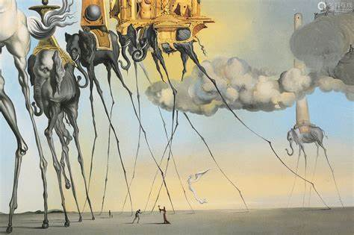
Figure 3 Temptation of St. Anthony (Dalí), 1946

The huge animals are the embodiment of the artist's inner emotions, life experiences, and thoughts and perceptions of things. To a certain extent, giant objects can also reflect the artist's thoughts and feelings about things. The feedback brought by giant objects in different situations is completely different. The word "giant" first appeared in science fiction. It was a fictional concept coined by Australian scholar Peter Nicholls in The Encyclopedia of Science Fiction.
[…]These have normally been built by a mysterious, now-disappeared race of ALIEN intellectual giants, and humans can only guess at their purpose, though the very fact of being confronted by such artefacts regularly modifies their mental programming and brings them that much closer to a CONCEPTUAL BREAKTHROUGH into a more transcendent state of intellectual awareness(see also SENSF OF WONDER) (Clute and Nicholls, 1979).

Huge objects are the embodiment of mystery, shock and oppression. Different giants carry different associations and bring different sensory experiences to people. To a certain extent, humans' different emotions towards giants come from humans' own desires. People project their desires, consciousness, nature, and emotions onto the huge objects, which is a bit like a mirror. From this perspective, these massive objects are a deliberate affront to humanity, and people's inner hearts are seen through, magnified, and refracted.

The giant animals combine the two elements of "giant" and "animal", both of which are a projection of the artist's inner thoughts, emotions, experiences and the results of his thinking about the outside world. They use this artistic technique to refer to a certain group or themselves, concretize abstract emotions, and transform their own emotions into a picture that can be seen and conveyed.

At the same time, the works of illustrators are closely related to their childhood experiences, social backgrounds, and living environments to a certain extent. These experiences and environments will become the inspiration for their creations, enriching the elements and storytelling of their paintings. Sometimes illustrators choose to use animals as the protagonists of the picture to express some emotions and feelings. From a certain perspective, the emotions that animals react to are purer than those of humans, and they can better highlight certain emotions in human consciousness. Illustrators also use the images of animals to show their own experiences, their own contradictions, and their own thoughts on external phenomena.

3. The giant animals are a mapping of the artist's own thoughts and experiences.

3.1 MonoKubo

Monokubo was a Japanese illustrator and designer who left this world on January 24, 2022. Her family did not explain the reason, but only posted the information on social media. Her death sparked discussion on social media, with some people who followed her movements and works speculating that her death might have been caused by some psychological problems based on her illustrations and some texts she posted on social media.

She is best known for her giant animal works. Her illustration books, Warm monsters (Figure 4) and Big hugs (Figure 5), feature warm interactions between characters and these giant animals.

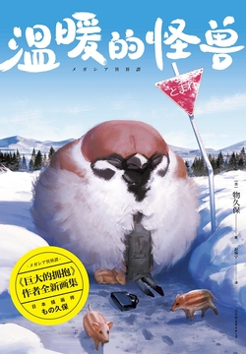
Figure 4 The warm monsters，2021

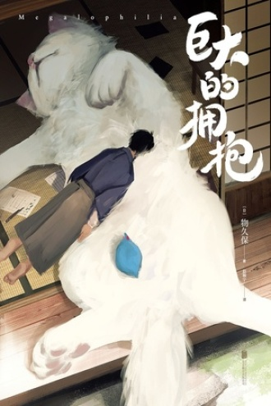
Figure 5 Big hugs，2020

Monokubo's works mostly depict giant creatures and human daily life. Most of these illustrations are warm, cute and healing, but one can always feel some loneliness and sadness, as well as a deep sense of fatigue with life. There was a comment on social media: From these pictures I can clearly feel that the author is seriously lacking in love and is in urgent need of protection (jefferychan, 2022).

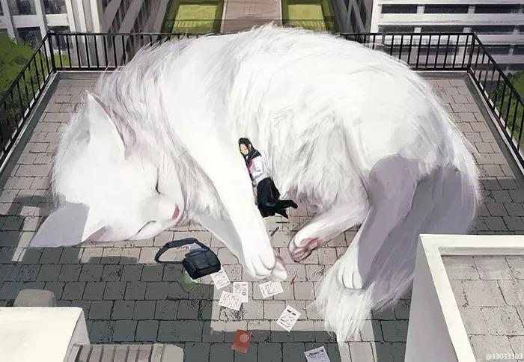
Figure 6 Giant organism，2017

The first impression of the illustration in Figure 6 is relaxation. The girl is quietly lying on the huge white cat to rest. She is completely immersed in the soft fur of the big cat. There are test papers and study materials scattered around her that fell out of her schoolbag. The huge cat and the human are both sleeping, and the sun is falling on them. This seems to be a way for the girl to relax and relieve fatigue after a tense and boring study.

In addition to providing objective visual information, color also has a huge impact on personal feelings and can cause certain emotional reactions (Hemphill 1996; Mahnke, 1996). Liu and Pei (2018) argue that different colors can evoke different emotions in viewers about an image, and they also argue that emotions play an important role in how people think and behave. If you look closely at this illustration, you can see that the color tone is on the cold side. Although the sun is shining on them, the light looks pale and the buildings behind them also look grey. The colors of the picture are not rich and bright, and combined with the characters, animals and the surrounding environment, there is a faint sense of decadence. These may be the reflection of the deep emotions of Monokubo. She hopes to convey warm emotions to the outside world, but the loneliness and helplessness deep in her heart cannot be ignored. She incorporates these emotions implicitly into the illustrations, perhaps hoping that readers can discover them, or perhaps because she is eager to struggle out of these emotions.

Animals' emotions are much purer than human. Some people feel that getting along with animals is more relaxing than getting along with people, and the emotional value brought by animals is higher than usual social interactions. Perhaps because of social pressure, social pressure or exhaustion from life, Monokubo placed her spiritual comfort on animals. In her world, perhaps the relaxation and sense of security brought by animals is stronger. The animals here are more like perfect companions and quiet guardians. When creating these illustrations, Monokubo seems to be immersed in her own fantasy world, looking for the sense of security and silence that real life cannot bring her.

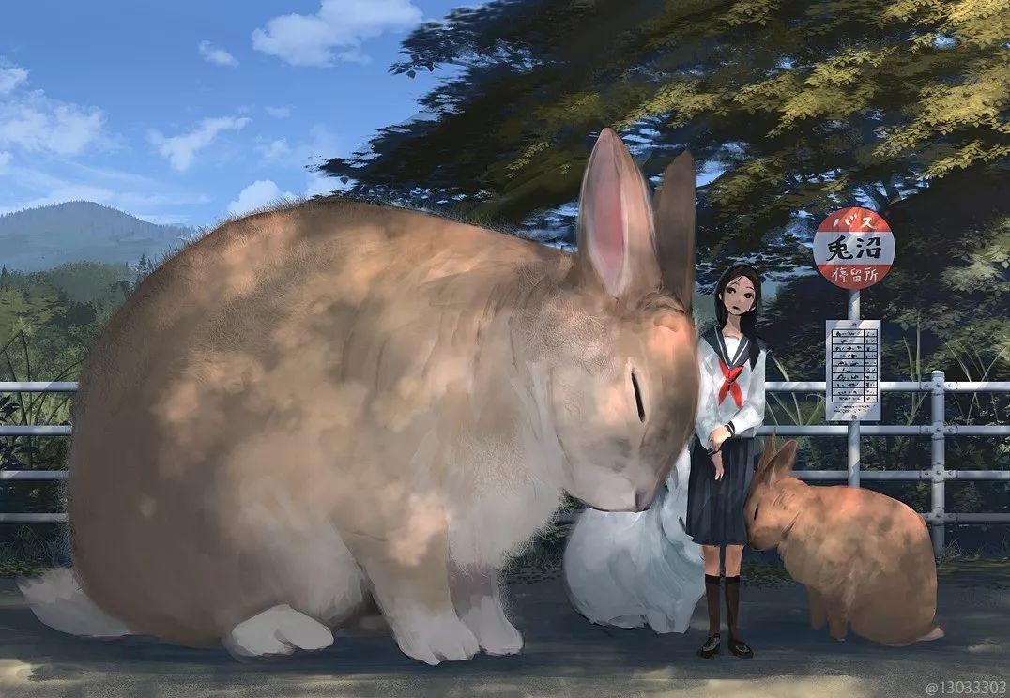
Figure 7 Giant organism，2017

According to the Oxford English Dictionary, the word safety refers to a condition of being protected from or not exposed to danger, or free from suspicion (Oxford English Dictionary, 1933, Vol. 9). According to this explanation, a sense of security is the feeling that one is protected or that the surrounding environment will not cause panic and fear. Some people feel safe when they are hugged by something big, and big dolls and blankets can make them feel safe. Although Monokubo did not elaborate on her experience, she once mentioned on social media that these animals were lent to people who were having trouble at work. Perhaps out of stress and anxiety caused by the trouble at work, she projected part of her inner self onto the picture. The interaction between the characters and the giant animals in the illustrations is more like her attempt to relax and feel at ease. From the pictures, we can see that what she experiences from society and life is more anxiety and sadness. Deep down in her heart, she may be in a state of lack of security. The giant animals reflect her deep desire for security. These huge animals are her protectors when she is injured in contact with the outside world. The loneliness and depression that cannot be ignored in the picture may also be due to the deep sense of powerlessness she feels in life, a kind of powerlessness and struggle that comes from knowing the problem but being unable to solve it.
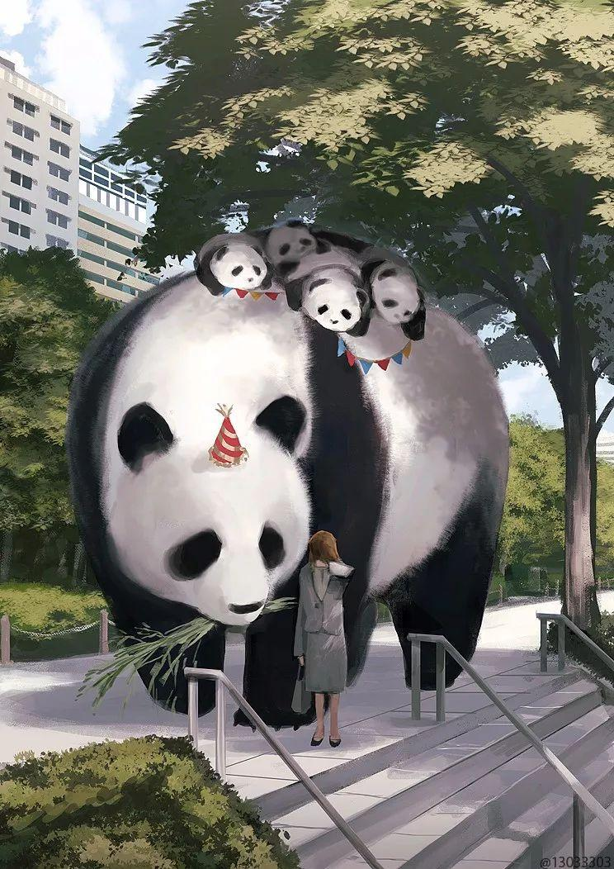
Figure 8 Giant organism，2017

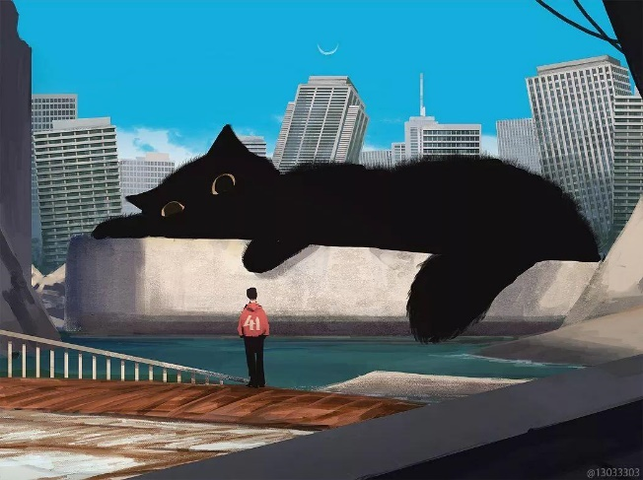
Figure 9 Giant organism，2017

3.2 Miyazaki Hayao

Hayao Miyazaki was born into a wealthy family in 1914, but a sudden change became a turning point in his childhood experience. His mother suffered from spinal tuberculosis (Greenberg, 2018, p01). The fear of losing his mother also became an important inspiration for his later creations.

Giant animals also appear in his work My Neighbor Totoro (1988). My Neighbor Totoro is his most ingenious and compassionate work, combining escapist fantasy with the painful reality of his childhood (Napier, 2018, p22).

The film begins with the background of the story. Sister Xiaoyue, sister Xiaomei and their father move into an old house with a yard in the countryside near their mother's sanatorium. The mother needs to recuperate in the sanatorium because of illness, which corresponds to the illness of Miyazaki's mother in his childhood. Although the two sisters are not very old, the elder sister is 11 years old and the younger sister is 4 years old, they have already gotten used to not having their mother around. They both skillfully helped their father clean the room, and the elder sister took on the responsibility of taking care of her younger sister while helping her father with housework (Li and Hu, 2014). Hayao Miyazaki once mentioned that he had a very good sister. The role of the sister played an important role in filling the emotional gap in his childhood. Here they correspond to Satsuki and Mei respectively.

When Hayao Miyazaki was a child, he heard the legend about Totoro, which left a deep impression on him. In Miyazaki's memory, people in his hometown said that Totoro (Figure 10) was a spirit living in the deep forest, and only kind-hearted children could see it (Li and Hu, 2014). The Totoro in the movie is also such a mysterious animal, with a strong sense of mysticism, and always appears when the two sisters need help.

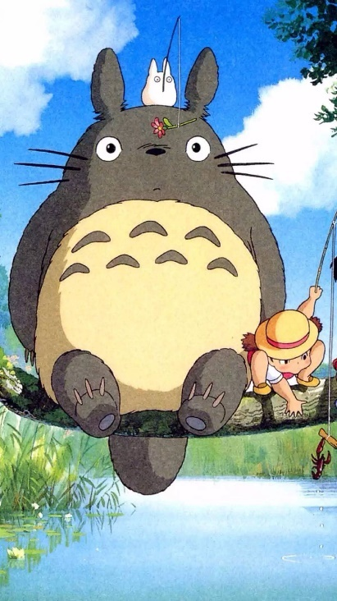
Figure 9 My neighbor Totoro，1988

The first time Totoro appeared was when Xiaomei was playing alone in the yard, while her sister Xiaoyue was at school and her father was busy at work. During the play, Xiaomei found a medium-sized and a small-sized Totoro. Driven by curiosity, Xiaomei began to follow them. In the process, Xiaomei accidentally fell into a tree hole and saw a huge Totoro. Xiaomei was not afraid of the big creature, but fell asleep on its furry belly (Figure 10). Xiaomei was only four years old, and her mother's hospitalization and inability to stay with her brought her emotional loss, and the appearance of Totoro temporarily made up for this loss. For Xiaomei, this expedition seemed more like a process of searching for maternal love (Li and Hu, 2014). This seems to confirm Miyazaki's feelings in his childhood. His mother was ill and hospitalized, and her condition was not optimistic. As a child, he was afraid of his mother's death. At the same time, as a child, he also hoped that his mother would get better. He may have imagined something at that time to reduce the fear of losing his mother.

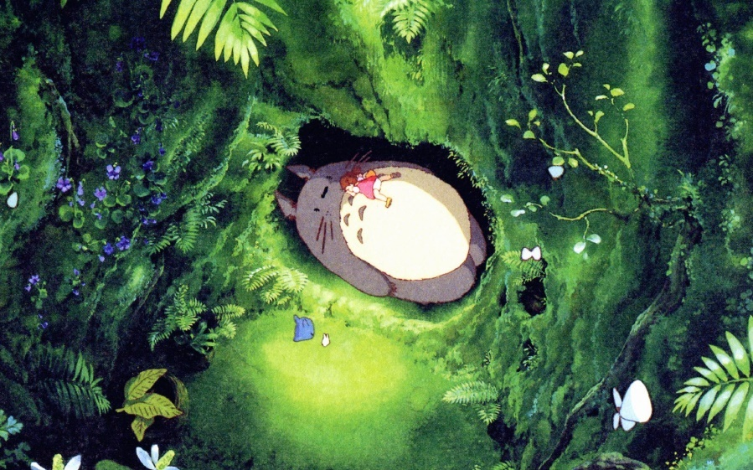
Figure 11 My neighbor Totoro，1988

The second time Totoro appeared was on a rainy night. Mei and Xiaoyue were waiting for their father in the rain, but their father did not show up. When they felt helpless and scared, Totoro appeared again and gave them acorn seeds (Figure 11). The appearance and behavior of Totoro comforted Mei and Xiaoyue.

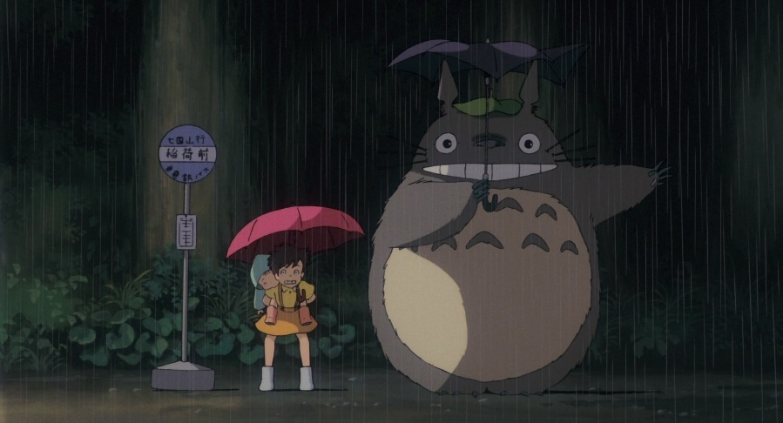
Figure 12 My neighbor Totoro，1988

The third time Totoro appeared was in the dream of the two sisters. In the dream, they planted acorn seeds together, and the acorn seeds grew into a big tree. Then Totoro took the two sisters to fly in the sky. Xiaoyue silently took on many things. She needed to study, help her father with housework and take care of her sister. But she is also only 11 years old, and these things are too much for her. Although Xiaomei does not have to consider so many things like her sister, she also has to bravely face the things in life that scare her. She is only 4 years old. For both of them, this dream was a wonderful experience of relaxation and relieving psychological stress, and it was a happy indulgence under the exhausting pressure of life (Li and Hu, 2014).

The next time Totoro appeared was when Mei was lost. At that time, her mother's condition suddenly changed, Mei was lost and her father was not at home. This was the time when Xiaoyue was most helpless and needed help the most. Totoro also appeared at this time and let the Totoro Bus take Xiaoyue to find Xiaomei, and also took them to the hospital to visit their mother.

Every time Totoro appears, it is when the sisters are helpless or lonely. In the movie, it is mysterious but also very heartwarming. It helps the sisters out of difficulties again and again and becomes their spiritual comfort. Totoro is more like a kind of compensation for the sisters' lack of emotions, making up for the lack of companionship between the two of them. Its size is huge, and the sense of security it brings to the two sisters is proportional to its size, which also shows that the two sisters actually have a great need for affection. The movie reflects some of Miyazaki's childhood experiences on a certain level, and also implies his feelings and thoughts about these experiences, so Totoro is like his fantasy and compensation for his childhood, and the embodiment of the warm help he received in his childhood experience.

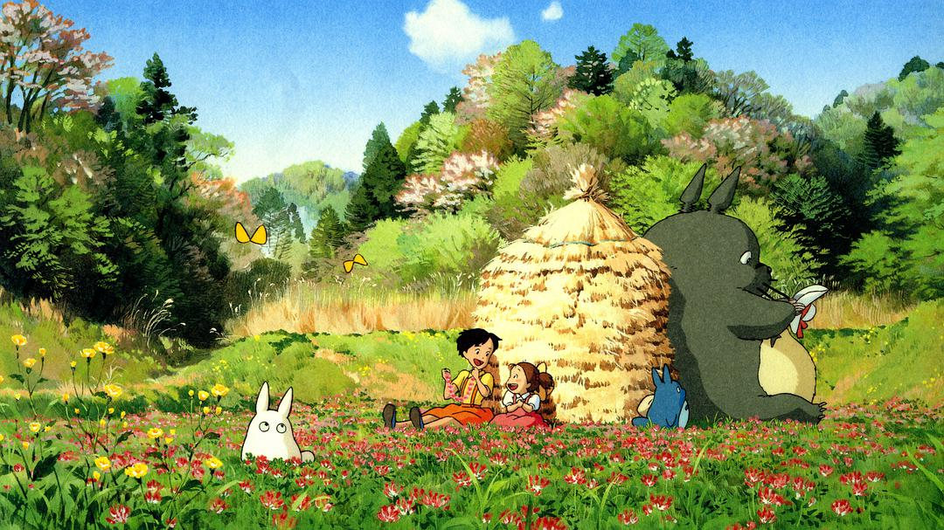
Figure 13 My neighbor Totoro，1988

3.3 Shaun Tan

Animals often appear in Shaun Tan's works. The representation of animals and the interaction between humans and animals in his paintings show his thoughts on immigration, self-growth, empathy, and the role of human society in the lives of animals (Baghban and Poursanati, 2024). This may have something to do with his upbringing. His father is a Chinese from Malaysia. He left his hometown to study in Australia in 1960 and met his mother. During Tan's childhood, he should have felt the conflict and integration between his parents' different living environments and different cultural backgrounds. Tan mentioned in an interview that he likes to think about things from different perspectives and observe the multifaceted nature of things (Tan, 2024). This may be related to his experience of multicultural conflict and integration.

In Tan’s picture book Tales from the Inner City (2018), there are many appearances of giant animals. The protagonists of this picture book are different animals, jumping foxes, huge killer whales floating above the city, snails so big that they fill the entire street, and many other distinctive animals. These stories confront humanity through powerful encounters with animals, body transformations, and invaded dreams (Zohreh and Susan, 2024). These stories are more about his own understanding of nature, with the giant animals being the embodiment of his own views. He believes that humans tend to view the world from a self-centered perspective, but this may be a bit "narcissistic", and perhaps humans should try to observe nature from other perspectives (Tan, 2024).

In an interview (2024) Tan mentioned:
[…]And with this book, I was interested in looking at human life from an outside perspective, in particular, from the point of view of other animals, so each story in this book, is about a particular animal(Tan, 2024).
Behind this book is more of Tan's own understanding of nature. These concepts are abstract, and he created these special animals through his imagination, turning his thoughts into concrete things. One of the stories in this book is about a giant snail (Figure 14), which lives quietly in the city, almost covering the streets. The background is the dim lights of the city at night. In the underground passage, there is a man sitting silently playing the guitar. In contrast to the snail, he looks particularly small.

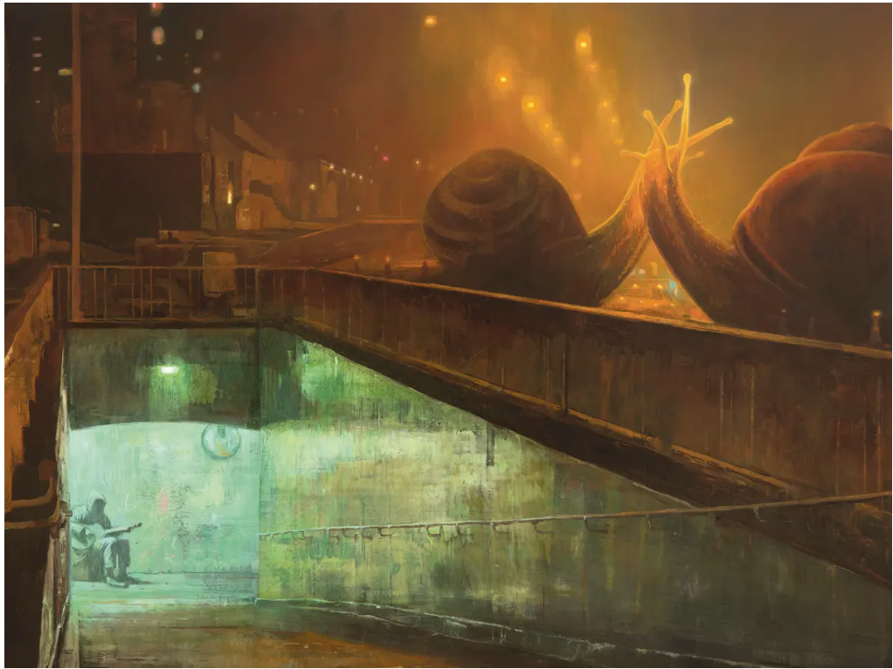
Figure 14 Tales from the Inner City，2018

In people's impression, snails are very small creatures, and people have always observed them from a bird's-eye view. People can also easily catch them, put them in glass bottles or transparent boxes for observation, and they don't seem to pose any threat. But if the situation is reversed, with the larger party being the snail and the smaller party being the human, how will the relationship between humans and snails change? Perhaps in this case, snails are dangerous to humans, and when snails appear in cities and in human-inhabited environments, it is humans who need to avoid them. Tan creates these stories with animals or giant animals as the protagonists because he is actively trying to transform and reshape the relationship between humans and animals through the interaction between animals and humans or the changes in size between the two (Zohreh and Susan, 2024). Animals invade human homes and dreams, changing the power status between them and humans and gaining control.

These stories have a distinct personal style and are Tan’s own reflections on nature and the relationship between humans and animals. He believes that animals may be able to live well without humans, but sometimes humans cannot live without animals (Tan, 2024). Under such a relationship, most humans still look at animals from a higher perspective, which he believes is a very "arrogant" approach. He changes his perspective to look at human society from the perspective of animals, creating a mysterious environment in which animals are both real and dreamy, and are also changing humans. As relationships change, the characters in these stories feel alienated from the animals, which Theodor W. Adorno asserts is the “price” humans pay for “increasing control over nature…” (Huggan and Tiffin Citation, 2015). Tan restores this alienation through art.

4. Conclusion

Giant creatures and animals are common elements in current artworks, and they carry the artists’ understanding of art and themselves. Artists draw inspiration from cultural backgrounds, era backgrounds, and life experiences, and transform these inspirations into abstract concepts to lay the foundation for their works. At the same time, they will constantly look for new inspirations from their surroundings to concretize these abstract concepts. These inspirations may be an element in a novel, a magical animal in a documentary, a movie, a comic book, or even a folk tale passed down from generation to generation.

Giant animals are one of the media that artists use to express themselves. They project their own experiences and their own thoughts on society and nature onto giant animals, and these giant animals are a mirror of themselves. The process of creating these giant animals is like looking into a mirror, looking at themselves in the mirror and recalling the process of examining themselves.

In this process, they will have a clearer understanding of their own emotions, their creative inspiration and motivation for their works, and their thoughts on society, the environment and nature. Whether it is Monokubo seeking a sense of security and warmth in giant animals to relieve his fatigue and sorrow from the outside world, or Hayao Miyazaki projecting his childhood emotional loss and the warm help he received onto Totoro, or Shaun Tan projecting his new relationship between animals and people and his thoughts from different angles onto giant animals, they always find some angles that are different from others to interpret their works, and their works are a display of their truest selves.

Reference

Australian Literature inChinese(2024), ‘Interview with Shaun Tan, Tales from the Inner City ’, 21 February. Available at: http://xhslink.com/a/s95a98YmWwb3(Accessed: 7 January 2025)

Baghban, Z., & Poursanati, S. (2024). Respect the power of the beast: an ecocritical analysis into interspecies relationships in Shaun Tan’s Tales from the Inner City. Journal of Graphic Novels and Comics, 15(4), 573–586. https://doi.org/10.1080/21504857.2024.2311710.

Clute，J. and Nicholls, P. (1993) ‘Big Dumb Objects’, The Encyclopedia of Science Fiction. New York: St. Martin's Griffin, pp.118-19.

Greenberg, R. (2018). From Fan to Professional. In Hayao Miyazaki: Exploring the Early Work of Japan’s Greatest Animator (p1). New York: Bloomsbury Academic. Retrieved January 7, 2025, from http://dx.doi.org/10.5040/9781501335976.ch-001

Haraway, D. J. (2016) Manifestly Haraway. Minnesota: University of Minnesota Press.

Hemphill, M. (1996). ‘A Note on Adults’ Color–Emotion Associations’ The Journal of Genetic Psychology, 157(3), 275–280. https://doi.org/10.1080/00221325.1996.9914865

Huggan, G., and H. Tiffin. 2015. Postcolonial Ecocriticism: Literature, Animals, Environment. The United Kingdom: Taylor & Francis.

Li Feifei and Hu Xianglong. (2014) ‘The role positioning and shaping of the animated film My Neighbor Totoro’, Beauty and Times, DOI:107-109. DOI:10.3969/j.issn.1003-2592(s).2014.04.038.

Mahnke, F. H. (1996). Color, environment, and human response. New York: Van Nostrand Reinhold.

Napier, S. (2018). ‘Constructing an Animator’，Miyazaki world. New Haven: Yale University Press, p22.

Néret, Gilles. (2015) Salvador Dalí, 1904-1989: la conquête de l'irrationnel. Petite collection 2.0. Köln [Paris]: Taschen. ISBN 978-3-8365-5999-7.

Oxford English Dictionary. (2019). (3rd ed.). Oxford: Oxford University Press.
Wikipedia（2024），Astro Boy. Available at: https://en.wikipedia.org/wiki/Astro_Boy (Accessed: 6 January 2025).

Wikipedia（2024），Science fiction. Available at: https://zh.wikipedia.org/wiki/ (Accessed: 6 January 2025).

Wikipedia（2024）, Astro Boy. Available at: https://en.wikipedia.org/wiki/Astro_Boy (Accessed: 6 January 2025).

Zhou Guoping. (2004) ‘ Nietzsche's philosophical contributions’, Journal of Yunnan University; Social Sciences Edition, 3(1):24-29. DOI:10.3969/j.issn.1671-7511.2004.01.005.

Bibliography

Australian Literature inChinese(2024), ‘Interview with Shaun Tan, Tales from the Inner City ’, 21 February. Available at: http://xhslink.com/a/s95a98YmWwb3(Accessed: 7 January 2025)

Baghban, Z., & Poursanati, S. (2024). Respect the power of the beast: an ecocritical analysis into interspecies relationships in Shaun Tan’s Tales from the Inner City. Journal of Graphic Novels and Comics, 15(4), 573–586. https://doi.org/10.1080/21504857.2024.2311710.

Clute，J. and Nicholls, P. (1993) ‘Big Dumb Objects’, The Encyclopedia of Science Fiction. New York: St. Martin's Griffin, pp.118-19.

Greenberg, R. (2018). From Fan to Professional. In Hayao Miyazaki: Exploring the Early Work of Japan’s Greatest Animator (p1). New York: Bloomsbury Academic. Retrieved January 7, 2025, from http://dx.doi.org/10.5040/9781501335976.ch-001

Haraway, D. J. (2016) Manifestly Haraway. Minnesota: University of Minnesota Press.

Hemphill, M. (1996). ‘A Note on Adults’ Color–Emotion Associations’ The Journal of Genetic Psychology, 157(3), 275–280. https://doi.org/10.1080/00221325.1996.9914865

Huggan, G., and H. Tiffin. 2015. Postcolonial Ecocriticism: Literature, Animals, Environment. The United Kingdom: Taylor & Francis.

Jiao Sue. and Sun hanjie.(2010), ‘On the Mood of Humanities and the Poetic Pursuit in Hayao Miyazaki’, Journal of Xinyang Normal University (Philosophy and Social Sciences Edition), DOI: 1003-0964(2010)01-0139-05.

Li Feifei and Hu Xianglong. (2014) ‘The role positioning and shaping of the animated film My Neighbor Totoro’, Beauty and Times, DOI:107-109. DOI:10.3969/j.issn.1003-2592(s).2014.04.038.

Li Miaomiao. (2012), ‘Interpretation of the Japanese animated film My Neighbor Totoro’, Journal of Jiamusi Education Institute, Available at: https://d.wanfangdata.com.cn/periodical/jmsjyxyxb201202067 (Accessed: 7 January 2025).

Mahnke, F. H. (1996). Color, environment, and human response. New York: Van Nostrand Reinhold.

Napier, S. (2018). ‘Constructing an Animator’，Miyazaki world. New Haven: Yale University Press, p22.

Néret, Gilles. (2015) Salvador Dalí, 1904-1989: la conquête de l'irrationnel. Petite collection 2.0. Köln [Paris]: Taschen. ISBN 978-3-8365-5999-7.

Oxford English Dictionary. (2019). (3rd ed.). Oxford: Oxford University Press.
Wikipedia（2024），Astro Boy. Available at: https://en.wikipedia.org/wiki/Astro_Boy (Accessed: 6 January 2025).

Wikipedia（2024），Science fiction. Available at: https://zh.wikipedia.org/wiki/ (Accessed: 6 January 2025).

Tan, Shaun. (2001), ‘Picture Books: Who Are They For?’, ERIC, Available at: https://eric.ed.gov/?id=ED458581(Accessed: 6 January 2025).

Wikipedia（2024）, Astro Boy. Available at: https://en.wikipedia.org/wiki/Astro_Boy (Accessed: 6 January 2025).

Yuko Murayama. et al. (2009), ‘The Sense of Security and Trust’, IGIGlobal, DOI: 10.4018/978-1-60566-132-2.ch029.

Zhou Guoping. (2004), ‘ Nietzsche's philosophical contributions’, Journal of Yunnan University; Social Sciences Edition, 3(1):24-29. DOI:10.3969/j.issn.1671-7511.2004.01.005.

