Programme: BSc Health and Social Care
Module: Changemakers: Creativity and Value Creation
Module code: BMHP5014
Student: Salma Begum
Student ID: 2409645
Lecturer: Parese Ahmed
Submission date: 2nd April 2026

MindBridge: Poster
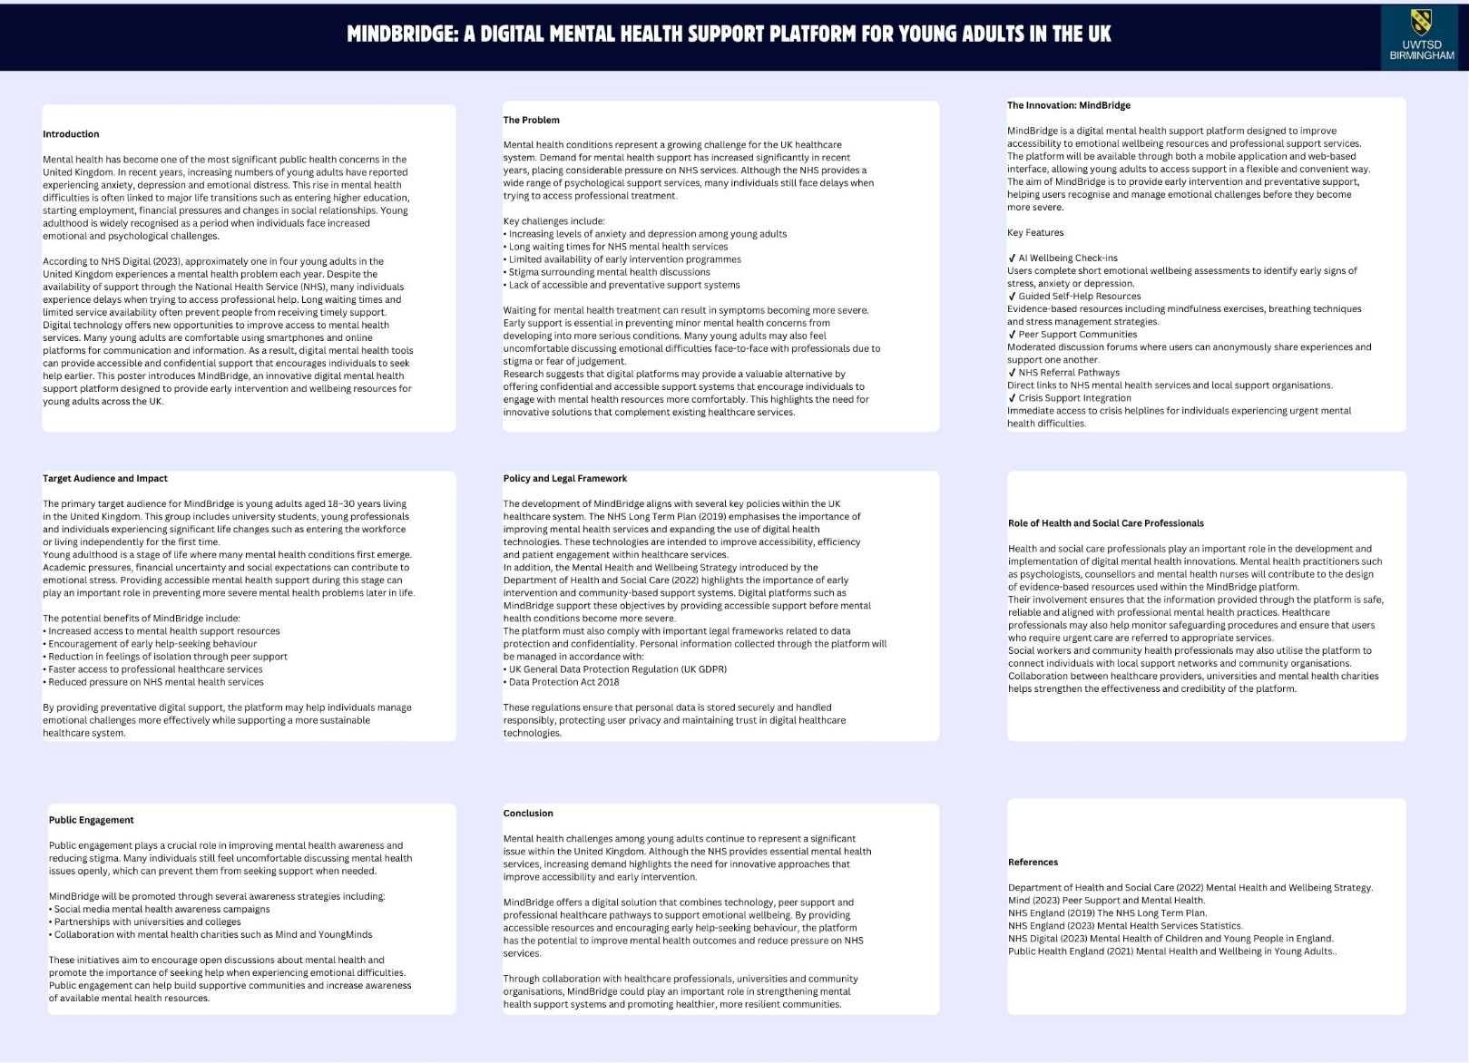

Pitch
MindBridge: A Digital Mental Health Support Platform for Young Adults in England
Introduction
Mental health is one of the most urgent public health challenges in England, especially among young adults. This stage of life often includes major transitions such as entering university, starting work, managing finances and living independently. While these experiences can be positive, they can also create stress, anxiety and emotional pressure. For many young adults, support is not accessed early enough, allowing problems to worsen over time.
Although the NHS provides essential mental health services, demand continues to rise. Long waiting times, limited capacity and the stigma attached to mental ill health can prevent people from seeking help when they first begin to struggle. Many young adults also prefer private, flexible and less formal ways of accessing support, particularly in the early stages of emotional distress.
This pitch proposes MindBridge, a digital mental health support platform for young adults aged 18 to 30 in England. The platform is designed to provide early intervention, improve access to support and connect users with appropriate professional services. By combining digital wellbeing tools, peer support and referral pathways, MindBridge offers a practical and preventative response to a growing need.
The Problem
Mental health difficulties among young adults are increasing, yet access to timely support remains a challenge. Young people often face academic pressure, employment uncertainty, loneliness, housing insecurity and changing relationships. These pressures can have a serious impact on emotional wellbeing.
A major issue is that many individuals delay seeking help. Some may not know what support is available, while others may fear judgement or feel uncomfortable approaching formal services. As a result, mild or moderate symptoms may escalate before any action is taken. This can affect education, work, relationships and long-term health.
The NHS has developed important services such as NHS Talking Therapies for anxiety and depression, but formal support alone is not enough to meet growing demand. There is a clear gap between the first signs of emotional difficulty and the point at which professional care is accessed. MindBridge is designed to close this gap by making support more approachable, immediate and accessible.
The Innovation
MindBridge is a mobile and web-based platform that supports young adults before their mental health difficulties reach crisis point. It does not replace NHS care but works alongside it to provide earlier support.
The platform has four key features.

First, it offers AI-assisted wellbeing check-ins. Users complete short emotional wellbeing assessments that help identify signs of stress, anxiety or low mood. These check-ins encourage self-awareness and help users recognise when support may be needed.
Second, MindBridge provides personalised self-help resources. Based on the user’s responses, the platform suggests practical tools such as breathing exercises, mindfulness activities, journalling prompts, sleep advice and coping strategies. This gives users immediate, private and flexible support.
Third, the platform includes moderated peer-support spaces. These allow users to connect with others facing similar experiences in a safe and supportive environment. Peer support can reduce feelings of isolation and help normalise conversations around mental health.
Fourth, MindBridge offers direct links to professional and community services. Users can be signposted to NHS Talking Therapies, crisis helplines, university wellbeing services and local charities. This ensures that those needing further support can move quickly towards appropriate care.
Together, these features make MindBridge both supportive and practical. It promotes prevention, encourages earlier help-seeking and improves navigation of mental health services.
Target Audience and Impact
The target audience is young adults aged 18 to 30 in England, including students, early-career workers and those going through major life changes. This group is particularly important because mental health conditions often emerge during this period, yet early support is frequently missed.
MindBridge would have benefits at both an individual and wider social level. For individuals, it would provide accessible support, build awareness of emotional wellbeing and encourage earlier action. It would help users manage challenges before they become more severe.
For the wider health system, the platform could reduce avoidable escalation of distress and ease some pressure on overstretched NHS services. By supporting prevention and early intervention, MindBridge contributes to healthier communities and a more sustainable mental health system.
Policy, Ethics and Professional Role
MindBridge aligns with current health and social care priorities, particularly the focus on mental health, prevention and digital innovation. However, trust and safety would be essential to its success.
All user data would need to be managed in line with the UK GDPR and the Data Protection Act 2018. Confidentiality, informed consent and secure data handling would be central. The platform would also require clear safeguarding procedures, risk monitoring and crisis referral pathways for users in urgent need.
Health and social care professionals would play an important role in the development of MindBridge. Psychologists, counsellors, mental health nurses and social workers would help create evidence-based

content and safe referral systems. Universities, charities and community organisations could also help promote the platform and connect it to existing support networks.
Public engagement would be equally important. Social media campaigns, partnerships with universities and collaboration with mental health charities could help reduce stigma and encourage use of the platform. Involving young adults in the design process would also ensure that MindBridge reflects their real needs and experiences.
Conclusion
In conclusion, mental health difficulties among young adults remain a major concern in England. Although the NHS provides valuable services, many people still struggle to access help early enough. This shows the need for innovative solutions that improve accessibility and support prevention.
MindBridge offers a realistic and valuable response. By combining wellbeing check-ins, self-help tools, peer support and referral pathways, it bridges the gap between emotional struggle and professional care. If implemented responsibly, it could improve mental wellbeing, encourage earlier intervention and reduce pressure on existing services.
MindBridge is therefore not only a digital innovation, but a practical investment in the health, resilience and future wellbeing of young adults.

Reference List
Department of Health and Social Care (2022) Mental health and wellbeing plan: discussion paper and call for evidence. London: Department of Health and Social Care. Available at: GOV.UK (Accessed: 15 March 2026).
Department of Health and Social Care (2023) Mental health and wellbeing plan discussion paper and call for evidence: results. London: Department of Health and Social Care. Available at: GOV.UK (Accessed: 15 March 2026).
GOV.UK (n.d.) The UK’s data protection legislation. Available at: GOV.UK (Accessed: 15 March 2026).
Mind (n.d.) Peer support groups for mental health. Available at: Mind (Accessed: 15 March 2026).
Mind (n.d.) Side by Side: our online community. Available at: Mind (Accessed: 15 March 2026).
NHS Digital (2023) Mental Health of Children and Young People in England, 2023 wave 4 follow-up. Leeds: NHS Digital. Available at: NHS Digital (Accessed: 15 March 2026).
NHS Digital (2025) Adult Psychiatric Morbidity Survey: Survey of Mental Health and Wellbeing, England, 2023/24 – Common mental health conditions. Leeds: NHS Digital. Available at: NHS Digital (Accessed: 15 March 2026).
NHS England (2019) The NHS Long Term Plan. London: NHS England. Available at: NHS England (Accessed: 15 March 2026).

NHS England (2023) Inclusive digital healthcare: a framework for NHS action on digital inclusion. London: NHS England. Available at: NHS England (Accessed: 15 March 2026).
NHS England (n.d.) NHS Talking Therapies, for anxiety and depression. Available at: NHS England (Accessed: 15 March 2026).
NHS England (2025) NHS Talking Therapies for anxiety and depression manual. London: NHS England. Available at: NHS England (Accessed: 15 March 2026).
The National Archives (2018) Data Protection Act 2018. London: The National Archives. Available at: legislation.gov.uk (Accessed: 15 March 2026).

