The student has been tasked with designing, building and programming a Lego Spike Robot [1] to navigate a two-part navigation challenge. the first part of the challenge is to follow a line and navigate around an obstacle placed on the line, and the second part of the challenge is to navigate through a maze that has the capacity to change its configuration from day to day [2]. The change is to ensure that the robot can navigate any form of maze instead of following a pre-programmed route. The robot should be able to navigate its way to a red line found inside the maze, which it will then output a sound or a visual identifier to show that it has completed its journey. This challenge will be done with a group of two or three. Each member of the team will have a role to fulfil to ensure that the robot works effectively. For example, one of the members of the team can focus on the mechanical aspect of the robot [3], another can focus on the coding behind the robot’s movements, and another can focus on the sensors functioning and ensuring that the robot can detect certain colours, distances and moving at the correct speed [4].
Research
The student will find videos and websites [5] [2] [3] to create a baseline for how the robot should function alongside an idea toward its design. The student will investigate the Lego spike prime app and figure out it’s layout and find the best functions and keyword, relevant to the robot’s functionality. The student will investigate the parts of the Lego Prime Kit [3], to determine the best parts for certain aspects of the maze.
The Lego spike kit comes with a few parts that will output a signal depending on its functionality. For example, the Lego Spike Kit has a colour sensor. This sensor can output a signal depending on what colour it sees. This tool is used to follow a line. A problem the student had encountered was the sensor was too sensitive to reflective surfaces, typically outputting white instead of the intended colour. The student had overcome this problem by moving the sensor away from the colour as the sensor was too close to the line, so moving the sensor back prove to be effective in tackling the problem. The Lego Spike Prime also came with motors, a distance sensor and a pressure sensor. The motors were essential as the motors allowed the robot to move, using wheels to function. The distance sensor was designed to output a signal depending on how close the robot gets to an obstacle.
Planning
Our group strategy was to collaborate on what parts should be used for the robot, figuring out what code is necessary for the robot to function and troubleshooting problems in a timely manner to make sure the robot can work as intended.
The student was primarily working on the physical aspect of the robot, making sure that the robot is functional, all the parts were correctly installed, and the robot was compact enough to navigate the maze without complications. The student had also helped the other students with troubleshooting problems, like brainstorming potential fixes to problems with the code. For example, the intended solution to the robot breaking off the line to navigate around a barricade was for it to detect the line once more, then turn into the line and follow it again. The robot detected the line, then refused to turn back into the line. The solution the student proposed was for the robot to reverse for a second, so that the robot can detect the line again and follow the line as intended.
The group had weekly lessons to ensure that we finished the project in a timely manner. Using these lessons, the student and their team were able to complete the robot’s physical frame alongside the code needed to make the robot functional. We had tested several different techniques to integrate into the robot, finally ending with the finished product; a functional robot capable of autonomously navigating a maze without user input.
Robot Design
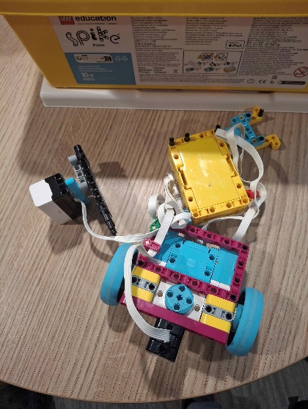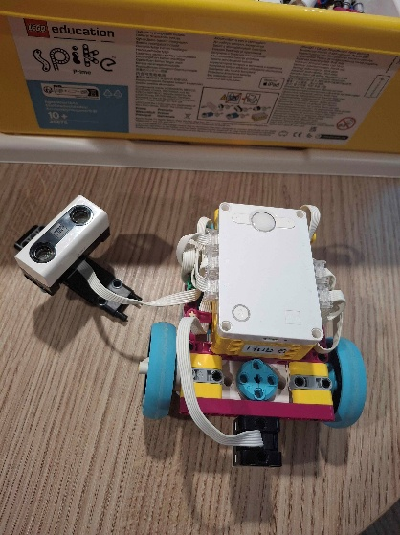
The robot was designed with compactness and efficiency in mind. The robot has a motion sensor attached to a motor. This will allow it to check its surroundings and change its course to a free space instead of constantly running into walls [2]. The robot has two wheels and a supporting ball-like tool to ensure that it can roll forwards without dragging itself across the ground, potentially breaking itself or ruining the build. The robot also has a colour sensor installed. This is essential to the build as following a line is required as part of the first task. The sensor can be sensitive, as if the sensor is too close, the sensor detects either black or white depending on the colour of the line itself. A simple fix for this problem was to bring the sensor further away from the floor itself so that the sensor has a better chance to detect the correct colour instead of white or black.
Implementation and coding
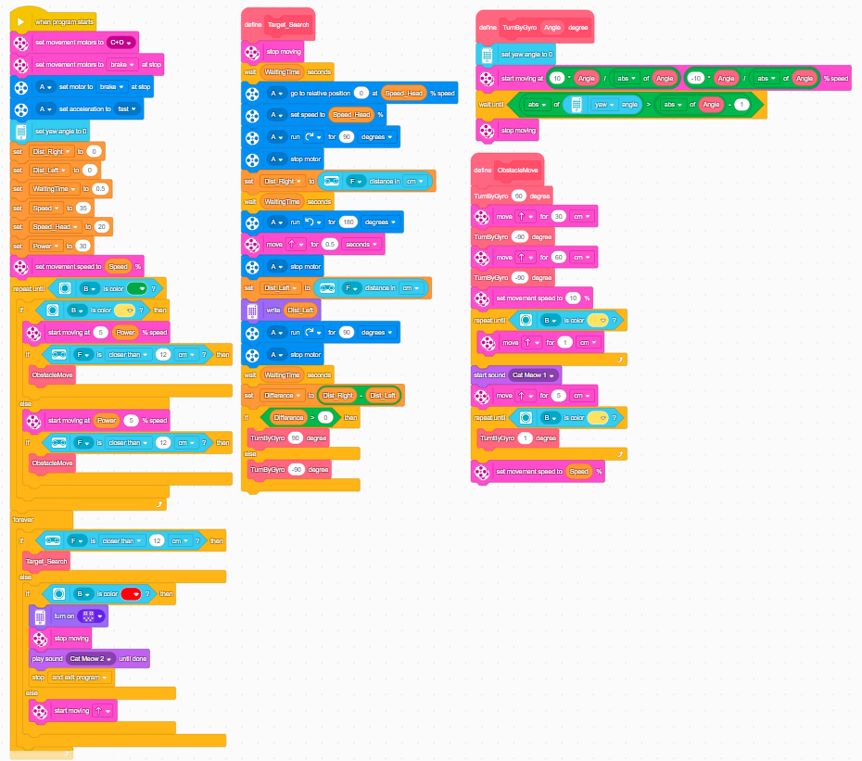
The group had used work block for programming. [4]The work block was simple in design but had a few problems with the implementation. The word blocks work off predetermined functions to string together a coherent code that will make the robot function as intended. the first problem with code block was that it didn’t want work with “repeat until” blocks. The intended feature of the repeat block was for the block to repeat what code blocks are inside until a condition is met. The block decided that it doesn’t want to repeat for the intended cycles, instead constantly repeating or not repeating at all. We fixed this by using different detectors, like the colour sensor, instead of using numbers. This allowed the robot to adapt to its environment instead of following a predetermined path. Another problem was with the robot’s core battery. The robot has six total slots for the tools necessary to make the robot function. This created a problem as the group could not implement every tool at their disposal. The group opted to not use the pressure sensor as it had the least amount of use with the build. Another problem occurred with the code block’s use of degrees, seconds and inches. These measurements were not completely consistent with degrees, inches and seconds, so the group had to use Trial and Error strategies to determine how to use these can be implemented. The group had to finely tune the numbers to ensure that the robot followed exactly what was expected of it, instead of it wandering away from the path and having to be reset manually. The logical control flow of the code block was fine but has had an issue. The code works from top to bottom, so if there is a problem in the code blocks, like if it cannot meet the if condition, it will completely ignore it. The if condition for the robot is to follow the line. so, if it sees the line for a second, it was supposed to correct itself and follow the line once more. The problem made itself known when it broke off from the line to navigate around an obstacle, it was supposed to meet the line again and turn to follow it. It instead decided to keep going forward and not stop until it was manually stopped. This problem was fixed by adding a few blocks that stopped it, made it reverse, then turn into the line and it then functioned as intended.
Testing and evaluation
The group had constantly tested and improved the robot [3]. The first initial problem found through testing was that one of the ports for the robot’s core battery wasn’t functional. The group had decided to simply not use that port and, by extension, not use the pressure sensor. This was not a problem as the pressure sensor was designed to feel if it has bumped into something. We circumvented this by using the motion sensor instead is it served the same purpose and allowed the robot to check if something is in front of it, look around using an attached motor, and to navigate into a direction that didn’t detect a wall. Another problem occurred when the robot was too big for the maze. The robot initially had a longer frame to facilitate all the tools needed to make the robot functional. The solution was to simply make everything more compact instead of longer, putting the colour sensor underneath the frame so that the robot can follow the line from the centre instead of the side. This also made the frame itself more stable as there was no parts hanging on the side with a little bit of support. Another problem was with the motor attached to the motion sensor. If the robot decided to rub against the wall, the sensor was attached by a single strut for support, so it could easily be ripped off it’s support and a manual fix was needed. A simple fix was to move the motor back so that it wasn’t as forward as before. This helped as it also fixed the balance of the robot. The wheels were initially in the back of the robot, with the ball support piece in the front. This proved a problem as the ball would sometimes get stuck in the support struts of the maze. By changing the location of the wheels, this allowed the robot to mount up into the maze with little effort. This also allowed the robot to ride up the wall if, when re-orienting, it would not always be at a 90-degree angle, so it will sometimes get itself caught on a wall and flip itself over or try and escape the maze. This was fixed by changing the numbers in the code block and figuring out the perfect numbers for its movement. Another problem was with the motion sensor. The motion sensor will sometimes not detect if a wall is present. This is because the motion sensor will sometimes, while rarely, investigate the gaps between the wood walls, which it will falsely believe that it sees an open space. It will then try and move through the wall, forcing it to go repeat this as it cannot complete the loop and check for a new opening. This must be fixed manually as there is not much the student can do to fix this. This is a problem with the sensor itself and its design, which the student has no power over and cannot change. The group had initially used the pressure sensor to allow the robot to detect if it is running into a wall, but the size and shape of the pressure sensor did not allow it to be effective as it would constantly get stuck in the wall’s openings and it would constantly rip itself out, so the group opted to forego the pressure sensor entirely as it’s role was taken over by the motion sensor. The motion sensor was far more effective at stopping the robot from running itself into a wall. Another issue is the colour sensor. It was initially on its own strut off to the left-hand side of the robot. This was changed as having the sensor in the middle of the robot allowed the robot to correct itself more effectively. This proved instrumental as this is what allowed it to correct itself as part of the requirements necessary to complete the task. Future iterations will be streamlined further and will move gracefully. Also, for future implementation, the student will further compact the robot to ensure that it can move swiftly and without worry for its weight distribution.

References

[1] | lego spike, “lego education SPIKE app V3.6.0,” [Online]. Available: https://education.lego.com/en-gb/downloads/spike-app/software/.
[2] | how i coded a lego spike prime robot to explore a maze. [Film]. robotical, maker & etc.
[3] | LEGO robotics - spike prime - getting started guide. [Film]. Sprattronics Learning Lab.
[4] | lego prime, “training camp 1: driving around,” [Online]. Available: https://education.lego.com/en-gb/lessons/prime-competition-ready/training-camp-3-react-to-lines/.
[5] | 3 ways to make your robot DODGE obstacles without losing the line. [Film]. robotical, maker & etc.

