Secure the network from common threats and attacks
ACCA4024 - Networks and Cyber Security Essentials Assignment
Joshua James Harries (2021807)
DDA BSc Applied Cyber Security
7/23/21

Table of Contents
Introduction 2
Task 1 2
Possible Security Breach - 1: 2
Possible Security Breach - 2: 2
Possible Security Breach - 3: 3
Task 2 3
Threats 3
Vulnerabilities: 3
“.meds” file format attack 4
Task 3 5
Intro to Packet Tracer Certification 5
Cybersecurity Essentials Certification 6
Task 4 6
References 6

Introduction
Dear Pop-Eye, owner of Olive-Oyl,
In this document, you will find a host of information relating to the recent security breaches in your company, Olive-Oyl. I will talk about the potential security breaches, ill explain what threats and vulnerabilities are, and ill give a brief guideline on how staff and customers can use the system and network safely and correctly.

Task 1

Possible Security Breach - 1:
Complimentary Wi-Fi, in my eyes, is the biggest contributing factor to the recent cyber-attacks, as it's essentially like leaving the front door open for an attacker to walk in, and inject their malicious code into your network eco-system.
In the above scenario, it was stated that after you appointed Wimpy as Market head and gave Wimpy the responsibility to increase the businesses income by 30%, this placed Wimpy in a tight position and when creating and implementing his new idea of complimentary Wi-Fi for all customers, Wimpy refused to invest in an infrastructure where the Wi-Fi would be on a separate network and instead used the same network that runs the business applications to grant users free Wi-Fi.
The reason this could be a potential breach for you and the Olive-Oyl company is that anyone can connect to the complimentary Wi-Fi which is run on the same network that the business applications are run on. If someone were to infiltrate the network all they would need is access to is the Wi-Fi, which is available to anyone with no checks, to be able to access all of the business applications and sensitive data and information, and could shut down the network and systems rendering them useless, steal information or even hold the company ransom, like using a .meds file attack.

Possible Security Breach - 2:
Disgruntled Employees, both past and present, or internal actors may want to get revenge on you and Olive-Oyl as a company itself based on past experiences they may have had with yourself and the company.
In the above scenario, it was stated that Bluto, a competitor for your business was closely watching the growth, and is not happy with the exemplary growth. He is thinking to bring down your business. He came to know about the Sales Head positions being withdrawn at the retail showroom. He hires Jack, one of the Ex-Sales Head at your retail showroom and Alice, a professional hacker. Bluto’s team worked out a plan and on a fine morning, one of the “Olive-Oyl” retail showroom workstations had all it is important documents/ services encrypted with “.meds” file format.
The reason this can be a potential breach for yourself is by having all your files encrypted in the .meds file format, including very important and business-critical files, can place you in a very vulnerable position where you may find yourself having to pay the attackers or even losing your data – this is called a ransomware attack, and is one of the most popular types of attack in the world, with almost 51% of companies and organisations being hit by one [1]. Disgruntled or internal actors play a massive role in this by knowing the systems and data that your company holds, so it makes it easier for the attackers as they already have the information needed, rather than brute-forcing it.

Possible Security Breach - 3:
Phishing Attack – when a hacker attempts to gain access through vulnerable people in the company, such as your staff.
In the above scenario, it was said that Wimpy decided to diversify his job responsibility to the Sales Executives. This forced Wimpy to give all Sales Executives full access to all business applications. Literally, at this point, all the users of this business have full access to all the business applications.
The reason this could lead to an attack is the Sales Execs may be stressed, overworked from the new workload, and may not have adequate Cyber Security training due to time or financial constraints. This can mean an attacker could send a malicious email to the sales execs (but not just limited to them, it can happen to any member of staff – you included) pretending to be from one of the system suppliers requesting them to log into the systems ‘webpage’ to verify their identity or reset their password etc. Once the staff member logs into this fake page, the attacker has all the information that the colleague has entered into the site, to access your systems. In 2020, 86% of organisations like yours had at least one user try to connect to a phishing webpage – meaning the user actually had clicked on the link [2]. According to a recent Microsoft security intelligence report, more than 45% of malware requires some form of user interaction, suggesting that it is a primary tactic used by attackers to establish their access into your network and into your systems.

Task 2

Threats
A cybersecurity threat is an act of malice that seeks to damage and infiltrate data or disrupt digital working in general. Cyber threats could be a successful cyber-attack that aims to gain unauthorized access, damage, disrupt, or steal an information technology asset, computer network, intellectual property or any other form of sensitive data. Sometimes, like in the Oxford Dictionary, a cyber threat is seen as a possibility, but in the industry, it's seen as an actual attack.
Cyber threats include computer viruses, data breaches, Denial of Service (DoS) attacks, social engineering, ransomware, third party software, cloud computing vulnerabilities and crypto-jacking.
Network threats are usually 2 types - Passive Network Threats, which is activities such as wiretapping and idle scans that are designed to intercept traffic travelling through the network, and Active Network Threats, which are activities such as Denial of Service (DoS) attacks and SQL injection attacks where the attacker is attempting to execute commands to disrupt the network’s normal operation, and potentially take it offline.

Vulnerabilities:
A vulnerability in cybersecurity is a weakness that can be exploited by cybercriminals to gain unauthorized access to a computer system. After exploiting a vulnerability, a cyberattack can install malware, run malicious code, steal sensitive data and even render the network, systems and equipment paralyzed and unable to be used [3]. The official definition of a cybersecurity vulnerability from ISO 27005 is “A weakness of an asset or group of assets that can be exploited by one or more cyber threats where an asset is anything that has value to the organization, its business operations and their continuity, including information resources that support the organization's mission” [4]. There are many causes of vulnerabilities including, but not limited to:
- Complexity
- Familiarity
- Connectivity
- Poor password management
- Operating system flaws
- Internet usage
- Software bugs
- Unchecked user input
- People

“.meds” file format attack
.Meds is malicious software that belongs to the Djvu ransomware family. This ransomware adds the ".meds" extension to all encrypted files. For example, "familyphoto.jpg" becomes "familyphoto.jpg.meds". An example of the ransom document is below.
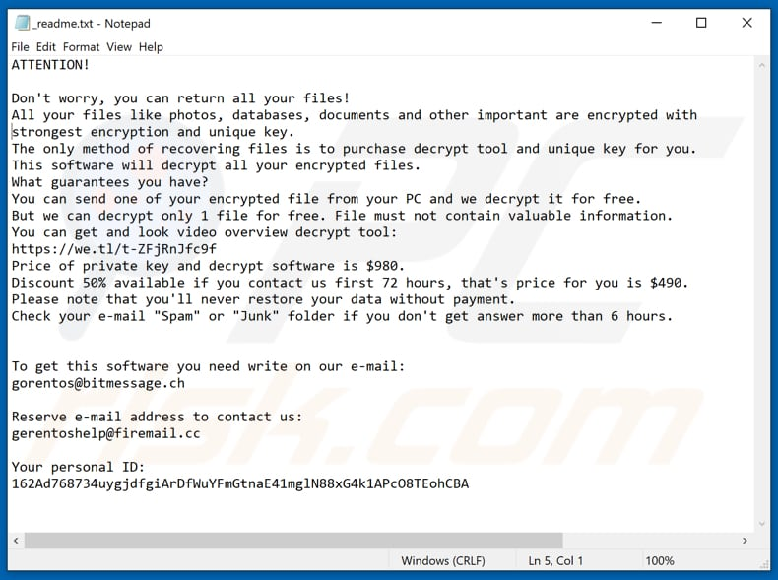 [5]
In a usual case, it is often impossible to decrypt files without specific tools held only by the ransomware developers, unless the ransomware has bugs, flaws, etc.

Task 3

Intro to Packet Tracer Certification
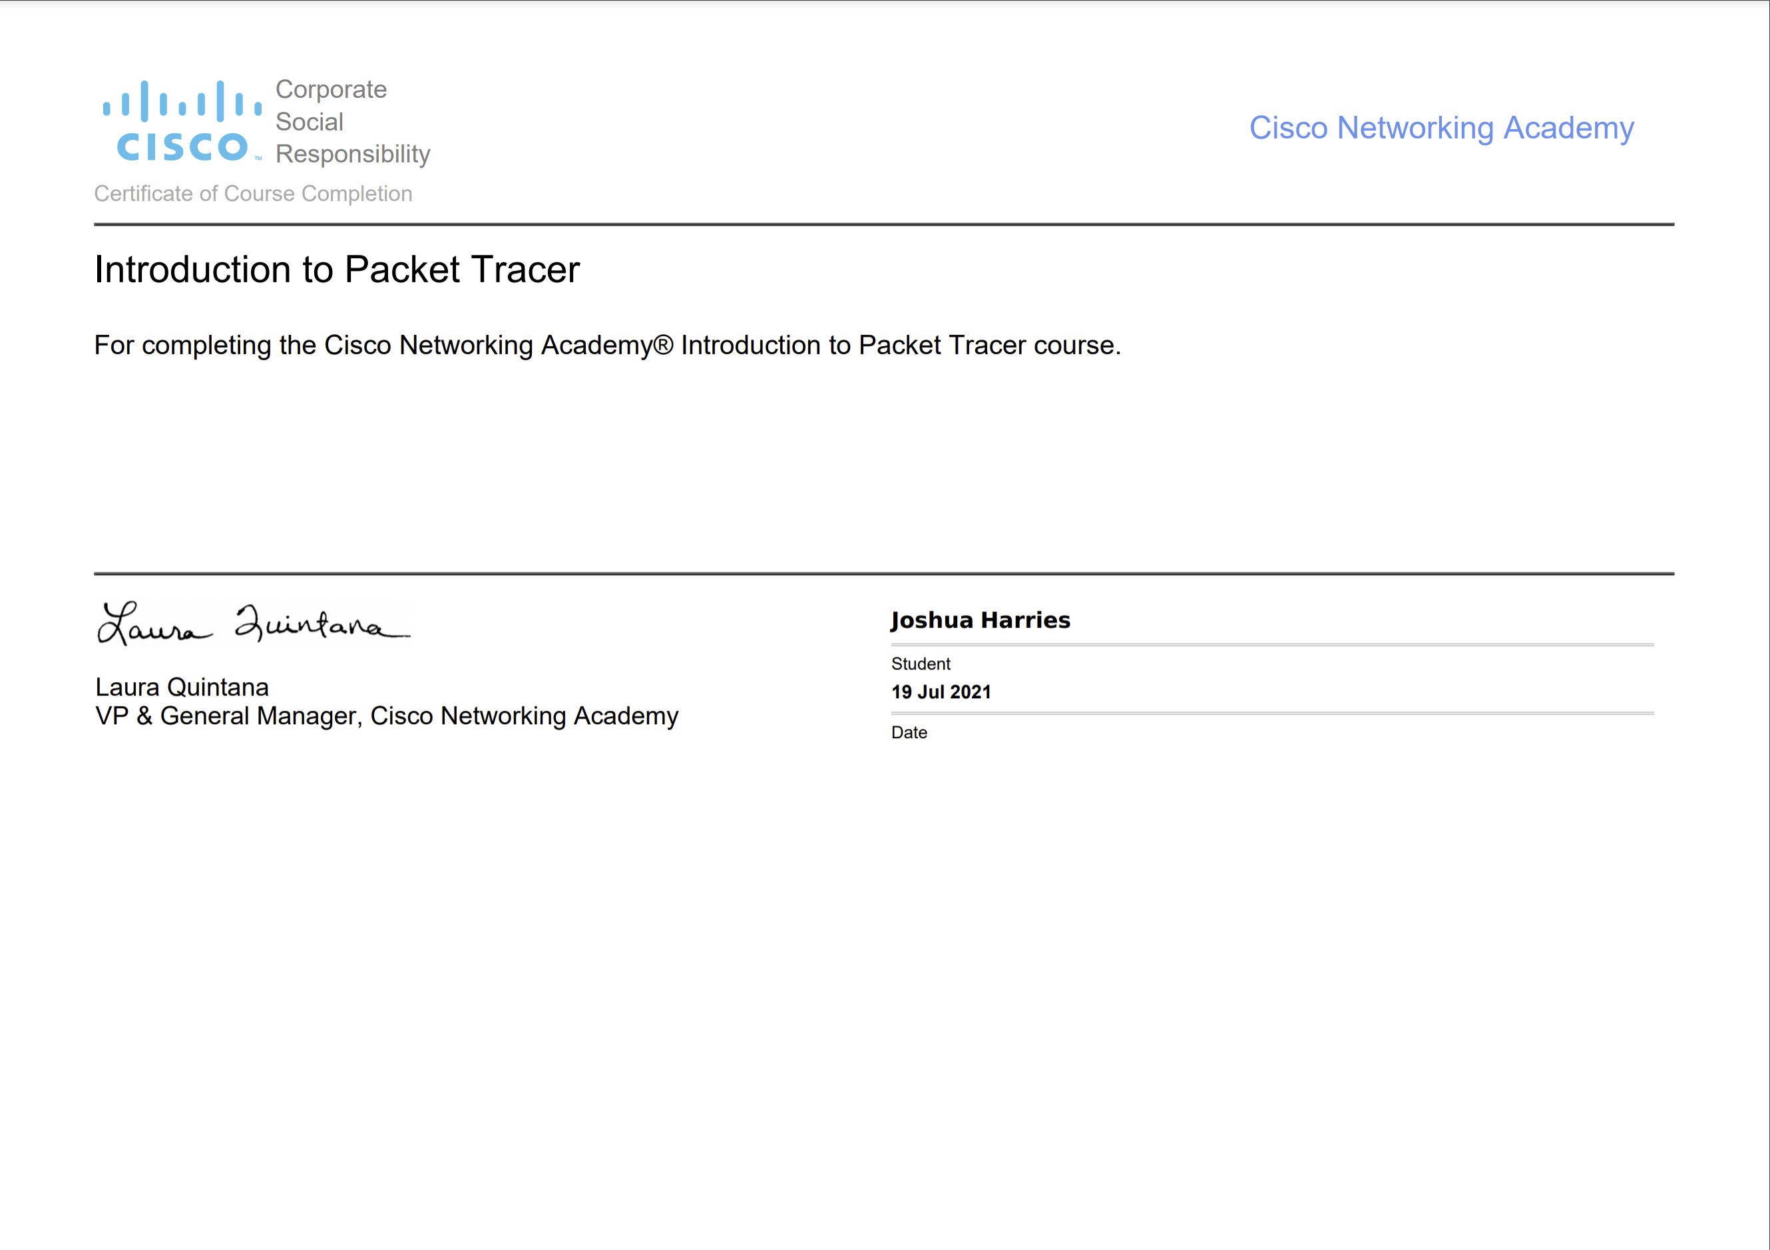
Digital Badge URL - https://www.credly.com/badges/647bd55c-3717-47a1-9b23-3fa203947438/public_url

Cybersecurity Essentials Certification
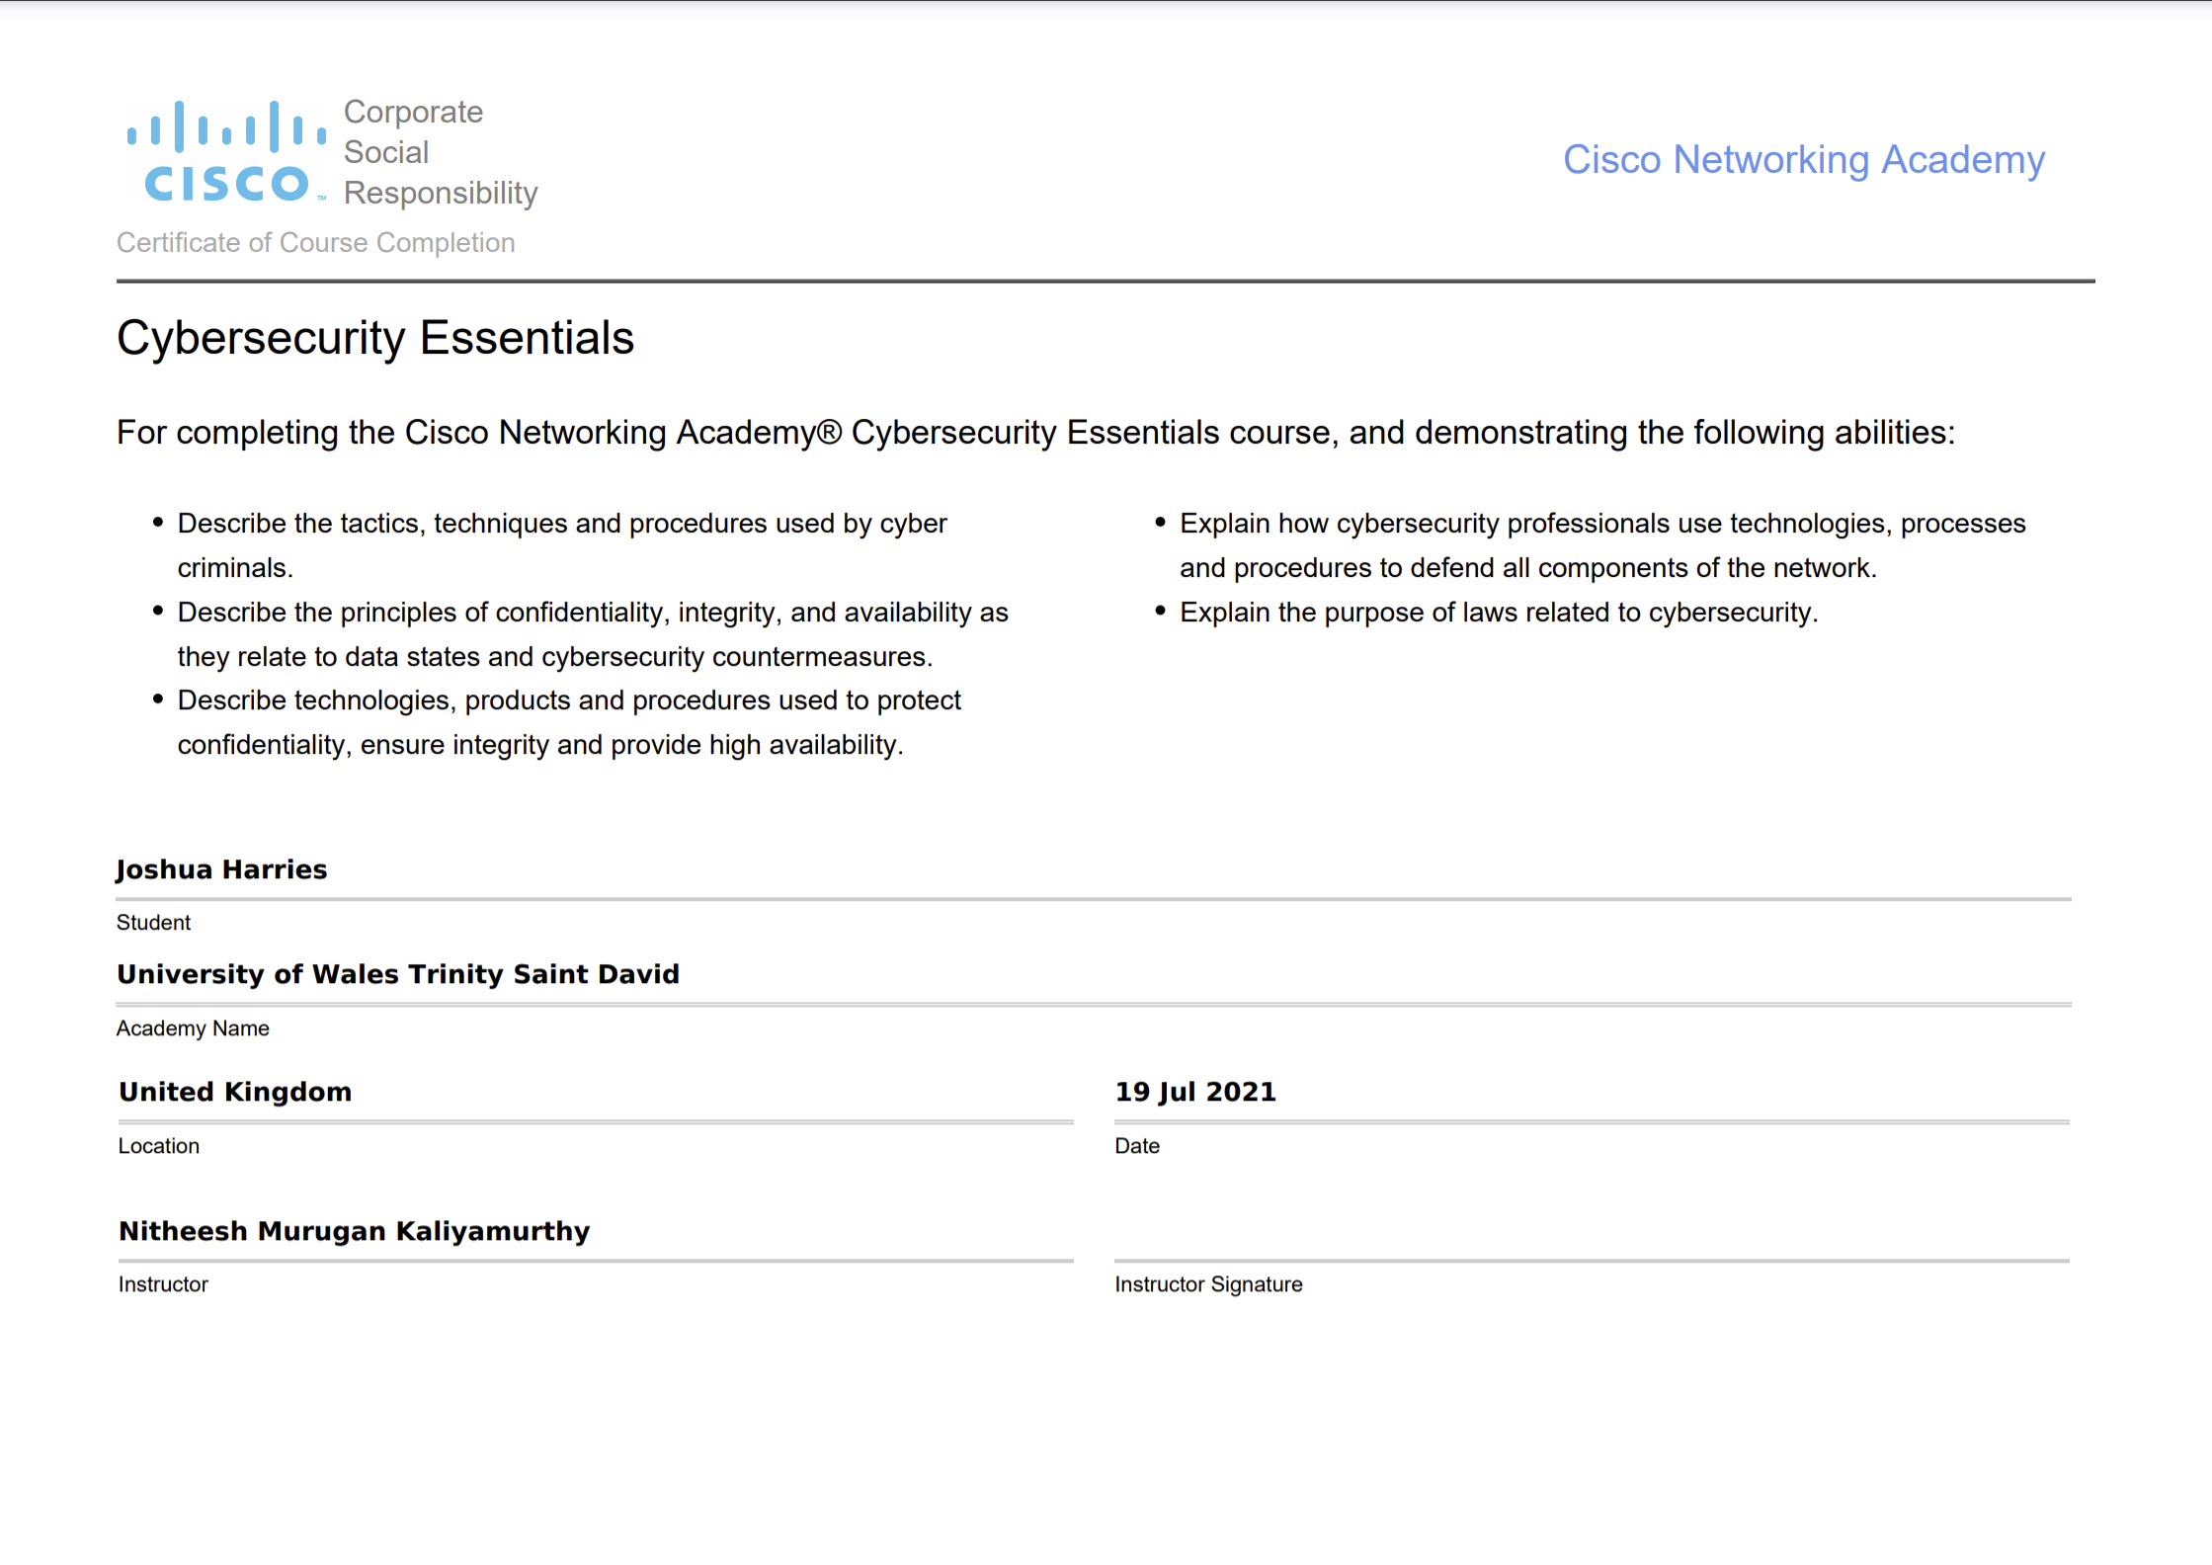
Digital Badge URL - https://www.credly.com/badges/9eda0c7b-47d4-442c-9140-289e36678373/public_url

Task 4
Here are some brief guidelines, or ‘top-tips’ for customers and staff to be safe online and to try and evade any potential threats and vulnerabilities.
- Limit personal information entered online
- Keep your privacy settings on and to the maximum setting possible
- Practice safe browsing, and be mindful to use only protected and trusted sites such as ones with HTTPS protection
- Be careful with what you download online
- Choose the strongest password possible, and do not write these down or reuse them on multiple sites/systems
- Be careful with what information you post online
- Ensure that your device has the latest updates and anti-virus software installed.

References

[1] | Sophos, “The State Of Ransomware 2020,” Sophos, 2020.
[2] | Cisco, “2021 Cybersecurity threat trends- phishing, crypto top the list,” Cisco, 2021.
[3] | A. T. Tunggal, “What is a Vulnerability?,” UpGuard, 25 05 2021. [Online]. Available: https://www.upguard.com/blog/vulnerability. [Accessed 23 07 2021].
[4] | ISO, “SO/IEC 27005:2018,” 07 2018. [Online]. Available: https://www.iso.org/obp/ui/#iso:std:iso-iec:27005:ed-3:v1:en. [Accessed 23 07 2021].
[5] | T. Meskauskas, “Avoid Meds ransomware attacks,” 04 08 2020. [Online]. Available: https://www.pcrisk.com/images/stories/screenshots201906/meds-homepage.jpg. [Accessed 23 07 2021].

