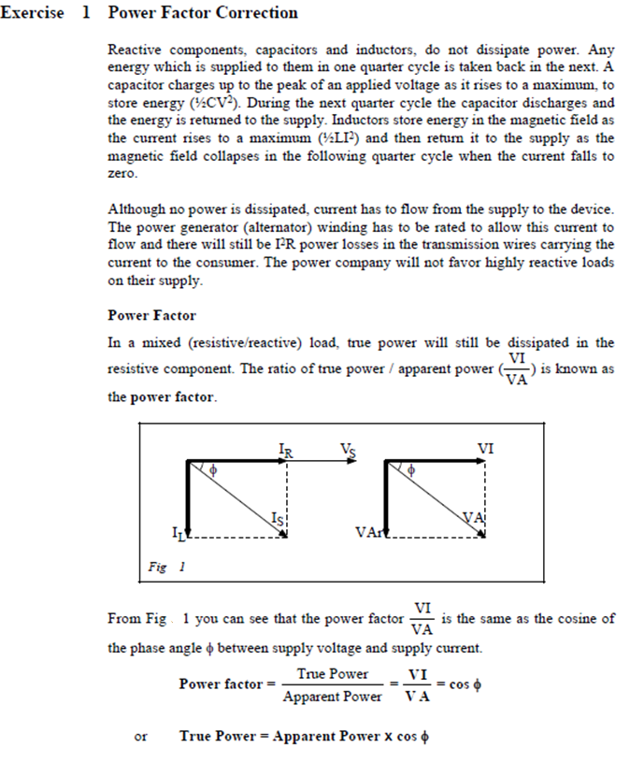

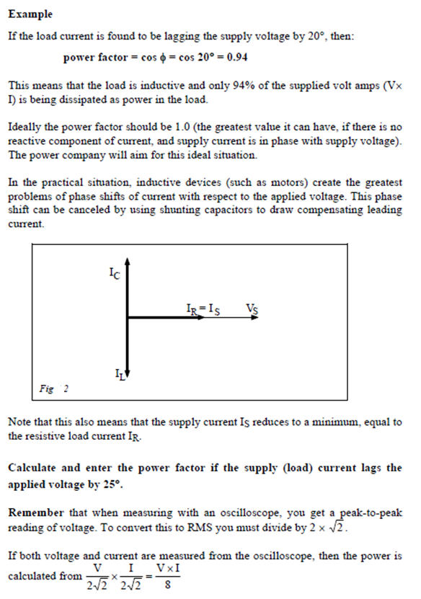

1.a.
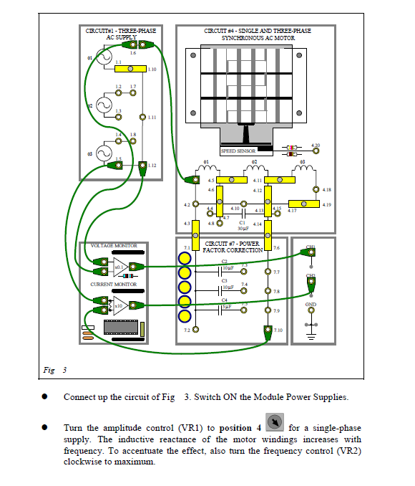

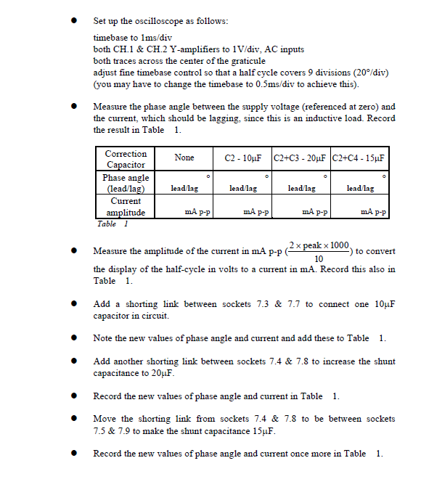

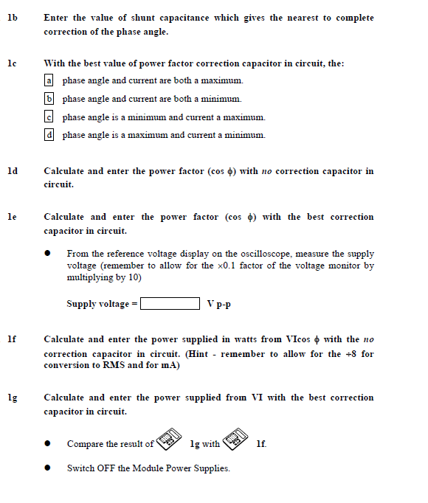

Notes:
1a. Cos(25) = 0.9063
Correction  Capacitor | None | C2 – 10uF | C2 + C3 – 20uF | C2 + C4 – 15uF
Phase Angle  (Lead/Lag) | 24°  Lag | 4°  Lag | 10°  Lead | 8°  Lead
Current Amplitude | 650mA | 536mA | 520mA | 606mA

1b. C2 – 10uF gives the nearest to complete correction of the phase angle.
1c. Using the best capacitor value of power factor correction in the circuit the best description of it out of a, b, c, d is C. Phase angle is a minimum and current a maximum.
1d. Cos(24) = 0.913
1e. Cos(4) = 0.913
2.486 x 2 x 10 = 49.72V
1f. 49.72 x 650x10-3 x cos(24) = 29.52 therefore 29.52/8 = 3.69W
1g. 49.72 x 536x10-3 x cos(4) = 26.59 therefore 26.59/8 = 3.32W
Power factor correction is normally achieved by using extra capacitors to compensate for the reactive power demand. In this case, it is clear to see that by using the best correction capacitor in the circuit, the overall power usage has decreased. This in real life terms would mean a reduction of power consumption therefore lower electricity bills and also extended equipment lifetimes.

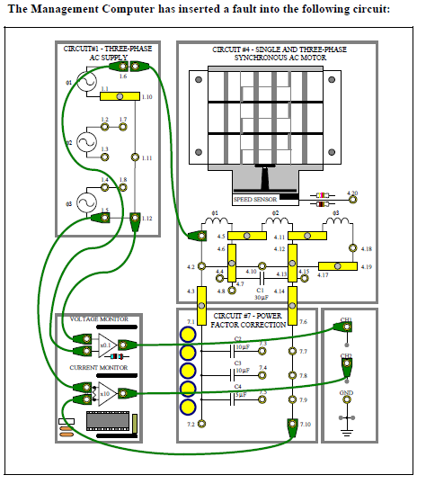

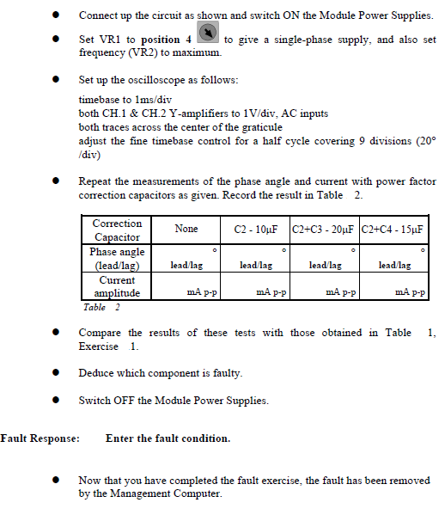

Notes:
The fault code entered was fault 9.
Correction  Capacitor | None | C2 – 10uF | C2 + C3 – 20uF | C2 + C4 – 15uF
Phase Angle  (Lead/Lag) | 44°  Lag | 22°  Lead | 50°  Lead | 45°  Lead
Current Amplitude | 314.2mA | 262.8mA | 480mA | 360mA

Initially there was a higher inductance measured as the phase angle lagged further and the current was lower. It is proposed that C1 is now open circuit, if this is the case the current would flow through winding 2 & 3 as shown in the image below.
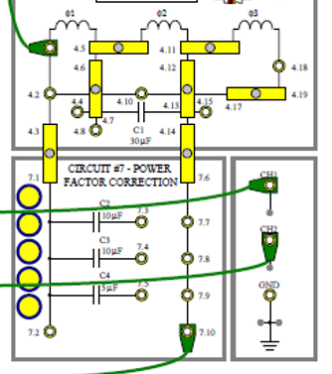

This was tested by removing the link shown in the image to the right. Once this was removed the motor stopped functioning.

