Barcelona Pavilion

Historical background
Designed by architect Ludwig Mies Van der Rohe and Lilly Reich in 1929, the Barcelona Pavilion was built as the German national pavilion for the 1929 Barcelona International Exhibition. The pavilion was to be a space representing the new Germany, no longer restrained by old monarchal and conservative outcomes. Opposing pavilions in other countries, which showed displays of national achievements, the German pavilion lacked exhibits, resulting in the building focusing on higher things. This was the first time since world war I that Germany could present itself outside its own borders, the pavilion was dedicated for representation, empty space and accordingly space-in-itself (MIES, mastering modernity p138). The Barcelona Pavilion is a symbol that reflects the modern architectural movement and has inspired architects for decades. After the closure of the pavilion, it was disassembled in 1930. However, as time went by, the significance of the building increased, showcasing Mie’s work throughout his career, which led towards its reconstruction. The building became a key reference to 20th-century architecture and modern design. In 1980, the head of the urban planning department at the Barcelona city council, architect Oriol Bohigas, confirmed the rebuilding of the Pavilion and selected architects Ignasi de Solà-Morales, Cristian Cirici, and Fernando Ramos to analyse, design, and supervise the reconstruction of the Pavilion.
https://miesbcn.com/the-pavilion/
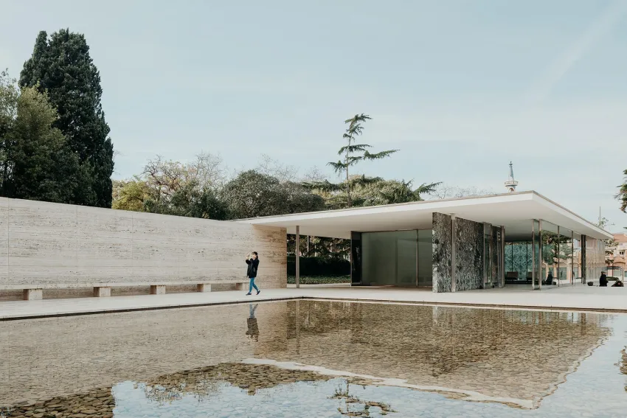
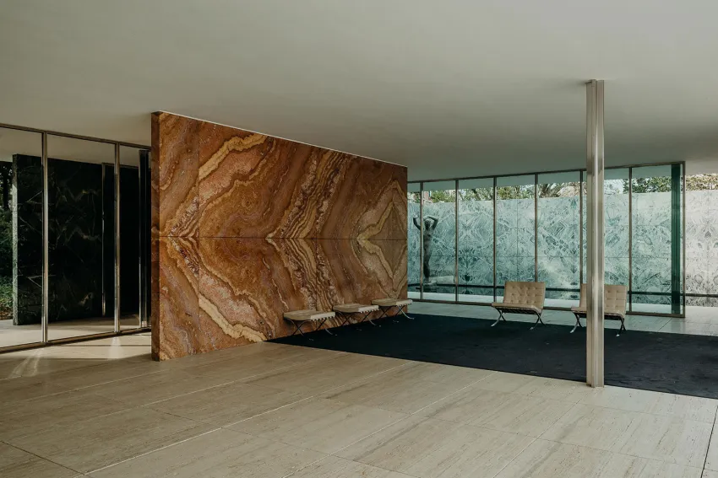

Materials
During the reconstruction of the pavilion, various materials were embedded in the design. The materials altogether created a juxtaposition due to Van der Rohe utilizing a combination of natural and industrial materials. White travertine marble surrounds the building, forming the outer envelope, dark green titanium marble engulfs the enclosures at the entrance as well as the smaller of the two pools. The interior includes warm rust coloured onyx for the main partition wall. The steel columns used are chrome-plated. The two pools create a contrast in texture as the rear pool’s floor is covered in glass, which shows the reflection of the building, while the front pool is covered in white pebbles, which also differ from the silky, untextured water above.
https://c20society.org.uk/building-of-the-month/barcelona-pavilion#:~:text=The%20Barcelona%20Pavilion%20was%20designed,Commissar%20General%20of%20the%20Reich.
The materials used were the same ones used in the previous Barcelona Pavilion in 1929. Mies Van der Rohe and Lily Reich specifically designed a chair for the pavilion, known as the ‘Barcelona chair’, and made up of leather and metal.

Ideas and theories underpinning the design
. Artist Justus Bier stated that the building's only ostensible function was to house receptions, Its deeper ideology, however, was to demonstrate the spirit of the Weimar Republic. As George Von Schnizel commissioner general for the German pavilion, put it, the pavilion was to be a space representing the new Germany, no longer restrained by old monarchal and conservative outcomes., the pavilion aimed to represent what Germans could do, what they are, how they felt at the time, it aimed to deliver the message that they didn’t want anything but clarity, simplicity, and honesty. the pavilion was dedicated for representation, empty space and accordingly space-in-itself (MIES,mastering modernity p138)
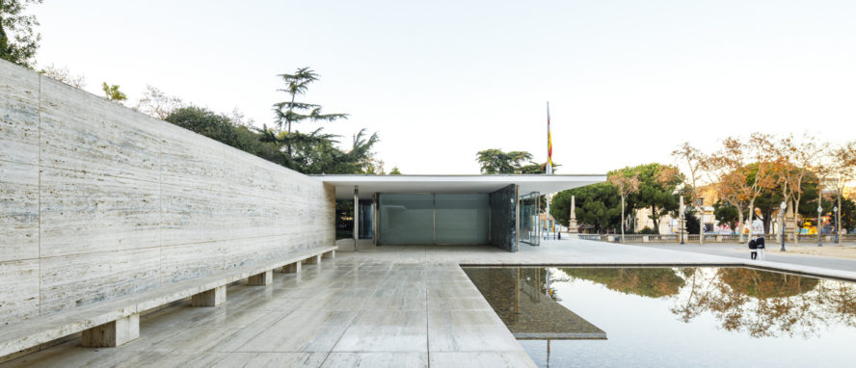
https://miesbcn.com/the-pavilion/

‘Was moved to a different location’
-talk about glazed windows in the materials
-talk about reflection on water
Talk about the pool and the reflection of water and how it makes the building look elevated

