COMMUNITY ENGAGEMENT
  - Assignment 1
BUSINESS MANAGEMENT
MIRCEA OCTAVIAN OLTEANU
2017632@student.uwtsd.ac.uk

Table of Contents
1.0 Introduction 2
2.0 Discussion 2
2.1 The sector in which company operates, size, structure, goals, mission and vision 2
2.2 Customer identification and their expectations from the organisation 3
2.3 Micro and macro analysis 8
2.4 Importance of training and development 10
2.5 Role in chosen organization 14
2.6 Explain the skills and knowledge needed to carry out the role 15
2.7 Explain what training and development requirements need to be considered 15
3.0 Conclusion 16
4.0 Reference list 17
5.0 Appendices 19
Appendix 1: Customer survey 19
Appendix 2: Employee survey 21
Appendix 3: Manager interview 23
Appendix 4: Training and development plan 25

1.0 Introduction
The study is centred on customer expectations and employees’ perception of coronavirus manufacturing company AstraZeneca. The study details the company, its customers and their expectations based on the good and services provided by it. Further, micro and macro analysis for the vaccine manufacturing company is provided. Apart from this, the perception of employees of AstraZeneca regarding the training and development are focused effectively. Primary data has been collected through interviews of 3 managers and surveys of 15 employees along with 15 customers. The importance of training and development is highlighted in the study. Moreover, the role of the Human resources manager is outlined in training and development.

2.0 Discussion

2.1 The sector in which company operates, size, structure, goals, mission and vision
AstraZeneca is one of the major pharmaceutical companies in the world that specializes in the development, discovery and manufacturing of medicines. In the era of the Covid-19 pandemic, the company has focused on developing vaccines against the coronavirus. It was founded in 1999 and its headquarters is situated in Cambridge, Great Britain. Pascol Sorito is the Chief Executive Officer (CEO) of the organization (astrazeneca, 2021).
The company generated $26,617 million in 2020. Further, the company received a 93 per cent score on the sustainability performance scorecard. It is observed that the sustainability performance increased from 86 per cent in 2019 to 93 per cent in the following year. The company reached approximately 25 million people across the globe through its access to healthcare programs (astrazeneca, 2021).
The company follows sustained growth aligned with R&D and commercial operations. The company is dedicated to the accelerated delivery of life-changing medicine and creating value for society and patients. The company intends to operate sustainably by outlining the connection between the needs of the society, business growth and limitations of the planet.

Figure 1: Organizational chart of Astrazeneca
(Source: astrazeneca, 2021)
The company has prioritised patient safety and continuity of medicines, research and development (R&D), contribution to society, along with safety and wellbeing of employees (astrazeneca, 2021). The purpose of the organization is to push the boundaries of science and deliver life-changing medicines and deliver benefits to patients. Further, it creates value for the shareholder by following science.
Mission statement
“We want to transform healthcare, change the lives of billions of people for the better and address some of the biggest healthcare challenges facing humankind” (astrazeneca, 2021).

2.2 Customer identification and their expectations from the organisation
The customers of Astrazeneca are community pharmacies, dispensing doctors, hospitals and non-dispensing doctors. The customers of Astrazeneca have several expectations such as the efficacy of medicines manufactured by the organization. As mentioned by Mazzetti et al. (2018), safety, price and sourcing of material for the development of medicines are focused by the customers. In order to analyse the expectations of customers, a survey of 15 customers is conducted online through Google forms. Close-ended questions are asked from customers regarding their expectations.
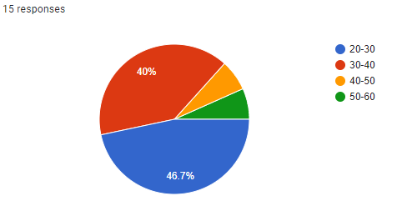
Figure 2: Age of Participants
(Source: Created by the learner)
The above figure portrays that 40 per cent of customers belong to the age group of 30 to 40 years and 46.7 per cent of customers belonged to the groups of 20 to 30 years.
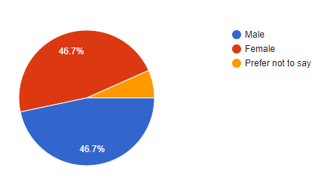
Figure 3: Gender of Participants
(Source: Created by the learner)
It is observed that 46.7 per cent of the customers of Astrazeneca were male and the equivalent percentage were females (Manko and Rosiński, 2021).
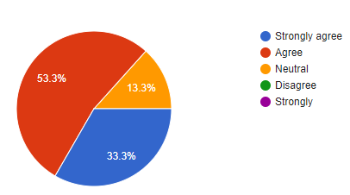
Figure 4: Quality of medicines manufactured by the AstraZeneca
(Source: Created by the learner)
It is observed from the above figure that 53.3 per cent of customers agreed on the better quality of medicines manufactured by the company. Further, 33 per cent of customers strongly agreed that the organization developed better medicines.
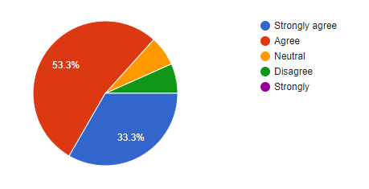
Figure 5: Efficacy of Vaccines
(Source: Created by the learner)
From the above figure, it can be interpreted that the efficacy of vaccines against coronavirus manufacture by the company is high. Around 33 per cent agreed strongly that AstraZeneca developed effective vaccines.
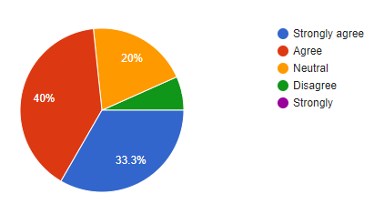
Figure 6: Safety of products
(Source: Created by the learner)
The pie chart above explains that products developed by the company are as safe as confirmed by 40 per cent of cuts through the online survey.
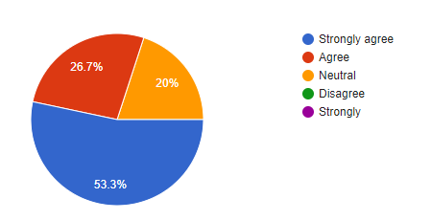
Figure 7: Sourcing of materials
(Source: Created by the learner)
Figure 6 indicates that 53 per cent of customers expect that the company sources its materials ethically.
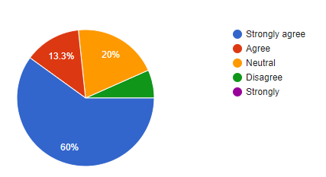
Figure 8: Inclusion of child labour
(Source: Created by the learner)
Further, it is observed that 60 per cent of customers expect that child labour need not be used for manufacturing pharmaceuticals products (Manko and Rosiński, 2021).
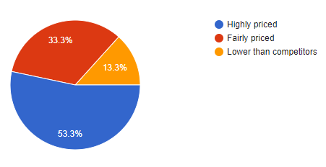
Figure 9: Price of pharmaceuticals
(Source: Created by the learner)
Around 53.3 per cent of customers of the company believe the cost of the product is highly-priced. On the other hand, 33 per cent indicated that the cost is fairly priced.

2.3 Micro and macro analysis
SWOT analysis of AstraZeneca
Strength | Weakness
High reputation  Better quality product  State-of-the-art R&D (astrazeneca, 2020)  Global reach in 100 countries | A legal proceeding in case of intellectual property including patents  Discontinuation of products  Shortage of drugs such as Cefotan
Opportunity | Threat
Develop vaccines against more diseases  Develop medicines for growing populations  Increased presence in emerging markets | Imitation of medicine by competitors  Changing regulation amidst the pandemic such as CoronaVirus Act 2020 (legislation.gov.uk, 2020)  Competition in developing vaccines
Table 1: SWOT Analysis
(Source: Created by learner)
PESTEL analysis
Macro factor | Analysis | Impact on organization
Political | The average political stability score of the UK is 0.47 against -0.06 of the world in 2019. It indicates that the UK has high political stability  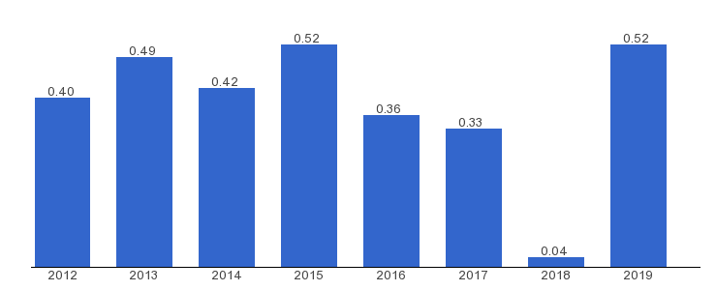  Figure 9: Political stability score between 2012 to 2019  (Source: theglobaleconomy, 2021) | Political stability is helpful in completing business activities without much disturbance.
Economical | The GDP of the UK in the first quarter of 2021 was £497,145 million (ons.gov.uk, 2021) | Stable economy is helpful in achieving growth for the organization
Social | Approximately 18 per cent of people in the UK are obese and 81 per cent drink alcohol (statista, 2020) | It indicates that people require high quality medicines for impeding their health
Technological | The technology sector in the UK is around £180 billion (telegraph.co.uk, 2018) | State-of-the-art technology helps in developing better medicine and through advanced R&D
Environmental | The UK is the most environmentally friendly in the European continent and the government intends to reach net-zero emission by 2050 (gov.uk, 2021). | It is beneficial for the company as authorities support inn lowering carbon emission
Legal | Human Medicines Regulations 2012 (SI 2012/1916) and National Health Service Act 2006 are applicable for pharmaceutical companies in the UK (lexology, 2019) | The company develops pharmaceutical by complying with regulations.
Table 2: PESTEL Analysis
(Source: Created by learner)

2.4 Importance of training and development
Training and development are important to an organization as it helps in achieving higher efficiency as well as promotes skilled employees. Further, effective skills such as communication, skill, leadership skill and critical reasoning are important along with industry-specific skills. As mentioned by Marx et al. (2020), it is important that the management of an organization arranges training and development programs frequently in order to employees and reskill them directed at increasing overall productivity and efficiency. The company provided on-line privacy training is provided to 36,295 employees in 2020. Further, Modern slavery awareness training to 72,173 employees in 2020.
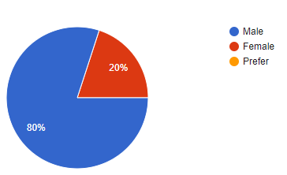
Figure 10: Gender of Employee
(Source: Created by the learner)
It is observed that 80 per cent of employees in the survey were male and 20 per cent were female.

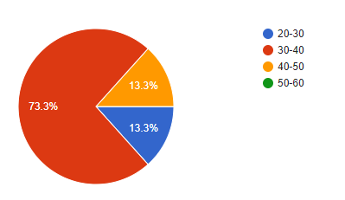
Figure 11: Age of Employee
(Source: Created by the learner)
It can be observed that 73 per cent of employees in Astrazeneca who participated in the survey were aged between 30-40 year.
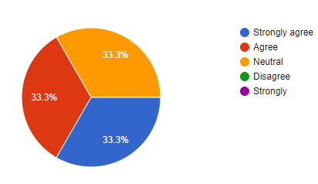
Figure 12: Importance of Training and development
(Source: Created by learner)
The above figure indicates that employees consider training and development important as indicated by 33 per cent of the participant in the survey.
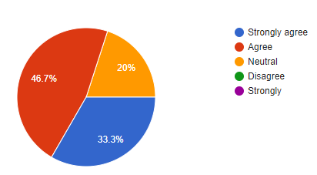
Figure 13: Role of Training and development in gaining competitive skills
(Source: Created by learner)
It is observed from the pie-chart above that 46 per cent of employees believe training and development are important for gaining competitive skills.
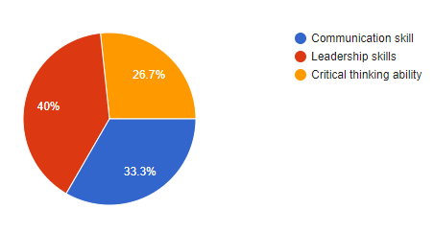
Figure 14: Important Skills
(Source: Created by learner)
On the other hand, it can be observed that communication skills are considered important for employees (Marx et al. 2020).
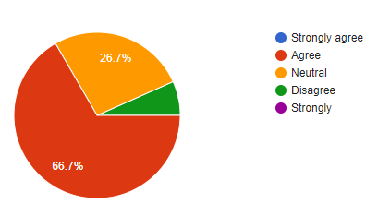
Figure 15: Relevance of Training and development
(Source: Created by learner)
Around 66 per cent of employees of the organization believe that training in relevant categories is important such as product development and innovation.
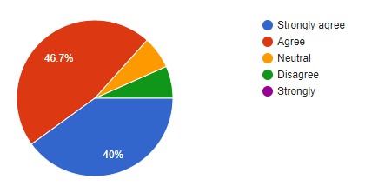
Figure 16: Training and development for product innovation and growth
(Source: Created by learner)
Approximately 46 per cent of employees strongly agree that training and development is essential for product innovation and growth of the organization
The primary data collected from 3 managers of Astrazeneca helps in understanding the importance of training and development. It is analyses form the interview of three manager that training and development is essential for skill addition. It is important for growth and development of organization as well as enhancement of employee efficiency and productivity.
Further, the manager indicated that training and helps in enhancing leadership skills, critical reasoning skill and communication skills that can be utilised for coordinating and collaborating with the workforce. The company provided Modern slavery awareness training to 72,173 employees in 2020. Further, on-line privacy training is provided to 36,295 employees in 2020.

2.5 Role in chosen organization
The role of the human resource manager is important in Astrazeneca as hiring new talent in the company is frequently required based on competitiveness. Further, retaining talent and knowledge in the organization is essential. The HR manager helps in identifying the requirements of the organization and recruits’ candidates in order to meet the vision and mission of the organizations. Further, the role of an HR manager is to identify the conflict between employees and resolve issues through an effective solution (Knoll and Wonodi, 2021). Moreover, it can be observed that the HR manager is responsible for providing effective training and development programs that can help in enhancing the skills of employees such as leadership, critical reasoning and communication skills.

2.6 Explain the skills and knowledge needed to carry out the role
As per Mcdonnell and Sikander (2017), the skills and knowledge that are required for carrying out the role of an HR manager are the educational qualification in management along with a diploma course in business administration. Moreover, the person is also needed to have enough patience to carry out the different roles and functions as an HR manager. On the other hand, the individual who wants to do the role of HR manager must have effective communication skills so as to speak properly with the employees to make them feel comfortable to share their issues. Moreover, a person also must have organisational skills to manage the different activities of the HR department in a systematic and scheduled way. As an HR manager, he or she must have the potentiality to make proper recruitment, scrutiny and final selection of the right candidate for the right job. It is also necessary for them to create trust and confidence among the employees by solving all of their professional and personal issues and grievances. The biggest skill and knowledge that must be there to carry out the role of an HR manager is to have decision-making ability (Lopez-Cabrales et al., 2017). This will help them in making realistic strategies for tackling the unwanted situation in the organisation.

2.7 Explain what training and development requirements need to be considered
The training and development requirements that are required to be considered for carrying out the role of an HR manager of Astrazeneca are acquisition of lessons and knowledge on affirmative action training, anti-harassment prevention training, cafeteria plans and ADA compliance training. They have also required training on background checking, implication of COBRA, leave management, employment law, labour law and retirement plan. On the other hand, the HR manager also required training on leadership and management activities. In order to perform the role of HR manager, it is important for a person to have training on auditing, management of records and benchmarking (Tyson and Wikander, 2017).
The HR managers of Astrazeneca also must have training on the ways of filling up personnel forms along with receiving training and development on the compensation and payroll for knowing different rules related to its laws and benefits so that they could make the employees understand about these things. In case of Astrazeneca specially, the training will also include special lessons on the process of recruitment and selection, as the HR managers of the firm need to hire efficient and competent human resources for dealing with the current challenging situation. Moreover, a person is also required to have knowledge about the policies regarding the worker’s compensation along with that of employee safety. This will help them to generate strict legal actions for ensuring the well-being of the employees in the organisation.

3.0 Conclusion
From the above study, it has been analysed that for becoming an HR manager a person must have good communication skills along with ability to identify and understand the issues of the employees and thereby solving them. It has helped in observing that the main goal of AstraZeneca is to bring a huge transformation in the healthcare system by providing quality medicines and other pharmaceutical products to the common masses. Moreover, the above study also assisted in understanding that the majority of customers agreed that this company makes very quality medicines along with the high efficacy of its vaccines against coronavirus.

4.0 Reference list
astrazeneca, 2021, Expectations of Third Parties, Available at < https://www.astrazeneca.com/content/dam/az/PDF/Sustainability/Expectations_of_Third_Parties_Handbook.pdf>[Accessed on 12 June 2021]
astrazeneca, 2021, Our business strategy, Available at < https://www.astrazeneca.com/our-company/our-strategy.html#:~:text=Driving%20growth%20through%20successful%20innovation,and%20treatment%20through%20to%20rehabilitation. >[Accessed on 12 June 2021]
astrazeneca, 2021, Our Company, Available at < https://www.astrazeneca.com/our-company.html >[Accessed on 12 June 2021]
gov.uk, 2021, Government introduces ground-breaking Environment Bill, Available at < https://www.gov.uk/government/news/government-introduces-ground-breaking-environment-bill >[Accessed on 12 June 2021]
Haugen, T., Seiler, S., Sandbakk, Ø. and Tønnessen, E., 2019. The training and development of elite sprint performance: an integration of scientific and best practice literature. Sports medicine-open, 5(1), pp.1-16.
Knoll, M.D. and Wonodi, C., 2021. Oxford–AstraZeneca COVID-19 vaccine efficacy. The Lancet, 397(10269), pp.72-74.
legislation.gov.uk, 2020, Coronavirus Act 2020, Available at <https://www.legislation.gov.uk/ukpga/2020/7/contents/enacted >[Accessed on 12 June 2021]
lexology, 2019, Pharmaceutical antitrust law in United Kingdom, Available at <https://www.lexology.com/library/detail.aspx?g=67b52abc-ef3b-48f4-85bb-de9cb639430f>[Accessed on 12 June 2021]
Lopez-Cabrales, A., Bornay-Barrachina, M. and Diaz-Fernandez, M., 2017. Leadership and dynamic capabilities: the role of HR systems. Personnel Review.
Manko, B.A. and Rosiński, J., 2021. A cross-sector international study of remote work and its management in the pandemic. International Journal of Business & Management, 9(1).
Marx, U., Akabane, T., Andersson, T.B., Baker, E., Beilmann, M., Beken, S., Brendler-Schwaab, S., Cirit, M., David, R., Dehne, E.M. and Durieux, I., 2020. Biology-inspired microphysiological systems to advance patient benefit and animal welfare in drug development. Altex, 37(3), p.365.
Mazzetti, M., Hedwall, M., Crowther, M., Lennard, S., Richardson, M. and Taylor, L., 2018, January. AstraZeneca Creates a Culture of Agility and Innovation. Project Management Institute.
Mcdonnell, L. and Sikander, A., 2017. Skills and competencies for the contemporary human resource practitioner: a synthesis of the academic, industry and employers' perspectives. The Journal of Developing Areas, 51(1), pp.83-101.
ons.gov.uk, 2021, Gross Domestic Product (GDP), Available at < https://www.ons.gov.uk/economy/grossdomesticproductgdp>[Accessed on 12 June 2021]
statista, 2020, Share of lifestyle trends of adults with an infectious disease in the United Kingdom in 2018, Available at < https://www.statista.com/statistics/420375/lifestyle-of-individuals-with-infectious-disease-in-the-united-kingdom/ >[Accessed on 12 June 2021]
telegraph.co.uk, 2018, The technology and media sector in the UK, Available at < https://www.telegraph.co.uk/business/tips-for-the-future/future-of-tech/ >[Accessed on 12 June 2021]
theglobaleconomy, 2021, United Kingdom: Political stability, Available at < https://www.theglobaleconomy.com/United-Kingdom/wb_political_stability/>[Accessed on 12 June 2021]
Tyson, S. and Wikander, L., 2017. The education and training of human resource managers in Europe. In Policy and practice in European human resource management (pp. 36-50). Routledge.

5.0 Appendices

Appendix 1: Customer survey
1.0 Please select your age
- 20-30
- 30-40
- 40-50
- 50-60
2.0 Please select your gender
- Male
- Female
- Prefer not to say
3.0 To what extent do you think Astrazeneca is providing better medicines?
- Strongly agree
- Agree
- Neutral
- Disagree
- Strongly
4.0 Do you think Astrazeneca is able to provide effective vaccines?
- Strongly agree
- Agree
- Neutral
- Disagree
- Strongly
5.0 Do you think products manufactured by Astrazeneca are safe?
- Strongly agree
- Agree
- Neutral
- Disagree
- Strongly
6.0 Do you think the company secures all material ethically?
- Strongly agree
- Agree
- Neutral
- Disagree
- Strongly
7.0 To what extent do you think Astrazeneca is against child labour in the manufacturing proces?
- Strongly agree
- Agree
- Neutral
- Disagree
- Strongly
8.0 Do you think the price of pharmaceuticals is reasonably priced by Astrazeneca?
- Highly priced
- Fairly priced
- Lower than competitors

Appendix 2: Employee survey
1.0 Please select your gender
- Male
- Female
- Prefer not to say
2.0 Please select your age
- 20-30
- 30-40
- 40-50
- 50-60
3.0 Do you think training and development is important for employees?
- Strongly agree
- Agree
- Neutral
- Disagree
- Strongly
4.0 Do you think training and development is helpful in gaining competitive skills?
- Strongly agree
- Agree
- Neutral
- Disagree
- Strongly
5.0 Please select the skills that are important according to you?
- Communication skill
- Leadership skills
- Critical thinking ability
6.0 Do you think the management of Astrazeneca provides relevant training according to industry standards?
- Strongly agree
- Agree
- Neutral
- Disagree
- Strongly
7.0 Do you think training and development help in product innovation and growth of the organization?
- Strongly agree
- Agree
- Neutral
- Disagree
- Strongly

Appendix 3: Manager interview
Interview transcript
Serial number | Question | Manager 1 | Manager 2 | Manager 3
 | Do you think training and development are important for the growth of organizations? | Yes, it is essential for adding skills to employees enhancement of productivity | Yes, it is highly important for the growth and development of employee and the organization | Yes, training and development reflect the efficiency of employees.
2 | Is training and development essential for product innovation? | It helps to explore new boundaries and order opportunities to innovate through effective training and development (Haugen et al. 2019). | Yes, it is important | Yes, effective training is important
3 | Does training and development help in adding skills? | Yes, skills are added through effective training modules | Definitely | Yes, certain skill is added through training
4 | What important skills are enhanced through training and development? | Skill such as communication is improved through training that helps in increasing coordination and collaboration | Critical skills can be enhanced through training and development | Leadership skills are enhanced by training and development

Appendix 4: Training and development plan

Training and development needs | How will this be achieved | Target date | Completion date | Responsible person | Potential outcome
Training on developing Management skills | It will be achieved by acquiring degree on human resource management along with increasing decision-making capability and creating trust among employees. | 22/5/2021 | 28//2021 | HR manager | It will help the HR in understanding the operational activities of business with much accuracy thereby handling it through strict monitoring.
Training on developing Leadership skills | It can be developed by practising decency with team members along with making the employees understand the strategy for doing a particular task related to production. | 23/5/2021 | 20/6/2021 | Team leader | It will help the team leader in generating good coordination with its own team members along with increasing the productivity.
Training on making medicines | Degree on pharmacy along with receiving vocational training from pharmaceutical institution | 22/5/2021 | 28/6/2021 | Employees | It will increase the efficiency and development of skills of employees relating to manufacture of medicines and other pharmaceutical products.

