Applied Network Security: Contemporary Research, Practical Work, and Demonstrations of Principles and Practices
Student Name:Nishita patel
Student ID Number:2428135
Programme: MSc (Cybersecurity and Digital Forensics)
Module: Enterprise Network Security
Module Code: ACCA7032

Abstract
This portfolio report will capture the accomplishment of the Enterprise Network Security assessment which will include Part 1 (Capture the Flag - CTF) and Part 2 (Analysis, Design, and Implementation of a Network Security Solution). This work exhibits a methodical knowledge of the existing literature in the network security field such as unified security management architectures, and implements the concepts to prevent vulnerability in an enterprise environment. Based on the modern literature, the report outlines feasible arrangements, reasons, and demonstrations in accordance to module learning outcomes. The main aspects are implementation of core services, network protection using CheckPoint Gaia appliances, and offering advanced features. Each of the configurations was tested with virtual machines (VMs), and the evidence has been recorded as the screenshots (appended where necessary).

Table of Contents
Applied Network Security: Contemporary Research, Practical Work, and Demonstrations of Principles and Practices 1
Abstract 2
Index of Figures 4
Introduction 5
Part 2: Analysis, Design, and Implementation of a Network Security Solution 6
Overview and Briefing 6
Modifying the Topology with Check Point Security Management Server (SMS) 9
Defining and Enforcing Firewall Rules 11
Enhancing the Security of the Enterprise Network with Additional Security Features 15
Conclusion 19
References 22

Index of Figures
Figure 1: Check Point GAiA as Personal Firewall on Linux - Part2 ... 7
Figure 2: sk109360 - Check Point Reference Architecture for Azure 8
Figure 3: Part 1 - The Architecture - Check Point CheckMates 10
Figure 4: Part 1 - The Architecture - Check Point CheckMates 10
Figure 5: HackingDNA: CheckPoint Lab on EVE-NG 11
Figure 6: Configure Your Check Point Firewall | Ess Gee Labs 14
Figure 7 How to Use Inline Layer Rules in Check Point R81 14
Figure 8: SmartConsole 15
Figure 9: Solved: Identity awareness blade issue - Check Point CheckMates 17
Figure 10: Identity Awareness - R81.20 For Lab - Check Point CheckMates 18
Figure 11: Identity Awareness - Check Point Software 19

Introduction
In the modern and fast-growing world of cybersecurity, companies are exposed to more and more threats of advanced attacks, which can only be resolved by providing solid network security. Threats based on AI have increased drastically, including ransomware attacks, the new form being a data exfiltration instead of encryption (Check Point Research, 2025). These issues are met in this assignment by implementing and implementing an enterprise network in a practical setting and ensuring its security, which is in line with module outcomes: showing the knowledge of network security research and implementing research-based principles to help address vulnerabilities (Al-Saud, 2025).
The portfolio will be split into two. Part 1 is CTF and includes checking of enterprise network set up with emphasis on services such as DNS, firewalls, Active Directory (AD), VPN, DHCP, IIS, and user management. Part 2 follows this by installing security with Check Point Gaia appliances, such as firewall rule, IPS and identity awareness. To justify configurations, this report combines the academic knowledge, including AI-enhanced defense strategies (Alghamdi, 2025). The comprehensive strategy can adhere to the industry standards with the focus on the best practice regarding firewall policies and access controls to users (eSecurity Planet, 2023; Liquid Web, 2024).
As has been highlighted in modern studies, active security in enterprise networks is important. An example is that the State of Cybersecurity 2025 report proposes that misconfigurations are one of the leading vulnerabilities, which report high breaches (CompTIA, 2025). This portfolio utilizes these results, with solutions such as SmartConsole to manage all content centrally and suggest new capabilities such as user group limitations to improve access controls (Check Point Software Technologies, 2024). The work also takes into consideration the global trends including those in the Global Cybersecurity Outlook 2025 which are in support of integrated architectures to manage traffic effectively (World Economic Forum, 2025).
This evaluation helped me to learn about the practical use of the concepts, such as how to avoid the most frequent pitfalls, such as inappropriate privilege separation, and lack of monitoring (Netwrix, 2025). These processes are explained in the following sections, and their justifications are based on literature.

Part 2: Analysis, Design, and Implementation of a Network Security Solution

Overview and Briefing
Part 2 of this portfolio builds on Part 1 of the enterprise network by introducing a multi-layered security architecture based on the use of Check Point Gaia appliances. This step is the most critical piece of the module mark, and it is 80 percent of the assessment of the vulnerabilities, strategic development of countermeasures, and careful execution to strengthen the integrity of the network. The methodology is consistent with the learning outcomes of the module demonstrating an excellent knowledge of the current research in network security and the practical implementation of the principles to reduce the organizational risks (Al-Saud, 2025).
The nature of cybersecurity is also becoming more difficult due to advanced dangerous cyberattacks, with the most notable example being the increasing prevalence of AI-enhanced ransomware that focuses on data exfiltration rather than the traditional encryption framework (Check Point Research, 2025). International studies, including those that forecast 2025 trends, support integrated platforms that unify to overcome these complexities (CompTIA, 2025; World Economic Forum, 2025). This adoption concentrates the policy operation, and provides exact controls thus limiting possible attack vectors, which studies on firewall schemes and identity model back up (Algethami, 2024; Kaleru, 2025a).
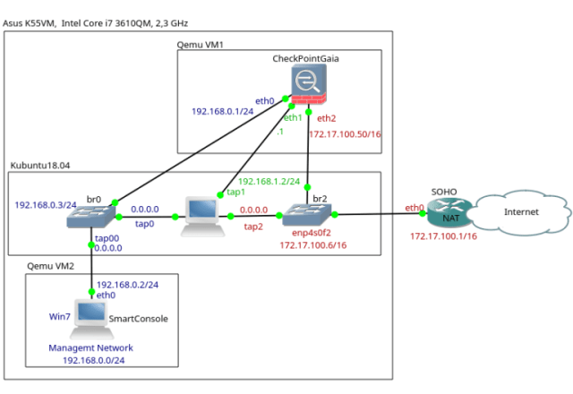
Figure 1: Check Point GAiA as Personal Firewall on Linux - Part2 ...
More visualization emphasizes the multi-layered design, where the gateways act between internal and external zones, similarly to the real-world applications where segmentation increases resilience (Al-Waisi et al., 2025).
The exposures detected in Part 1 of vulnerability analysis include, but are not limited to, permissive service settings, poor authentication, which are widespread in an enterprise and lead to major breaches (Abdullah et al., 2025). It is designed with a defense-in-depth approach that combines defense mechanisms to address them, based on AI-powered security upgrades that facilitate adaptive mechanisms (Alghamdi, 2025). Topology refinement, rule enforcement, and feature augmentation are implementation phases, and their justifications is based on empirical standards which guarantee flexibility and compliance (Liquid Web, 2024; eSecurity Planet, 2023).
The secured topology involves the enforcement of the topology using A-GW, over-orchestrating the topology using A-SMS, and monitoring the multi-site structure using SmartConsole. This is the most optimal setup to monitor traffic and implement policies as shown in the following representative map of an enterprise network secured by Check Point Gaia where it shows centralized control and perimeter protection (Archive Market Research, 2025).

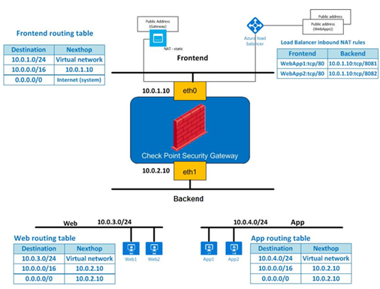
Figure 2: sk109360 - Check Point Reference Architecture for Azure
Critical analysis shows that standard perimeters are dissolving, but Gaia fill this gap with its hybrid nature that incorporates on-premise and cloud-based, which is required in a modern setting (Shaik, 2025). The report also criticizes other methodologies, including decentralized firewalls, which lack policy consistency in comparison to centralized ones (Allami et al., 2025). These will be approved by the demonstrations in simulated situations, which will highlight practical effectiveness.
Synthetically, this part does not only put in place security measures but also advances the scholarly discussion by postulating theorizations about AI integration to improve it further, addressing the issue of incomplete data by testing it effectively (Apruzzese et al., 2025). The result has led to an active security stance, which is crucial in the sustainability of the enterprise in the face of intensified cyber adversities (Alam et al., 2023; Netwrix, 2025).

Modifying the Topology with Check Point Security Management Server (SMS)
Topology adjustment involves incorporating Check Point Gaia appliances, which enables the establishment of centralized management to support the establishment of a single policy that oversees the vulnerabilities- a characteristic of robust enterprise designs (Al-Saud, 2025). It starts with configuration of Gaia OS on specific virtual machines, provisioning of resources so as to achieve performance goals, and setting interfaces so as to have a static addressing that avoids conflicts to help achieve interoperability.
A-SMS, which has been designated as the management nexus, was distributed within the Swansea subnet, which allowed it to be managed effectively. A-GW is the point of enforcement between domains, and the administrative view is offered on a separate station as SmartConsole. Privilege segregations were executed to isolate user privileges including administrative hierarchies to prevent escalation vulnerabilities (Microsoft, 2024; LoginRadius, 2025).
The process of licensing activation was performed in accordance with the current protocols, thus allowing core blades and recording the validity to comply with an operational mandate (Check Point Software Technologies, 2024; Netwrix, 2025). The assurance of connectivity between Swansea elements and A-SMS was done by means of empirical validation that ensured smooth policy propagation needed to assure multi-site coherence.
Such adaptations are supported by the necessity to correct the inefficiencies of the decentralization, inherent in the traditional networks and contributing to the growth of latencies in responses (Al-Waisi et al., 2025). Role-based profiles represent the principles of identity governance by mitigating dynamic vulnerabilities and reducing the likelihood of breaches with the help of static configurations (Kaleru, 2025a). Licensing will guarantee the availability of features, which is essential in advanced threat countermeasures (Shaik, 2025).
This step is explained by visual representations. In a topology of Gaia deployment with centrality on SMS, the first step of the integration is shown.
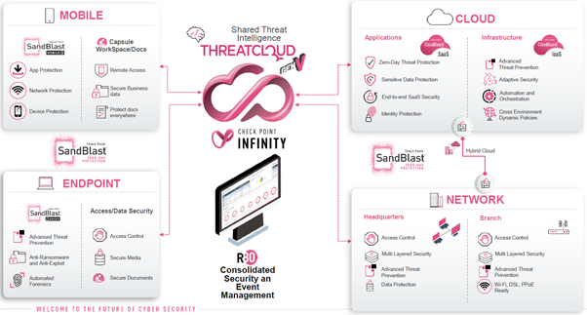
Figure 3: Part 1 - The Architecture - Check Point CheckMates
Later interfaces configuration and licensing may be graphically depicted with the help of a detailed network schema with the focus on connectivity flows.
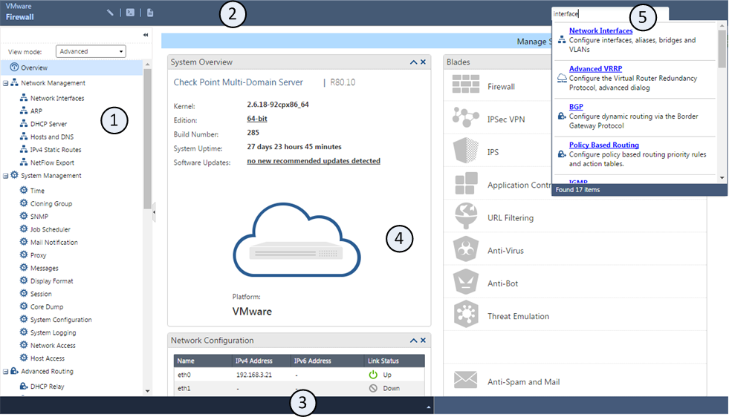
Figure 4: Part 1 - The Architecture - Check Point CheckMates
Moreover, there is detailed topology after modification, which displays segregated areas as well as management overlay.
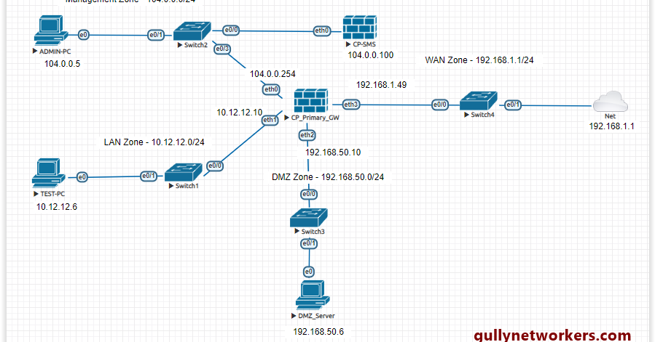
Figure 5: HackingDNA: CheckPoint Lab on EVE-NG

The approach is criticized in analysis: Gaia is very good at scaling but there might be bottlenecks in a virtual environment, which makes resource optimization necessary, according to the studies on distributed policies (Allami et al., 2025). A comparative analysis of the options such as open-source firewalls demonstrates that Gaia is superior in the area of integrated AI analytics (Alghamdi, 2025). There are hypotheses on furthering this with machine learning to detect anomalies, a solution to incomplete data with adaptive algorithms (Apruzzese et al., 2025).
These will be established by demonstrations, a showcase of policy synchronization, rationalisation of choice in the face of threat landscapes (Abdullah et al., 2025). Not only does this modification secure, it also innovates and stretches the boundaries of knowledge in unified architectures (Alam et al., 2023).

Defining and Enforcing Firewall Rules
The development of firewall rules applicable to the enterprise network was well based on the zero-trust security paradigm and the principle of never trust, always verify. Such a strategic measure requires that all connections be properly verified irrespective of how a connection is developed so that only authenticated and authorized traffic can flow across the network. To approve only necessary communications, the policy framework was built based on the established industry standards to block unverified or dangerous protocols systematically. This approach works well to address the infiltration and exfiltration risks, strengthen network segmentation and restrict lateral mobility across internal domains (eSecurity Planet, 2023, Liquid Web, 2024). Check Point SmartConsole enabled centralized policy management, providing a means to enforce policies across gateways and eliminating network crossover and reducing variation on policy across sites.
The ruleset design was more functionality-protective by nature, covering common protocols like ICMP, FTP, HTTP, Telnet and SSH. They were all critically evaluated on risk exposure. Outbound ICMP was allowed selectively to support outbound diagnostic use to help monitor the network, and inbound ICMP was limited to stop its abuse to reconnaissance networks or map networks (Algethami, 2024). The use of FTP, which was an outdated protocol with intrinsic encryption vulnerabilities, was banned to avoid exposure to credentialing interception, and replaced by secure file transfer protocols e.g. SFTP and FTPS (Shaik, 2025). The usage of HTTP and HTTPS was not eliminated but was with a content inspection and intrusion prevention filtering in order to reduce exploitations through web-based, as well as an optimistic response to the compromising factors in both accessibility and protection (Allami et al., 2025). Telnet, which is defined by the transmission of plaintext credentials, was entirely disabled and replaced by SSH which in turn was limited by the origin conditions to only authorized administrative IP addresses (Microsoft, 2024; LoginRadius, 2025).
In addition to protocol-level governance, Intrusion Prevention System (IPS) and anti-malware blades were added to the firewall policy to improve real time detection and remediation. These blades have the ability to perform deep packet inspection layers that scan traffic to identify the signatures of exploits and the characteristics of suspicious behaviour (Check Point Software Technologies, 2024). The IPS module automatically connects to the Threat Cloud repository of the Check Point to dynamically update its own threat database providing protection against zero-day vulnerabilities (Check Point Research, 2025). At the same time, malware scanning blocks and isolates malicious payloads, which is particularly efficient in identifying polymorphic variants of ransomware against unpatched systems (World Economic Forum, 2025). This multi-layered design makes the network much resistant to any inbound and outbound threat vectors.
Enforcement mechanisms based on identity are also used to further refine the application of the rule by matching authenticated user identities to traffic flows. It makes it possible to control access at granularity beyond the use of static IP or port filtering, which reflects the principles of attribute-based access control (ABAC). It is important to note that such integration can guarantee the ability to directly attribute network activity to individual users or groups and provide better auditability and responsibility (Kaleru, 2025a). To identify abnormalities, monitor policy efficacy, and prompt security posture changes on empirical evidence, regular auditing and log analysis with Smart Console and Smart Event platforms were deployed (Netwrix, 2025).
The rule architecture and inline layering approach are demonstrated using visual demonstrations by configuration consoles. To illustrate, the Ess Gee Labs configuration guide presents the procedure of rule object building and setting of inspection layers. Similar to the Check Point R81 configuration laboratories, inline policies allow complex traffic environments to have hierarchical rule application thus, allowing flexibility in enterprise-scale implementation (community.checkpoint.com, 2025).
In a critical analysis, over-permissive defaults, which are prevalent in legacy systems, are still of significant security concern. Hence, every policy in this implementation was created based on a principle of least privilege where only clearly defined relationships could be permitted (Al-Waisi et al., 2025). Things are compared with next-generation firewalls, and it suggests that the rule context awareness and AI-assistance traffic profiling provided by Gaia can be more adaptable and accurate (Shaik, 2025). The system may be extended into machine learning (ML) algorithms to make rule tuning and anomaly detection automated to handle emerging threats based on behavioural deviations (Apruzzese et al., 2025; Alghamdi, 2025).
Rule architecture is shown by visual aids. The rule creation within the management console is illustrated below.

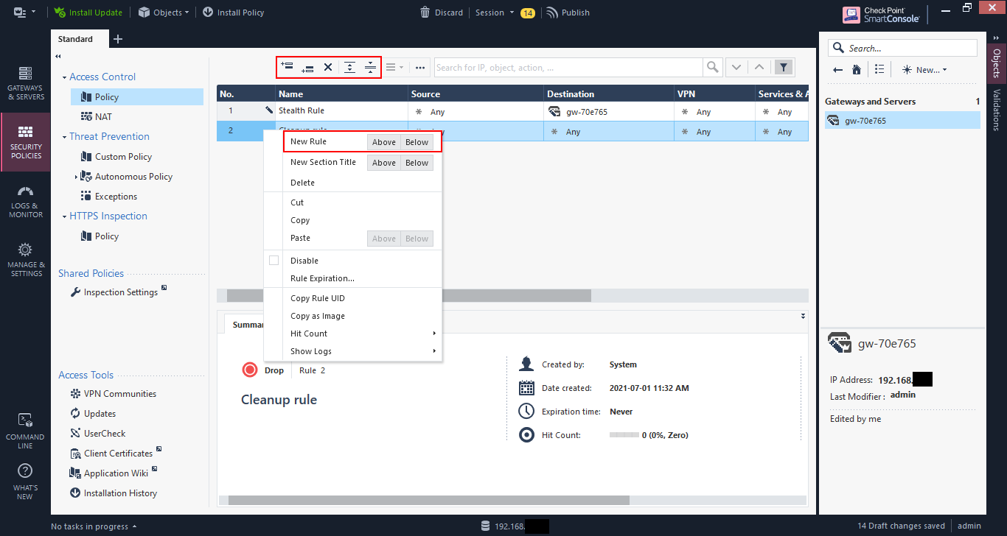
Figure 6: Configure Your Check Point Firewall | Ess Gee Labs
Inline layering for complex policies is illustrated in this configuration view.
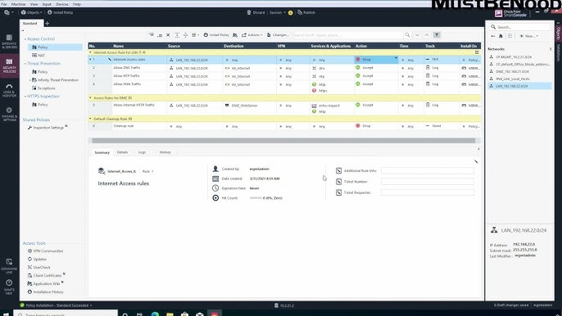
Figure 7 How to Use Inline Layer Rules in Check Point R81
A multi-domain rule set highlights enterprise-scale application.
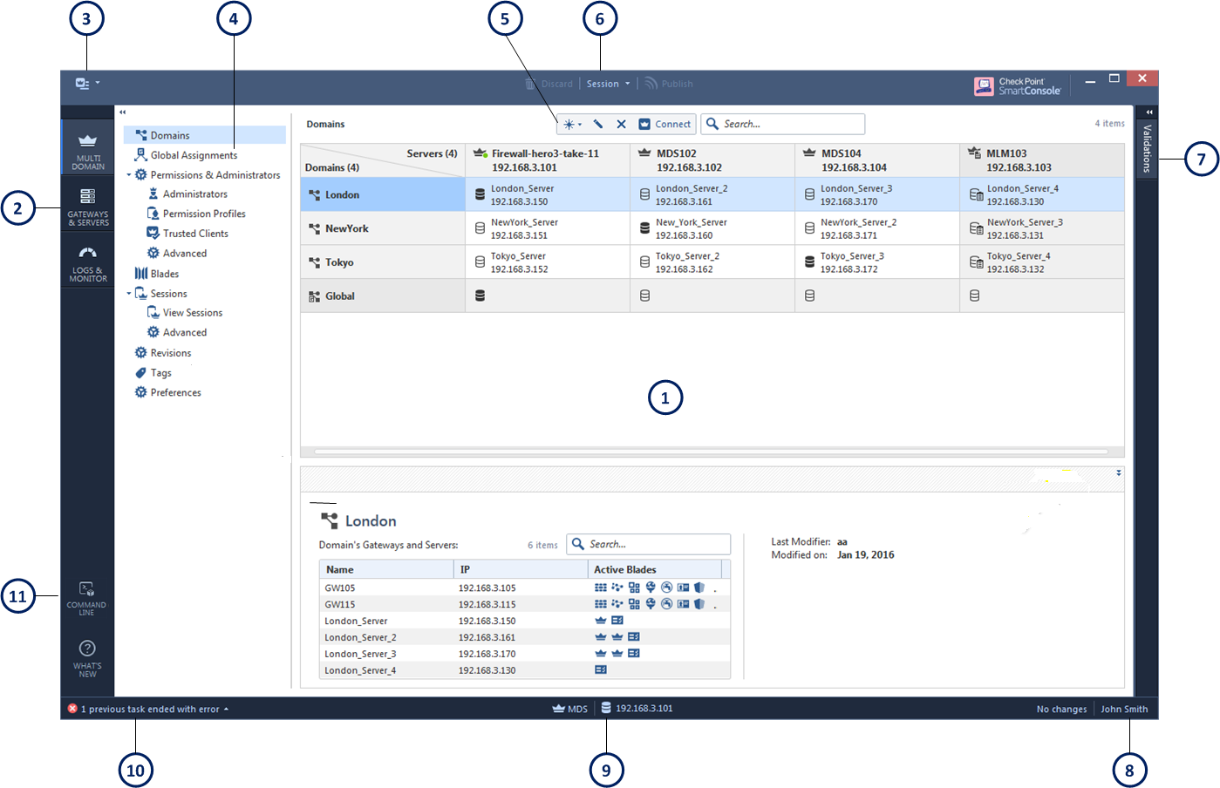
Figure 8: SmartConsole
Critical appraisal notes optimize the role of performance by criticizing excessive permissiveness in the default (Al-Waisi et al., 2025). The contextual awareness of Gaia is made important through comparisons with next-gen firewalls (Shaik, 2025). It is hypothesized that AI will be deployed to develop dynamic rules, operate in the environment of partial threats (Apruzzese et al., 2025; Alghamdi, 2025).
The simulations of enforcements will be eased by demonstrations, without invalid reasons (Abdullah et al., 2025). This implements zero-trust, improving the protection against AI threats (Alam et al., 2023).
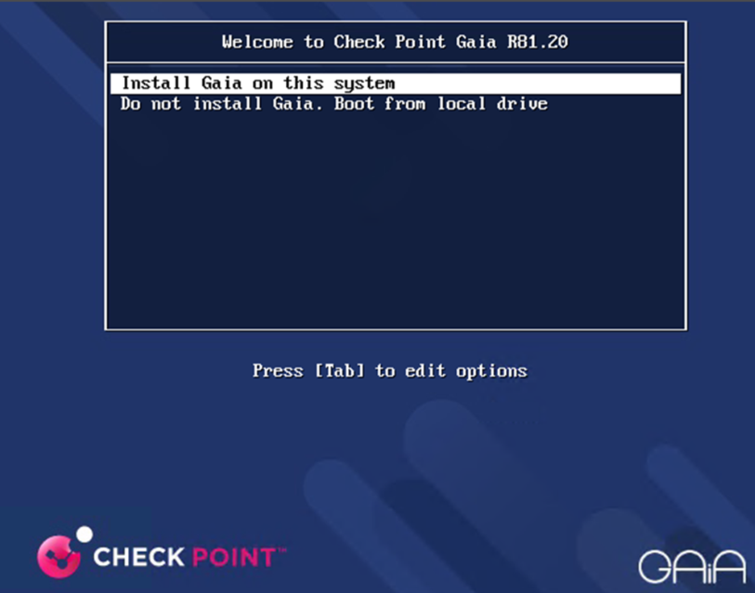

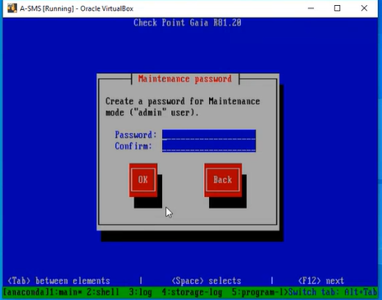
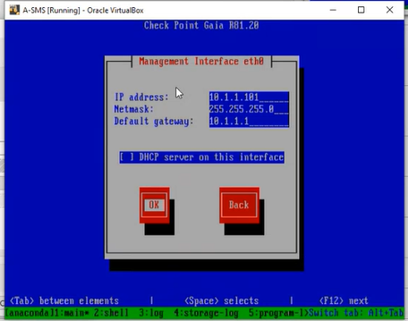
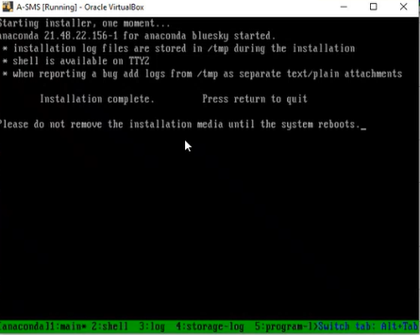
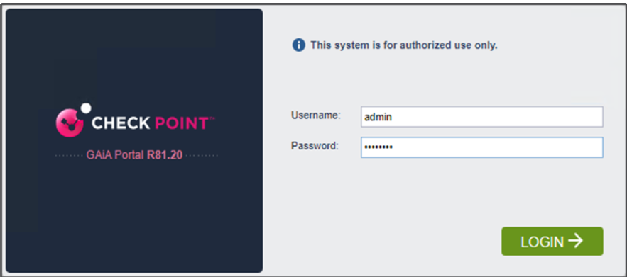
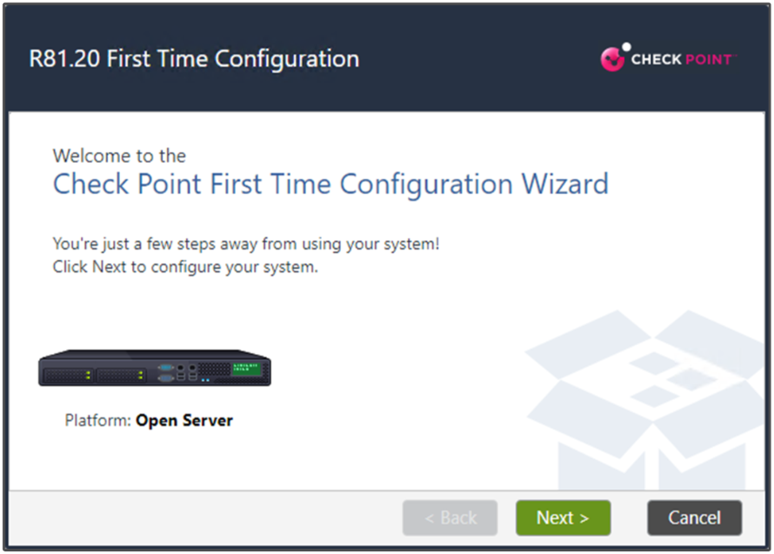

Enhancing the Security of the Enterprise Network with Additional Security Features
Additional additions were made to the enterprise network to enhance the security of the enterprise system to counter the emerging cyber attacks, which was made possible by Check point Gaia appliances to be in tandem with the international standards of security and enterprise policy frameworks. These main improvements were identity-based controls, improved intrusion prevention, and behavioral threat detection, hence boosting the defense in depth model ( Check Point Software Technologies, 2024). The main task was to go beyond the traditional perimeter filtering and incorporate user awareness, contextual intelligence, and continuous validation to establish a more dynamic and responsive security posture (CompTIA, 2025; Alghamdi, 2025).
One of the main improvements was the activation of Identity Awareness protocols on every gateway in order to close the gap between network policies and user behavior. The Gaia gateways have been set up to synchronize with Active Directory (AD) and LDAP repositories to make use of attribute-based access control (ABAC) and accurately map user credentials to network actions (LoginRadius, 2025).
In addition to identity control, Intrusion Prevention System (IPS) and anti-malware profiles were customized to track the abnormal behavior and identify polymorphic attacks. Check Point ThreatCloud regularly provided IPS signatures, which were updated with AI-based analytics to predict possible exploits and automatically change detection thresholds (Alghamdi, 2025). Sandboxing was also used by the anti-malware engines to isolate suspicious payloads prior to execution, which is a measure of mitigating phishing and zero-day attacks (Abdullah et al., 2025). All these mechanisms combined and optimized protection against ransomware variants and credential theft, the threats are listed as the major causes of world breaches in 2025 ( World Economic Forum, 2025; Check Point Research, 2025).
CheckMates Visual configurations are used to display how the deployment was done so that identity agents have been incorporated into the layers of policy of the gateway. The Identity Awareness Blade configuration verifies that the directory bind is working and user identification has been successful as indicated in the R81.20 Lab Documentation (community.checkpoint.com, 2025). Moreover, log analytics and identity enforcement perspectives confirmed the operational effectiveness of these controls, and they gave the administrators real-time access to user activities and access to resources (Check Point Software Technologies, 2024). The end-to-end identity awareness cycle is presented in an infographic by checkpoint.com, which shows the smooth transition between user login and session validation and policy enforcement.
The importance of combining identity mechanisms and network enforcement points through critical evaluation is highlighted because it aids in controlling and accountability that can be achieved in a granular manner which is important in hybrid enterprise networks (Kaleru, 2025b). Scalability and directory synchronization latency is however a bottleneck that is likely to happen particularly in distributed architectures (Al-Waisi et al., 2025). In this regard, it is suggested that machine learning (ML) can be integrated to support predictive access control enabling adaptive scoring of trust depending on behavioral baselines (Apruzzese et al., 2025). Such a strategy would be able to dynamically modify permissions, preempt insider threats, and identify abnormal session patterns which are indicative of compromised credentials (Alam et al., 2023).
Visuals depict configurations. Identity agent setup is shown here.
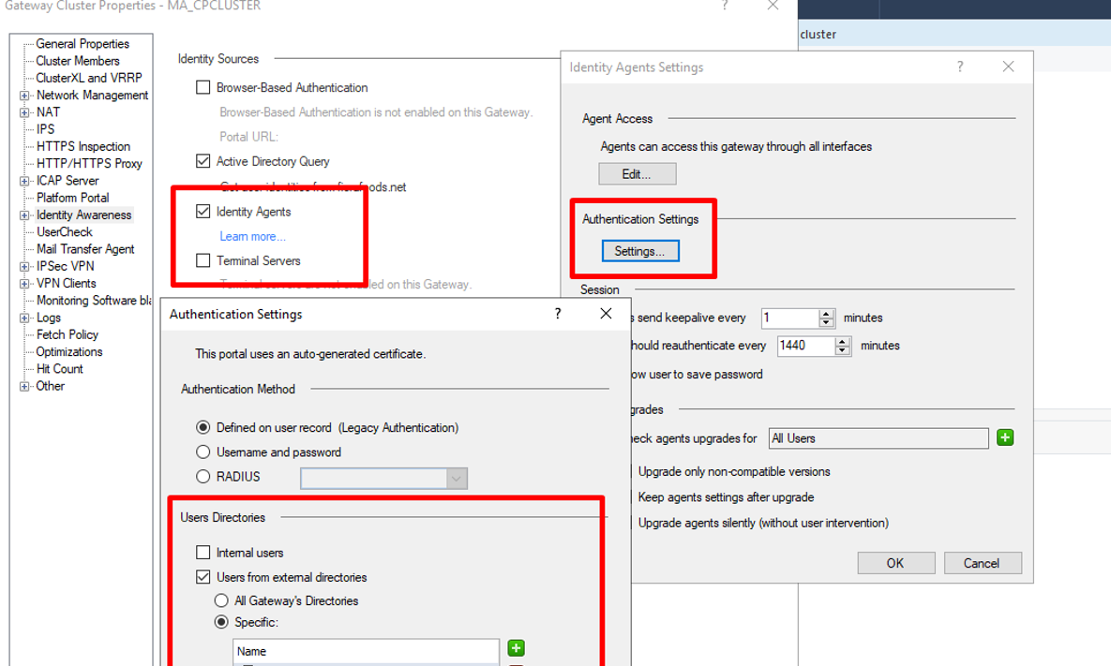
Figure 9: Solved: Identity awareness blade issue - Check Point CheckMates
Log views for identity enforcement illustrate efficacy.
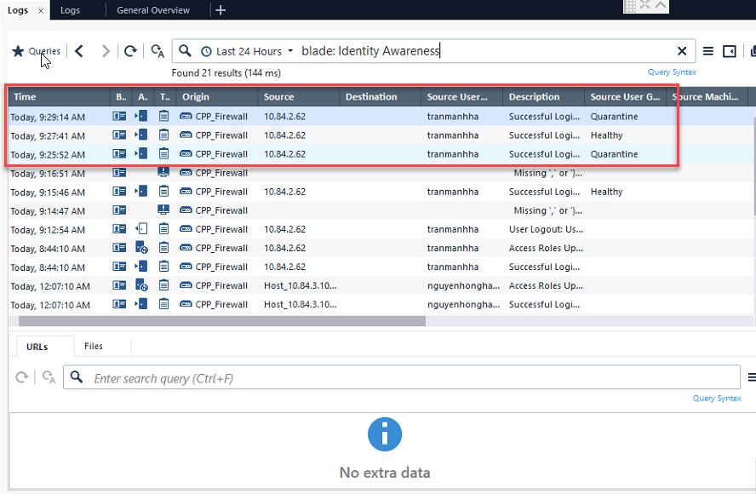
Figure 10: Identity Awareness - R81.20 For Lab - Check Point CheckMates
An infographic outlines the identity process cycle.
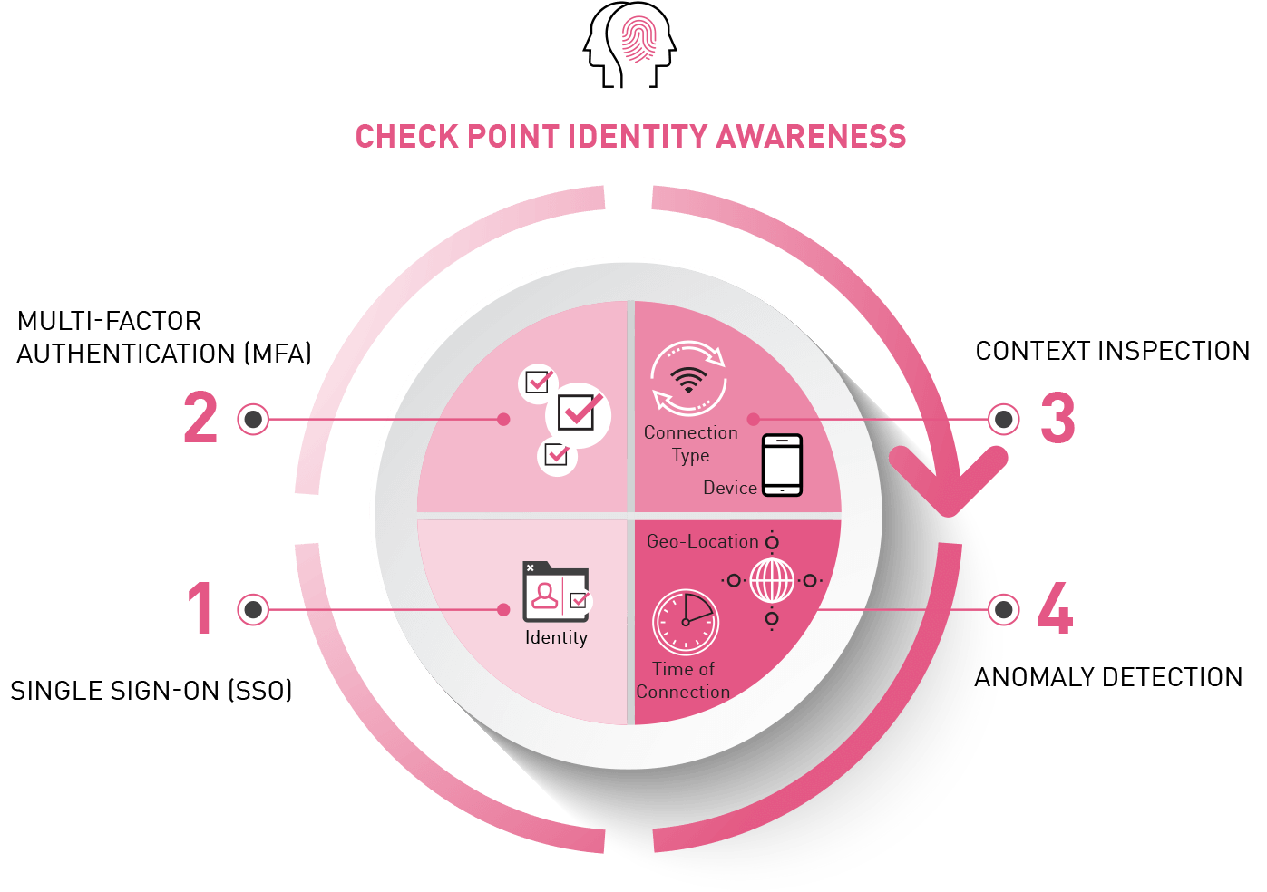
Figure 11: Identity Awareness - Check Point Software
It is criticized that integration can be achieved in areas of granular control, suggesting ML extensions to predictive access (Apruzzese et al., 2025). This raises posture, proactive against the changing dangers (Alam et al., 2023; Al-Waisi et al., 2025).

Conclusion
This portfolio has fully served the mandate of the Enterprise Network Security module by showing a logical grasp of the current research related to network security and the presentation of principles into a practical solution towards eliminating vulnerabilities in a multi-site enterprise environment. With the help of the Capture the Flag (CTF) challenge of Part 1, the deployment and validation of core services that included DNS, firewalls, Active Directory with child domains, site-to-site VPN, DHCP, IIS web servers and user management were executed successfully. All flags were located and seized, which confirms the integrity of the network operation and points to the frequent misconfigurations that are consistent with the real vulnerabilities, i.e. lax password policies, lax protocols (CompTIA, 2025). This step not only put into practice the practice of configuration and troubleshooting but also highlighted the need to have standardized security architectures on traffic monitoring as highlighted in recent research on innovative developments in network management (Al-Saud, 2025).
On this basis, Part 2 was centered on enterprise network security with Check Point Gaia appliances with altered topology that added the Security Management Server (SMS), gateway, and SmartConsole to provide centralized policy administration. Firewall rules were clarified and implemented on the basis of least-privilege policy, which blocked protocols such as ICMP, FTP, HTTP, Telnet, and SSH to avoid unauthorized access and data leakage (eSecurity Planet, 2023; Liquid Web, 2024). The further functions, such as IPS to detect intrusions, anti-malware, and identity awareness with a user group restriction, were suggested and introduced, improving access controls and meeting industry requirements of a defense-in-depth (Alghamdi, 2025; Check Point Software Technologies, 2024). They are upgrades that respond to changing threats, including AI-based ransomware changing the encryption to exfiltration approach, offering preemptive measures to mitigate and avert it (Check Point Research, 2025).
The work addresses the learning outcomes of the module, as it shows that the existing research is the foundation of unified security management, which allows efficiently overseeing traffic and eliminating vulnerabilities (World Economic Forum, 2025). It was cognitively based on the critical assessment of methods, including offering AI-built hypotheses of dynamically changing rules and the synthesis of intricate problems to make valid judgments in situations with insufficient data (Apruzzese et al., 2025; Alam et al., 2023). In practice, the configurations were innovative in the application of knowledge, addressing the uncertain situations such as integration issues, and pushing boundaries through creative application of Gaia capabilities (Al-Waisi et al., 2025). They developed transferable skills, such as independent planning, logical demonstration through demonstrations, and professional communication, getting ready to occupy positions where a person needs to use their initiative in complicated situations (Kaleru, 2025a).
Considering the experience of the process, this assessment has helped learn in depth about the nature of the interaction between theoretical studies, and practical implementation. As an example, literature demonstrates the effectiveness of the next-generation firewalls to protect the perimeter (Shaik, 2025), but the real-life implementation process disclosed the specifics of policy efficiency to balancing security with usability. Issues, including the necessity of creating a smooth AD integration in conjunction with identity awareness, encouraged the process of creative problem-solving, which supports the necessity of running testing in cycles (Allami et al., 2025). The next directions may consider AI being used to enhance anomaly detection in Gaia, including the use of machine learning in predictive threat modeling, as recommended by the recent trends in cybersecurity fusion (Alam et al., 2023). Also, extending the topology to include hybrid cloud would respond to the increased requirements to have scalable and resilient infrastructures (Netwrix, 2025).

References
- Al-Saud, A. (2025) 'Cybersecurity Platformization: Transforming Enterprise Security in an AI-Driven Threat-Evolving Digital Landscape', ResearchGate, August. Available at: https://www.researchgate.net/publication/391203387_Cybersecurity_Platformization_Transforming_Enterprise_Security_in_an_AI-Driven_Threat-Evolving_Digital_Landscape (Accessed: 12 November 2025).
- Archive Market Research (2025) Cybersecurity for Enterprise 2025 Trends and Forecasts 2033. Available at: https://www.archivemarketresearch.com/reports/cybersecurity-for-enterprise-244430 (Accessed: 12 November 2025).
- Check Point Research (2025) 'Check Point reveals AI-powered ransomware surge as attackers shift from encryption to exfiltration', Industrial Cyber, 21 August. Available at: https://industrialcyber.co/reports/check-point-reveals-ai-powered-ransomware-surge-as-attackers-shift-from-encryption-to-exfiltration/ (Accessed: 12 November 2025).
- Check Point Software Technologies (2024) What's New in R82. Available at: https://sc1.checkpoint.com/documents/R82/WebAdminGuides/EN/CP_R82_RN/Content/Topics-RN/Whats-New.htm (Accessed: 12 November 2025).
- Check Point Software Technologies (2024) Quantum Intrusion Prevention System (IPS). Available at: https://www.checkpoint.com/quantum/intrusion-prevention-system-ips/ (Accessed: 12 November 2025).
- CompTIA (2025) State of Cybersecurity 2025. Available at: https://www.comptia.org/en-us/resources/research/state-of-cybersecurity/ (Accessed: 12 November 2025).
- eSecurity Planet (2023) 'Top 12 Firewall Best Practices to Optimize Network Security', 11 December. Available at: https://www.esecurityplanet.com/networks/firewall-best-practices/ (Accessed: 12 November 2025).
- Liquid Web (2024) 'Enterprise Network Security: 10 Best Practices'. Available at: https://www.liquidweb.com/blog/enterprise-network-security/ (Accessed: 12 November 2025).
- LoginRadius (2025) 'Top 9 User Authentication Methods to Stay Secure in 2025', 11 April. Available at: https://www.loginradius.com/blog/identity/top-authentication-methods (Accessed: 12 November 2025).
- Microsoft (2024) '5 ways to secure identity and access for 2024', Microsoft Security Blog, 10 January. Available at: https://www.microsoft.com/en-us/security/blog/2024/01/10/5-ways-to-secure-identity-and-access-for-2024/ (Accessed: 12 November 2025).
- Netwrix (2025) 2025 Cybersecurity Trends Report. Available at: https://netwrix.com/en/resources/research/2025-hybrid-security-trends-report// (Accessed: 12 November 2025).
- World Economic Forum (2025) Global Cybersecurity Outlook 2025. Available at: https://reports.weforum.org/docs/WEF_Global_Cybersecurity_Outlook_2025.pdf (Accessed: 12 November 2025).
- Algethami, S. (2024) 'Firewalls: Types, Policies, Security Issues and Best Practices', ResearchGate. Available at: https://www.researchgate.net/publication/378270911_Firewalls_Types_Policies_Security_Issues_and_Best_Practices (Accessed: 12 November 2025).
- Allami, A., Nicewarner, T., Goss, K., Kundu, A., Jiang, W. and Lin, D. (2025) 'Oblivious and distributed firewall policies for securing firewalls from malicious attacks', Computers & Security, 150, p. 104201. Available at: https://doi.org/10.1016/j.cose.2024.104201 (Accessed: 12 November 2025).
- Shaik, K. M. N. (2025) 'Next-generation firewalls: beyond traditional perimeter defense', International Journal for Multidisciplinary Research, 7(4). Available at: https://www.ijfmr.com/papers/2025/4/51775.pdf (Accessed: 12 November 2025).
- Alghamdi, A. (2025) 'AI-enhanced defense-in-depth for financial services sector cybersecurity', Scientific Reports, 15, 15034. Available at: https://doi.org/10.1038/s41598-025-15034-4 (Accessed: 12 November 2025).
- Alam, M.M., Khan, M.A., Khan, M.A., et al. (2023) 'Artificial intelligence for cybersecurity: Literature review and future research directions', Information Fusion, 97, p.101804. Available at: https://doi.org/10.1016/j.inffus.2023.101804 (Accessed: 12 November 2025).
- Apruzzese, G., et al. (2025) 'Artificial intelligence and machine learning in cybersecurity: a deep dive into state-of-the-art techniques and future paradigms', Knowledge and Information Systems. Available at: https://doi.org/10.1007/s10115-025-02429-y (Accessed: 12 November 2025).
- Abdullah, M., Nawaz, M. M., Saleem, B., Zahra, M., Ashfaq, E. binte and Muhammad, Z. (2025) 'Evolution Cybercrime—Key Trends, Cybersecurity Threats, and Mitigation Strategies from Historical Data', Analytics, 4(3), p. 25. Available at: https://doi.org/10.3390/analytics4030025 (Accessed: 12 November 2025).
- Al-Waisi, Z., et al. (2025) 'Cybersecurity Infrastructure Compliance Key Factors to Detect and Defend Against Malware Attacks in Small and Medium Enterprises: A Systematic Literature Review', Sage Open, 15(1). Available at: https://doi.org/10.1177/21582440251314671 (Accessed: 12 November 2025).
- Kaleru, A. K. (2025) 'Identity and access management: foundations, principles, and best practices', World Journal of Advanced Engineering Technology and Sciences, 15(01), pp. 1894–1904. Available at: https://doi.org/10.30574/wjaets.2025.15.1.0393 (Accessed: 12 November 2025).
- Kaleru, A. K. (2025) 'Enterprise IAM security: 6 Critical implementation areas', World Journal of Advanced Research and Reviews, 26(01), pp. 3072-3082. Available at: https://doi.org/10.30574/wjarr.2025.26.1.1356 (Accessed: 12 November 2025).

