Report

Abstract This report is divided into three parts. It mainly introduces the difference between NoSQL and SQL, analyzes the business information and implements the database. The database is optimized and the corresponding index is designed. At the same time, the scheme of changing the distributed design of the database is put forward.

NOSQL AND SQL
SQL is based on relational model, while NoSQL is less based on model. SQL stores structured data in the form of tables (columns, rows), relationships or connections between tables. It is suitable for predetermined tables or structures. NoSQL is based on several types of unstructured storage, such as key value pairs, column families, graphical databases and so on. It is highly flexible and dynamic. SQL is vertical scalability, which is reflected in increasing the power of hardware. NoSQL is horizontal scalability, which increases the capacity by adding more machines or database servers. SQL is a very powerful database language, which can be used to define and manipulate data. NoSQL does not have standard query statements. In terms of transactional operations, SQL database is the best in terms of data, such as deletion, update and insertion. NoSQL selects the best data. In terms of transaction, SQL emphasizes acid through SQL database, while NoSQL emphasizes Cao theory. SQL database provides better consistency than any relational database. NoSQL is that all entities in the database after transaction are consistent, and there is no guarantee of reading and writing. SQL uses normalization to reduce data redundancy and improve performance. NoSQL uses a single table to store all records, which belongs to non-normalization. SQL database uses the primary key in the non-relational database table to collect the data required to be recorded. NoSQL database can use multiple conditions to record, but it is relatively inefficient. When the database structure is completed, SQL can directly enter and process data, while NoSQL adopts different formats and uses restful interface to realize data operation.

Business analysis and customer issues
By analyzing the scenario description, the following ER diagram is designed
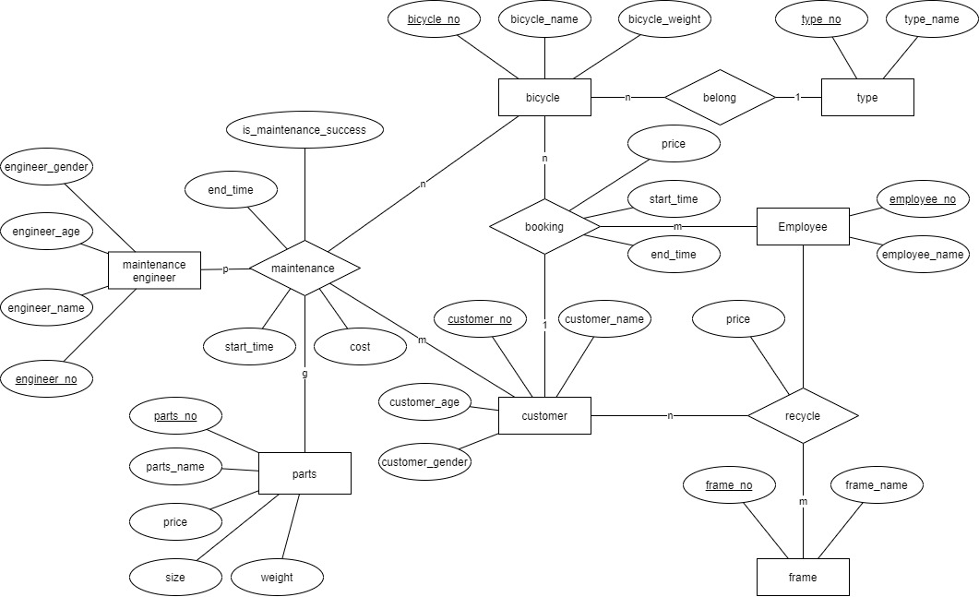

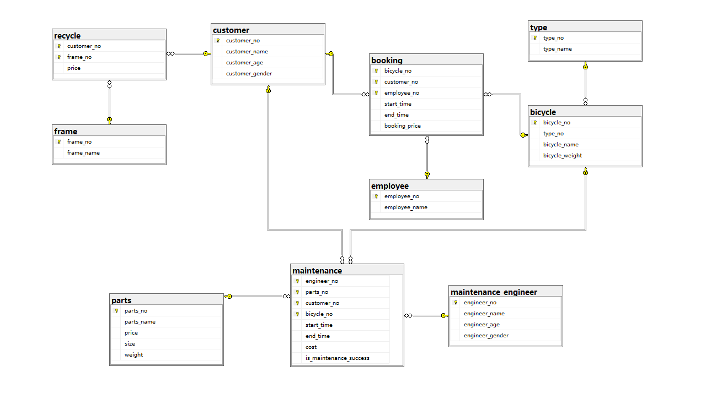

The maintenance records and maintenance costs of maintenance engineers can be recorded using the intermediate relationship of maintenance. Recycle can record the recovered bicycle frames, and booking records the customer's reservation information.
It can be seen from this ER diagram that we have a separate parts list to record the price and size of each part when customers repair bicycles, which can make it easier to manage our data uniformly At the same time, each bicycle has different types, and it is also designed in this model. When customers Book bicycles, we add the start lease time and end lease time to the relationship booking to record the lease duration and mark the price.

For questions raised by users
- Sometimes bicycle repair bookings are recorded but the details of the specific return date(s) as requested by customers are not registered in the system.

The solution to this problem only needs to judge whether the user has registered. If the user has not registered, the transaction will be rolled back

b. Customers are able to book bicycle hire times that are not registered as possible schedules available.

Judge whether the bicycle has rental time. If there is a specified rental time, the data can be inserted into the reservation table

Distributed design scheme
In the actual production environment, the amount of data in the booking table may be too large. We can reduce the pressure on the server through the horizontal partition technology. Partitioning a reservation table divides the table into two or more smaller segments based on partitioning keys.
Global operations submitted by users are transformed into local operations on vertically partitioned tables for multiple sites by a combination of linked servers and stored procedures. Using stored procedures ensures the ACID nature of distributed transactions.

