BMSW4001
Academic and Employability Skills (ACE)

Task 2: Report

Table of Contents
Introduction 3
Gibbs Reflective Cycle 4
Reflection on my learning in this module 6
Topic 1- Time management 6
Topic 2- Organising study 8
Topic 3- Academic Writing 10
Topic 4- Public speaking and giving presentations 12
Conclusion 14
References 15

Introduction
The aim of the report is to study about Academic and Employability Skills. I have to learn knowledge, establish identities, engage in disciplinary procedures, gain social status, and improve my career with control over academic writing. Complex concepts are conveyed in academic writing in a style that is precise, logical, justified, and supported by evidence. I need to ensure enthusiasm and energy as Speakers because I am actively engaged in the activity and not just delivering a speech in an effort to persuade an audience to do something. It is my responsibility as a public speaker to sway the audience and foster an atmosphere in which everyone leaves with their feet up (Dawson et al, 2018)

Gibbs Reflective Cycle
Gibbs' reflective technique is divided into levels, every of which calls with a purpose to respond to a chain of questions with the intention to replicate as deeply as possible. In keeping with Gibbs, the levels have to include description, emotions, assessment, evaluation, conclusions, and an action plan. This paradigm seeks to organise mind and separate emotions. (Dansieh, 2011)
Description
I am being asked to describe the circumstance at this point, not to judge or infer anything. While being descriptive, try to be as specific as I can. Our mental processes are frequently slowed down via the diverse levels so that we don't draw conclusions too unexpectedly. (Keevy et al, 2018).
Feelings
Once again, I should hold off on analysing the circumstance. A description of my emotional reaction to the circumstance I encountered is requested. Think about how my actions affected other people as well as how I felt and how my body felt. (Dawson et al, 2018).
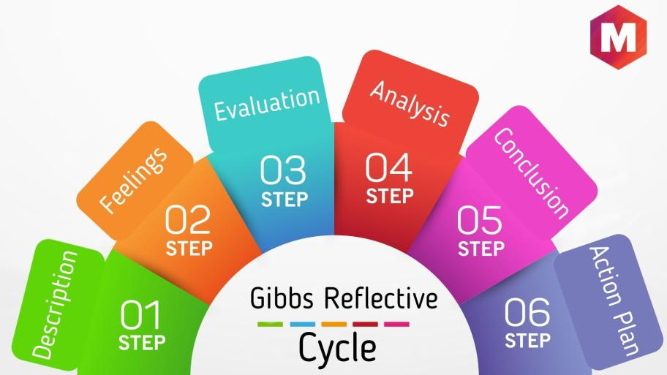
Figure: Gibbs (Dansieh, 2011)

Evaluation
How do I interpret the current circumstances? What really was happening? Were the experiences of various persons comparable or dissimilar (Keevy et al, 2018).
Analysis
Following an evaluative evaluation of the scenario, I may start a more thorough evaluation by means of taking the aforementioned questions into account. I ought to also consist of pointers from resources outdoor of my know-how at this point to resource. (Kesson et al, 2012).
Conclusion
While drawing conclusions, I have to take into account each the general applicability and my unique circumstance. Take into account my effects' implications for me personally, my instant surroundings, and later, a much wider target market. (Dansieh, 2011)
Action plan
I want to take this stage very significantly in case I want to expand my capabilities and learn from precise situations. Don't forget what I could do in a different way and how I could make my preparation better. (Custodio et al, 2019).

Reflection on my learning in this module

Topic 1- Time management
All of us can do much more with far less effort if we recognise the value of time and use it wisely. Only having good time management skills sets a successful I apart from the others. I should master time management since it is a crucial life skill. (Mackenzie et al, 2009) By taking charge of our life, these abilities not only assist us in making better choices but also help us develop as people. Time management done well removes tension and worry, allowing us to concentrate more on learning and flourishing. One may manage their workload and pursue their objectives to the fullest extent by managing their time strategically. (Kesson et al, 2012).
Being productive and completing all of my scheduled tasks within the set deadline or timetable is effective time management. (Kesson et al, 2012). I have significant tests coming up as an example. Lacking time management skills, she'll have to study extremely late at night since she didn't study effectively all day long; instead, she spent the most of the day fooling about online and hanging out with friends. This I will have more time available in the evenings to choose sleep over cramming, which will immediately translate into greater performance during those crucial examinations if she starts studying as soon as she comes home from school. (Custodio et al, 2019).
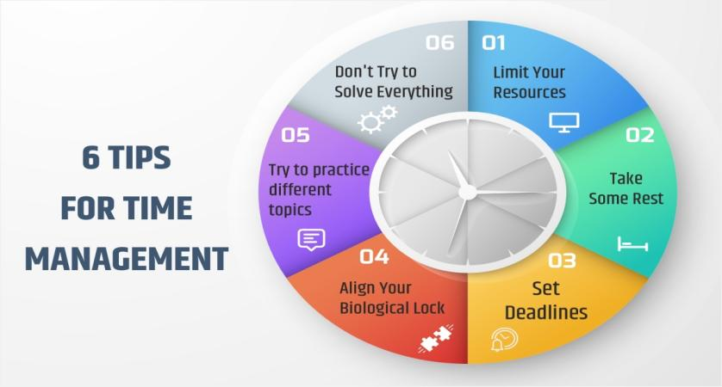
Figure: Time management (Cottrell, 2017).
I may inspire and even delight the audience if I am an effective public speaker because I become likeable and credible. When I capture an audience's interest with an informative speech, I may help them grasp the topic better and help them remember what I said long after I've done. Prioritizing the things that need to be completed right away is crucial when making a timetable. For instance, completing my assignments prior to spending time with my study group or pals can help I remember the material for the long run. (Cottrell, 2017)
This implies I should schedule time for studying when there aren't any other distractions. I'll be able to complete my task on schedule thanks to this. I can better manage everything if I know how to prioritise goals and chores, ensuring that I meet all of my deadlines. My anxiety will be lessened if my to-do list is well-defined and I have a realistic idea of how long each activity will take. Since I'll be able to plan ahead for the work that needs to be done and know when I may reschedule or take a break if necessary, I'll be able to predict when to do it. (Custodio et al, 2019).
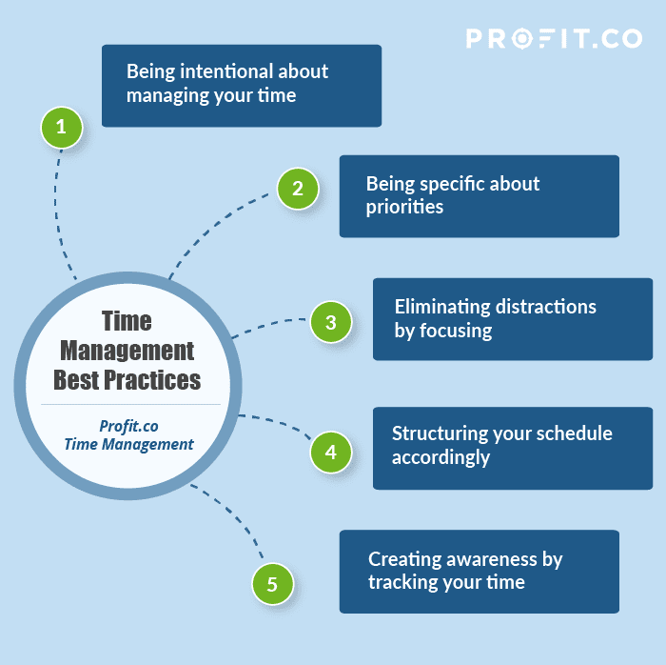
Figure: Time management (Cottrell, 2017).

Topic 2- Organising study
A crucial first step in developing study abilities is being organised so that I can study efficiently. The advice on this page may seem apparent to I, but many individuals choose to ignore the obvious and try to "jump right in" to studying without properly preparing and organising. It is advised that I locate an appropriate study location so that my study time will be productive. The next step is to ensure that I have easy access to the tools and materials I will need for studying. For some individuals, finding a proper study space might be difficult. (Boissy et al, 2016).
But, I may be fortunate sufficient to have quick get admission to a library, college, college, or school centres, as well as a nonviolent office at work. (Mackenzie et al, 2009) However, a lot of individuals study at home, which is often unsuitable for productive learning. Spend some time identifying the environment and circumstances that are most conducive to my ability to learn; strive to have a flexible and adaptive attitude as my scenario or circumstances may vary during my studies. I'll be more hesitant to ask for assistance if I start to lose confidence. (Cottrell, 2017)
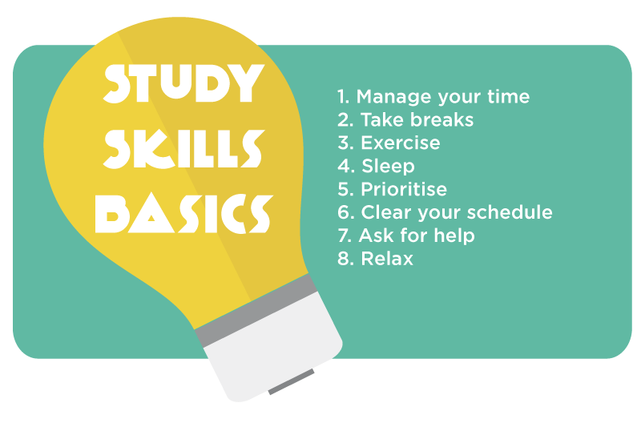
Figure: Organising study (Boissy et al, 2016).

The situations that different individuals find themselves in and the best ways that they learn vary greatly. I will need to locate a location where I can keep all of my supplies close at hand, including my computer, books, schedule, notes, and writing supplies. If I are studying in a family environment, having a computer accessible all the time may not be realistic. Perhaps I share a computer with someone else? In such cases, it is important to plan my study schedule and have access to a computer when necessary. (Mackenzie et al, 2009)
The presence of any potential irritants or distractions should also be considered, and I should make every effort to get rid of them. Having everything I could need within reach of my chair is often helpful since it can save needless movement and interruptions as I attempt to focus. It is a smart idea to consider establishing a research connection with my contacts. This might refer to my employer or co-workers at work. It's always a good idea to know who to call for various forms of help, even simply pals who can listen. (Boissy et al, 2016).
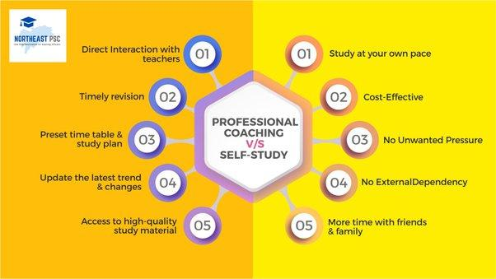
Figure: Organising study (Bartfiled et al, 2010)

Topic 3- Academic Writing
Writing done for academic objectives is referred to as academic writing. It involves engaging in discussion with people; however the flow of the talk is different from how a usual communication takes vicinity. (Maxwell et al, 2015) Language is a large thing that each non-native English speakers and native English audio system stumble upon at the same time as writing. In other phrases, the primary motive of the difficulty that many researchers have while writing for educational purposes is a lack of familiarity with the grammatical conventions of educational writing, as opposed to a lack of in-depth information of the troubles to be protected. (Bartfiled et al, 2010)
There are several styles of instructional writing. I write for an expansion of motives in instructional environments. Further to writing many different kinds of texts, we additionally produce studying responses, book critiques, argumentative essays, literature critiques, empirical research articles, grant applications, convention abstracts, commentaries, memos, and plenty of other kinds of texts. Every of those kinds of academic writing have a distinct aim, structure, and language elements- It is possible to produce, codify, communicate, evaluate, renovate, teach, and acquire information and ideologies in academic subjects via academic writing. (Maxwell et al, 2015)
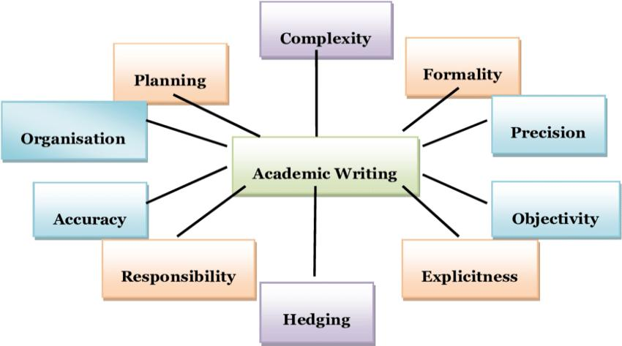
Figure: Academic Writing (Bartfiled et al, 2010)
Writing in an academic style is important for academic performance as well as for mastering a discipline (Whiteman, 2013). It calls for a variety of difficult abilities and is an advanced literacy challenge. Learning to write for academic reasons include, Growing talent in educational writing is a time-eating and hard system that can take years and calls for ongoing mental and emotional challenges. (Bartfiled et al, 2010)
Learning to write well for academic purposes requires patience, perseverance, awareness, experience, reflection, and help. (West et al, 2013). For inexperienced authors and academic newcomers, writing for publication may be a confusing process that inspires fear. A good publishing record is mostly dependent on improving one's academic writing abilities. To improve my chances of being published, I'll need more information, abilities, and dispositions. (Moore et al, 2017)
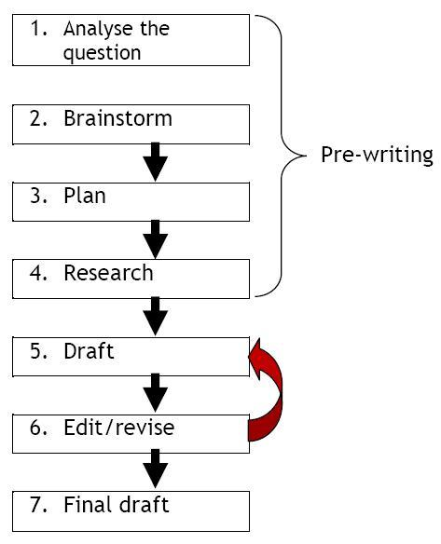
Figure: Academic Writing (Bartfiled et al, 2010)

Topic 4- Public speaking and giving presentations
Our society's foundation is communication. Without the capacity to communicate effectively, advancement in the workplace and in life would be very difficult. A very essential and despised kind of communication is public speaking. The most prevalent phobia experienced by individuals worldwide is Glossophobia, often known as Speech anxiety. It is straightforward to be the kid that sits inside the back of the class and would not improve their hand to avoid similar eventualities all through essential college. But public talking is a vital capability to have and to expand within the professional international. (Arnold et al, 2019).
Easy, every day interactions among colleagues, managers and workforce, advertising specialists and clients, and so forth- (Peng et al, 2017)- it could have a widespread influence to my career path and degree of achievement in my subject. The capability for persuasion, or the ability to win over an audience, is a important talent to own in business, specifically inside the subject of public members of the family. Working on my public speaking talents allow I to end up greater persuasive both inside and outside of the workplace. Gaining confidence and, therefore, a peaceful and composed manner in front of a target market come from getting to know public speaking. (Mumford et al, 2017).
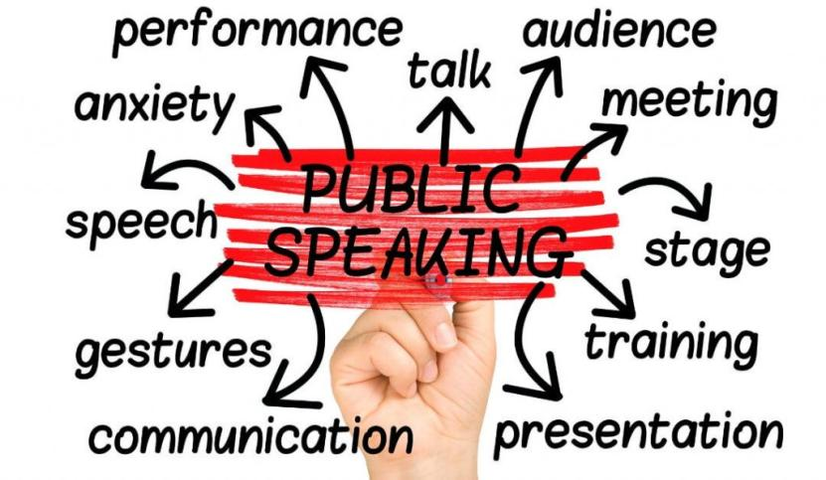
Figure: Public speaking (Arnold et al, 2019).
Of direction, it is important to be knowledgeable approximately the topic I are discussing, but I furthermore might need to be equipped to counter any capability objections and speak with composure even as giving a persuasive speech of any sort, inclusive of a sales presentation to a client (Nation, 2017). Being knowledgeable is crucial, of course, but more significantly, the ability to ignite people's enthusiasm via effective public speaking will inspire my audience to act. Having an influence on the world by expressing my ideas and information in an engaging manner is what is meant when someone says they have a voice in the world. Being an expert in public speaking enables me to connect with the audience and earn their trust. (Arnold et al, 2019).
Public speakers are leaders who can motivate their listeners to put in more effort to accomplish their objectives. (Peng et al, 2017). One of the maximum essential factors of public speaking is having the capability to teach. Informative public speaking is a crucial ability for a success career in all sectors of employment, from giving studies papers and PowerPoint displays in class to pitching thoughts and products for my company or consumer. (Neumann et al, 2010).
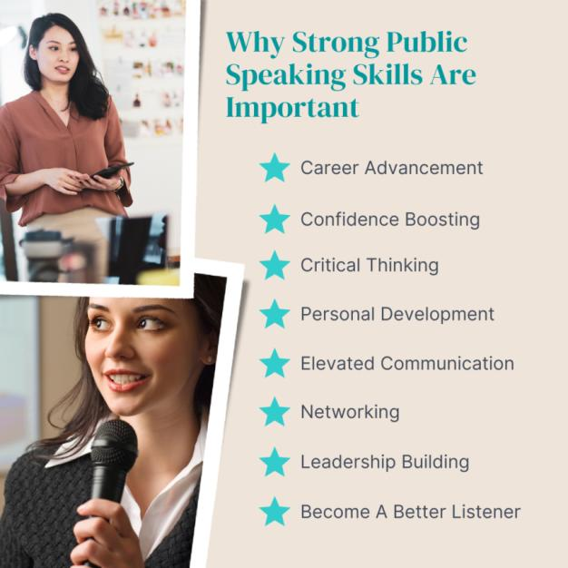
Figure: Public speaking (Neumann et al, 2010).

Conclusion
Thus, in conclusion, when I first start studying, I could neglect crucial equipment or environmental aspects that I need. As I study more, I'll become more aware of what I need and where I need to be for best focus. When studying, it's important to get assistance and support. When I don't ask for assistance when I need it, my confidence and self-esteem may suffer, which may have an adverse effect on my academic performance. I believe that public speaking enables me to provide a persuasive and convincing argument while speaking to any audience about an idea or an argument for or against anything. (Arnold et al, 2019).

References
Arnold, E.C. and Boggs, K.U., 2019. Interpersonal Relationships E-Book: Professional Communication Skills for Nurses. Elsevier Health Sciences.
Bartfeld, E. and Lass, A., Irody Inc, 2010. System and method for real time management of a drug regimen. U.S. Patent 7,747,454.
Boissy, A., Windover, A.K., Bokar, D., Karafa, M., Neuendorf, K., Frankel, R.M., Merlino, J. and Rothberg, M.B., 2016. Communication skills training for physicians improves patient satisfaction. Journal of general internal medicine, 31(7), pp.755-761.
Cottrell, S., 2017. Critical thinking skills: Effective analysis, argument and reflection. Macmillan International Higher Education.
Custódio, C., Ferreira, M.A. and Matos, P., 2019. Do general managerial skills spur innovation? Management Science, 65(2), pp.459-476.
Dansieh, S.A., 2011. SMS texting and its potential impacts on students' written communication skills. International Journal of English Linguistics, 1(2), p.222.
Dawson, P. and Guare, R., 2018. Executive skills in children and adolescents: A practical guide to assessment and intervention. Guilford Publications. FB
Keevy, M. and Mare, D.J., 2018. Pervasive skills development for aspirant chartered accountants: Academic versus training programmes. Journal of Economic and Financial Sciences, 11(1), pp.1-9.
Kesson, E.M., Allardice, G.M., George, W.D., Burns, H.J. and Morrison, D.S., 2012. Effects of multidisciplinary team working on breast cancer survival: retrospective, comparative, interventional cohort study of 13 722 women. bmj, 344, p.e2718.
Mackenzie, A. and Nickerson, P., 2009. The time trap: The classic book on time management. Amacom.
Maxwell, S.M., Hazen, E.L., Lewison, R.L., Dunn, D.C., Bailey, H., Bograd, S.J., Briscoe, D.K., Fossette, S., Hobday, A.J., Bennett, M. and Benson, S., 2015. Dynamic ocean management: Defining and conceptualizing real-time management of the ocean. Marine Policy, 58, pp.42-50.
Moore, T. and Morton, J., 2017. The myth of job readiness? Written communication, employability, and the ‘skills gap’in higher education. Studies in Higher Education, 42(3), pp.591-609.
Mumford, M.D., Todd, E.M., Higgs, C. and McIntosh, T., 2017. Cognitive skills and leadership performance: The nine critical skills. The Leadership Quarterly, 28(1), pp.24-39.
Nation, P., 2017. Fluency practice in the four skills. In The 15th Asia TEFL & 64th TEFLIN International Conference: Program Book (pp. 18-35).
Neumann, V., Gutenbrunner, C., Fialka-Moser, V., Christodoulou, N., Varela, E., Giustini, A. and Delarque, A., 2010. Interdisciplinary team working in physical and rehabilitation medicine. Journal of rehabilitation medicine, 42(1), pp.4-8.
Peng, X.B., Berseth, G., Yin, K. and Van De Panne, M., 2017. Deeploco: Dynamic locomotion skills using hierarchical deep reinforcement learning. ACM Transactions on Graphics (TOG), 36(4), pp.1-13.
West, M.A. and Lyubovnikova, J., 2013. Illusions of team working in health care. Journal of health organization and management, 27(1), pp.134-142.
Whiteman, M.F., 2013. Writing: The nature, development, and teaching of written communication. Routledge.

