Ways of Perceiving: writing task 1200 words
Student Name: Leila Roworth
P Number: 1702604
Programme of Study: Surface Pattern Design
Module: M4X01559
Words: 1369

Collaborative Zine
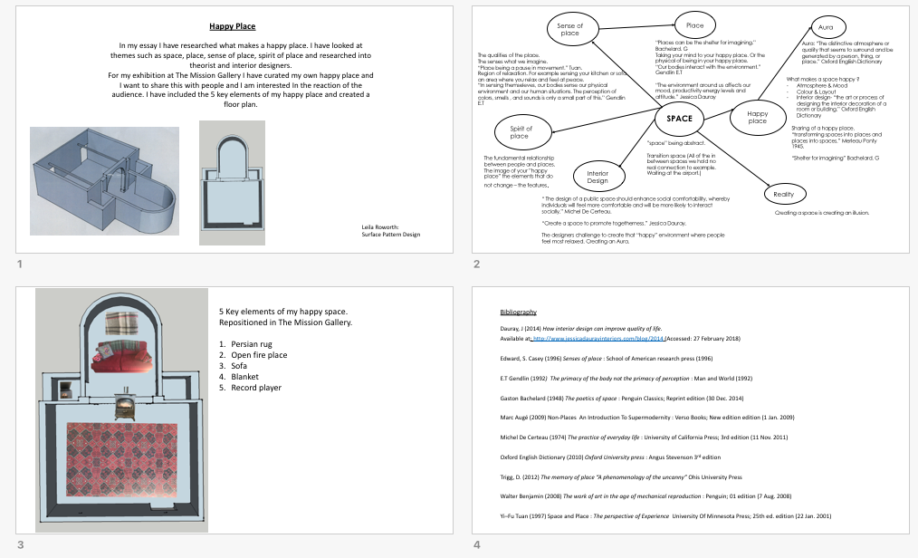

The theme of this exhibition is happy place. As you step into The Mission Gallery you will be

provided with a head set that will guide you through the space. The head set will provide

information, allowing the mind to imagine “my happy place” while visualising the separated

elements. The gallery will contain the five key elements of my happy place which include: a

fire place, a rug, a sofa, a blanket and a radio. This is essentially my living room at home, an

interior space. I am interested in the separation of the elements and the space between

them. I question whether seeing them as separates will affect my perception of my happy

place.

In this essay I will be answering the question, what makes a happy place? I am interested in

how we as humans, interact with space. Additionally, why some of us have an imagined

happy place that we visualise as a mechanism to relax ourselves.

According to Tuan (1997 : 138) “Place is a pause in movement.” It therefore only becomes

part of our reality when we recognise it as a place. To recognise it as a place it must hold

some value to us. The objects within my happy place signify the comforts of being at home

it alludes security and is very womb like in the sense of feeling safe and being protected. It is

hard to define happy space as it can be more of a sensory experience. If we

hold no real value to a place it may as well just be “transition space” Augé uses this term

(2009 : 94). The difference between transition space and a person’s happy place is that

there are no distinctive qualities in a transition space it may be the airport waiting lounge.

Augé (2009 : 94) writes about this and calls them “Non-Places” whereby people are just

making an exchange, in these places we hold no connection. I think that in order to hold

connection to a place there must be a sentimental reason or significant memory.

When reimagining a place, we sometimes think of the “Aura” of the place it is a “distinctive

atmosphere or quality” OED (2010 : 13). Consequently, spaces have the ability to change

one’s mood due to these factors. Gendlin (1992 : 334) says that our “perception of colours,

smells and sounds” is only a small part of our bodies realizing themselves in an

environment. These factors however are all subjective to the person who is placed in the

environment as each person would be stimulated in different ways by different senses. Aura

was a term used by Walter Benjamin (1936 : 34) he believed that even the “most perfect

reproduction of an artwork would always be lacking one element, its unique existence in the

place where it happens to be” this refers to its presence in time and space which can be

described as the aura. I think that because different places have different atmospheres to

appreciate an original you must see it in the place where it was imagined to be. Although,

you can move a piece of art work it may not have the same effect on the viewer if it is in a

different surrounding to where the artist had originally placed it. My happy space is made

up of elements extracted from my living room but to take them out of my home they

change as they are being taken away from the aura of my house similar to moving an

artwork. It is hard to recreate “aura” of one place and place it in another location as the

sensory experience can be very different in other places often the aura of a place is unique.

Sense of place are the qualities of the place. Gendlin (1992 : 335) argues that “our bodies

sense our physical environment.” It is much easier to remember consistent environments

such as rooms in your home as you can sense them. What they smell like, how they are

decorated because our bodies have realized themselves in these comfortable surroundings

which makes them easier to visualise as a method for relaxation. Bachelard (1958 : 8)

believes certain spaces can become a “shelter for imagining”. I would argue that for a space

to become a place where you can imagine, you must feel safe and relaxed such as your

home or a place where you spend long periods of time. I think that feeling safe in a place

and allowing it to become a shelter for your imagination means that you can allow yourself

the freedom to relax and become more productive as you are within your comfort zone.

Interior designers have an important role of creating social spaces be that in the home or in

a work place environment. These spaces must allow people to relax and feel comfortable

but also encourage and stimulate productivity. By creating these spaces, they are creating

an illusion which allows the body to feel a certain way. Often interior designers are aiming

to create spaces that feel comfortable. This is why I believe that coffee shops and

restaurants usually have similar layouts to signify a relaxed environment. Casey (1996 : 45)

says that “by grasp of one place allows me to grasp what holds in other places.” This

repetition of social surroundings leads the illusion to social comfortability. Dauray (2014)

provides information that elements such as colours, textures and art work in that space

need to be carefully placed and considered in order to create space that promotes

“togetherness”. I agree with this statement by considering the placement of chairs and

tables you are encouraging the way people interact with one another. Michel De Certeau

(1974 : 109) says that public space should “enhance social comfortability” allowing people

to feel more comfortable. This illusion of comfortable space is a façade of recreating the

home environment to encourage people to express themselves and socialise.

When reimagining my happy place, I feel a spiritual connection due to the spirit of the place.

This is the fundamental relationship I hold with myself and the place as they are the

features I imagine which do not change. But by taking my happy place away from its original

state changes the spirit of place and the aura as the location changes therefore, the aura

and sense of place is also changed. My home represents family and security the people

involved in that space are important to me. Trigg (2012 : 3) says that “without human

involvement place would lose definition.” By placing elements of my living room within The

Mission Gallery but without the people I connect with the place. I question whether my

happy place would lose a sense of value that I hold to the place. The idea of the sharing of

my happy place intrigues me. I would be excited to see how people would react within the

space. I think the outcome of the exhibition would be the reaction of the audience and how

they sense themselves within the space.

Bibliography

Augé, M (2009) Non-Places An Introduction To Supermodernity: London Verso Books; New edition (1 Jan. 2009)

Bachelard, G (1948) The poetics of space : Penguin Classics London : Reprint edition (30 Dec. 2014)

Benjamun, W. (2008) The work of art in the age of mechanical reproduction : Penguin London: 01 edition (7 Aug. 2008)

Dauray, J (2014) How interior design can improve quality of life.
Available at: http://www.jessicadaurayinteriors.com/blog/2014 (Accessed: 27 February 2018)

De Certeau, M (1974) The practice of everyday life : University of California Press; 3rd edition (11 Nov. 2011)

Edward, S. Casey (1996) Senses of place : School of American Research Press (1996)

Gendlin E.T (1992) The primacy of the body not the primacy of perception : Man and World. New York

Oxford English Dictionary (2010) Oxford University press : Angus Stevenson 3rd edition

Trigg, D. (2012) The memory of place “A phenomenology of the uncanny” Ohis University Press

Tuan, Yi–Fu (1997) Space and Place : The perspective of Experience University Of Minnesota Press; 25th ed. edition (22 Jan. 2001)

