Applied Computing
Introduction to web and database concepts
iNTRODUCTION TO WEB REPORT
02/01/2023
Cai Perry
2304939
Contents
No table of contents entries found.

Introduction
This is the report for the second part of the module “intro to web and database concepts” covering the process of my assignment where I had to hand code a website. This report will document the coding of the website, and the result shown from a browser. The second part of the report will display my evaluation of my fully implemented website, explaining the usefulness, accessibility and how well it is optimized for search engines.

Requirements
After research a topic to base my website on, I initially went for the idea of a luxury online retailer (similar to brands such as Rolex, Burberry etc), but after some further consideration, I felt that I wouldn’t be able to display a good range of features to my website, as wen drafting the pages, I struggled to get more than 4 that still stayed relevant to the chosen topic.
Eventually, I decided to choose to base my website on a fictional theme park. I felt that this was a good choice, as there are many aspects of a theme park, and therefore a wider array of pages to put onto my website. The purpose of the website is to encourage guests to visit. I have done this by promoting all the enjoyable things that this service offers. Another reason why this was a good choice of topic because of the wide target audience. Of course, the main target audience would be for parents and adults, as the website includes booking information, but I was able to choose a vibrant colour scheme and pictures that would appeal to children too.

Implementation
In this section, I will include screenshots of all the pages of my website in the browser form.

Showcase*
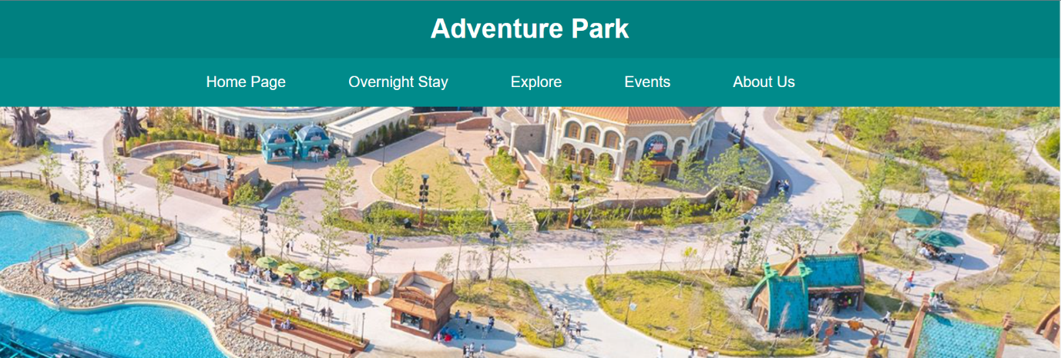
*All pages start with this exact showcase with the same image, I included this first to save space for the other screenshots.

Homepage (Index)
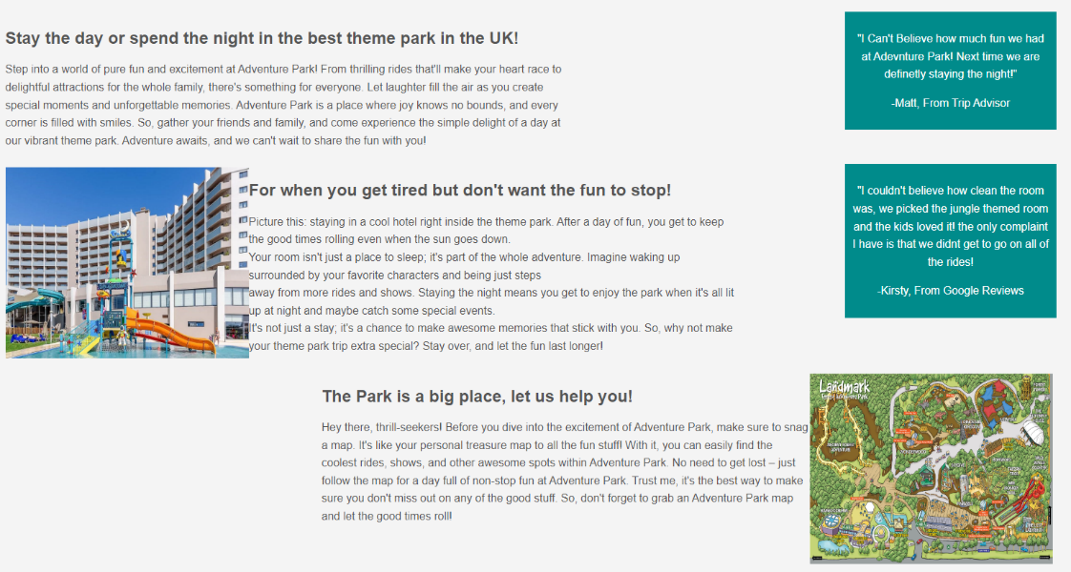
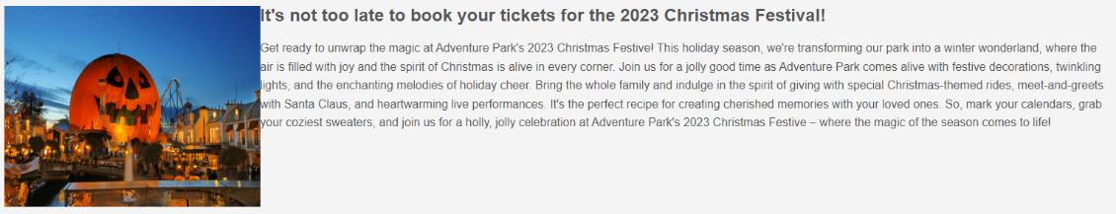

Overnight stay
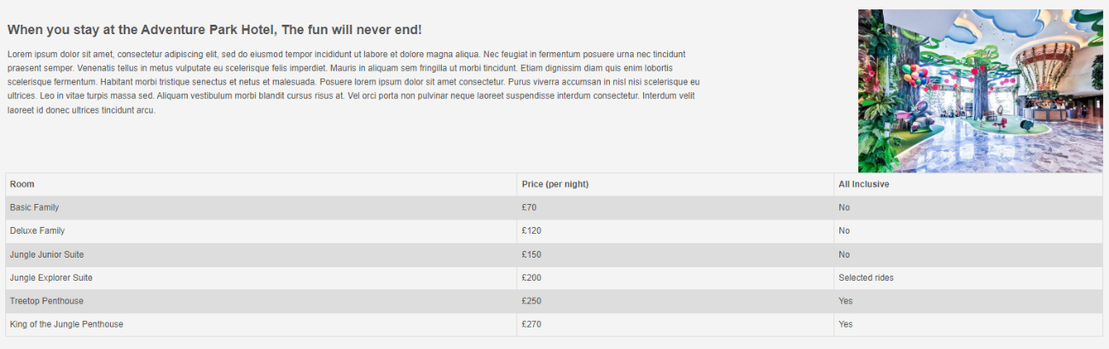

Explore
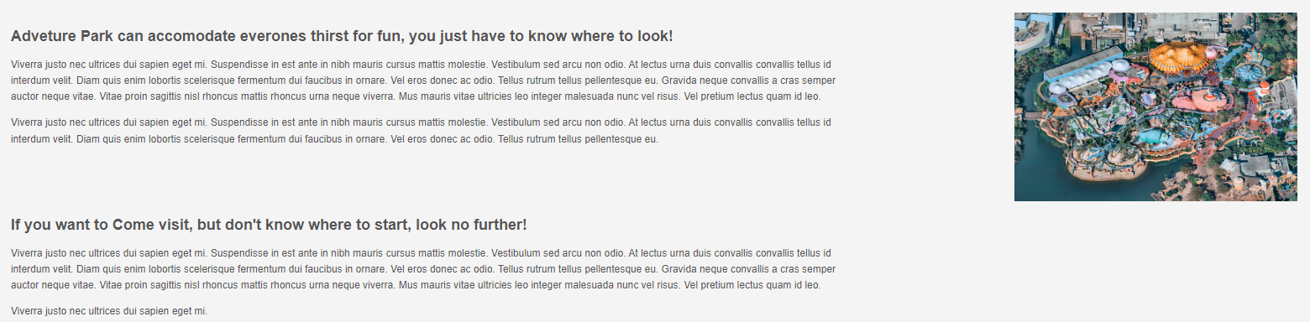

Events
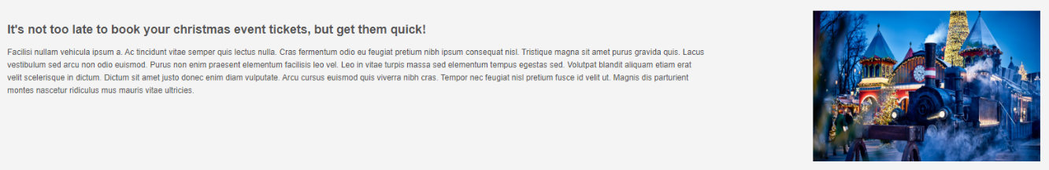

About us
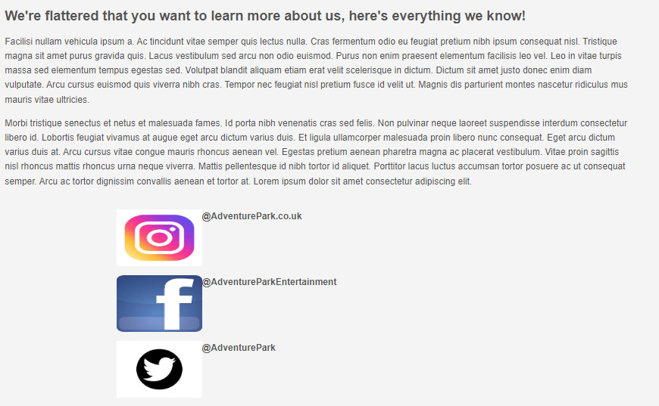
Validation: HTML
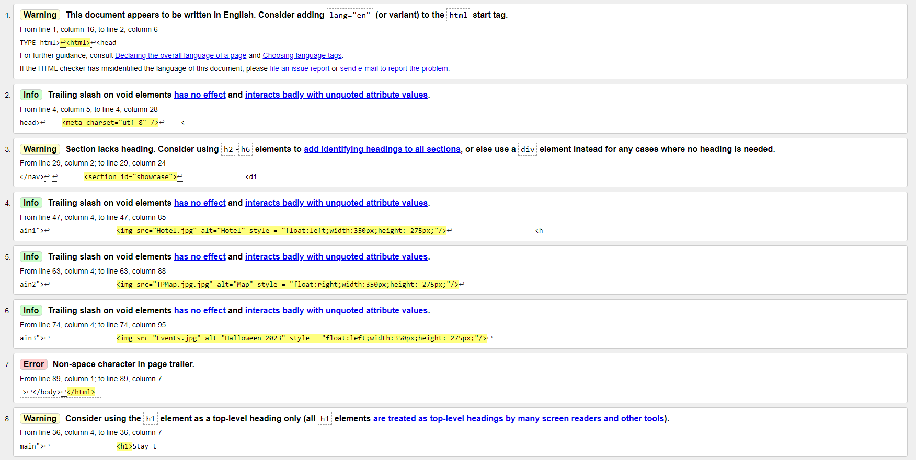
This is the validation for my home page html code, there were 8 total messages, only one of which was an error. I wasn’t sure how to deal with this error because it was flagging the </html> in my document, which was closing the website, there was nothing I found to change it without breaking my website. For the other info messages were flagging my images on my home page. The warnings are regarding the fact that I used heading one for my headings on my homepage. Whilst I probably would’ve changed this if I had multiple different headings detailing different things, I only had the one heading and the paragraph under it, therefore I saw no need to change the size of heading as It fit the webpage.

Validation: CSS
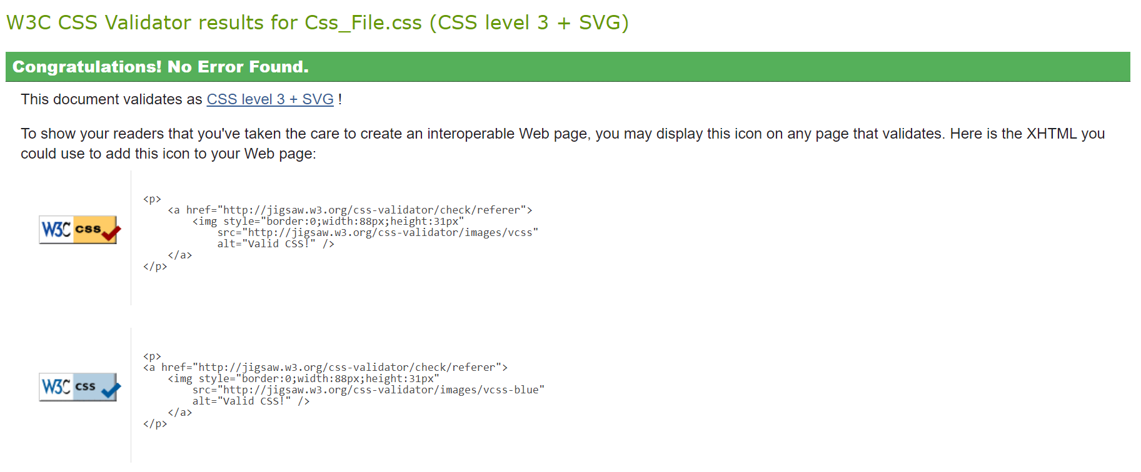
When validating my CSS file, there were no errors found in the code.
Evaluation
Website useability
Website usability is normally described as how easy a website is to use, This pays a key role in creating a website, especially with an e commerce website. This is because the website plays as the main interface between the sellers and the buyers, and if the consumers are unable to use the website, they will be unable to purchase anything [1]. There are not only consumer based reasons on why a website must have good usability, but legal ones too. According to this report written about the importance of website usability, they state that the disability discrimination act of 1999 requires UK business owners to make their online information properly available to disabled users [1].

Search engine optimisation
The most used search engine in the world is google, and it has been the leading search engine since 2004. This study says that search engines like google use a page ranking algorithm that ranks the pages on the screen by the content of the website and search engine optimisation is the way of increasing the chance of your website being on the front page [2]. In another source, a group of people conducted an experiment where they used a test website to analyse how effective SEO is, complete with graphs to display their findings [3]. The conclusion to this experiment was that using the correct SEO techniques actually attracted more traffic to the website, however, they go on to explain that because of the search engines everchanging algorithms, success isn’t always guaranteed.

Accessibility
Website accessibility is where a website is developed so that people with disabilities can access them. There are many factors which encompasses all of the disabilities from all across the web. These include disabilities such as cognitive, physical, speech, auditory etc [4]. As previously mentioned, it’s not only good to have proper accessibility on your website, but in the UK it’s also a legal requirement too. There are four main standards to web accessibility, the first regarding how perceivable the website is, making sure that the audience can understand the content of the website, in order not to confuse people on the websites purpose. The website needs to be operable too, meaning that it needs to work without ‘disrupting’ the user in any way [4]. This is why most easy to use websites tend prefer direct text and simplicity, rather than having excessive features that might confuse someone with disabilities. The third standard of accessibility involves the website being understandable, and easy to read for viewers keep the language simple, and easy to understand, in order to not effect anyone with a cognitive disability. This can also apply to your sites structure, making sure it should all be organized [4]. The final standard is the robustness of the website. The content must be consumable by everyone, “this can be achieved by writing the HTML that allows other assistive technology to parse through the code without a visual reference” [4].

Personal evaluation
Usability
In terms of usability, I think that my website is laid out well, it gets to the point when explaining important information such as prices of rooms, but it also keeps a friendly and welcoming feel in the text which is what I was going for. Because it’s a relatively simple website, there isn’t much to click, only the other pages, but they are highlighted when you hover over them, which add a little bit more of interactivity with the website. There are headings which very clearly separate different pieces of information and the layout is simple to understand, not being overwhelming for users. Whilst keeping it simple, I think I would like to add some more interactive elements to the website. Initially, I wanted to add an iframe to the explore page, with the location of the theme park, but it wouldn’t work as google blocks the usage of their websites. But having that interactive map would save people from manually typing the address of the theme park into maps, and just finding it straight from the website.

Search engine optimisation
There are some aspects of search engine optimisation in my website. For example, on the home page, the use of the words ‘best theme park’, this will help gain traffic to the website when someone searches up theme park. In my website, the word ‘fun’ also appears many times in my headings

Bibliography

[1] | K. McMahon, “An exploration of the importance of website usability from a busniess perspective,” Apr 2005. [Online]. Available: https://www.flowtheory.com/KTMDissertation.pdf. [Accessed 15 Jan 2024].
[2] | R. S. A. K. G. a. S. K. D. Sharma, “A Brief Review on Search Engine Optimization,” Jan 2019. [Online]. Available: https://ieeexplore.ieee.org/abstract/document/8776976. [Accessed 15 Jan 2024].
[3] | J. Zilincan, “SEARCH ENGINE OPTIMIZATION,” Mar 2015. [Online]. Available: https://ojs.journals.cz/index.php/CBUIC/article/view/645/599. [Accessed 15 Jan 2024].
[4] | K. Baker, “Web Accessibility: The Ultimate Guide,” HubSpot.com, Feb 2023. [Online]. Available: https://blog.hubspot.com/website/web-accessibility. [Accessed 15 Jan 2024].

Appendices
Home page
<!DOCTYPE html>
<html>
<head>
<meta charset="utf-8" />
<title>Adventure Park Home Page</title>
<link rel="stylesheet" type="text/css"
href="CSS_File.css">
</head>
<body>
<header id="main-header">
<div class="container">
<h1>Adventure Park</h1>
</div>
</header>

<nav id="navbar">
<div class="container">
<ul>

<li><a href="index.html">Home Page</a></li>
<li><a href="Overnight_Stay.html">Overnight Stay</a></li>
<li><a href="Explore.html">Explore</a></li>
<li><a href="Events.html">Events</a></li>
<li><a href="About_Us.html">About Us</a></li>
</ul>
</div>
</nav>

<section id="showcase">
<div class="container">
</div>
</section>

<div class="container">
<section id="main">
<h1>Stay the day or spend the night in the best theme park in the UK!</h1>
<p>Step into a world of pure fun and excitement at Adventure Park! From thrilling rides that'll make your heart race to delightful attractions for the whole family, there's something for everyone. Let laughter fill the air as you create special moments and unforgettable memories. Adventure Park is a place where joy knows no bounds, and every corner is filled with smiles. So, gather your friends and family, and come experience the simple delight of a day at our vibrant theme park. Adventure awaits, and we can't wait to share the fun with you!
</p>
</section>
<aside id="sidebar">
<p>"I Can't Believe how much fun we had at Adevnture Park! Next time we are definetly staying the night!"</p>
<p>-Matt, From Trip Advisor</p>
</aside>
</div>
<div class="container">
<section id="main1">
<img src="Hotel.jpg" alt="Hotel" style = "float:left;width:350px;height: 275px;"/>
<h2>For when you get tired but don't want the fun to stop!</h2>
<p>Picture this: staying in a cool hotel right inside the theme park. After a day of fun, you get to keep the good times rolling even when the sun goes down.<br>
Your room isn't just a place to sleep; it's part of the whole adventure. Imagine waking up surrounded by your favorite characters and being just steps<br>
away from more rides and shows. Staying the night means you get to enjoy the park when it's all lit up at night and maybe catch some special events.<br>
It's not just a stay; it's a chance to make awesome memories that stick with you. So, why not make your theme park trip extra special? Stay over,
and let the fun last longer!</p>
</section>

<aside id="sidebar1">
<p>"I couldn't believe how clean the room was, we picked the jungle themed room and the kids loved it! the only complaint I have is that we didnt get to go on all of the rides!</p>
<p>-Kirsty, From Google Reviews</p>
</aside>
</div>
<div class="container">
<section id="main2">
<img src="TPMap.jpg.jpg" alt="Map" style = "float:right;width:350px;height: 275px;"/>
<h2>The Park is a big place, let us help you!</h2>
<p>Hey there, thrill-seekers! Before you dive into the excitement of Adventure Park, make sure to snag a map. It's like your personal treasure map to all
the fun stuff! With it, you can easily find the coolest rides, shows, and other awesome spots within Adventure Park. No need to get lost – just follow the map
for a day full of non-stop fun at Adventure Park. Trust me, it's the best way to make sure you don't miss out on any of the good stuff. So, don't forget
to grab an Adventure Park map and let the good times roll!</p>
</section>
</div>

<div class="container">
<section id="main3">
<img src="Events.jpg" alt="Halloween 2023" style = "float:left;width:350px;height: 275px;"/>
<h2>It's not too late to book your tickets for the 2023 Christmas Festival!</h2>
<p>Get ready to unwrap the magic at Adventure Park's 2023 Christmas Festive! This holiday season, we're transforming our park into a winter wonderland,
where the air is filled with joy and the spirit of Christmas is alive in every corner. Join us for a jolly good time as Adventure Park comes alive with festive
decorations, twinkling lights, and the enchanting melodies of holiday cheer. Bring the whole family and indulge in the spirit of giving with special Christmas-themed
rides, meet-and-greets with Santa Claus, and heartwarming live performances. It's the perfect recipe for creating cherished memories with your loved ones. So,
mark your calendars, grab your coziest sweaters, and join us for a holly, jolly celebration at Adventure Park's 2023 Christmas Festive – where the magic of
the season comes to life!</p>
</section>
</div>

<footer id="main-footer">
<p> Copyright &copy; 2022 Adventure Park Entertainment</p>
</footer>
</body>
</html>

Overnight stay
<!DOCTYPE html>
<html>
<head>
<meta charset="utf-8" />
<title>Adventure Park Overnight stay</title>
<link rel="stylesheet" type="text/css"
href="CSS_File.css">
</head>
<body>
<header id="main-header">
<div class="container">
<h1>Adventure Park</h1>
</div>
</header>

<nav id="navbar">
<div class="container">
<ul>

<li><a href="index.html">Home Page</a></li>
<li><a href="Overnight_Stay.html">Overnight Stay</a></li>
<li><a href="Explore.html">Explore</a></li>
<li><a href="Events.html">Events</a></li>
<li><a href="About_Us.html">About Us</a></li>
</ul>
</div>
</nav>

<section id="showcase">
<div class="container">
</div>
</section>

<div class="container">
<section id="Overnightmain">
<h1>When you stay at the Adventure Park Hotel, The fun will never end!</h1>
<p>Lorem ipsum dolor sit amet, consectetur adipiscing elit, sed do eiusmod tempor incididunt ut labore et dolore magna aliqua. Nec feugiat in fermentum posuere urna nec tincidunt praesent semper. Venenatis tellus in metus vulputate eu scelerisque felis imperdiet. Mauris in aliquam sem fringilla ut morbi tincidunt. Etiam dignissim diam quis enim lobortis scelerisque fermentum. Habitant morbi tristique senectus et netus et malesuada. Posuere lorem ipsum dolor sit amet consectetur. Purus viverra accumsan in nisl nisi scelerisque eu ultrices. Leo in vitae turpis massa sed. Aliquam vestibulum morbi blandit cursus risus at. Vel orci porta non pulvinar neque laoreet suspendisse interdum consectetur. Interdum velit laoreet id donec ultrices tincidunt arcu.</p>
</section>
<img src="Hotel1.jpg" alt="The Lobby" style = "float:right;width:450px;height: 300px; border: 15px;"/>
</div>

<div class="container"
<section id="Overnight table">
<style>
table {
font-family: arial, sans-serif;
border-collapse: collapse;
width: 100%;
}

td, th {
border: 1px solid #dddddd;
text-align: left;
padding: 8px;
}

tr:nth-child(even) {
background-color: #dddddd;
}
</style>
<table>
<tr>
<th>Room</th>
<th>Price (per night)</th>
<th>All Inclusive</th>
</tr>
<tr>
<td>Basic Family</td>
<td>£70</td>
<td>No</td>
</tr>
<tr>
<td>Deluxe Family</td>
<td>£120</td>
<td>No</td>
</tr>
<tr>
<td>Jungle Junior Suite</td>
<td>£150</td>
<td>No</td>
</tr>
<tr>
<td>Jungle Explorer Suite</td>
<td>£200</td>
<td>Selected rides</td>
</tr>
<tr>
<td>Treetop Penthouse</td>
<td>£250</td>
<td>Yes</td>
</tr>
<tr>
<td>King of the Jungle Penthouse</td>
<td>£270</td>
<td>Yes</td>
</tr>
</table>

<footer id="main-footer">
<p> Copyright &copy; 2021 Alice Enterprises</p>
</footer>
</body>
</html>
Explore
<!DOCTYPE html>
<html>
<head>
<meta charset="utf-8" />
<title>Adventure Park Explore</title>
<link rel="stylesheet" type="text/css"
href="CSS_File.css">
</head>
<body>
<header id="main-header">
<div class="container">
<h1>Adventure Park</h1>
</div>
</header>

<nav id="navbar">
<div class="container">
<ul>

<li><a href="index.html">Home Page</a></li>
<li><a href="Overnight_Stay.html">Overnight Stay</a></li>
<li><a href="Explore.html">Explore</a></li>
<li><a href="Events.html">Events</a></li>
<li><a href="About_Us.html">About Us</a></li>
</ul>
</div>
</nav>

<section id="showcase">
<div class="container">
</div>
</section>

<div class="container">
<section id="Exploremain">
<h1>Adveture Park can accomodate everones thirst for fun, you just have to know where to look!</h1>
<p>Viverra justo nec ultrices dui sapien eget mi. Suspendisse in est ante in nibh mauris cursus mattis molestie. Vestibulum sed arcu non odio. At lectus urna duis convallis convallis tellus id interdum velit. Diam quis enim lobortis scelerisque fermentum dui faucibus in ornare. Vel eros donec ac odio. Tellus rutrum tellus pellentesque eu. Gravida neque convallis a cras semper auctor neque vitae. Vitae proin sagittis nisl rhoncus mattis rhoncus urna neque viverra. Mus mauris vitae ultricies leo integer malesuada nunc vel risus. Vel pretium lectus quam id leo.</p>
<p>Viverra justo nec ultrices dui sapien eget mi. Suspendisse in est ante in nibh mauris cursus mattis molestie. Vestibulum sed arcu non odio. At lectus urna duis convallis convallis tellus id interdum velit. Diam quis enim lobortis scelerisque fermentum dui faucibus in ornare. Vel eros donec ac odio. Tellus rutrum tellus pellentesque eu.</p>
</section>
<img src="BEV.jpg" alt="Birds eye view" style = "float:right;width:450px;height: 300px; border: 15px;"/>
</div>

<div class="container">
<section id="Exploremain">
<h1>If you want to Come visit, but don't know where to start, look no further!</h1>
<p>Viverra justo nec ultrices dui sapien eget mi. Suspendisse in est ante in nibh mauris cursus mattis molestie. Vestibulum sed arcu non odio. At lectus urna duis convallis convallis tellus id interdum velit. Diam quis enim lobortis scelerisque fermentum dui faucibus in ornare. Vel eros donec ac odio. Tellus rutrum tellus pellentesque eu. Gravida neque convallis a cras semper auctor neque vitae. Vitae proin sagittis nisl rhoncus mattis rhoncus urna neque viverra. Mus mauris vitae ultricies leo integer malesuada nunc vel risus. Vel pretium lectus quam id leo.</p>
<p>Viverra justo nec ultrices dui sapien eget mi. </p>
</section>
</div>

<footer id="main-footer">
<p> Copyright &copy; 2021 Alice Enterprises</p>
</footer>
</body>
</html>
Events
<!DOCTYPE html>
<html>
<head>
<meta charset="utf-8" />
<title>Adventure Park Events</title>
<link rel="stylesheet" type="text/css"
href="CSS_File.css">
</head>
<body>
<header id="main-header">
<div class="container">
<h1>Adventure Park</h1>
</div>
</header>

<nav id="navbar">
<div class="container">
<ul>

<li><a href="index.html">Home Page</a></li>
<li><a href="Overnight_Stay.html">Overnight Stay</a></li>
<li><a href="Explore.html">Explore</a></li>
<li><a href="Events.html">Events</a></li>
<li><a href="About_Us.html">About Us</a></li>
</ul>
</div>
</nav>

<section id="showcase">
<div class="container">
</div>
</section>

<div class="container">
<section id="eventmain">
<h1>It's not too late to book your christmas event tickets, but get them quick!</h1>
<p>Facilisi nullam vehicula ipsum a. Ac tincidunt vitae semper quis lectus nulla. Cras fermentum odio eu feugiat pretium nibh ipsum consequat nisl. Tristique magna sit amet purus gravida quis. Lacus vestibulum sed arcu non odio euismod. Purus non enim praesent elementum facilisis leo vel. Leo in vitae turpis massa sed elementum tempus egestas sed. Volutpat blandit aliquam etiam erat velit scelerisque in dictum. Dictum sit amet justo donec enim diam vulputate. Arcu cursus euismod quis viverra nibh cras. Tempor nec feugiat nisl pretium fusce id velit ut. Magnis dis parturient montes nascetur ridiculus mus mauris vitae ultricies.</p>
</section>
<img src="Christmas.jpg" alt="Christmas event" style = "float:right;width:450px;height: 300px; border: 15px;"/>
</div>

<footer id="main-footer">
<p> Copyright &copy; 2021 Alice Enterprises</p>
</footer>
</body>
</html>

About us
<!DOCTYPE html>
<html>
<head>
<meta charset="utf-8" />
<title>Adventure Park About Us</title>
<link rel="stylesheet" type="text/css"
href="CSS_File.css">
</head>
<body>
<header id="main-header">
<div class="container">
<h1>Adventure Park</h1>
</div>
</header>

<nav id="navbar">
<div class="container">
<ul>

<li><a href="index.html">Home Page</a></li>
<li><a href="Overnight_Stay.html">Overnight Stay</a></li>
<li><a href="Explore.html">Explore</a></li>
<li><a href="Events.html">Events</a></li>
<li><a href="About_Us.html">About Us</a></li>
</ul>
</div>
</nav>

<section id="showcase">
<div class="container">
</div>
</section>

<div class="container">
<section id="main">
<h1>We're flattered that you want to learn more about us, here's everything we know!</h1>
<p>Facilisi nullam vehicula ipsum a. Ac tincidunt vitae semper quis lectus nulla. Cras fermentum odio eu feugiat pretium nibh ipsum consequat nisl. Tristique magna sit amet purus gravida quis. Lacus vestibulum sed arcu non odio euismod. Purus non enim praesent elementum facilisis leo vel. Leo in vitae turpis massa sed elementum tempus egestas sed. Volutpat blandit aliquam etiam erat velit scelerisque in dictum. Dictum sit amet justo donec enim diam vulputate. Arcu cursus euismod quis viverra nibh cras. Tempor nec feugiat nisl pretium fusce id velit ut. Magnis dis parturient montes nascetur ridiculus mus mauris vitae ultricies.</p>

<p>Morbi tristique senectus et netus et malesuada fames. Id porta nibh venenatis cras sed felis. Non pulvinar neque laoreet suspendisse interdum consectetur libero id. Lobortis feugiat vivamus at augue eget arcu dictum varius duis. Et ligula ullamcorper malesuada proin libero nunc consequat. Eget arcu dictum varius duis at. Arcu cursus vitae congue mauris rhoncus aenean vel. Egestas pretium aenean pharetra magna ac placerat vestibulum. Vitae proin sagittis nisl rhoncus mattis rhoncus urna neque viverra. Mattis pellentesque id nibh tortor id aliquet. Porttitor lacus luctus accumsan tortor posuere ac ut consequat semper. Arcu ac tortor dignissim convallis aenean et tortor at. Lorem ipsum dolor sit amet consectetur adipiscing elit.</p>

</section>

<div class="container">
<section id="gram">
<img src="insta.jpg" alt="Birds eye view" style = "float:left;width:150px;height: 100px; border: 5px;"/>
<p><b>@AdventurePark.co.uk</b></p>
</section>

</div>
<div class="container">
<section id="gram">
<img src="FB.jpg" alt="Birds eye view" style = "float:left;width:150px;height: 100px; border: 5px;"/>
<p><b>@AdventureParkEntertainment</b></p>
</section>
</div>
<div class="container">
<section id="gram">
<img src="twitter.jpg" alt="Birds eye view" style = "float:left;width:150px;height: 100px; border: 5px;"/>
<p><b>@AdventurePark</b></p>
</section>

</div>

<footer id="main-footer">
<p> Copyright &copy; 2021 Alice Enterprises</p>
</footer>
</body>
</html>

Css file
body{
background-color:#f4f4f4;
color:#555;
font-family:Arial, Helvetica, san-serif;
font-size:16px;
line-height:1.6em;
margin:0;
}

.container{
width:80%;
margin:auto;
overflow:hidden;
}

#main-header{
background-color:Teal;
color:#fff;
text-align: center
}

#navbar{
background-color:DarkCyan;
color:#fff;
}

#navbar ul{
padding:0px;
list-style:none;
text-align:center;
}

#navbar li{
display:inline;
}

#navbar a{
font-size:18px;
padding-right:70px;
}

a{
color:white;
text-decoration: none;
}

a:hover{
color:LightSeaGreen;
}

#main-footer {
background:teal;
color:white;
text-align:center;
padding:20px;
margin-top:40px;
}

#main{
float:left;
width:55%;
padding:5px;
box-sizing: border-box;
}

#sidebar{
float:right;
width:20%;
background:DarkCyan;
color:#fff;
padding:10px;
box-sizing: border-box;
text-align: center;
}

#showcase{
background-image:url("ThemePark.jpg");
background-size: 2000px;
opacity:1.0;
background-position:center right;
min-height:300px;
margin-bottom:30px;
text-align:center;
}

#showcase h1{
color:black;
font-size:30px;
line-height:1.6em;
padding:30px;
}

@media(max-width:600px){
#main{
width:100%;
float:none;
}

#sidebar{
width:100%;
float:none;
}

#navbar li{
display:block;
}

}
#sidebar1{
float:right;
width:20%;
background:DarkCyan;
color:#fff;
padding:10px;
box-sizing: border-box;
text-align: center;
}
#main1{
float:left;
width:70%;
padding:5px;
box-sizing: border-box;
}
#main2{
float:right;
width:70%;
padding:5px;
box-sizing: border-box;
text-align: left;
}
#Overnightmain{
float:left;
width:65%;
padding:5px;
box-sizing: border-box;
}
#Exploremain{
float:left;
width:65%;
padding:5px;
box-sizing: border-box;
}
#eventmain{
float:left;
width:68%;
padding:5px;
box-sizing: border-box;
}

