Computer architecture and operating systems
ASSIGNMENT 1 – 7th April 2023

Networks and Cyber Security
Che Morris - 2203458

Table of Contents
Introduction 2
Key Functions of General Operating Systems 3

Introduction
Throughout the course of this report, I will be covering some of the key functions of modern day operating systems, including some aspects from operating systems later on in the last decade during times where computers were not as commonly used by every day people. I will also be covering a variety of Batch, Windows PowerShell and Bash commands in both Windows and Linux and their uses, these will vary in practicality from very simple commands like printing a message to the screen and others for testing internet and network connectivity. Some of these commands that we learn along the way will then be used to create some Batch and Bash scripts, varying in how difficult they are to script with.

Key Functions of General Operating Systems
As general operating systems are the software that manages most of a computer’s basic functions, there are some key functions that are managed by the OS that are critical to everyday use and functionality.
One of the important functions is memory management, memory management allocates and tracks memory usage. Managing the memory effectively keeps the system running stable and performing well, if memory is managed effectively processes should still run effectively and the system should be stable under high load. The OS can also take advantage of virtual memory, which is “a technique that is used by operating systems to provide users with a large amount of memory” [1]. This process is called “paging” or “swapping” allowing data to be moved to the hard disk when a process is not in use to free up more physical memory. An overview of this can be seen on the Windows Task Manager, as seen below.
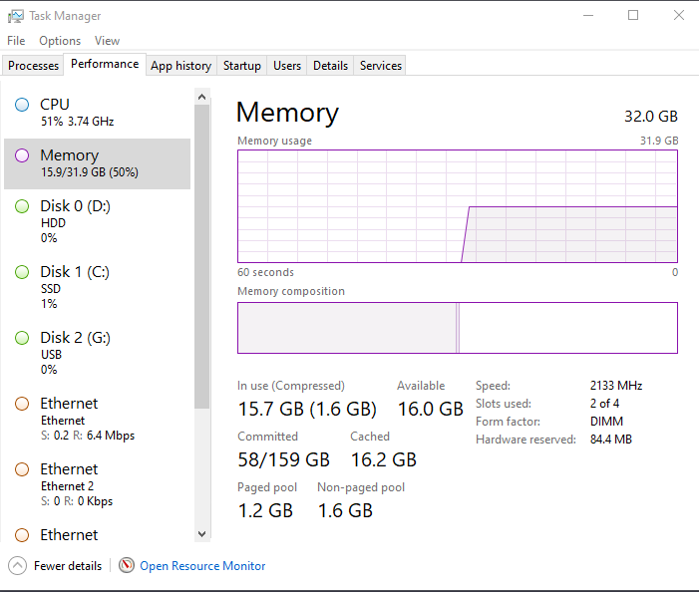
Figure 1 Windows Task Manager - Memory
OSs also allow for process management, which puts the OS in charge of “process development, scheduling, impasse management, and process termination” [2]. One of these, process scheduling, is essential as “operating systems allow more than one process to be loaded into the executable memory at a time” [3]. The scheduler will decide which order tasks are ran in and how much time each process gets to run its tasks.
They come standard with security these days, this security is used to “protect the OS from threats, viruses, worms, malware or remote hacker intrusions” [4] through multiple preventive measures. Users can also choose to install different firewalls and antiviruses of their choice, but typically the OS security remains in place alongside it. System security is also dependent on the user and can be strengthened by keeping on top of OS updates and creating user accounts with passwords.
A key component of operating systems is device management, this means “controlling the Input/Output devices like disk, microphone, keyboard, printer, magnetic tape, USB ports, camcorder, scanner, other accessories” [5]. It is also in charge of device discovery, driver installation and device configuration. The drivers are usually installed automatically once a new device is discovered but sometimes when they cannot be found, or a more efficient driver is available elsewhere can be installed manually. These drivers let the new device and the OS communicate correctly and let the OS get the most out of the new hardware that it can.

Use of Windows OS CLI Commands
Windows has a lot of commands that are usable in both the command prompt and PowerShell. I’ll now be documenting the use of 10 of these, five for each.
The ‘echo’ command is a command usable in batch and allows the user to return a message or a variable within the command prompt.
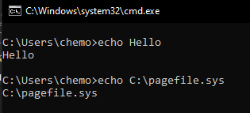
Figure 2 Echo Command
The ‘CD’ command allows the user to change the directory they are currently using in the command prompt. This can be used within a directory so for example if I was in C:\Users I could run ‘cd chemo’ and it would go into that directory or you can use it with a path as shown below.
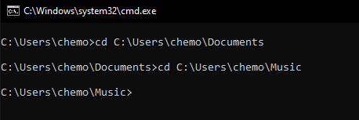
Figure 3 CD Command

The ‘Dir’ command allows for a user to see all the files or sub directories within a directory. The ‘/w’ switch here shows the items here in a wide format allowing for more to be displayed per use. Without the use of the switch it will be displayed in a list.
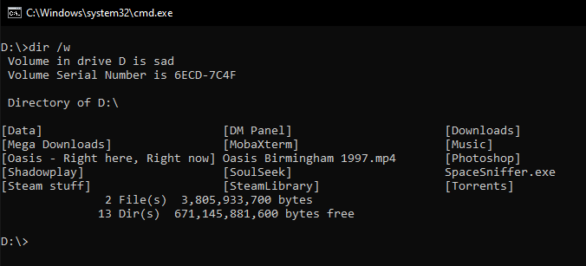
Figure 4 Dir Command

The ‘Del’ command allows for a user to delete a file or multiple files using the command prompt. The below screenshot shows the directory I’m in before I deleted the file and after using the previously demonstrated ‘Dir’ command.
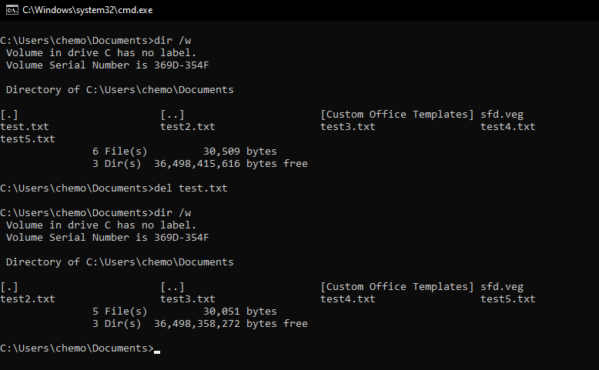
Figure 5 Del command

The ‘Mkdir’ command allows for a user to create a new directory using the command prompt. I also use the previously demonstrated ‘dir’ and ‘del’ commands here as well. Paths can also be used with this command.
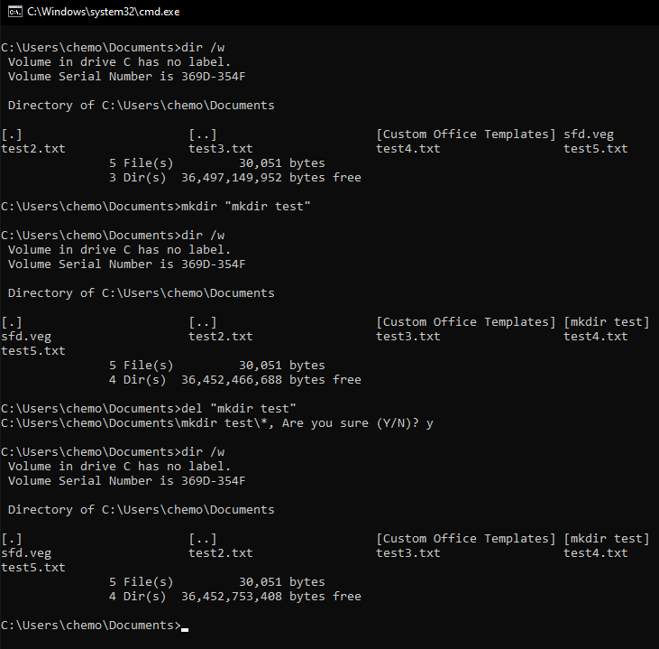
Figure 6 Mkdir Command

The ‘Get-Process’ command is a PowerShell command that shows the user a list of processes currently running on the system. Providing a process ID will display information on that specific process.
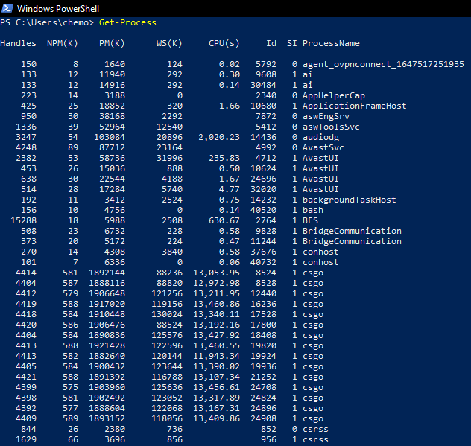
Figure 7 Get-Process Command

The Get-Help command is a PowerShell command that will show the user detailed help information about PowerShell commands, this should also include examples on how to use them.
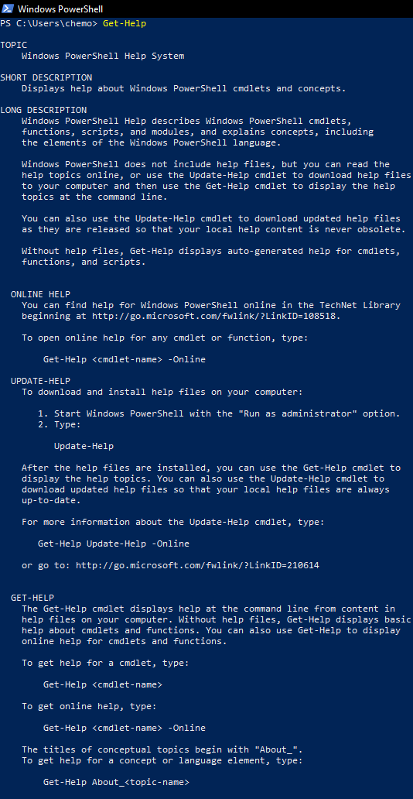
Figure 8 Get-Help Command

The New-Item command will create a new item, these can be directories or files. In the below screenshot I created the directory ‘test’. You can specify what Item Type you would like to create using the -ItemType argument.
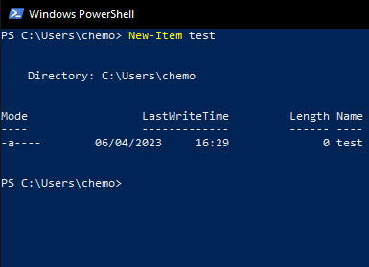
Figure 9 New-Item Command
The Remove-Item command will remove items from a directory, this can also be used to delete directories.
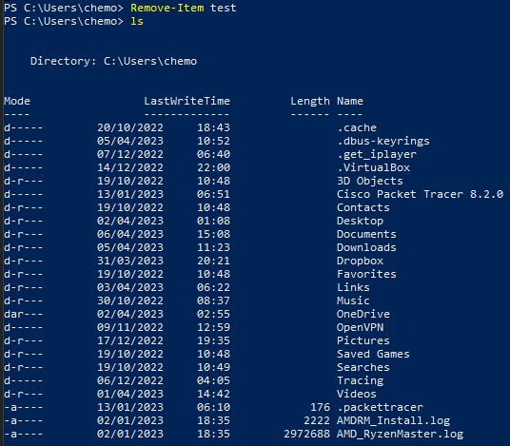
Figure 10 Remove-Item Command
The ‘Test-Path’ command checks whether a directory exists or not. If a directory exists it will return ‘True’ and if a directory does not exist it will return ‘False’.
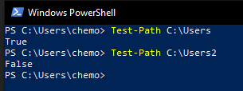
Figure 11 Test-Path Command

Use of Linux OS CLI Commands
Some of the commands that are in Windows are quite similar to the commands in Linux, but there are quite a few new commands that I will be introducing.
The ‘cd’ command in Linux allows for you to change directories. Putting a .. after this command will allow you to move up one directory in the file system and putting a ~ will allow you to go back up one directory.
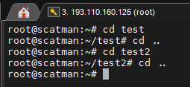
Figure 12 CD Command
The ‘ls’ command lists all files and directories in the current directory that the user is in. It can also be used to list files in other directories if you specify a path.
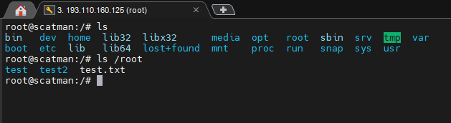
Figure 13 LS Command

The ‘mkdir’ command makes a directory in the current working directory. The below screenshot shows the before and after of the mkdir command in use.
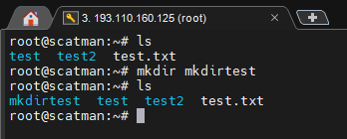
Figure 14 Mkdir command
The ‘cp’ command allows for files to be copied to other directories. Using the -r switch with this command will allow for directories to also be copied, as shown below.
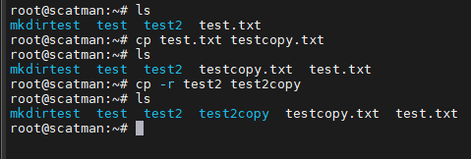
Figure 15 CP Command
The ‘rm’ command can be used to delete a file or directory, examples of both can be seen in the screenshot below.
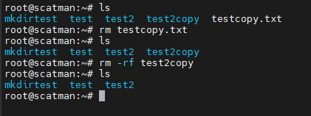
Figure 16 RM Command

The ‘mv’ command allows for users to move files or directories into other directories, this can be done through names of files if you’re already in a directory or can be done through using file paths, both are shown below.
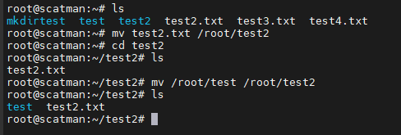
Figure 17 MV Command
The ‘ps’ command will display all running processes, this is used to check the status of all processes ran by the user. By default this command only shows information about the processes running in the current session.
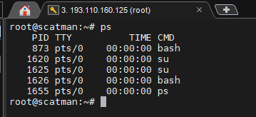
Figure 18 PS Command
The ‘ping’ command allows for users to test connectivity to different hosts, for the example below I used google.com, but this will work with any domain or IP address.
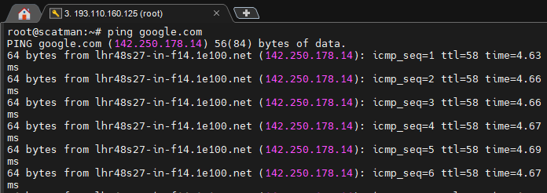
Figure 19 Ping Command

The ‘date’ command will allow you to see the current date and time as set on the system. Using the –set argument will allow you to change the date and time on the system, but this is not recommended.
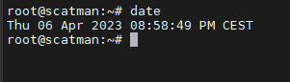
Figure 20 Date Command
The ‘top’ command will show an overview of all system processes, their process ids, what user ran them, resource usage and the time that they’ve been open for. This information is updated every few seconds to show the most up to date information.
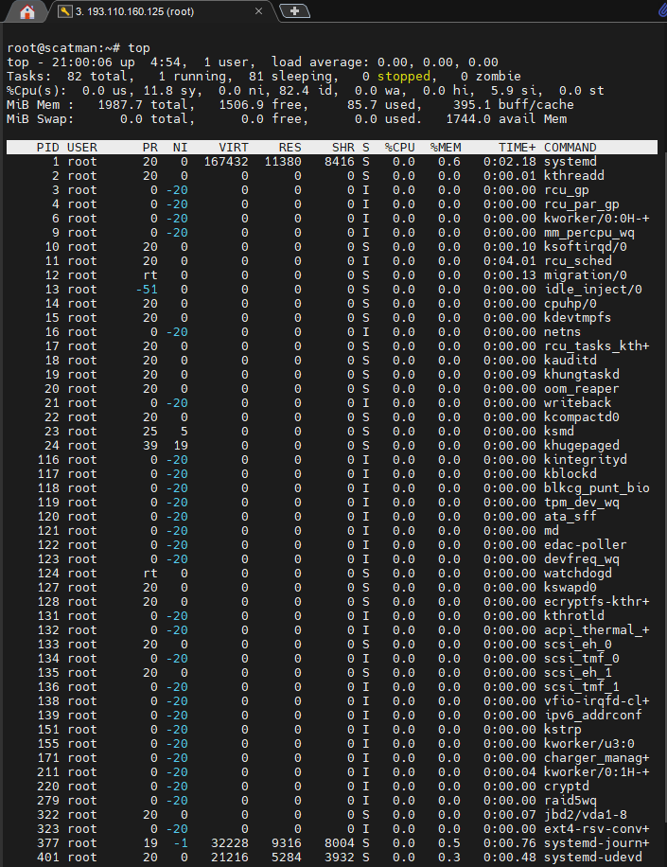
Figure 21 Top Command

Use of Windows OS Scripts
To begin showing off Windows Batch Scripting, I will start by using variables. These variables can either be custom variables, in this case ‘fname’, ‘lname’ and ‘age’, but can also be predetermined system variables, in this case %date% and %time%. The following code will output to the user the name and age set in the code and the date and time.
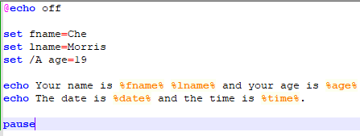
Figure 22 Variable Code
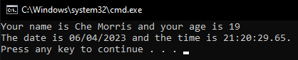
Figure 23 Variable Output

If we use ‘set /p’ we can prompt the user to input either a value or a string and store that in a variable, here I use it to ask the user for two numbers and then using ‘set /a’ store the total of the numbers.
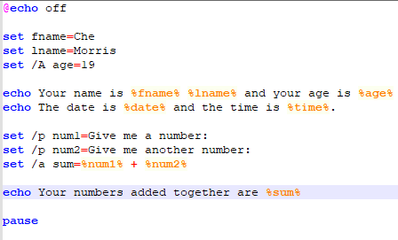
Figure 24 Variable Code 2
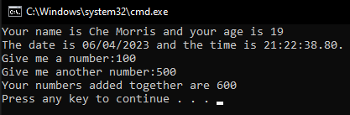
Figure 25 Variable Output 2
I will now be changing the message where the numbers get added together, and will be utilising if and if else statements to check whether the total of the numbers is larger or smaller than 20. The result of both sides of the if statement is shown in the output below.
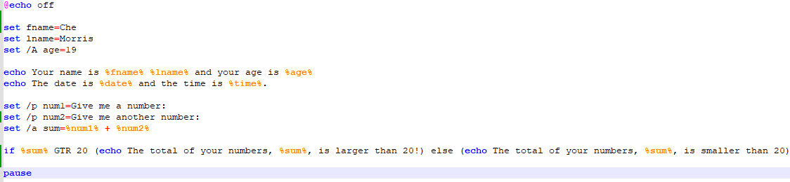
Figure 26 If Else Code

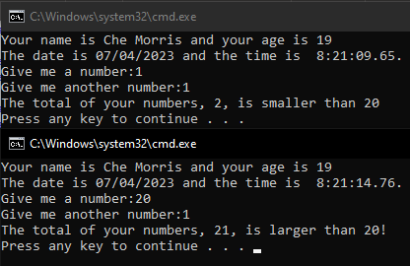
Figure 27 If Else Output
In batch you can also use for loops, for example the following code will count from one to ten and output the numbers in the command prompt.
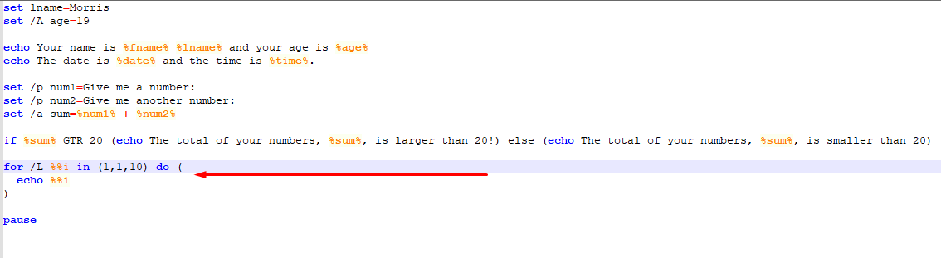
Figure 28 For Loop Code
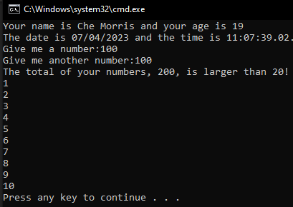
Figure 29 For Loop Output

I will also add an Array to this script. I’ve decided to create mine about food, and will create an array that includes some of my favourite foods, then using a variable I will prompt the user and let them add another food to the list.
Figure 30 Array Code
Figure 31 Array Output
I will now combine the two previous things I covered, arrays and loops, to create a loop that lists out everything that is in the food array. This will also include the one the user specified earlier in the code.
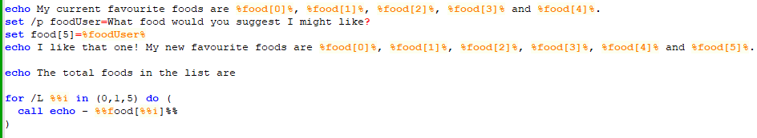
Figure 32 For Loop with Arrays Code
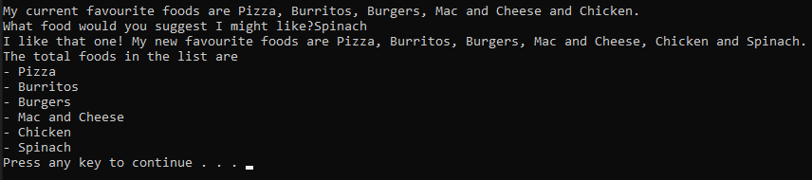
Figure 33 For Loop with Arrays Output

Something that I should have thought about earlier and did at the start of this script was set the title of the window and change the colour to make it look a bit easier on the eyes, I will change the title of the script to ‘My Script’ and I will change the colour to blue. I also added a few empty ‘echo’ commands around some of the texts so that it wasn’t so squished together.
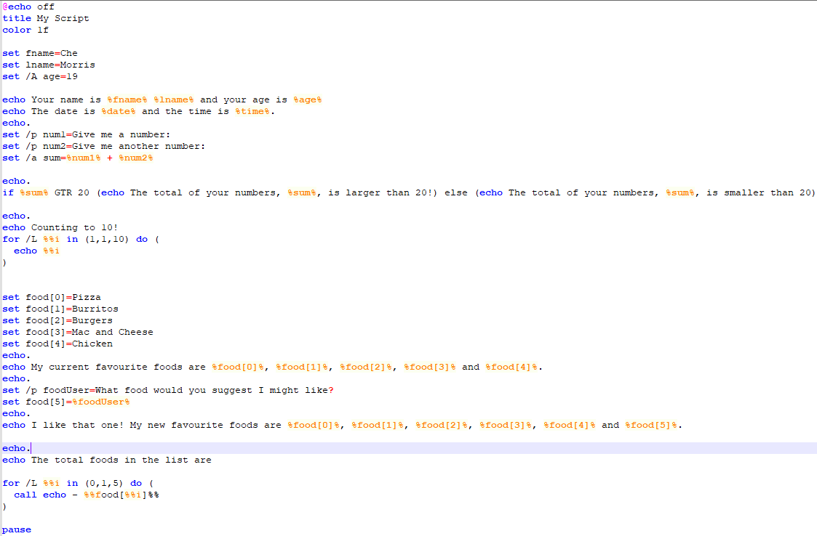
Figure 34 Empty Echo Commands and Title and Colour Change Code
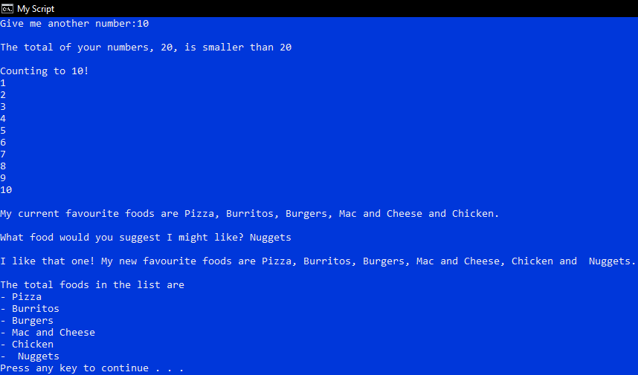
Figure 35 Output

That will be the final form of the script, a nice script to keep track of data about the user, the date, calculations, counting, foods and even give the end user an option to add to it.

Use of Linux OS Scripts
I will be using my Ubuntu server through SSH to create my bash script, and to begin I will start by putting #!/bin/bash at the top of my script to let the OS know that I will be using bash for the commands and scripts within the file.
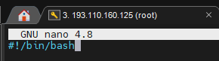
Figure 36 Start of script
Variables are a bit different in bash compared to batch, they are even similar (would you believe that). All you have to do to create a variable in bash is just put the name of the variable and what you want to store in it, I will do this now by once again storing my name in the script and outputting it using the echo command.
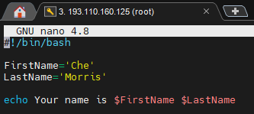
Figure 37 Basic Variable Code
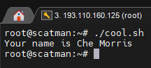
Figure 38 Output

I will now create a variable that stores the users age, but I will do it differently this time and ask the user for the year they were born using the ‘read’ command and will calculate their age by taking away the year they were born from the current year.
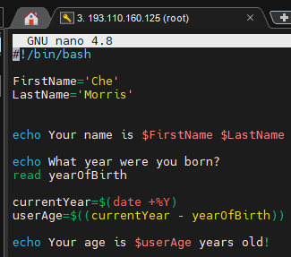
Figure 39 Prompting the user and running calculations
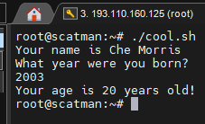
Figure 40 Output

Following the narrative of the code I have already written, I will create a guessing game where the user has 10 tries to guess the age of Ubuntu, which will stay up to date as I’ll use the same calculation using the year it was released (2004), this will use a for loop and some if then and elif statements. At this moment in time the correct answer would be 19.
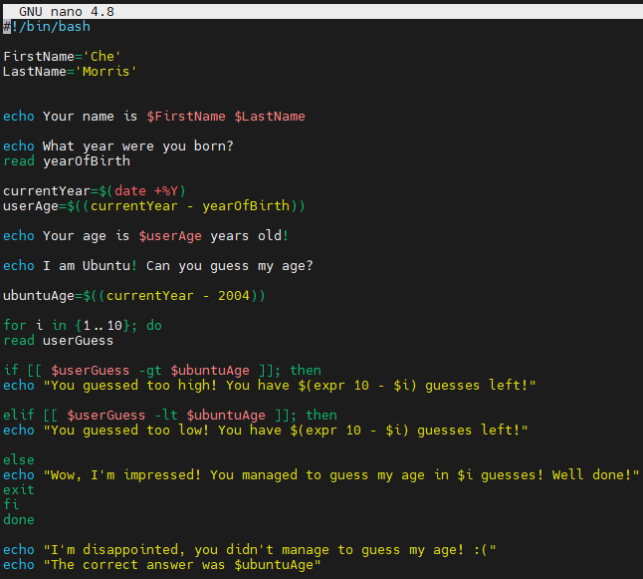
Figure 41 Code for a number guessing game including if then and elif statements and a for loop
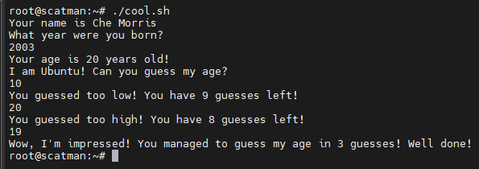
Figure 42 Output

I will now add something after the number guessing game using case statements to see whether the user liked the game or not, this will be a simple yes or no and I will thank them for their answer after I have gathered it. Sidenote, while doing this I realised I had to remove the exit command from the loop and replace it with break otherwise it wouldn’t use my new code.
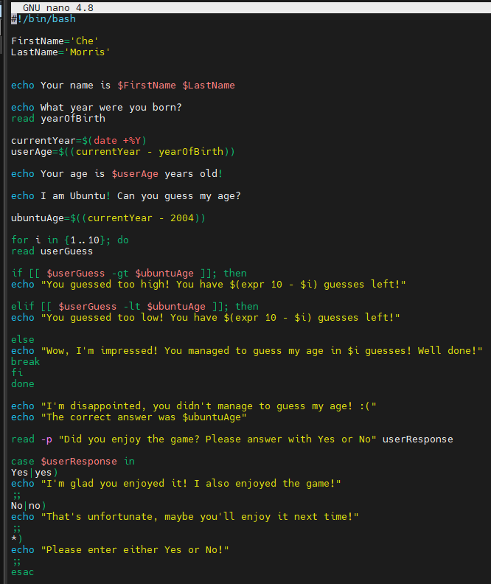
Figure 43 Code using case statements
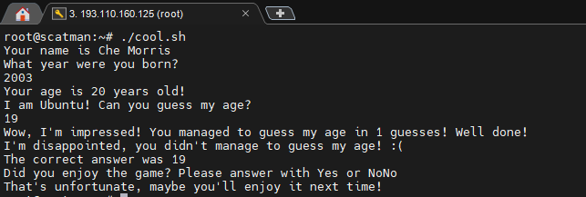
Figure 44 Output
This is the final form of my bash script, I do enjoy bash a lot more than I do batch and I’m way more familiar with it.

Conclusion
This report has been my favourite to complete yet. I’ve always been someone who has enjoyed learning about coding and scripting and someone who is even quite familiar with Bash and Batch already. Throughout the course of the report, we have looked at different commands and their uses in two different operating systems, Windows and Linux and even used three different ways of doing this with the use of Bash, Batch and PowerShell. Before starting this module, I had no prior experience with PowerShell but have seemed to pick it up quite quickly.
The Batch commands we looked at are probably the most practical ones and the easiest to do as Batch has been around for over three decades now and has always been known to be an easy way to do things in Windows and DOS. PowerShell is relatively new, only being introduced in 2006 with the release of Windows Vista but none the less seems relatively simple as the commands are just plain English when compared to Bash and Batch, I can’t say the same for PowerShell scripting though as I did not attempt that.
The Bash commands are where I have probably shined the most as I’ve used Linux for several years in the past and I am quite experienced with it, using it for multiple scripts throughout the last ten years. I did do this on a server that I own, hence the use of the MobaXTerm SSH Client and not a VM or another online method.
Overall, I am pleased to say that I’ve learned quite a bit throughout the course of not just this report, but being taught in the module as well and have learned some quite advanced skills that hopefully will carry over when I am scripting for other things in the future.

References
[1] J. Tyson. How Virtual Memory Works. Available: https://computer.howstuffworks.com/virtual-memory.htm [Accessed Mar 26, 2023].
[2] A. Sharma. Process Management In Operating System. Available: https://www.scaler.com/topics/process-management-in-operating-system/ [Accessed Mar 26, 2023].
[3] Tutorialspoint. Operating System - Process Scheduling. Available: https://www.tutorialspoint.com/operating_system/os_process_scheduling.htm [Accessed Mar 26, 2023].
[4] M. Rouse, "Operating System Security," Available: https://www.techopedia.com/definition/24774/operating-system-security-os-security. [Accessed Mar 26, 2023].
[5] Javatpoint. Device Management in Operating System - javatpoint. Available: https://www.javatpoint.com/device-management-in-operating-system [Accessed Mar 26, 2023].

Appendices

Work on OS Types
Since the development of UNIX in 1969, which laid the foundation for modern day operating systems, we’ve come a long way in the different types of operating systems that are used nowadays. The two types of OS used the most are general-purpose and mobile operating systems. General-purpose operating systems would be desktop OSs like Windows, Linux and MacOS, that are used on a daily basis by many people and tend to be quite feature rich allowing users to do many tasks in the simplest way possible. Likewise, a mobile OS would also be used daily by pretty much everyone these days and run on mobile phones, devices and wearables and typically include Android, iOS and Windows Phone OS. They manage everything on the phone including wireless connectivity, network connectivity and accessing installed applications ​[1]​ but due to the constant connectivity can lead to the devices battery draining quickly and may be confusing for users. A type of OS that benefits billions but isn’t seen by most people is the Real Time OSs. These share many features with general-purpose OSs but handle important life dependent systems like electric cars, factory machines, medical systems and air traffic control systems ​[1]​. They are designed to be used when processing time must be short so compared to a general-purpose OS have far shorter processing time and have execution patterns that are understood and predictable ​[2]​, due to this they tend to be more stripped down and designed to be ran on more lightweight systems.
​​References
​[1] Anonymous (). Types of Operating Systems (With OS Functions and Examples). Available: https://www.indeed.com/career-advice/career-development/types-of-operating-systems [Accessed Mar 25, 2023].
​[2] WALT Labs. (-06-01T09:00:10+00:00). What s the Difference Between an RTOS and a GPOS?. Available: https://waltlabs.io/difference-in-a-rtos-and-a-gpos/ [Accessed Mar 25, 2023].

​​

Evidence of engagement with online certified course (Linux Unhatched)


