

Brendan Lee-Cook

Titration

UWTSD
OME Degree Apprenticeship

Beng
Academic Year: 2023 – 2024

Supervisor: Dr Ewa Kazimierska
March 2024

© UWTSD year. All rights reserved. No part of this publication may be reproduced without the written permission of the copyright owner.

Academic integrity declaration
I declare that:
- the work submitted has been written by me alone.
- the work submitted has not been previously submitted to this university or any other.
- that all content, including primary and/or secondary data, is true to the best of my knowledge.
- that all quotations and references have been duly acknowledged according to the requirements of academic research.
I understand that to knowingly submit work in violation of the above statement will be considered by examiners as academic misconduct.

Table of Contents
Academic integrity declaration i
List of Terms iii
List of Equations iv
1. Introduction 1
1.2 Purpose of experiment 1
1.3 Hypothesis 1
1.4 Variables and uncertainty 1
2 Materials 2
2.2 Materials and Equipment 2
3 Method 3
3.2 Procedure 3
4 Results 4
4.2 Experimental data 4
5 Discussion 7
6 Conclussion 8
References 9
Appendix 10
Titration results 10

List of Terms
Titration: a technique used to measure the volume of a solution of known concentration that is required to react with a measured amount (mass or volume) of an unknown substance in solution.
Burette: a piece of calibrated glassware used to measure volume; a graduated glass tube about 40 cm long with a stopcock on one end. The volume measurement is made by reading the fluid level in the burette before and after the titrant, the fluid in the burette, is dispensed through the stopcock.
Standard solution: a solution of exactly known concentration.
Unknown: a substance or a mixture about which something is not known.
Indicator: a substance which is added to the reaction system in small amounts; it indicates that the reaction is complete (has reached the endpoint) by changing colour.
Endpoint: the stage in the titration at which the indicator colour change is observed, indicating that the reaction is complete.
Equivalence point: point in titration at which the amount of standard solution added is just enough to completely neutralize the unknown solution.
Meniscus: concave line of liquid at the top of the container.

List of Equations
- Moles H⁺ = moles OH⁻
- moles acid (n_{A}) = moles base (n_{B})
- M = n/v
- M_{A}V_{A} = M_{B}V_{B}
M = Molarity
n = number of moles
v =Volume

Introduction

Purpose of experiment
Using Acid-Base titration techniques, accurately determine the concentration of a sample of Hydrochloric acid (HCl).
The HCl acid will be reacted with a Sodium Hydroxide (NaOH) Base standard solution.

Hypothesis
The unknow concentration of a sample of HCl can accurately be determined using the method of Acid-Base Titration.
By placing the unknown HCl into an Erlenmeyer flask with a known quantity of a Phenolphthalein indicator before slowly titrating a standard solution of NaOH into the flask. Then, measuring the quantity of NaOH needed to neutralise the acid based on the reaction with the indicator we will be able to determine the concentration in the HCl

Variables and uncertainty
As this technique requires judging colour change by eye there is human error to take into account when interpreting the results.
It is also important to ensure that calibrated measuring equipment is used for this method and in the preparation of the standard solutions and indicators.

Materials

Materials and Equipment
Chemicals:
- 80 mL standard NaOH solution, M_{B} = 0.1026 mol/L
- 80 mL HCl solution with an unknown concentration
- Phenolphthalein indicator (colourless in acidic solution, pink in basic solution)
- Deionised water (DI)
Equipment:
- 1x Burette, 50 mL attached to a burette stand with clamp
- 1x Pipette, 10 mL, with pipette filler
- 3x Erlenmeyer (conical) flasks, 100 mL
- 1x Small funnel to fill the burette
- 1x Plastic pipette
- 1x Wash bottle with deionised water
- 1x Graduated cylinder, 10 mL
- 1x White tile or white paper to go under the titration flask
- 1x Beaker for the waste
List from UWTSD- OME Programme, ACDB4011: Titration^{[1}

Method

Procedure
Experimental set-up:
First step is the washing procedure for all of the equipment each piece of equipment shall be washed with deionised water followed by the solvent that it shall be used with.
Pipette: Washed with DI water then with HCl.
Burette: Washed with DI water then NaOH
Funnel washed with DI water then Naoh
Erlenmeyer flask. Washed with a small quantity of DI water only.

After all equipment has undergone its own washing procedure the burette shall be filled using the funnel with Standard NaOH. Using careful pouring and utilising the stop tap on burette ensure the meniscus of NaOH is level with the zero marking with no trapped air. Record initial reading.

Pippette 25 ml of HCl into each of 3 Erlenmeyer flasks

4 drops of phenolphthalein indicator and 10 ml of DI water shall be added to each Erlenmeyer flask containing HCl The flask shall be gently swirled.

Experimental procedure:
Firstly a rough titration shall be run to gauge the volume of NaOH for HCl neutralisation. However, as mild a colour change as possible shall be aimed for to ensure likelihood of successful titration in subsequent rounds.
Using the burette stop tap run the NaOH into the HCl solution to within 2 ml of the rough titration level. When within 2 ml slow the pour rate to a dripping technique ensuring that only a drop at a time is added as titration continues.
Once the palest colour change possible is achieved record measurement of volume from burette within 0.05 ml

The experimental procedure shall be continued until two volumes of NaOH solution differ by no more then 10 ml for neutralisation of HCl. Each run of the experimental procedure shall have an initial and final reading from the burette recorded for data analysis.

Results

Experimental data
FLASK | 1 rough titration | 2 | 3
V _{HCl} (mL)  from pipette | 25 | 25 | 25
Initial burette reading | 0.00 | 20.35 | 20.00
Final burette reading | 20.35 | 40.15 | 40.05
V _{NaOH} (mL) | 20.35 | 19.80 | 20.05
Table 1: Results from titration experiment.
These readings were then used to calculate: Moles of NaOH, Moles of HCl and Molarity of HCl.
Moles of NaOH was calculated using equation n =M x v giving the results in the table below
Moles of NaOH | 0.1026 mol/l * 0.02035 l  = 2.06 x 10⁻³ mol | 0.1026 mol/L *0.0198 L  =2.03 x10⁻³ mol | 0.1026 mol/L * 0.02005 L  = 2.06 x 10⁻³ mol
Table 2 results for Moles of NaOH
Then the molarity of HCl was calculated using M_{A} = M_{B} V_{B} / M_{A} giving the results in table 3

Molarity of HCl | 0.1026 mol/L x 0.02035 L / 0.025 L  = 0.084 mol/L | 0.1026 mol/L x 0.0198 L / 0.025 L  = 0.081 mol/L | 0.1026 mol/L x 0.02005 L / 0.025 L  = 0.082 mol/L
Table 3 results for molarity of HCl
Finally, these results were used to calculate the number of mols of HCl per sample recorded in table 4

Moles of HCl | 2.1 x 10⁻³ mol | 2.01 x 10⁻³ mol | 2.05 x 10⁻³ mol
Table 4 results of Moles of HCl

The complete table of results is shown below in table 5
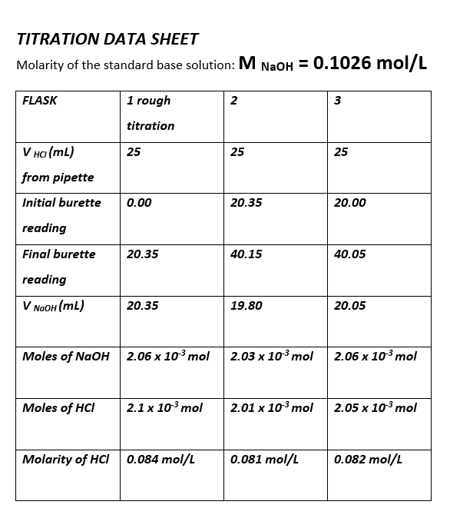
Table 5 complete titration results
The molarity of the HCl is between 0.084 mol/L and 0.081 mol/L
These results show a very close link between the quantity of acid and base needed for neutralisation which is made closer still when the concentrations of both the acid and bases are in closer alignment.

Discussion
This experimental set-up determined that the molarity of the HCl solution was between 0.081 mol/L and 0.084 mol/L these are a good indication of the actual concentration. This means for a simple and inexpensive experimental set-up concentraional ranges can be determined for a range of analytes.
Titration can also be a useful method for explosive classification purposes:
The insensitive high explosive 3-nitro-1,2,4-triazol-5-one (NTO) is a weak acid (pKa 3.76) due to the labile N–H bond. The weakly acidic character of this compound is exploited for its assay by aqueous acid-base titration. The NTO sample was dissolved in water and the resultant solution was titrated against 0.07 N NaOH solution using phenolphthalein as indicator. Regular batch samples were assayed by this method and the results were compared with those obtained by the HPLC method. The aqueous acid-base titration method was found to be suitable for the quality control of the product.^{[2]}
As mentioned in section 1.4 this technique can be improved upon if efforts are made to reduce the human error that can be an issue with colou determination.

Conclussion
The findings from this experiment support the hypothesis that titration is a useful tool for determining the concentration of certain analytes. There was some ambiguity with the measurements taken in this experimental set up and more accurate results could be achieved with both; greater repetition and finer tuned instrumentation.

References
[1] University of Wales Trinity St David – OME-Programme-ACDB 4011: Titration

[2] Nandi, Amiya & Singh, Sunil & Kunjir, Ganesh & Singh, Jaivindra & Kumar, Alok & Pandey, Raj. (2013). Assay of the Insensitive High Explosive 3-Nitro-1,2,4- triazol-5-one (NTO) by Acid-Base Titration. Central European Journal of Energetic Materials. 2

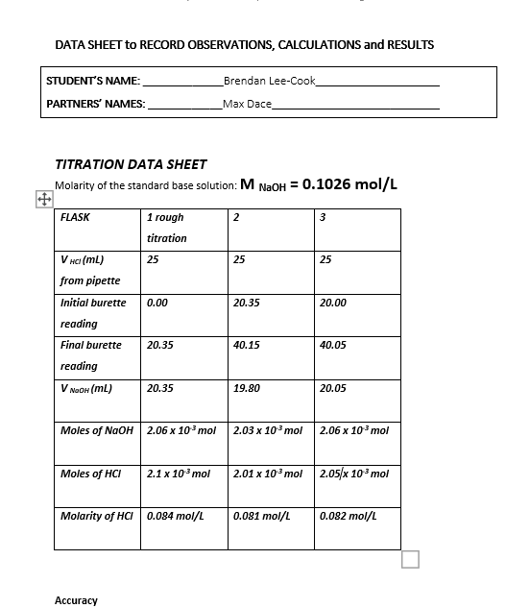
Appendix

Titration results

