Operating Systems
Computer Architechture and Networks
Jake Wears
[Year]
Contents
Modern Operating Systems 2
Windows CLI Commands 3
Linux CLI Commands 4
Windows Batch Scripts 5
Linux Bash Scripts 6
Conclusion 7
References 8

Modern Operating Systems

The greatest feature of most modern OS’ is a Graphical User Interface (GUI). A GUI can provide an unparalleled level of usability. The modern GUI makes it possible for anyone to use a computer as all the UI is easy to see and accessible. GUI’s come in many forms and are used on many types of hardware, including video game consoles, PC’s and server units. The most common OS is Windows and 1.5 billion users have been created on it, it is installed on over 200 million systems. Usually, the GUI’s can be customised to the users wishes. As well as that it has the features needed to perform other actions ¹.

Another bonus is easy troubleshooting. Almost every issue with a computer will have a tell given by the OS. The author had an issue with RAM and their OS informed them of the issue, thus they were able to fix it.
Both Windows and Mac provide competent defence to most basic attacks. Unless a major vulnerability is detected within an early build of an update, all new OS’ should keep users safe from the majority of attacks. Most modern OS’ come with competent anti-viruses and usually require specific user actions to come under threat ².
While the OS’ of the past may have had some hardware integration, anything that can connect via to the PC can be used. This can include mice, keyboards, printers, wheels to name a few. All that these pieces of hardware require is connecting and potentially a firmware update.
Modern OS’ are extremely user friendly. With little instruction, users who have little to no experience with a system can use and take advantage of the features offered by newer systems. OS’ such as Windows 10 are extremely intuitive, with users being able to create folders to organise files with just simple clicking and dragging. It is also simple to change things about the computer, audio outputs can be changed with a simple click, screen resolution can be changed easily, the OS can be used as a bridge between hardware and software if necessary to tweak aspects of parts or their performance figures.


There are however differences between the 3 main series of OS today, that being Windows, Mac OS and Linux. Windows and Linux can be put onto any machine, where as Mac OS is exclusively for Apple devices. None of these OS’ are better than the other ones, they all have advantages and disadvantages. Mac has a layout which can be confusing for new users, Windows is the easiest to hack because scripts and hacks are designed to attack the OS and Linux has limited support by software’s such as Steam, thus worse for a casual user.

Windows CLI Commands
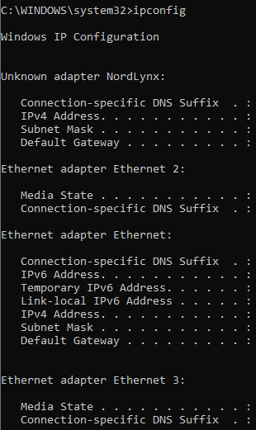
CLI commands are mostly used by developers. They can be used to do many of the things that can be done with a normal GUI, and have additional access to commands that the GUI cannot use ⁴.
One of the more useful commands that the CLI can use, in the authors opinion is ipconfig. This command allows the user to find out specific information about their computer, which can be useful when modifying or improving a system’s networking capabilities. Shown is an ipconfig, performed on the authors system. As they have multiple connection points and software running, ipconfig picks up both their VPN and their ethernet ports. This information also allows them to see their own IP and the IP the one that is being perceived as their public address.
This command is useful when being used in conjunction with developing. When a network is being setup or configured, ipconfig can be used to refresh the DHCP and DNS settings. This can be useful when trying to link it to a server or other network.

Another useful tool is tracert. Tracert is used for network diagnosis and within this level of diagnosis if reveals the path that a systems connection takes to reach a target website ⁴. All that is needed to perform this is an IP address. The image below is a tracert being performed. It shows exactly how many jumps are needed to get to the target IP, up to a maximum of 30 jumps. It also shows how much time this takes, which will usually be in milliseconds.
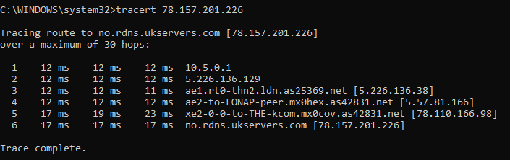

Linux CLI Commands

The main difference between most OS and Linux, is Linux is open source, which means that anyone can access the source code and edit Linux if they wish ⁵. Depending on what version of Linux you use, it is geared to different uses, Debian being a user-based experience and Kali being geared more to Cyber Security experts.
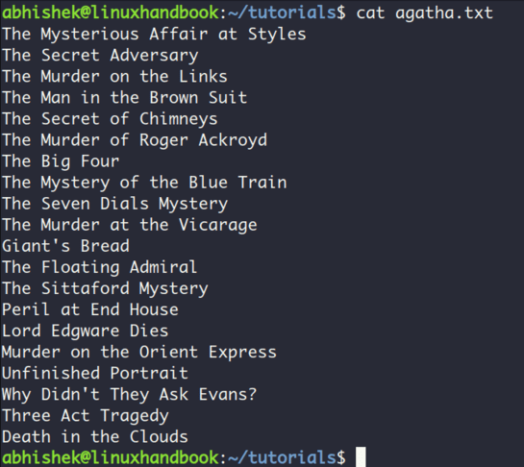
The first useful command to be noted is cat. Cat stands for concatenate. It is used to create files. To use it, the user enters cat, the name of the file and the file extension. It can be used to create folders, txt documents and can be used to join files together.
Linux is full of useful commands, but it’s interesting commands grow once the specialised versions of Linux are used. Kali is a version of Linux which the author is somewhat experienced with, it can be used to great affect to help improve the cyber security of networks, as Kali is made to try to find and expose these issues.
The below command is NMAP. NMAP stands for network mapper, its use is to inform the user of all the different devices using the network it is on. This can be useful for identifying potential threats in companies, as it shows the IP’s and MAC addresses of all the systems on the network. In this specific screenshot it is scanning the subnet. At the bottom of the command, it details how many systems there are on the network and how long the scan took. This tool is good for diagnostics and making sure that only devices recognised are on the system. The command is laid out, nmap and the IP of whatever is being scanned ⁷. It can also be used for scanning ports, to identify weak ports and potentially exploitable ports.
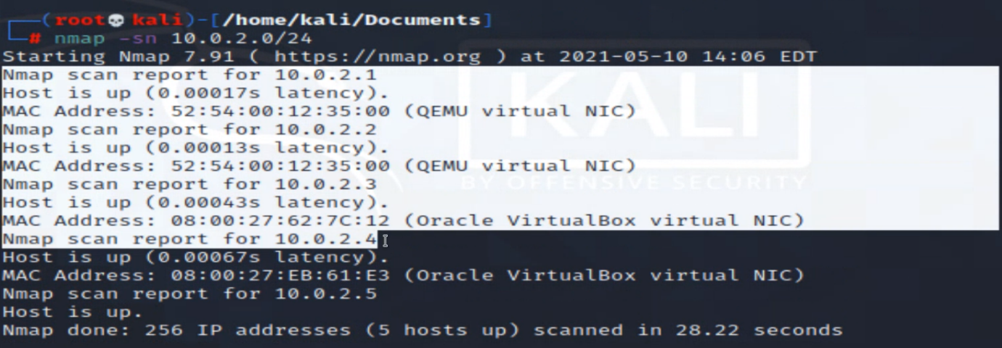

Windows Batch Scripts

Batch Files are a way for users to input custom sets of commands into the command line. They can be used like .exe’s to execute one command after another. This can be used in a variety of ways to help speed up any work on a command line that is done often ⁸. They usually end in .bat, but can also end in .cmd and .btm. Once clicked on, they open a CLI, perform whatever task is necessary as detailed within the document and then shuts the CLI down. This is a batch command created by the author.

Batch commands can be used to greatly speed up tasks. They can take advantage of any function used by the CLI normally, except are performed with the speed of a computer, thus can be extremely fast. myscript, above was loaded with just ping, before being edited. This made the CLI open and shut almost instantly. This is an image of it pinging google.com. To get screenshots of these commands, the user must be quick.
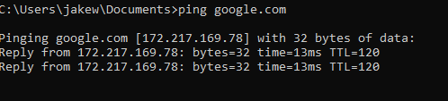
Below is an example of linking 2 commands together, both the ping and tracert command.
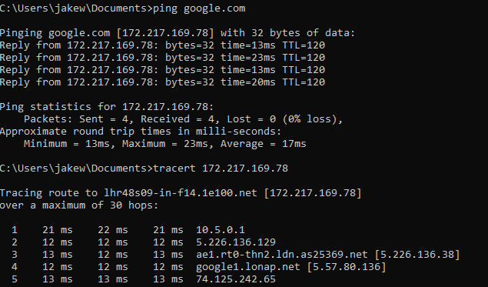
Overall it took 6 jumps, to get to the IP that google.com gave us.

Linux Bash Scripts

Bash and Batch scripting are different things. Bash scripting is similar to writing code as there are specific variables required to do specific things. All Bash scripts are written within a shell. A shell is based within a terminal window, which looks similar to the command line of a Windows OS.
To start a script off as a Bash script, it has to be prefixed with the shebang #! and this must be he first line of the script.
Bash scripts must be executable, so suitable file format is required to make them work. This is a .sh extension. If it is to be saved, the shebang at the start of the file is unnecessary and can be started with a different command.
While they can be used for more the batch scripts, they can also be used for running multiple commands together as well as performing task automation ⁹. These are a few of the basic uses for the format. Bash scripts are an essential piece of coding for Linux users, as they can make the experience much more streamlined and efficient. This obviously depends on which version of Linux is being used, but a knowledge of Bash scripts will help with all users.

Conclusion

To conclude this report, the author has learnt much about modern operating systems in general and has increased their knowledge on how to effectively use their OS.
Before beginning this assignment, the author had no idea about batch/bash scripting and had limited knowledge on how to utilise the command line of their basic Windows machine, or how to utilise as many commands as they know now. They knew much about the benefits of a Modern OS over MS DOS or other early OS but were less knowledgeable on the amount of people using these systems, or just how complete they are. Windows 10, for example, is an extremely competent piece of software, keeping both the experience easy and streamlined enough to encourage everyday use, while also integrating some features to introduce users to more in depth and complicated concepts. Linux is almost the opposite, while still including a GUI in most cases, OS’ such as Kali provide an almost unique experience, encouraging exploration of networking and bettering the user’s knowledge of the command line.
While the author could do basic commands on the CLI, and they had an idea of how much could be done on it but was unaware that a user could run their entire system through it if they wished. They could follow tutorials to troubleshoot and fix problems but was unaware as to how easy it is to use the command line.
The author was also unaware that users could make scripts to use on the command line, so was completely unaware of how in depth it was. They were also unaware of how pivotal a skill it is, to have a smooth-running Linux system. They were also surprised by how easy it was to create Batch scripts. Unfortunately they were unable to try out bash scripts due to a lack of a working VM. However, the Batch scripts that were used were interesting and with time, they could be transformed into more useful scripts rather than interesting ones.

Word count 1802

References

- BBC Bitesize. n.d. Graphical user interfaces - User interfaces - GCSE ICT Revision - BBC Bitesize. [online] Available at: <https://www.bbc.co.uk/bitesize/guides/zwb4jxs/revision/3> [Accessed 27 May 2021].
- Panda Security Mediacenter. 2021. Windows 10: Do I need to install an antivirus software?. [online] Available at: <https://www.pandasecurity.com/en/mediacenter/mobile-news/need-antivirus-windows-10/#:~:text=Microsoft%20has%20Windows%20Defender%2C%20a,already%20built%20into%20Windows%2010.&text=An%20AV%20Comparatives%202017%20study,protection%2C%20usability%2C%20and%20performance.> [Accessed 27 May 2021].
- Hoffman, C., 2016. Here’s What’s Different About Windows 10 for Windows 7 Users. [online] How-To Geek. Available at: <https://www.howtogeek.com/219034/here%E2%80%99s-what%E2%80%99s-different-about-windows-10-for-windows-7-users/#:~:text=Microsoft%20has%20made%20many%20low,start%20menu%20and%20desktop%20windows.> [Accessed 28 May 2021].
- Hostinger Tutorials. 2021. What Is CLI and Why Would You Use It Over GUI?. [online] Available at: <https://www.hostinger.co.uk/tutorials/what-is-cli> [Accessed 28 May 2021].
- Thousand Eyes. 2021. What is Traceroute & What is it For?. [online] Available at: <https://www.thousandeyes.com/learning/glossary/traceroute> [Accessed 28 May 2021].
- Edureka. 2020. Linux vs Windows | Different Types Of Operating Systems | Edureka. [online] Available at: <https://www.edureka.co/blog/linux-vs-windows/#:~:text=Linux%20is%20an%20open%20source,code%20according%20to%20his%20need.> [Accessed 28 May 2021].
- Ferranti, M., 2018. What is Nmap? Why you need this network mapper. [online] Network World. Available at: <https://www.networkworld.com/article/3296740/what-is-nmap-why-you-need-this-network-mapper.html#:~:text=Nmap%2C%20short%20for%20Network%20Mapper,ports%20and%20detecting%20security%20risks.> [Accessed 28 May 2021].
- Seobility.net. n.d. What is batch scripting and how does it work? - Seobility Wiki. [online] Available at: <https://www.seobility.net/en/wiki/Batch_Scripting#:~:text=Batch%20scripts%20are%20used%20to,particularly%20useful%20for%20repetitive%20tasks.> [Accessed 28 May 2021].
- Yesmin, F., 2018. 30 Bash Script Examples – Linux Hint. [online] Linuxhint.com. Available at: <https://linuxhint.com/30_bash_script_examples/#:~:text=Bash%20scripts%20can%20be%20used,important%20for%20every%20Linux%20user.> [Accessed 28 May 2021].

