Certificate in Higher Education Skills for the Workplace

Name: Syed Miah
I.D: 1714970
Module Code: BMSW4005
Module Title: Reflective Portfolio
Lecturer: Janett

Reflective Portfolio
This reflective portfolio will include information for myself and other employees. In addition, the portfolio will include a reflection of self-awareness using tools such as Johari Window and a personal SWOT analysis. It will also include a reflection on a classroom mock interview that was done with the lecturers. It will show the feedback I received and why feedback is important. Furthermore, the reflective portfolio will include a development plan. It will demonstrate the knowledge needed for employees to plan and successfully attain future employment.

Reflection of self-awareness
Self-awareness is to have consciousness of motives, and all feelings and desires. It allows everyone to be aware of themselves and what they want to achieve. ‘Conscious knowledge of one's own character, feelings, motives, and desires’ (Oxford Dictionary, 2018) This shows that self-awareness is all about building knowledge and focusing on details about the environment.
The self-awareness process is to analyse what you are like now and what u want to become. It allows you to analyse any problems or self-criticism that you might experience. It will show the ways to reduce self-criticism and discrepancies. The process allows you to change yourself currently and in the future. Self-awareness is always knowing and owning your feelings. Self-awareness is also having the right type of feelings in the correct moment.
Tools used for self-awareness
There are many tools that can be used to improve and visualise self-awareness. These tools can be used to help enhance and understand more about your own self-awareness and how to develop yourself. This allows employees to work on their own personal character in order to become more suitable and desired by employers. One of the tools that can be used to assess someones self-awareness is the SWOT tests. Another tool that can be used to assess self-awareness is finding out what learning style is more effective for you.

SWOT Analysis
SWOT analysis can be used to identify the key strengths of a person. SWOT stands for strengths, weaknesses, opportunities and threats. It also allows them to recognise their weaknesses. It also allows people to analyse any opportunities they may have and it can also help them identify any threats they need to keep in mind.

Strengths | Weakness
Good Ideas and use of research  Good Listening skills  Creativity  Patient  Respectful  Educational skills  Teamworking skills  Dedication | Unorganised  Quiet
Opportunities | Threats
Learn new skills | Not experienced enough

The SWOT analysis helped me to analyse my strengths, weaknesses and any opportunities I might get. It also helped me realise any threats that might come my way. The table shows that my strengths include good ideas and use of research. This shows that I can implement my ideas properly and can also do further research to enhance my knowledge. Another one of my strengths are that I am good at listening. This is an important skill because employers want staff members to listen to them in order to effectively finish a task. I am very creative this shows that I have different ideas and approaches to every task. I am patient, this shows that although I work hard, I can also wait for results in order to improve myself. In addition, another one of my strengths is that I am respectful. This is an important employability skill because all employees must be well mannered in order to work efficiently as a team or independently. The SWOT analysis shows that my weakness is that I am sometimes unorganised. This is a bad trait as employers want people who are always organised and have everything, they need to complete all tasks. Another one of my weaknesses is that I am quiet. Although this is sometimes good, in most cases it is also very bad. This is because being quiet does not help employers recognise you. It hinders your ability to get employed as employers want someone who constantly talks and communicates on how they always feel. The opportunities I have is that I still have the time to learn new skills to fit roles for certain jobs. This allows me to specifically achieve targets and goals that can help attract more employers. The threats that may come in the way is that I am not experienced enough. This means that I do not have the full experience to do certain jobs straightaway and I would have to put the time in to be patient and learn.

Types of learning styles
Active – An active learner learns the work by doing practical work as they understand it better.
Reflective – This is when the learner thinks or even research on the task before it is started so they have a better idea of how to do it.
Sensing – These types of learners like to learn all the facts and solve problems before applying it to their task
Intuitive – These learners like to think on the spot to find out the answers. They do not usually have a routine to learn they just do the task when it is given out.
Visual – Learners that understand things using pictures and graphs are visual learners. Pictures help them acknowledge and understand the work.
Verbal – This is when a person can reason, learn, or solve problems using their language
Sequential – These learners prefer to take the task in steps and learn the work in steps as this helps break the task down to them
Global – It is when people apply their globally learn methods that they have explored from people and places around the world.
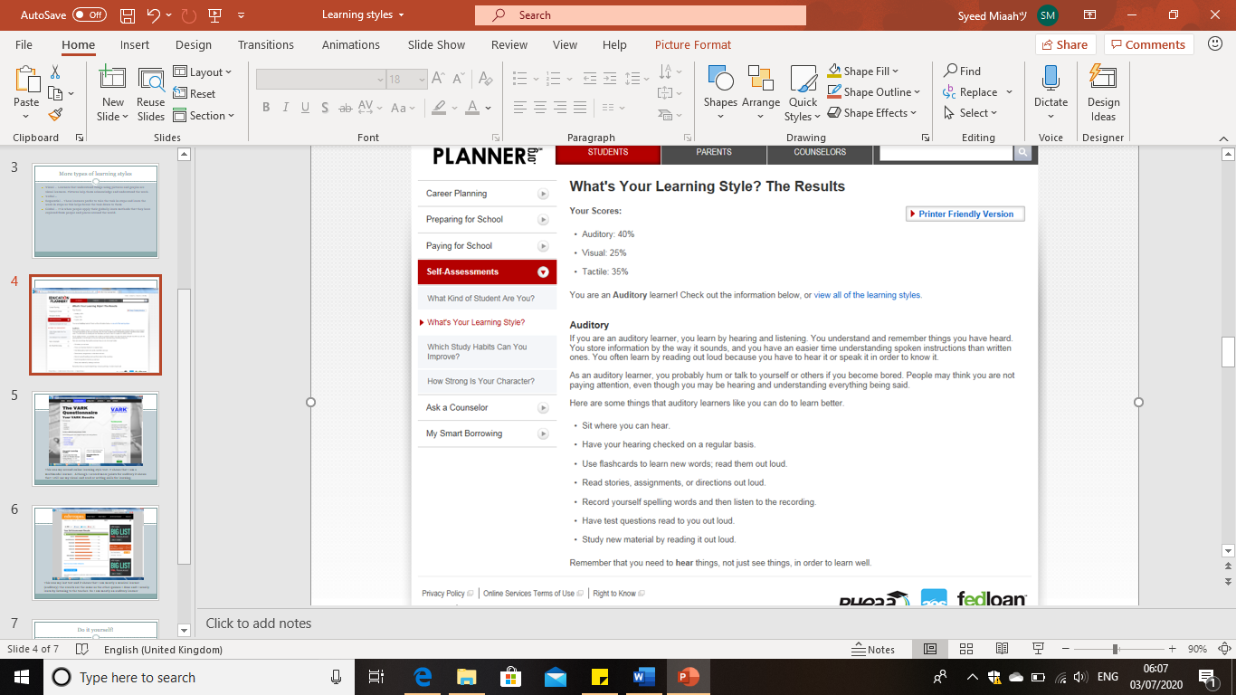
This is my first online learning style test. It shows that I am an auditory learner so that means I like learning by listening to the information instead of visually seeing graphs or pictures. Knowing your learning strengths can help you find out what your weakness and strength is. This will help you improve your work.

Mock Interview and Feedback
I had done a mock interview in class with my lecturer. This was to see how I behave and conduct myself during an interview. It has helped me be more confident and have more knowledge on how I should approach my interviews. It is important to receive feedback from peers to self-improve to be a better person and in this case a better employee. During the mock interview I had to prepare myself. This was done by revising more about the company where I applied for a job. I had to research more about the company so I could have more knowledge. This would help me answer any questions the interviewer would ask me about the company. It is important for an employee to know about their company. This is because they would be held responsible if anything was to go wrong. I had also practiced how to shake hands properly and what kind of body languages to use. As I had applied for a bank job, I had to be sure that I knew information about the bank’s history. I had to also revise on certain laws and regulations all banks must follow. This was so I had all round knowledge in case the interviewer wanted to test me even further. In addition, I had also practice speaking clearly in a well-mannered fashion. This was so the employer knew that I am a good candidate who can express themselves clearly. I had to also be polite and ask questions to the interviewer so they could know that I am interested in the job and would make a good employee. The feedback I received from the mock interview showed that I had a good chance in receiving the job offer. This was because I had dressed appropriately and gave good responses. I had also asked questions about the company such as other roles in the company and chances of receiving promotions etc. The mock interview helped me analyse areas I needed to improve on such as dressing more formally and having a relaxed body language. I could have also gone more in depth with my explanations to give the interview a clear picture of how I could make a positive effect on the company.
Feedback from others is important because it helps the person realise what others see in them. Gaining feedback can improve personality because it helps others understand their strengths and weaknesses. It will help them get rid of or improve their weaknesses to become a better person. Feedback needs to be valid as it helps with employability skills. Feedback helped me with employability skills because it helped me find out what I was missing, and it helped me overcome certain weaknesses to overall make myself a stronger person. Having excellent employability skills are attractive traits which employers really look for when hiring a candidate to take on their job. I have received many feedbacks in class which has helped me motivate and improve myself. These feedbacks have helped me improve myself for an employer to employ me.

What are employability skills do I have?
Employability skills are essential skills that are needed for a person to be successful in a business. There are different employability skills employers look for in candidates. Skills such as communication skills are important. This is because employers often look for candidate that can communicate well with others and are well organised. Teamwork skills and knowledge such as educational skills are a bonus and helps employers assign someone fit for the job. These employability skills help enhance a person’s attributes and gives them endless opportunities.

Educational
Feedback for education helps employers know that you are educated and have good knowledge in certain subjects. Education shows that you can handle theoretical data and manage your work properly. It also shows that you can complete tasks and prepare for tests. Education is important because it helps develop many positive attributes such as time management, organisational skills, teamwork skills, written and communicational skills. These are skills all employers look for because a person who has these skills are often hard working and reliable.
Organisational skills
Being organised is a very important part of employability. Employees must be organised in order to complete their tasks with ease. Someone who is organised is more reliable because they have already planned what they’re going to do. They make good leaders as they take procedures seriously. A person who is organised are usually more relaxed because they have structured themselves to efficiently complete tasks. Organisational skills will overall show to employers that you can manage yourself.
Determination
Determination is being determined and focussed. This is important because employers want employees that are willing to learn and work as hard as they can. Success is not attainable without determination. If a person is more determined than another person, he is more likely to achieve what he wants as he is focussed on that achievement. These modules helped me be more determined when doing the work as I had to think hard and determine what I was going to talk about.
Teamwork Skills
Team skills is working in a group to efficiently to complete a task. It is important to work as a team because there are usually more employees in a company so the employer requires the employees to get along and achieve the best they can as a group. Example of teamwork is working together as a team to complete a task that is set. This can help achieve the job much quicker and efficiently if it’s done right.
Team skills is working in a group to efficiently to complete a task. It is important to work as a team because there are usually more employees in a company so the employer requires the employees to get along and achieve the best they can as a group. Example of teamwork is working together as a team to complete a task that is set. This can help achieve the job much quicker and efficiently if it’s done right. Teamwork is a very important skill because it shows employers that you can work with others to complete a task or create something together. It shows that you are a fun person who knows how to work as a team. It also shows that you know how to communicate and get a long with others regardless of their ideas. Employers look for teamwork skills because it shows to them that the candidate can work well with others to improve themselves. Feedback in teamwork helped me improve myself as I knew what I was missing. My team had told me I have had brilliant ideas, but I needed to speak louder. This shows that I had good teamwork skills as I must improve on the volume of my voice so the audience can easily hear me and understand what I’m about to talk about.

Communicational skills
Written and communicational skills are very important to employers. This is because employers need people who can speak well. Businesses require their customer service to speak in a polite manner and help customers. Someone with good communicational skills would stand out from the crowd as it shows they can talk clearly in a respectful manner. Written communicational skills are also important because it shows you can write properly to get a message across.
Customer service skills
Customer service is advising and helping the people who buy or use products from a company. It is important as most jobs requires the employee to help the customers. Unsatisfied customers can ruin a business as this will give people a bad impression of the company. Therefore, Employers need people that can help customers be satisfied and happy.
Adaptability
Adaptability is adjusting and fitting in somewhere. Having this attribute helps a person be disciplined and learn to cope in different environment. It also helps a person be comfortable around others as they can adapt to new things. This helps them see things from a different point of view. People that know how to adapt very quick have an amazing attribute because they learn to get used to different working environments. This is what most employers look for in an employee.

Personal development plan
January 2020 December 2020
Plan for each month in between

My future aspiration is to be a businessman. To do this I must continue my studies and learn about new businesses. I will have to work in different types of jobs to understand how different businesses work. I will need to research on many jobs and speak to influential people to get new ideas. I will also need to work hard and try to achieve the best in everything I do. I must learn new skills and increase my current skills. This is so more employers will want to employ me in the future. In addition, I will have to read books on businesses and look on the internet to find ways of starting my own business. I must learn to speak clearly and research on specific topics, so I know more about it. I will need to manage my time well and improve my planning skills. I will have to work for businesses that I think will help me develop new ideas and open doors for more opportunities. Furthermore, I will have to look at other examples of businesses and professional workplaces to gain more knowledge. I must work on my organisational skills to ensure that I have all the information I need to start my own business. I will have to learn how to interact more efficiently in a team and individually. This will overall help me improve my communicational skills.
The personal development plan table below helps me to identify my target. It allows me to set myself a date for my target to be completed. I must include each target and how I will work to achieve them. It shows the effort I had done to complete them and by the due date or time.

Target | Action to achieve | Evidence of completion | Target date
Keep up to date with my university work | Allow enough time when completing a task.  Practice the skills learnt.  Motivate myself to complete all the work.  Be organised and understand what needs to be done. | All the assignments have been completed | 2020
Improve knowledge on businesses | Practice the skills and modules learnt in university.  Research on other businesses.  Purchase books to learn further.  Ask questions to other business owners. | I have studied all the modules that gave better knowledge overall on business | 2020
Gain experience | Gain experience in a capable industry.  Broaden my knowledge and contacts within the industry.  Understand other areas of the industry I might be interested in. | Achieve a suitable role in the industry.  Study and finish the work to gain more knowledge and practical skills.  Develop and maintain good contacts within the workplace | 2020
Staying motivated to achieve good grades | Must attend all lectures and always write notes.  Research the topics in more detail by myself.  Be more involved in the activities and group work.  Listening to feedback from others | Work constantly completed to a good standard.  Researched and understood the topics more clearly.  Interpreting some of the feedback to the work to improve overall grades. | 2020

References
Forcey. C | Hubspot | True meaning of self awareness | 2018
https://blog.hubspot.com/marketing/self-awareness [Accessed on 04/06/2020]
Ackerman. C | Positive Psychology | What is self awareness? | 2020
https://positivepsychology.com/self-awareness-matters-how-you-can-be-more-self-aware/
[Accessed on 04/06/2020]
Mind Tools | Stretegy tools | SWOT analysis | 2020
https://www.mindtools.com/pages/article/newTMC_05.htm [Accessed on 06/06/2020]
Learning Styles | Overview of learning styles | 2020
https://www.learning-styles-online.com/overview/ [Accessed on 12/06/2020]
Smith. M | Mind Valley | Understanding learning styles | 2019
https://blog.mindvalley.com/types-of-learning-styles/ [Accessed on 12/06/2020]
Education Planner | Learning styles quiz | 2016
http://www.educationplanner.org/students/self-assessments/learning-styles-quiz.shtml
[Accessed 12/06/2020]
Indeed | How to prepare for interview | 2020
https://www.indeed.com/career-advice/interviewing/how-to-prepare-for-an-interview
[Accessed on 12/06/2020]
Dignen. B | World of better learning | Why feedback is important | 2014
https://www.cambridge.org/elt/blog/2014/03/17/five-reasons-feedback-may-important-skill/
[Accessed on 14/06/2020]
Youth Central | 8 Job skills you should have | 2019
https://www.youthcentral.vic.gov.au/jobs-and-careers/plan-your-career/8-job-skills-you-should-have [Accessed on 18/06/2020]
Indeed | Employability skills definition and 10 examples | 2019
https://www.indeed.com/career-advice/finding-a-job/employability-skills
[Accessed on 18/06/2020]

