
Project planning and management in workplace
Thonuma Hassan 1710575

December 20, 2019
University of Wales Trinity Saint David

Table of Contents
Introduction 2
Main Findings 3
Initiating stage 3
Planning Stage 5
Executing Stage 6
Monitoring and Evaluating Stage 8
Closing Stage 10
Conclusion 13
References 14

Introduction
The central theme of this report is based on project management, as organisations carry out a lot of project-based work to aim to reach a specific goal or achieve a particular success criteria (Apm.org, 2019). All the projects are maintained and controlled by applying tools and techniques, as most organisations believe that these tools helps to improve the efficiency and effectiveness of the project by increasing the productivity, overall performance level and allows the project to run smoothly between each task (BC Campus,2019).
In order to explain these tools further, this report will look into the project helping Cardiff Muslim schools charity week, as the school is a self- funded establishment, its aim was to split their donations with Latch and Islamic relief to raise £4000 by having the children engage in various activities to raise awareness (CMPS,2019).

Main Findings
Most project management goes through the project life cycle practises of initiating, planning, executing, monitoring and evaluating and the closure stages as a guideline to ensure that the project is running efficiently and effectively to receive the best possible outcome for the project (Villanova University,2019).

Initiating stage
The project life cycle begins with the start-up process of the initiating stage, this is where the reason of starting up the project is discussed as well as the opportunities present a method on how to gain benefits from that opportunity (BC Campus,2019). The initiating stage can only be achieved by the feasibility research, team, the reviews, business case, project charter and the project office (Ray,2018). The Cardiff Muslim project team’s initiating phase was a success as the factors were all considered, for instance project manager was appointed within the team as the group felt that the individual held great responsibilities and skills to time manage, have effective communication abilities and help run and lead the team with great leadership skills (Landu,2019).
Certain tools that help with the running of a project that provides a visual representation is the use of a Quad chart, as its purpose is to help with planning, and communication purposes to explain the reasons of the project to provide results (Chegg,2019).
For example, implementing the Quad chart into Cardiff Muslim primary it demonstrates the purpose of a project and analyses the customers, such as the involvement of parents, children, teachers, local communities and local businesses. Following through with presenting the desired results highlights the school raising profile, promotes the school and creates a better marketing strategy for the school. These results are benefited through the secondary measure by having a higher profile in the community and helps with generating a lot more funds. Furthermore, the measure of success will create awareness amongst the local communities and business, as well as educating the children on effective leadership skills through the workshop (Chegg,2019).
Moreover, this technique has helped the project management team to align their values with the organisations by analysing the iron triangle, this analyses a project time, cost and scope (Mroz,2017). However, Mroz (2017), further mentions that these three restrictions are not only considered during a project, managers now align their values alongside it to deliver a better service to customers beliefs of the organisation. Considering Cardiff Muslim primary school their values were highlighted to be of a faith school, this aligned with the teams belief as they were from the similar background providing a greater motivation to reach out to the wider Muslim community (Loffredo,2017).
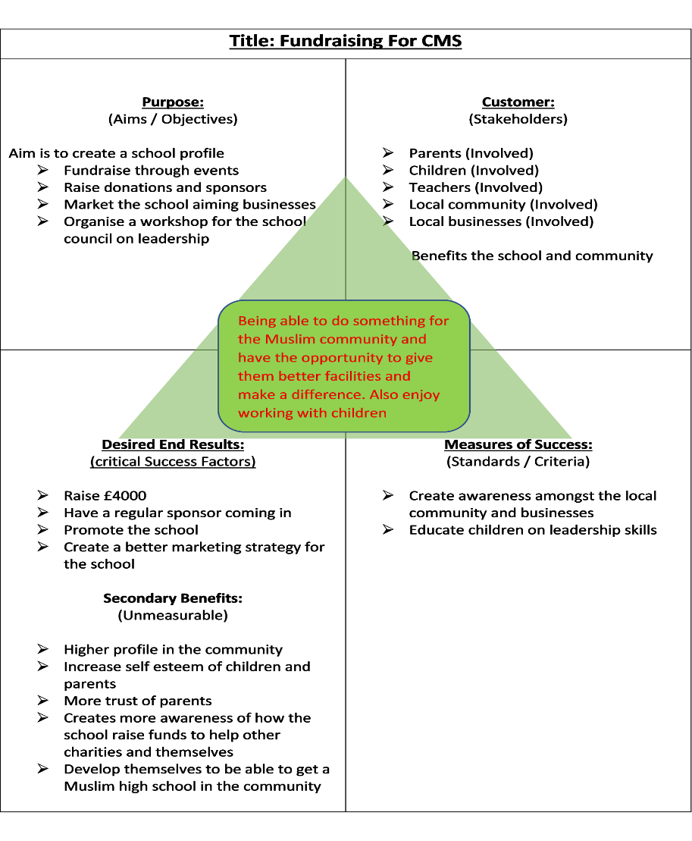

Figure 1.1- Quad Chart

Planning Stage
The planning stage is the second step of the project life cycle, it is here where the organisation set objectives and provides a written guideline to steer the team into the right direction without wasting time or resources (Villanova University,2019). Essentially the planning phase is effective as it provides a written project plan discussing what particular resources, finance and material would be required in the project (James,2016). Planning involves certain processes that require acknowledgment through determining the resources availability, having a project budget in place and, allocating various tasks to team members based on their skills they possess, as it ensures that individuals attention is not diverted to unnecessary tasks preventing any time from being wasted (Villanova University,2019). The planning phase was used effectively by the project team as the project manager planned on creating a schedule to delegate roles to each activity during charity week, by analysing the individuals transferable skills and knowledge (James,2016).
Furthermore, the planning phase analyses various techniques that can help with the performance of the project, such as the stakeholder analysis that helps to identify important individuals that would be involved in the project (Product Plan,2019). The stakeholder analysis categories the levels of involvement, influencers and person of interest by identifying who to focus on first within the model (Product Plan,2019). As mentioned by Bryd (2019), the stakeholder analysis brings projects a great deal of benefits as it helps with connecting with influential stakeholders, that can help to secure and support the project providing valuable contribution and resources.
The stakeholder analysis can involve many stakeholders such as project sponsors, customers and various suppliers (Bryd,2019). Considering the planning phase for the stakeholder analysis, the project team ranked the Muslim community as having the top priority for spreading the awareness much faster, as the community participation can raise the funding by 60 percent than single fundraisers (Galperin,2019). Regarding these stakeholders, communication was achieved by spreading awareness through posters, leaflets and donation boxes in local businesses (Bryd,2019).
Further analysing the Mckinsey 7s framework the organisation can become hard to manage, in relations to Cardiff Muslim primary it is made up of a flat structure, the project team can be overwhelmed by the task at hand. Therefore, the Mckinsey 7s tool eliminate any issues during the planning phase, by analysing the amount of staff that would be needed to finish the tasks during charity week (Jurevicious,2013).

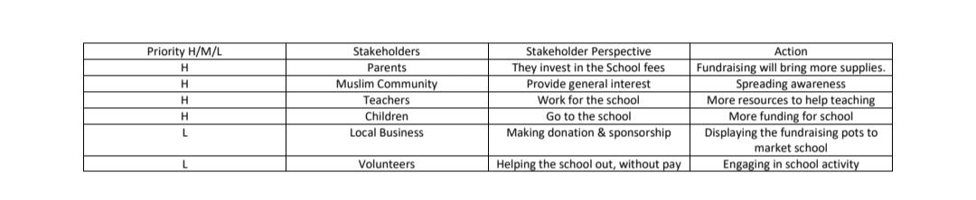
Figure 1.2- Stakeholder Analysis

Executing Stage
Further into the project life cycle the executing phase is than performed as all the previous plans are than delivered to the customer or to the service (Orange Scrum,2019). This aspect is important in the project life cycle as it ensures that all resources, objectives, and deliverables both internally and externally are shared between the team and other stakeholders (Orange Scrum,2019). The execution stage processes consist of acquiring the project team; by keeping stakeholders updated of the progression, also ensuring that deadlines are met by holding a review meeting to manage the project efficiently (Pavlov,2019). For instance, the Cardiff Muslim project team created a Just giving crowd funding page to increase its donations through social media, as sated by NVCO (2019) that social media is an effective form of communicating to other stakeholders on how their donations can make a difference and what support will be required.
It is important that the executing stage is maintained through the Work breakdown structure (WBS), as this an important aspect of the project deliverable it organises the responsibilities, tasks and activities into manageable parts (Work Break Down Structure,2019). Essentially the WBS is formed up of the top down approach, this consists of breaking down the logical chunks into further subheadings (Work Break Down Structure,2019). Whereas the bottom up approach focuses on listing all of the tasks, and rearranging them into a structure (Clayton,2016). For instance, the project team followed through with the bottom up approach by focusing on a few key deliverables such as marketing and awareness, this was progressed through the project by creating posters for charity week and using social media to post the crowdfunding page providing information on the cause.

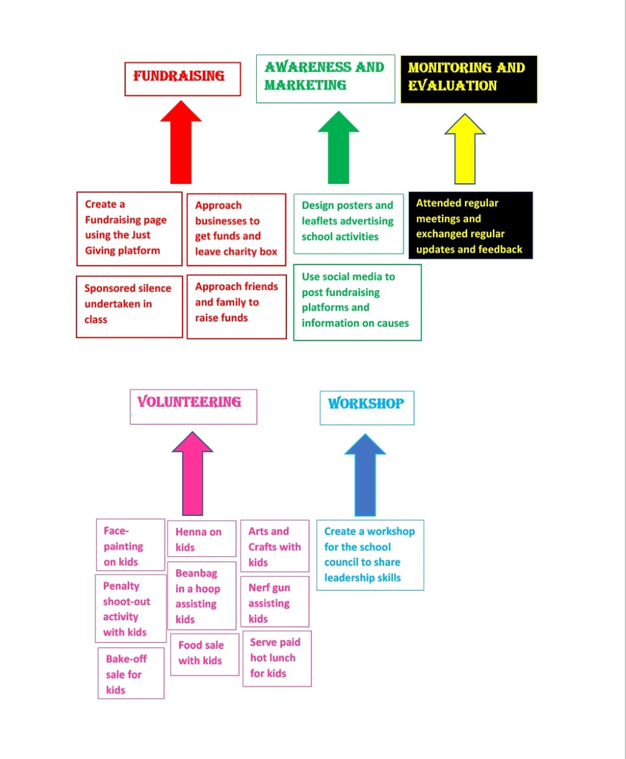

Figure 1.3- Work Break- Down Structure (WBS)

Monitoring and Evaluating Stage
The project is constantly monitored from the beginning of the planning process, it is here which monitoring follows a systematic and routine based method by collecting information from the project (Landu,2018). The purpose of monitoring is to gain learnt experience from the results that can be further processed into a documentation to help with decision making for future plans and practices (Landu,2018). Therefore, once the monitoring is being constantly checked and monitored, the information that is presented is than implemented through the Evaluation stage (Villanova University,2019). The evaluation phase is a process that involves the organisation or team to review all the criteria and tasks achieved from a completed project, evaluation helps to assess the data and information created that help with tactical decision to improve on future projects (Villanova University,2019).
The project team demonstrated an effective use of monitoring and evaluating the project, as it was controlled and maintained by the risk analysis that was used to monitor any risks that may have affected the running of the project (Lavanya & Malarvizhi, 2008).
For instance, the project team recognised the risks present in the project such as having cancellation for the activities during charity week and the workshop, not hitting the £4000 target, also breaking the silence for the sponsored silence, or having the crowdfunding page shut down. All these risks highlighted through the risk analysis enabled the project team to find solutions by rescheduling the activities and regularly monitoring and checking the crowdfunding page to ensure that there is no issues.
It is further demonstrated that the project team have effectively used the technological approach from the PESTLE analysis, through technological advances as Cardiff Muslim primary market themselves through printing out their leaflets and posters to eliminate any effects and potential threats to the project (CIPD,2018).
The iron triangle is presented within the risk analysis showing the interlinked time, cost and quality of the project (Mroz,2017). The project team experienced this as a member that was in control of doing the henna for the charity week, had to focus on ensuring that the quality of the henna was efficient, as well as the time was taken into consideration as the children took their time with choosing what henna design to pick, lastly the cost was measured as the money was spent on the ink and paper for the henna design printouts (Mroz,2017).
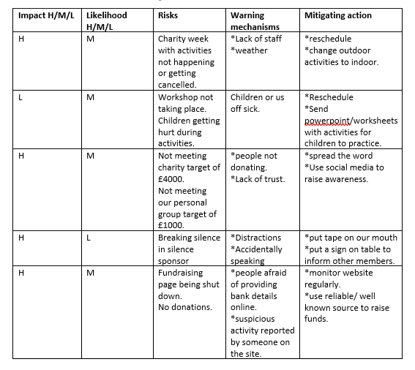

Figure 1.4- Risk Analysis

Closing Stage
The closing stage is the last process of the project life cycle this consists of ensuring that all deliverables are closed, releasing any project resources and finalising and notifying stakeholders the closure of the project (BC Campus,2019). The closing stage allows the project team to reflect and evaluate the strengths and weakness that they faced during the project and enables any suggested improvements to be made for future references (BC Campus,2019). For instance, the project team reflected on the Gibbs reflective cycle that helps to analyse the experiences, as the team achieved the best possible outcome by following the life cycle and keeping in contact with each other at each turning point (The University of Edinburugh,2019). Furthermore, analysing the closing stage there are soft evaluation present as these demonstrate certain processes and changes in attitude (Doyale,2019). For instance, in the workshop the children provided the team feedback expressing what they have learnt from being an effective leader, by expressing and communicating their experiences of the activities. Whereas as the hard evaluation is implemented through the figures as the school raised up to £4825.63 as the end result of the project, it was further implemented as the Deputy head provided the team with certificates to reward them for their achievements (Doyale,2019).
However, it is clear that project team would have preferred to have extra time for the preparation and execution of the workshop activities for leadership as not all games were achieved, as time management helps to increase the effectiveness and productivity (Cassidy,2019). The project team analysed the Gantts chart, this is commonly used to understand the teams scheduled time, by viewing the start and end dates of the project (Project Manager,2019).
The project team implemented the Gantts chart by including various activities from creating posters, attending meetings and having to arrange the workshop. As stated by Bowen (2019), the Gantts chart has its limitations for not presenting the available resources. It is recommended to use the project network diagram, as its purpose is to scope the project it ensures that the details of each task is critically analysed as well as it presents ranges of allocated resources (Christensen,2016).

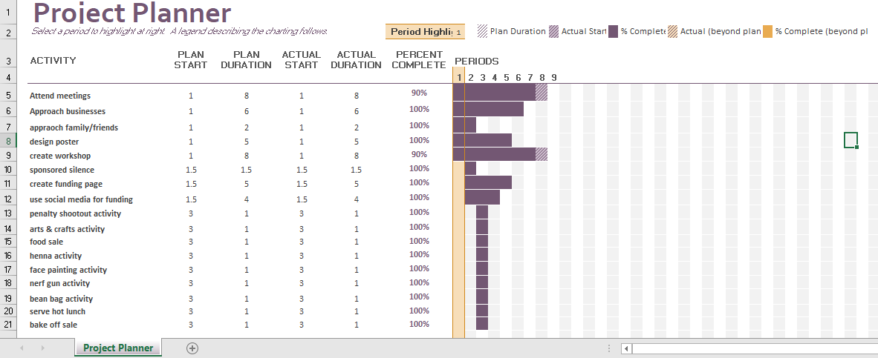
Figure 1.5- Gantt Chart

Conclusion
To conclude the researcher learnt various techniques and tools that helped with managing the time and teams responsibilities (BC Campus,2019). The researcher believes to improve their performance, using the Gantts chart in the initiating stage is a better approach as it helps to keep tasks in order (Ray,2018). Similarly, the Gantts chart was more applicable in the closing stage of the life cycle.
Furthermore, the researcher has room for improvement as the Mckinsey 7s framework in the planning phase reduces the chance of any problems to occur with staff (Jurevicious,2013). The researcher identified that for future projects and development analysing the execution stage, using the top- down approach would have provided the WBS with a lot of logical information and approaches (Work Break Down Structure,2019).
Whereas the researcher can use the Boston chart in the monitoring and evaluating phase to develop and improve themselves to capture the opportunities for future development in the project (Oxford Learning Lab,2019).

References

Apm.org. (2019), ‘What is Project Management’, [Online]. Available: https://www.apm.org.uk/resources/what-is-project-management/. Accessed: [2019, December,14]

BC Campus. (2019), ‘The Project Life Cycle’, [Online]. Available: https://opentextbc.ca/projectmanagement/chapter/chapter-3-the-project-life-cycle-phases-project-management/. Accessed: [2019, December,09]

Bowen. R. (2019), ‘Disadvantages of Gantt Charts- How Can Gantt Charts Stifle Projects?’, [Online]. Available: https://www.brighthubpm.com/project-planning/52723-disadvantages-of-gantt-charts/. Accessed: [2019, December,14]

Bryd. B. (2019), ‘Six Sigma Stakeholder Analysis’, [Online]. Available: https://blog.masterofproject.com/stakeholder-analysis/. Accessed: [2019, December,10]

Cassidy. L. (2019), ‘Project Management: Time Estimates and Planning’, [Online]. Available: https://www.projectsmart.co.uk/project-management-time-estimates-and-planning.php. Accessed: [2019, December,14]

Chegg. (2019), ‘Question: What Is A Quad Chart?’, [Online]. Available: https://www.chegg.com/homework-help/questions-and-answers/quad-chart-quad-chart-one-page-summary-project-visual-well-descriptive-simple-tool-extreme-q25204961. Accessed: [2019, December,09]

Christensen. E. (2016), ‘7 Alternatives to Gantt Charts’, [Online]. Available: https://www.lucidchart.com/blog/gantt-chart-alternatives. Accessed: [2019, December,14]

CIPD. (2018), ‘PESTLE Analysis’, [Online]. Available: https://www.cipd.co.uk/knowledge/strategy/organisational-development/pestle-analysis-factsheet. Accessed: [2019, December,12]

Clayton. M. (2016), ‘Are you a “Top-down” or a “Bottom-up” sort of Person?’, [Online]. Available: https://onlinepmcourses.com/are-you-a-top-down-or-a-bottom-up-sort-of-person/. Accessed: [2019, December,11]

CMPS. (2019), ‘About Us’, [Online]. Available: https://cmpswales.org/. Accessed: [2019, December,14]

Doyale. A. (2019), ‘Hard Skills vs Soft Skills: What’s the Difference’, [Online]. Available: https://www.thebalancecareers.com/hard-skills-vs-soft-skills-2063780. Accessed: [2019, December,16]

Galperin. L. (2019), ‘Benefit of Event Fundraising’, [Online]. Available: https://support.mightycause.com/hc/en-us/articles/360016332172-Benefits-of-Event-Fundraising. Accessed: [2019, December,10]

James. J. (2016), ‘What are the Benefits of Planning a Project’, [Online]. Available: https://www.activia.co.uk/blog/what-are-the-benefits-of-planning-a-project. Accessed: [2019, December,10]

Jurevicius. O. (2013), ‘McKinsey 7s Model’, [Online]. Available: https://strategicmanagementinsight.com/tools/mckinsey-7s-model-framework.html/. Accessed: [2019, December,10]

Landu. P. (2018), ‘How to Improve Your Project Evaluation Process’, [Online]. Available: https://www.projectmanager.com/blog/improving-project-evaluation-process. Accessed: [2019, December,12]

Landu. P. (2019), ‘12 Essential Project Management Skills’, [Online]. Available: https://www.projectmanager.com/blog/project-management-skills. Accessed: [2019, December,09]

Loffredo. S. (2017), ‘Do Your Career and Work Values Align?’, [Online]. Available: https://www.insidehighered.com/advice/2017/11/13/importance-aligning-your-career-your-core-values-essay. Accessed: [2019, December,09]

Mroz. K. (2017), ‘Beyond the Iron Triangle: Infusing Your Projects with Value’, [Online]. Available: https://www.linkedin.com/pulse/beyond-iron-triangle-infusing-your-project-value-kamil-mroz. Accessed: [2019, December,09]

N. Lavanya, T. Malarvizhi. (2008), ‘Risk Analysis and Management a Vital Key to Effective Project Management’, [Online]. Available: https://www.pmi.org/learning/library/risk-analysis-project-management-7070. Accessed: [2019, December,12]

NCVO. Knowhow. (2019), ‘Social Media’, [Online]. Available: https://knowhow.ncvo.org.uk/campaigns/communications/social-media. Accessed: [2019, December,11]

Orange Scrum. (2019), ‘ Execution In Project Management’, [Online]. Available: https://www.orangescrum.com/tutorial/introduction-to-project-management/execution-in-project-management. Accessed: [2019, December,11]

Oxford Learning Lab. (2019), ‘Boston Matrix (Products Portfolio Model)’, [Online]. Available: https://www.oxfordlearninglab.com/p/the-boston-matrix. Accessed: [2019, December,14]

Pavlov. I. (2019), ‘Project Management Life Cycle. Main Steps and Phases’, [Online]. Available: https://www.bitrix24.com/articles/project-management-life-cycle-main-steps-and-phases.php. Accessed: [2019, December,11]

Product Plan. (2019), ‘What is Stakeholder Analysis’, [Online]. Available: https://www.productplan.com/glossary/stakeholder-analysis/. Accessed: [2019, December,10]

Ray. S. (2018), ‘Project Initiation: How to Start your Project Off Right’, [Online]. Available: https://www.projectmanager.com/blog/project-initiation. Accessed: [2019, December,09]

The University of Edinburgh. (2019), ‘Gibbs Reflective Cycle’, [Online]. Available: https://www.ed.ac.uk/reflection/reflectors-toolkit/reflecting-on-experience/gibbs-reflective-cycle. Accessed: [2019, December,14]

Villanova. University. (2019), ‘Five Phases of the Project Management Lifecycle’, [Online]. Available: https://www.villanovau.com/resources/project-management/5-phases-project-management-lifecycle/. Accessed: [2019, December,10]

Work Break Down Structure.com. (2019), ‘Work Breakdown Structure (WBS)’, [Online]. Available: https://www.workbreakdownstructure.com/. Accessed: [2019, December,11]

