

Assessment 1 – Reading Task Template
Upload your photo of your A3 in-class notes here:
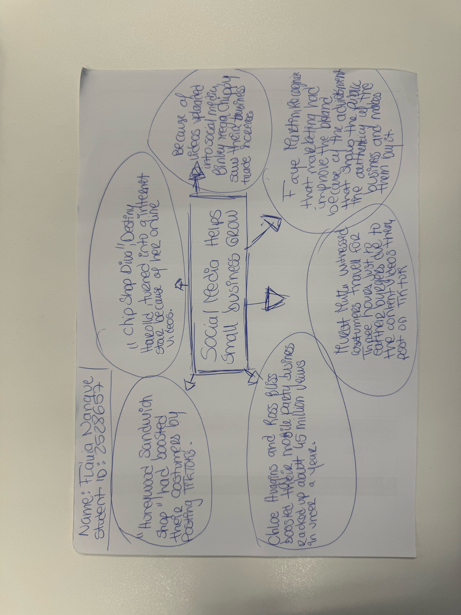

1. Answer these questions using the sentence starters below
a. What is the main idea of the text?
The main idea is to show us the impact of internet , social media consistency can make on the growth of the business’s
b. What are two key points?
One key point is that being consistent on your social media presence such as posting on TikTok or instagram can make your business very successful
Another key point is the fact that customers can share information about the product and make it expand by sharing it on social media platforms
c. What part of the text did you find most important? Why?
The most important part is where we can clearly see that the public make the huge difference to the business, looking into he Honywood Sandwich Shop as an example that on a random Tuesday morning they were packed with costumers because of the contents posted by the costumers themselves.
d. Was anything unclear or difficult to understand?
Everything was very clear
e. How did your group help you understand the text better?
I done it alone
2. One sentence reflection
Question: What did you find challenging about this task?
The hardest part was to do it by myself with the help of my colleagues shared ideas

