James Denton – 1702202
Internet of Things – Smart Cities Applications
Smart & Connected Devices II
Dr. John Rees

TABLE OF CONTENTS

- Task 1 – Smart Road Safety Solutions
  - Abstract
  - Introduction
  - Driver Assistance
  - Traffic Enforcement
  - Autonomous Car Assistance
  - Conclusion

- Task 2 – Smart City Implementation
  - Introduction
  - Design and Implementation
  - Conclusion

- References

Task 1 – Smart Road Safety Solutions

ABSTRACT
Road safety is an important issue to almost everyone, as everyone is either a driver, pedestrian, cyclist, etc. The current road safety solutions do a good job in reducing the number of fatalities per year as the number of drivers continues to rise. However, recent IoT technology presents an opportunity to improve this further by improving driver information, regulating driving behaviour, more efficiently enforcing the rules of the road and creating a more hospitable road network for upcoming autonomous cars.

INTRODUCTION
The research question proposed is to investigate “How can cities leverage the benefits of digitalization to relieve stress on overstretched services and resources?”
According to the Department for Transport, there were 1784 road deaths reported in 2018 compared to 3221 reported in 2004 (and 6325 reported in 1979) [1]. This, despite the number of registered cars in the UK between 2004 and 2018 having risen by 3.1 million [2]. As such, it can be gathered that implementation of road safety solutions has helped to significantly reduce loss of life and improve safety on roads. However, roads can still be made safer and the number of road deaths further decreased, while reducing the burden that is placed on government resources and services. This can be done through the use of IoT (Internet of Things) smart road safety solutions discussed below.

DRIVER ASSISTANCE
One such smart innovation is Dynamic Road Markings. This is a type of road embedded with multiple series of parallel LEDs used to display road markings. This would allow for more efficient redirection of traffic around obstacles using the LEDs to merge and close off affected lanes prior to an accident site or construction zone while also allowing for closing of lanes to improve passage for emergency response vehicles. It could also be used to redirect traffic to a different road entirely. The use of LEDs to replace road markings also allows for greater visibility of lane designation during dark or adverse driving conditions, reducing the risk of a collision caused by moving into a different lane. There is also improvement to safety as a result of better flowing traffic, as the sudden breaking required when approaching traffic could result in a high-speed collision if the driver is not focused. Finally, it also features traffic management benefits in changing the distribution of lanes to support demand [3]. If this innovation was combined with proximity sensors integrated into the LEDs that detect obstructions over top of themselves, it would allow the dynamic road markings to independently route around the obstruction without human input [4]. This would have economic benefits due to not needing large signs or police vehicles to enforce this, as well as safety benefits due to being able to react more quickly, reducing the risk of more vehicles being involved in the crash.
Another smart innovation that could increase road safety is smart speed breakers. These are short, smart speed bumps that lie level with the road and actuate via piezoelectric distance sensors embedded in the roads that detect the speed of a given vehicle. These would be placed within “High risk” areas such as a sharp corner or school zone. If the speed of a given vehicle is judged as too fast to safely traverse the area, the speed bumps activate and slow the vehicle down [5]. As the speed bumps do not deploy under safe speeds, the rapid braking and acceleration caused by static speed bumps does not occur. This start/stop action that is caused by static speed bumps is responsible for up to a 60% rise in pollution within its surrounding area [6]. Exposure to air pollution has been linked to increased risk of premature mortality, lung cancer, chronic bronchitis, and reduced life expectancy [7]. The WHO (World Health Organisation) estimates that 7 million premature deaths annually are linked to air pollution, making it the largest environment health risk worldwide [8]. A report was conducted by Public Health England into costs to the NHS as a result of air pollution. The total NHS and social care cost due to particulate matter and Nitrogen Dioxide in 2017 was estimated at £42.88 million [9]. Hence, the potential savings from reducing pollution are very large.
A further innovation to improve road safety is the smart crash barrier. This would include an environmental sensor to inform on conditions e.g. wet, icy. In addition, a proximity sensor to detect stationary objects blocking the roadway. However, this does not eliminate the possibility of a crash, and as such a micromechanical sensor is used to detect a collision with a barrier i.e. a crash event [10]. This could be combined with existing MIDAS (Motorway Incident Detection and Automatic Signalling) technology first introduced to the M25 Motorway in 1995. MIDAS uses a series of traffic monitoring “loops” imbedded within the road to detect traffic volume and flow. This information is then relayed to the driver via electronic signs positioned upstream [11]. The smart crash barrier could therefore utilise existing signs to communicate an obstruction in the roadway, icy conditions, etc. to drivers, significantly reducing the cost of implementing such a system. A reduction in the number of crashes occurring in general will alleviate stress on emergency services.
Another smart highway safety measure that improves road safety is Acoustic animal deterrent devices. This type of device is in use in Hertfordshire and works by emitting a sound unpleasant to the animal being deterred, in this case Deer. The goal is to deter the animals from going near the roads. This could be used in conjunction with a standard interactive road sign (triggered when a vehicle is exceeding the speed limit) to urge drivers to slow down [12].

TRAFFIC ENFORCEMENT
An existing smart highway safety measure is the installation of average speed cameras (SPECS cameras). These are a series of at least 2 cameras setup along a stretch of road (typically motorway). They utilise ANPR (automatic number plate recognition) to identify the car and enforce any resulting fine. The cars number plate is then recorded at every camera and the time taken between each camera calculated and compared against the lowest possible time given the highest possible legal speed. If the car exceeds this, it must have been speeding and the information is passed on to the relevant authority [13]. A study was performed on several stretches of motorway (the A6514, 1610, B6004 and A631) around Nottingham calculating the annual average casualties on these roads prior to the introduction of average speed cameras. The result was a decrease of over 50% across all routes, thus the contribution to safety by this form of camera is clearly demonstrated [14].
Another type of smart speed enforcement camera is the variable speed camera. This is typically enforced with a series of radar based Gatso cameras [15] mounted to overhead gantries above each lane. These cameras are used to enforce a temporarily reduced speed limit on a motorway. This is communicated to drivers via electronic signs mounted to the same overhead gantries. As a car passes under the gantry, its speed is measured and if the current speed limit is exceeded, a photograph of the car is taken [16]. This should help to prevent drivers travelling at unsafe speeds during poor driving conditions i.e. heavy rainfall, while simultaneously generating ticket revenue.
Another way of leveraging digitalisation to improve road safety is via UAVs (Unmanned Aerial Vehicles) i.e. Drones. These already have widespread use for crop monitoring in agriculture, and have been tested performing package deliveries by companies such as Amazon [17], hence these devices could be adapted to fly to a crash site with a camera attached and capture footage of a given road event and send it via cellular communication to the relevant party. These could also be used for active monitoring of traffic and to report traffic offenses such as using a mobile phone while driving or driving without valid MOT, Tax or Insurance [18]. This could replace fuel-hungry HGVs currently used to enforce this by police [19], save on labour and be deployed in much large numbers than current solutions allow, leading to greater ticket revenue and a greater deterrent to repeat the activity in the future, thus improving safety.

AUTONOMOUS CAR ASSISTANCE
While applying smart systems to help drivers is of paramount importance, the gradual shift toward automated driving is eventually going to result in a majority of driverless vehicles. Hence, road networks should see tweaks to make them more suited to this task. A survey was performed by Philippe Nitsche, Isabela Mocanu and Martin Reinthaler at the Austrian Institute of Technology and given to a number of experts from automotive, academic and R&D industries as well as several public authorities. The participants were questioned on the most important road infrastructure requirements to support autonomous driving. These were: Clear visibility of lane markings, standardisation of lane markings by colour, shape and luminance, distinctive roadwork road markings, complete removal of old lane markings (so as to not confuse the autonomous system) and continuous, visible road delineation and curbs [20]. In order to achieve these requirements, smart solutions such as the Dynamic Road Markings discussed in the “Driver Assistance” section above could be used. To ensure safe conditions on the road, the design of roads will need to be tweaked in the wake of autonomous vehicles and ensure that a spike in accidents that would further strain emergency services does not occur.

CONCLUSION
The goal of this assignment was to find smart road safety improvements that are more efficient than existing “dumb” solutions in minimising strain on resources and services. The first section focused on driver assistance and finding ways to increase safety through electronic road markings that independently detect obstructions and route traffic around. In addition to this, there was also smart crash barriers and MIDAS, which aim to inform drivers of poor road conditions using existing electronic signage as well as driver warning signs with acoustic animal deterrents to help prevent collisions with animals. Finally, there was smart speed breakers, which are speed-actuated speed bumps that only raise for speeders, having the same slowing effect as a static speed bump but without the additional emissions that they create, improving air quality. All of these safety solutions have inherent cost savings simply due to reducing the demand for police, ambulance and fire services, as well as the wider NHS.
The traffic enforcement section focuses on the utilisation of smart technology to more efficiently police the roads and provide fines to those breaking the law. More specifically average speed cameras, which measure the time for a car to travel between 2 cameras to determine if the vehicle was speeding. There are also variable speed cameras, which enforce a restricted speed via electronic signs during poor driving conditions. Finally, there is UAVs or Drones, which are unmanned aerial craft that could be used to enforce driving violations such as mobile phone usage, speeding, lack of tax, insurance or MOT, etc. in greater numbers than with current solutions. The enforcement of these violations results in additional revenue and saves money on human enforcement.
The final section relates to adapting roadways to make them more suitable for autonomous (self-driving) vehicles. This involves efficient removal of old road markings and using continuous and distinctive markings for roads to ensure the autonomous vehicles are not confused and crashes are therefore avoided.
In conclusion, there are numerous ways to significantly increase road safety through the use of recent IoT innovations, however the design of roads will likely change significantly into the future as vehicles become more independent and environmentally friendly.

Task 2 – Smart City Implementation

INTRODUCTION
The theme of this smart city implementation is “smart safety solutions for a university campus.” This was chosen due to its relation to the “smart road safety solutions” theme of Task 1, as well as its compatibility with existing sensors in the chosen simulation software: Packet Tracer. The simulation includes multiple buildings and external areas containing smart devices designed to ensure the safety of all staff and students.

DESIGN AND IMPLEMENTATION
The implementation consists of a series of surveillance cameras placed around the campus area that activate when the motion detector placed alongside is tripped. the physical topology is pictured below. All devices used in this implementation are wired via ethernet to avoid the possibility of interference inherent with WiFi. The CCTV Cameras and Sensors are connected via a dedicated switch located within the university main building (pictured in the Figure below) that can be viewed below in the logical network topology (Figure 4). The function of these devices can be viewed in Figure 2 and 3 below.
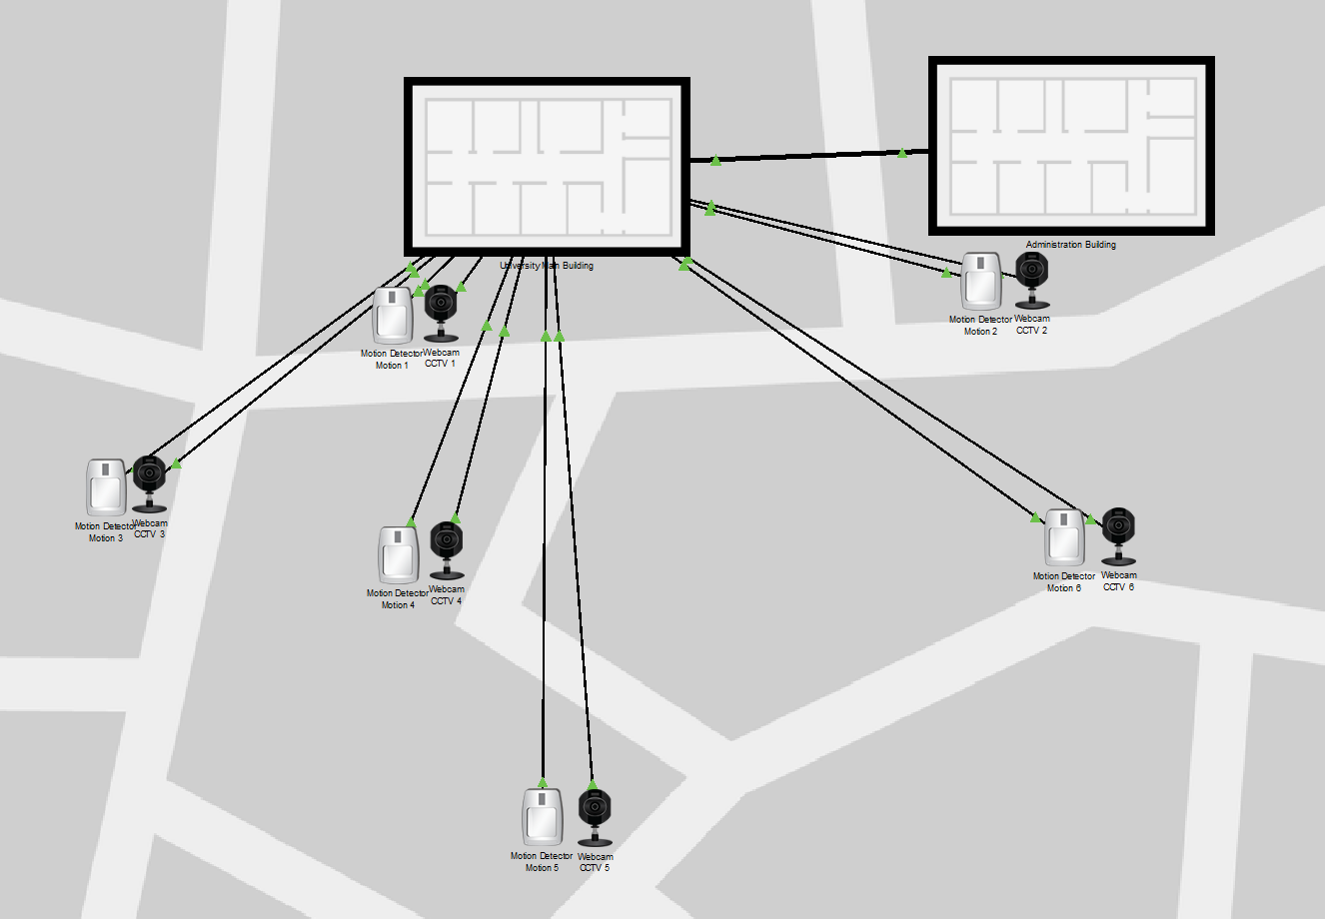
Figure 1 : The Wider Campus, Physical Topology

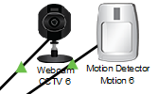
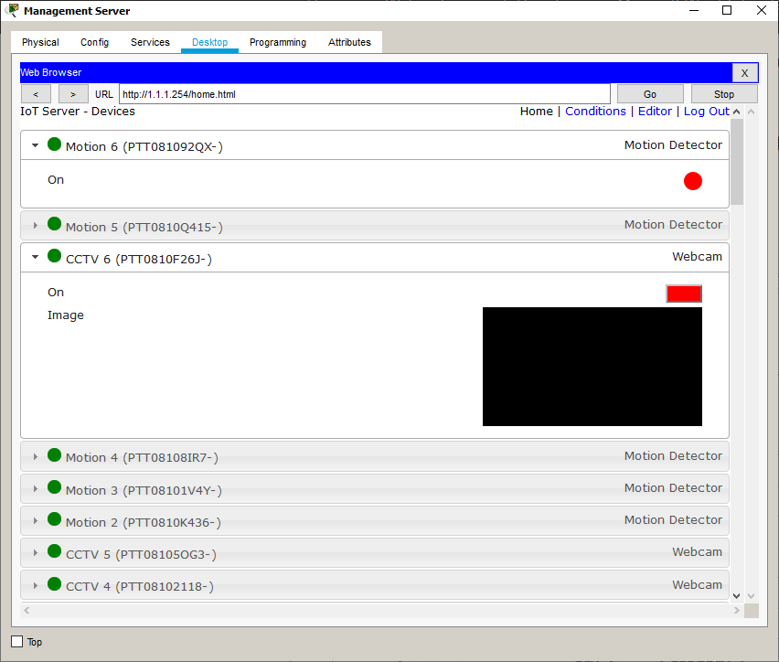
Figure 2 : Camera and Motion Detector, Standby
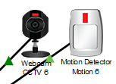
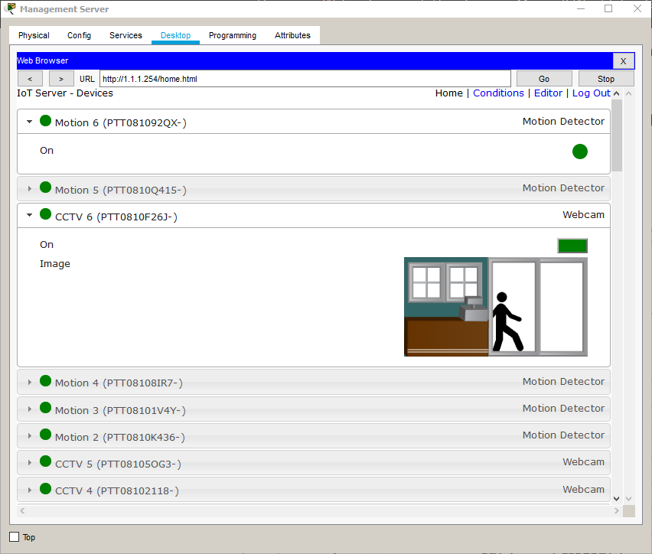
Figure 3 : Camera and Motion Detector, Activated

The logical topology of the network is pictured in Figure 4. This consists of a “primary switch”, into which the IoT Registration Server and all other Switches are connected via Gigabit Ethernet. This helps to ensure that the links do not slow network performance. The Registration Server is used for controlling the IoT devices, toggling them and changing their behaviour with “Device Conditions”.

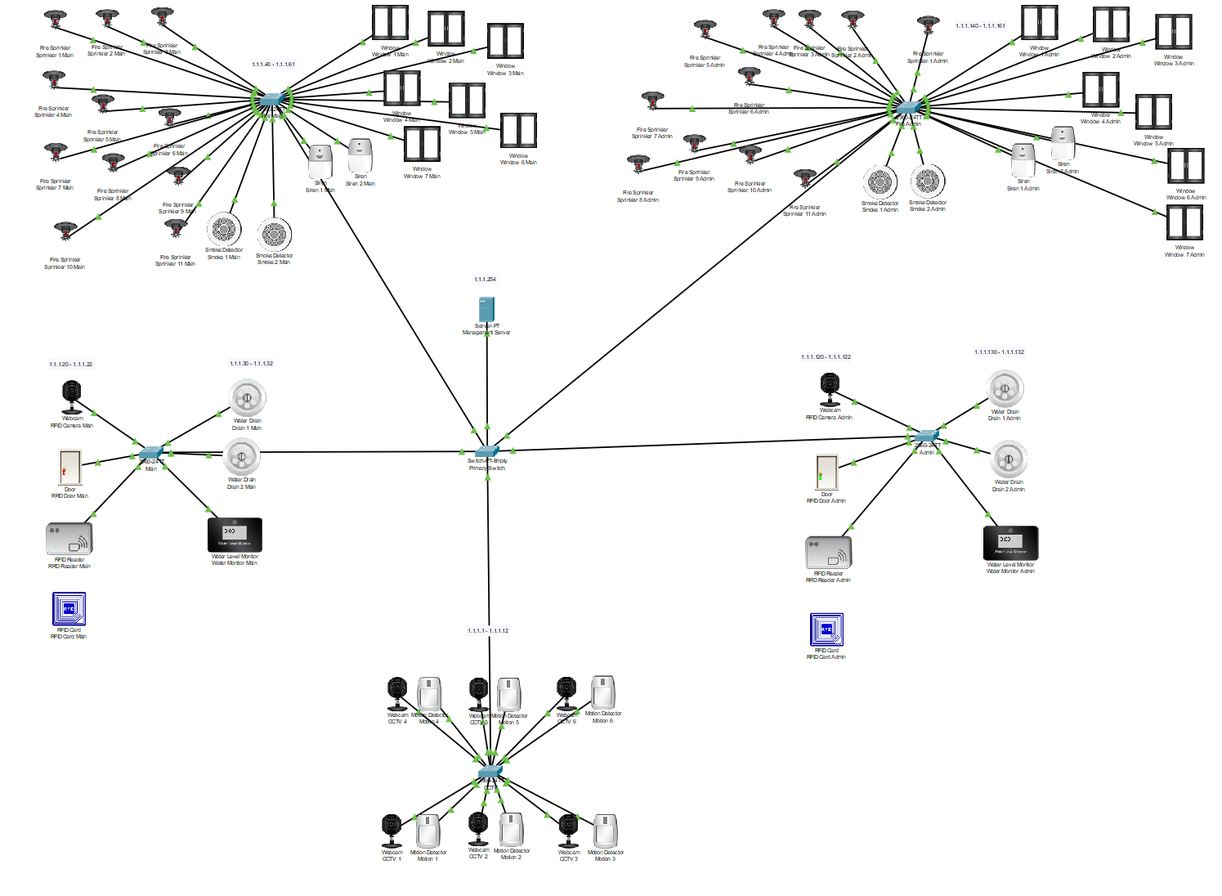
Figure 4 : Logical Network Topology

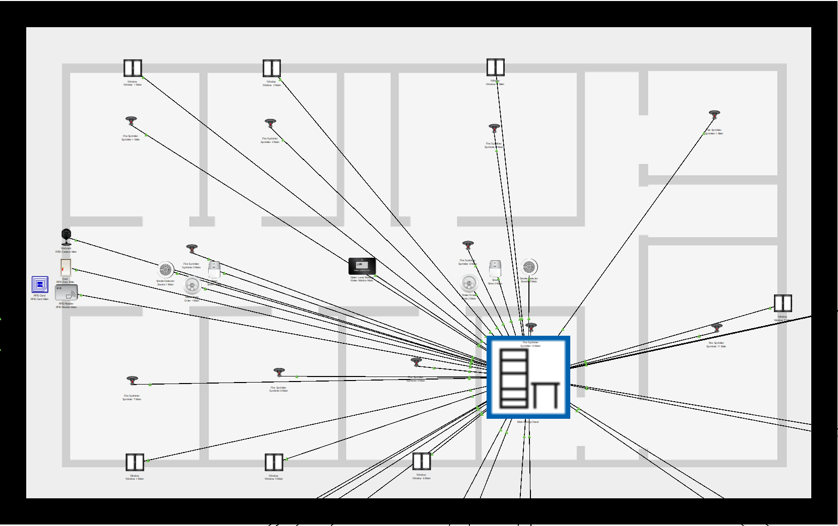
Figure 5 : Main Building, Physical Topology
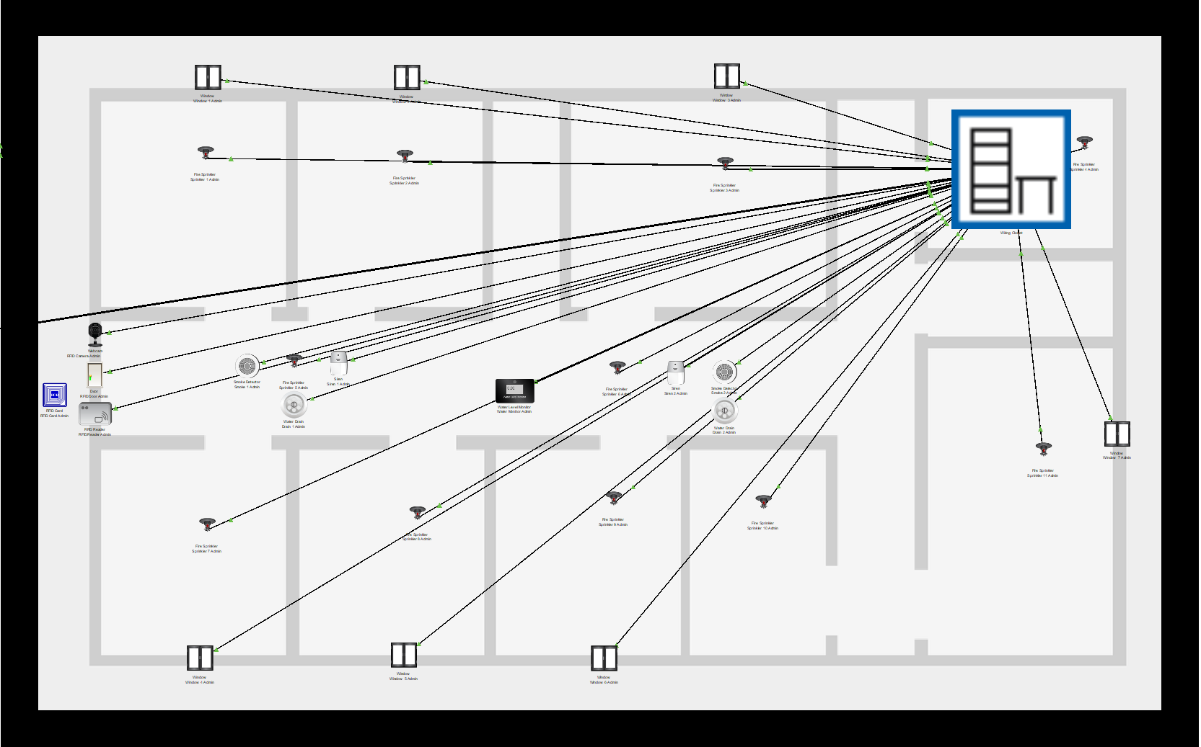
Figure 6 : Administration Building, Physical Topology
The physical topology of both buildings can be viewed in figure 5 and 6 above. All devices are cabled into the wiring closet. The cable connecting the two buildings can be viewed entering the “wall” in figure 6. In Figure 5, the cables for the CCTV Cameras and Motion Sensors can be viewed leaving the topology diagram.
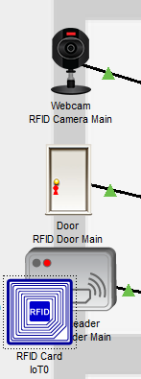
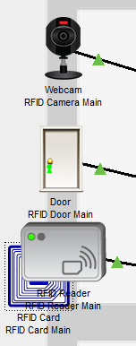
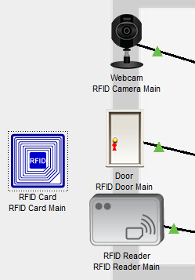
Figure 7 : Function of RFID-Enabled Door
The safety equipment in each of the buildings is the same (other than the CCTV switch located in the main building) and consists of an RFID Reader and RFID-Enabled Door that utilises RFID cards to authenticate people entering the building. When the correct card is presented, the reader sets its state to valid and unlocks the door, or invalid if an incorrect card is presented. A camera then activates to take a photo of the person attempting to enter (pictured in Figure 7).

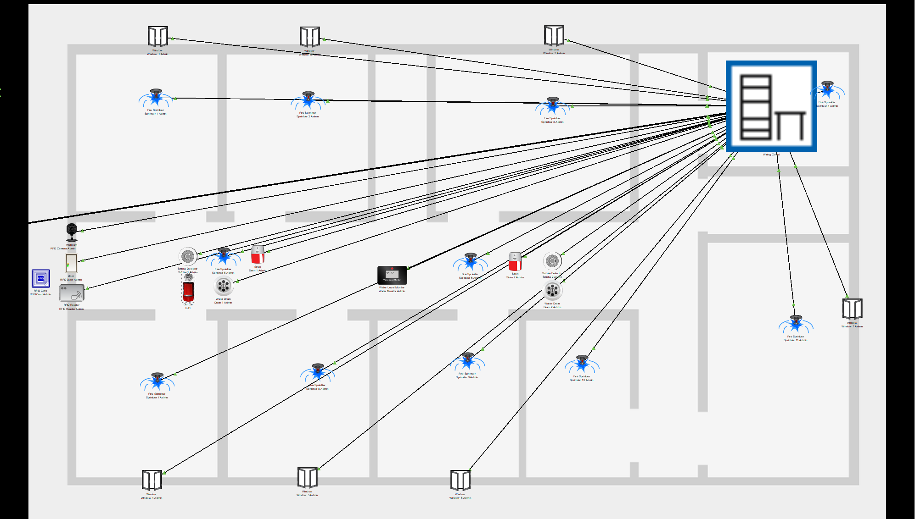
Figure 8 : Fire Prevention System
There is also a water monitor that activates two drains mounted in the floor if the water level is high and the threat is no longer present. These drains are used to attempt to mitigate water damage caused by activation of the sprinklers, which are attached to a different switch, along with 2 smoke detectors, 2 sirens and 7 windows (all IoT-enabled).
If the smoke detector is triggered, the sprinklers activate to attempt to put out any fires and the sirens activate to alert anyone currently occupying the building and instruct them to vacate the premises. Concurrently, the smart windows open to attempt to vacate the smoke from the building and reduce the risk of smoke inhalation.
At this point, if the water level is high and smoke is no longer detected by the smoke detector, the smart drains will activate and drain the water, reducing the potential for water damage. This fire mitigation system can be viewed in the Figure above (the smoke from a fire is simulated by an “old car”). The Device Conditions used to achieve this are pictured below in figure 9 and 10.
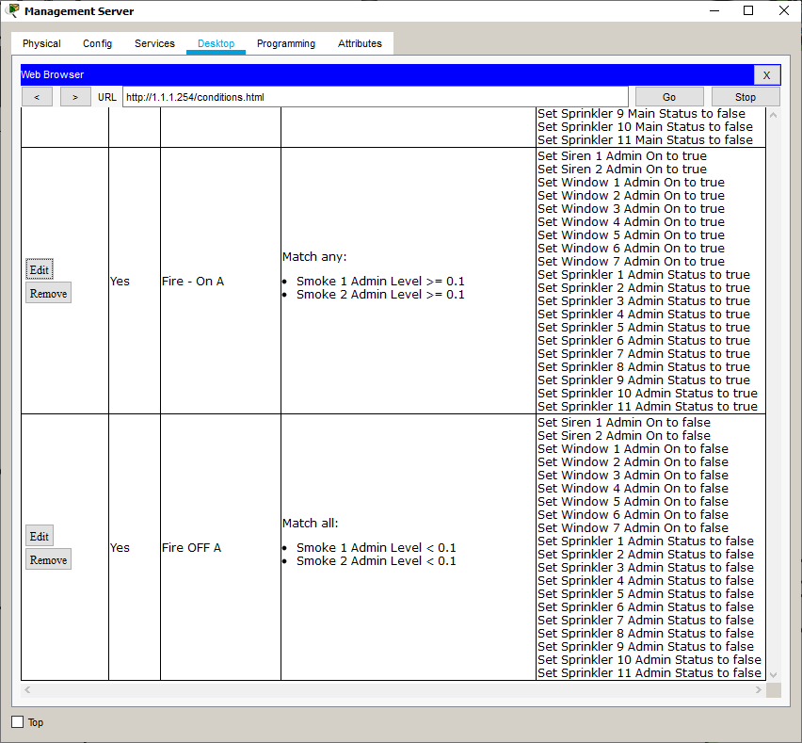
Figure 9 : Device Conditions - Sprinklers, windows, Smoke Detectors and Sirens
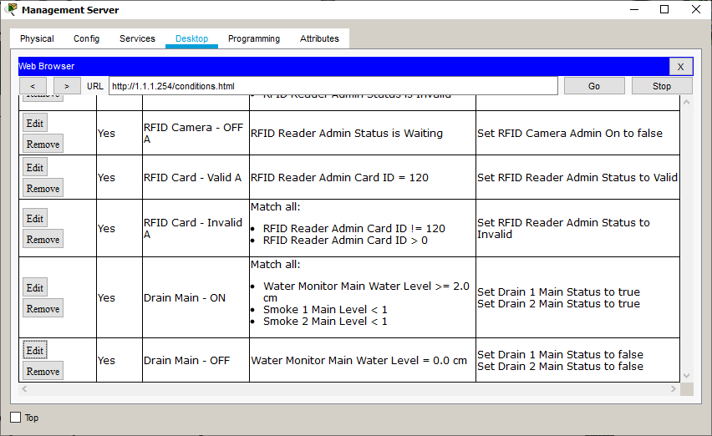
Figure 10 : Device Conditions - Drain and Water Monitor

CONCLUSION
The goal of this task was to implement smart safety features into a university campus simulation. This involved implementing a smart fire mitigation system consisting of sprinklers, drains, smoke detectors, smart windows and sirens, as well as a smart RFID door system that provided access to each building. Outside of the buildings, a smart CCTV solution with motion detectors was implemented. However, the implementation did mostly focus on the interior of buildings and could have involved more safety solutions that focused on the campus itself. The IoT devices included in the packet tracer simulation software limited the implementation of certain solutions discussed in Task 1, such as smart speed bumps. In conclusion, the implementation was a functional system in all ways and hence, a success.

REFERENCES

[1] | Department for Transport, "Reported road casualties in Great Britain: 2018 annual report," Government Digital Service - GOV.UK, 2019.
[2] | N. Sönnichsen, "Number of cars in the UK 2000-2016 | Statista," Statista, 25 November 2019. [Online]. Available: https://www.statista.com/statistics/299972/average-age-of-cars-on-the-road-in-the-united-kingdom/. [Accessed 30 November 2019].
[3] | T. Nguyen, "Ahead of the Curb: Smart Roads," in 2018 IEEE International Smart Cities Conference (ISC2), Kansas City, 2018.
[4] | M. Karpiriski, A. Senart and V. Cahill, "Sensor networks for smart roads," in Fourth Annual IEEE International Conference on Pervasive Computing and Communications Workshops (PERCOMW'06), Pisa, 2006.
[5] | P. V. Manitha, S. S. Anandaraman, K. Manikumaran and K. Aswathaman, "Design and development of enhanced road safety mechanism using smart roads and energy optimized solar street lights," in 2017 International Conference on Energy, Communication, Data Analytics and Soft Computing (ICECDS), Chennai, 2017.
[6] | Smart Bumps, "The real cost of speed bumps - SmartBumps," Smart Bumps, [Online]. Available: http://smartbumps.com/the-cost-of-speed-bumps/. [Accessed 1 December 2019].
[7] | M. Kampa and E. Castanas, "Human health effects of air pollution," Environmental Pollution, vol. 151, no. 2, pp. 362-367, 2008.
[8] | World Health Organisation, "WHO | 7 million deaths annually linked to air pollution," WHO, 25 March 2014. [Online]. Available: https://www.who.int/mediacentre/news/releases/2014/air-pollution/en/. [Accessed 9 December 2019].
[9] | Public Health England, "Estimation of costs to the NHS and social care due to the health impacts of air pollution," PHE publications, London, 2018.
[10] | P. E. M. Frere, "Smart Road Restraint Systems (Smart RRS): Integrating sensing technology into crash barriers," in IET and ITS Conference on Road Transport Information and Control (RTIC 2012), London, 2012.
[11] | P. Morris and P. Negus, "MIDAS system development on the M25," in IEE Colloquium on Incident Detection and Management (Digest No: 1997/123), London, 1997.
[12] | J. Jones, "Technology to reduce road casualties," in IET Road Transport Information and Control - RTIC 2008 and ITS United Kingdom Members' Conference, Manchester, 2008.
[13] | SpeedCamerasUK.com, "SPECS average Speed Cameras Explained and How They Work," Active Alliance Ltd., 8 February 2019. [Online]. Available: https://www.speedcamerasuk.com/SPECS.htm. [Accessed 6 December 2019].
[14] | K. Charlesworth, "The effect of average speed enforcement on driver behaviour," in IET Road Transport Information and Control - RTIC 2008 and ITS United Kingdom Members' Conference, Manchester, 2008.
[15] | SpeedCamerasUK, "Gatso Speed Cameras Explained and How They Work," Active Alliance Ltd., 2019 February 8. [Online]. Available: https://www.speedcamerasuk.com/gatso.htm. [Accessed 8 December 2019].
[16] | SpeedCamerasUK, "Variable Speed Cameras Explained and How They Work," Active Alliance Ltd., 8 February 2019. [Online]. Available: https://www.speedcamerasuk.com/variable-speed-cameras.htm. [Accessed 8 December 2019].
[17] | BBC News, "Amazon makes first drone delivery - BBC News," BBC, 14 December 2016. [Online]. Available: https://www.bbc.co.uk/news/technology-38320067. [Accessed 9 December 2019].
[18] | H. e. a. Menouar, "UAV-Enabled Intelligent Transportation Systems for the Smart City: Applications and Challenges," IEEE Communications Magazine, vol. 55, no. 3, pp. 22-28, 2017.
[19] | Auto Express, "Unmarked police trucks to clamp down on distracted drivers | Auto Express," Dennis Publishing Limited, [Online]. Available: https://www.autoexpress.co.uk/car-news/103215/unmarked-police-trucks-to-clamp-down-on-distracted-drivers. [Accessed 2 December 2019].
[20] | P. Nitsche, I. Mocanu and M. Reinthaler, "Requirements on tomorrow's road infrastructure for highly automated driving," in 2014 International Conference on Connected Vehicles and Expo (ICCVE), Vienna, 2014.
[21] | Centers for Disease Control and Prevention, "Pedestrian Safety | Motor Vehicle Safety | CDC Injury Center," U.S. Department of Health & Human Services, [Online]. Available: https://www.cdc.gov/motorvehiclesafety/pedestrian_safety/index.html. [Accessed 30 November 2019].

