RICHARD VALENTINE MAMUTO
STUDENT NUMBER 2442383
DATABASE ASSIGNMENT

ECORIDE ELECTRIC BIKE RENTAL DATABASE SYSTEM: DESIGN, IMPLEMENTATION AND EVALUATION

Table of Contents
1. Introduction 3
2. Scenario Analysis and System Requirements 3
3. Entity-Relationship Diagram (ERD) 4
4. Data Model and Normalization 5
4.1 First Normal Form (1NF) 5
4.2 Second Normal Form (2NF) 6
4.3 Third Normal Form (3NF) 6
5. Implementation in MySQL Workbench 6
5.1 Schema Creation 6
5.2 Table Creation 7
5.3 Sample Data Population 7
6. Query Development 10
6.1 Query for Ongoing Rentals 10
6.2 Query for Bikes Due for Maintenance 10
6.3 Query for Available Bikes at a Station 10
6.4 Most Frequently Rented Bikes 11
6.5 Bike Maintenance History 11
6.6 Rider Rental History 11
7. Validation and Testing 15
7.1 Primary and Foreign Key Testing 15
7.2 Update and Calculation Testing 15
7.3 Constraint Testing 15
7.4 Nullability Testing 15
7.5 Query Validation 15
8. Design Decisions and Reflection 15
8.1 Use of Controlled ENUM Types 16
8.2 Separation of Rental and Maintenance Data 16
8.3 Allowing NULL for StationID 16
8.4 Inclusion of Calculated Fields 16
8.5 Alignment with Real-World Needs 17
8.6 Identified Limitations 17
9. Conclusion 17
References 18

1. Introduction
Cities are changing their modes of transport drastically with green and dynamic modes of transport being adopted in urban areas. Electric bike rentals are a core segment of this change, which provides low cost and green transportation options as an alternative to conventional transit. Such services need effective data management systems in order to perform well. An effective database does not only facilitate day to day activities of the business but also guarantees the integrity of the data, assists in making decisions and also aids in long term planning of services.
This report outlines the process of creating a relational database of EcoRide, an imaginary electric bikes rental program. MySQL Workbench has been used to design and implement the database, in structured steps such as the analysis of the scenario, my entity-relationship modelling, normalization, population of the sample data, writing of SQL queries, and operational testing. The report provides a description of design choices, the performance of a system, and documents of how the database satisfies the functional specifications of electric bike rental service.
The general objective of the project is to develop a working database which would emulate real-life activities like rider registration, bike availability management, rent processing process and maintenance activities. The below subsections give a detailed description on how the database was conceptualised, implemented and validated.

2. Scenario Analysis and System Requirements
EcoRide is an electric bike rental company run in the city and having a variety of docking stations. The program allows registered clients to rent out bikes at any station and leave them in another. There is a need to maintain the bikes, in order to maintain safety and reliability and this is done by the designated staff members. EcoRide hence needs a database which can hold, manipulate, and retrieve the information in a number of operational fields.
From the scenario, the key system requirements were identified as follows:
- The system has to contain all the details of the riders such as identification and contact details.
- The system should be able to monitor every bike such as the type, condition, battery level, locality, and service history.
- The system should capture the rental transactions, such as, start time, end time, locations, costs and the status of the rental.
- The system should be able to handle the maintenance logs and record the information such as the date of service, description, price, and the staff member assigned to do the work.
- The system should be able to store operational data about the availability of the bikes, the ones that are often rented.
On these requirements, six main entities were determined as follows: Rider, Bike, Station, Staff, Rental, and Maintenance. These objects and the association between them are the basis of the database structure. The relations are reflected in the processes of the real world: riders rent bikes, staff takes care of bikes, and stations serve as collection and transfection points.

3. Entity-Relationship Diagram (ERD)
A logical relationship among the six entities was created in the form of an Entity-Relationship Diagram (ERD) [1]. The ERD captures cardinalities as well as dependencies necessary in the functionality of the system.
Key relationships include:
- Rider to Rental: A rider can have many rentals; each rental belongs to one rider.
- Bike to Rental: A bike may be rented numerous times throughout its lifetime.
- Bike to Maintenance: Each maintenance record links back to a specific bike.
- Staff to Maintenance: Staff members can complete multiple maintenance activities.
- Station to Bike: A station hosts multiple bikes at any given time.
- Station to Rental: Rentals capture the station where the bike was collected and where it was later returned.
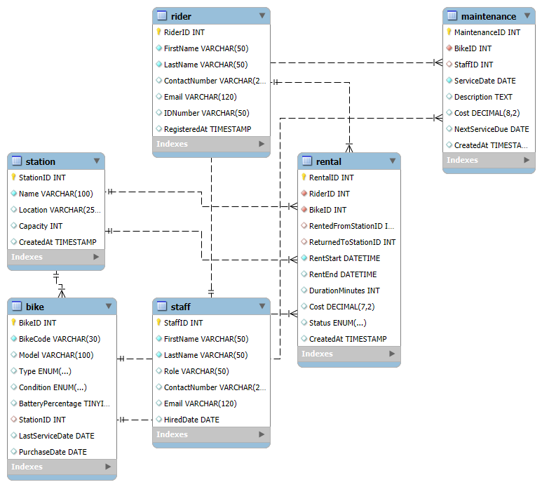
Figure 1: Entity Relationship Diagram
(Source: Obtained from MySQL Workbench)
Each instance has a unique identifier, which is a primary key and referential integrity through a foreign key. Nullable foreign key values were added where it is logically suitable such as in the case where a rental has not ended yet; the return station can be left unused.

4. Data Model and Normalization
The normalization was used to guarantee that a database is of high standards in terms of consistency, and also gets rid of redundancy [2]. Tables have been brought to the Third normal form (3NF) and the rationale of each step is stated below.

4.1 First Normal Form (1NF)
There are no repetitive groups in all the tables. Indicatively, in the Rider table, the attributes are unique with individual first name, last name, email, and identification number with no multiple values per column. Likewise, there are one value of condition, type, and station location of a bike in the Bike table.

4.2 Second Normal Form (2NF)
All the non-key fields are totally dependent on a primary key since each table has one primary key. On the Rental table, e.g. the rental status, cost and duration of the rental are only dependent on the RentalID. Partially dependent requests are nonexistent.

4.3 Third Normal Form (3NF)
There are no transitive dependencies in the database. Attributes do not rely on non-key fields. Indicatively, the description of the maintenance and the service due date are not present in the Bike table but in the Maintenance table along with these values [3]. On the same note, the station information is also centrally stored in the Station table to avoid redundancy.
The normalization process guarantees that every table has its specific purpose, efficient updates, and that the normalization process does not have problems of update anomalies.

5. Implementation in MySQL Workbench
MySQL Workbench was used to implement the database, and its application had a systematic approach including creating a schema, creating tables, inserting sample data, and testing.

5.1 Schema Creation
A separate schema, ecoride_db, was created. This isolated environment enables all the tables, queries and data that are pertinent to the project to exist without any other database. The encoding of characters was configured as utf8mb4 to use universal text formats.
Figure 2: Database Creation
(Source: Obtained from MySQL Workbench)

5.2 Table Creation
Tables were well prepared using the right type and constraints of data. Primary keys were declared as auto-increments to simplify and make it efficient [4]. There were foreign key constraints that were added to uphold relationships within the system. As an illustration, the Station table is linked with the Bike table by the use of StationID, the behaviour of which is ON DELETE SET NULL to avoid the unwanted loss of bike records.
The fields like bike condition and rental were controlled and were of ENUM type. This will provide uniformity in the data keying and will make the validation easier.

5.3 Sample Data Population
Sample data were inserted in all the tables to demonstrate the maximum capacity of the system. The data included:
- The amount of the stations of the different names and capacities is five.
- Five staff with different posts and acquaintances.
- A number of bikes in various stations and among the models of different conditions.
- Records of rentals completed and ongoing of rentals [5].
- Maintenance activities: contains the service history and service requirements.
This data set will enable realistic testing and demonstrate how the database will be functioning in a real operational scenario.
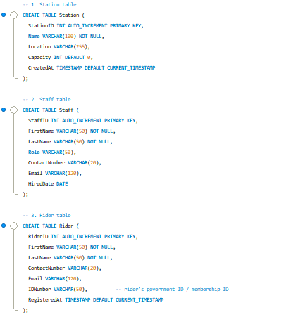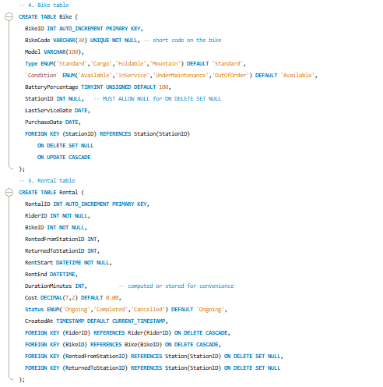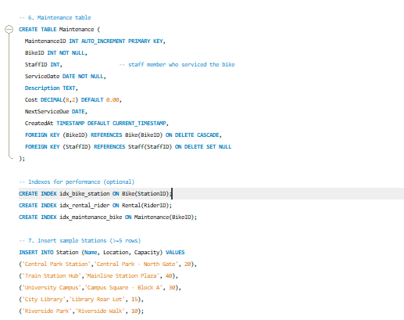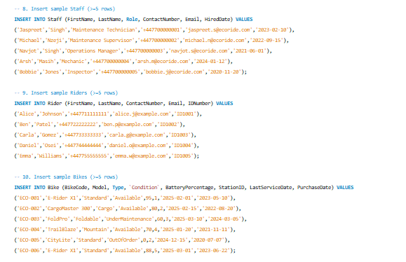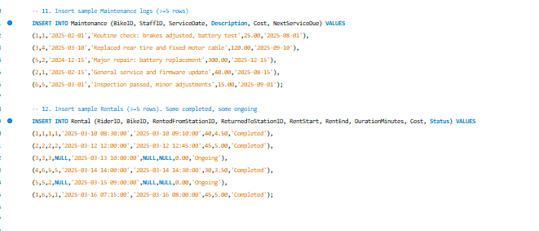

Table 1: Table Creation and data insert
(Source: Obtained from MySQL Workbench)

6. Query Development
Various SQL queries were created to reflect meaningful results and demonstrate how the database is useful in making operational decisions.

6.1 Query for Ongoing Rentals
A query gets all the rentals that are underway. It combines the Rental, the Rider and Bike table to show the times of rental commencement, bike information, and the names of the riders [6]. This will be necessary to track the existing use of assets and predict returns.

6.2 Query for Bikes Due for Maintenance
The other query is that of the bikes that have to be serviced in the next 30 days. This helps in maintenance beforehand thus providing availability, safety and reliability of the fleet.

6.3 Query for Available Bikes at a Station
A station query was designed to show all bikes that availed at a chosen station. This helps the customer service and operational employees to harmonize bikes in the locations in the city.

6.4 Most Frequently Rented Bikes
The query marks the best performing bikes by using the past records of the number of rentals. It can be used in procurement planning, the identification of popular models as well as in optimisation of stocks.

6.5 Bike Maintenance History
An inquiry produces an entire maintenance history of a given bike [7]. It is particularly applicable in audits, troubleshooting frequent problems, and long-term maintenance planning.

6.6 Rider Rental History
All rentals done by a particular rider can be accessed through the system. This makes it transparent, customer questions can be asked and it is easy to follow patterns of use.
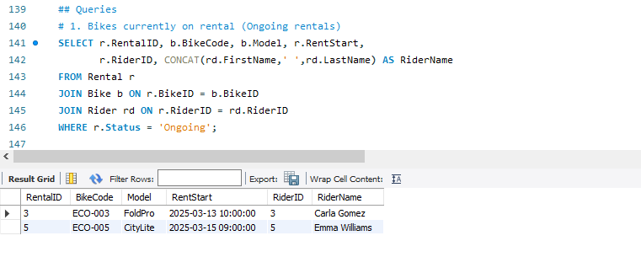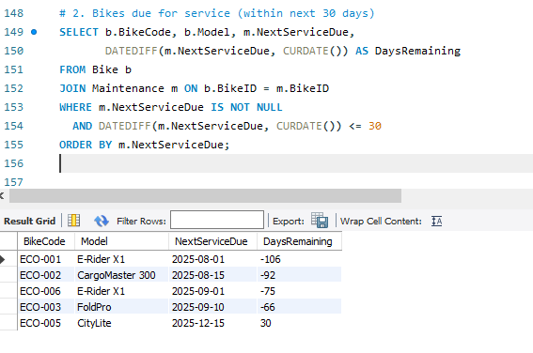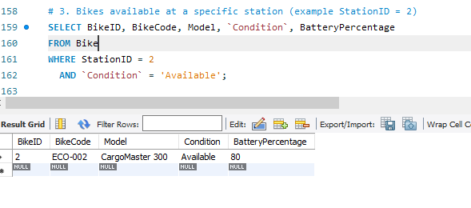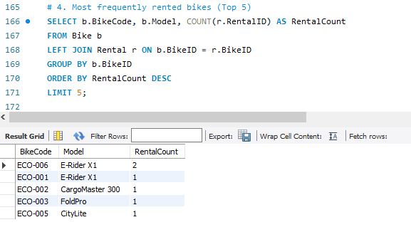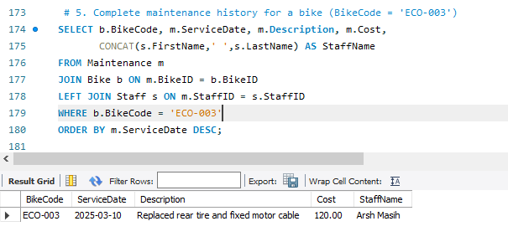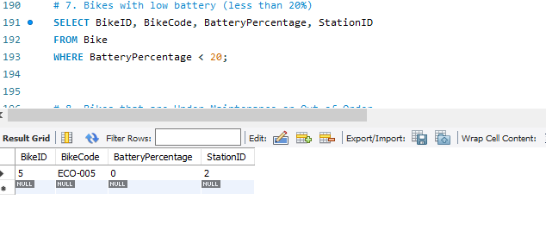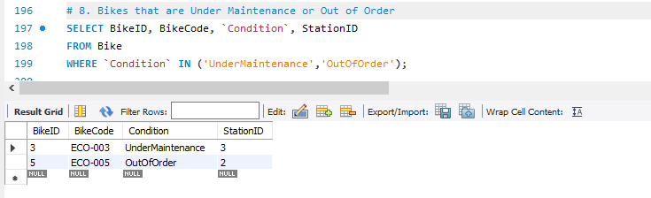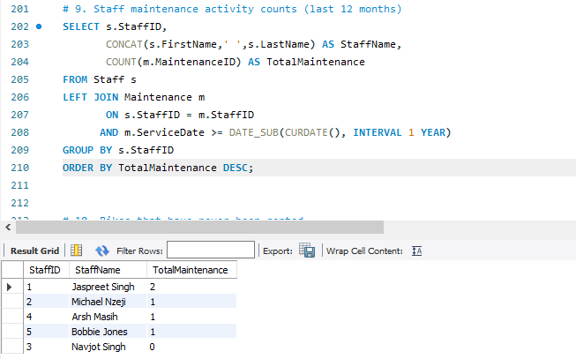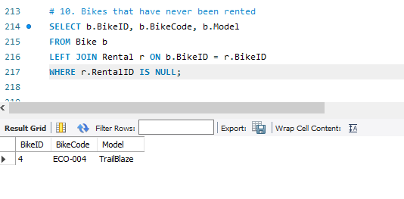

Table 2: Queries
(Source: Obtained from MySQL Workbench)

7. Validation and Testing
A series of tests were conducted to make sure that the database can fulfil all functional requirements and works properly.

7.1 Primary and Foreign Key Testing
Integrity tests were done through the test of trying to add records whose value of the foreign key is invalid. As anticipated, these entries were not accepted by the database, which proves a good referential integrity.

7.2 Update and Calculation Testing
Tests confirmed that the revision of the rental records was right, as it would compute duration and cost in the TIMESTAMPDIFF function [8]. This proves that the database is dynamic in pricing or hourly computing of the cost of renting a car.

7.3 Constraint Testing
Columns receiveing ENUM values were also tested to make sure only valid predefined values could be entered in. The incorrect values caused errors which showed that constraints were enforced correctly.

7.4 Nullability Testing
The database did not allow any errors regarding the fact that it allowed NULL values in a field like ReturnedToStationID and StationID where it should have been. As an example, other bikes that are being serviced temporarily do not have a station assigned to it.

7.5 Query Validation
All formulated queries were put to test and they generated valid and stable results. This proves that the relationships and joins are well formatted.
Insert screenshots of testing outputs here.

8. Design Decisions and Reflection
A number of design choices influenced the evolution of the EcoRide database system each of which was oriented at the provision of the accuracy, usability, and operational relevance [9]. These choices were based on practical considerations, data integrity requirements, and the practical requirements of an electric bike rental business.

8.1 Use of Controlled ENUM Types
Among the major choices was that of relying on ENUM data types when defining the following attributes, bike condition, bike type, and rental status. The system eliminates the problem of publication of inconsistent or invalid entries which are likely to occur due to free-text entry through limiting values to ones that are predefined. This would be a way of standardisation of records and important when considering verification to be done in data entry as well as querying. ENUM uses less room than extra lookup tables, and it has the benefit of being readable and controllable, which is why it is appropriate to fields where the categories are stable and predictable.

8.2 Separation of Rental and Maintenance Data
The other critical design choice was to store the rental activity and maintenance activity in different tables. Despite having a direct correlation to the bikes, the purpose and data type of both processes are diametrically opposite. Rental records are concerned with the rider activity, specification of time, and expenses, whereas maintenance records are related to the technical work, the involvement of staff, and services schedules [10]. The separation of these entities ensures there is no redundancy, ease of reporting and maintaining clean historical records. The separation also enables each table to develop in its own way in case there is a change in the operational needs in the future.

8.3 Allowing NULL for StationID
The move to enable the StationID field in Bike table to take in the NULLs was also a calculated one. Under an actual scheme of an electric bike, the bike might not have a station assigned to it temporarily, such as during inspection, repair, redistribution, and transport. Allowing NULL will guarantee that the system will not display these transitional states incorrectly by compelling false data to be entered. It also facilitates the operation through flexibility of the movement of bikes in and out of stations.

8.4 Inclusion of Calculated Fields
Rental duration and rental cost are some of the calculated fields of the system. Though these values can be calculated dynamically using SQL functions, the direct storage of the values has performance advantages particularly when there are frequent reports or when the data is large. This option is efficient and accurate, because the length of time and expenditure are determined once a rental has been done.

8.5 Alignment with Real-World Needs
All queries and table structures were modeled to help in supporting actual operational functions such as the monitoring of low-battery bikes, tracking of current rentals, analysis of high-demand bikes, and the maintenance scheduling. Such alignment makes the database useful in the daily management and the strategic decision making.

8.6 Identified Limitations
The functionality of the system is subject to a variety of limitations. It has no processing payments, no authentication of its users and no real time telemetry such as GPS or battery diagnostics. These features are not necessary in the specified academic scope, but such options can be done in the future improvements of the system.

9. Conclusion
EcoRide database system is an effective effort to demonstrate how structured relational database is structured and implemented to assist the electric bike rental operations. It has been subjected to scenario analysis and entity modelling, normalization, and implementation using MySQL Workbench, and extensive validation to provide a working system, which is reliable.
The system supports all major operational functions like the management of riders, bike tracking, the management of the rental processing and maintenance. The query development also demonstrates the analysis capabilities of the system that provides an impression of the trends in the rental, maintenance, and deploying of resources.

References
[1]
J. Wamburu, S. Lee, M. H. Hajiesmaili, D. Irwin, and P. Shenoy, “Ride Substitution Using Electric Bike Sharing,” Proceedings of the ACM on Interactive, Mobile, Wearable and Ubiquitous Technologies, vol. 5, no. 1, pp. 1–28, Mar. 2021, doi: https://doi.org/10.1145/3448081.
[2]
K. N. Genikomsakis, N.-F. Galatoulas, and C. S. Ioakimidis, “Towards the development of a hotel-based e-bike rental service: Results from a stated preference survey and techno-economic analysis,” Energy, vol. 215, p. 119052, Jan. 2021, doi: https://doi.org/10.1016/j.energy.2020.119052.
[3]
S. Dunga, O. Oni, and O. M. Longe, “Electronic Booking and Payment Platforms for Inter-Campus E-Bikes,” Engineering Proceedings, vol. 41, no. 1, p. 12, 2023, doi: https://doi.org/10.3390/engproc2023041012.
[4]
J. Kim, T. Jung, Y. Choi, D. Kim, and H. Cha, “Optimizing Profitability of E-Scooter Sharing System via Battery-aware Recommendation,” Proceedings of the 22nd Annual International Conference on Mobile Systems, Applications and Services, pp. 575–587, Jun. 2024, doi: https://doi.org/10.1145/3643832.3661859.
[5]
V. Mega, “The Energy Race to Decarbonisation,” Human Sustainable Cities, pp. 105–141, 2022, doi: https://doi.org/10.1007/978-3-031-04840-1_4.
[6]
S. Suripto, G. A. W. Utomo, K. Purwanto, K. T. Putra, M. Y. Mustar, and M. Rahaman, “Design and Analysis of Solar-powered E-bike Charging Stations to Support the Development of Green Campus,” Journal of Electrical Technology UMY, vol. 6, no. 2, pp. 85–93, Dec. 2022, doi: https://doi.org/10.18196/jet.v6i2.16543.
[7]
H. Zhao, J. Gao, and X. Cheng, “Electric Vehicle Solar Charging Station Siting Study Based on GIS and Multi-Criteria Decision-Making: A Case Study of China,” Sustainability, vol. 15, no. 14, p. 10967, Jan. 2023, doi: https://doi.org/10.3390/su151410967.
[8]
A. Singh, S. S. Shaha, N. P. G, Y. R. Sekhar, S. Saboor, and A. Ghosh, “Design and Analysis of a Solar-Powered Electric Vehicle Charging Station for Indian Cities,” World Electric Vehicle Journal, vol. 12, no. 3, p. 132, Aug. 2021, doi: https://doi.org/10.3390/wevj12030132.
[9]
M. J. Booysen, C. J. Abraham, A. J. Rix, and I. Ndibatya, “Walking on sunshine: Pairing electric vehicles with solar energy for sustainable informal public transport in Uganda,” Energy Research & Social Science, vol. 85, p. 102403, Mar. 2022, doi: https://doi.org/10.1016/j.erss.2021.102403.
[10]
R. Talavera-Garcia, G. Romanillos, and D. Arias-Molinares, “Examining spatio-temporal mobility patterns of bike-sharing systems: the case of BiciMAD (Madrid),” Journal of Maps, vol. 17, no. 1, pp. 7–13, Jan. 2021, doi: https://doi.org/10.1080/17445647.2020.1866697.

