Roxanne Finn

2121653

BMSW4001_birm

Academic and employability skills

Lecturer - Doreen Nyaa Amundam

Task 1 – Academic report

‘What is the most effective way to motivate staff?’

Introduction

There are several ways to effectively motivate staff within the workplace. Throughout this module I will explore different theories and methods to achieve this outcome. I will research different literature to get a good understanding of the various ways you can motivate staff, and which is the most effective.

There are many different theocratical models that explain different factors that attribute to staff motivation.

Throughout this report I will explore and compare these models and I will conclude which I feel is the most effective to motivate staff within their workplace.

We will consider models such as Abraham Maslows Heirarcy of needs, Hertzbergs two factor theory and McCellends theory of needs.

Abraham Maslow defines this within the theory of ‘Maslow hierarchy of needs’. This theory suggests that humans are motivated to satisfy 5 basic needs.

However, HertzBergs two factor theory suggests that motivational needs can be sub categorises in to two area which are hygiene factors and motivating factors.

McCellends theory again is different as it identifies three separate motivating factors.

There are further theories that I will consider within this report before i seek my conclusion.

The different ways that staff can be motivated?

The different factors and ways to motivate staff, these can be sub categorised into key several areas.

- Pay
- Recognition and rewards
- Additional holiday entitlements
- Good working conditions
- Job security
- Personal development
- Career progression
- Additional benefits

Pay – Salary will always be a main motivating factor as staff will always need to be able to live and support themselves and / or their families. When staff feel they are adequately paid for their role they will be increasingly motivated to achieve their desired outcomes within their role. If staff feel they are adequately paid this will further aid their job satisfaction and encourage them to want to do well with in their role. A good salary brings a sense of security and allows them to feel accomplished and gives them a high status which they enjoy. Paying staff well contributes massively to motivation. To keep skilled staff, you will have to pay a competitive salary. If staff performance deserves a pay rise, then they should get one. This will ensure they feel appreciated and valued, in turn motivating them to do well.
If pay rise is not an option another way to motivate is performance-based bonuses for employees. This will show you care about their future. A manager that shows interest and involvement in the future of their employees works wonders for motivation. Being a good mentor and advocate will build trust and motivation about their career ant their future within your company.

Recognition and rewards – Reward management deals with the strategies, policies, and practices needed to make sure that the staff feel valued and how they contribute to the business ensuring the best achievement and team goals is recognized and rewarded. Reward management in action is about the design, execution and preservation of reward systems. Overall, recognition of employee achievements and activities provides a positive environment in addition to motivating employees and improving their overall moods.
Additional holiday entitlements – Another way to motivate staff is to offer extra holiday entitlements for factors like attendance, overtime, reaching targets, years of service etc Being this generous with additional entitlements and doing so annually allows staff flexibility to use holiday entitlement both for restorative breaks and to take time away from work to deal with family, caring or other commitments.

Good working conditions – Good working conditions touch on the working environment as an aspect of the employee’s terms and conditions of employment. This covers many areas such as space, temperature, lighting, ventilation, humidity and welfare facilities, including access to drinking water and cleanliness. This can also cover matters as the organisation of work and work activities like training, health and safety and well-being. As well a healthy work like balance. Thus, motivating staff to work better.

Job security – Job security is very motivating as it’s an assurance that if an employee can keep their job for the foreseeable future with little influences from outside factors. Most people desire job security first and for most as when we are sure that we will keep their job with relative ease and don’t have to worry about different risks that may make them lose their jobs, we can focus on doing a better job and developing our career. Hereby motivating staff to do a great job.

Personal development – Personal development enhances a person’s capabilities and quality of life, motivating potential, the realization of dreams and aspirations. Personal development will take place over a person’s entire lifetime it’s not limited to one stage in life. This is an ongoing act of assessing your life goals and building your skills and quality’s. By developing staff’s personal skills their more likely to feel a sense of fulfilment in their personal and professional life as they grow, progress and succeed.

Career progression – Career progression, simply put, is the progression of climbing the ladder during a person’s work life. Some organisations motivate staff by giving pay rises, being given additional responsibilities, moving them forward, promoting and offering new challenges and opportunities ensuring staff are motivated to get the most out of there career. Also enhancing a person’s self-actualization ensuring they take full advantage of his or her talents while being mindful of his or her limitations.

Additional benefits – Additional benefits can be used to motivate staff. All generations across the workplace appreciate extra benefits. The main four being medical benefits, life insurance, retirement plans and disability insurance. However, these benefits have grown over the years into lots of other benefits at work such as working hours & leave, skills development, food & beverages, employee clubs, activities and gifts.

Maslow theory confirms that the above directly contributes to staff morale within a working team. The diagram below shows how those eight areas feature when motivating staff.

Diagram A
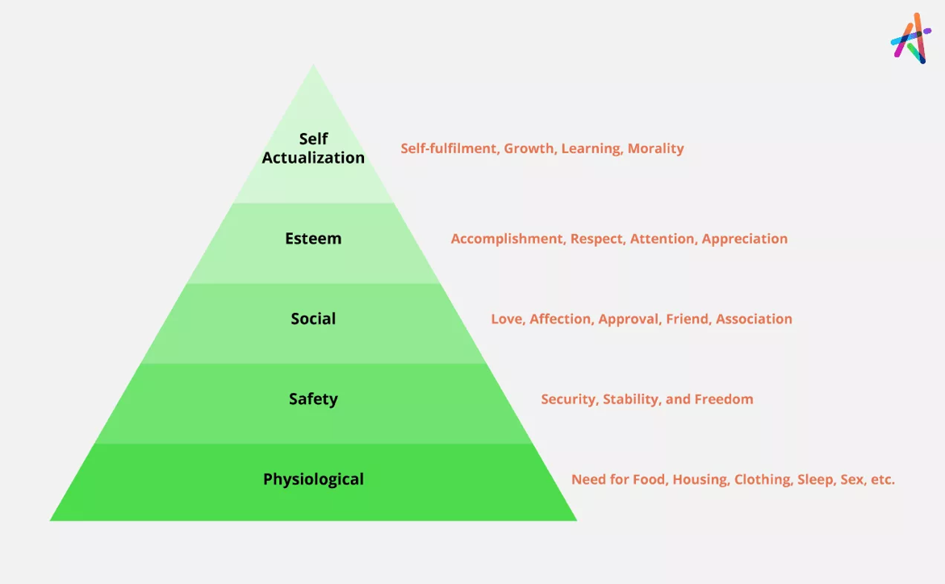

Herzberg two factor theory argues that staff motivation can be placed in to two categories, which are motivation and hygiene theory also known as the two factor theory, published in his “One more time: How do you motivate employees.” The conclusion he came to were very influential and still our seen as good motivators nearly half a century later.

Herzberg conclusion suggests that job satisfaction and job dissatisfaction are not opposites shown in the table below.

Diagram B
Factors for Satisfaction | Factors for Dissatisfaction
Achievement  Recognition  The work itself  Responsibility  Advancement  Growth | Company policies  Supervision  Relationship with supervisor and peers  Work conditions  Salary  Status  Security

Whereas McCellends Theory of Needs suggests the dominant motivators are achievement, affiliation, and power. McCellends also says depending on the person and their character will depend on which motivator will suit them. This depending on our culture and life experience.

Using this theory can help you identify the dominant factors of people in the team. Using two steps.

Step one- Identify the drivers based on the persons personality traits and previous actions.

Step two- Structure your approach by leadership styles ant structuring each personal projects, ensuring to keep the person engaged, motivated and happy whilst at work.

Armstrong and Brown (2019) reward management, argues there are also three driving factors as shown below.

Diagram C

Conclusion
After researching relevant literature regarding the above theories of motivation and reading lots a relevant literature my conclusion of “What is the most effective way to motivate staff” is to ensure staff have sufficient recognition for the work they do.

I have came to this conclusion following extensive research from several different sources that have measured the outcomes of different motivating theories and how they were put into practice. Not only this I have analysed their effectiveness with on the workplace.

Whilst no employee wants to be in a dingy and boring workplace. Keeping working areas well-lit and clean ensures a much better experience. It is clear that recognition for a job well done is the most likely way to encourage and motivate your staff with in the work place.

In the artictle by Philips et al (2017) there is clear evidence that recognition is the most effective way to motivate staff. You can see this where it states:

“A survey presented in Herzberg’s publication of over 1600 employees from various back- grounds including hospital personnel and nurses revealed that job satisfaction is more likely to result from these moti- vating factors as opposed to dissatisfaction-avoidance fac- tors like salary, working conditions, and interpersonal relationships.¹ Specifically, Herzberg’s reported survey iden- tified that achievement and recognition had the largest impact on job satisfaction and may have long-term effects on employees and their attitudes toward work.
A more recent survey performed in 2014 by researchers with the Nursing Executive Center² identified that an area for improvement in staff engagement among nurses was in the pro- vision of recognition related to achievements and contributions to care. This survey was completed by more than 340000 employees within 575 health organizations. Assessment of the survey results revealed that meaningful recognition provided in a timely fashion can lead to an engaged workforce. Providing effective recognition for employees is possible by linking rec- ognition to specific accomplishments, allowing recognition to be delivered by a person who possesses professional impor- tance, and delivering recognition in a timely fashion.³
Overall, recognition of employee achievements and activities provides a positive environment in addition to motivating employees and improving their overall moods”

Based on this evidence I can conclude that happy staff are hard working staff. The more staff feel recognised they are more likely to work hard, in turn give an increased work ethic which will then have several positive outcomes for them and their organisation.

Staff will stay within your business if they have reason to, offering benefits and rewards and giving staff room to grow within the company will create fully motivated staff. Whilst money and benefits are important, they are not the primary motivating factor. If staff feel reward for a job well done, they will be more likely to do an excellent job and see the job through.

Giving employees room to grow within the company is a huge motivator. This could be with more money but also the physiological factor of feeling good, feeling their trusted and respected for their work. A key job satisfaction factor is feeling fully fulfilled at work which can only be achieved by rewards and recognition from your peers or hierarchical management.

I believe motivating your staff by setting clear goals. Some employees love a challenge. Setting achievable goals and rewarding and celebrating these are very motivating. Working towards something. Coming to work every day with the same menial tasks and no goals can become very tiresome and unmotivating.

Being heard at work can also be a major motivating factor for employees feeling their wants and needs are heard. Whether it be an idea for a new process or a different way for their position, listening to their ideas will be very motivating and make employees feel important, however this is still recognition in the sense that it is recognition of their contribution to their work or piece of work.

To ensure you keep staff motivated to work hard and give it their best effort is the key to a successful and healthy business. There will be some employees that need a little nudge to work harder and some employees that will do it off their own back but, in the end, recognition plays the most significant role in motivating employees. A lot of literature suggests that motivation and morale will be improved massively with increased recognition from managers.

Afterall if an employee produces outstanding work that no one appreciates or recognises why would they continue to be a high-performance employee?

Referencing

Abraham Maslow theory of hierarchal needs https://www.knowledgehut.com/tutorials/project-management/motivation-theories

McCellends theory of needs https://www.mindtools.com/pages/article/human-motivation-theory.htm

Hertzburg two factor theory https://www.mindtools.com/pages/article/herzberg-motivators-hygiene-factors.htm

Armstrong and Brown (2019) chapter 1 – reward management

CMI (2001) Eight ways bad managers kill converstion – and motivation.

Cohen (2006)

Philips et al (2017)

https://www.thebalancecareers.com/how-great-managers-motivate-their-employees-1918772

