

Assessment 1 – Reading Task Template
PART 1: Upload your photo of your A3 in-class notes here:
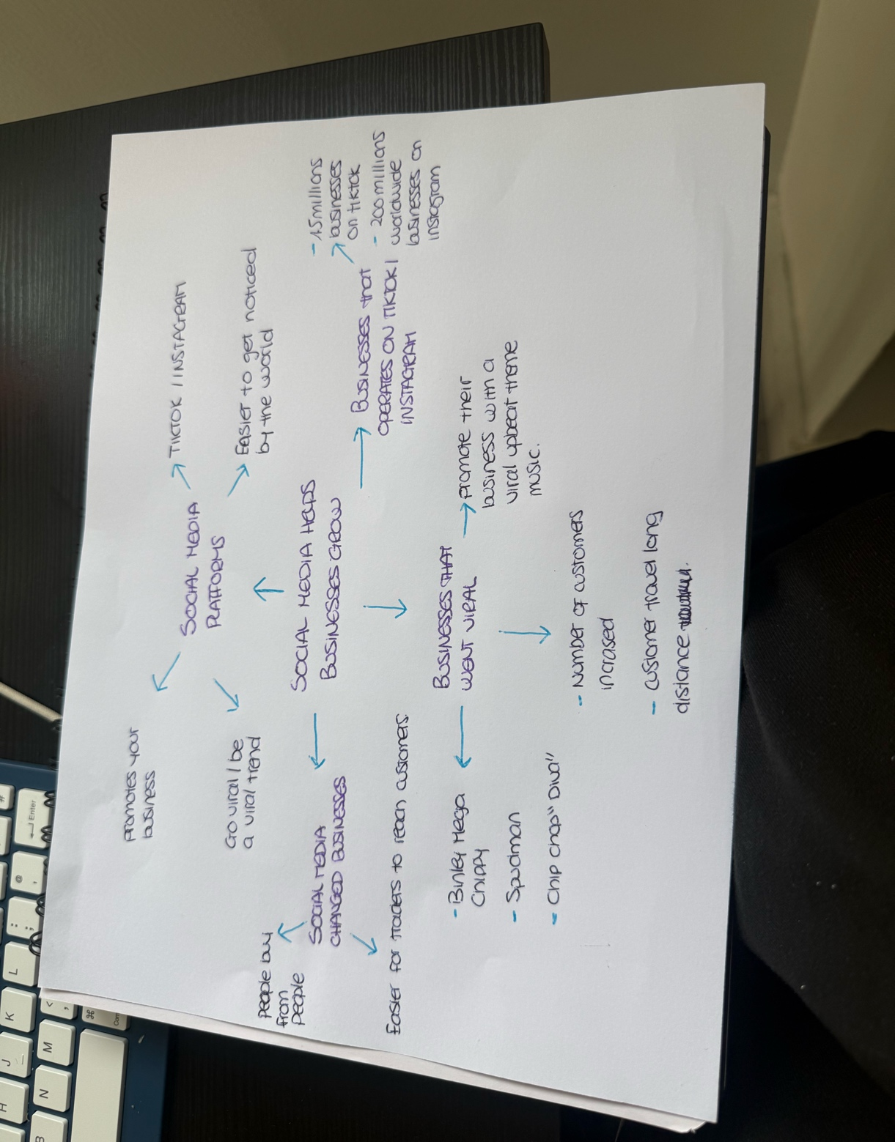

PART 2:
- Answer every question below in 1-3 full sentences.
- Use your own words. Do not use generative AI to answer these questions.
- Include a specific detail from the text when asked.
REMINDER
- The main idea is the overall message of the whole text.
- A key point helps to explain the main idea.
- A specific detail or example from the text shows that the key point is true.

- What is the main idea of the whole text?
The main idea is that social media can help small businesses become more popular, grow their businesses, and get more customers.

- What is one key point that supports the main idea, and which specific example from the text shows this?
One key point is that most businesses that went viral saw their number of customers increase. For example, some customers travel up to 3 hours to get the chicken burger from Honeywood Sandwich Shop.
- What is a different key point that supports the main idea, and which specific example from the text shows this?
Another key point that supports the main idea is that businesses that use Tiktok and Instagram can get millions of views. For example, Little Love’s pamper Bus, that got about 45 million views in under a year.

- Which part of the text do you think is most important, and why?
The most important part is that social media plays a big part in the growth of many businesses because it brings a lot of customers to businesses.

Reflection:
- What did you find difficult in this task (including in-class components), and why was it difficult?
I found it difficult to find the key points because there was a lot of information in the text, so I had to go through it twice to find the key points.

- What helped you with this difficulty, and how did it help you?
Making the mind map helped me organise the information, the key points, and the ideas and understand the text better.

