

[Programme: Certificate of Higher Education Skills for the Workplace (Health & Social Care)]
Module: Introduction to Public Health
Student Name: KEDIJA ALI HUSSEN
Student ID: 2434785
Lecturer Name: Caroline Salami
Submission Date: 11 December 2025

Table of content
Introduction 3
Main body 3
Heart Disease Consequences in the Community and to the NHS 3
The measurement, monitoring and control strategies of heart disease are strategised. 4
Explain the factors influencing the health and well-being of Heart Disease Patients. 5
Conclusion 6
References 8

Introduction
Heart disease also known as cardiovascular disease is the term used to explain a category of diseases that affect the structure and functioning of the heart such as coronary artery disease, heart failure and congenital heart defects. It is mainly triggered by the constriction or clogging of the coronary arteries or improper operations of the heart muscle resulting into a weak blood flow and oxygen in circulation to the vital organs. Signs and symptoms are not serious but are usually accompanied by chest pain, shortness of breath, fatigue, palpitations, ankle dizziness and swelling. Globally, heart disease has been the number one cause of death registering about 17.9 million deaths annually as indicated by the World Health Organisation. It is a significant epidemic affecting the UK population, with an estimated death rate of approximately 160,000 individuals yearly with millions in chronic heart diseases receiving long-term care (WHO, 2025). These statistics prove the magnitude of the problem and the increasing necessity of prevention, early intervention and high-quality treatment services.

Main body

Heart Disease Consequences in the Community and to the NHS
The problem of heart disease is currently one of the most important health issues, both in the world and in the UK, as it causes the premature death, disability, and dependency on health and social care facilities. Being a chronic disease, it leads to morbidity and reduced quality of life due to physical limitation in ability, resulting in numerous hospital admissions and creating unremitting treatment requirements. People with heart disease in the community are usually limited in terms of employment and social performance, as well as independence, which leads to emotional stress and less involvement in society (Conduah et al., 2025). Family and caregivers are also subjected to financial and emotional strains by offering medication, mobility and lifestyle changes.
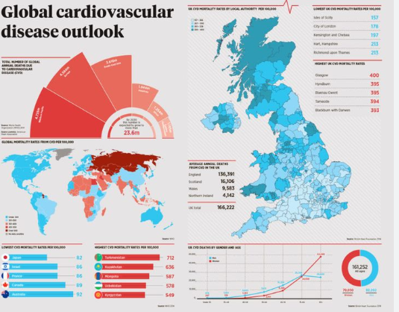
Figure 1: Global cardiovascular disease
(Source: WHO, 2025)
The financial implication on the NHS resources is significant. Heart disease contributes to excessive services used such as emergency admission, cardiac monitoring, and long-term pharmacological care. Campling et al., (2022) point out the economic burden of comorbidities by showing that the cost of hospitalisation due to the corresponding conditions, like community-acquired pneumonia, is significantly higher when heart disease is present. In addition, the specialised cardiac teams, diagnostic technologies and intensive care interventions also add a strain on the budgets of the NHS. The population with underlying cardiovascular disease showed poorer results during the COVID-19 pandemic. Williams et al., (2023) discovered that patients with congestional heart disease were at higher risk of clinical complications through COVID-19, which contributed to the additional workload on healthcare services since the disease increased their hospitalisation and prompting protective clinical procedures. Also, the impact of health inequalities is considered to affect the most as the most affected communities are deprived, which results in a high incidence of heart disease and affects the NHS resources in the poorer communities more. Long-term coordination is also required in the heart disease services. Forsyth et al., (2025) demonstrate that community, primary care, and social support to people with heart failure with preserved ejection fraction (HFpEF) are extremely important and dependable. This underscores the fact that heart disease is a medical issue in addition to being a significant cause of health and social care workload in the country.

The measurement, monitoring and control strategies of heart disease are strategised.
The UK has a policy of monitoring heart disease with components of systematic screening, national data collection, and continuous assessment of risk. The NHS makes use of the NHS Health Check Programme which is aimed at screening risk factors like high cholesterol, obesity and hypertension. According to Wald et al., (2024), this screening programme can be discussed as the equivalent of Polypill prevention measures, which are also expected to prevent the heart attack and stroke prior to their appearance by detecting and controlling risk at the population level.
The data systems are also important, and prevalence and mortality rates obtained by using the public health surveillance would be used to inform policy and resource distribution. Primary care risk tools help clinicians identify and track progression in early diagnosis, and periodic lifestyle, medication response, and symptom changes evaluation can help intervene in time (Blenkinsopp et al., 2025). Pharmacological management is imperative. Polypharmacy occurs in the treatment of heart failure because patients have several diseases simultaneously. Stolfo et al., (2025) offer clinical consensus advice on the management of intricate medication regimens to enhance it and reduce adverse events. To minimise the occurrence of cardiovascular events and deterioration of the disease, preventive medications, such as statins, anticoagulants, and antihypertensive therapies, are administered.
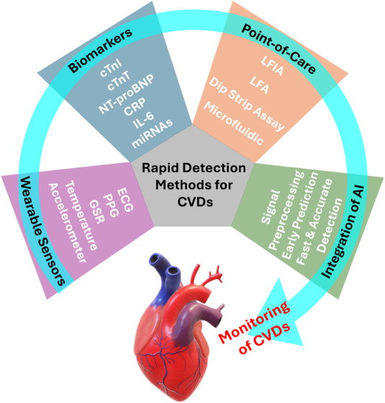
Figure 2: Monitoring of cardiovascular diseases
(Source: Stolfo et al., 2025)
Health promotion campaigns are aimed at lifestyle change which includes smoking cessation, physical exercise, and dietary changes. The approaches show an ecological paradigm, which considers the fact that behaviour is conditioned by the interaction of individuals, medical workers, and broader social contexts (Pronk et al., 2025). Public health programs thus operate at several levels, both at the individual level and a system of environmental obstacles such as access to food, poverty, and secure outdoor areas. Lastly, patient perspectives direct service improvements. Wray et al., (2024) also note that clear communication, emotional support, and continuity of care are important values to people with congenital heart disease. They enhance the efficacy and the availability of interventions aimed to promote heart health.
Heart Disease impacts on Social Care Services
Mental health and counselling services should also be provided in the community to address the problem of anxiety and fear of hospitalisation, which are other challenges that increase the demand (Conduah et al., 2025). Also, the deaths due to the heart disease are usually preceded by the period of palliative care, which presupposes the assistance of multidisciplinary teams. With ageing of the population, systems of social care should be modified to satisfy increased prevalence of chronic cardiac diseases and increased survival rates. According to Forsyth et al., (2025), the number of individuals with heart failure is on the increase, and it requires more closely coordinated channels between hospitals and community care environments.

Explain the factors influencing the health and well-being of Heart Disease Patients
Heart disease is an experience that is influenced by psychological, social biological and environmental factors. Smoking, diet, and physical inactivity are lifestyle practices that continue to increase the disease process and health disparity (Liamputtong, 2025). The poor have fewer access to healthy food, safe places to exercise, and frequent health care and consequently have worse outcomes.
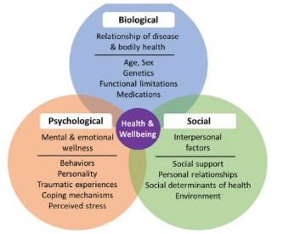
Factor effecting in heart diseases
Source:
Phycological factor
A major role is played by mental health. Uncertainty, anxiety, and depression may affect medication compliance and interest in treatment programs. Witts et al., (2024) discovered that perceived social support is a robust prognostic variable of treatment adherence in adults with non-communicable chronic illnesses. Positive experiences and supportive family networks in relation to healthcare teams consequently become supportive of better outcomes. Health is also further influenced by environmental and community contexts. According to Pronk et al., (2025), the well-being of a population depends on such factors as local green areas, economic status, and occupation. Therefore, the prevention and management of heart diseases demand more than medical-therapy interventions, including using the strategy of promoting equitable and supportive environments through the use of community-based health measures.
Biological factor
Even relationship and intimacy are influenced. Piegza et al., (2025) mention that coronary heart disease causes restrictions that undermine sexual functionality, reducing self-esteem, and relationship satisfaction. Saffati et al., (2025) also position the problem of erectile dysfunction as an indicative of well-being (both physical and emotional). To solve these issues, one must discuss them openly and use sensitive support of the health professionals. The strategies used in coping affect quality of life immensely. According to Conduah et al., (2025), adaptive strategies (self-management education, support groups, and stress-reduction methods) can assist individuals in adapting to their heart disease and living a normal life. Those who obtain education about symptom diagnosis and lifestyle change become more empowered and less hospitalised.
Social factor
It is also determined by the quality of healthcare services. Wray et al., (2024) emphasise that personalised communication, access to digital support, and interruption of care transitions are the elements of good care in congenital heart disease. When services prove to be worse than these expectations, the stress levels among the patients become high which is detrimental to their well-being and to the trust they have on the healthcare system.

Conclusion
Long-term management needs, poor well-being and high costs of healthcare remain a significant burden to individuals, families, communities and the NHS in terms of the heart disease. Morbidity and mortality should be minimised by effective monitoring, prevention and treatment approaches including screening, lifestyle interventions and maximised medication management. Nonetheless, a broad variety of biological, social and environmental factors can influence the condition, which explains why it is important to target not only personal health behaviours but also determine factors that cause health problems on a bigger scale. Enhancing patient experiences and enhancing support networks and inequalities is one of the ways of improving outcomes of patients with the disease. Due to the increase in the population ageing and the increase in survival rates, the demand of coordinated health and social care services will keep on increasing. Thus, heart disease is a severe issue in the context of the broader public health planning, and its continuous enhancement is required in order to provide accessible, person-centred and sustainable cardiac care to the population of the UK.

References
Blenkinsopp, A., Duerden, M. and Blenkinsopp, J., 2025. Symptoms in the Pharmacy: A Guide to the Management of Common Illnesses and Disease Prevention. John Wiley & Sons.
Campling, J., Wright, H.F., Hall, G.C., Mugwagwa, T., Vyse, A., Mendes, D., Slack, M.P. and Ellsbury, G.F., 2022. Hospitalization costs of adult community-acquired pneumonia in England. Journal of medical economics, 25(1), pp.912-918.
Conduah, A.K., Essiaw, M.N. and Ofoe, S.H., 2025. Coping With Chronic Illness: A Systematic Review of Adaptive Strategies Across Cancer, COPD, Diabetes and Heart Disease. Public Health Challenges, 4(4), p.e70129.
Forsyth, F., Deaton, C., Kalra, P.R., Green, M., Harrison, M.E., Tavares, S., Dirksen, A., Kuhn, I., Farquharson, B. and Austin, R.C., 2025. What services are currently provided to people with heart failure with preserved ejection fraction in the UK, and what are their components? A protocol for a scoping literature review. European Journal of Cardiovascular Nursing, 24(1), pp.83-88.
Forsyth, F., Deaton, C., Kalra, P.R., Green, M., Harrison, M.E., Tavares, S., Dirksen, A., Kuhn, I., Farquharson, B. and Austin, R.C., 2025. What services are currently provided to people with heart failure with preserved ejection fraction in the UK, and what are their components? A protocol for a scoping literature review. European Journal of Cardiovascular Nursing, 24(1), pp.83-88.
Liamputtong, P., 2025. Concepts of Health, Health Behavior, and Environments: An Introduction. In Handbook of Concepts in Health, Health Behavior and Environmental Health (pp. 1-17). Singapore: Springer Nature Singapore.
Piegza, M., Smolarczyk, J. and Piegza, J., 2025. Sexual and Cardiovascular health. Factors Influencing on the Quality of Sexual Life of Coronary Heart Disease Patients-a Narrative Review. Vascular Health and Risk Management, pp.51-60.
Pronk, N.P., Woodard, C., Zimmerman, F.J. and Arena, R., 2025. An ecological framework for population health and well-being. Progress in Cardiovascular Diseases.
Saffati, G., Seyan, Z., Rendon, D.O., Almuhaideb, M., Hinojosa-Gonzalez, D.E., Kronstedt, S. and Khera, M., 2025. Erectile dysfunction as a holistic indicator of well-being: a narrative review. Sexual Medicine Reviews, 13(1), pp.11-19.
Stolfo, D., Iacoviello, M., Chioncel, O., Anker, M.S., Bayes‐Genis, A., Braunschweig, F., Cannata, A., El Hadidi, S., Filippatos, G., Jhund, P. and Mebazaa, A., 2025. How to handle polypharmacy in heart failure. A clinical consensus statement of the Heart Failure Association of the ESC. European Journal of Heart Failure, 27(5), pp.747-759.
Wald, N.J., Hingorani, A.D., Vale, S.H., Bestwick, J.P. and Morris, J., 2024. Comparing screening based on the NHS Health Check and Polypill Prevention Programmes in the primary prevention of heart attacks and strokes. Journal of Medical Screening, 31(2), pp.59-65.
Williams, S.G., Frain, S., Guo, H., Carr, M.J., Ashcroft, D.M. and Keavney, B.D., 2023. Clinical risk associated with COVID-19 among 86000 patients with congenital heart disease. Open Heart, 10(2).
Witts, W.K., Amu, H., Kwafo, F.O., Angaag, N.A. and Bain, L.E., 2024. Influence of perceived social support and other factors on treatment adherence among adults living with chronic non-communicable diseases in the Ho Municipality of Ghana: A health facility-based cross-sectional study. PloS one, 19(9), p.e0308402.
HO, 2025, Cardiovascular diseases, Available at: https://www.who.int/health-topics/cardiovascular-diseases#tab=tab_1 [Accessed on 0.12.2025]
Wray, J., Pagel, C., Coats, L., Chester, A.H., Kennedy, F. and Crowe, S., 2024. What does good care look like to people living with congenital heart disease in the 21st century? Qualitative online, asynchronous discussion forums. BMJ open, 14(7), p.e079691.

