UNIVERSITY OF WALES TRINITY SAINT DAVID – LONDON CAMPUS.

STUDENT NAME - ELIZABETH OGUNBANWO
STUDENT ID NUMBER – 1712627
C0URSE NAME - CERTIFICATE IN HIGHER EDUCATION SKILLS FOR THE WORKPLACE
MODULE CODE – BMSW4004
MODULE NAME – PROBLEM SOLVING AND DECISION MAKING (RE-SIT) MAY, 2020
LECTURER NAME – Y. KUMOR
ASSIGNMENT TASK – 4000 WORDS

INTRODUCTION.
Problem solving and Decision Making- This assessment task will analyse , identify and review the main causes of workers difficulties at workplace, the problems they face and the decision they make and how poor decision can affect workers achievement and success, therefore, Personal, I think it is so important that workers are sufficiently aware of problem solving skills and how to apply them systematically. In a nutshell, there is a book that opened my eyes widely on how to solve problems and vital decisions to make, Adair J (Decision Making and Problem Solving, 2013). These problem solving skills can make a big difference to workers career at any stage at workplace.

CASE STUDY : TOY “R” US was established in 1948 by Charles Lazarus with the headquarters in Wayne, New Jersey, United States. It is a toy, clothing , baby product retailer and video game store.
Toy “R” Us spreads across United States, United Kingdom, Australia and France with 807 locations, It was owned by Tru Kids Incorporation.in US, Canada, Portugal and Spain and Scandinavia.

The company net income is $36 million in 2016, while the revenue is $11.5B. in 2016, and the total assets is $6.908B. as of 2016, the company employed over 64,000 employees before liquidation in 2017.
The store Parent is Interstate Department Stores (1966-1978)’ it has many outlets such as Kids “R” Us and Toys “R” Us. This company existed in toy business for over 65 year and established over 800 stores in America. The company
was expanding as a chain company and became the leading toy retail
In 2004, It accepted partnership with Toys for Tots foundation to lead as a donation site for any donating toys or cash donations, according to Toys for tots, this partnership raised over $55 million and donated more than 4 million in toys. This company also made a contribution of $7.6 million to Save the Children initiatives when a natural disaster hurricane Sandy struck also in 2016, the company gave a $1 million grant to ´´Give the Kids the world village.

This company has constantly put in place quality welfare pattern and pledge to take a total measures against vendors, The company was responsible for meeting those standards , it introduced Stricter product safety standard was later in use in 2007, which was exceeding federal requirements, alongside the new standards was a need for materials inside toys to meet a requirement of 250 parts per million of lead for all productions for the retailer.
In July 2001, It later launched an international flagship store in New York ‘s Times Square which was priced $35 million. This 110,000 square- foot store comprised of diverse themed section like an amusement gallery.
Toys “R” Us are responsible for these great products:
- Barbie with a full size dream-house.
- electronic, Jurassic Park
- Lego
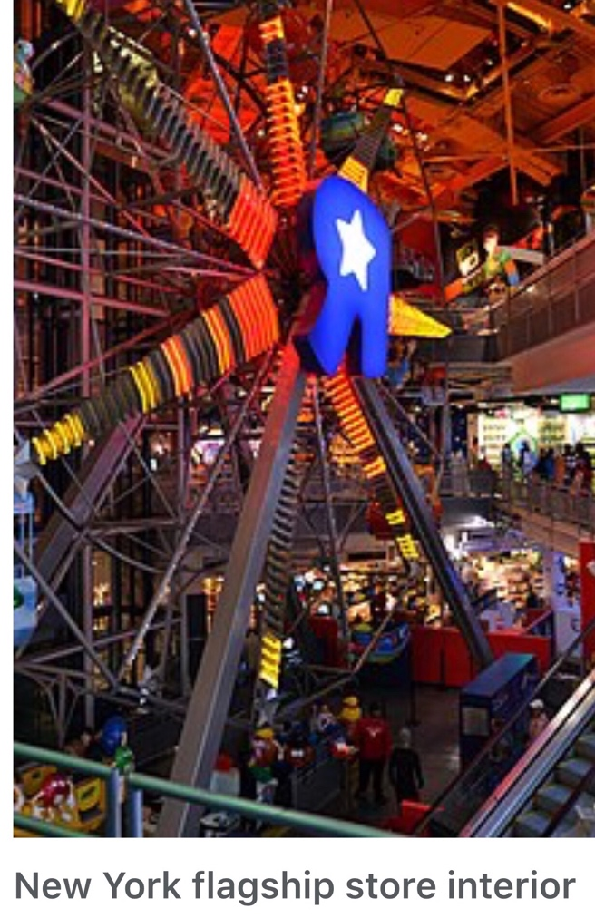
- Wonka and Ferry wheel

All these attracted thousands of tourists all over Europe Asia and Africa for a period of over 12 years. By 18th of September 2017, Toys “R”Us Inc. went bankruptcy, granted that the new move would give room for pliability to deal with $5 billion in long time due debt, the company later took a loan of $2 billion so it can pay suppliers for the forthcoming holiday period and sinked money to upgrade current operations, the company lost $126 million in the same time in the previous year. The company was paying four hundred million dollars a year to pay its debt, which stopped it from investing on improvements to in-store experiences to compete with Amazon and Walmart. U.S and Canadian operations originally would be affected and that the small and big stores but the online sales sites would continue to run.
Organisation: Meaning
Now, if you are to find solutions to organisational problems, you must be aware what an organisation is; There are lots of definitions for an organisation but a classic definition struck me more; Each school of theory—Scott (1961) It is analysed as outstanding , human connection and modern ,aimed to make headway of the reality of corporate development and functioning. However, he explained that there are no looser or winners for fighting over opposing the principles of organisation reality.

SOCIAL & TECHNICAL (SOCIOTECHNICAL) STRUCTURE VIEW
Respective narrators have given us opinions of the scope of organisation and management problems and efforts to improve change and growth. They all identified that the organisation was a social structure and therefore, the quest, technology needs, producers must address the social psychology of an organisation (Katz & Kahn,1978)
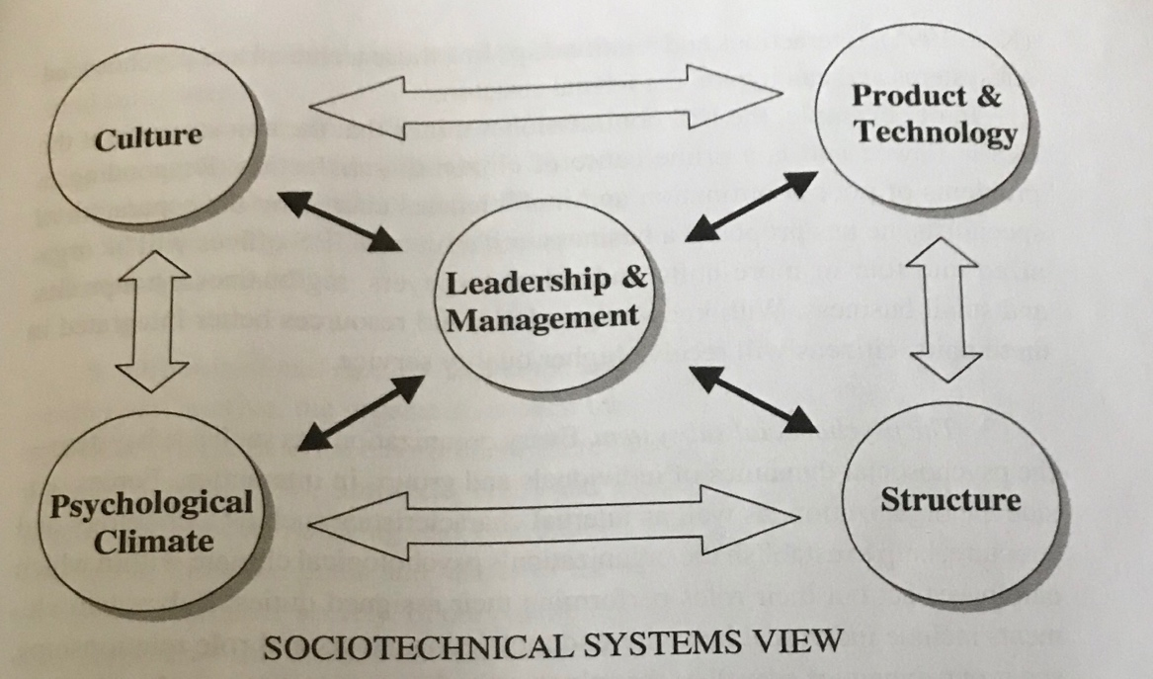

Solutions to causes of problems and how to solve the problem :
- Break-Even Analysis
- Fishbone
- SWOT Analysis
- Pestle Analysis
- Porter five force

Break-Even Analysis.
Break-even analysis is a method used by manufacture department and accountants.This method basically explains production costs such as variable cost and fixed cost at various levels of activity. For example, an establishment with a very low fixed costs will have a lower break-even level of sale. It says what you need to sell either monthly or annually, in order to cover your costs of doing business

- Total variable cost
The costs alter as the manufacture output changes as well. They amount to payment output-related inputs for examples, direct labour, raw substance, fuel and income-related costs i.e as dividend, Bonus, premium .
There is clearly difference between “Direct” variable costs and “Indirect” variable costs.

Direct variable costs are the costs that change as the amount of goods or services that a business produces. These are expenses which are spent in producing goods, wages and raw materials, It’s mainly for products or services.
Indirect variable costs cannot be directly attributable to production, unlike direct variable costs but they vary with output, example is depreciation maintenance and labour costs.

- Fixed costs
Fixed cost doesn’t alter, its fixed with an increase or decrease in the volume of goods. Occasionally, in some cases after a long period of time, fixed costs can change, due to a result of additional new factory unit and so on.
Examples of fixed costs:
- Depreciation
- Rent and rates
- Research and development
- Insurance
- Payment on loans

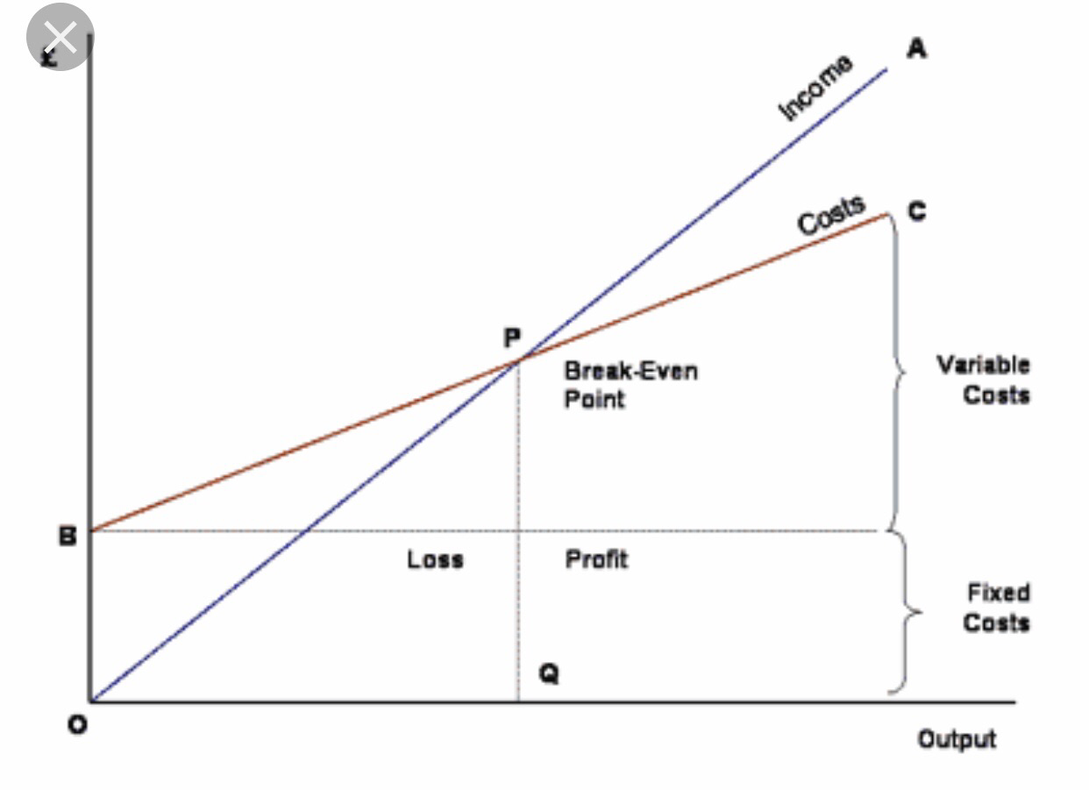

Break- Even analysis technique

SWOT Analysis will be used to examine the facts that will help to recognise the problem in order to inform the decision- making process.
SWOT analysis is a strategic planning procedure used to recognise the value of strengths, weaknesses, opportunities and threats connected with corporate or project planning by an individual or an organisation. This plan is used mainly to assist big and small organisations. For examples: Prices of raw materials, Competitors and customer shopping trends.
Though, it is a simple analysis but the usefulness of of it framework analyses a company ‘s strengths, weaknesses , opportunities and threats. It helps you to give your special attention on your strengths, reduce threats and take the greatest possible approach to opportunities available to you.

There are four components of SWOT Analysis namely:
Strengths, Weaknesses, Opportunities and Threats, These named components can also be classified into 2 factors.
The internal factors and the external factors. According to Albert Humphrey that led a convention at the Stanford Research Institute between 1960s and 1970s (to these days it’s called SRI International) using data from Fortune 500 companies Although Humphrey did not claim the invention of SWOT and the origins still remain unknown.

Internal Factors
- The Internal factors are strengths and weaknesses, it simply means the resources and experience that are currently available at an organisation, ie
- Financial resources that consist of funding income and investment opportunities.
- Physical resources, this includes locations, facilities and equipment
- Human resources includes employees, volunteers, target audiences
- Access to natural resources, regarding trademarks, patent and copyrights.
- Current processes of employee programs department Hierarchies and software systems in the organisation.

External Factors
- The External factors are Opportunities and Threats.
External factors influence and affects every company, organisation and individual. It is specifically talking with reference about things you or your company do not control such as:
- Market trends, new products and technology.
- Economic trends, national and international financial trends.
- Funding, donations, legislature and other sources.
- Demographics / ageing population
- Relationships with suppliers and business partners.
- Political environment and economic regulations.

Based on Business news daily owned by Linda Pophal, the CEO of Strategic Communications Consulting firm, she attributed that strategies should be focused on leveraging strengths and opportunities to overpower weakness and threats. Pophal continued by saying that this is the part of strategy development where organisations have an opportunity to be most creative and where innovation ideas can emerge but if only the analysis has been appropriately prepared in the first place.

Strengths
- Everything that the company does exceedingly well.
- All the qualities that singles the company out from the competitors.
- Real assets like intellectual property, capital, proprietary and technologies.
- Internal resources like skilled and intelligent staff.


Weakness
- Tangible assets the company lacks
- The competitors do better than the organisation.
- Limitation of resources.
- Lack of unique selling preposition.
- Ideal location for company success.

Opportunities
- Little competitors within the area
- Inadequately provided market for specific products.
- Sudden needs for products and services.

Threats
- Negative press/ Media coverage.
- Changes in regulatory environment.
- Poor customer relation or attitudes.
- Emerging competition.
- Market demand dries up.
- Natural disaster.
- Shortage of materials.
- Future development in technology.

Pestle Analysis
This is generally a device that is used in breaking down and complying with the macro- environmental elements that may have a progressive impact on an organisation‘s products . This tool is very needed and useful when creating a new business or getting to a foreign market- “Business to you” (2016). Mostly used in partnership with other logical business tools, for an example SWOT analysis.

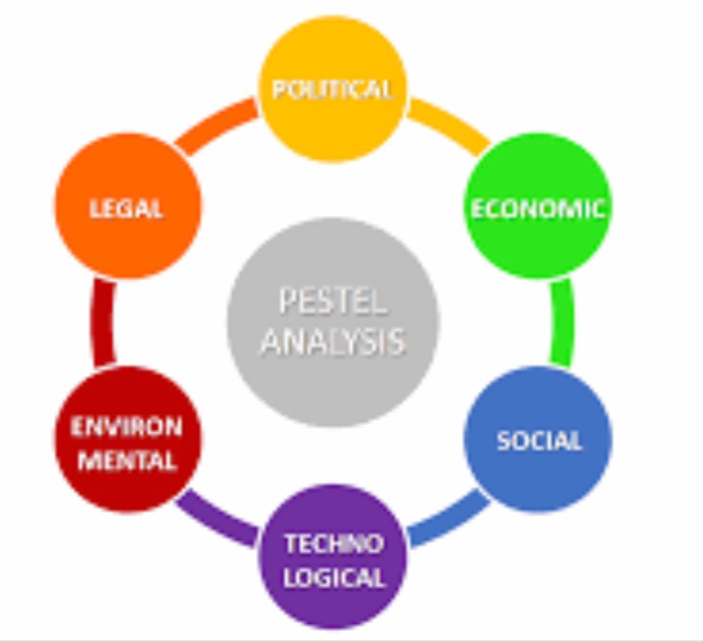
Pestel Analysis Diagrams

Political factors
There must be consideration concerning government control on businesses , which includes government policies, political stability or instability, tax policies and corruption foreign
trade policy. There are so many features of government policy that can affect business mainly because firms and organisations must follow the law. Political factors can impact business organisations in so many ways:
- It could put on a risk factor and cause a major loss.
- It could cause an increase and decrease in tax.
- It is among the tiniest expected factors.

Below are the list of political factors affecting business:
- Corruption level
- Tariffs
- Bureaucracy
- Trade control
- Freedom of the press
- Education law
- Employment law
- Anti-trust law
- Environmental law
- Health and safety law
- Competition regulation
- Regulation and deregulation
- Government involvement in trade and unions and agreements
- Important restrictions on quality and quantity of product.
- Consumer protection and e-commerce
- Laws that regulate environment pollution.

Economic factor
This factors includes economic growth, interest rates, employment, unemployment rates, inflation foreign exchange, and the cost of raw materials. These factors are macro-economical factors and micro-economical factors.

Social factors or socio-cultural factors
Organisation must focus on social environment and identity emerging market trends that will help the organisation marketers to understand their customers’ needs and wants. These factors are change in family demographics , attitudes of the population, age distribution, level of education health consciousness and career attitudes .By so doing, marketers can understand customers and consumers.

Technological factors
This factor explains the rate of development, innovation, and technology advancement and upgrade an organisation needs.It is fast and greatly impact the way we market our products and services. Technological factors affect marketing positively:
- New ways of producing goods and services
- New ways of distributing goods and services
- New ways of communicating with target market.
- Research and development.
- Automation

Legal factors
There are legal laws to adhere in an organisation in order to operate a successful business. health and safety, equal opportunities, advertising standards, consumer rights and law, product labelling, international trade regulations restrictions and product safety. All companies must know these in order to market successfully.

Environmental factors
Climate change is a very important factor to be considered when we are discussing about environmental factor because it is a natural occurrence. Examples are increasing scarcity of raw materials, pollution targets and recycling waste disposal and doing business as an ethical and sustainable company.

Major reasons why Toys “R” Us Failed.
- Toys “R”Us relied on holiday sales to stay on
- It failed to innovate its business model
- Ignoring the usefulness of mistakes
- Failure to incorporate technology and adapt to changing
- It failed to notice consumer behaviour
- Struggling to design and accept product development.
- Failure to accept that shopping experience has moved online. The Wharton School, Knowledge@Wharton partners.(podcasts).

On January 2018, the company announced it would liquidate and close up to 182 of its stores in the U.S as part of its restructuring, as well as convert up to 12 stores into co- branded Toys “R” Us and Babies “R” Us stores. On June 29,Toys “R” Us shut down all of its remaining U.S. stores, after 70 years of operations.
The company operations in other international markets such as Asia and Africa were less affected but chains In Canada, parts of Europe and Asia were eventually sold to third parties.

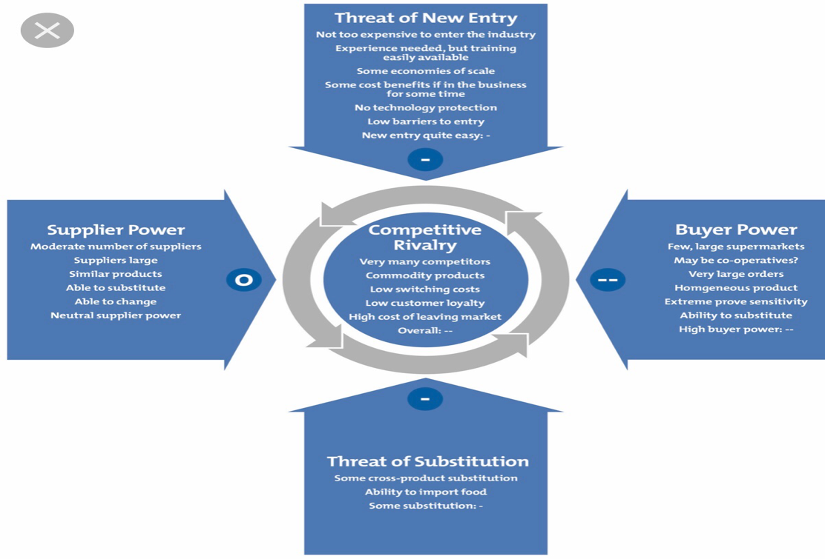
Porter’s five forces
According to Micheal Porter, a Harvard Business School Professor, ( Porter’s, M. 1979), In his model he inspires companies to look far off their competitors measures and study what other points could help improve the business nature. press forward to achieve their laid down goals.framework is a tool for analysing competition of a business. It assess the threats to the profitability of your business strategy by identifying who holds the balance of power in your market or situation.

Porter’s five forces framework
- Threats of new Entry
- Threats of Substitution
- Bargaining power of suppliers
- Bargaining power of buyers
- Competitive rivalries.

Threats of new entry :

Threats of new entry Toy ´´R ´´ US failed because they did not quickly introduce innovation and modern technology into the business, to enable them compete with their competitors both small once and big players in the industry.
Customer Service in the business decrease because most of their competitors were offering better products with better health and safety standards in the toy industry .The prices of their competitors were cheaper with good quality so it was quite easy to loose existing customers to their competitors therefore this translates to the company loosing money making the business not profitable.(Porter‘s, M.1979)

Threat of substitution :

However, the threat of Substitution occurs to Toys ´´R ´´ Us loosing their sales volume to their competitors due to quality and products cheaper prices comparable in the toy industry. It’s quite sure that in business customers will always shop around source where they will get better value for money to enable them spend less and save money.
When this happened in organisation it does weaken and threaten the company position to make profit as a business.

Bargaining power of suppliers :

Therefore, here Toy ´´R´´ US will have to do Critical business analysis which will includes asking the organisation top managers to find out how strong are our competitors out there in the same industry competing to get a fair market share? How big are our competitors, what’s the financial capabilities and strength, to enable them stand in our way as a big rival, also the company to put into into consideration customers satisfaction survey to determine the organisation current position in the industry to know the next strategy to adapt in the business going forward.

Bargain power of buyers:
This is a very powerful force among Porter five forces model because buyers use bargaining power to force price reductions, dictate a better quality and increase competition. Buyers power can influence products quality, services and prices, products bought from the company represent an outstanding percentage of the buyers’ costs or purchases. Customers compare the prices of different products online and make their decisions. Buyers relatively focus on company, threats of backward integration to replace products. Porter, M. (1998).Competitive Strategy

Competitive Rivalry:

However, these are are situations where the organisation Toys ´´R ´´ US will need to focus and look well at the strength of their competitors as business to know how many rivals they have in the industry, who are they, how satisfactory are customer to their goods and services compare to our organisation customers services?
After carefully looking into the above factors and if the rivalry is intense, Toys ´´R ´´ US can attracts new customers by prices cuts, lunch new advertisement on t.v , fm radio
Station and online to reach more larger audience as potential customers to boost its position in the toy industry.
Furthermore, when these new strategies work well the organisation will start to get more customers that buy its products good goods and services resulting to the company making profits as they continue to compete with their competitors in the same industry. And when these trend continues in the organisation the company will have a market advantage and edge over its competitors.

Solution to Toys ´´R´´ US business operations problem:
Organisational problems can hit any company or business, no matter how big, popular, or small an organisation is, These below points are the solution to organisation problems
- . Recognising issues.
- . Try to understand everyone’s interests.
- . Write down all possible solutions.
- . Staff motivation.
- . Meeting costumers demands.
- . Salary increment
- . Evaluate the options.
- . Agreements should be documented.
- . Continue to monitor and evaluate. Gary V. (5 Common Company Problems and Solutions that Demand Attention).

Different things can motivate people as we all have our dreams, aspirations and beliefs that compel us. Individuals have their different reasons, listening to their thoughts matter a lot, giving incentive will make employees work harder for a company.

Evaluation
Self evaluation must be considered by weighing the alternatives, intensive suggestions should be allowed with a set of intelligent people, try to create a number of useful ideas and estimate every one of them critically to see how effective they can be in solving the organisation problems . All gathered informations
will be valuable to refine organisation problems presently and in the future. These are the best options to guide you. Take ideas and advice outside the company, from another companies that have suffered the same fate but have scaled through and succeeded.
- Be ready to take risks
- Loosen up before trying to pinpoint alternatives
- Use different ideas to get results
- Take advantage of the situation and turn it to opportunities.
- Innovation and Renovation.
- Enhance and upgrade.

The importance of stakeholder analysis in reshaping businesses.
Stakeholder analysis is a process of connecting projects stakeholders, how their needs can influence the project and inputs that the stakeholders will give ( Golembiewski, 1993; Mitchell, Angle, & Wood, 1997) Organisations may expand their chances of success by taking the time to observe their stakeholders and how an organisation can accommodate their needs and interests, keeping your stakeholders close will always keep you ahead.
Stakeholders can help to fix some certain problems when they are still minimal.( blog.masterofproject.com) Accessed 2 May, 2020.

The best decision will be evaluated .
However, now that the best decision has been identified in the organisation, it will now be communicated to the company stakeholders to make strategic final decision to solve the organisation problem.
Below are some of the best decision collectively agreed by me and other top managers to solve the problems in the organisation.
- Recognising the issues
- Write down all possible solutions
- Staff Motivation by increasing their salaries with 3% annually
- Meeting customer demand and good customer services
- Continue to carry out online survey to monitor and evaluate ( Book Author Gary, A. 5 Common company Problem and solution that demands attention)
- Ready to take risks after organisation risk assessment analysis
- Take advantage of the organisation strength turn it to opportunity
- Ready to innovate with Morden technology into the organisation.

Conclusion
However, my conclusion will be that when Toyś´ R ´´ Us will implement the new business strategy above the the organisation will be in a better business position making customer happy by improving customer services and good value for money with low prices that will attract new customers to change the business to profitable organisation.
Problem solving skills are absolutely necessary in any workers life either at workplace or when looking for employment at any given time.
Decision making is very important aspect in life and work for it usefulness link to breakthrough and effectiveness at workplace. The decision making process is usually guided by an individual ‘s values, concepts and belief but must be effective to bring success.
In conclusion, decision making is a significant ideas in everyday life because it’s attached to our success and potency in various situations which are based on different inventions and models.

References
- Weissman, Cale G.-(2018) Why Toys work has failed us.
- Adair J.- (2013)-Decision making and Problem Solving.
- Scott- (1961)- Each School of theory.
- Katz & Kahn Social Psychology ( 1978)
- Humphrey, A.- Data from 500 companies . (1960s-1970s).
- Linda P- Strategic Communication Consulting Firm.
- Porter, M. (1998) - Competitive strategy.
- https//blog.masterproject.com ( Accessed 27 April 2020)
- Maund, A. et al (2017) Certificate in higher education Skills for the workplace student yearbook Sage Publication Ltd London
- Morgen, P. ( 2017 ) The business student guide to study and employability Sage Publication Ltd London.
- Toys R Us company profile information,Business description,History,Background information on Toys R Us Inc. December 1, 2012.
- Robert B, Cialdini – (2007) - INFLUENCE – The Psychology of Persuasion.
- Golembiewski.(1993) -Mitchell et al.

