17 November 2024

Gareth Jenkins
Student number 99091195

Illustrated Glossary for an undergraduate textbook on material culture studies, Materiality and the new materialisms.
Thinking with things. hpan5013.
Glossary.

Actor Network Theory (ANT) – is a social theory created in the 1980’s by the Frenchman Bruno Latour in which everything in the social and natural world, both human and non-human, live in continually changing networks of relationships. Specific networks shape the properties of these entities, and they are essentially changeable. ANT questions many established methodologies by considering nonhuman actors as equal to humans (Chapman, 2023, pp.101-131). All worldly existence from living organisms to nanoparticles and other non-living entities are formed and reformed in dynamic webs of meandering material interrelations. Latour claimed that “actant-rhizome ontology” would be a more appropriate term, but this has been challenged (Blok, & Farias & Roberts, 2020, p. xx).

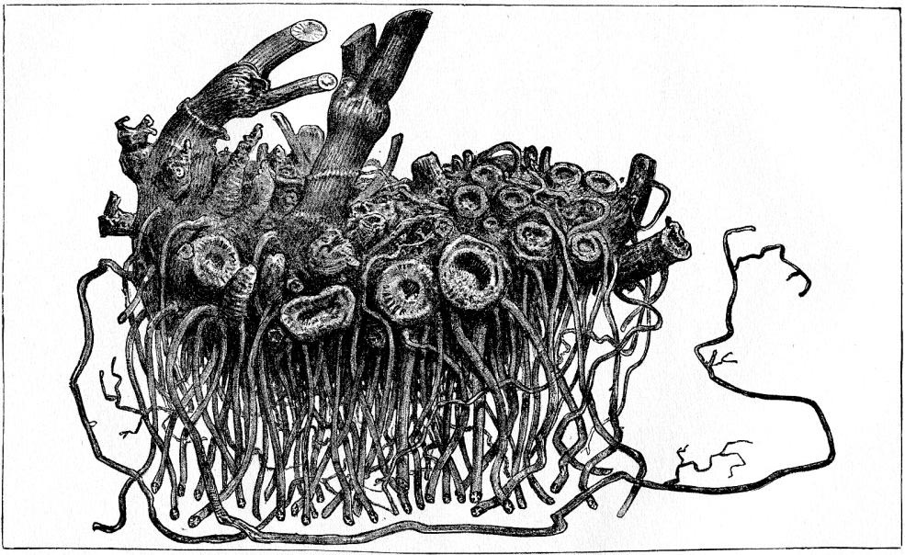
A rhizome network of relationships (Taken from Lloyd, John Uri & Curtis Gates Lloyd [1884] Plate XXIII. A fresh rhizome of Cimicifuga racemosa. In Drugs and Medicines of North America. Cincinnati: Lloyd & Lloyd).

Affordance – the theory by a psychologist James Gibson in 1979, that discusses the interaction between life forms and their environment. That claims objects can perform (afford) an action or a series of actions. They can motivate or assist activity without mandating or demanding it. Johnson uses the example of a doorknob, which furnishes or allows the act of turning it (Johnson, 2020, pp.143-145). Knappett uses a similar analogy by using the example of a chair. A chair provides an affordance to sit, and sometimes to hold open a door. These affordances are not what people recognise or consider as their purpose, even though it could be quite obvious, but the objects are in their own sense providing the affordance (Knappet, 2005, pp.45-52) (see Agency and Object Biography).
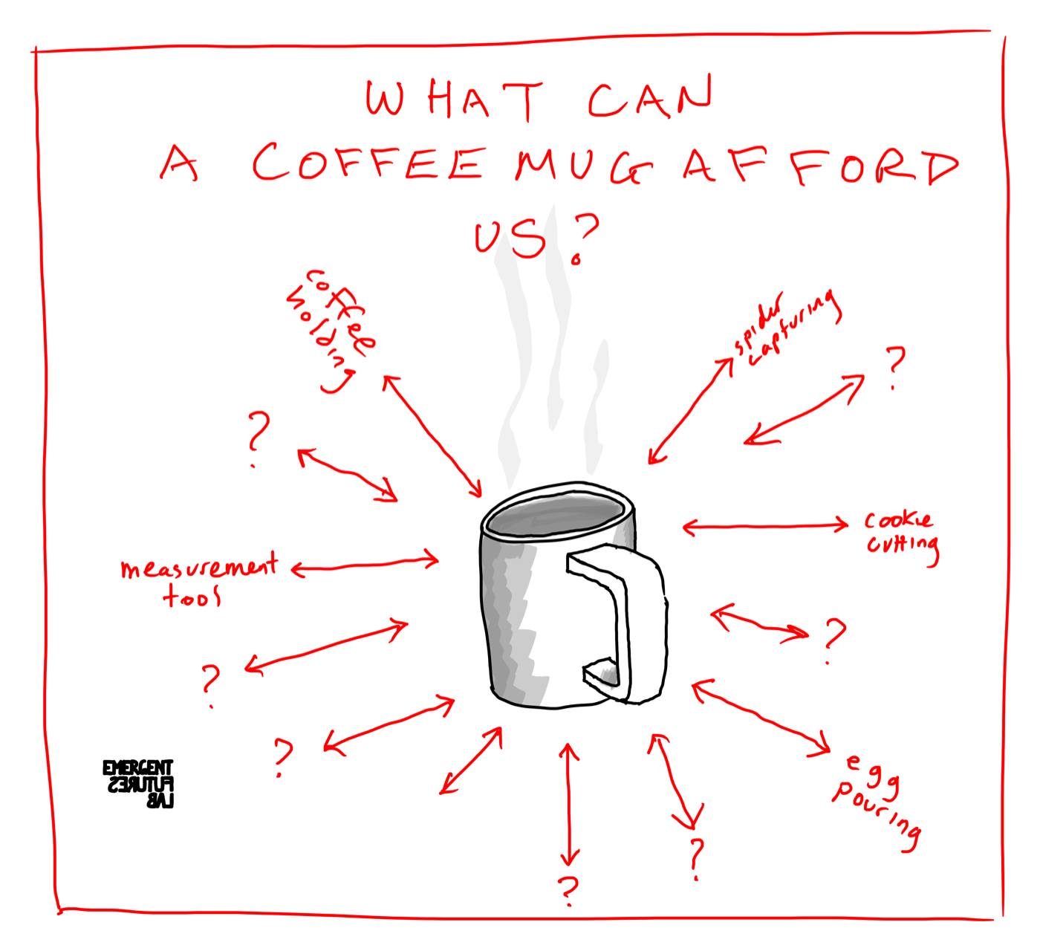

(Taken from Emergent Futures Lab. 2024).

Agency - a concept that emphasises the link between people's conscious and unintentional acts and their social, ideological, and material circumstances. It is a train of thought that claims objects have their own agency similar to human social activities, which create, direct influence, and guide human actors. In archaeology agency theory can be used to generate a more diversified and open-ended narrative of ancient cultures (Bennett, 2010, pp.20-38; Chapman, 2023, 98-101; Gell, 2013, pp.28-72; Johnson, 2020, pp.141-145). (See also Assemblage Theory).

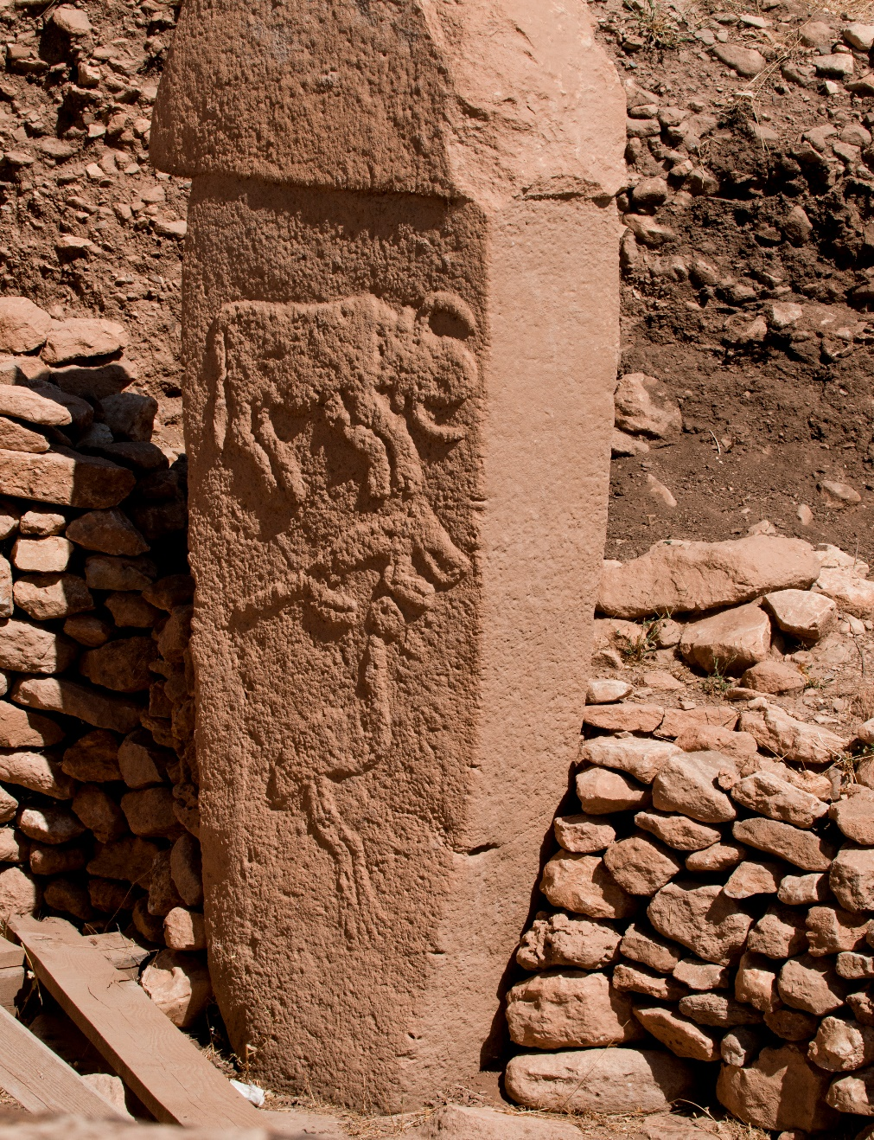
“Göbekli Tepe is a c. 12,000-year-old archaeological site in Anatolia, Turkey. The site chronology is divided into three levels, Layer I being the most recent and Layer III the oldest and deepest level. Layer III is also the most sophisticated level, with enclosures characterised by different thematic components and artistic representations. This pillar comes from Enclosure A and depicts a grouping of an auroch (a very large and now extinct bovine), a fox and a crane, positioned one above the other” (Teomancimit, 2020).

Agential realism is a philosophical theory proposed by Karen Barad that employs quantum theory to rethink our view of the universe, our perception of the world and how things influence and inter-act with one another. Matter is not fixed, it is material in the process of becoming itself, a congealing of action. Matter should be seen as an active participant in how the world works and continues to work (Barad, 2003, pp.801-831). (see Agency and Vibrant Matter).
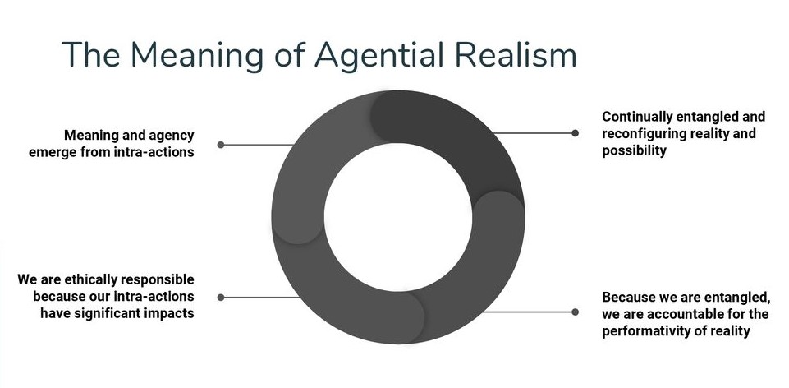
The meaning of Agential Realism diagram (King, 2019).

Anthropocentric is seeing humans as the most significant entity in the cosmos. It is a human centred point of view which construes or views the world in terms of human ideals and experiences (Johnson, 2020, pp.154-155).
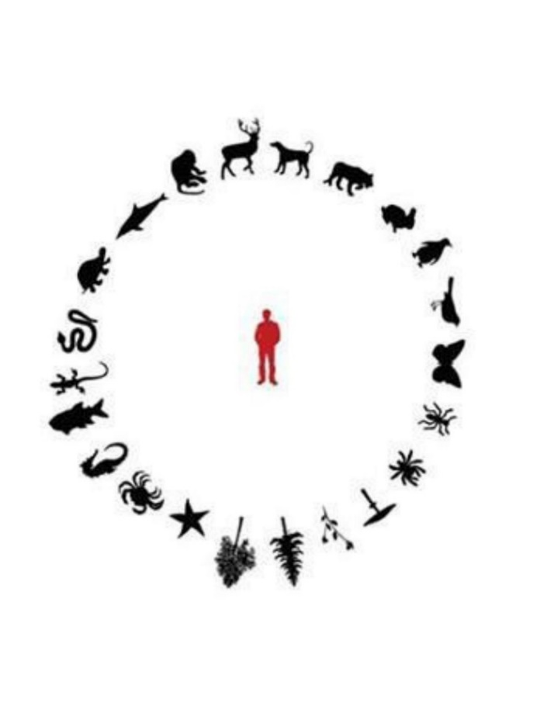
(Pang, ND.)
Assemblage theory – a theory first formulated by Gilles Deleuze and Felix Guattari in 1987. Originally known as agencement in French, which refers to the matching or fitting together of a collection of parts and the result of these connections. The English translation therefore does not capture its true meaning. It is made up of various diverse and varied liaisons and relations across time by different entities. Assemblages exist everywhere and are adaptable, natural, free flowing and open to change. They include ideas, emotions, symbolism, as well as material entities, which come together to create a single form (Chapman, 2023, pp.138-141: DeLanda, 2016, pp.1-8). (See also Actor Network Theory and Agency).
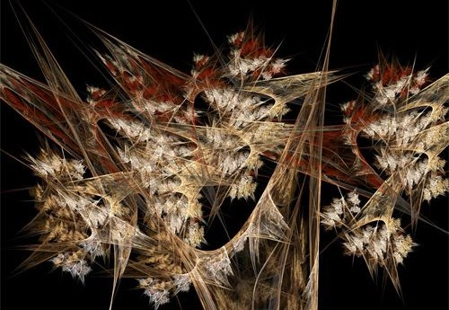

(Taken from DeLanda, 2016).

Cartesian a philosophical perspective invented by Rene Descartes, (1596-1650), that looks at the universe and the world through the lens of dualism, the concept that humans are made up of two different substances: mind and matter. Having opposing pairs of notions such as mind/body, good/evil, and nature/culture. Rather than having a more comprehensive or fluid perspective of the world (Atmanspacher, 1994, pp. 1-15; Johnson, 2020, pp.135-139).
Enchainment a theory that claims that there is a permanent relationship between an object's owners or users and the object itself. This relationship is formed as the thing acquires a unique biography. Permanent things within cultures are symbolic of how social identities are reconstructed over time. Linked to theories on the fragmentation of objects during ritual practices, enchainment is a means of explaining human connections to these objects and understanding how humans have created binding senses of identity (Chapman, 2000, pp.23-48; Brittain & Harris, 2010, pp. 581-594). (see Fragmentation).

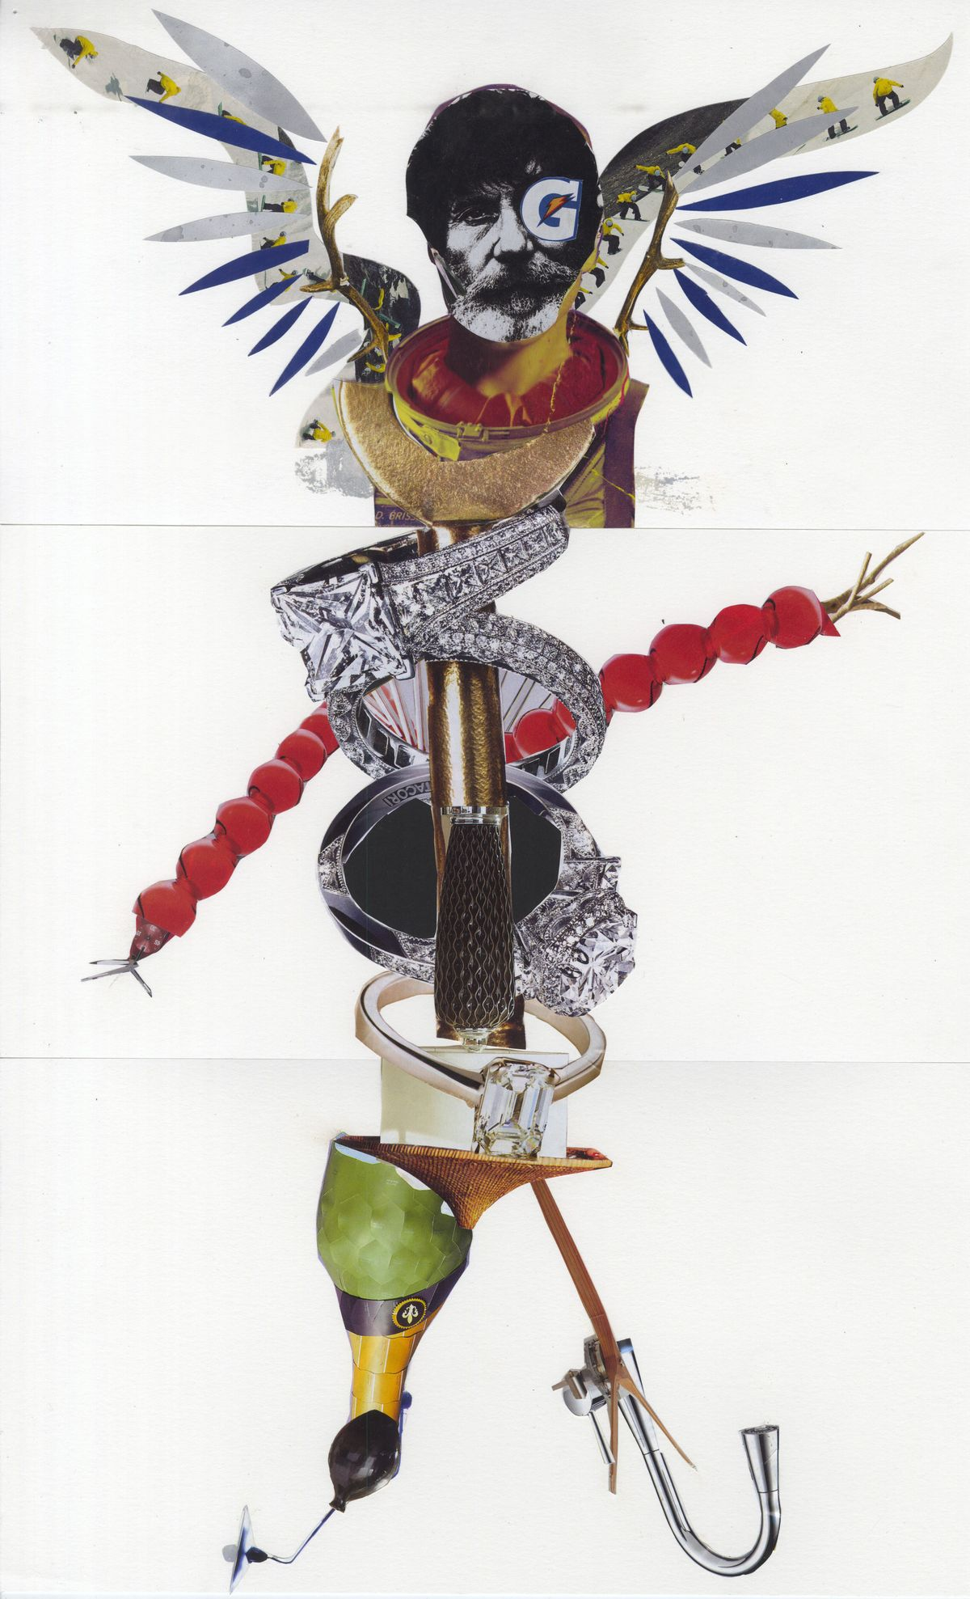
(Pinterest, 2024).
Epistemology is a field of philosophy which refers to the theory of knowledge and is concerned with how information is collected and from where. The term comes from the Greek epistēmē ("knowledge") and logos ("reason"). An ideal framework for evaluating archaeological evidence is one that combines a realist epistemology with a materialist perspective. To achieve any progress, archaeologists must also investigate mental conceptions, sensory experiences, and environmental factors. They must also generate possibilities that differ from what was previously considered, and then carefully examine such hypotheses (Chapman, 2023, pp. 17-20; Trigger, 1998, pp. 1-34).


(https://philosophy.institute/epistemology/)

Fragmentation Theory – looks at the deliberate breaking of objects and placing or arranging the broken pieces in various social contexts. The practice is believed to be symbolic and be part of religious beliefs and death ritual practices within many early cultures. It is believed that the breaking may allow the tool’s spirit to return to the cosmos, and to honour the gods. There are various techniques used for this intentional destruction, including, burning, breaking, drilling, and throwing away, with items usually being stone tools and vessels. However, the exact manner of breakage is often difficult to determine as non-intentional factors such as natural forces may also have played a part (Dubreuil et al.2019, pp.1-15; Brittain & Harris, 2010, pp.581-594). (See also Enchainment).

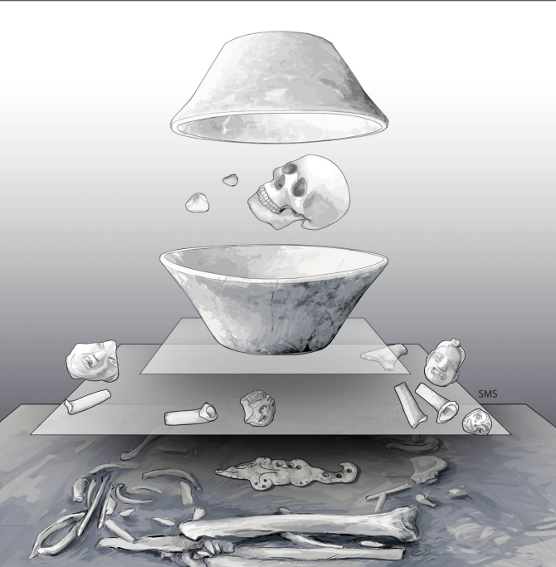

Cahal Pech Burial with fragmented objects symbolically arranged (Morton, Awe & Pendergast, 2019).

Kinaesthetic awareness is the ability to perceive and interpret the position, movement, and action of the body in relation to its environment. Ingold experimented with flying a kite and using a potter’s wheel to interpret the inter-related cognitive processes of past cultures. He theorised that human movement creates a “bodily kinaesthesia” which he claims marries together movement in an on-going engagement with social and material environments (Ingold, 2013, pp.98-103).



Modern dance can create emotion through a sensory experience of movements, for both the performer and the audience (Anand, 2022).

Material Culture – The study of objects and their connection to cultural and historical settings, communities, ideologies, and religions. It is a core discipline within archaeological investigation and interpretation (Chapman, 2023, pp.88-90; Johnson, 2020, pp.69-71). Humans are defined by their material culture. A culture that involves social interactions as well as physical objects. We are a consequence of the material culture that we have created (Scarre, 2021, pp. 26-27).

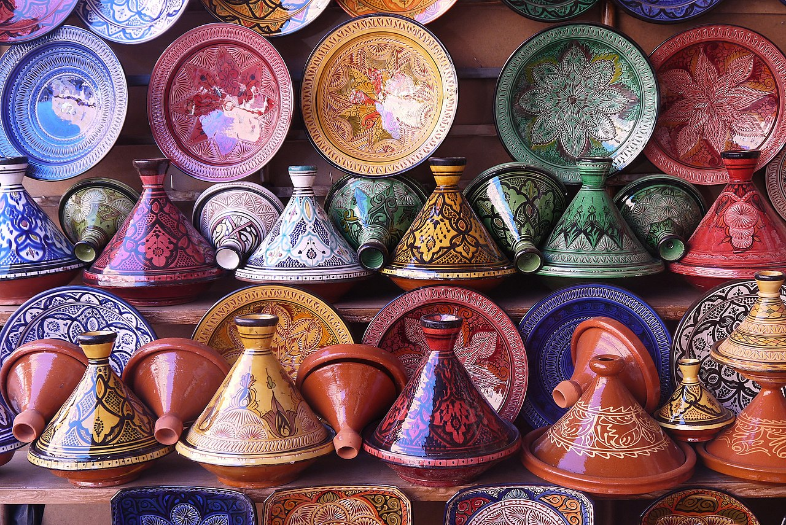

Pottery is a recognised form of material culture and is commonly found as archaeological artefacts (Wikipedia, 2024).

Mereological parts. The word Mereology comes from the Greek “meros,” which means “part” and concerns the study of the relationships between parts and wholes. Mereology examines the nature of relationships between whole and parts of objects. It asks the question is there an infinite collection of parts or wholes and questions their complex relationships. It links in with Actor Network Theory (ANT) that views all parts of a system as equally important, and that everything exists in constantly shifting networks (Bryant,2012, pp.1-2).

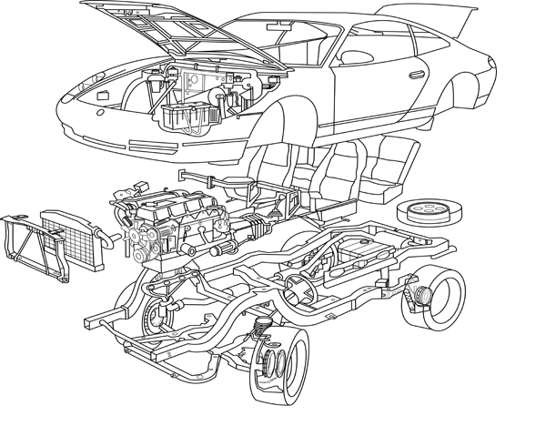

An exploded view of a car highlights the multiple relations that are necessary to create a whole (Bryant, 2012).

Morphological means the system of comparison of shapes and related forms, which can be used to understand the related significance of cultural artefacts and enable the construction of typologies and provide a date for a particular item or place (Gell, 2013, pp.166-167). There are critics of this method, who caution regarding the assumption that patterns of morphological attributes have definite sequential importance, particularly when any accidental alteration during the life of the artefact can change its worldly distribution (Flenniken & Raymond, 1986, pp.603-614). (see Ontology).
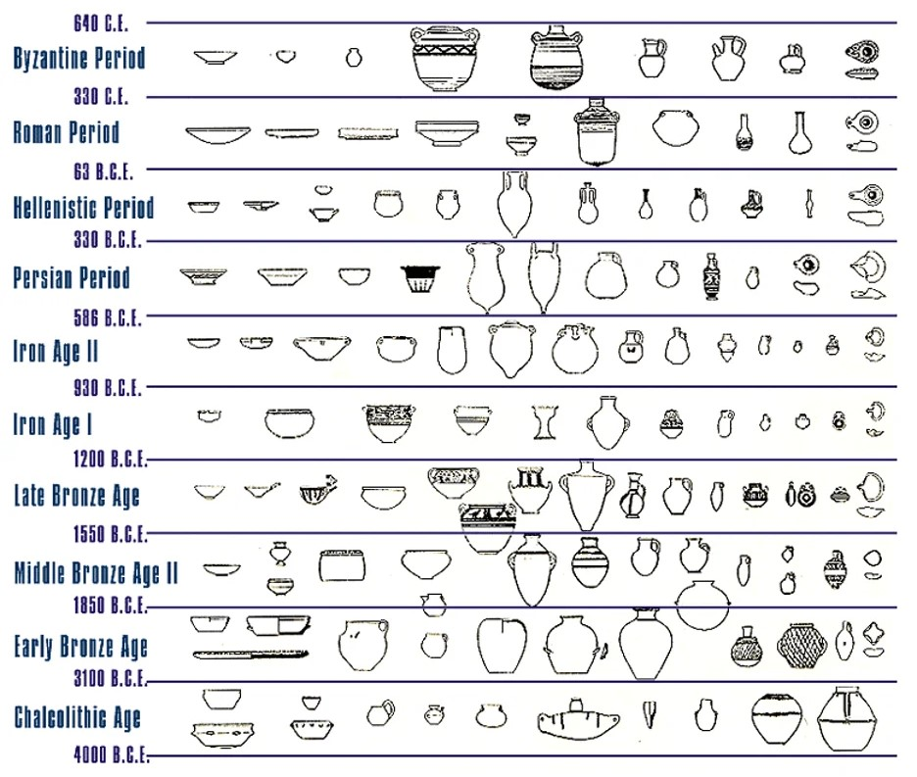

The durability of pottery enables its use as a chronological tool in archaeology (Kennedy, 2020).
New Materialism a philosophical theory which maintains that matter is the primary substance in nature and that everything, including mental states and awareness, is the product of material interactions between material entities. Matter is dynamic, active, and self-organising force that is constantly changing in flux. It is not a passive uniform substance but an entangled network of relations that is always open to the other. New Materialisms insert humans as matter in the world (Barad, 2003, pp.801-831; Govier & Steel, 2021, pp.298-317). (See also Agential Realism and Vibrant Matter).

The self-organising force of matter (Cole & Frost, 2010).

Object biography – refers to the idea that all objects have a life history. By exploring the life of an object, by unravelling its history through time, its acquirement, its manufacture, use, storage, care, repair and disposal, it is possible to create a biography that enables archaeologists to determine how artefacts are associated with the varying contexts in which they are found. On object’s life can be re-created by following its biography (Joy, 2009, pp.540-556; Kopytoff, 1986, pp.64-90). A biography can also provide information relating to its social status, its meaning and significance to the people involved with it, and how it influences human interaction (Johnson, 2020, pp.143-144). (see Agency).

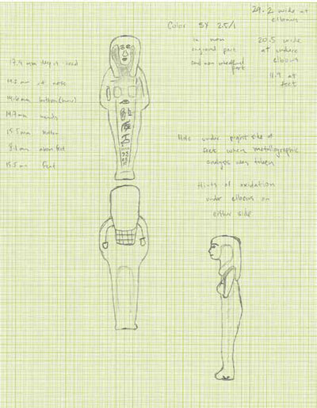

Drawing of a bronze shawabti from Tanis by Daniel Salas, whilst creating its object biography (Taken from the Penn Museum Magazine, Vol.60, no.2. 2018)

Ontology in simple terms a branch of philosophy that examines the nature of being. In archaeology it is the study of what entities or structures that exist, how they relate to one another, and what they can be asserted to exist as (Chapman, 2023, pp.17-22; Renfrew & Bahn, 2020, pp. 43-46). (see Morphological).

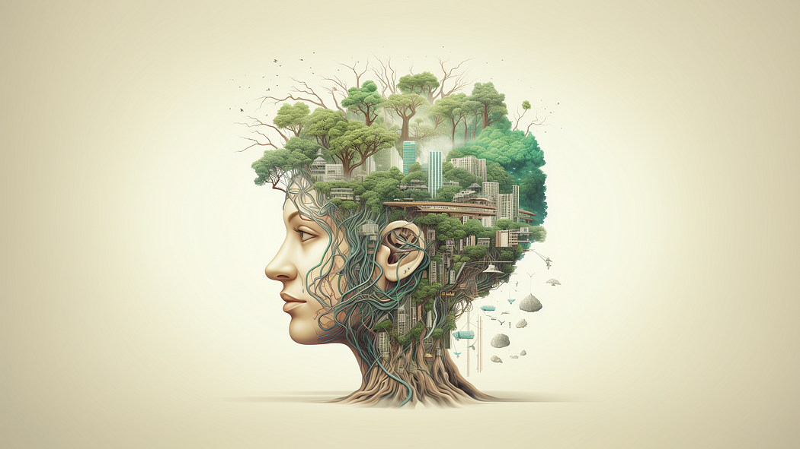

Environment and Mind (Harbour, 2023).

Personhood means the value of being a person and can relate to human attributes such a human being, agency, and self-awareness. It is argued that we have a very Westernised view of people and that more thought should be given towards how earlier cultures would have seen themselves (Chapman, 2023, pp.127-129). The concepts of position, individual importance and race are seen in a variety of different ways within different cultures. The evolution of ceremonial activity, personal ornamentation and the building of colossal structures are seen as important indicators of the emergence of civilisation and are a core theme in archaeology (Renfrew & Bahn, 2020, pp. 220-222).


“A person is one who is embodied” (Camilleri, 2022).

Phenomenology is the study of events or things which present our lived experiences of the world, and how it has shaped our understanding (Renfrew & Bahn, 2020, p.41). It has been seen as a very controversial theory within philosophy, however within archaeological study a more sympathetic and collaborative approach to understanding human knowledge and interactions has been used. An approach that has provided a more subjective view of past cultures (Johnson, 2020, pp.137-139). (see also Personhood).

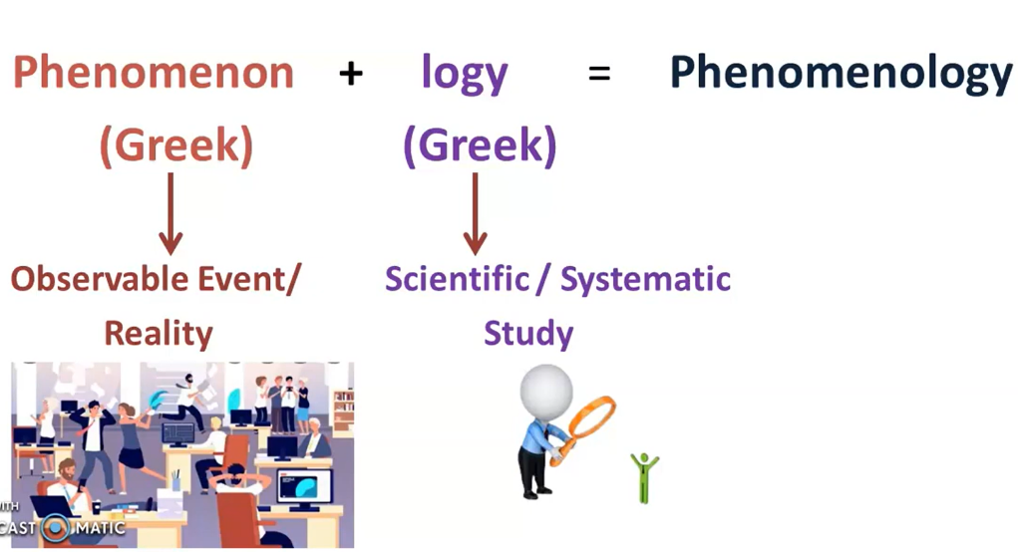

What is phenomenology? (Salihu, 2023).

Sensorial archaeology - The senses are the most fundamental aspect of our interaction with the environment, and they serve as the conduit for all values and behaviours. Even our memories are formed and activated by our sensory interactions with the material world. The sensory link we have with the material environment even creates and activates our memories. Our senses move groups of bodies through lights, sounds, colours, textures, moods, temperatures, odours, emotions, tastes, and stories; without the senses, the affective flows that move these would stop. Without our senses, we would be unable to influence and be affected by the world and other bodies (Pellini, 2020, pp.1-10).
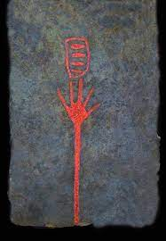

(Taken from Fahlander & Kjellstrom, 2010).

Things & Thing Theory - There are various interpretations of the nature of ‘things.’ It is understood that the meaning of things can vary across different cultures. Some scholars claim that things can include both physical entities and living experiences (Chapman, 2023). Bill Brown in his ‘Thing Theory’ believes things are created during human interaction, particularly when they malfunction, break, or lose their ingrained societal values (Brown, 2001). However, things have also been described as non-human, lifeless matter which can invoke and create events. Things can be ‘actants’ and have the ability to act and to bring about active, positive, powerful, precise, and astute outcomes (Bennett, 2010, pp.1-19). (see Vibrant Matter).

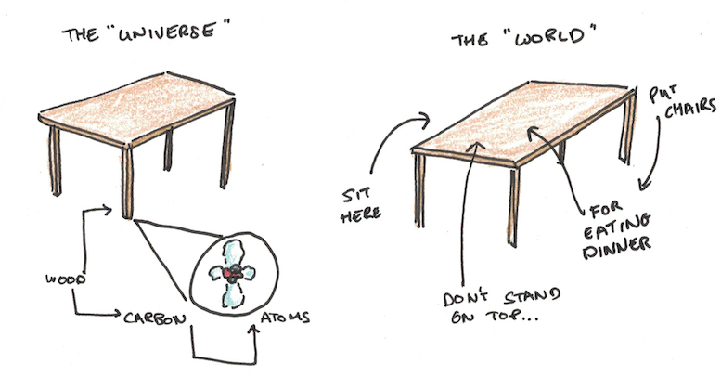

The things in our lives and how they interact (Taken from Scott Young podcast 2020).

Vibrant Matter is a theory by Jane Bennett in which she recognises that non-human forces play a role in all events. She believes that there is a "vital materiality" that flows through and between all bodies, human and non-human. Bennet states that vibrant matter is an ‘onto-story’ that represents the world as a network of actors, assemblages, and ecosystems. She believes that matter and energy are two sides of the same coin, that they are the generator of all things visible and not visible. She believes in the “common materiality of all that is” (Bennet, 2010, pp.116-122). (see also Agency, Agential Realism, New Materialism and Things).

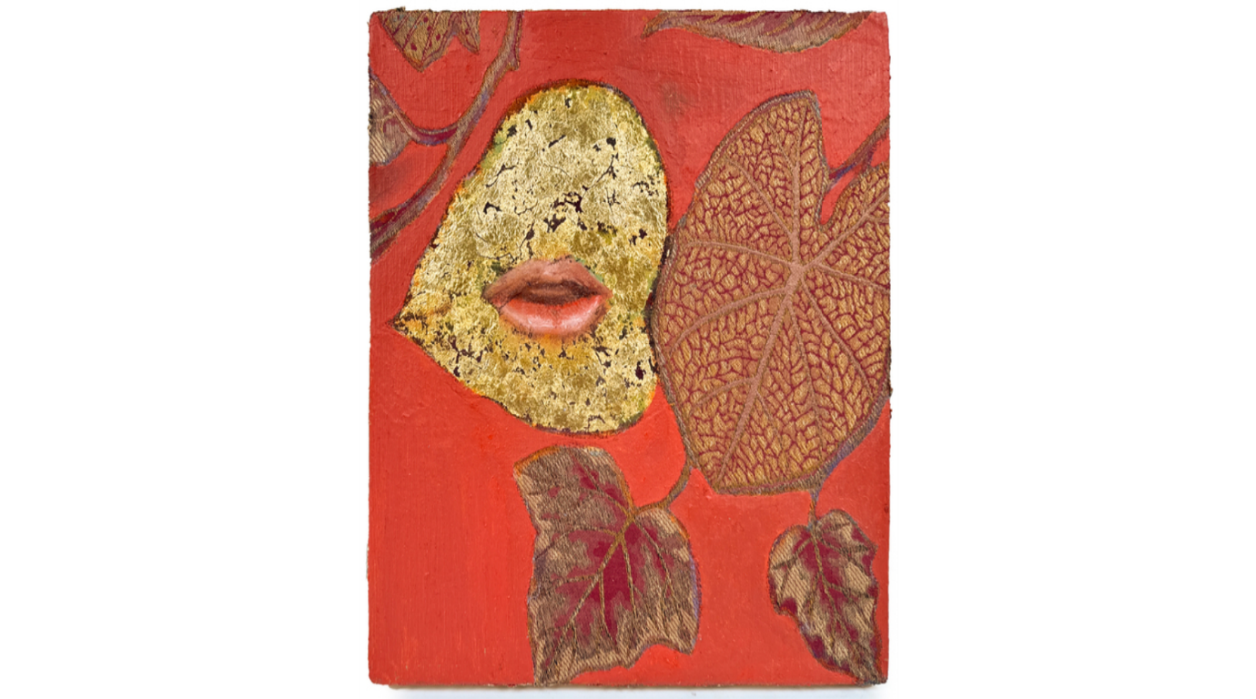
(Zupan, 2024).

Bibliography.
Anand, M. (2022). What is Kinesthetic Empathy, Rejoice in Motion [blog]. Available at: https://rejoiceinmotion.com/index.php/2022/01/18/what-is-kinesthetic-empathy/ (Accessed: 10 November 2024).
Atmanspacher, H. (1994). Complexity, meaning and the cartesian cut. Journal of Consciousness Studies. 1. pp. 168-181. Available at: https://www.researchgate.net/publication/233670297_Complexity_meaning_and_the_cartesian_cut (Accessed: 16 November 2024).
Barad, K. (2003). Posthumanist Performativity: Toward an Understanding of How Matter Comes to Matter. Signs, 28(3), 801–831. https://doi.org/10.1086/345321
Bennett, J. (2010). Vibrant Matter: A Political Ecology of Things. Duke University Press.
Blok, A. & Farias, I. & Roberts, C. (Eds.) (2020). The Routledge Companion to Actor-Network Theory. Routldege.
Brittain, M., & Harris, O. (2010). Enchaining arguments and fragmenting assumptions: reconsidering the fragmentation debate in archaeology. World Archaeology, 42(4), 581–594. http://www.jstor.org/stable/20799450 (Accessed: 8 November 2024).
Brown, B. (2001). ‘Thing Theory’. Critical Inquiry, Vol.28, No.1, pp. 1-22. University of Chicago Press. Available at: http//www.jstor.org/stable/1344258 (Accessed: 21 October 2024).
Bryant, L. R. (2012). Democracy in Objects: Mereology and Exploded Views. Larval Subjects [blog]. Available at: https://larvalsubjects.wordpress.com/2012/04/23/democracy-in-objects-mereology-and-exploded-views/ (Accessed: 10, November 2024).
Camilleri, A. (2022). What are the Characteristics of personhood? Philosophy MT. Available at: https://philosophymt.com/what-are-the-characteristics-of-personhood/ (Accessed: 10 November 2024).
Chapman, J. (2000). Fragmentation in Archaeology: People, places and broken objects in the prehistory of south-eastern Europe. Routledge.
Chapman, R. (2023). Archaeological Theory: the basics. Routledge.
Cole, D. & Frost, S. (Eds.) (2010). New Materialisms: Ontology, Agency, and Politics. Duke University Press. Available at: https://www.dukeupress.edu/new-materialisms (Accessed: 10 November 2024).
DeLanda, Manuel. (2016). Assemblage Theory. Edinburgh University Press.
Dobres, MA. (2014). Agency in Archaeological Theory. In: Smith, C. (eds) Encyclopedia of Global Archaeology. Springer, New York, NY. Available at: https://doi.org/10.1007/978-1-4419-0465-2_252 (Accessed: 8 November 2024).
Fahlander, F. & Kjellstrom, A. (2010). ‘Making Sense of Things: Archaeologies of Sensory Perception’. Stockholm Studies in Archaeology 53. Stockholm University.
Flenniken, J. J. & Raymond, A. W. (1986). Morphological Projectile Point Typology: Replication Experimentation and Technological Analysis. American Antiquity, Vol. 51, No. 3, pp. 603-614. Cambridge University Press. Available at: https://www.jstor.org/stable/281755 (Accessed: 16 November 2024).
Gardner, A., (2012). Agency uncovered: archaeological perspectives on social agency power and being human. Taylor & Francis.
Gell, A. (1998). Art and agency: an anthropological theory. Oxford: Clarendon Press.
Goring-Morris, A. & Hovers, E. & Belfer-Cohen, A. (2009). The dynamics of Pleistocene and early Holocene settlement patterns and human adaptations in the Levant: An overview. Available at: https://www.researchgate.net/publication/216209765_The_dynamics_of_Pleistocene_and_early_Holocene_settlement_patterns_and_human_adaptations_in_the_Levant_An_overview (Accessed: 8 November 2024).
Harbour, R. (2023). Environment and Mind in Ontological Design: Is our Mind Shaped by the World we Create? Available at: https://medium.com/age-of-awareness/ontological-design-is-our-mind-shaped-by-the-world-we-create-d73aa1206b1f (Accessed: 10 November 2024).
Ingold, T. (2013). Making: Anthropology, Archaeology, Art and Architecture.Routledge.
Johnson, M. (2020). Archaeological Theory: An Introduction. 3^{rd.} Ed. Wiley Blackwell.
Joy, J. (2009). ‘Reinvigorating Object Biography: Reproducing the Drama of Object Lives’. World Archaeology, Vo. 41, No. 4, pp.540-556. Taylor & Francis Ltd.
Kennedy, T. (2020) Pottery in Archaeology. Drive Thru History [blog] Available at; https://drivethruhistory.com/pottery-in-archaeology/ (Accessed: 10 November 2024).
King, J. (2019). A Quantum Vision for Environmental Literacy. University of Wisconsin-Stevens Point. Available at: https://slideplayer.com/slide/16286924/ (Accessed: 8 November 2024).
Knappet, C. (2005). Thinking Through Material Culture: An Interdisciplinary Perspective. University of Pennsylvania Press.
Kopytoff, I. The Cultural biography of things: commoditization as process. In Appadurai, A. (Ed.) (1986). The Social life of things: Commodities in cultural perspective. Cambridge University Press.
Malafouris, L. (2015) ‘How Did the Mycenaeans Remember? Death, Matter, and Memory in the Early Mycenaean World’, in C. Renfrew, M.J. Boyd, and I. Morley (eds.) Death Rituals, Social Order and the Archaeology of Immortality in the Ancient World: ‘Death Shall Have No Dominion’. Cambridge: Cambridge University Press, pp. 303–314.
Morton, S. G., & Awe, J. J., & Pendergast, D. M. (2019). ‘Shattered: Object fragmentation and social enchainment in the eastern Maya lowlands’. Journal of Anthropological Archaeology, Vol.56, 1011108. Available at: https://doi.org/10.1016/j.jaa.2019.101108 (Accessed: 10 November 2024).
Pellini, J.R. (2020). Sensory Archaeology. In: Smith, C. (eds) Encyclopedia of Global Archaeology. Springer. Available at: https://doi.org/10.1007/978-3-030-30018-0_3327 (Accessed: 14 November 2024).
Renfrew, C. & Bahn, P. (2020). Archaeology: Theories, Methods and Practice, 8th Edition. Thames & Hudson.
Salihu, M. M. (2023). [YouTube]. What is Phenomenology? Sociology for Competitive Exams. Available at: https://www.youtube.com/watch?app=desktop&v=yA6afvE7HAA (Accessed: 10 November 2024).
Teomancimit. (2020). Göbekli Tepe - Layer III, Enclosure A, Pillar 2. World History Encyclopedia. Retrieved from https://www.worldhistory.org/image/13199/gobekli-tepe---layer-iii-enclosure-a-pillar-2/ (Accessed: 8 November 2024).
Trigger, B. G. (1998). ‘Archaeology and Epistemology: Dialoguing across the Darwinian Chasm.’ American Journal of Archaeology, Vol. 102, No. 1, pp.1-34. Archaeological Institute of America. Available at: https//www.jstor.org/stable/506135 (Accessed: 16 November 2024).
Xinjia Pang, (nd). Posthuman Readings: Anthropocentrism and the Politics of the Living (Chapter 4). Available at: https://www.cca-ai.com/presentation-5 (Accessed: 8 November 2024).
Zupan, N. (2024). Vibrant Matter [Mixed Media on wood panel (embroidery, silk, acrylic, 24K gold, and oil)]. Available at : https://www.artsy.net/artwork/natasha-zupan-vibrant-matter-number-54 (Accessed: 10 November 2024)

