

Evaluating the Impact of Staff Training and Leadership on Food & Beverage Service Quality: A Case Study of Ashford International Hotel & Spa

Student Name: Silvia Karova
Lecturer`s Name: Kathryn Flynn
Word Count: 6643
Student ID: 2221481
Date of Submission:04/11/2025

Abstract
This was a case study focused on the Ashford International Hotel, which is one of the prominent hotels in the UK and offers competition to Hilton and Marriott. This company was chosen to analyse the importance of training and leadership in the food and beverage services. Research onion model was used for designing the methodology. The research used mixed data. The data was collected with the help of interviews (5 managers) and a survey (25 employees). The data was analysed with the help of thematic analysis (qualitative) and descriptive analysis (quantitative). The findings suggested that training and leadership are essential for improving the day-to-day services for the food and beverage employees. 2 of the qualitative data collection participants stated that they currently training of these employees needed depth, whereas 44% of the responders stated that they were only somewhat satisfied with their training. The recommendation of the research included using primary qualitative data only, among other ways, the future scope of the research was suggested for analysing the longitudinal data and performing a large-scale survey on multiple organisations for better generalisability.

I acknowledge the use of Google Scholar on 04.November 2025 to check my work using the prompt(s):
- Please check the following text for readability, grammar and syntax.
- I confirm that I have not presented any AI generated text as my own work. I confirm I have copies of my drafts, notes, and other resources I used before, and after the use of AI tools which I may be asked to provide in evidence.

I acknowledge the use of Grammarly (https://www.grammarly.com/) on 04.November 2025 to check my work using the prompt(s):
- Please check the following text for readability, grammar and syntax.
- I confirm that I have not presented any AI generated text as my own work. I confirm I have copies of my drafts, notes, and other resources I used before, and after the use of AI tools which I may be asked to provide in evidence.

Acknowledgement Statement format for AI Tool(s) usage.

I confirm that I have not presented any AI generated text as my own work. I confirm I have copies of my drafts, notes, and other resources I used before, and after the use of AI tools which I may be asked to provide in evidence.

Signed : ____Silvia Karova_______________________________

Acknowledgement
I would like to acknowledge the role of my supervisors who helped this study with their insightful critiques. I would also like to show gratitude to my peers who helped me through this lengthy process, and I am forever indebted to my parents for their unwavering support.

Table of Contents
Abstract 2
Acknowledgement 3
Chapter 1: Introduction 6
1.1 Background 6
1.2 Aim and Objectives 7
Chapter 2: Literature Review 7
2.1 Beverages and foods of Ashford 7
2.2 Leaders affecting the level of services 8
2.3 Ways to improve training for staff and leadership development in the food and beverage department 9
2.4 Conceptual Framework 10
2.6 Theoretical Framework 10
2.7 Literature Gap 11
Chapter 3: Methodology 12
3.1 Introduction 12
3.2. Research Philosophy 12
3.3. Research Approach 13
3.4. Research Strategy 13
3.5. Research Choice 13
3.6. Time Horizon 14
3.7. Research Technique and Procedures 14
3.8. Conclusion 14
Chapter 4: Findings and Discussion 15
4.1. Introduction 15
4.2. Findings 15
Findings of the Qualitative data collection 20
4.3. Discussion 22
Chapter 5: Conclusion and Recommendations 25
5.1. Introduction 25
5.2. Conclusion of the Research 25
5.3. Recommendations for future Research 27
5.4. Conclusion 29
References 30
Appendices 34
Appendix 1: Ethics Form 34
Appendix 2: Survey Results 34
Appendix 3: Interview Transcript 34
Appendix 4: AI Acknowledgement Statement 34
Appendix 5: Research Permission 34

Chapter 1: Introduction

1.1 Background
The Ashford International Hotel and Spa is a four-star hotel, which offers 179 spacious rooms, stylish interiors, restaurants and offers variety of services within the area. This hotel is well situated in Hotel in Ashford, London, near the Kent coast and the Channel Tunnel. According to Ashford International Hotel (2025), this hotel helps in hosting all the special occasions and provides better services and facilities. This hotel is considered to hold a strong market position in the local area of Kent. This hotel holds the competition with various hotels, including Hilton, Premier Inn, and Marriott. This hotel serves a diverse market and serves the major population of the UK. These offering of services and competitors helps in serving a better competitive advantage within the market. According to Travel and Tour World (2025), Canada, Japan, and the UK are emerging as the leaders in the global hotel market trends. Despite the challenges in the US hospitality industry, these areas are making remarkable growth within the hospitality sector.
There are various impacts of staff training and leadership, and Food and Beverage service quality on the Ashford Hotel. According to Neupane and Khanal (2022), training is considered to be an essential procedure, which helps the employee in gathering more opportunities and learn from experience. The UK hotel industry is facing criticism in training and recruitment of employees due to rising uncertainties in the political and economic spheres. The post-Brexit situation is also affecting the situation in terms of training the employees. There can be use of these impacts in a positive way in order to add value to the sector. The general impacts of leadership will lead to boost the overall leadership performance and will help in empowering the workforce. The general impacts of staff training include enhancing the guest experience and increasing employee retention. According to Arwab et.al (2023), training is the most influential element of HRD and helps in achieving the goal of individual performance. The motivation for staff training helps in participating the employee in creative activities. The Ashford Hotel is establishing its quality in food and beverages. According to the food quality is considered to be the key component of food quality, with the touch of local food, the hospitality sector trends to fulfil the growing customer needs and requirements. The touch of local food helps in establishing sustainability. The food and beverages are associated with the visitors' demand for quality, health, and authenticity. This helps in increasing overall customer satisfaction, increasing the brand reputation and revenue.

1.2 Aim and Objectives
Aim
To evaluate how staff training and leadership styles influence food & beverage service quality at Ashford International Hotel & Spa.
Objectives
- To see how the hotel trains its food and beverage personnel right now.
- To see how different types of leaders affect the level of service.
- To provide ideas on how to improve training for staff and leadership development in the food and beverage department.

Chapter 2: Literature Review

2.1 Beverages and foods of Ashford
The food and beverages refer to food and drinks used and offered by the Ashford hotel. According to Ashford Borough Council (2025), Ashford, to promote its services, conducts the Ashford Food and Drink festival. This festival includes Ashford town Centre, offering food and drinks with the help of vendors throughout the whole city. The Horizon Restaurant holds the classic and modern touch and provides services for celebrating special occasions. According to Abdullah, Sufi, and Kumar (2023), there is stiff competition faced by the UK hospitality sector, and to excel that there is a use of fresh food. There is an offering of high-quality meals and services in food and drinks. The consumers judge the overall quality of services on the basis of the quality of food and drinks. According to Ashford Borough Council (2025), Ashford is expanding its business in the food and drink cluster. There is rapid growth in the Wine industry, which includes the Gusbourne, Chappel Down, and Biddenden Vineyards. The Ashford supports the Food and Drink community, which involves the introduction of a community for promoting food and Drink and helps in providing recent updates and information on the local foods and products.

2.2 Leaders affecting the level of services
There is are variety of leadership theories considered to be useful in Ashford International hotel, these include the transformational, servant and situational or contingency and behavioural leadership theories. According to Zia et.al (2022), the culture of the hospitality industry is considered to be unique from all other sectors. Leadership is considered to be the prevailing factor that tends to believe in the values and goals of its organisation. The Servant leadership (SL) is important as it shows its main concern in providing the service with ethical behaviour. The organisation following this approach leads to lay significant approach to organisational and employee performance. There are various key aspects of servant leadership that Ashford can adopt to add efficiency within the system. Introducing the SL helps in empowering the employee, helps in improving the level of services, decreasing the turnover, helps in building trust and collaboration, and promoting the culture of ethics and sustainability. The next leadership is transformational, using transformational leadership in the UK hospitality sector will help in responding to broader applications, which include responding to existing challenges within the industry, such as Brexit and Covid Covid-19 pandemic. This will help in fostering the culture of innovation and creativity and tends to increase organisational commitment. According to Mahmood, Zaman, and Chaman (2024), transformational leadership helps in increasing the morale of its team and manages the role more effectively. This leadership will help Ashford in increasing its influence and inspire the people and their potential.
The next is the situational and contingency theory of leadership. This theory is considered to be highly relevant to the Ashford International hotel. This theory is helping Ashford navigate through crisis management, which includes the leader playing an important role in managing during the time of crisis. This theory is helpful for the hotel in implementing the new services of spa services, which will include the major role of the leader in implementing the services through stages. This will help the leader in carrying out the day-to-day routine operations. According to Chepkwei (2021), contingency theory is considered to be important and is assumed to be best suitable for all situations. This theory helps in establishing relationships among the prevailing conditions of the organisation with the help of using comparative approaches. The last is that behavioural leadership can be applied to the Ashford hotel management. This theory helps in focusing on leaders' styles and actions. This theory will be applied to the hotel and will lead to adapting to various suitable styles to promote efficiency within the system. This will help in focusing on tasks and setting clear and precise goals for the Ashford Hotel. It will help in promoting an interactive, participative, and supportive environment. According to XIA (2022), the different leadership styles have different effects on the employee psychology and behaviour in different cultures and environments. Based on this behaviour theory helps, people can choose the leaders based on their actions. Introduction of this leadership will help in increasing the flexibility and accessibility within the Ashford Hotel and its framework.

2.3 Ways to improve training for staff and leadership development in the food and beverage department
There can be the use of various methods to ensure and develop methods in the food and beverage department. There can be implementation of mixed methods which involve e-learning, food safety, customer services, mentorship programs, cross-training and various opportunities and responsibilities to the employees. According to Dale et.al (2023), online or e-learning in the hospitality sector helps in mitigating the challenges coming in the future. The Online learning programs will help in providing all the important insights into ongoing policies and upcoming policies. The use of food safety measures adds importance to the degree of consumer protection. According to Mastilović, Vukotić and Ćerović (2024), the consumers are considered to be potential guests and attach importance to food safety comparable to the importance. Food safety holds importance and manages the accommodation facilities that provide a combination of tourists and catering services. The next is customer services, which involve ensuring effective services reach customers and increasing the satisfaction and brand image. According to Buhalis and Moldavska (2022), there is a use of various tools and techniques in order to improve customer service. The customer service helps in improving the efficiency of the operations and expanding the capability. Many other ways involve the mentorship programs and providing opportunities and responsibilities, which help in ensuring focus on skills, mastering technology and promoting communication.

2.4 Conceptual Framework

Figure 1 Conceptual Framework

2.6 Theoretical Framework
The theoretical framework involves demonstrating the valuable insights of the beverages and food of Ashford, the role of leaders in affecting the service level and ways to improve development in the food and beverages department. The beverages and food of Ashford involve the Ashford promoting its food and beverage services through the festivals. Although the UK hospitality sector faces stiff competition this ensuring high-quality food services helps provide a competitive advantage to them. The role of leaders affects the type of services, and the leadership theory involves the transformational, servant, contingency or situational and behavioural theories. The application of these theories helps in adding value and enhancing the hotel's reputation. There are use of various methods used to improve the staff and training programs in the food and beverages department. This includes online learning programs, customer services, food safety measures, and mentorship programs that help add value to the employee and the hotel management.
There are use of various theories are used in this research, including the leadership theory, such as transformational leadership. According to Mahmood, Zaman, and Chaman (2024), transformational leadership helps in increasing the morale of its team and manages the role more effectively. According to Chepkwei (2021), contingency theory is considered to be important and is assumed to be best suitable for all situations. This theory helps in establishing a relationship. The next is Servant leadership (SL), which is important as it shows its main concern in providing the service with ethical behaviour. These theories help in improving the overall framework of the hotel.

2.7 Literature Gap
In the current literature, there are different gaps present, whether it be a lack of data on the Ashford International hotel. Furthermore, this represents that there is are lack of information in regard with particular leadership styles which is followed within the organisation. This presents a strong literature gap in existing sources. This in turn is leading to various time constraints and resource availability.

Chapter 3: Methodology

3.1 Introduction
This research is based on the Ashford International Hotel, which offers 179 rooms with stylish restaurants among other leisure facilities. According to Ashford International Hotel (2025), the company provides Elemis SPA, a health club, numerous meeting spaces and is fit for family and professional gatherings.
This research methodology would make use of the research onion model, given by Saunders and his colleagues.

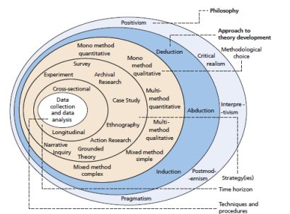
Figure 1: Research Onion Model
(Source: Wimalaratne and Kulatunga, 2022)

3.2. Research Philosophy
According to Wimalaratne and Kulatunga (2022), the research philosophy is the system of assumptions and beliefs about how knowledge is developed. There are 4 main types of research philosophies, including positivism, pragmatism, interpretivism and realism. This research made use of a pragmatism research philosophy, which is beneficial because of its flexibility, practicality, and support for making use of mixed research methods for solving or understanding real-world research issues. However, the disadvantage of this philosophy is that it could be difficult in the curriculum and neglect the past, as it is solely focused on the present and future.

3.3. Research Approach
The second layer of the research onion model has three types, including deductive, abductive and inductive. The abductive research approach was utilised in the study because of its flexibility and creativity, which allows the researcher to gain new theoretical insights between data and theory for an accurate explanation. Abdelhakim (2021) refers to this process as the process of creating a new descriptive proposal idea. On the other hand, it gives a disadvantage in the research as it could be challenging to implement and may include subjective bias.

3.4. Research Strategy
The research strategy refers to the overall plan for conducting the research, which details how the data is to be collected in order to answer the questions of the research. This study made use of the survey research strategy and case study research strategy. Abdelhakim (2021) suggests that the survey strategy is used to study the differences between individuals and the interrelations between diverse variables. Additionally, a case study provides an in-depth understanding of the topic, along with allowing for to study of rare situations, which would facilitate the collection of rich data. However, a case study would limit the generalisability of the research findings and could be extremely time-consuming. Whereas, survey would allow generalisability and standardised data, however, it includes disadvantages like low response rates and a lack of depth.

3.5. Research Choice
Research choice is suggested to be the decision of the researcher on combining the types of data, and it offers three choices, including mono-method, multi-method and mixed method. This research chose the mixed method. Mulisa (2022) suggested that a mixed method includes the analysis of both qualitative and quantitative data in a single research or study. The research made use of a survey (quantitative) and an interview (qualitative), which gave it the benefit of a comprehensive understanding and exploration of different perspectives; however, it also increased the workload and the complexity of the study.

3.6. Time Horizon
Time horizon refers to the timeframe chosen for the data collection. It could be of cross-sections (where data is collected at a single point in time) or longitudinal (data is collected over time). This research used the cross-sectional strategy. Wisenthige (2023) stated that the cross-sectional studies' diverse dimensions of the same population. It is regarded as a cost-effective and fast way which helps with a larger sample size; however, it is unable to track changes and is often prone to bias.

3.7. Research Technique and Procedures
It refers to the specific technique of data collection and analysis. This research collected data with the help of a survey method, with a sample size of 25 participants from the food and beverage staff chosen through convenience sampling, which would be analysed with statistical analysis. The interview method would be used as well, with a sample size of 5 and would be analysed with thematic analysis.

3.8. Conclusion
This research methodology made use of the research onion model, which chose the pragmatism research philosophy, abductive research approach, case study and survey research strategy, mixed research method, cross-sectional time horizon and survey and interview as the data collection method with the thematic and statistical analysis.

Chapter 4: Findings and Discussion

4.1. Introduction
The primary focus of the research was on different aspects of the services of the food and beverage services that are affected by the training of the employees and the leadership in the company. The research made use of primary qualitative and quantitative research to collect the relevant data. Quantitative data from the research were collected through a survey strategy from 25 participants from the workforce of the food and beverage department, which will now be analysed with the help of descriptive analysis. Whereas the qualitative data collection was done with the help of interviews with 5 individuals from the management. This data will be analysed with the help of the thematic analysis. These individuals were selected through convenience sampling.
This chapter will mention the major findings of the research, analysing the data collected through descriptive analysis and thematic analysis. It will aid the study in interpreting the findings for better representation of the research significance.

4.2. Findings
Findings of the Quantitative data collection
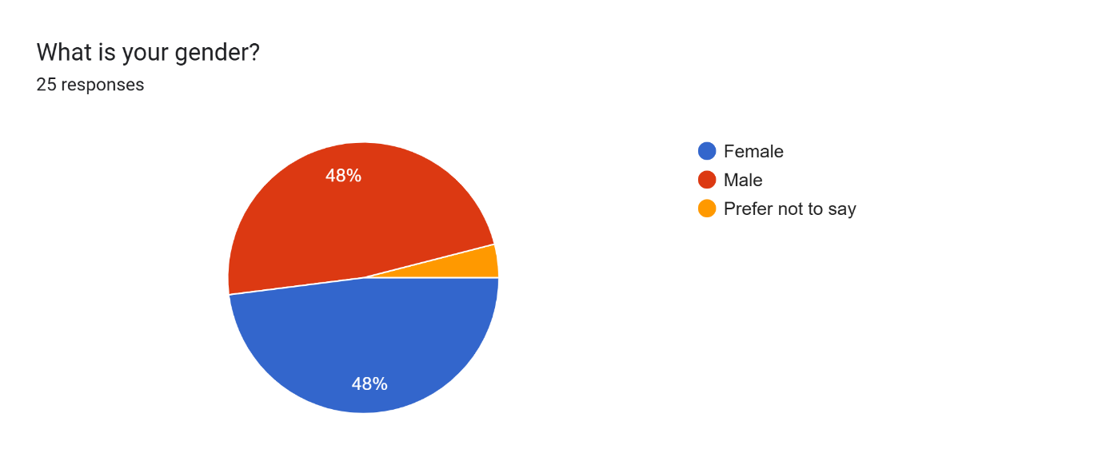
The first question of the research was focused on the gender of the participants, and the results suggested that 48% of the participants were male, whereas 48% of these responders were female, and the remaining 4% of the responders preferred not to mention their gender. This suggests that the research presented a generalised result, with equal opinions of males and females.
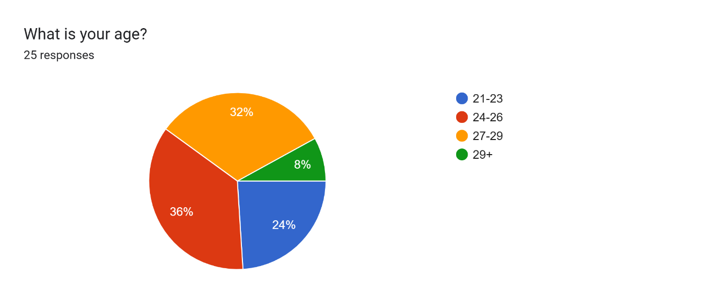
The second question focused on the age group of the research sample; 36% of the research responders were between the ages of 24-26 years old, followed by the 27–29-year-olds who were 32% and 21- to 23-year-olds who were 24%. The rest of the population (8%) was above the age of 29. It suggests that the sample consisted mostly of young adults.
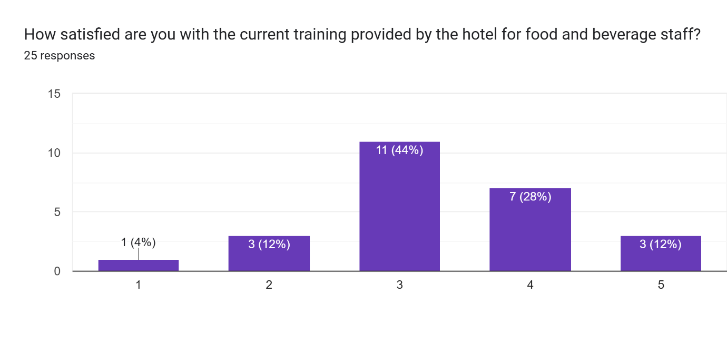
The responders were asked about their satisfaction kevel with the current training that is provided to them by the hotel for food and beverage staff, to which 44% of the responders suggested that they were somewhat satisfied, 28% stated they were dissatisfied 12% suggested they were satisfied, 12% stated they were very dissatisfied whereas only 4% of the responders suggested that they were very satisfied with the training. It implies a requirement in the training.
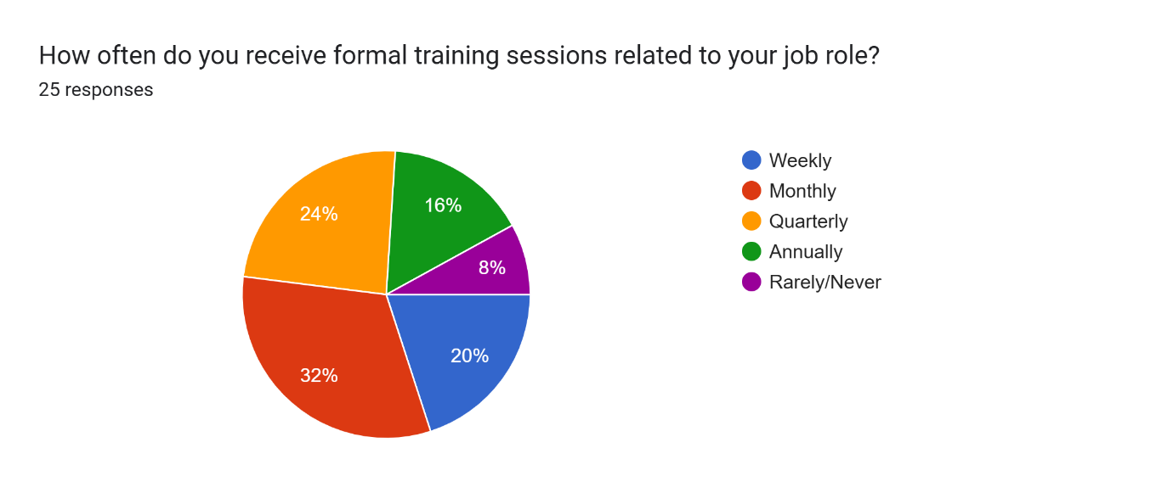
Next, the sample staff were asked about the frequency of tehri formal training sessions related to their job role, 32% suggested that they received it monthly, 24% stated they received it quarterly, 20% suggested that they received it weekly, and 16% of the employees suggested that they received training annually. Whereas 8% of the employees stated that it was rarely.
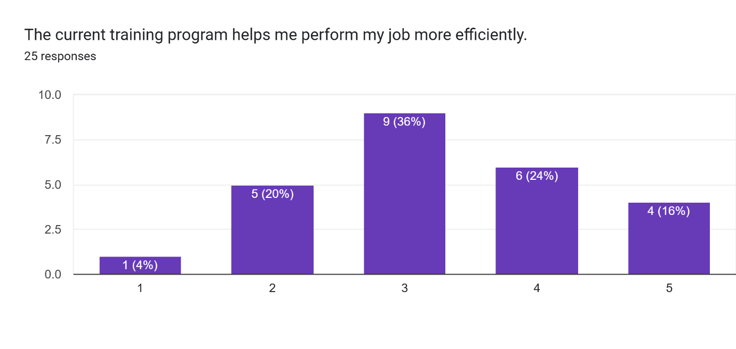
The responders were asked if they think the current training programmes helped them with their job efficiency, to which 36% stated they were neutral about this statement, 24% suggested they disagreed, 20% stated they agreed, 16% suggested strong disagreement, and the rest 4% stated strong agreement.
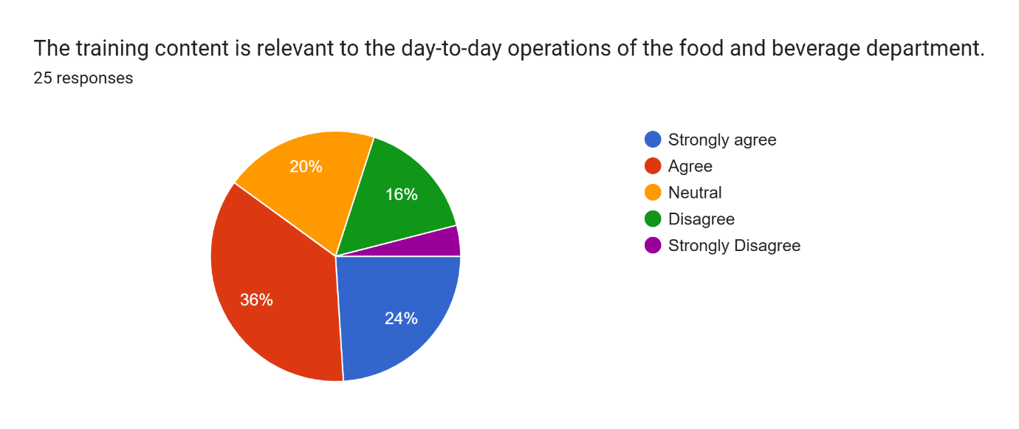
Following this, the responders were asked if they think the training content is relevant to the day-to-day operations of the food and beverage department. 36% agreed with it, 24% strongly agreed, 20% were neutral, 16% disagreed, and the rest 4% strongly disagreed.
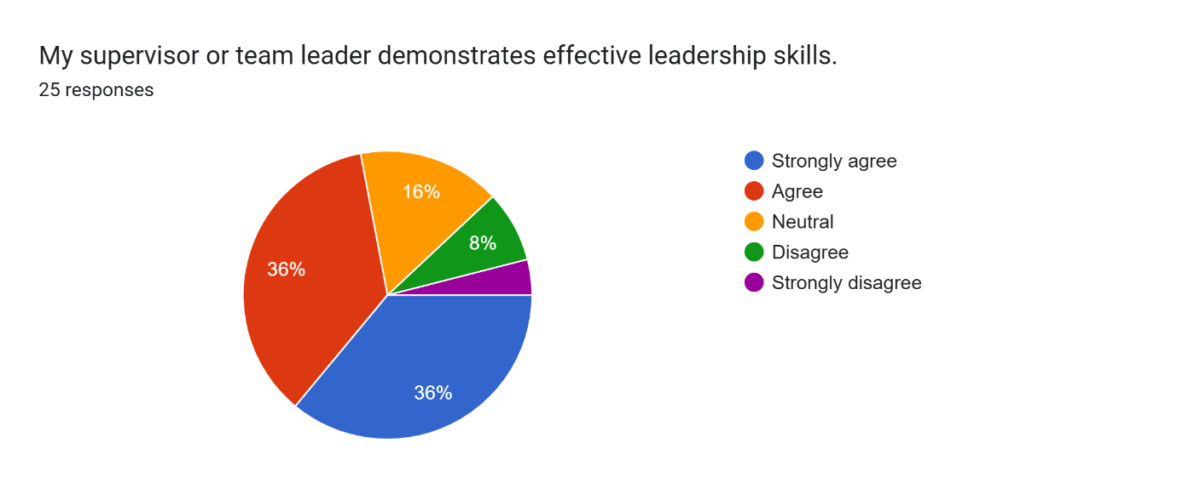
Then they were asked about the effectiveness of leadership demonstrated by their leader, to which 36% agreed, 36% strongly agreed, 16% were neutral 8% disagreed, and 4% strongly disagreed. It suggests overall efficiency in leadership.
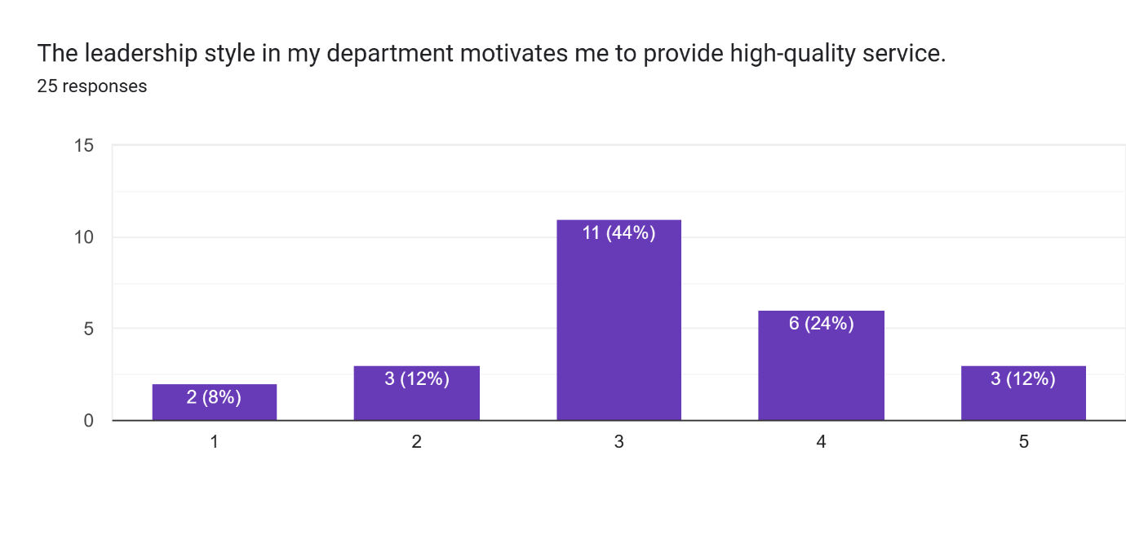
The responders were asked if he leadership style in their department motivated them to provide high-quality service. 44% were neutral about it, 24% disagreed, 12% strongly disagreed, 12% agreed, and only 8% strongly agreed.
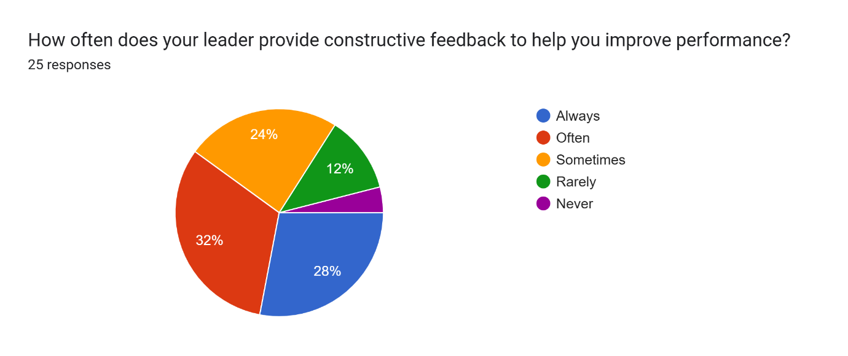
The participants were asked how often their leader provides constructive feedback to help them improve performance. 32% of the participants answered with often, 28% answered with always, 24% answered with sometimes, 12% answered with rarely, and 4% answered with never.
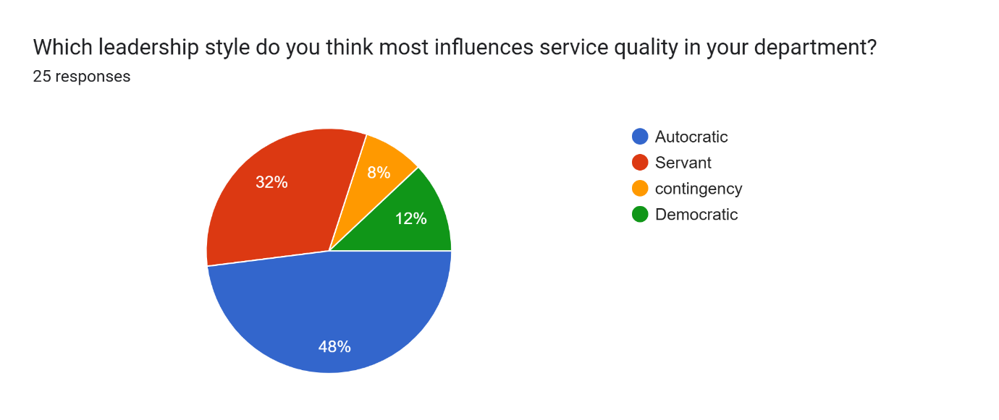
Next, they were asked which leadership style they think most influences service quality in their department, 48% answered with autocratic, 32% suggested servant, 12% stated democratic, and the rest 8% stated contingency style of leadership.
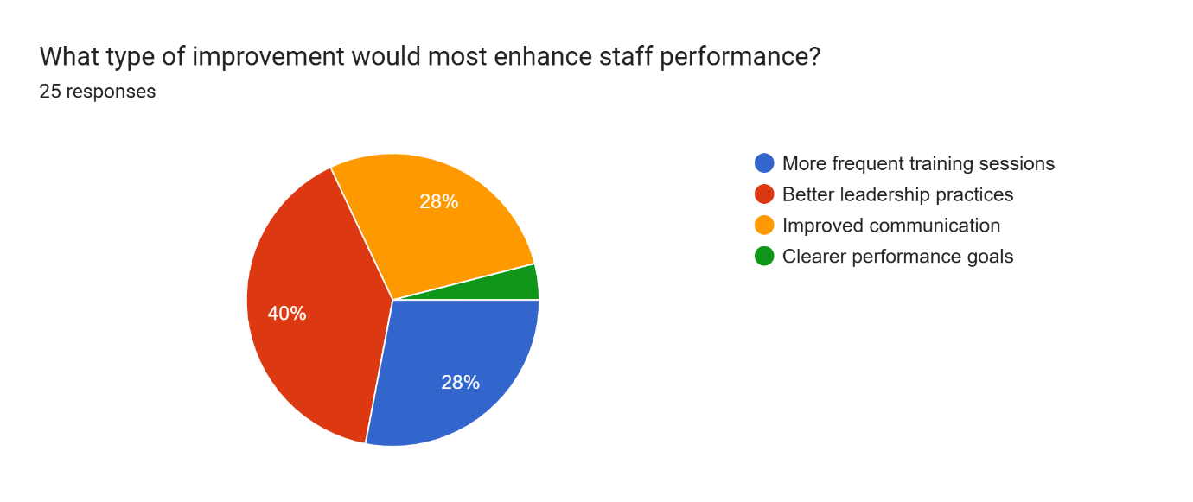
The last question asked them about the type of improvement that would most enhance staff performance. 40% of the responders answered with better leadership practices, 28% suggested improved communication, the next 28% stated more frequent training sessions, and 4% suggested Clearer performance goals

Findings of the Qualitative data collection
In the interview, the responders were asked about their gender and age, instead of focusing on their extremely personal details, which helped the research in safeguarding the confidentiality of the participants. The participants were ages 22, 24, 28, 35 and 32; three of them were women and two of them were men. These participants belonged to the management department, so when they were asked about the quality of training provided to their staff members, one of them suggested that they were extremely dissatisfied because the training was too vague and superficial. The rest of the respondents seem to be satisfied with the training; however, they suggested a few changes and additions.
Next, they were asked about the frequency of training they got related to their job. They suggested that after being managers, the frequency was reduced to once a year.
Upon asking about their training and its relations with their daily activities, 2 of the participants suggested that their training helped them with overseeing staff, strengthening their operational oversight and staff management. One of them stated that it helped them in ensuring the satisfaction of the customers, which improved the customer relationship.
The managers were then asked about the leadership practices that seem to work best on their team. One of the participants states that they worked on building positive culture, while 2 of them stated that open communication helped them with better decision-making processes. One of the interviewees suggested that they empower employees by ensuring high-quality standards while leading them. The last responder stated that encouraging innovative methods to handle daily tasks has helped them motivate their team.
Next, they were asked about how often they provide feedback to their team. One of the responders answered with ‘often’, one of them stated sometimes, and the other 3 responders suggested that they provided feedback sometimes. They gave vague answers.
Next, they were asked about the leadership style that they think most influences service quality in their department. The first and third responders suggested autocratic leadership, the second responder suggested servant leadership, the fourth responder stated contingency, and the last responder stated that they found the democratic leadership to be the most efficient.
Lastly, they were asked about the type of improvement that would most enhance the staff performance. The first responder suggested that the training sessions should be enhanced for the staff and for the managers for better results, the second responder stated better and more integrated leadership practices would help the staff feeling more confident and trusted in the work, the third responder suggested that the company should invest in open and clear communication strategies, which would enhance the efficiency of the company. The fourth responder suggested enhanced focus on the empowering and supportive work culture is the most effective tool. Lastly, the fifth responder stated that the managers and the employees should be provided with clearer performance goals, which would help in understanding their expectations even better.

4.3. Discussion
Beverages and foods of Ashford
The Ashford offers variety of food and drink services in order to promote the brand reputation and expansion. In order for efficient promotion services by there is requirement for well-trained staff and management. According to survey collected from employees, the maximum percentage is satisfied with the training and programs offered by Ashford, which helps in providing better services of products. The training programs were conducted on the monthly basis to ensure regularity and these training programs help the employee in adding efficiency to the overall framework. According to Abdullah, Sufi, and Kumar (2023), there is stiff competition in the UK hospitality sector and this competition can be overcome through ensuring these training programs. The introduction of training programs helps play vital role in improving the overall customer satisfaction, improving services and adding to operational efficiency. These training programs in Ashford will help boost the confidence and motivation of the employees. According to Ashford Borough Council (2025), Ashford is expanding its business in food and drinks because its food and beverages department is excelling and growing rapidly in Gusbourne, Chappel Down and Biddenden Vineyards. Along with training programs, there is an introduction of community in order to promote food and Drink and keep records of all recent updates of local foods and information.
Leaders affecting the level of services
There is of variety of leadership theories used in Ashford in order to improve services. According to Zia et.al (2022), the UK hospitality sector is becoming unique in all other sectors. The leadership is considered to be the most important factor, which tends to add value to the organisation. According to the survey, the different leadership styles help in motivating the staff and provide high-quality services. There are use of different models of leadership, which involve the servant leadership, transformational leadership, situational and contingency theory of leadership and behavioural theory of leadership. All these theories help in understanding the needs, requirements and preferences of the organisation and lay the framework according to it, later this helps in adding value to the organisation. According to XIA (2022), each of the leadership styles holds different psychological impact on the minds of people and helps them to choose the leader based on their actions. The introduction to leadership helps in increasing the flexibility and efficiency within the system. There is the mechanism of feedback, which allows the leaders to seek constructive feedback from the employee. This helps in creating an environment of accountability and responsibility within the system. According to the survey conducted among employees, the Ashford leaders are considered to be active and respect the mechanism of leadership, which shows them being active in participation. According to the survey performed form the employee asking the following of theories within the system, the majority was supported by the Autocratic theory of leadership, which states that this theory can be applied within the framework of Ashford Hotel to improve the services of food and beverages. According to Ciulla (2020), leadership affects the relationships between the leaders and employees, which later impacts the mutual purpose. The quality of leadership depends on the type of leader and their actions. The value of leader of an organisation depends on the type of leadership theory.
Ways to improve training for staff and leadership development in the food and beverage department
There are variety of ways to develop the better department of food and beverages, there is use of various ways such as e-learning, food safety, customer services, mentorship programs, and various opportunities and responsibilities. According to the survey, there are several observations made into consideration, such as that the survey was conducted with the employee of age group 24 to 26 years. There is an introduction to various training programs, which help in enhancing the staff performance and there is the use of various leadership styles, where the preference was given to autocratic leadership. According to Mastilović, Vukotić, and Ćerović (2024), the consumers are considered to be potential guests and are attracted to the importance of food safety and its importance. In order to improve the brand and reputation of the organisation, the main consideration is given to staff training and leadership development. The staff training helps in providing valuable foundational base to the organization, it helps in increasing confidence and job satisfaction, the properly trained staff helps in creating the positive environment and encourages open experience. The leadership helps in keeping business competition, helps in strengthening brand and reputation, fosters positive work culture and keeps the spirit of competition alive. The food and beverages play an important role in shaping the overall success and impact on the service quality and food safety. To ensure better services within the framework, the training helps in an essential part and looks into fulfilling the needs for specifying the job requirements in order to meet the organizational goals and objectives. Staff training and development play a crucial role in delivering success in the hospitality industry. The food and beverages help in providing tourists and catering services. To improve staff and leadership development in the food and beverage department, it is important to focus on training and teamwork. Regular workshops on customer service, hygiene, and new food trends can help staff build their skills and confidence. Leaders should get training in communication, teamwork, and problem-solving so they can guide their teams better. Giving staff chances for promotion and regular feedback keeps them motivated. According to Buhalis and Moldavska (2022), there is use of tools and techniques to improve customer service.

Chapter 5: Conclusion and Recommendations

5.1. Conclusion of the Research
Ashford International Hotel offers many services, including a one-of-a-kind experience in its hotels and with spa, dining areas and health clubs, which is why it holds a strong position in the market. This hotel is known for hosting first-rate social occasions and providing accommodations and services, giving it a great competitive advantage. This hotel is known for serving a diverse range of populations and markets in the United Kingdom. There are certain factors that affect the leadership in a company, specifically considering the Food and beverage services. Leadership, along with staff training, is one of the factors that influence the overall quality of services, which is also being criticised in the hotel industry of the United Kingdom. It is a result of rising uncertainties in the economic and political spheres. The training of the employees also gets affected by the post-Brexit situation. However, during the primary quantitative research, it was found that 44% of the respondents suggested that they were only somewhat satisfied with the training provided to the food and beverage staff, suggesting that the organisation needs to enhance the services of its staff. 2 of the participants agreed on this question in the qualitative primary data as well, suggesting that the current training plan was good enough, however, lacked depth, which made it difficult for the staff to adopt with efficiency. One of the participants also suggested that they were not at all satisfied with their training, stating that it is too superficial and does not help properly.
The aim of this study was to evaluate the effect of staff training and the style of leadership on the food and beverage service quality at the Ashford International Hotel and Spa. The objectives of the study are to analyse how the employees are trained in the hotel for the food and beverage personnel currently. The second objective of the research was to analyse diverse types of leaders and leadership that affect the overall level of service, and the last objective of the research was to provide insights into the improvement of training for the staff and leadership in the food and beverage department.
It was found that Ashford International Hotel and Spa promotes its services by conducting the Ashford Food and Drink festival, which includes the Ashford town centre, which helps the vendors of the entire city. Ashford International Hotel has been expanding its food and drink cluster. The company also supports the food and drink community in which introduces them to promote food and drink and helps them provide recent updates and information on the local products and foods. It was suggested through primary quantitative research that only 20% of the participants were satisfied with their training performance and that it was impacting the efficiency of their job, whereas 36% of these participants agree that the training content is relevant to their day-to-day operations in the food and beverage department.
The research analysed a number of studies, through which it was found that a number of theories could be applied to the case of Ashford International Hotel, which was inclusive of the transformational, situational or contingency and servant leadership theories. 44% of the responders in the primary quantitative research suggested that the leadership style in their department motivated them to deliver a high-quality service to the customer, which suggests the importance of the right leadership in the company. It was found that servant leadership helps in the empowerment of the employee, while also contributing to the betterment of the services and decreasing the turnover rate in the organisation. It feeds innovation and creativity in the organisation, while also creating commitment. The situational and contingency theory of leadership is also considered to be relevant for the hotel, as it helps in navigation through diverse crises. The findings of the research suggest that different types of leadership result in different outcomes for the organisation. One of the respondents of the primary qualitative research also suggested that they were not aware of the different aspects through which leadership might affect their organisation. It suggests a lack of awareness and knowledge among the staff members.
While considering the methods for the improvement of the training of staff and leadership in the company, it was found that the application of a mixed method would be beneficial for the organisation. These methods would include online learning, mentorship programmes and customer service.
The research made use of the research onion model, which helped in summarising the approach taken by the research. It also justified its choices while noting the diverse advantages and disadvantages of the approaches.
The research philosophy chosen by the study was pragmatism, with an abductive research approach, a case study and a survey research strategy. It made use of a mixed research method as its research choice; he data was collected at a single point in time, making it a cross-sectional study. Finally, for the data collection and analysis, the survey and interview methods were used, which were then analysed with the help of statistical and thematic analyses, respectively.

5.2. Recommendations for future Research
The disadvantages of the research resulted from the fact that it was mixed research; hence, the recommendations are also related to the same. If future researchers choose to use this approach, they could align the methods with the goals, plan for better integration, and create a clearer research design. Analysing the dataset independently first, synthesise findings and reflexively acknowledge limitations. Despite the difficulties in the assessment related to this research method, it is still suggested because of the numerous benefits offered by this method, including the explanation of the “why” and “what” behind a particular process. It also enhances the real-world applicability of the research results, along with allowing the researchers to look at the larger picture. As per the statement of Garai-Fodoret al. (2022), if the qualitative results are analysed with the traditional content analysis methods, it would help in designing the hypotheses of the quantitative release while also helping in designing the standardised questionnaire as well.
Other than this, it is recommended to future researchers that since this result helped in analysing the overall effect of training and leadership, they could focus on the effectiveness of the specific training method on the improvement of the food and beverage services. These training methods are inclusive of job shadowing, role-playing, apprenticeship training, online learning, gamification, mentoring, pre-shift meetings and classroom training. In addition to this, this study has already laid the foundation and given the proof of the effect of leadership on the quality of services; future research could compare different approaches of leadership and compare the effect on the quality of services in the food and beverage industry. Furthermore, the research had made use of the case study research strategy, hence focusing on just one company, which includes the limited generalisability, potential for the researcher bias, extensive resource demands, narrow scope, subjectivity and time-consuming. Future researchers could make use of other strategies, which would help them with a wider sample, which would help with more generalisable research results, while also decreasing the chances of biases in the results. Abdelwahed et al. (2024) state the importance of primary quantitative research by suggesting that it is an effective and reliable approach which gives important implications for its reproducibility and policy development. It is recommended for researchers to focus on the primary quantitative research method, which would allow them to collect data firsthand, ensuring the accuracy and reliability of the data. Researchers are able to minimise bias with the help of objective and numerical data. Other than this, the researchers could ensure the relevancy and specificity of the data as well, and the research questions could be tailored, hence making it more flexible and easier to collect data. Numeric data are analysed as easily as well, and the researchers could make use of a new statistical tool to further analyse a larger sample with ease. The findings of the primary research would not be subjected to the same limitations or biases which might persist in the secondary data.
Other than this, the utilisation of primary qualitative research and secondary qualitative research has its own advantages, which could be conducted by future studies to increase the depth of the data in the research. As per the statement of Shaw et al. (2022), the qualitative secondary analysis is stated to be the use of data that was collected and explored with a differing point of view. The secondary qualitative research is considered to be significantly faster and more cost-effective when compared to the primary research; it also reduces the overall effort and time by eliminating the sampling, recruiting and data collection procedures. It would help the researcher in analysing a much larger dataset, which would help in increasing generalisability and extending the existing research. It helps in reaching hard-to-access groups as well, who are difficult to recruit otherwise. This research was focused on the cross-sectional type of time horizon due to time and resource limitations; however, if future research wants to analyse the trends over time, they could make use of a longitudinal type of research as well, which would help them in tracking the progress of new phenomena over time, while also avoiding repetition of new data.

5.3. Conclusion
The main objective of the research was to analyse the effect of training and leadership on the food and beverage department of the Ashford International Hotel. The relevant data were collected through the survey research method from 25 participants and 5 interview participants. The recommendation section suggested various ways that could be adopted by future research to contribute more to this field while building on this study. It also suggests different methods to overcome the overall difficulties associated with this research.

References
Abdullah, O., Sufi, T. and Kumar, S., 2023. Impact of food and beverage quality and service quality towards customer satisfaction and customer retention, A study of five-star hotels. International Journal of Professional Business Review: Int. J. Prof. Bus. Rev., 8(5), p.98. https://dialnet.unirioja.es/descarga/articulo/8957031.pdf
Arwab, M., Adil, M., Nasir, M. and Ali, M.A., 2023. Task performance and training of employees: the mediating role of employee engagement in the tourism and hospitality industry. European Journal of Training and Development, 47(9), pp.900-920. https://www.researchgate.net/profile/Mohd-Nasir-4/publication/363040371_Task_performance_and_training_of_employees_the_mediating_role_of_employee_engagement_in_the_tourism_and_hospitality_industry/links/63c278fcd7e5841e0bc8744c/Task-performance-and-training-of-employees-the-mediating-role-of-employee-engagement-in-the-tourism-and-hospitality-industry.pdf?origin=journalDetail&_tp=eyJwYWdlIjoiam91cm5hbERldGFpbCJ9
Ashford Borough Council. 2025. Ashford Food & Drink Festival 2025 proves to be a Town Centre hit. Ashford Borough Council. https://www.ashford.gov.uk/news/latest-news/ashford-food-drink-festival-2025-proves-to-be-a-town-centre-hit/
Ashford hotel. 2025. About us. Ashford hotel. https://www.ashfordhotel.co.uk/
Buhalis, D. and Moldavska, I., 2022. Voice assistants in hospitality: using artificial intelligence for customer service. Journal of Hospitality and Tourism Technology, 13(3), pp.386-403. https://eprints.bournemouth.ac.uk/36952/3/Voice%20Assistants%20in%20Hospitality%208NOV21%20CLEAN.pdf
Chepkwei, A., 2021. Strategy implementation in hospitality industry: global perspective. Journal of Strategic Management, 6(1), pp.33-45. https://www.academia.edu/download/80664673/799.pdf
Dale, C., Robinson, N., Catahan, N., Doran, C., Marsh, S. and Evans, M., 2023.][ Together in Electric Dreams: Hospitality Management, Education and Training post COVID-19-the Challenges and Opportunities offered by Technology. International Case Studies for Hospitality, Tourism and Event Management Students and Trainees, p.10. https://www.researchgate.net/profile/Elizabeth-Ineson/publication/374006183_International_Case_Studies_for_Hospitality_Tourism_and_Event_Management_Students_and_Trainees_Vol_14/links/65096f3f82f01628f0312054/International-Case-Studies-for-Hospitality-Tourism-and-Event-Management-Students-and-Trainees-Vol-14.pdf#page=28
Mahmood, S., Zaman, S. and Chaman, S., 2024. The Role of Transformational Leadership and Intellectual Capital to Improve Service Quality in Tourism Sector. Pakistan Social Sciences Review, 8(4), pp.515-635. https://www.ojs.pssr.org.pk/journal/article/download/876/688
Mastilović, J.S., Vukotić, J.R. and Ćerović, S.R., 2024. Challenges and importance of food safety management in hospitality industry. Food and Feed Research, 51(1), pp.19-30. https://aseestant.ceon.rs/index.php/ffr/article/download/48449/24926/
Neupane, R. and Khanal, T.R., 2022. EVALUATION OF THE IMPACTS OF TRAINING ON EMPLOYEE PERFORMANCE IN THE UK HOTEL INDUSTRY: AN ANALYSIS OF EMPLOYEES’PERSPECTIVES AT MARRIOTT INTERNATIONAL. International Journal of Research-GRANTHAALAYAH, 10(3), pp.57-85. https://pdfs.semanticscholar.org/9998/18868ef301d019696060860db1525b03a38f.pdf
Travel and Tours world. 2025. Canada, Japan, and UK Lead Hotel Market Trends as United States Struggles with RevPAR Decline in 2025. Travel and Tours world. https://www.travelandtourworld.com/news/article/canada-japan-and-uk-lead-hotel-market-trends-as-united-states-struggles-with-revpar-decline-in-2025-here-is-a-new-report/
XIA, S., 2022. LEADERSHIP STYLES AND THEIR IMPACT ON EMPLOYEE ENGAGEMENT IN THE UK HOSPITALITY INDUSTRY ORGANIZATIONS (Doctoral dissertation, SIAM UNIVERSITY). https://e-research.siam.edu/wp-content/uploads/2023/03/IMBA-2022-IS-Leadership-Styles-and-Their-Impact-on-Employee-Engagement-in-the-Uk-Hospitality-Industry-Organizations.pdf
Zia, M.Q., Naveed, M., Bashir, M.A. and Iqbal, A., 2022. The influence of servant leadership on employees' outcomes via job embeddedness in hospitality industry. Journal of Hospitality and Tourism Insights, 5(3), pp.612-628. https://www.researchgate.net/profile/Asif-Iqbal-55/publication/351160644_The_influence_of_servant_leadership_on_employees%27_outcomes_via_job_embeddedness_in_hospitality_industry/links/61e9c08e5779d35951c0e65e/The-influence-of-servant-leadership-on-employees-outcomes-via-job-embeddedness-in-hospitality-industry.pdf
Abdelhakim, A.S., 2021. Adopted Research Designs by Tourism and Hospitality Postgraduates in The Light‎ of Research Onion. International Journal of Tourism and Hospitality Management, 4(2), pp.98-124. https://ijthm.journals.ekb.eg/article_206774_39a512b92a6470df762792c8d0c60a12.pdf
Abdelwahed, N.A.A., Al Doghan, M.A., Shah, N. and Soomro, B.A., 2024. Entrepreneurial orientation and product innovation performance: developing the linkages through strategic human resource management and technology capability. Journal of Science and Technology Policy Management. https://www.researchgate.net/profile/Mohammed-Aldoghan/publication/382995501_Entrepreneurial_orientation_and_product_innovation_performance_Developing_the_linkages_through_strategic_human_resource_management_and_technology_capability/links/66bf43c8145f4d35535f9f1c/Entrepreneurial-orientation-and-product-innovation-performance-Developing-the-linkages-through-strategic-human-resource-management-and-technology-capability.pdf
Ashford International Hotel. 2025. ASHFORD INTERNATIONAL HOTEL & SPA, KENT, PART OF THE QHOTELS COLLECTION. Available at: https://www.ashfordhotel.co.uk/ (accessed on: 14 October 2025)
Garai-Fodor, M., Szemere, T.P. and Csiszárik-Kocsir, Á., 2022. Investor segments by perceived project risk and their characteristics based on primary research results. Risks, 10(8), p.159. https://www.mdpi.com/2227-9091/10/8/159
Mulisa, F. (2022). When does a researcher choose a quantitative, qualitative, or mixed research approach?. Interchange, 53(1), 113-131. https://www.researchgate.net/profile/Feyisa-Mulisa/publication/356567326_When_Does_a_Researcher_Choose_a_Quantitative_Qualitative_or_Mixed_Research_Approach/links/674965bb790d154bf9b386b0/When-Does-a-Researcher-Choose-a-Quantitative-Qualitative-or-Mixed-Research-Approach.pdf
Shaw, P.A., Sumner, A.L., Halton, C.C., Bailey, S.C., Wolf, M.S., Andrews, E.N. and Cartwright, T., 2022. “You're more engaged when you’re listening to somebody tell their story”: A qualitative exploration into the mechanisms of the podcast ‘menopause: unmuted’for communicating health information. Patient education and counseling, 105(12), pp.3494-3500. https://www.sciencedirect.com/science/article/pii/S0738399122004050
Wimalaratne, P.L.I. and Kulatunga, U., 2022. A methodology to study the complexity of buildability in construction projects: phenomenological research perspective. In Proceedings of the 10th World Construction Symposium (pp. 24-26). Sri Lanka: Ceylon Institute of Builders and University of Moratuwa. https://ciobwcs.com/downloads/papers22/WCS2022_Proceedings_2.pdf
Wisenthige, K., 2023. Research design. In Social Research Methodology and Publishing Results: A Guide to Non-Native English Speakers (pp. 74-93). IGI Global. https://www.researchgate.net/profile/Krishantha-Wisenthige/publication/369157621_Research_Design/links/662d330d06ea3d0b74138ab6/Research-Design.pdf

Appendices

Appendix 1: Ethics Form

Appendix 2: Survey Results

Appendix 3: Interview Transcript

Appendix 4: AI Acknowledgement Statement

Appendix 5: Research Permission

