DS 1 Assignment

My Screenshots/Photos
- Please add 4–6 screenshots or photos of your digital life.
- You can use your phone or laptop.
- For each screenshot, write one or two sentences explaining what it shows.

Screenshot/Photo 1
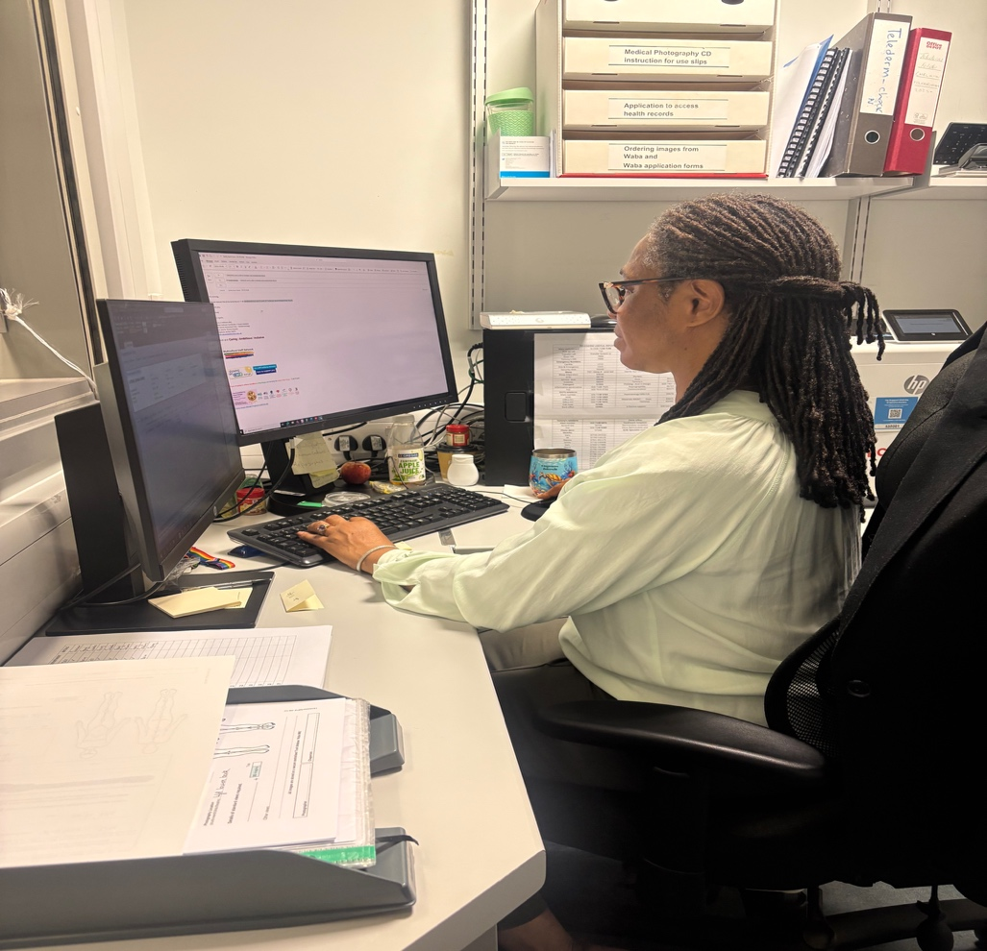
In this photo it displays the use of my digital skills by me being able to manage two screens simultaneously and being able to switch between programs to deliver optimise in submission of my daily work task.

Screenshot/Photo 2
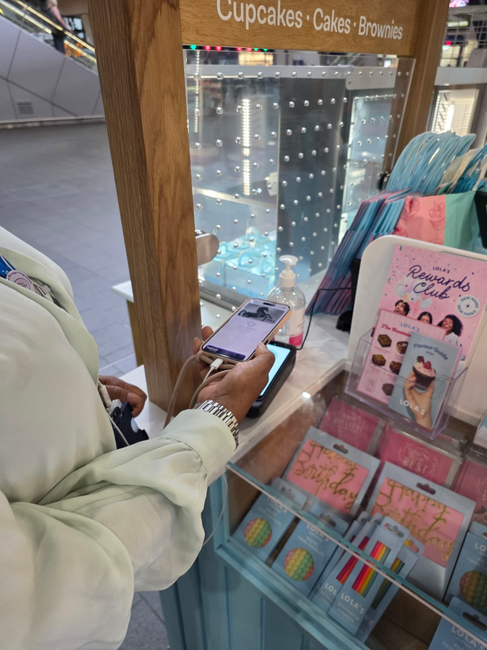
[The image displayed shows my use of digital skills in using point of sale technology in payment for goods received. This is in the use of my banking application and the point-of-sale choice provided by the vendor.

Screenshot/Photo 3
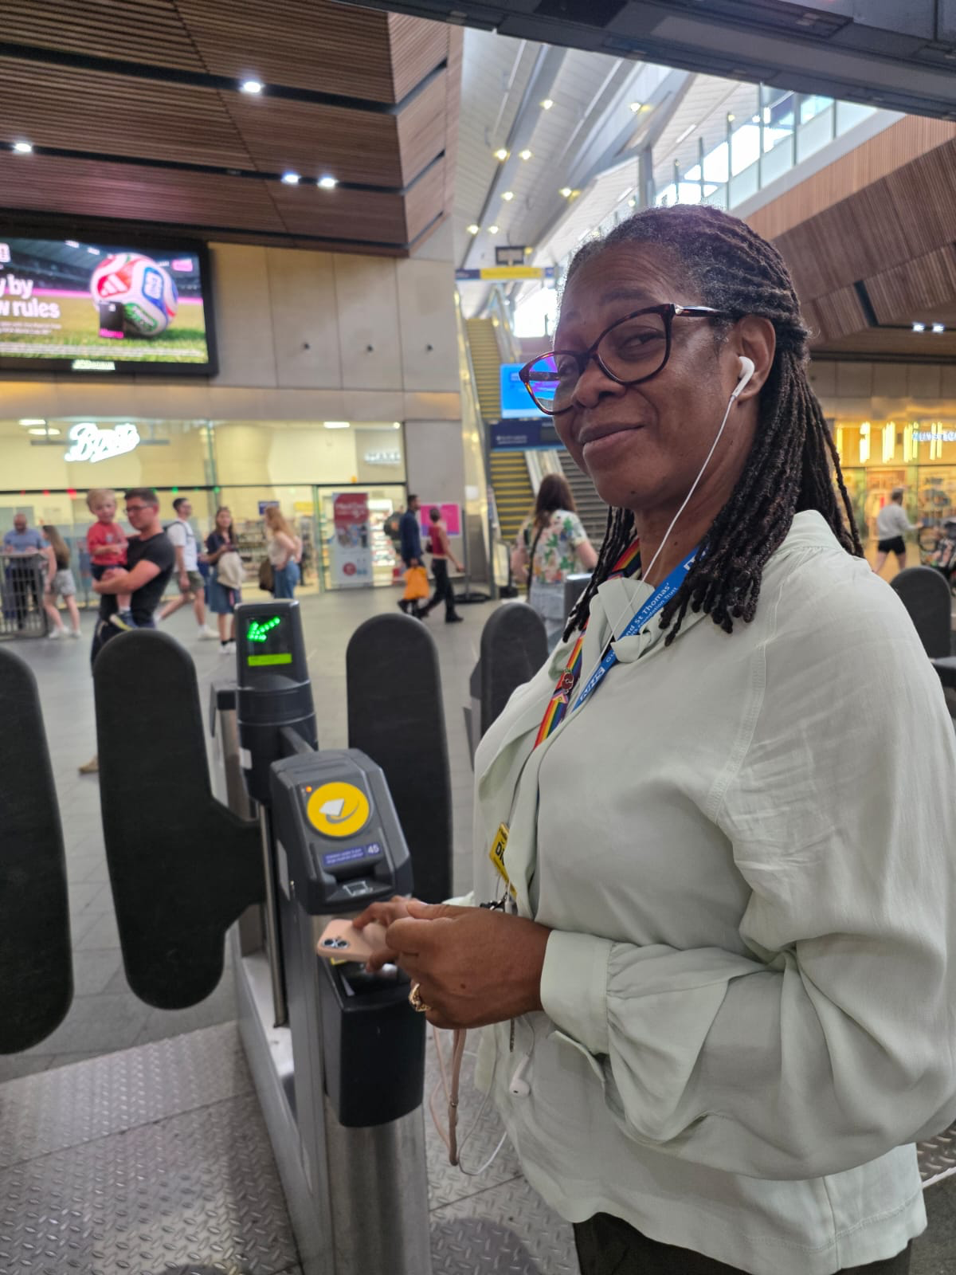
This image displays the use of digital technology using direct payment through bank application for travel. It enables the use of nonphysical card contact.

Screenshot/Photo 4
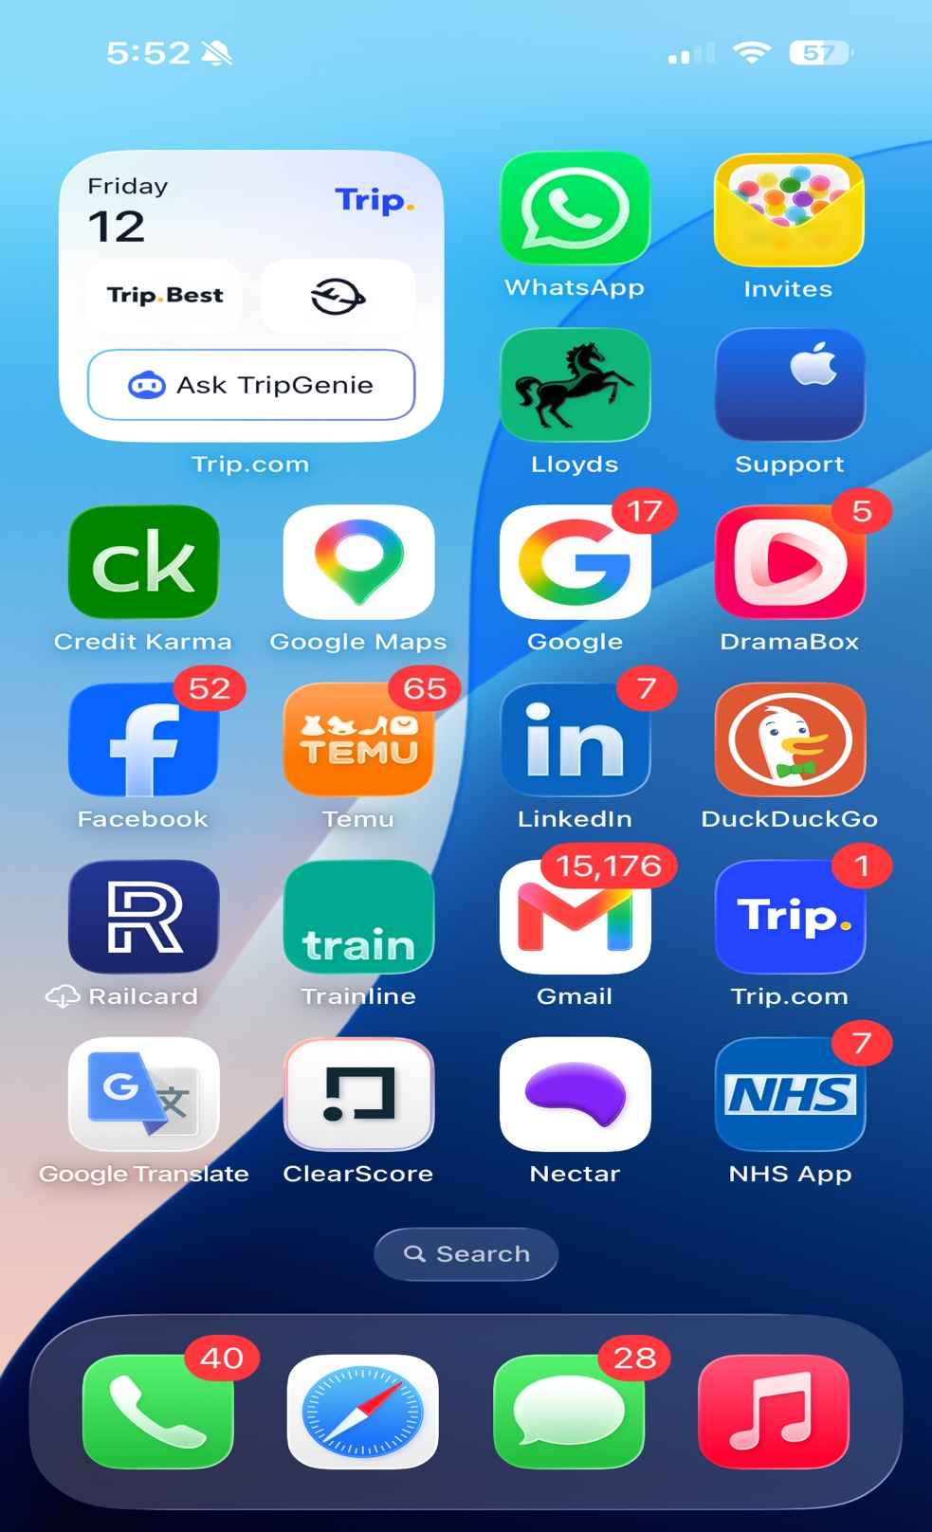
This image displays the mediums which I used to displays the methods I use in my digital life. It shows that I support various digital platforms in my daily routine.

Screenshot/Photo 5
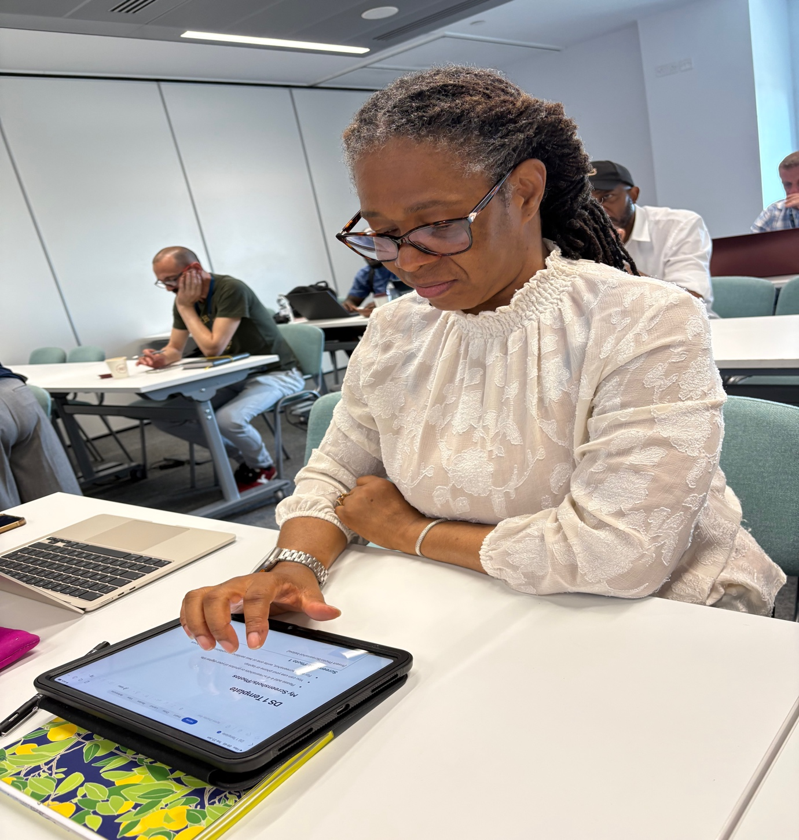
This imagine displays the use of my digital skill in completing various class tasks in achieving work due.

Screenshot/Photo 6
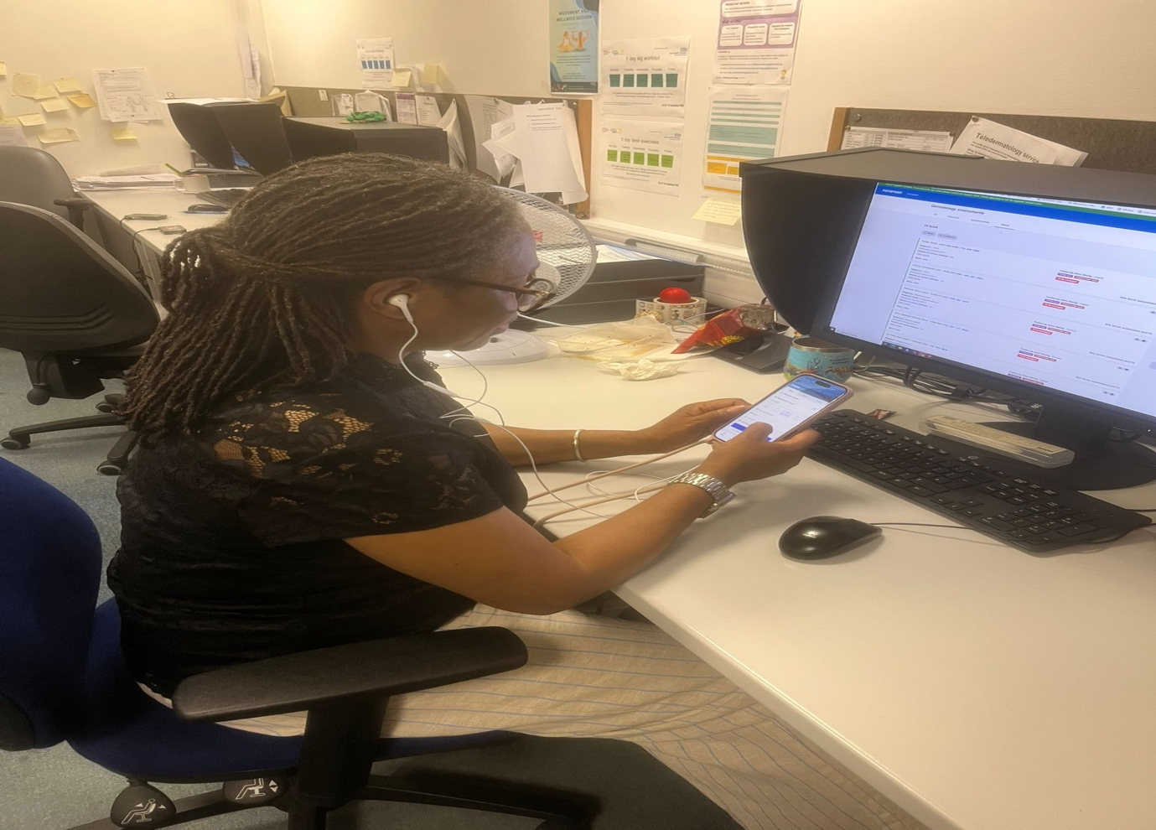 This image displays that I am adaptable in using one screen to achieve my work completion. This shows that I can move between the various platforms on a single device.

My Short Reflection
- Write 5–8 simple sentences about your digital life.
- You can use the sentence starters below if helpful.
Dionne’ reflection
I utilise the use of various digital tools in my daily life such as an iPad, laptop, and cellular phone. The use of these varied devices allows my life flexibility in completing various activities.
I use digital skills to complete tasks, search for new or improved old services for information, look up things I am unclear about and search for houses or travel websites.
I want to improve the use of Ai in optimising my writing skills as well as search options in improving myself and in the use of my daily tasks for better work balance.
I often use Microsoft office/365 in my daily tasks but feel that I need to improve in these areas to become a more efficient individual.
I am hoping for this module to help me improve myself in the use of digital skills in becoming a better person in my career and self confidence in using technology.
Digital skills are important for me because I would like to become a more productive and effective person, leader, and mentor to my colleagues and other members of staff that I meet. .

Sentence starters
- I use digital tools to …
- I feel confident when I …
- I want to improve …
- I often use these tools: …
- I sometimes feel nervous about …
- I hope this module will help me …
- Digital skills are important for me because …
You can write more if you want.

Submission Checklist
Before you submit, please check:
​​​ ☐ I added 4–6 screenshots
☐ I wrote short sentences for each screenshot
☐ I wrote my short reflection
☐ My work is my own
☐ My file opens correctly
​​☐ My file opens correctly

