Management Economics
Assessment 1
LCBB5003

Student name: Andrei Nalivaico
Student ID: 2021614

Executive Summary
The report has depicted all the core factors of management economics. This particular report has described a famous beverage sector of the UK. The company is known as Coca-Cola and the report has given a detailed description of the company including its history, overall business activities and its business profile. The report has focused on a particular product of the company which is a famous soft drink and also the reason for choosing it. The report has further discussed its influence on demand and equilibrium. Finally, the report has highlighted the influencing factors regarding the price elasticity of demand.

Table of Contents
Introduction 4
Description of the Coca-Cola Company 5
Demand and Market Equilibrium 6
Price Elasticity of Demand 12
Conclusion 15
References 16

Introduction
Management economics defines the implementation of certain economic theses to the issues of management. This can be executed for resolving the problem within the business. This provides the management to assume, plan and make decisions for the better advancement of the company. The following report will shed light on all the important factors of management economics by focusing on the economic activities of a particular business in the UK. The report will highlight a famous beverage sector, known as Cola-Cola. This will include a brief description of the company and its overall business activities. First, the report will discuss the concept of demand and equilibrium in the market with proper diagrams. After that, the report will describe how the price of substitutes, complements, customer income and their preference affect the fluctuations in demand. Finally, the report will explain the influencing factors of price elasticity and how Coca-Cola is getting affected by it.

Description of the Coca-Cola Company
The Coca-Cola Company is a famous multinational beverage sector in America, established in 1892. This particular company sells and produces alcoholic and non-alcoholic beverages, soft drinks and syrups. The market stock of the Coca-Cola company is recorded on the NYSE and this company is the segment of the DJIA. The Coca-Cola drink was originated by John Stith Pemberton in 1886 who was a pharmacist by profession. This drink was first advertised as it can give relief from headaches which is why it was sold in drugstores and pharmacies as a curative or remedial beverage. Pemberton experimented with his beverages and achieved all the business objectives during the month. Frank Robinson, the bookkeeper of John, created the company logo and named the beverage Coca-Cola. Robinson selected the name because of the crucial ingredients which were leaves of coco and Kola nuts. Based on the financial data of the annual report in 2005, the company had sold its products in 200 countries approximately. Eventually, in 2010, Coca-Cola was one the first brands that made more than £1 billion in yearly grocery sales in the UK. Coca-Cola is a publicly traded business enterprise. The company stock is recorded on the Stock Exchange Index of New York. Generally, Coca-Cola Bottlers has an exclusive channel with the company that provides the bottles in which the product is supplied, distributed and sold to retail stores, restaurants, fast food chains, and vending machines all over the country and outside of the country. The company provides five hundred brands or more in more than two hundred countries all over the world in 2020. The company also declared that it would break off half of the brands mainly because of the pandemic situation of COVID-19. The main motive for choosing the soft drink Coca-Cola is mainly because of its popularity in public and it emphasised more on the brand name rather than the product. It is said to sell ‘happiness’ on the bottles rather than only soft drinks (coca-colacompany, 2022).

Demand and Market Equilibrium
Definition of Demand
The demand for a product totally depends on the desirability of the consumers. Demand focuses on when the customers display their willingness and interest to purchase a certain product or service. Market demand refers to a kind of demand that is for a specific product or service within the market. The entire demand for products or services within the market is known as aggregate demand (Amadeo, 2022).
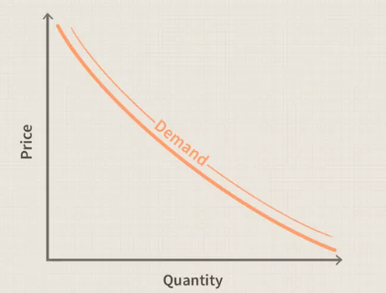
(Figure 1: The Demand Graph)
(Source: Munro, et al., 2021)
Definition of Equilibrium
The state of equilibrium occurs when the overall forces of the economy are properly balanced. As a result, the variables of the economy remain constant from the market equilibrium values. When the levels of supply and demand in the market match with each other, the market equilibrium can be observed in the economy (Munro, et al., 2021).
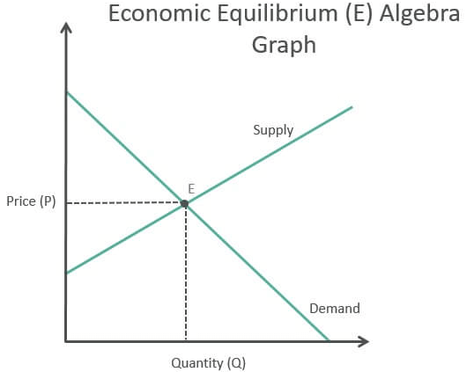
(Figure 2: The Economic Equilibrium Graph)
(Source: Rietveld and Eggers, 2018)

The demand for Coca-Cola or for a matter of fact any product is affected by some crucial factors which indicate of the demand is reducing or increasing for the particular product in the economy.
Price of Substitutes:
Sometimes, the goods get substituted when the demand for a product grows automatically after the increase in the price of another product. Substitute products are the alternatives for the customers which generates competition and cheap prices within the market economy. When the price of one product increases, the customers will automatically switch to another cheaper product for their use. Similarly, in this case, the substitution for Coca-Cola can be Pepsi. When the market price of Coca-Cola increases, the demand for it automatically decreases as the price and demand have an inverse connection, as per the law of demand. The interchangeable characteristic of both of these products is because of the resemblance of the objective they mainly serve. Thus, the price of substitutes does affect the increase and decrease in the demand graph (CFI Team, 2022).
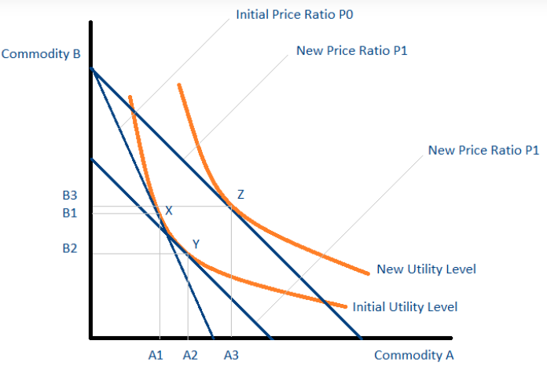
(Figure 3: The Graph of Substitution Product Price)
(Source: Munro, et al., 2021)

Price of Complements:
The complementary goods are the items which are purchased together with the actual product. These complimentary goods can not be sold separately and sometimes hold a cheap price in the market. When the price of the actual product increases, the demand for each of the complementary products will reduce. The popularity of complementary goods evolves with the popularity of the actual product. Similarly, the complementary goods of Coca-Cola can be its raw materials. An increase in the price of raw materials can affect the price of actual products and the overall production cost. When the price of raw materials of Coca-Cola increases, the value of the actual product automatically increases and as a result, the demand for the product will drop. Therefore, the price of complementary goods influences the demand for Coca-Cola to a great extent (Rietveld and Eggers, 2018).
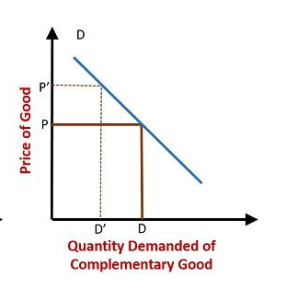
(Figure 4: The Graph of Complimentary Product price)
(Source: Rietveld and Eggers, 2018)

Consumer Income:
The income of the consumer recognises the fluctuations in the demands of the consumer for particular products and services. Moreover, if the income of the consumer rises, they will gradually increase their demand for more goods. On the contrary, when the income of the consumer decreases, their demand for more products automatically reduces. Similarly, when the income of the consumer increases their demand for Coca-Cola will automatically increase. They will buy more products as per their demand. The effect of income depends on the theory of consumer choice that prefers the consumption expenditures and demand diagrams of the consumer. Therefore, when the income of the consumer increases, the demand for Coca-Cola will gradually increase (Zanzalari, 2022).
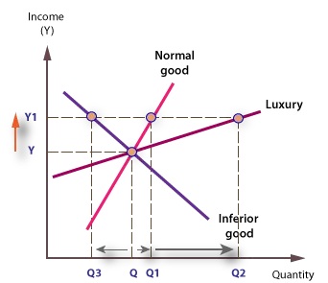
(Figure 5: The Graph of Consumer Income and Demand)
(Source: Kamdar, 2018)

Consumer Taste and Preference:
The demand for a particular product will be affected by the taste and fondness of the consumer conclusively. When the preference, taste and fondness are positive, the demand for the product will also increase. On the other hand, when they are negative, demand will decrease. Similarly, when the consumer prefers Coca-Cola more than any other beverage, the demand for Coca-Cola will automatically increase. On the contrary, when consumers prefer its substitutes more, the demand for Coca-Cola will decrease (Kamdar, 2018).
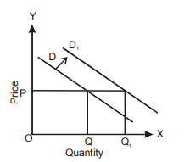
(Figure 6: The Graph of Change and Preference and the Demand)
(Source: Kamdar, 2018)

Price Expectations of Consumers:
The consumer always expects the value of products to reduce so that they can purchase more in the future. As a result, consumers will resist their desirability to buy the product at the present as there are focusing on their expectations of price reduction in the future which resulted in a decrease in demand in the present. On the other hand, when the consumer expects an increase in the price level henceforward, the product’s demand will automatically increase in the present. Similarly, when consumers expect the value of Coca-Cola will fall in the future, they will resist their buying the product temporarily and as a result, the demand for Coca-Cola will also decrease in the present moment and vice versa. Therefore, the price expectations of the consumer have a huge impact on the demand for Coca-Cola. When the price expectations get high, the demand will increase in the present and when the expectations get low, the demand will decrease in the present.
Demographics or the number of Consumers:
The availability of great numbers of consumers affects the demand curve in the economy. When the number of consumers increases in the country, the demand for the product will automatically increase. Thus, heavily populated countries affect the demand more and underpopulated countries affect the demand curve in a very slight manner. The number of customers or buyers shifts the demand graph whenever there is any change. The relation between the number of consumers and demand is proportionally straightforward. With the increase in consumers, there is an increase in demand. Similarly, a highly populated country will purchase more Coca-Cola rather than the underpopulated one. Hence, the number of consumers will highly influence the demand curve.

Price Elasticity of Demand
The price elasticity of the demand is the estimation of certain changes in product consumption which is related to the price changes. The process of price elasticity is utilised by economists to have a better understanding of the changes in the demand and supply curves (Denson, 2019). The supply of a product also acquires price elasticity just like a demand. When the demand for a certain product change significantly even with slight changes in price, it means the particular product is superbly elastic (Ebbing and Luethje, 2021). When the price elasticity of the product is more than 1, the product is supposed to be elastic and if it is lower than 1, the product is inelastic. When the price elasticity of the product is 0, then the product is considered perfectly inelastic. When the price elasticity of the goods is exactly 1, then it is considered unitary elasticity (GUO, 2022).
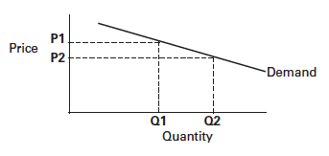
(Figure 7: The Graph of the Demand Elasticity)
(Source: Denson, 2019)
Substitution Effects, Luxury vs. Necessity:
The product or services can get easily replaced or substituted if the demand for the product is elastic. When the product can not get easily replaced then the demand for the product is supposed to be inelastic. The demand for necessary goods is generally inelastic and the demand for luxurious goods is usually elastic. Necessary goods are needed for daily survival and are much needed, for example, food and water. Luxurious goods define the goods which people want for their enjoyment and do not need those goods for survival. Luxury products are not only desirable but also a little more expensive than necessary goods. Luxury product is the emblem of higher status. The more people purchase luxurious products, the more their status in the economy will evolve. Coca-Cola generally is not one of the necessary goods, as it is mainly constituted as a luxury product but the brand name of the company is so powerful, consumers continue purchasing Coca-Cola. Thus, Coca-Cola is surely an elastic item and when the price of Coca-Cola increases people will focus more on the substitute product. This simply defines that the demand for Coca-Cola is very delicate to the factors of price. Thus, the factor of necessary and luxurious goods does affect the demand elasticity of Coca-Cola (Gordon, 2022).
Income effect, Percentage of Income:
When consumer faces a decrease in their income, it automatically decreases their demand for a particular product as they cannot afford to purchase the products or similar quantities of the product. The more the percentage of income expended on the products, the greater demand would become elastic. The factor of income elasticity is also an important factor that affects the demand graph of the product. Income elasticity is a type of elasticity that indicates the economic calculation of how the quantity demanded depends on the change in income. Overall values of elasticity in income affect the elasticity of demand (CFI Team, 2021). Based on this, the products can be divided into inferior and normal products. Normal products acquire the elasticity of income in the demand graph positively. When the income of the consumers rises, their demand will increase at every level of price. Coca-Cola falls under the category of normal goods because the demand for Coca-Cola largely depends on consumer income. Based on its elasticity, Coca-Cola can take a small portion of the consumer income. Coca-Cola can be luxurious but it does not take large portions of the income. Therefore, the demand for Coca-Cola in the countries increases mainly because of its price range (Gordon, 2022).

Pricing Policy of Coca-Cola
Business enterprises approach particular pricing policies to decide the price ranges at which they can offer better services or products. Pricing policies acquire various considerations that include competition, profit goals, the total number of sales, the business health of the firm, flexibility, regulations of the Government and processes of price adjustments. Pricing is a very crucial factor for each of the companies as the profit is gained through the price. The price factor gives maximum profit to the companies and the utmost gratifications to the customers. Coca-Cola kept some particular factors in their mind while deciding the price ranges. First, price of the Coca-Cola will be set depending on the demand of the consumers. Second, prices will be set depending on the maximum revenue of the company. Third, prices cannot be too elevated or too cheap than the charged price of the competitors. Fourth, pricing should be viewed from the point of view of the target market. As Pepsi is the perfect competitor of Coca-Cola in the market, the pricing of Coca-Cola cannot too much increase or decrease as contrasted with the price of Pepsi. Coca-Cola follows certain pricing policies to boost its profitability. First, Coca-Cola follows the policy of promotional pricing by providing promotional prices very often. Second, this also follows the pricing policy of market penetration. The main business objective of Coca-Cola is to target each consumer of the particular nation so that Coca-Cola can set their price ranges at a certain level that no other company can provide to their consumers. As a result, Coca-Cola imposes similar prices likewise their competitors (Seele, et al., 2021).

Conclusion
The above-mentioned report has discussed all the essential factors of management economics by portraying the business activities of the Coca-Cola Company and the desirability of Coca-Cola in the economic market. The report has assessed the Coca-Cola company by giving a vivid description of its history, its role in the beverage industry, its overall business activities and all the other aspects of the business profile of the company. First, the report has analysed the concept of demand and market equilibrium in the economy. secondly, the report has described all the important factors with relevant diagrams that can influence the demand for the product such as the price of substitution goods, the price of the complementary goods, the income of the consumers, their taste and desirability for the product, their price expectations in future context and the number of the consumers. Thirdly, the report has given a brief description of the price elasticity in the demand and how the demand for Coca-Cola is affected by the factors of price elasticity. This has compared the luxurious and necessary goods and given the consumer's viewpoint about categorizing Coca-Cola. this has also described how this factor has affected the demand elasticity of Coca-Cola. After that, this has explained how the percentage of income influenced the demand elasticity of Coca-Cola. Finally, the above report has focused on the crucial pricing policies of the Coca-Cola Company (Brondoni, 2019).

References
Amadeo, K., (2022). What Is Demand?. [Online] Available at: https://www.thebalancemoney.com/what-is-demand-definition-explanation-effect-3305708 [Accessed 29 November 2022].
Brondoni, S.M., (2019). Shareowners, stakeholders & the global oversize economy. The coca-cola company case. Symphonya. Emerging Issues in Management, (1), pp.16-27.
CFI Team, (2021). Income Effect. [Online] Available at: https://corporatefinanceinstitute.com/resources/economics/income-effect/ [Accessed 28 November 2022].
CFI Team, (2022). Substitution Effect. [Online] Available at: https://corporatefinanceinstitute.com/resources/economics/substitution-effect/ [Accessed 29 November 2022].
coca-colacompany, (2022). The Cocacola Company. [Online] Available at: https://www.coca-colacompany.com/ [Accessed 29 November 2022].
Denson, C., (2019). Price Elasticity of Demand for Mississippi State University: 2000-2014. Research in Higher Education Journal, 36.
Ebbing, T. and Luethje, C., (2021). Price elasticity of demand for consumer innovation. In Academy of Management Proceedings (Vol. 2021, No. 1, p. 14812). Briarcliff Manor, NY 10510: Academy of Management.
Gordon, J., (2022). Income Effect - Explained. [Online] Available at: https://thebusinessprofessor.com/en_US/economic-analysis-monetary-policy/income-effect-definition [Accessed 28 November 2022].
Gordon, J., (2022). Substitution Effect (Economics) - Explained. [Online] Available at: https://thebusinessprofessor.com/en_US/economic-analysis-monetary-policy/substitution-effect-definition [Accessed 29 November 2022].
GUO, V., (2022). PRICE ELASTICITY OF DEMAND: MODEL, STRATEGY, EXAMPLES, & HOW TO CALCULATE IT. [Online] Available at: https://www.priceintelligently.com/blog/bid/154374/price-elasticity-101-the-necessities-and-your-pricing-strategy [Accessed 29 November 2022].
Kamdar, R., (2018). The inattentive consumer: Sentiment and expectations. Manuscript. https://rupalkamdar. github. io/pdfs/Inattentive Consumer. pdf.
Munro, E., Wager, S. and Xu, K., (2021). Treatment effects in market equilibrium. arXiv preprint arXiv:2109.11647.
Rietveld, J. and Eggers, J.P., (2018). Demand heterogeneity in platform markets: Implications for complementors. Organization Science, 29(2), pp.304-322.
Seele, P., Dierksmeier, C., Hofstetter, R. and Schultz, M.D., (2021). Mapping the ethicality of algorithmic pricing: A review of dynamic and personalized pricing. Journal of Business Ethics, 170(4), pp.697-719.
Zanzalari, D., (2022). What Is the Income Effect?. [Online] Available at: https://www.thebalancemoney.com/income-effect-5216807 [Accessed 28 November 2022].

