Task One – Semiotic analysis
Tangled
Semiotics is “the study of signs and sign-using behaviour” (Britannica, 2018). It was discovered by Ferdinand de Saussure and Charles Sanders Peirce. Saussure defined semiotics as “the life of signs within society.” (Britannica, 2018) whereas Peirce defined it as “something which stands to somebody for something,”. Two slightly different interpretations to the study which I will be using to depict the movie poster of Tangled.
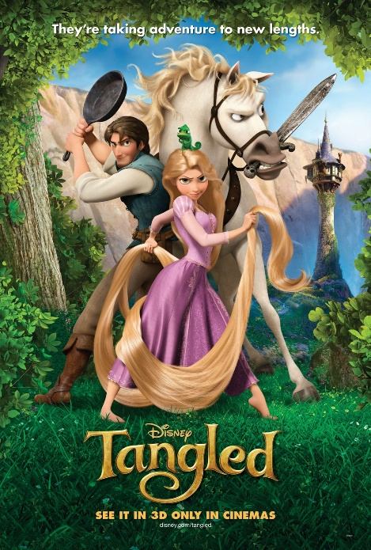
Fig 1, (Proof, 2010, Tangled)

Tangled is an American animated musical fantasy comedy film that is based on the German fairy tale “Rapunzel”. It is produced by Walt Disney Animation Studios. The film was written by Dan Folgelman and directed by Nathan Greno and Bryon Howard. (Wikipedia Contributors, 2019). The poster was designed by Proof and is #3 of 6 posters (Impawards.com, 2025) that were designed for this movie, all of which were designed by various artists and studios involved in the film’s productions.

In this movie poster, the first thing to catch the viewers eyes are the characters of the movie, Rapunzel, Flynn, Pascal and Maximus. “An index, which is associated with its referent” (Britannica, 2018) The arrangement of the characters is an iconic sign of this showing their importance in the movie, the clear main character being Rapunzel as she is in the centre. Her stance symbolizes her determination to achieve her dream. The positioning of Fylnn Ryder back-to-back with Rapunzel symbolizes an alliance with the two characters suggesting that at one point they were on different sides and have overcome this to help one another throughout the movie. Pascal is described as “generally seen mounted on Rapunzel's shoulder and is usually looked to whenever the princess is in need of guidance or motivation.” (Disney Wiki, 2010) which is clearly portrayed in the poster as he in sat on her head.

“Something which stands to somebody for something,” (Britannica, 2018)
This encodes in the title “Tangled” to symbol her life to be “messed up” (Toby, 2015) allowing the viewer to depict the type of Disney princess Rapunzel will be. The serif type face represents a formal and upper-class style linking to Rapunzel royal status. The titles colour being the same as her hair directly connotates again that she is the main character and this is her story. The “off gold” (Toby, 2015) shade decodes her innocence and purity which is juxtaposed by my analysis of her facial expression and positioning. The ‘G’ in ‘Tangled’ is curled which imitates Rapunzel’s hair and directly matches the hair she also holding suggesting that her hair is part of the main plot of the movie.
My first response to this poster was that it was an innocent Disney movie about a princess with long hair, however after analysing the semiotics of the characters and the typography use it is shown to involve adventure, struggle and have a deeper understanding of her story.

Bibliography
Britannica (2018). Semiotics. In: Encyclopædia Britannica. [online] Available at: https://www.britannica.com/science/semiotics. [Accessed 29 Nov. 2025].
Disney Wiki. (2010). Pascal. [online] Available at: https://disney.fandom.com/wiki/Pascal.
Impawards.com. (2025). Tangled Movie Poster (#3 of 6). [online] Available at: http://www.impawards.com/2010/tangled_ver3.html [Accessed 29 Nov. 2025].
Toby, S. (2015). Research: Tangled Poster Analysis. [online] gcsemedia. Available at: https://sophietoby.wixsite.com/gcsemedia/single-post/2016/11/03/Tangled-Poster-Analysis [Accessed 29 Nov. 2025].
Wikipedia Contributors (2019). Tangled. [online] Wikipedia. Available at: https://en.wikipedia.org/wiki/Tangled. [Accessed 29 Nov. 2025].

