Name: Andreea Madalina Gheorghiu
Student ID: 1813703
Module code: BMSK4003_LON
Assignment Name: Digital Skills and Research Methods
Lecturer’s Name: Balendran Kandasamy

Table of Contents
Introduction 2
What makes McDonald’s a global business? 2
Chart 1: The Big Mac Index 3
Chart 2: Sales Growth 4
Why does McDonald’s food appeal to others? 4
How is it to work for McDonald’s? 5
What is their most commonly sold items? 5
What impact does it have on people? 6
What is their audience? 6
Conclusion 6
References 7

Why does fast food appeal to people?

Introduction
In this assignment I will be talking about fast food, to be specific, McDonald’s. I do have some knowledge about this as I have been working in the company for over a year as a Crew trainer. I will be talking about why their food appeal to others, what makes them a global business, how is it to work for the company, what is their sales target per day, what is their most common sold item and many other things in order to get an understanding as in to what benefits and disadvantages this type of food has on people.

What makes McDonald’s a global business?
McDonald’s is one of the most known fast food restaurants in the world. They have used different strategies of marketing and global development and effective management to get to where they are now. According to Mujtaba (2007) McDonald’s have achieved their best practices in the global food industry and international growth trends and challenges. In 1973 McDonald’s started to spread across the United States and started to become known due to their marketing strategy as they were mostly advertising to middle and upper class citizens as it can be seen in India and China. However because McDonald’s has some offers on their food meals, it became easy for the lower class citizens to access it. Before they open a branch in different countries, the company does a lot of research in regards to the economic situation, cultural, social, technological and political which allows the company to gain financial success everywhere. India was one of the hardest markets to enter due to the governmental hardships imposed by their government. In order to adapt to this the franchise came up with burgers that are not made with beef but more with chicken and lamb due to religious purposes, they have also came up with spicy flavors in order to meet the general taste preferences of the audience. They are also known for their employment opportunities as they offer a chance to anyone and can give a boost in their careers. Also pricing can be difficult as there are a lot of different currencies all over the world so the company needs to work on strategies and change their prices in accordance to the market they are targeting. The business is trying to maintain a price range based on the location and population income as in some countries their products can be undervalued, so sometimes they chose to open stores in big cities such as New Delhi, Shanghai, Beijing and the list can carry on (Mujtaba, 2007)

Chart 1: The Big Mac Index
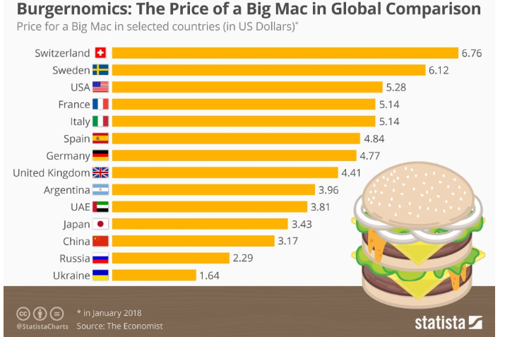

Source:
https://www.dubaichronicle.com/2018/06/05/burgernomics-price-of-a-big-mac-in-dubai-10-highest-worldwide/

There were a lot of challenges for McDonald’s to overcome but in 2001 they were at their lowest as the fad of eating healthy came along, especially in the Unites States, their home town, McDonald’s became the least visited fast food restaurant. Meanwhile Subway’s sales were increasing due to their low calories subs. McDonald’s had to think of a new strategy and they started to introduce fruit snacks for kids and healthier meals for adults, such as salads and grilled chicken flat bread. This strategy helped the company increase their sales comparing to the year before (Mujtaba, 2007).

Chart 2: Sales Growth
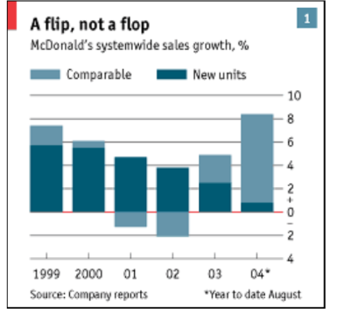

Source:
https://www.researchgate.net/publication/228490432_McDonald's_Success_Strategy_And_Global_Expansion_Through_Customer_And_Brand_Loyalty

Why does McDonald’s food appeal to others?
First of all McDonald’s has accessible prices and it could be a treat sometimes. For example to attract the children they have the Happy Meals that come in a colorful box with a toy from the most recent or known cartoon, as for adults as soon as you enter McDonald’s you have pictures of succulent burgers that capture your attention. Although I mentioned previously that they have introduced healthier meals and salads, a very few people order them, but just the concept of ‘’ having healthier meals’’ on the menu makes people feel less guilty when ordering what they actually want. Their adverts and presenting of new promotions or their food is always colorful and it would catch anyone’s attention having them wanting to go and buy their new products (Battey, 2017)

How is it to work for McDonald’s?
For this question I can speak from personal experience as I work for the company. Working for McDonald’s can be stressful and fun at the same time. The opportunities they give are amazing. Personally, I started working for the company in May 2018 as a crew member, by November the same year they have promoted me to a Crew trainer and by February 2019 they have asked me if I want to go onto the Shift Management course to become a shift manager within the company. This shows that it gives a very good opportunity to young people to get a boost in their career. After more than a year that I have been working for this company I have developed and improved a lot of skills, such as confidence, problem solving, time management and most importantly team working. Also the company gives a chance to everyone regardless of their nationality, religion, sexuality, etc. it gives the opportunity of flexible hours, so you can work around your academic year or if it happens to have a second job, McDonald’s gives you the chance to work around your schedule. They also provide a lot discounts for their employees, such as car insurance discounts, cinema, gym memberships, clothes etc. and also on the shift they provide a full meal and desert for their employees. My favorite part of working in McDonald’s is when we all work as a team to give our customers the best customer service experience which can automatically boost their sales and make the customers want to come back for more. To conclude this, I can say that even if you are not planning to make a career in McDonald’s even though you get the chance to, it is a good opportunity to work on your confidence, customer service and other very important skills for our future jobs and day to day lives.

What is their most commonly sold items?
Their most common sold item is surprisingly their fries. They serve approximately 9 million pound of the stuff every day. According to ‘’Los Angeles Times’’ they have done their own Fast Food French Fry Rankings and out of 19 popular fast food restaurants, McDonald’s came on as the second best French fries. Their second best seller is the Big Mac people went as far as saying that is the world’s best hamburger. This burger was introduced 52 years ago and it serves over 70 million people every day over 120 countries. According to ‘’ The New York Times’’ by 2006 the double cheeseburger it was one of the best sellers for McDonald’s along young adults. Richard Adams which is the former McDonald’s executive said that a regular store would sell around 300 to 400 double cheeseburgers every day from the saver menu only. According to an employee the chicken McNuggets are in the top 3 items that sell out. They first appeared on the menu in 1983 and by 1986 it has been accounted to 8 percent of McDonald’s sales. Since they have removed the artificial preservatives in the third quarter of 2016 fiscal year their nuggets sales increased by 10 percent. Last but not least is an item from their breakfast menu which is the Sausage and Egg McMuffin which was introduced in 1971. According to Cheyenne (2019) ‘’ The Egg McMuffin was createed by Herb Peterson in California, and four years later, the sandwich appeared in McDonald’s across the country. And with the option of adding sausage’’ this wasn’t available in restaurant nationwide until 2003 (BUCKINGHAM, 2019).

What impact does it have on people?
Most people see McDonald’s as a fast and convenient way of buying some food whether they are on their lunch break at work or they want to have a treat. Even though it is not seen as healthy on the other hand is very hard to stay away from it just because McDonald’s is everywhere. In Chicago they celebrated the opening of their 25.000th store. McDonald’s has expanded over 115 countries starting from Arctic Circle to the Southern tip of New Zealand. In 1998 their sales were 36$ Billion making it more than Burger King, Taco bell and Pizza hut together which made it a target for those who are against fast food. The company estimates that 1 out of 15 Americans have their first work experience in McDonald’s. it has also had a bad impact on people and especially young people, it has increased the obesity rate, especially in America. It has made people less active and unsociable due to their obesity complex. This problem it is not caused particularly by McDonalds, but by the new chaotic life style and fast food in general (Coeyman, 1999)

What is their audience?
As I have mentioned above their main target audience is middle and upper class people. However with their server menu offers and other ways of getting discounts like the 1.99 vouchers they also attract lower class people and teenagers. Children also love McDonald’s due to their happy meal food offers that comes with toys (Mujtaba, 2007).

Conclusion
In conclusion over the years McDonald’s has grew a lot and improved a lot more when it comes to food and menu diversity. For example in Romania McDonald’s also sells hot and spicy wings and has a larger variety of desserts. In order to make the business successful they always find different ways and strategies to adapt to the requirements and audience of the country they want to open the store in. They also have to take into consideration religious beliefs and location. In order to make a good profit they have to choose the location carefully, for example in a capital city or a busy area in a big city or a place that has a lot of tourists that might be curious of that country’s menu diversity and options. On the other hand it has given a lot of opportunities to many people across the world in regards to work. They employ people from all backgrounds and religion. It also gives the opportunity of growth within company. One of the disadvantages of McDonald’s and fast food in general is that it increased the rate of obesity all over the world, especially when it comes to young adults. This is bad as it makes young people more comfortable going and buying food from McDonald’s because is quick and has accessible prices than to cook a healthy meal at home. To conclude this, McDonald’s and not only has its good and bad aspects

References
Battey, L. (2017, November). Sprint Valley . Retrieved from https://sprintvalley.com/why-were-loving-it-the-psychology-behind-mcdonalds-restaurant-of-the-future-a49a657670e3
BUCKINGHAM, C. (2019, May). Eatthis . Retrieved from https://www.eatthis.com/mcdonalds-least-most-popular-items/
Coeyman, M. (1999, August). The Christian Science Monitor. Retrieved from https://www.csmonitor.com/1999/0804/p16s1.html
Mujtaba, B. G. (2007, January). Research Gate . Retrieved from https://www.researchgate.net/publication/228490432_McDonald's_Success_Strategy_And_Global_Expansion_Through_Customer_And_Brand_Loyalty

