Name – Cory Sibley

Student Number – 2507186

Word Count – 2156

Module – Construction Materials

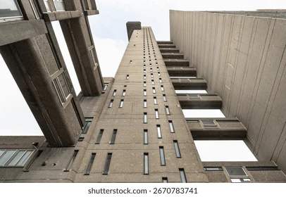

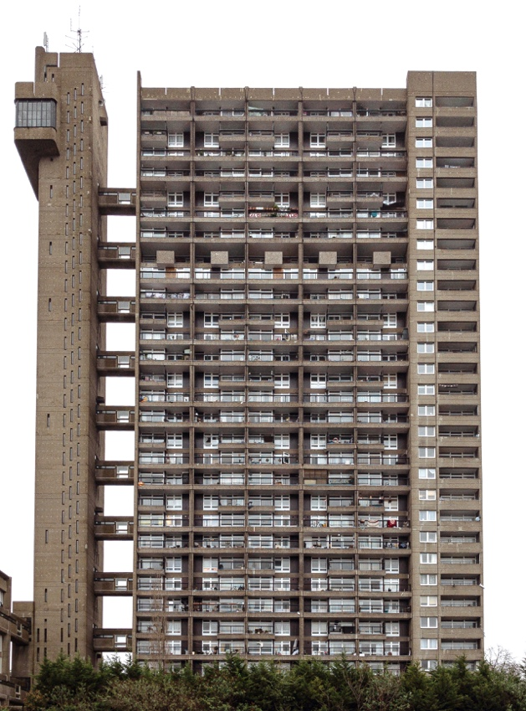

Introduction
Reinforced concrete has been one of the most important structural materials in modern construction because it combines the compressive strength of concrete with the tensile strength of steel reinforcement. This makes it appropriate for tall, sturdy, and fire-resistant structures, especially in urban housing from the 20th century (The Concrete Centre). Trellick Tower in North Kensington, London, is a suitable case study since, according to Historic England, it is a concrete-framed construction made of in-situ reinforced concrete with some precast elements (Historic England). The tower, which was designed by Ernő Goldfinger and constructed between 1968 and 1972, is a prominent example of high-rise housing made of exposed concrete. Its original construction and design will be examined, the concrete frame's performance will be evaluated, and the broader effects of concrete production on the environment and community will be evaluated.

Building Background
The project, which was constructed between 1968 and 1972, was a component of the post-war endeavour to replace dirty, antiquated housing with more densely populated, contemporary housing. According to Historic England, the complex consists of 217 apartments, shops, an office, and community amenities, indicating that the tower was not just meant to be a residential structure. Rather, it was intended to be a mixed-use communal housing project that would accommodate daily urban living in a small space. Because the building's initial function was directly related to efficiency, density, and long-term public use, it presents an excellent case study for this assignment. Modernist planning concepts, particularly the idea that building higher may open ground-level space for people instead of covering the entire site with low-rise buildings, had a significant influence on Goldfinger's architectural objective. This goal is apparent in Trellick Tower's unique design, which links the main residential block to a separate service tower with lifts and access paths, lowering noise levels close to the apartments and facilitating effective circulation. The structure is described by Historic England as an L-shaped complex with a semi-freestanding service tower. Heritage commentary also points out that the placement of loud lifts and plants away from the apartments was a purposeful architectural element. As a result, the tower's design combined social purpose, structural clarity, and an aesthetically expressive exposed-concrete character in addition to housing residents.

Construction Method and Structural Form
Trellick Tower was constructed primarily using in-situ reinforced concrete, meaning the main structural elements were cast on site rather than assembled entirely from factory-made components. The structure was described by Historic England as 'bush-hammered in-situ reinforced concrete with some pre-cast pebble-finished panels', indicating that while certain non-primary components were prefabricated for efficiency and finish quality, the core structural system relied on site-cast concrete. Since in-situ concrete could give the mass, rigidity, and fire resistance needed for a tall housing block while also enabling the architect to produce the striking sculptural shape associated with Brutalist architecture, this technique was appropriate for a high-rise residential project. The intricate concrete mouldings were created in situ using formwork, according to Historic England, confirming that staged concrete pours, shuttering, and reinforcing installation were crucial to the construction process. Structurally, the tower consists of a 31-storey main residential block linked every third floor to a semi-freestanding 35-storey service tower. The service tower contains lifts, stairs and refuse chutes, while the lower adjoining block provides additional accommodation and facilities. This arrangement is important because it shows how the structural form and construction method worked together: reinforced concrete made it possible to create a stable, repetitive frame for the flats while separating circulation and servicing functions into a distinct vertical element. The use of in-situ concrete therefore supported both structural performance and Goldfinger’s wider design aim of producing an efficient, durable and visually expressive housing block.

Analysis of the Concrete Framing Material

Strength, Durability and Climatic Resistance
Trellick Tower was an appropriate fit for reinforced concrete because it blends steel's tensile strength with concrete's compressive strength, making it suitable for a tall residential structure supporting numerous stories of repetitive loads. The bulk and stiffness required to support the linked tower shape and repeating floor plan were also supplied by the in-situ reinforced concrete frame. The Concrete Centre points out that concrete does not burn or release harmful gases, which is a significant benefit in multi-story homes. Concrete also performs well in fire scenarios. When planned and maintained correctly, it can also have a long service life (Historic England; The Concrete Centre). Given that it can withstand typical rain, wind, and temperature fluctuations, reinforced concrete typically works well in London's climate. Long-term exposure, especially to exposed external factors, can still result in carbonation, cracking, water intrusion, and corrosion of the reinforcement. This relates to Trellick Tower because, unlike a clad construction, the concrete surface is purposefully exposed to weathering. Because of this, the material has a high potential for endurance, but only in situations where upkeep and repairs are maintained (Historic England; Goyal et al., 2018).

Time, labour, programme and cost compared with steel framing
Since reinforced concrete involves formwork, reinforcement fixing, concrete pouring, and curing before full structural capacity is reached, it often demands a slower and more labour-intensive construction procedure than steel framing. This would have had an impact on Trellick Tower, whose construction was largely dependent on site-based activities due to the considerable use of in-situ concrete and moulded finishing. Steel frames, on the other hand, may be erected more quickly since main components can be prefabricated and welded together effectively, cutting down on program duration and interruption. According to Historic England and The Concrete Centre, concrete is therefore less effective in terms of programs. However, because of its mass and fire resistance, which minimise the need for additional fire-protection equipment and offer effective acoustic separation, concrete can partially counterbalance this drawback. Despite the lengthy construction procedure, these combined advantages may still offer reinforced concrete an affordable option for recurring high-rise housing (The Concrete Centre).

Ease of assembly and adaptability over the life cycle
Concrete may be cast into a variety of shapes and finishes, which gives it flexibility during the design and building phases. Trellick Tower clearly demonstrates this; the intricate concrete mouldings and expertly made in-situ finish are noted by Historic England, demonstrating how the material enabled Goldfinger to create a striking sculptural appearance. For a Brutalist building where the structure and finish were intended to be apparent, reinforced concrete thus provided strong architectural freedom during assembly (Historic England). Later in the building's life cycle, the weakness emerges. Compared to many steel-framed systems, reinforced concrete is less flexible once it is cast because significant modifications may include drilling, cutting, or breaking structural components, which is expensive and disruptive. This is particularly important in Trellick Tower since the access arrangement, service tower, and main block were all planned as a single integrated system. As a result, the frame was useful when it was initially constructed but less adaptable for future reconfiguration (Historic England; The Institution of Structural Engineers).

Problems with integrating services and how these are solved
Integrating services into concrete structures can be challenging since structural concrete is more difficult to modify than lightweight framed construction. The Concrete Society emphasises that structural and building-services engineers must work closely together since service needs have a direct impact on structural arrangement. In practice, penetrations, risers and ducts must be designed ahead of time, as cutting into slabs or walls later is inconvenient and may damage performance (The Concrete Society, 2025). Trellick Tower demonstrates how this issue can be handled through design. Its semi-freestanding service tower separates lifts, staircases, and garbage chutes from the main residential complex, concentrating critical servicing and circulation operations in a single vertical zone. This decreases the need for meddling within the accommodation block while also improving organisation (Historic England).

Demolition and End of Life Issues
At the end of its life, a reinforced concrete building is generally more difficult and disruptive to demolish than a steel-framed building. Concrete structures are heavy, demolition is noisy and energy-intensive, and the work usually requires extensive breaking, crushing and waste handling. Separation of embedded steel reinforcement from the concrete also adds complexity. For a large high-rise structure such as Trellick Tower, these issues would be especially significant because of the building’s size, mass and urban location (Lachat et al., 2021). However, concrete can be crushed and repurposed as recyclable aggregate or subbase material. This improves the circular economy case for concrete, but it does not eliminate the disruption and energy consumption associated with destruction. Trellick Tower's listed designation reduces the likelihood of complete demolition, implying that renovation and continuous usage may be more feasible life-cycle solutions than replacement (Historic England; Lachat et al., 2021).

Negative Impacts of Concrete Production on the Environment and Community
Although reinforced concrete provides tremendous structural and durability benefits, its manufacture has severe environmental and community consequences. The main environmental risk stems from cement production, as the calcination process in cement kilns emits enormous amounts of CO2. According to the Concrete Centre, calcination is responsible for around 70% of CO₂ emissions from cement manufacturing in the UK. Despite its lengthy service life, concrete is sometimes blamed for its high carbon content. Industry sources also accept that concrete and cement must decarbonise swiftly, with the Global Cement and Concrete Association laying out a net zero pathway precisely because sector emissions remain significant (The Concrete Centre, 2025; Andrew, 2018; GCCA, 2021). Concrete production also affects communities beyond carbon emissions because it depends heavily on the extraction and transport of raw materials such as limestone and aggregates. Mineral extraction can cause environmental pressures that must be controlled through the planning process, according to UK government guidance on minerals planning, while dust is a common issue connected with mineral sites. In actuality, quarrying and aggregate transport can cause dust, noise, high vehicle traffic, visual intrusion, and disturbance for surrounding communities, as well as damage to landscapes, habitats, and waterways. These impacts demonstrate that the consequences of concrete production are not only global due to climate change, but also local due to nuisance and environmental degradation near extraction and processing sites (Ministry of Housing, Communities, and Local Government, 2014; Institute of Air Quality Management, 2016). Nevertheless, a lower-carbon mix design can mitigate some effects. The Concrete Centre adds that employing cement substitutes like GGBS or fly ash can dramatically cut greenhouse gas emissions in some concrete mixes. However, this decreases rather than eliminates the overall environmental burden, therefore concrete production remains a significant sustainability concern for the building sector (The Concrete Centre, 2025; Van den Heede and De Belie, 2012).

Aggregate Grading Analysis
Sieve Size (mm) | Mass(g) | % on sieve | % Passing
125 | 0 | 0 | 100
75 | 0 | 0 | 100
63 | 0 | 0 | 100
37.5 | 120 | 9.6 | 90.4
20 | 137 | 10.96 | 79.44
10 | 143 | 11.44 | 68
6.3 | 105 | 8.4 | 59.6
3.35 | 45 | 3.6 | 56
2 | 130 | 10.4 | 45.6
1.18 | 63 | 5.04 | 40.56
0.6 | 105 | 8.4 | 32.16
0.3 | 102 | 8.16 | 24
0.212 | 109 | 8.72 | 15.28
0.15 | 98 | 7.84 | 7.44
0.063 | 55 | 4.4 | 3.04

The particle size distribution curve indicates that the sample is a broadly well-graded aggregate, with a continuous spread of particle sizes rather than a single-sized or gap-graded composition. The percentage passing gradually increases across the sieve range, indicating that the sample includes a balanced mix of fine and coarse particles. The completed sieve analysis reveals that the material contains around 3.04% silt-sized particles, 56.56% fine aggregate, and 40.4% coarse aggregate, indicating that the sample is primarily a sand and gravel mixture with a small fraction of very fine material. This is often a positive outcome, since a well-graded aggregate is more likely to compact well, with smaller particles filling the spaces between bigger particles, lowering overall void content. In practice, this can lead to increased density and a more stable aggregate structure. The relatively low proportion of silt-sized material is also important when assessing suitability. Excessive fines can increase water consumption, limit workability control, and have a negative impact on concrete strength and durability if the material is designed for structural usage. In this example, however, the particles concentration looks to be minimal, indicating that the sample is not unduly silty. The smooth contour of the grading curve also suggests that there are no significant differences in particle size, supporting the conclusion that the material is reasonably well graded. Overall, the sample looks to be adequate for direct use as a general aggregate, particularly in applications requiring a sand and gravel aggregate. However, final acceptability would still be determined by the intended application, as compliance with specification limits for grading, maximum particle size, cleanliness, and particle shape must be established prior to use.

Conclusion
Trellick Tower demonstrates that reinforced concrete was an effective material choice for a high-rise housing scheme because it provided the strength, stiffness, fire resistance, and durability required for a tall residential building, as well as allowing Goldfinger to achieve a bold and distinctive architectural form (Historic England, 2024). Its in-situ reinforced concrete frame supported both the structural requirements of the building and its social function as dense urban housing. However, the analysis reveals that concrete has significant disadvantages, including slower construction than steel, reduced adaptability for later changes, difficulties with service integration, significant end-of-life challenges, and high embodied carbon associated primarily with cement production (The Concrete Centre; Andrew, 2018). Overall, Trellick Tower demonstrates that reinforced concrete can provide long-term structural and architectural value; however, this must be balanced against its environmental effect and life-cycle restrictions.

References
Institute of Air Quality Management (2016) Guidance on the assessment of mineral dust impacts for planning. Available at: https://assets.publishing.service.gov.uk/media/66017f9cf1d3a06c5532ad20/CD71NP_1.PDF
Lachat, A., Garbaz, M., Trigaux, D., Boehm, C. and Laloui, L. (2021) ‘From buildings’ end of life to aggregate recycling under a circular economy: Quantitative assessment of CO2 and energy impacts’, Sustainability, 13(17), p. 9625. Available at: https://doi.org/10.3390/su13179625
Ministry of Housing, Communities and Local Government (2014) Minerals. Available at: https://www.gov.uk/guidance/minerals
Scrivener, K.L., John, V.M. and Gartner, E.M. (2018) ‘Eco-efficient cements: Potential economically viable solutions for a low-CO2 cement-based materials industry’, Cement and Concrete Research, 114, pp. 2–26. Available at: https://doi.org/10.1016/j.cemconres.2018.03.015
The Concrete Centre (n.d.) Performance & sustainability. Available at: https://www.concretecentre.com/Performance-Sustainability.aspx
The Concrete Centre (n.d.-a) Fire resistance. Available at: https://www.concretecentre.com/Performance-Sustainability/Fire-Resistance.aspx
The Concrete Centre (n.d.-b) Embodied carbon. Available at: https://www.concretecentre.com/Performance-Sustainability/Whole-life-carbon/Embodied-carbon.aspx
The Concrete Centre (n.d.-c) Performance & sustainability. Available at: https://www.concretecentre.com/Performance-Sustainability.aspx
The Concrete Society (2025) Integration of building services. Available at: https://www.concrete.org.uk/fingertips/integration-of-building-services/
The Institution of Structural Engineers (n.d.) Concrete design guide. Available at: https://www.istructe.org/thestructuralengineer/article-series/concrete-design-guide/
Van den Heede, P. and De Belie, N. (2012) ‘Environmental impact and life cycle assessment (LCA) of traditional and “green” concretes: Literature review and theoretical calculations’, Cement and Concrete Composites, 34(4), pp. 431–442. Available at: https://doi.org/10.1016/j.cemconcomp.2012.01.004

