TESCO Strategic Management

Course Name: Strategic Management

Course Number: BMMB7013

Student Name: Shiying He

Student ID: 1804629

Executive Summary
This report focuses on the proposal of relevant reshaping strategies for Tesco in UK to meet rising challenges based on a thorough strategic analysis. This report presents an overall analysis exploring from strategic position to strategic choices, then finally to the strategy in action. Starting from a brief introduction about the definition of strategy and the chosen company’s background, macro-environment of Tesco is comprehensively analyzed in this report by using PESTLE framework. Then Porter’s five forces analysis is used to evaluate the food retail industry. This report also takes stakeholders’ importance and influences into consideration when positioning the strategy. VRIO analysis is applied to deeply assess Tesco’s strategic resources which can be turned into its competitive advantages. This report also analyzes Tesco’s organizational culture which may have an impact on its business strategy under the context of culture web. Based on the thorough strategic position, this report critically points out the strengths, weaknesses, opportunities and threats of Tesco based on a thorough SWOT analysis to see which advantages Tesco can take advantage of and which problems Tesco should pay attention to thus to construct a good strategic choice for Tesco. At last, through identifying the strategic drift, this report proposed some suggestions on how to implement innovative strategies in practical action.

Introduction

Definitions of Strategy
There have been loads of different viewpoints on the definition of strategy in all ages. Chandler (1963, p 13) defines strategy as “the determination of the long-run goals and objectives of an enterprise and the adoption of courses of action and the allocation of resources necessary for carrying out these goals”. Porter (1996) thinks a competitive strategy is how to be different which needs a deliberate choice of varied activities to deliver unique values. Drucker (1994) considers the function of a strategy is to help the company to gain competitive advantages. Mintzberg (2007, p 3) regards strategy as “a pattern in a stream of decisions”.

Company Overview
Tesco PLC, headquartered in Hertfordshire, is one of the largest groceries and general merchandise retailers in the UK. The company retails not only foods but also some non-food products. It has an extensive range of products comprising beverages, fresh food, baby products, flowers and plants, toys, home furnishings, household appliances, electronics and so on. It also possesses a lot of exclusive brands such as Tesco, Finest, Tesco Bank, etc. The company extends its business operation with thousands of shops in several countries across Europe and Asia, (Marketline, 2018) including the Czech Republic, Poland, India and Thailand (Tesco, 2019a). Tesco (2019b) sets its core purpose for “serving shoppers a little better every day”. It has never been ignored that serving customers is at the heart of Tesco’s business mission both from those colleagues in the shops and supporters standing behind.

Main Findings of Strategic Analysis
Johnson et al (2017) have proposed the exploring strategy framework for organizations to set their customized business strategies, including understanding the strategic position at first, then evaluating strategic choices for future development, and implementing strategy in action at last.

Strategic Position

PESTLE Analysis
It is useful to use PESTLE analysis to evaluate the broad macro-environment at first. In terms of political factors, Brexit is one of the most influential issues which will diminish Tesco’s competitive advantages in the British retail market (Potts, 2018). Since Tesco is a large multinational retailer with food products and non-food products both from domestic suppliers and international suppliers, the UK’s withdrawl from EU to some extent will have an impact on its overall profit margins through the increasing import duties on fresh food (Anon, 2018). What’s more, the corruption perception index which was accepted since 1995, has become a leading indicator of corruption in public sectors all over the world. The United Kingdom was always stable in a low level of corruption and bureaucracy however its score dropped a little bit in the year of 2018 which indicated a rising possibility of corruption (Transparency International, 2019).
In terms of economic factors, the UK government has significantly reduced the interest rate since 2009 (Trading Economics, 2019a).
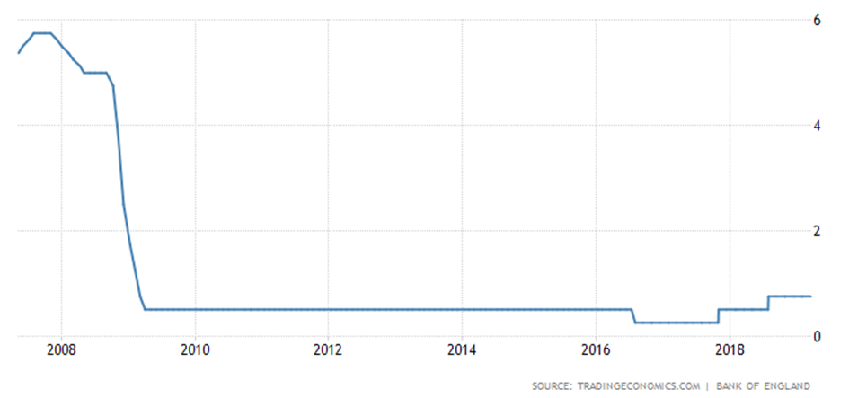Thus consumers have a stronger purchasing power which brought about the decreasing rate of unemployment (Trading Economics, 2019b).
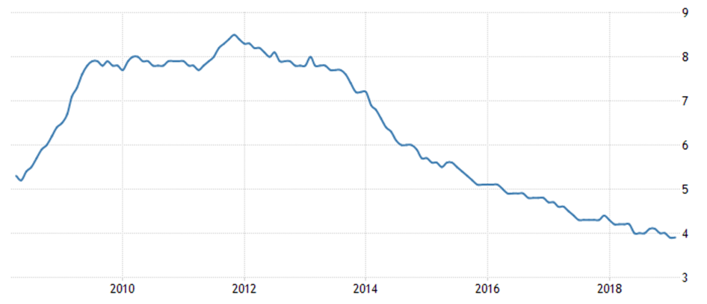
However, the ascending inflation and stagnant wage growth caused by Brexit squeezed the powerhouse of UK’s economy. The slowing household consumption has weakened British economic growth. People expand the definition of daily essentials from groceries to cars and holidays. Hence, it may add pressure to Tesco’s sales revenue in food products (Martin, 2017).
From the perspective of social issues, Chernev (2018) points out that people are getting more and more conscious about health which can strengthen Tesco’s competitiveness in retailing organic and fresh food and drinks. Tesco has witnessed organic sales increase by 15% in 2017. The increasing demand in organic food such as fish, dairy products, fruits and vegetable urges the company to build stronger partnership with more organic orchards. However, there are still concerns from customers about the price and availability of organic foods (Tesco, 2017a). Besides, Office for National Statistics (2019) have shown that British people are living longer than expected thanks to ongoing advances in health-care policies and technologies and their growing awareness of having healthier lifestyles. Tesco should thoroughly consider the possible problem that the old generation will buy less in stores.
With the rapid development of technology, Tesco has caught up with the trend by implementing its radio-frequency identification system and digital marketing approach. Also, the company has a larger amount of followers on Facebook and Twitter, both of which are great social media platforms. Nonetheless, Tesco should pay attention to applying niche and popular technologies such as artificial intelligence and augmented reality into supply and value chains in order to grab customers’ interest and gain more sales. (Anon, 2018)
In terms of legal factor, although Tesco is constantly expanding its business footprints with lots of stores opened all over the world, it is always making efforts to increase its online retailing capacity through a comprehensive collection and analysis of customers’ purchase behaviors and preferences (Anon, 2018). However, the underlying danger of leaking privacy online caused mounting concerns about personal data usage. The GDPR regulation will become stricter which has more limitation on the company to collect, store and analyze customers’ personal data (European Commission, 2019). Besides, in 2011, the standard rate of value-added tax has risen to 20% (GOV.UK, 2019). Since lots of the products in Tesco include value-added tax, the company needs to increase its set price to cover the cost of this tax (Anon, 2018).
In terms of environmental factor, Tesco has reduced carbon emissions by 26% since 2015 and announced the target that source of 65% electricity will be gained from renewable sources by 2020 (Tesco, 2019c). The supermarket giant is encouraged to contribute its effort for an incredible transition away from fossil fuels to renewable and environmentally friendly resources such as wind and solar energy to generate electricity. It has played a vital role in combating climate change which will win itself a good reputation (Ian, 2017) but tightening environmental policies may have a negative influence on its competitive position compared with other rivals in the UK (Anon, 2018).

Porter’s Five Forces Analysis
Potter (1979) observed his five forces analysis as a strategic management tool to assess the industry and dig into the potential profitability within the given industry. Managers at Tesco can use this holistic strategy framework to build a strategic position in retail industry and explore underlying opportunities for greater margins within the whole consumer service sector.
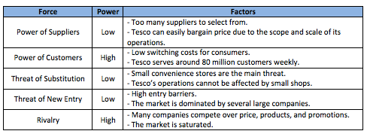
If existing market players compete with each other fiercely and intensely, the prices will be forced to drop thus the overall profitability of the industry will fall as a result (Fern Fort University, 2019). Tesco maintains its leading position with an evidently huge market share of grocery stores in Great Britain
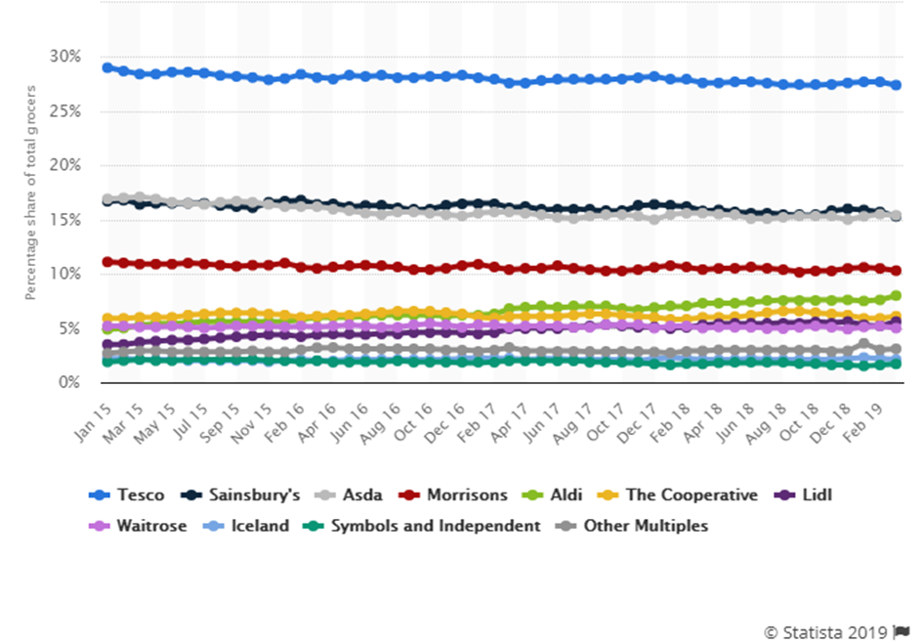
although there is always a high level of competition from other rivals including direct competitor supermarkets such as Sainsbury’s and Morrison and additional competitive organizations like Marks & Spencer’s which differentiates itself by narrowly concentrating on the middle up to the upper class segments who prefer more exquisitely-branded products in a higher quality (Joshaddo, 2017). However, attractive discounts at Lidl still increase the possibility of losing a large amount of family customers living at a low level who are favor of buying similar products at a lower price.
The threat of substitute of products and services was relevantly low in the past because Tesco sells a comprehensive range of products in the whole supermarket chain (Dudovskiy, 2016). 80% of the buy in food market retail in the United Kingdom was mainly captured by Tesco, Asda, Sainsbury’s and Morrison. However in recent years, Aldi and Lidl have witnessed the increase in their market share, together accounting around 10% of the grocery market, which posed a threat on Tesco to maintain profitability (Ho, 2016). Besides, consumers can choose to buy non-food products in other famous retail stores such as Zara and H&M (Anon, 2018).
As for new entrants, they will bring extensive innovation not only in products but also in the ways of operating a business which will address pressure on Tesco to lower price and cut costs in order to present a substantially profitable performance (Fern Fort University, 2019). However, it would take a lot of time and resources for new supermarkets to produce something new authorized by local government. New operators have to choose a lower price or a higher quality as their strategy to establish their market value (UKEssays, 2016).
The bargaining power of buyers is relatively high as buyers are at the heart of a transaction who can easily change their preferred places to purchase goods (Anon, 2018) based on their satisfaction about the price, customer service and quality of goods (Joshaddo, 2017). Customers feel more attracted towards the lower prices which can be easily compared and selected through the availability of a large number of retail stores (UKEssays, 2016).
Suppliers play a dominant role in the retail industry because almost all of the companies purchase their raw materials from a large quantity of suppliers. Powerful suppliers in consumer service sector can exert their negotiating strength to draw higher prices from retail companies (Fern Fort University, 2019). Nevertheless, the bargaining power of Tesco suppliers is low since Tesco has a plethora of suppliers of food and non-food products all around the globe. Therefore, it is hard for suppliers to negotiate product prices because they are fear of being abandoned out of thousands of supply chains (Anon, 2018). But, Tesco has the bad history of delaying payments to its suppliers for improving its own finances, posing unfair treatment on suppliers and demanding invalid payments from suppliers (Armstrong, 2016). Poor supplier treatment has drew an extensive attention from media and increasing bad reviews have damaged its brand image (Dudovskiy, 2016). If Tesco does nothing to build a healthy and reasonable relationship with suppliers, it will struggle in the retail industry.

Stakeholder Analysis
It is vital to analyze who the stakeholders are within one organization because they stay closely with its business performance. In the case of Tesco, there are external stakeholders including trade unions, UK government, local and national communities, banks and suppliers, and internal stakeholders including customers, employees, managers, owners, board directors and shareholders (Bunting, 2018).
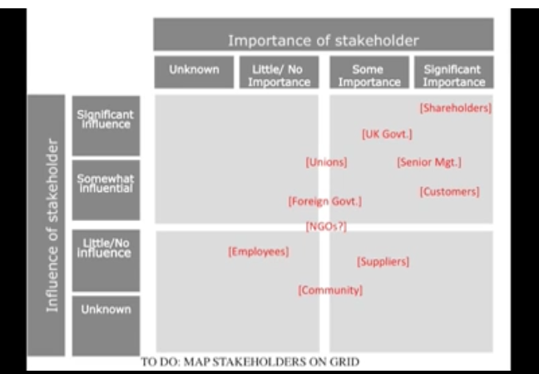
The UK government with a strong importance and influence (University of Nottingham, 2015) is happy to see that Tesco has a great capability of hiring people because more people are employed to pay tax which helps the government to spend less on supporting the unemployed and to save more money to be used on the improvement of health and education. It is local community’s role to give a permission for a business to open a new store. Successful business will bring general wealth to local community and contribute to local projects through donations or other supports. Also the crime rate in the local community will potentially decrease thanks to its local prosperity. As for suppliers, they are the important third party who are responsible for on-time and fresh supplies at market price for Tesco but have little say in decision-making since they are scared of losing contracts with Tesco (Bhatia, 2019).
Customers, also as the important and influential stakeholder (University of Nottingham, 2015), would like to see Tesco make improvements in producing high-quality goods and providing satisfying services which may have great value for their money (Study Moose, 2016). Employees can influence Tesco’s business performance by their productivity and efficiency in completing their job (Bunting, 2018) and their interest is to get the opportunity of promotion and good rewards based on their security of employment (Study Moose, 2016). Managers are interested in maintaining the business running smoothly (Bunting, 2018) and owners are responsible for dictating to the business operation. Therefore, a conflict will arise that owners would like to save money in hiring more managers in order to achieve higher profits (Bhatia, 2019).

VRIO Analysis
Barney (1995) firstly developed the VRIO framework to evaluate strategic resources as competitive advantages within one organization.
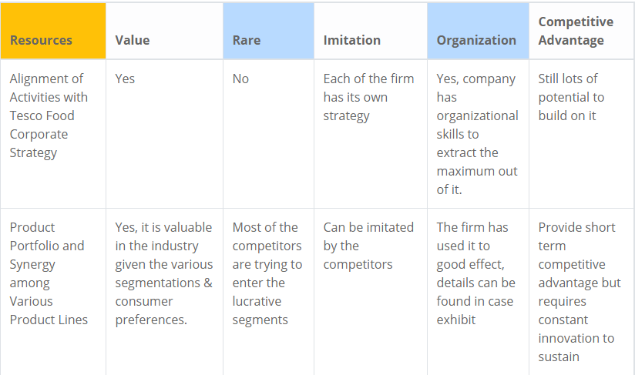
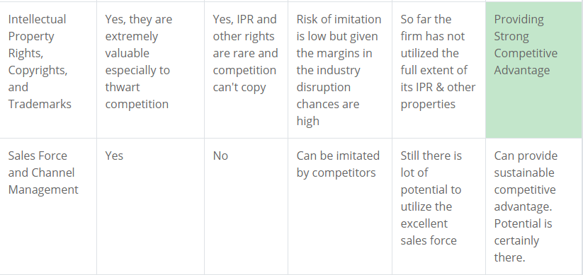
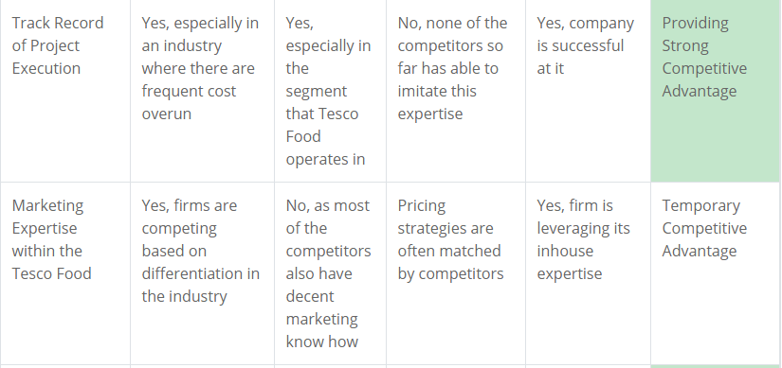
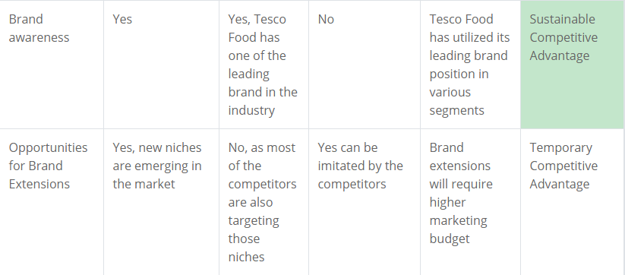
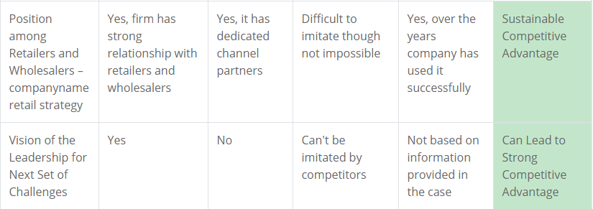
There are two categories of resources within one organization, tangible resources and intangible resources. In the case of Tesco, workforce, global and local stores are tangible entities while brand image, online stores, information technology, special relationship with supply chain partners, expertise of managers and goodwill of the company are all intangible but powerful resources. The brand awareness of Tesco has value and rareness which cannot be easily imitated since Tesco is the leading brand in the food retail industry. The company has utilized this leading brand position in various segments so brand awareness can be regarded as a sustainable competitive advantage. The global and local presence of Tesco has a strong value as it diversifies the revenue streams and separates company's balance sheet from economic cycles but can be imitated by competitors. Nevertheless, it still provides strong competitive advantage. Distribution and logistics costs competitiveness are valuable since they lower cost and is difficult for competitors to imitate. Therefore, it can provide medium to long-term competitive advantage. The wide range of its product portfolio is valuable for the synergy in the industry due to various segmentations and customer preferences and many competitors are trying to enter the lucrative segments. This strength can offer short-term competitiveness but need to be sustained through constant innovations. Vision of leadership for challenges is valuable, rare and inimitable which can lead to strong competitive advantage. The company fully utilized the valuable and rare supply chain network flexibility to keep the business running sustainably although some competitors are sharing same suppliers. Marketing expertise within Tesco is valuable for its differentiation but most of the competitors also pay attention to the cultivation of decent marketing talents. Some pricing strategies are likely applied by competitors so marketing expertise can only be considered as temporary competitive advantage (Alvarez, et al., 2018).

Organizational Culture
According to (Root, n.d.), organizational culture is the symbol of the professional values a company adopts that indicates the way of its interaction with employees, suppliers, partners and customers. The mission strategy of a company is a conclusion of how it comprehends its role and the beliefs it embraces to realize its goals. Since the organizational culture drives the company forward to do its business in terms of the forecast of potential risks, incentive pays for high employee retention rate and a unified focus on the common goal, it does affect how to develop business strategy. It is helpful to analyze the organizational culture by exploring the culture web which involves six elements to form the paradigm of a company (Johnson, et al., 2017).
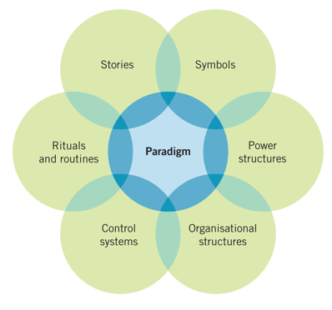
In relation to stories, Tesco was founded by Jack Cohen who sold surplus groceries from a stall in London in 1919. It already has a history of a century (TESCO PLC, 2019d). Concerning rites and rituals, Tesco is devoted in fulfilling employee’s potentials by recognizing talented staff and powering them up through various training and development schemes. Protector line is provided for staff to raise their concerns relative to misconduct at work (TESCO PLC, 2018). Regarding symbols, Tesco has occupied a leading position in the retail industry in UK through its steering wheel strategy which involves people in all dimensions and shows its core focus on employees as their biggest asset. (Anon, 2014). Besides, Tesco clubcard, the most rewarding loyalty scheme, has experienced different changes to meet customers’ requirements which is getting easier and simpler to use. So the little blue contactless card can also be regarded as a symbol for the company (TESCO PLC, 2017b). In terms of organizational structures, Tesco is structured by two main parts. One is the board comprising the chairman, group chief executive, chief financial officer and some non-executive directors. The other part is executive committee which consists of executive directors and senior executives who are in charge of the stores operated in other countries (TESCO PLC, 2019e). On the subject of control systems, the company is guided by UK Corporate Governance Code which lays out main rules and specific provisions to manipulate companies to follow good governance practice. What’s more, Tesco needs to disclose if they have obeyed the rules throughout the financial year under the monitoring of the Financial Services Authority. As regards to power structures, Tesco adopts talent planning program for vacancies. Accordingly, more and more its own employees will have the opportunity to sit at management positions (Anon, 2014). Also, every colleague is treated fairly without any discrimination on their nationality, age, sex, religion or political belief. Everyone is offered with the same chance to get promoted based on their merits and contribution to the company (TESCO PLC, 2018).
All in all, Tesco has established the ordered and closely-united organizational culture where all the staff work in a safe and comfortable environment with mutual respect and trust. Tesco has always been making efforts in converting their mission which is “to create value for customers to earn their lifetime loyalty” into their strategy (Anon, 2014).

Strategic Choice

SWOT Analysis
To figure out what internal strengths and weaknesses a company possesses and what external opportunities and threats the company may face will be helpful for it to be armed with a solid strategy for perfecting its business (Parsons, 2018).
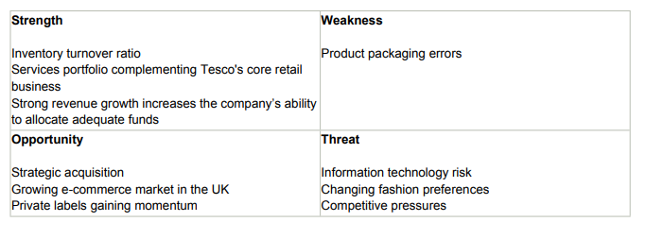
With regard to the strengths within Tesco, its inventory turnover ratio is increasing, and inventory turnover days are getting less. This is an indication of the higher demand for its products which may be driven by attractive promotional activities. Besides, Tesco has always attached great importance to its retailing services comprising online store selling, banking service, telecommunication service and market research, all of which complementing each other in a harmonious way. Tesco Bank offers various services like customers credits, savings accounts, insurance and mortgages. Tesco Mobile provides exclusive services for customers in stores and online including offering value tariffs with rewards like Clubcard points. Customers expect more multi-channel services where they can easily mix and match. The integrated retailing services within Tesco allow it to cross sell its products which is seen as a competitive advantage to drive margins. Moreover, strong revenue growth exhibited by Tesco in the previous years has boosted its capability of allocating abundant funds to realize the prospect of future growth.
As for weakness, there have been several product recalls for Tesco recently. Manufacturing errors, wrong packages and unspecified raw materials made Tesco under suspicion from customers.
In terms of opportunities, Tesco focuses on strategic mergers and acquisitions. It acquired Booker, the largest food wholesale operator in the UK in 2018, which will bring benefits for independent retailers, consumers and small businesses and offer the company a chance to expand wholesale and retail business. Besides, the online retail market keeps rising in the UK. Tesco online store offers a wide range of products for customers, also a direct delivery service. The established presence in e-commercial market will drive Tesco’s growth. What’ more, customers prefer to buy private label products to match with their low budget during an economic downturn. Higher sales in Tesco-branded products will contribute to a strong bottom line since these private label products have higher margins.
Regarding threats Tesco may face, first of all, it is the problem arising within information technology system since its business is mostly operated under the help of IT system both in real stores and online stores. Besides, the increasing threat of leaking personal data of employees, customers and third parties will make the company at risk if there is no strict confidentiality or effective protecting system. The second threat appears with the changing fashion preferences of customers. People’s tastes are volatile, especially women in apparel and beauty products so the company needs to be proactive in predicting trends and responding to the changes quickly and regularly or the changing factors may hamper the growth prospects. Last threat is caused by intense competition. Tesco is under a huge pressure of cutting prices among other rivals, not only key competitive supermarkets like Sainsbury’s, but also other ones like Mark and Spencer’s which is expanding operations to get more popularity. Tesco must strengthen its market position through improvements in its operating performance both in online and convenience stores or it will lag behind in the industry due to the fierce competition (Marketline, 2018).

Generic Strategies
Porter (1980) developed three generic strategies which he believed that the clear and customized one, whether specific or hybrid, is essential for a company to beat a variety of competitors and survive in the long run. As a giant retailer, Tesco should follow the framework to obtain a sustainable competitive position.
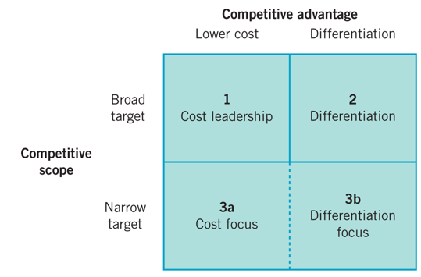
The cost-leadership strategy is commonly used in the market where standard products are not particularly different from others, generally accepted and frequently bought by consumers so that a lower cost in products should work for the company (Woodruff, 2018). Based on the threats caused from intense rivalry discussed before in the SWOT analysis, Tesco should well control its operating cost and offer its products and services to a broader market at the lowest price in order to generate high profit margins (UKEssays, 2018a).
The differentiation strategy has a focus on the unique products and services which a company is capable to offer and consumers are willing to pay for. The company can charge premium prices for its products and services which will ideally offset the higher production and serving costs only when customers regard the goods with unique characteristics and values are worthwhile. Therefore, the company can gain a reasonable profit from using this strategy (Woodruff, 2018). As for Tesco, according to the threat analysis of the SWOT analysis presented before, in order to beat competitors, it has to strive to innovate products and services with distinct features and values that attract customers to purchase however the price inelasticity will exist on the part of buyers (UKEssays, 2018a).
The focus strategy can be either a cost-focus strategy or a differentiation-focus strategy. The former pays attention to figuring out the idiosyncrasies of a limited market segment and the unique requirements of specific buying groups. The latter targets at a narrow niche market based on the spending habits of a small buyer group (Woodruff, 2018). Tesco can focus on creating internal efficiencies which in return helps to withstand external pressures. Apart from the mass market Tesco has targeted at, it can also confine its products and services to a smaller market areas (UKEssays, 2018a). But it is important for the company to spot the changing customers’ taste and buying habits in time since it will be difficult for the company to switch direction to sell to the broad market again (Woodruff, 2018).

Strategy in Action
Based on the framework of generic strategies discussed above, it is important for Tesco to implement the strategies in action. A successful cost-leadership strategy should consider optimizing all aspects of a company’s operations. Tesco needs to study how to use labors efficiently and find more ways to improve productivity. Tesco should exploit the economies of scale since higher volumes is persuasive to bargain lower prices with material suppliers and save the spending on transportation. Tesco should be generous in the investment in the latest technology to remain competitive. With the help of advanced technology, the methods of distribution will evolve constantly. It is necessary to find the lowest cost to distribute goods all the time. And reducing costs in production is essential for the cost-leadership strategy too. For example, Tesco can implement just-in-time inventory controls for raw materials so that the financing costs of assets will be reduced.
A successful differentiation strategy should firstly strive to build a creative and talented product development team who is able to investigate into the market and explore into the deep minds of potential customers to identify appealing features and persuade them to pay more of the products. Then an eloquent sales team is required to advertise the unique characteristic of the products and convince consumers that they will not regret for buying the valuable goods. Tesco should also concentrate on raising an excellent marketing campaign to promote its high reputation of selling high-quality and innovative products. Meanwhile, Tesco should never neglect two facts. One is that competitors will not stay idle, losing market share but will fight for a new differentiation campaign. The other is that consumers can easily change their taste. Since they can be attracted by Tesco’s new products one time, their interests will fade away as the debut of another new goods produced by its competitors (Woodruff, 2018). Hence, Tesco should always be prepared to notice any changes and accept the challenges.

Acoording to Balogun, et al. (2016), there are four generic types of change. Based on both external and internal analysis of Tesco in UK, there is no need for the company to have transformational change but it should change a little bit step by step, evolving towards a better leading retailer in the long run.
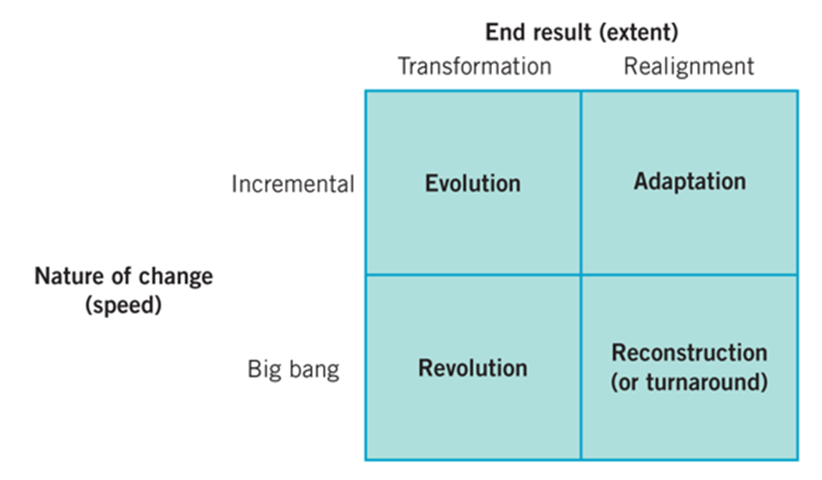

Kotter’s 8-step change
Experiencing the incremental change, Tesco should adopt Kotter’s (1996) 8-step change model to improve its performance and productivity.

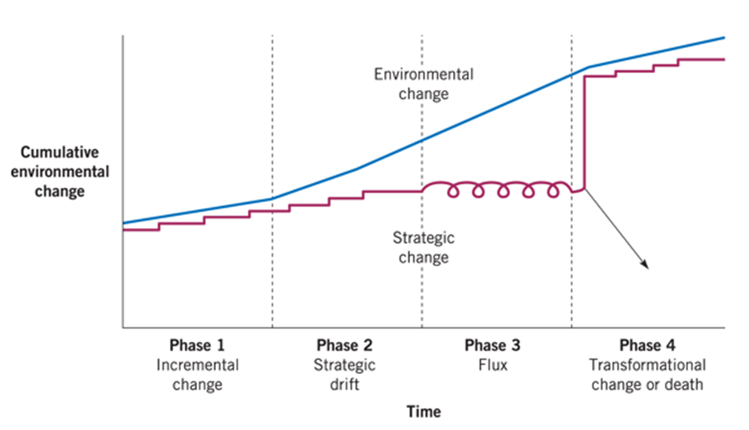
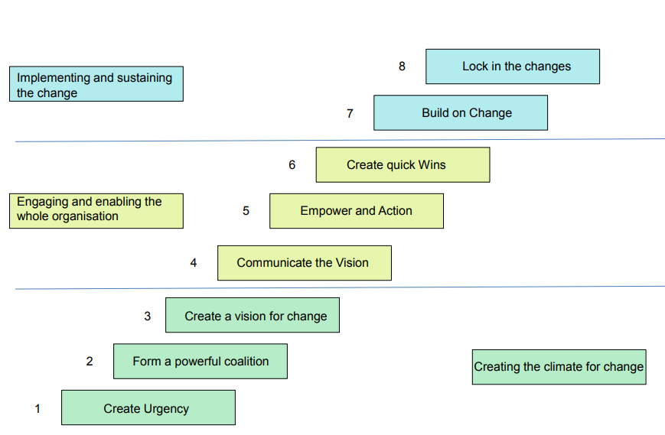
Firstly, developing a sense of urgency for change is helpful to spark the initial motivation to drive the change. Tesco should identify its potential change and imagine the outcomes in the future if everything stays the way they are now. Then the company should examine its opportunities which could become long-term benefits and discuss how to change in a constructive way by inviting and persuading all the staff to think and talk.
Secondly, it is necessary to convince people to accept the change which has to be done. A strong leadership and visible support from senior executives are needed to lead the change. Tesco should identify the true leader and build a committed team within the change coalition.
Thirdly, it is essential to link all the ideas and concepts floating around when thinking about the change to an overall vision which people can easily grasp and comprehend. Tesco should be prior to determine the value of the change, then generate a summarized vision to its future, and implement it in practice within the coalition.
Fourthly, communicating within the company about its set vision frequently and powerfully is required to consolidate the vision within each step of the implementation. Tesco should hold frequent discussions about the change vision to provide an open and honest platform for people to address their concerns about the change. Also, it will be eye-catching to lead the change by example.
Fifthly, a specific delegation of each task is helpful to avoid unwanted conflicts between leaders and employees. Tesco should identify the main leaders who are responsible for delivering the change and construct an organizational structure with clear job descriptions and then recognize and reward those people who have made contributions to the change.
Sixthly, a taste of victory in the early stage of the change is inspiring for the staff to keep working on the change. Tesco should choose an approachable short-term target and ensure that there are no strong resistant forces during the change.
Seventhly, consolidating improvements and high performance is essential for achieving the long-term goals. Tesco should analyze both right and wrong movements and criticize what needs to be improved in the remaining time frame. It is vital to keep the change alive and choose a new leader from the change team to build on the change.
Lastly, making the change part of the corporate culture is beneficial to add value to the existing performance of the company. Tesco should discuss the change progress and successful examples with people in every chance. The company should ensure that staff are trained and developed in an inclusive environment with values and change ideas. The key members of the change team and those who have contributed a lot to the change should be recognized and always remembered by rest of the staff. When planning to replace the leaders of the change, it is vital for Tesco to make sure that their legacy will not be lost or forgotten (UKEssays, 2018b).

Conclusion and Recommendation
From the foregoing, it can be concluded that Tesco, as a leading food and non-food retailer in the UK, has an increasing inventory turnover ratio, a complementary products and services portfolio and a strong revenue growth. Strategic mergers and acquisitions, growing e-commerce market and increasing preference towards private labels provide huge opportunities for Tesco to develop further. However, product recalls are areas of weakness and information technology risk, fierce competition and changing customer tastes bring about some potential threats on the company. So Tesco has to make some reshaping strategies to meet the challenges arising from the incremental change. It should pay attention to improve the quality of its products and be careful about the package. It should build safer confidential scheme to protect customers’ personal data from being leaked. In face of intense competition from both key rivals and emerging competitors, the company should take corresponding actions to respond to their challenges. What’s more, the company should always catch up with the trend and recognize customers’ change tastes and buying habits in time to draft new suitable strategies accordingly. Being innovative and creative both in products and services is the everlasting principle for a company to remain sustainable success in the long run.

References
Alvarez, B. J., McLoughlin, P. D. & Shelman, M., 2018. Tesco Group Food VRIO Analysis & Solution. [Online]
Available at: http://blueoceanuniversity.com/frontpage/vriocase/13853-tesco-food
[Accessed 23 4 2019].
Anon, 2014. TESCO P.L.C Analysis: Cultural Web, 7-Strategies & SWOT Analysis. [Online]
Available at: http://milotmorina.blogspot.com/2014/03/tesco-plc-analysis-cultural-web-7.html?view=flipcard
[Accessed 14 4 2019].
Anon, 2018. Tesco Supermarket: PESTLE, SWOT, Porter’s Five Forces and Value Chain. [Online]
Available at: https://15writers.com/sample-reports/tesco-pestel-swot-porters-five-forces-value-chain/
[Accessed 1 4 2019].
Armstrong, A., 2016. Five ways Tesco turned the screws on its suppliers. [Online]
Available at: https://www.telegraph.co.uk/finance/newsbysector/retailandconsumer/12122662/Five-ways-Tesco-turned-the-screws-on-its-suppliers.html
[Accessed 25 3 2019].
Balogun, J., Hailey, H. V. & Gustafsson, S., 2016. Exploring Strategic Change. 4 ed. London: Pearson.
Barney, J., 1995. Looking Inside for Competitive Advantage. Academy of Management Executive, 9(4), pp. 49-61.
Bhatia, R., 2019. Stakeholders-at-tesco. [Online]
Available at: https://www.academia.edu/8603327/Stakeholders-at-tesco
[Accessed 3 4 2018].
Bunting, O., 2018. Tesco Stakeholders!. [Online]
Available at: https://prezi.com/p/2mdeinac0r-w/tesco-stakeholders/
[Accessed 22 4 2019].
Butler, S., 2019. Tesco says shoppers are feeling ‘Brexit fatigue’ but not stockpiling. [Online]
Available at: https://www.theguardian.com/business/2019/apr/10/tesco-dave-lewis-says-shoppers-are-feeling-brexit-fatigue-but-not-stockpiling
[Accessed 13 4 2019].
Capon, C., 2008. Chapter 5: Stakeholders, culture and change. In: Understanding Strategic Management. Harlow: Pearson Education Limited, pp. 136-170.
Chandler, A. D., 1963. Strategy and Structure: Chapters in the History of American Enterprises. Cambridge: MIT Press.
Chernev, A., 2018. Strategic Marketing Management. 9 ed. Chicago: Cerebellum Press.
Drucker, P., 1994. The Theory of Business. Harvard Business Review.
Dudovskiy, J., 2016. Tesco Porter’s Five Forces Analysis. [Online]
Available at: https://research-methodology.net/tesco-porters-five-forces-analysis/
[Accessed 22 4 2019].
European Commision, 2019. 2018 reform of EU data protection rules. [Online]
Available at: https://ec.europa.eu/commission/priorities/justice-and-fundamental-rights/data-protection/2018-reform-eu-data-protection-rules_en
[Accessed 13 4 2019].
Fern Fort University, 2019. Tesco Plc Porter Five Forces Analysis. [Online]
Available at: http://fernfortuniversity.com/term-papers/porter5/lse/497-tesco-plc.php
[Accessed 3 4 2019].
GOV.UK, 2019. VAT rates. [Online]
Available at: https://www.gov.uk/vat-rates
[Accessed 22 4 2019].
Henry, A., 2018. Understanding Strategic Management. 3 ed. Oxford: Oxford University Press.
Ho, G., 2016. Lidl and Aldi push up UK market share. [Online]
Available at: https://www.express.co.uk/finance/city/643877/Lidl-Aldi-push-UK-market-share
[Accessed 11 4 2019].
Ian, J., 2017. Tesco to switch to 100% renewable electricity this year in UK and by 2030 worldwide. [Online]
Available at: https://www.independent.co.uk/environment/tesco-switch-renewable-lectricity-energy-uk-2017-by-2030-worldwide-supermarket-a7739076.html
[Accessed 12 4 2019].
Johnson, G. et al., 2017. Exploring strategy : text and cases. 11 ed. Harlow: Pearson Education Limited.
Joshaddo, 2017. PORTER’S 5 FORCES ANALYSIS OF TESCO. [Online]
Available at: https://joshaddo.wordpress.com/2017/01/18/porters-5-forces-analysis-of-tesco/
[Accessed 31 3 2019].
Kotter, J., 1996. Leading Change. Massachusetts: Harvard Publishing Press.
Marketline, 2018. Tesco PLC. [Online]
Available at: file:///C:/Users/Administrator/Downloads/34972414-9A41-4048-A7B6-1B0017054743.pdf
[Accessed 11 4 2019].
Martin, W., 2017. Brexit has sent Britain's consumers down a slow, painful road away from prosperity. [Online]
Available at: https://www.businessinsider.com/brexit-uk-consumer-economic-impact-2017-9?r=UK
[Accessed 12 4 2019].
Meng, G., 2018. Strategic Management Of Tesco. [Online]
Available at: https://myassignmenthelp.com/free-samples/strategic-management-of-tesco
[Accessed 31 3 2019].
Mintzberg, H., 2007. Tracking Strategies: Towards a General Theory. Oxford: Oxford University Press.
Morden, T., 2017. Principles of Strategic Management. 3 ed. London: Routledge.
Nwagbara, U., 2010. Managing Organizational Change: Leadership, Tesco and Leahy's Resignation. e-Journal of Organizational Learning and Leadership, 8(2), pp. 30-52.
Office for National Statistics, 2019. Overview of the UK population: November 2018. [Online]
Available at: https://www.ons.gov.uk/peoplepopulationandcommunity/populationandmigration/populationestimates/articles/overviewoftheukpopulation/november2018
[Accessed 15 4 2019].
Parsons, N., 2018. What Is a SWOT Analysis, and How to Do It Right (With Examples). [Online]
Available at: https://www.liveplan.com/blog/what-is-a-swot-analysis-and-how-to-do-it-right-with-examples/
[Accessed 24 4 2019].
Porter, M., 1980. Competitive Strategy: Techniques for Analyzing Industries and Competitors. Ney York: Free Press.
Porter, M., 1996. What is Strategy?. Harvard Business Review.
Potter, M., 1979. How competitive forces shape strategy. Harvard Business Review.
Potts, O., 2018. Tesco’s new Brexit supermarket doesn’t stack up. [Online]
Available at: https://www.spectator.co.uk/2018/09/tescos-new-brexit-supermarket-doesnt-stack-up/
[Accessed 3 4 2019].
Root, G., n.d. The Impact of Corporate Culture on Business Strategy. [Online]
Available at: https://smallbusiness.chron.com/impact-corporate-culture-business-strategy-21891.html
[Accessed 22 4 2019].
Study Moose, 2016. Stakeholders of Tesco Essay. [Online]
Available at: https://studymoose.com/stakeholders-of-tesco-essay
[Accessed 31 3 2019].
TESCO PLC, 2017a. Organic food sales strongest for over a decade. [Online]
Available at: https://www.tescoplc.com/news/news-releases/2017/tesco-organic-food-growth/
[Accessed 21 4 2019].
TESCO PLC, 2017b. Tesco reveals exciting new improvements to Clubcard. [Online]
Available at: https://www.tescoplc.com/news/news-releases/2017/tesco-reveals-exciting-new-improvements-to-clubcard/
[Accessed 25 4 2019].
TESCO PLC, 2018. Our Code of Business Conduct. [Online]
Available at: As regards to Power Structures, Tesco-careers.com (2013) explains that Tesco applies Talent Planning for vacancies. Accordingly, more than eighty percent of management positions come from Tesco’s employees.
[Accessed 24 4 2019].
TESCO PLC, 2019a. Our businesses. [Online]
Available at: https://www.tescoplc.com/about-us/our-businesses/
[Accessed 11 4 2019].
TESCO PLC, 2019b. Core Purpose and Values. [Online]
Available at: https://www.tescoplc.com/about-us/core-purpose-and-values/
[Accessed 29 3 2019].
TESCO PLC, 2019c. Our carbon footprint. [Online]
Available at: https://sustainability.tescoplc.com/sustainability/foundations/topics/carbon-footprint/
[Accessed 23 4 2019].
TESCO PLC, 2019d. History. [Online]
Available at: https://www.tescoplc.com/about-us/history/
[Accessed 24 4 2019].
TESCO PLC, 2019e. Tesco's Board and Executive Committee. [Online]
Available at: https://www.tescoplc.com/about-us/board-and-executive-committee/board/
[Accessed 23 4 2019].
Trading Economics, 2019a. United Kingdom Interest Rate. [Online]
Available at: https://tradingeconomics.com/united-kingdom/interest-rate
[Accessed 13 4 2019].
Trading Economics, 2019b. United Kingdom Unemployment Rate. [Online]
Available at: https://tradingeconomics.com/united-kingdom/unemployment-rate
[Accessed 11 4 2019].
Transparency International, 2019. Corruption Perceptions Index 2018. [Online]
Available at: https://www.transparency.org/cpi2018
[Accessed 14 4 2019].
UKEssays, 2016. PESTEL and five forces analysis of Tesco. [Online]
Available at: https://www.ukessays.com/essays/marketing/pestel-and-five-forces-analysis-of-tesco-marketing-essay.php#citethis
[Accessed 3 4 2019].
UKEssays, 2018a. Doing research on Tesco UK. [Online]
Available at: https://www.ukessays.com/essays/business/doing-research-on-tesco-uk-business-essay.php
[Accessed 24 4 2019].
UKEssays, 2018b. Tesco Change Management Strategy. [Online]
Available at: https://www.ukessays.com/essays/business/strategic-change-management-in-the-case-of-tesco-business-essay.php
[Accessed 26 4 2019].
University of Nottingham, 2015. Tesco-Stakeholder-Mapping. [Online]
Available at: https://mediaspace.nottingham.ac.uk/media/2.3.X-Tesco-Stakeholder-Mapping/1_5sy3308v
[Accessed 22 4 2019].
West, D., Ford, J. & Ibrahim, E., 2015. Strategic Marketing: Creating Competitive Advantage. 3 ed. Oxford: Oxford University Press..
Woodruff, J., 2018. Four Generic Strategies That Strategic Business Units Use. [Online]
Available at: https://smallbusiness.chron.com/four-generic-strategies-strategic-business-units-use-496.html
[Accessed 25 4 2019].
Wood, Z., 2017. Tesco says price rises are last resort as UK growth hits seven-year high. [Online]
Available at: https://www.theguardian.com/business/2017/jun/16/tesco-price-rises-uk-growth-inflation-pound-brexit
[Accessed 22 4 2019].

